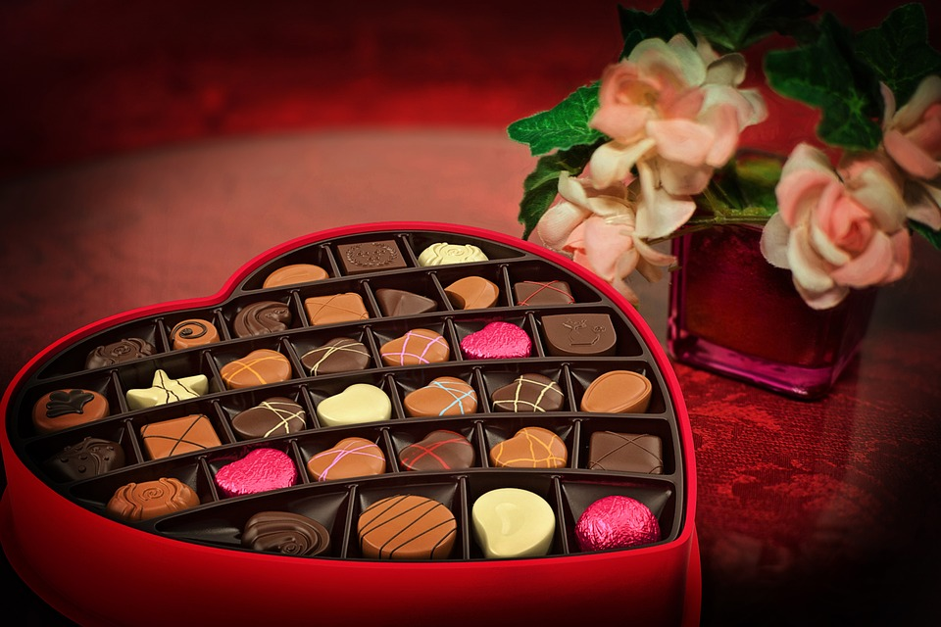CHOCOLATES:

Chocolate is a food product made from the fruit of a cacao tree (Theobroma cacao).

chocolate, food product made from cocoa beans, consumed as candy and used to make beverages and to flavor or coat various confections and bakery products.