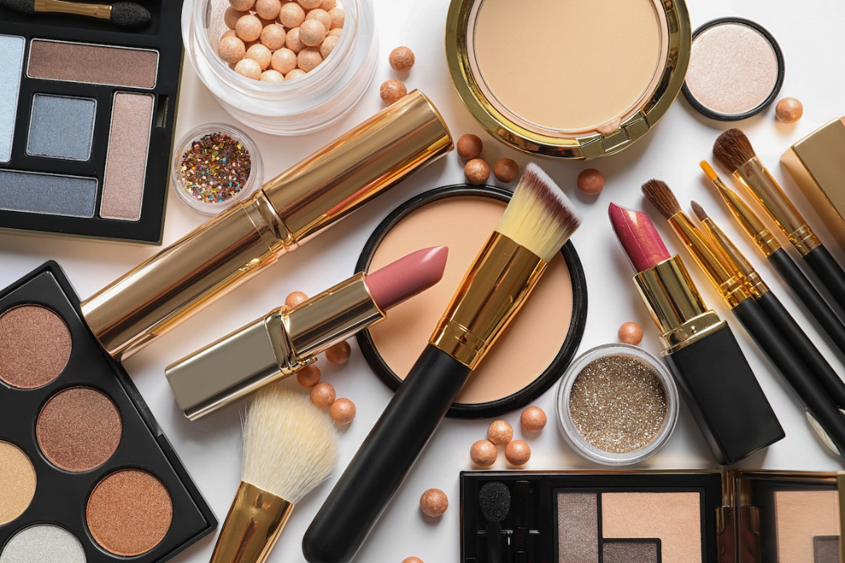COSMETICS:

Cosmetics are constituted mixtures of chemical compounds derived from either natural sources, or synthetically created ones. Cosmetics have various purposes. Those designed for personal care and skin care can be used to cleanse or protect the body or skin.