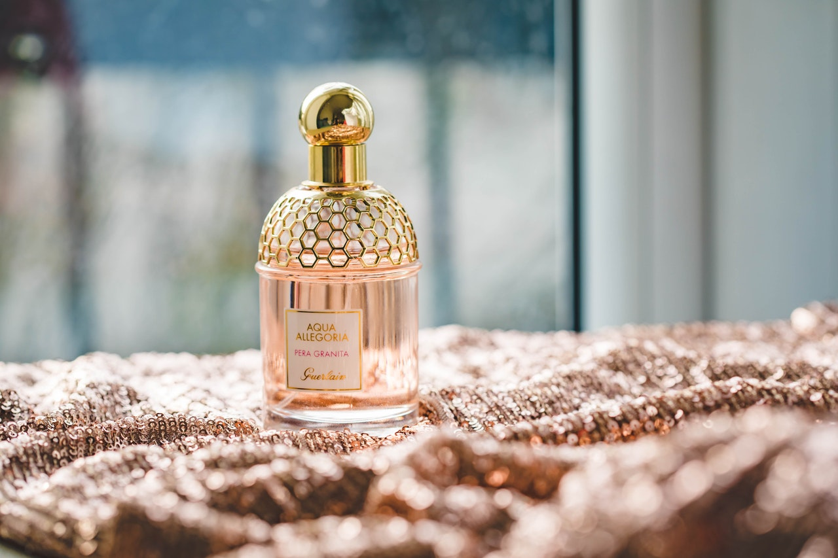FRAGRANCES:

Perfume is a mixture of fragrant essential oils or aroma compounds, fixatives and solvents, usually in liquid form, used to give the human body, animals, food, objects, and living-spaces an agreeable scent. Perfumes can be defined as substances that emit and diffuse a substances that emit and diffuse a pleasant and fragrant odor.