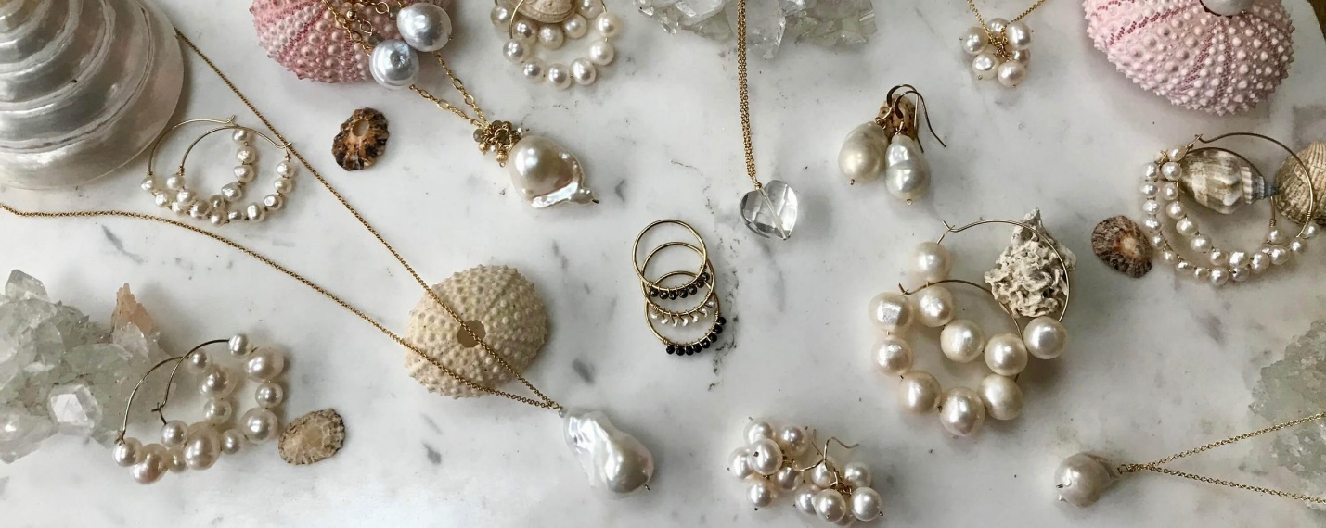JEWELRY:

Jewelry consists of decorative items worn for personal adornment, such as brooches, rings, necklaces, earrings, pendants, bracelets, and cufflinks. Jewelry may be attached to the body or the clothes.