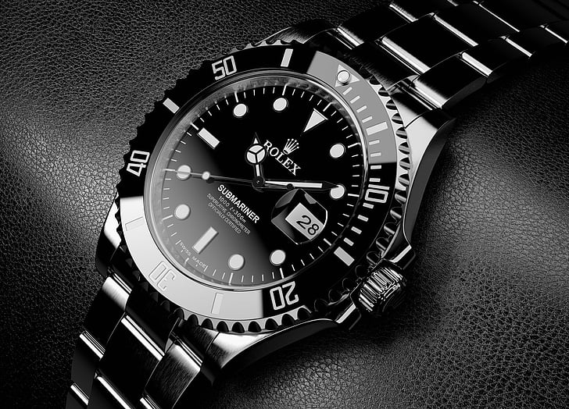WATCHES:

A watch is a portable timepiece intended to be carried or worn by a person. It is designed to keep a consistent movement despite the motions caused by the person's activities.