- Create a Pandas DataFrame for student examination marks and perform the following:
    - Display subject-wise average marks using groupby().
    - Remove Duplicate Records
    - Handle Missing Values

Solution :-

import pandas as pd
import numpy as np
data = {
"RollNo": [1, 2, 3, 3, 4],
"Name": ["Aman", "Bina", "Chirag", "Chirag", "Divya"],
"Subject": ["Math", "Math", "Math", "Math", "Math"],
"Marks": [78, np.nan, 65, 65, 90]
}
df = pd.DataFrame(data)
print("Original DataFrame:")
print(df)
# 1) Handle missing values
df["Marks"] = df["Marks"].fillna(df["Marks"].mean())
# 2) Remove duplicate records
df = df.drop_duplicates()
# 3) Subject-wise average marks
avg_marks = df.groupby("Subject")["Marks"].mean()
print("\nAfter Cleaning:")
print(df)
print("\nSubject-wise Average:")
print(avg_marks)

output:

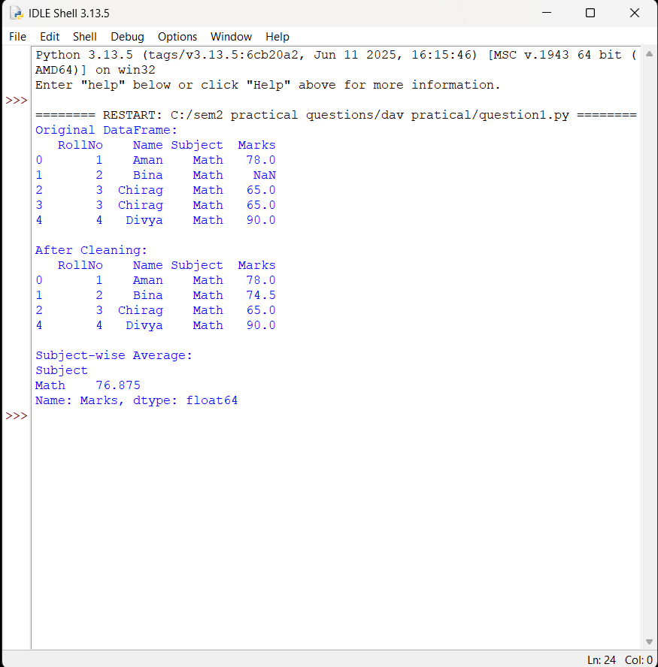

- Demonstrate NumPy broadcasting, slicing, and filtering using a marks array and classify students as Pass/Fail using np.where().

Solution :-

import numpy as np

marks = np.array([35, 67, 89, 40, 22, 55])
# Broadcasting: add grace marks to all students
grace = 5
updated = marks + grace
# Slicing: first 3 students
first_three = updated[:3]
# Filtering: marks >= 40
passed_marks = updated[updated >= 40]
# Pass/Fail classification
result = np.where(updated >= 40, "Pass", "Fail")

print("Original:", marks)
print("After Grace:", updated)
print("First 3:", first_three)
print("Passed Marks:", passed_marks)

print("Result:", result)

output:

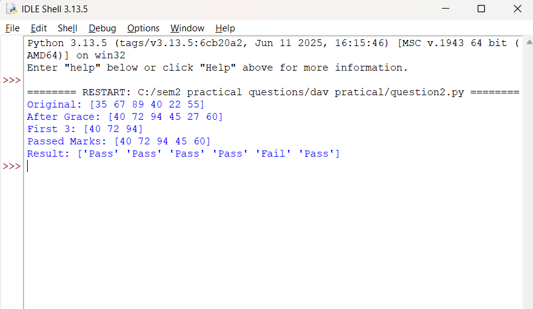

- Using Pandas, reshape student marks data from wide format to long format using melt() and explain the output.

Solution :-
import pandas as pd

df = pd.DataFrame({
"RollNo": [1, 2, 3],
"Name": ["Aman", "Bina", "Chirag"],
"Math": [78, 88, 65],
"Science": [72, 91, 70],
"English": [69, 85, 75]
})

print("Wide Format:")
print(df)

long_df = df.melt(id_vars=["RollNo", "Name"],
value_vars=["Math", "Science", "English"],
var_name="Subject",
value_name="Marks")
print("\nLong Format (after melt):")
print(long_df)

output:

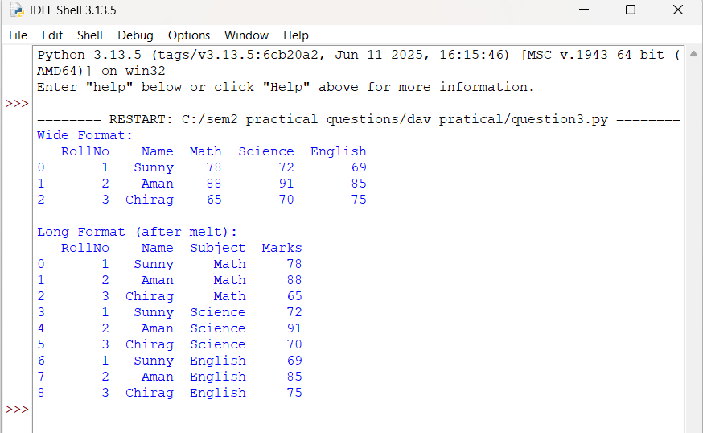

- Create a dataset of daily sales and apply rolling window functions to calculate 3-day moving average and rolling sum.

Solution :-
import pandas as pd

sales = pd.DataFrame({
"Date": pd.date_range("2026-01-01", periods=10),
"Sales": [1200, 1500, 1100, 1700, 1600, 1800, 1400, 2000, 2100, 1900]
})

sales["MA_3"] = sales["Sales"].rolling(window=3).mean()

sales["Sum_3"] = sales["Sales"].rolling(window=3).sum()

print(sales)

output:

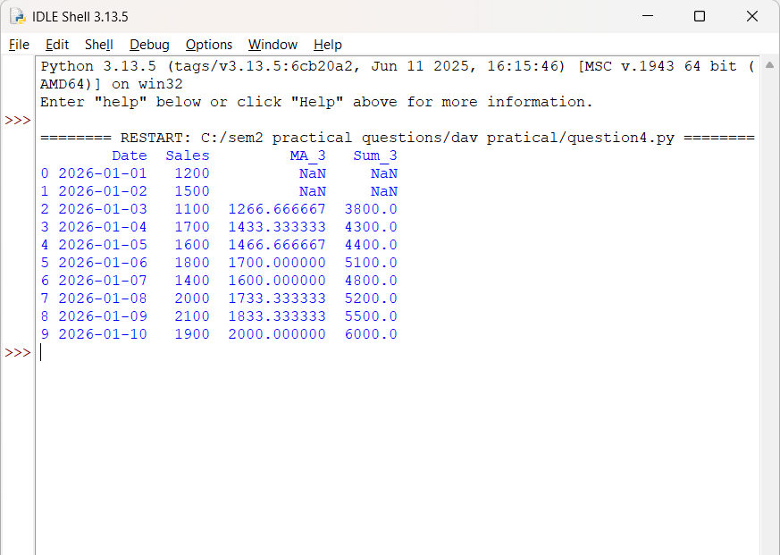

- Write a Python program to perform full CRUD operations on SQLite
- Create table
- Insert records
- Update records
- Delete records

Solution :-
import sqlite3

conn = sqlite3.connect("students.db")

cur = conn.cursor()

# a) Create table
cur.execute("""
CREATE TABLE IF NOT EXISTS marks (
rollno INTEGER PRIMARY KEY,
name TEXT NOT NULL,
subject TEXT NOT NULL,
marks INTEGER NOT NULL
)
""")

# b) Insert records
students = [
(1, "Aman", "Math", 78),
(2, "Bina", "Math", 88),
(3, "Chirag", "Math", 65)
]

cur.executemany("INSERT OR REPLACE INTO marks VALUES (?,?,?,?)", students)
conn.commit()

# c) Update marks

cur.execute("UPDATE marks SET marks=? WHERE rollno=?", (90, 2))
conn.commit()

# d) Delete record

cur.execute("DELETE FROM marks WHERE rollno=?", (3,))
conn.commit()

# e) Fetch final data

cur.execute("SELECT * FROM marks")
rows = cur.fetchall()
print("Final Records:")
for r in rows:
print(r)
con.close()

output:

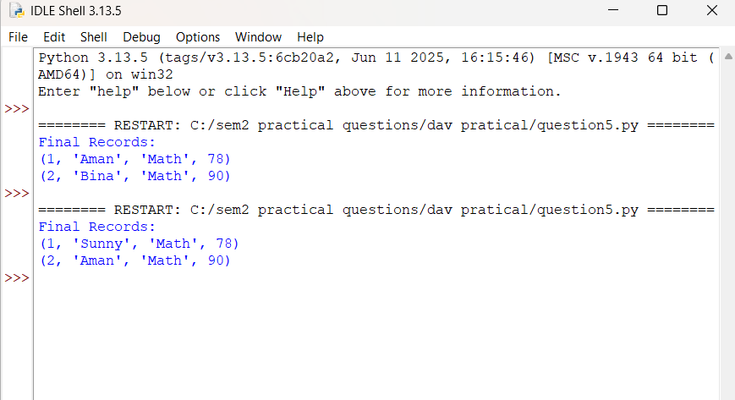

- Connect Python to MongoDB using PyMongo and perform:
- Insert one and multiple records
- Update a document
- Delete a document
- Display record

Solution :-
from pymongo import MongoClient
client = MongoClient("mongodb://localhost:27017/")
db = client["collegeDB"]
col = db["students"]
# a) Insert one document
col.insert_one({"rollno": 1, "name": "Aman", "subject": "Math", "marks": 78})
# Insert multiple documents
col.insert_many([
{"rollno": 2, "name": "Bina", "subject": "Math", "marks": 88},
{"rollno": 3, "name": "Chirag", "subject": "Math", "marks": 65}
])
# b) Update a document
col.update_one({"rollno": 2}, {"$set": {"marks": 90}})
# c) Delete a document
col.delete_one({"rollno": 3})
# d) Display records
for doc in col.find({}, {"_id": 0}):
print(doc)
client.close()

output:

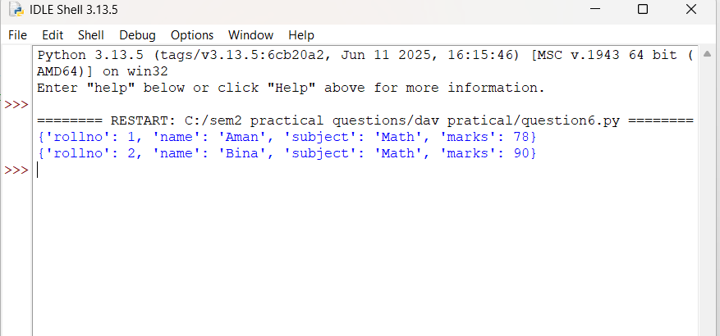

- Read data from SQLite into Pandas, modify the DataFrame, and write it back to a new SQLite table.

Solution :-
import sqlite3
import pandas as pd

conn = sqlite3.connect("students.db")

# Read table into DataFrame
df = pd.read_sql_query("SELECT * FROM marks", conn)
print("Original from SQLite:")
print(df)

# Modify DataFrame
df["marks"] = df["marks"] + 2 # add bonus marks

# Write to new table
df.to_sql("marks_bonus", conn, if_exists="replace", index=False)
print("\nWritten to new table: marks_bonus")
print(pd.read_sql_query("SELECT * FROM marks_bonus", conn))
con.close()

Output:

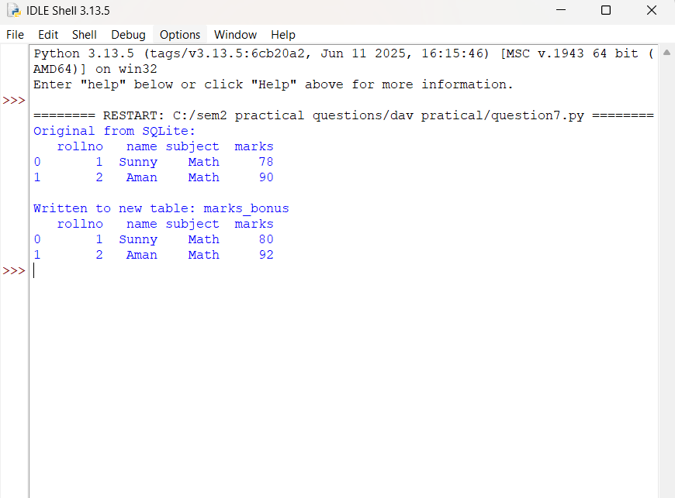

- Read MongoDB collection into Pandas DataFrame, remove _id field, and reinsert the cleaned data back into MongoDB.

Solution :-
from pymongo import MongoClient
import pandas as pd

client = MongoClient("mongodb://localhost:27017/")

db = client["collegeDB"]
col = db["students"]

# Read MongoDB to DataFrame
docs = list(col.find())
df = pd.DataFrame(docs)
print("Original DataFrame:")
print(df)

# Remove _id column
if "_id" in df.columns:
df = df.drop(columns=["_id"])

# Clear collection and reinsert cleaned data
col.delete_many({})
col.insert_many(df.to_dict(orient="records"))
print("\nCleaned data inserted back.")

client.close()

Output:

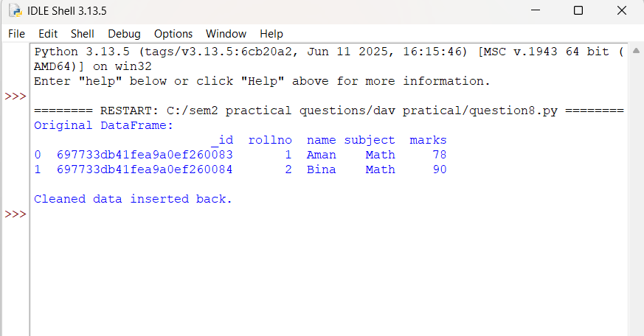

- Using a student examination CSV file, create the following Seaborn plots and explain each:
- Boxplot
- Heatmap
- Pairplot

Solution :-
import pandas as pd
import seaborn as sns
import matplotlib.pyplot as plt

df = pd.read_csv("student_marks.csv")

# Boxplot
sns.boxplot(data=df, x="Subject", y="Marks")
plt.show()

# Heatmap (correlation)
pivot = df.pivot_table(index="Name", columns="Subject", values="Marks")
sns.heatmap(pivot.corr(), annot=True)
plt.show()

# Pairplot
sns.pairplot(pivot.dropna())
plt.show()

output:

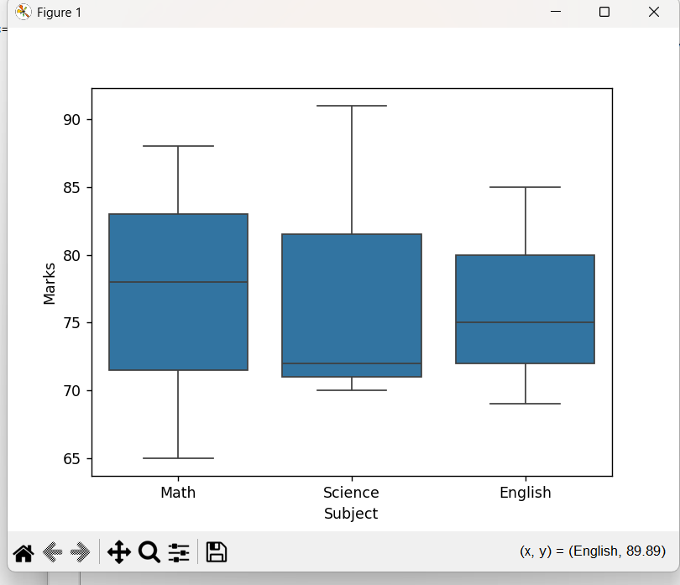

output:

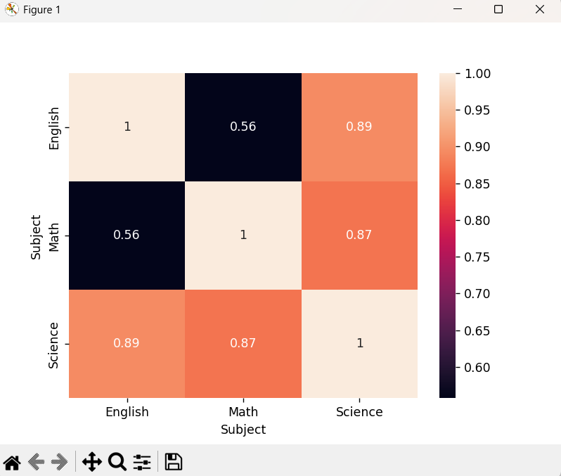

output:

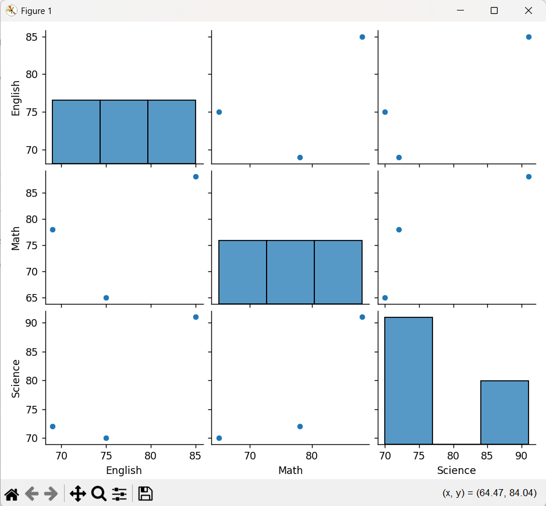

- Using Tableau Public, perform the following tasks on a suitable dataset (e.g., Student Examination Data / Sales Data / Superstore Dataset):
- Connect the dataset in Tableau Public and explain the Tableau Public interface, including Data Pane, Sheets, Dashboard, and Show Me options.
- Create calculated fields (such as Total Marks or Profit Ratio) and apply filters and parameters to analyze the data dynamically.

Solution :-
a) Connect dataset + Interface:
1. Open Tableau Public ® Create a Visualization.
2. Connect to your file (CSV/Excel) using the left Connect panel.
3. Data Pane (left): shows Dimensions (categorical) and Measures (numeric).
4. Sheet: build charts by dragging fields to Rows/Columns/Marks.
5. Show Me: suggests chart types based on selected fields.
6. Dashboard: combine multiple sheets into one view.

b) Calculated fields + Filters + Parameters:
1. Calculated Field examples:
- Total Marks = [Math] + [Science] + [English]
- Profit Ratio = SUM([Profit]) / SUM([Sales])
2. Filters:
- Drag field to Filters shelf (e.g., Subject, Class, Region) and select values.
3. Parameters:
- Create Parameter (e.g., Select Subject) ® Use it in a Calculated Field to change view dynamically.
4. Use parameters + filters to interactively analyze student performance or sales/profit.

Output:
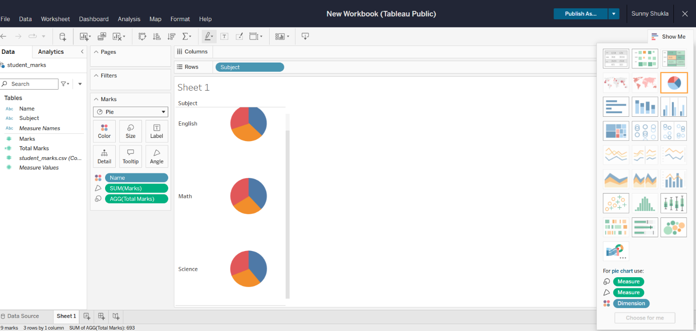

Output:
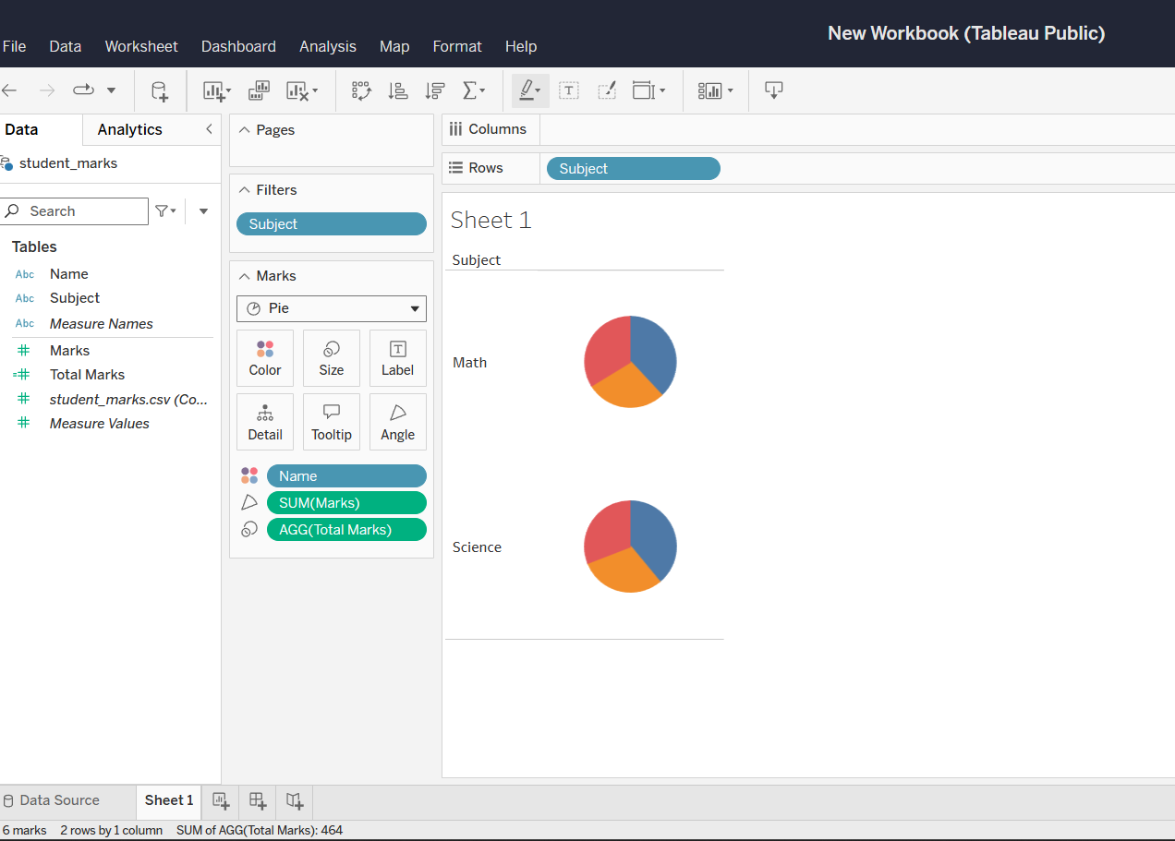

Output:
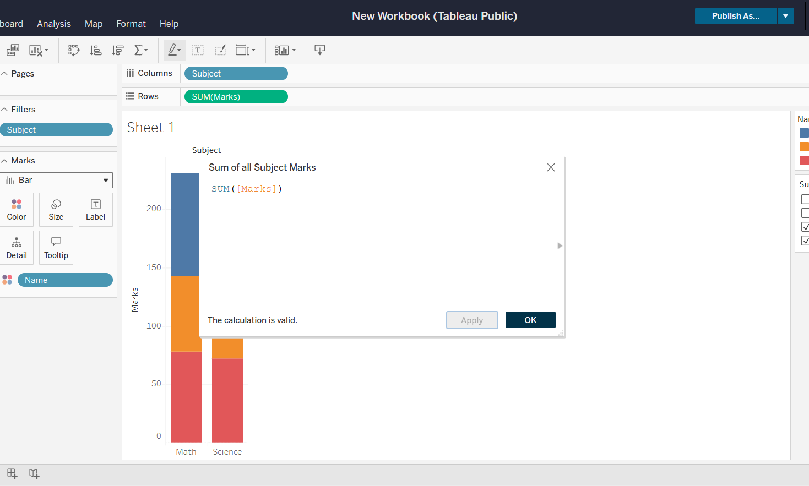

Output:
