- API call using axios/fetch Create node js project and call below api using axios/fetch https://jsonplaceholder.typicode.com/posts

Solution:-
Create Node.js Project
- mkdir api-demo
- cd api-demo
- npm init -y

Crate File: fetchApi.js
Code:-
fetch("https://jsonplaceholder.typicode.com/posts")
.then((response) => response.json())
.then((data) => {
console.log("Data fetched using Fetch:");
console.log(data);
})
.catch((error) => {
console.error("Error:", error);
});

Output:
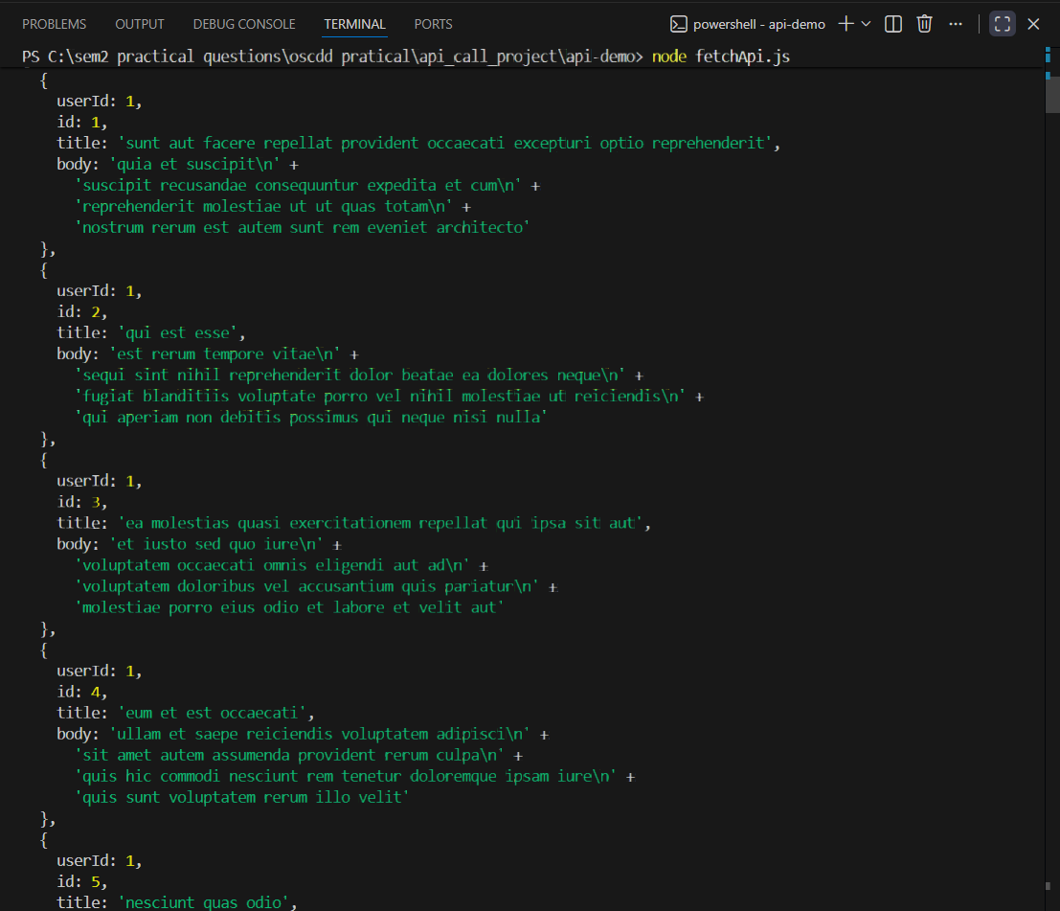

Output:
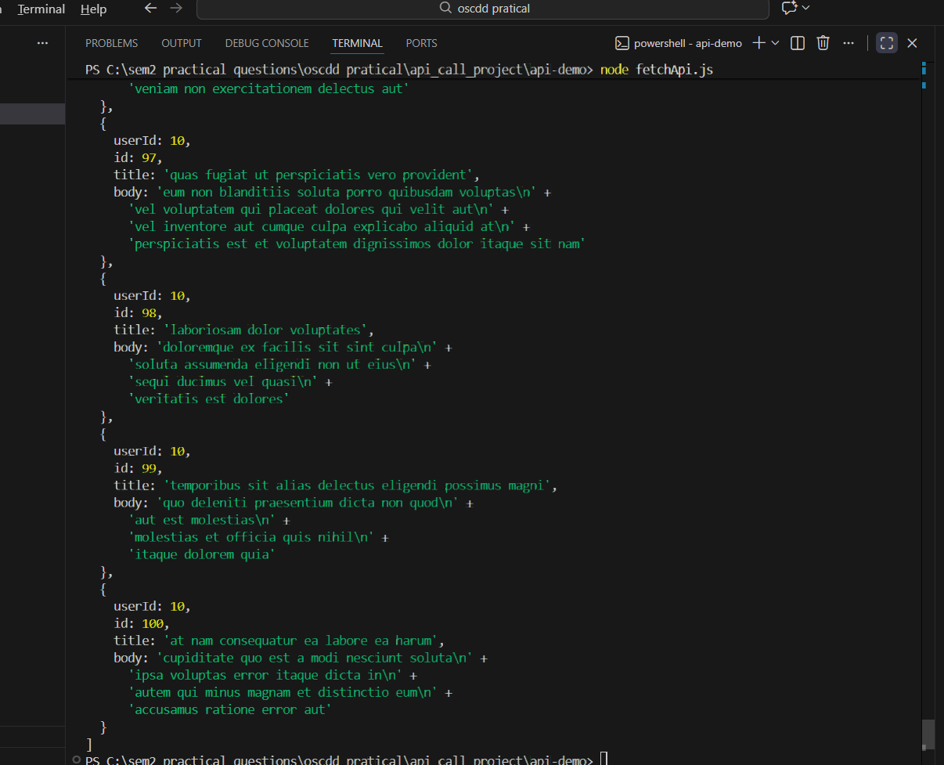

- Create a basic static website using HTML and CSS with two HTML pages, host it using GitHub Pages, and explain each step.

Solution:-
Step 1:- Create Project Structure:
static-website/
├── index.html
├── about.html
└── style.css
Code:-
Step 2 :- File:index.html
<!DOCTYPE html>
<html>
<head>
<title>Home Page</title>
<link rel="stylesheet" href="style.css">
</head>
<body>
<h1>Welcome to My Website</h1>
<p>This is the home page.</p>
<a href="about.html">Go to About Page</a>
</body>
</html>
Step3:-File: about.html
<!DOCTYPE html>
<html>
<head>
<title>About Page</title>
<link rel="stylesheet" href="style.css">
</head>
<body>
<h1>About Us</h1>
<p>This is the about page.</p>
<a href="index.html">Back to Home</a>
</body>
</html>

Step4:-File: style.css
body {
font-family: Arial, sans-serif;
background-color: #f4f4f4;
text-align: center;
}

h1 {
color: #333;
}

a {
color: blue;
text-decoration: none;
}
Step 5:-Upload to GitHub
*Create repository on github
* Upload all files
* Go to settings -> Pages
* Select branch main
* Click save

Output:
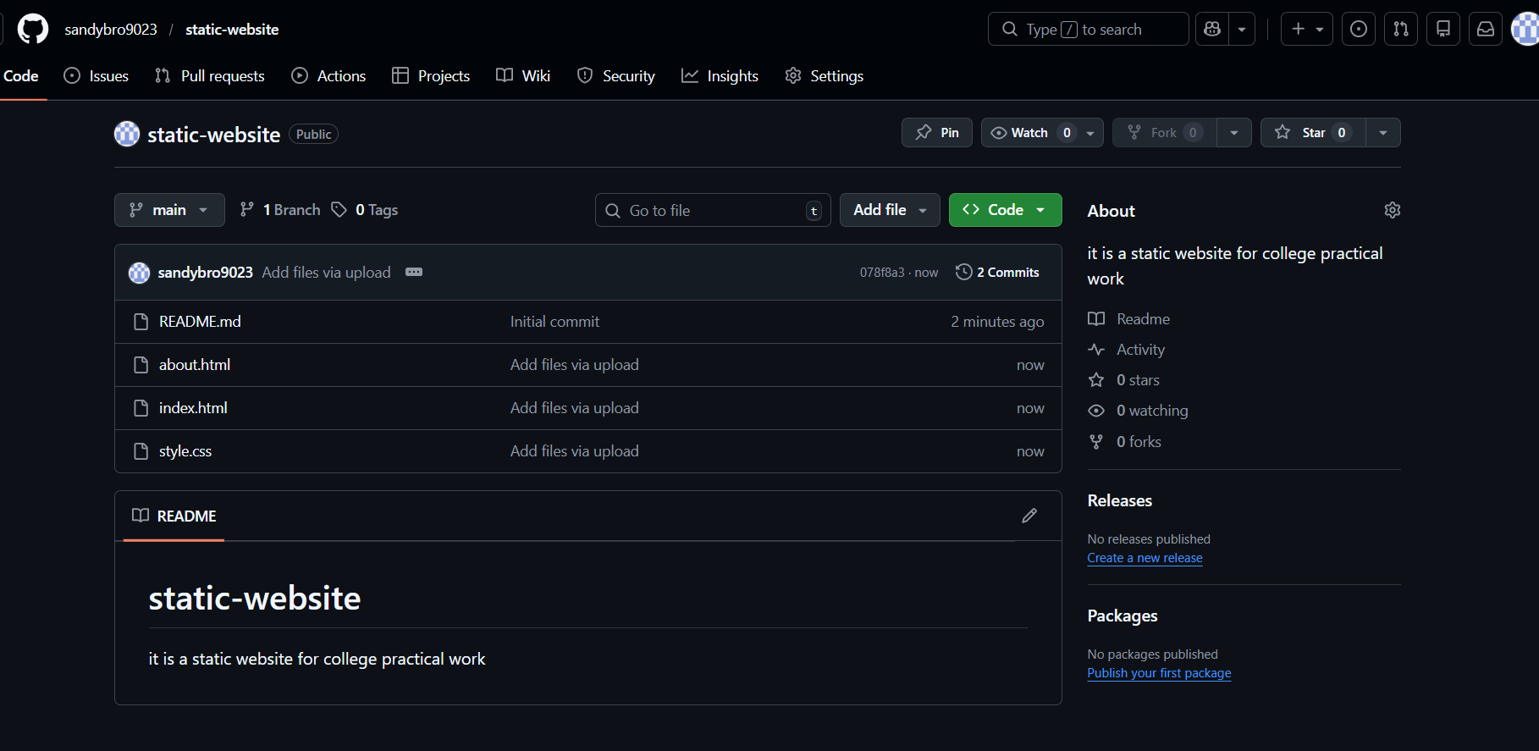

Output:
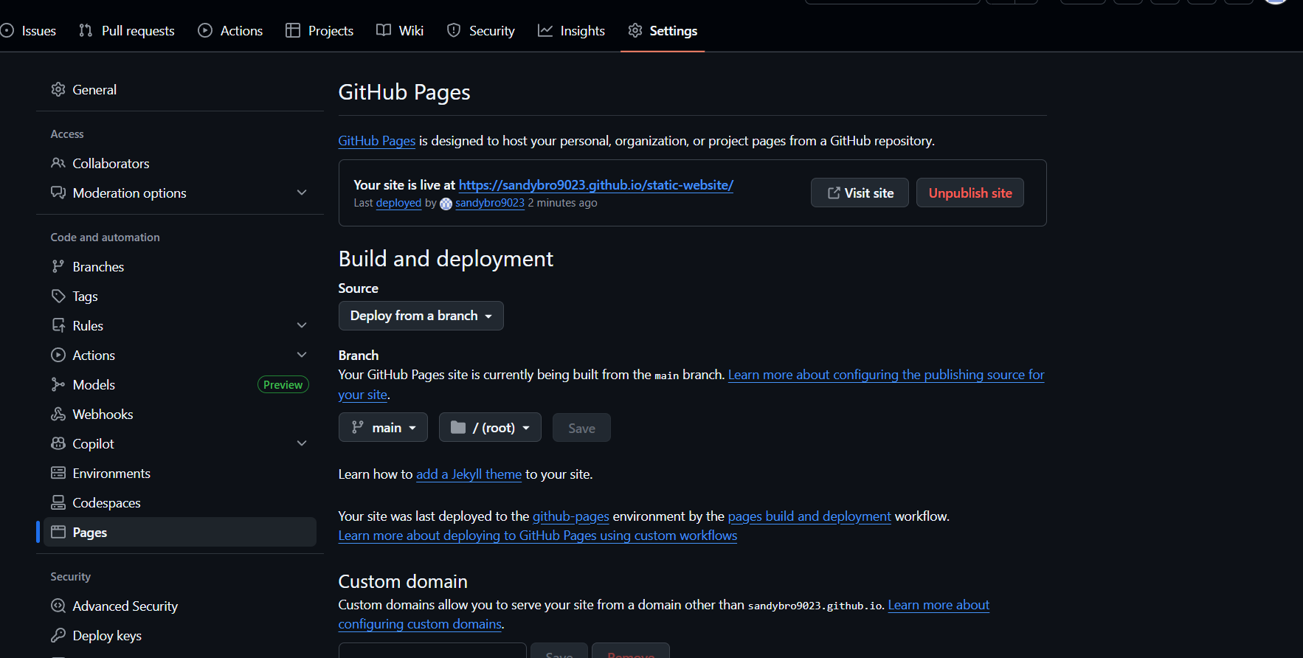

Output:
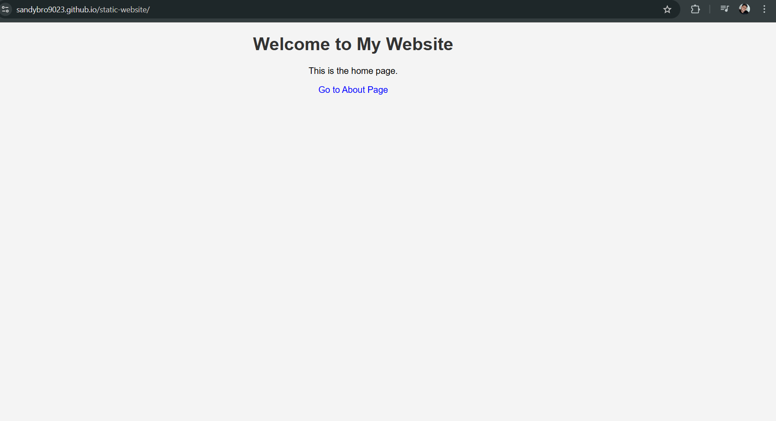

- Host a project stored in a GitHub repository on Netlify and explain the deployment process.

Solution:-
Step 1: Push Project to Github
* EnsureProject in a Github repostiory

Step 2: Login to Netlify
Go to:
https://www.netlify.com
Login using Github

Step 3: Deploy Website
• Click Add new site
• Select Import from GitHub
• Choose repository
• Build command → Leave empty
• Publish directory → /
• Click Deploy

Step 4: Live Website
Netlify generates a URL like:
* https://your-site-name.netlify.app

Output:
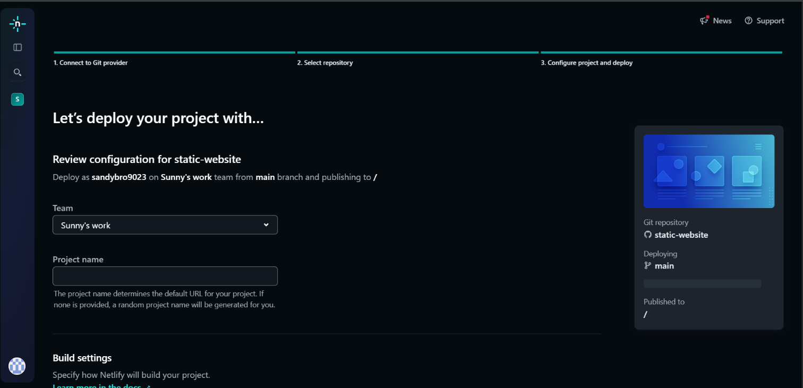

Output:
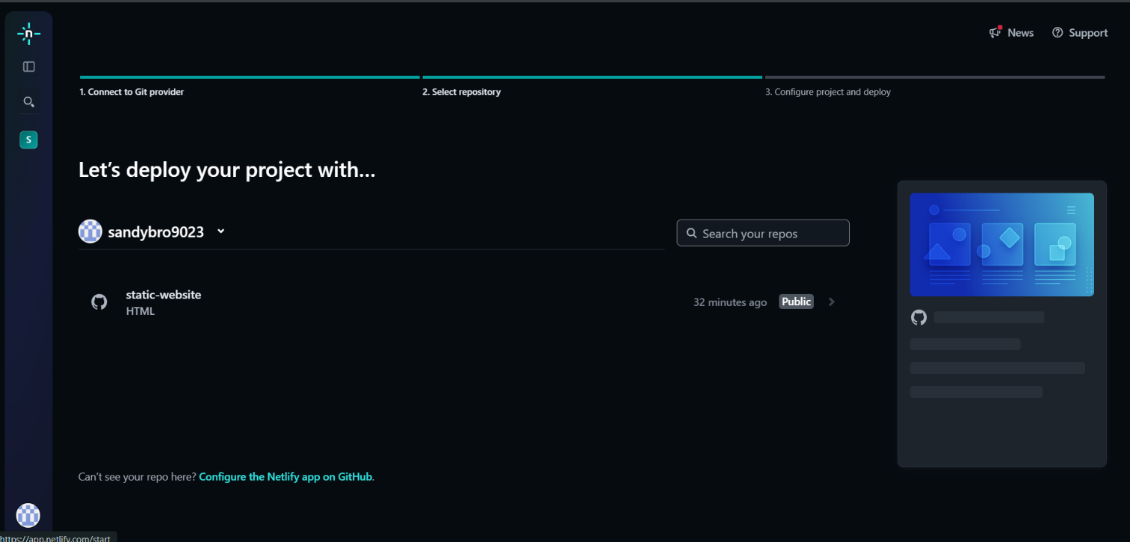

Output:
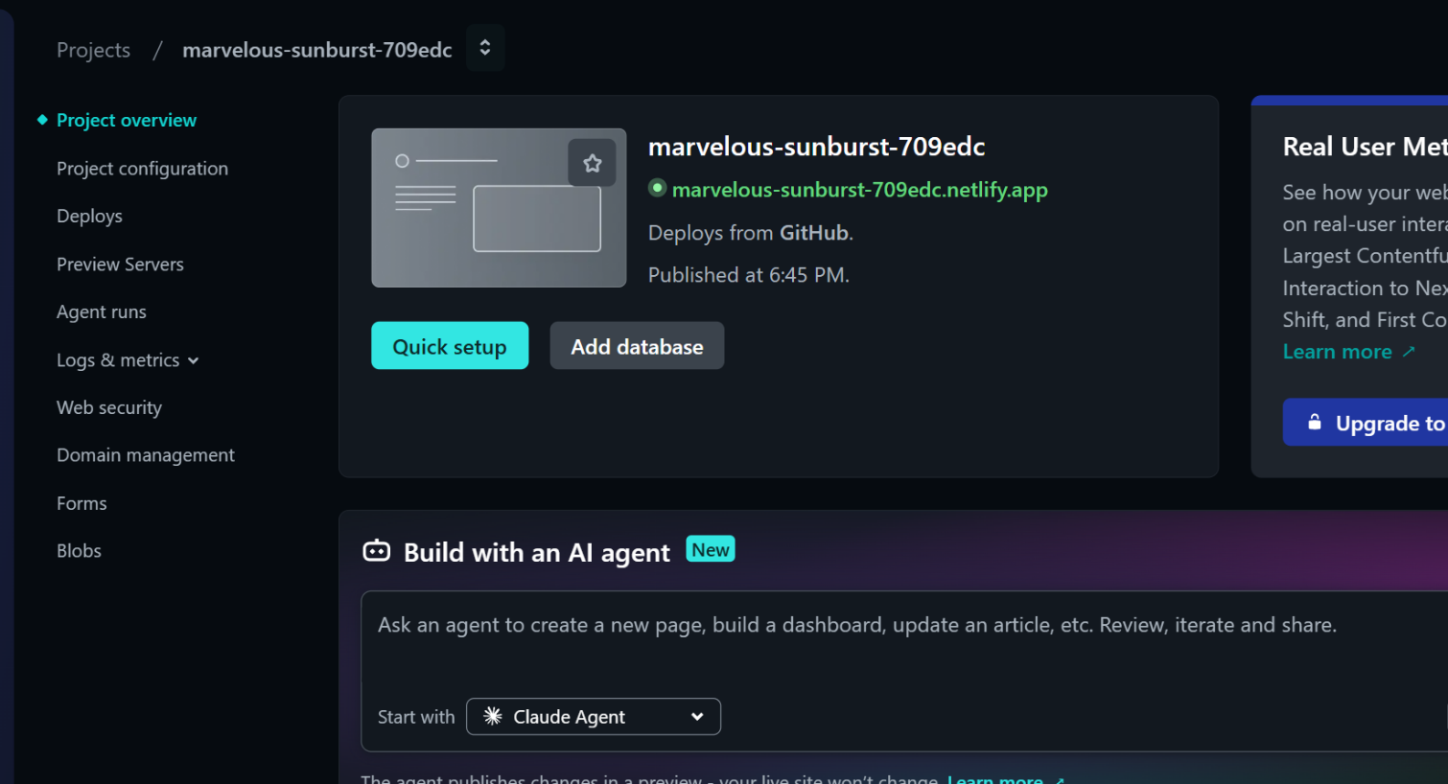

Output:
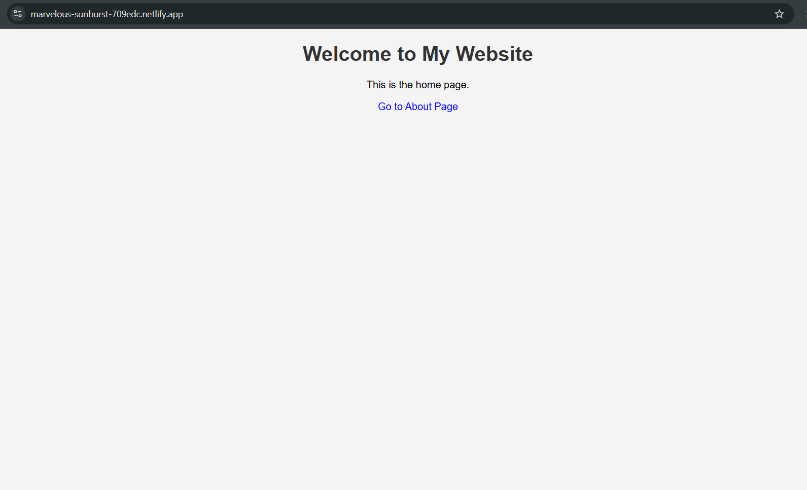

Output:
