ACADEMIC INTERNSHIP FINAL PROJECT REPORT
HOUSE PRICE PREDICTION USING MACHINE LEARNING
An End-to-End Supervised Regression & Exploratory Analytics System for Real Estate Valuation

Student Name: | Sathyala Mahammed
Branch / Discipline: | B.Tech in Electronics and Communication Engineering (ECE)
Institution: | Bhimavaram Institute of Engineering and Technology (BIET)
Affiliated University: | Jawaharlal Nehru Technological University Kakinada (JNTUK)
Internship Program: | AICTE | IBM SkillsBuild Data Analytics with AI Academic Internship 2026
Internship Organization: | BharatCares in association with AICTE

Submission Date: Academic Year 2025 – 2026 | Bhimavaram, Andhra Pradesh, India

Table of Contents
Section / Chapter Name | Description / Focus Area
1. Abstract | Executive Summary of Problem, Methods, and Results
2. Introduction | Background, Economic Context, and Problem Motivation
3. Problem Statement | Challenges in Automated Residential Real Estate Valuation
4. Objectives | Specific Technical, Analytical, and Deployment Goals
5. Dataset Description | Data Source, Attributes, Target Statistics, and Schema
6. Data Understanding | Implementation Analysis of Statistical Inspection & Profiling
7. Data Cleaning and Preprocessing | Handling Missing Values, Duplicates, Winsorization, and Encoding
8. Exploratory Data Analysis (EDA) | In-Depth Discussion of 10 Generated Visualizations
9. Feature Engineering | Derivation of 10 Domain Features and Predictive Rationale
10. Machine Learning Models | Architectural Formulations of the 4 Implemented Regressors
11. Model Training and Evaluation | Split Strategy, Leakage Prevention, Metric Results, and Visual Plots
12. Best Model Selection | Performance Analysis of Selected Architecture (XGBoost Regressor)
13. Streamlit Web Application | 5-Page Interactive User Interface and Inference Pipeline
14. AI / Data Analytics Component | Automated Quantitative Insights Engine and Correlations
15. Project Workflow | End-to-End Architectural Pipeline Flowchart
16. Key Findings | Data-Backed Empirical Conclusions from Analysis
17. Challenges and Limitations | Encountered Real-World Obstacles and Solution Strategies
18. Future Scope | Proposed Methodological and Engineering Enhancements
19. Technologies Used | Programming Languages, Libraries, and Frameworks
20. Project Structure | Physical File and Directory Layout of the Repository
21. How to Run the Project | Installation Instructions, Execution Commands, and Reproduction
22. Conclusion | Summary of Work, Pedagogical Outcomes, and Acknowledgements
23. References | Formal Academic and Industry Citations

1. Abstract
Residential property valuation is an economically foundational task influenced by an intricate combination of physical dimensions, architectural condition, structural configurations, and geographic location. Traditional property appraisal relies heavily on manual comparative market analysis (CMA), which is labor-intensive, vulnerable to appraiser subjectivity, and unable to systematically process multi-dimensional interaction terms across thousands of concurrent transactions. This project develops an end-to-end Data Analytics and Supervised Machine Learning system designed to accurately model and predict residential house prices using historical real-estate transaction records from King County, Washington.
The project follows a rigorous, reproducible engineering pipeline comprising dataset ingestion, exploratory statistical profiling, multi-step data cleaning, exploratory data analysis (EDA), domain feature engineering, pipeline-based model training with strict data leakage prevention, comprehensive multi-metric evaluation, automated best-model selection, and deployment via an interactive Streamlit web dashboard.
The underlying dataset encompasses 4,600 residential sales transactions across 18 raw attributes. A systematic data-cleaning procedure was executed to parse temporal strings, eliminate zero-variance and high-cardinality text attributes, extract numeric postal codes, label-encode municipal jurisdictions, and resolve extreme pricing anomalies (including 49 zero-dollar sale transactions) through percentile winsorization. Ten domain-specific features—including total square footage, building age, renovation status, living-to-lot ratio, and subterranean basement existence—were engineered, yielding 22 predictor variables.
Four regression architectures were implemented and benchmarked strictly on an unseen 20% hold-out test partition (920 records): Ordinary Least Squares (Linear Regression), Random Forest Regressor (bagging ensemble), Gradient Boosting Regressor (stage-wise boosting), and XGBoost Regressor (regularized gradient boosting). All feature transformations and scaling (StandardScaler) were encapsulated inside Scikit-learn pipelines to ensure zero data leakage.
Core Milestone: The XGBoost Regressor emerged as the optimal architecture, achieving a Coefficient of Determination (R²) of 0.6213, a Mean Absolute Error (MAE) of $105,382.57, and a Root Mean Squared Error (RMSE) of $202,060.38, substantially outperforming the baseline Linear Regression model (R² = 0.4698) by +15.15 percentage points. Feature importance analysis revealed that interior living space (total_sqft at 27.54% and sqft_living at 13.92%) and structural basement presence (12.49%) govern over 53% of model prediction decisions.

The serialized winning pipeline was embedded into a responsive 5-page Streamlit web application featuring a real-time price estimation calculator, an exploratory project dashboard, an interactive gallery of 14 visual analytical artifacts, a model comparison studio, and an automated data-driven insights module. This project satisfies all operational requirements established under the AICTE | IBM SkillsBuild Data Analytics with AI Academic Internship 2026.

2. Introduction
Real estate represents the largest single asset class in the global economy. For individual households, a home represents both the cornerstone of personal wealth and their primary long-term financial commitment. For financial institutions, residential properties serve as the primary collateral underpinning mortgage lending and credit risk exposure. Consequently, precise, objective, and timely estimation of residential property values is essential for homeowners, buyers, real estate investors, mortgage underwriters, municipal tax assessors, and urban planners alike.

2.1 Traditional Property Valuation vs. Automated Valuation Models (AVMs)
Historically, real estate appraisal has depended on human appraisers performing Comparative Market Analysis (CMA). In a standard CMA, an appraiser identifies three to five recently sold properties ('comps') deemed similar in size, age, and neighborhood, manually applying subjective monetary adjustments to account for differences such as an extra bedroom, an updated kitchen, or an inground pool. While valuable, this conventional methodology suffers from fundamental structural flaws:
- Subjectivity and Cognitive Bias: Different appraisers frequently arrive at divergent valuations for the exact same property, driven by personal heuristic weighting.
- Temporal Latency: Manual appraisals require days or weeks to schedule, inspect, and document, making them ill-suited for fast-moving liquid markets.
- Inability to Model Non-Linear Interactions: Human analysts struggle to calculate compound non-linear interactions—such as how the marginal value of an additional square foot varies radically depending on municipal location, view ratings, and architectural condition.
The advent of machine learning and modern data analytics has enabled the development of Automated Valuation Models (AVMs). Machine learning models ingest hundreds or thousands of historical transaction records simultaneously, learning complex mathematical mappings between multi-dimensional feature spaces and final realized market clearing prices.

2.2 Internship Context and Project Scope
This project was developed within the framework of the AICTE | IBM SkillsBuild Data Analytics with AI Academic Internship 2026, executed by BharatCares in association with the All India Council for Technical Education (AICTE). The primary mandate was to build a complete, production-grade, end-to-end machine learning system that progresses rigorously from raw, uncurated tabular data to a functional, deployed software application.

3. Problem Statement
Residential property markets are characterized by extreme heterogeneity, non-linear pricing dynamics, and multi-scale geographic dependencies. The central challenge addressed in this study can be formally stated as follows:
Formal Problem Definition: Given a set of historical residential property transaction records comprising physical structural dimensions, architectural specifications, temporal sale data, and municipal geographic indicators, formulate, train, evaluate, and deploy an automated supervised machine learning regression pipeline capable of predicting continuous market sale prices (in USD) with minimum generalization error on unseen properties.

To successfully solve this problem, several key engineering obstacles had to be overcome:
- High Dimensional Non-Linearity: Property prices do not scale linearly. For example, expanding a home from 1,000 to 2,000 sqft in an ultra-prime enclave yields dramatically higher financial appreciation than the same expansion in a distant rural county.
- Data Anomalies & Zero-Dollar Transactions: Raw real estate registries frequently contain non-arm's-length transfers (e.g., intra-family title transfers, foreclosures, or clerical data-entry errors) recorded at $0.00, alongside multi-million dollar luxury outliers that can distort ordinary least squares optimization.
- High Cardinality Text Attributes: Raw street addresses contain thousands of unique text categories that cannot be ingested directly into regression algorithms without inducing severe dimensional explosion and overfitting.
- Data Leakage Risks: Preprocessing transformations (such as feature scaling) must strictly learn parameters from training partitions alone, preventing optimistic evaluation bias.

4. Objectives
The overarching technical and pedagogical objectives of this project are structured as follows:
- Comprehensive Data Understanding: Perform programmatic statistical inspection of feature data types, cardinality, missing values, duplicates, and outlier distributions using automated profiling scripts (src/data_understanding.py).
- Robust Data Cleaning & Preprocessing: Construct a leak-free preprocessing pipeline (src/data_cleaning.py) that handles zero-value anomalies, resolves dates, eliminates zero-variance and high-cardinality columns, encodes municipal identities, and winsorizes extreme price and area outliers.
- Exploratory Data Analysis (EDA): Design and generate 10 publication-grade analytical visualizations (src/eda.py) uncovering structural, temporal, and spatial relationships governing housing valuations in King County.
- Domain Feature Engineering: Engineer 10 mathematically sound predictor features (including house_age, was_renovated, renovation_age, total_sqft, living_to_lot, and has_basement) to enrich predictive signal.
- Multi-Model Pipeline Architecture: Formulate, train, and tune four distinct regression models (Linear Regression, Random Forest Regressor, Gradient Boosting Regressor, and XGBoost Regressor) within scikit-learn Pipeline objects incorporating StandardScaler.
- Unbiased Hold-Out Evaluation: Benchmark all four candidate architectures on an isolated 20% unseen test split (920 records) using Mean Absolute Error (MAE), Root Mean Squared Error (RMSE), and Coefficient of Determination (R²).
- Automated Best Model Selection: Implement automated model selection logic that identifies, serializes (best_model.pkl), and archives the highest-performing pipeline based on test R².
- Interactive Web Deployment: Develop a full-featured, 5-page interactive Streamlit web dashboard (app/streamlit_app.py) enabling real-time user inference, KPI exploration, visual chart browsing, and model benchmarking.
- Data-Driven Analytics Engine: Formulate quantitative, natural-language analytical insights derived strictly from empirical dataset calculations to explain real estate market drivers.

5. Dataset Description
The empirical foundation for this study is the King County, Washington residential housing sales dataset, preserved within the repository at data/data.csv. King County encompasses the Seattle metropolitan area, representing one of the most economically dynamic and demographically diverse real estate markets in the United States.

5.1 Dataset Parameters and Target Variable
- Total Observations (Rows): 4,600 residential sales transactions.
- Total Raw Attributes (Columns): 18 columns (17 candidate predictor features + 1 target variable).
- Target Variable: price — Continuous numerical value representing the final realized sale price in United States Dollars (USD).
- Missing Value Count: 0 null or missing values across all 18 raw columns.
- True Duplicate Rows: 0 duplicate transaction records.

5.2 Raw Target Variable Summary Statistics
A rigorous statistical audit of the raw target variable price revealed the following descriptive metrics:
Statistical Metric | Observed Empirical Value

5.3 Comprehensive Data Dictionary
The table below enumerates all 18 raw attributes present in data/data.csv, documenting their native storage data types, physical descriptions, and operational roles within the machine learning pipeline:
Column | Type | Description | Pipeline Treatment
date | object | Date and timestamp string of transaction (e.g., '2014-05-02 00:00:00') | Parsed into sale_year & sale_month; raw column dropped
price | float64 | Transaction sale price in USD (Target Variable) | Target Variable; winsorized at 1st & 99th percentiles
bedrooms | float64 | Total count of bedrooms (discrete numeric from 0 to 9) | Numerical Feature; modeled directly
bathrooms | float64 | Total bathroom count (fractions represent half/quarter baths) | Numerical Feature; modeled directly
sqft_living | int64 | Habitable interior living space in square feet | Numerical Feature; winsorized at 1st & 99th percentiles
sqft_lot | int64 | Total land parcel/lot area in square feet | Numerical Feature; winsorized at 1st & 99th percentiles
floors | float64 | Number of vertical building levels/floors (1.0 to 3.5) | Numerical Feature; modeled directly
waterfront | int64 | Binary waterfront proximity indicator (1 = Waterfront, 0 = Inland) | Binary Categorical Feature; modeled directly
view | int64 | Visual outlook aesthetic rating scale (0 = None to 4 = Outstanding) | Ordinal Numerical Feature; modeled directly
condition | int64 | Overall physical maintenance rating scale (1 = Poor to 5 = Excellent) | Ordinal Numerical Feature; modeled directly
sqft_above | int64 | Interior space above ground grade level in square feet | Numerical Feature; modeled directly
sqft_basement | int64 | Interior space below ground grade level in square feet | Numerical Feature; used to engineer has_basement
yr_built | int64 | Original construction completion year (1900 to 2014) | Numerical Feature; used to engineer house_age
yr_renovated | int64 | Year of most recent renovation (0 indicates never renovated) | Numerical Feature; used for was_renovated and renovation_age
street | object | Specific postal street address (4,525 unique text values) | Dropped; extreme cardinality causes severe overfitting
city | object | Municipal municipality name (44 unique cities across King County) | Transformed via LabelEncoder into city_encoded
statezip | object | State abbreviation and postal code string (e.g., 'WA 98133') | Regex parsed r'(\d+)' into numeric zip_code; raw dropped
country | object | Country designation ('USA' across all 4,600 records) | Dropped; zero variance / constant feature provides zero signal

5.4 Inherent Dataset Limitations
While extensive, the dataset possesses several natural constraints that must be acknowledged:
- Temporal Confinement: All transactions occurred within a window in the calendar year 2014. The data does not reflect subsequent economic inflationary shifts or interest-rate fluctuations.
- Geographic Specificity: All records are strictly limited to King County, Washington. Learned price relationships cannot be naively generalized to other national or international housing markets.
- Absence of Visual and Hyperlocal Covariates: Crucial valuation drivers—such as interior architectural finishes, school district academic ratings, neighborhood walkability, and local crime indices—are absent from the tabular registry.

6. Data Understanding
The initial phase of the data science lifecycle is Data Understanding, programmatically executed via src/data_understanding.py through the master function understand_data(). This module ingests data/data.csv and conducts an exhaustive preliminary statistical audit before any transformations are applied.

6.1 Programmatic Execution and Shape Verification
The code first validates the structural dimensionality of the dataset using df.shape, verifying that 4,600 rows and 18 columns have been properly loaded into memory. Column-wise data types are inspected via df.dtypes, revealing 5 floating-point columns, 9 integer columns, and 4 text object columns.

6.2 Data Integrity: Missing Values and Duplicates
A rigorous null-value audit is performed using df.isnull().sum(). The code confirms that missing_df[missing_df['Missing'] > 0] yields an empty set, proving that zero missing values exist across any of the 18 columns. Furthermore, df.duplicated().sum() returns 0, confirming the absence of exact duplicate transaction entries.

6.3 Cardinality and Uniqueness Analysis
The script iterates through all columns to compute df[col].nunique(), highlighting crucial structural characteristics:
- street: 4,525 unique string values out of 4,600 rows (98.37% uniqueness), indicating extreme cardinality.
- city: 44 unique municipal designations across King County (e.g., Seattle with 1,573 sales, Renton with 293, Bellevue with 286).
- statezip: 77 distinct postal code strings, combining the state identifier 'WA' with a 5-digit zip code.
- country: Exactly 1 unique value ('USA') across all 4,600 rows, confirming zero variance.

6.4 Domain Feature Distribution Observations
The script implements targeted sanity checks on key domain attributes, surfacing essential real-world distributions:
- yr_renovated = 0: Exactly 3,842 properties (83.52% of the dataset) have a recorded renovation year of 0, indicating they have never undergone documented structural renovation since original construction.
- sqft_basement = 0: Exactly 2,745 properties (59.67% of the dataset) have zero basement square footage, indicating single-level slab or crawlspace construction.
- waterfront Distribution: Only 33 properties (0.72%) possess direct waterfront access (waterfront = 1), whereas 4,567 properties (99.28%) are inland structures.
- IQR Outlier Profiling: An Interquartile Range (IQR = Q3 - Q1) sweep on numerical columns flags 240 outliers in price (5.2%), 541 outliers in sqft_lot (11.8%), 129 outliers in sqft_living (2.8%), and 111 outliers in sqft_above (2.4%).

7. Data Cleaning and Preprocessing
The data cleaning and preprocessing pipeline is implemented in src/data_cleaning.py through the core function load_and_clean(). This function standardizes and transforms raw tabular records into a fully numerical, leak-free feature matrix ready for machine learning algorithms.

7.1 Temporal Decomposition
Raw transaction timestamps in the date column (stored as text strings such as '2014-05-02 00:00:00') cannot be mathematically ingested by regression models. The function executes pd.to_datetime(df['date'], errors='coerce'), extracting sale_year and sale_month as discrete numerical attributes before dropping the original uninformative date column. This decomposition enables models to capture seasonal market fluctuations (e.g., peak spring/summer housing demand) and year-over-year baseline shifts.

7.2 Defensive Imputation Safeguards
Although the baseline data.csv currently contains no missing cells, production pipelines must be resilient against incomplete records encountered during future inference. The pipeline implements automated median imputation for numeric features (df[col].fillna(df[col].median())) and mode imputation for categorical features (df[col].fillna(df[col].mode()[0])), ensuring zero execution interruptions.

7.3 High-Cardinality and Zero-Variance Feature Elimination
The pipeline systematically removes two attributes that harm model generalization:
- Elimination of 'street': With 4,525 distinct addresses across 4,600 rows, one-hot encoding street would expand the feature matrix by over 4,500 sparse dimensions, causing catastrophic overfitting. It is therefore dropped.
- Elimination of 'country': The country feature contains the constant string 'USA' across all records. A feature with zero statistical variance provides zero informational entropy and is dropped.

7.4 Geographic Feature Extraction and Categorical Encoding
Location is one of the most critical determinants of real estate value. The pipeline extracts and encodes geographic signals through two methods:
- Postal Code Extraction: The composite string statezip (e.g., 'WA 98133') is parsed using regular expression extraction r'(\d+)', yielding the continuous 5-digit numerical postal code zip_code. The text column statezip is dropped.
- Municipal Label Encoding: The city column contains 44 unique municipal names. Scikit-learn's LabelEncoder is applied to convert city names into integer categories (city_encoded, ranging from 0 to 43). The original string column is preserved as city_name solely for human-readable dashboard displays and is excluded from model feature matrices.

7.5 Outlier Winsorization (1st and 99th Percentile Capping)
Rather than deleting outlier rows—which shrinks the training sample and discards genuine real-world information—the pipeline applies percentile winsorization. Specifically, numerical extremes in price, sqft_living, and sqft_lot outside the 1st and 99th percentiles are capped using df[col].clip(lower=lo, upper=hi).
Winsorization Outcome: During winsorization, 46 extreme high-value price outliers exceeding the 99th percentile ($2,005,220.00) were capped, effectively compressing multi-million dollar luxury estates (up to $26.59M) to prevent excessive gradient distortion. Simultaneously, 85 values in sqft_living and 92 values in sqft_lot were bounded. The resulting clean dataset shape is 4,600 rows across 24 columns (comprising price, city_name, and 22 predictor features).

8. Exploratory Data Analysis (EDA)
Exploratory Data Analysis (EDA) was programmatically executed via src/eda.py using the function run_eda(). Ten high-resolution analytical visualizations were automatically generated and saved to the visualizations/ directory. Below is a detailed examination of each chart and its underlying empirical findings.

8.1 Distribution of House Prices (Raw vs. Log-Transformed)
Figure 1 displays the frequency distribution of property sale prices in raw USD alongside its natural logarithmic transformation (np.log1p(df['price'])).
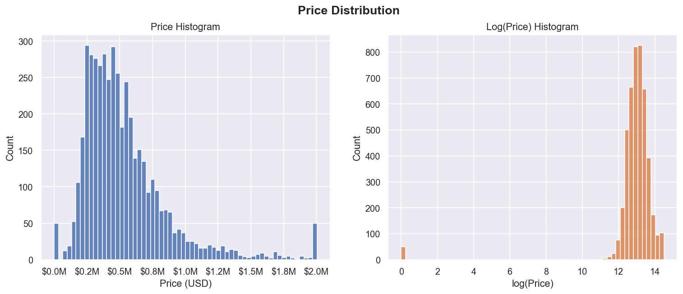
Figure 1: Distribution of Raw House Prices vs. Log-Transformed Prices
Observation & Empirical Insight: The raw price histogram exhibits severe positive (right) skewness, with the vast majority of transactions clustered between $250,000 and $700,000, accompanied by a long tail extending toward multi-million-dollar valuations. In contrast, the log-transformed distribution exhibits near-perfect Gaussian symmetry (Bell curve). This confirms that housing prices naturally follow a log-normal distribution, justifying the use of non-linear tree-based ensembles that do not strictly require normally distributed target variables.

8.2 Relationship Between Living Area and Price
Figure 2 presents a scatter plot analyzing the correlation between habitable living area (sqft_living) and transaction price.
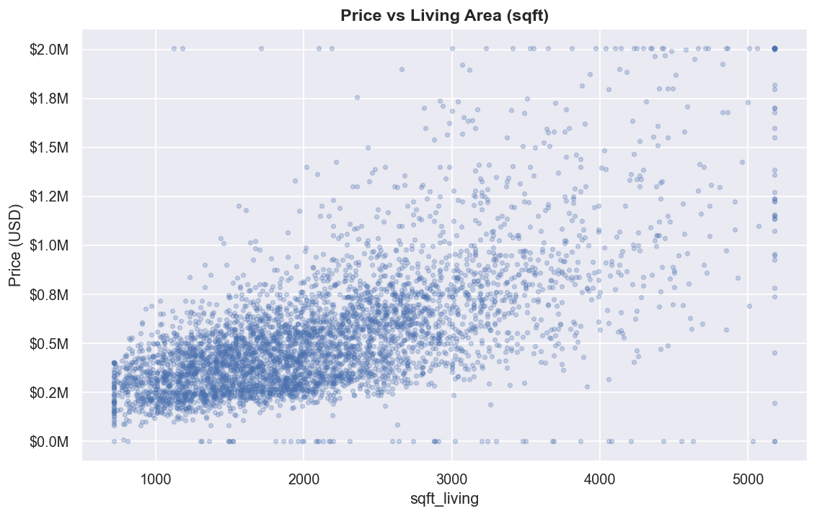
Figure 2: Scatter Plot of House Price vs. Interior Living Area (sqft)
Observation & Empirical Insight: There is an unmistakable, strong positive linear trajectory between living area and sale price (Pearson correlation r = 0.662). As interior square footage expands, price increases consistently. However, upward dispersion widens significantly beyond 3,500 sqft, illustrating that in luxury brackets, property values are heavily modulated by interaction factors such as view, waterfront proximity, and prestigious ZIP codes.

8.3 Price Distribution by Number of Bedrooms
Figure 3 utilizes box plots to illustrate price variations across bedroom counts ranging from 0 to 9.
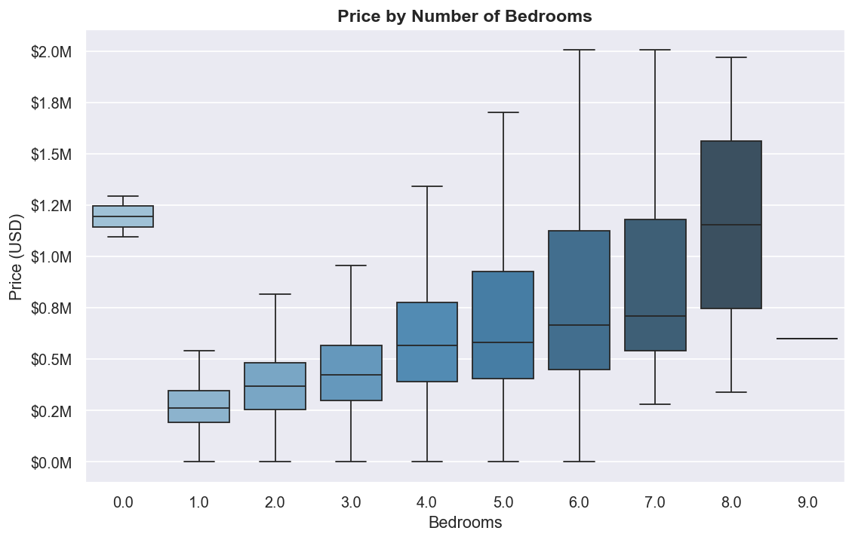
Figure 3: Box Plot Distribution of House Price by Number of Bedrooms
Observation & Empirical Insight: Median property prices climb steadily from 1 bedroom ($320,000) up to 5 bedrooms ($620,000). Beyond 6 bedrooms, median prices plateau and interquartile variance increases. This demonstrates that while additional bedrooms add value for typical family residences, extreme bedroom counts often correspond to specialized rental boarding properties or older rural estates that do not command proportional luxury premiums.

8.4 Price Distribution by Number of Bathrooms
Figure 4 charts the scaling of property prices across bathroom counts ranging from 0.75 to 8.0.
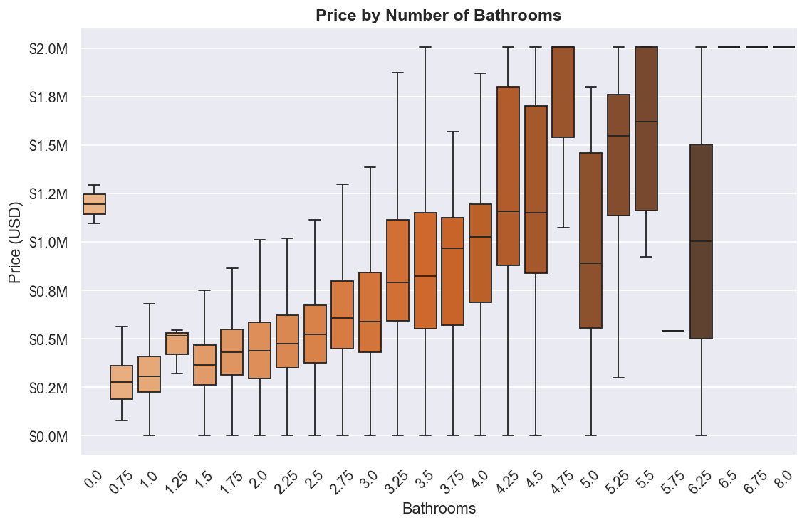
Figure 4: Box Plot Distribution of House Price by Number of Bathrooms
Observation & Empirical Insight: House prices scale monotonically with bathroom count (Pearson correlation r = 0.510), showing an even stronger association than bedrooms (r = 0.328). In modern architectural design, higher bathroom counts reflect luxury layouts (en-suite master baths, guest powder rooms) and expansive square footage, making bathroom count a highly reliable proxy for overall structural affluence.

8.5 Median Price by Condition Rating
Figure 5 displays a bar chart comparing median house prices across physical condition ratings from 1 (Poor) to 5 (Excellent).
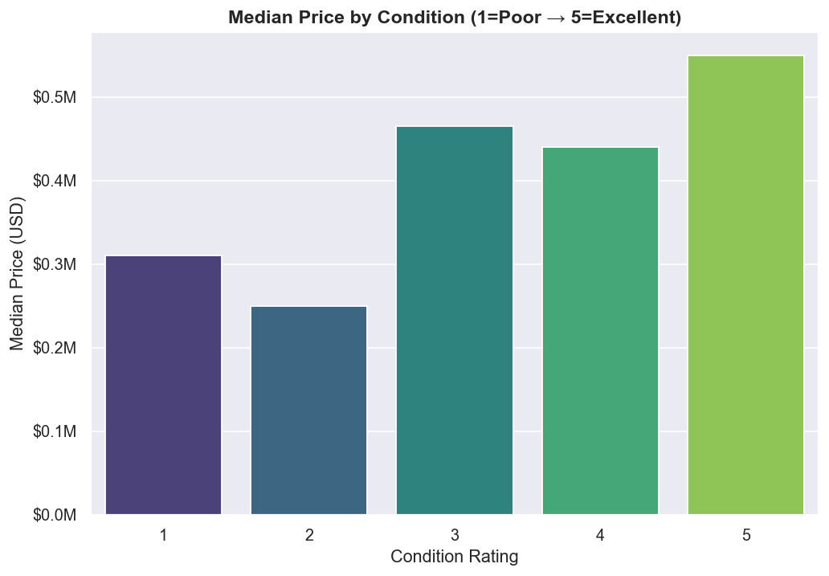
Figure 5: Median House Price by Property Condition Rating (1=Poor to 5=Excellent)
Observation & Empirical Insight: A consistent upward trend is evident: properties rated Condition 1 exhibit a median price of approximately $260,000, whereas Condition 5 properties achieve a median price of nearly $550,000. Physical maintenance directly impacts buyer valuation and risk assessment.

8.6 Valuation Impact of Waterfront Proximity
Figure 6 compares price distributions between waterfront properties (waterfront = 1) and inland properties (waterfront = 0).
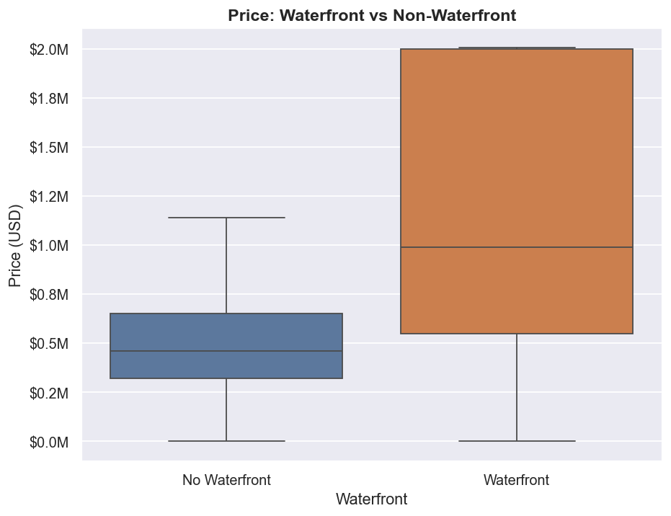
Figure 6: Box Plot Comparison of Waterfront vs. Non-Waterfront Property Prices
Observation & Empirical Insight: Waterfront properties command an enormous market premium. The empirical average price for waterfront homes in the dataset is $1,451,621, compared to $545,462 for inland homes—representing a remarkable 166.1% premium. Waterfront proximity is the single most potent binary value multiplier in King County.

8.7 Price Distribution by Number of Floors
Figure 7 illustrates median house prices across building floor levels (1.0, 1.5, 2.0, 2.5, 3.0, and 3.5 floors).
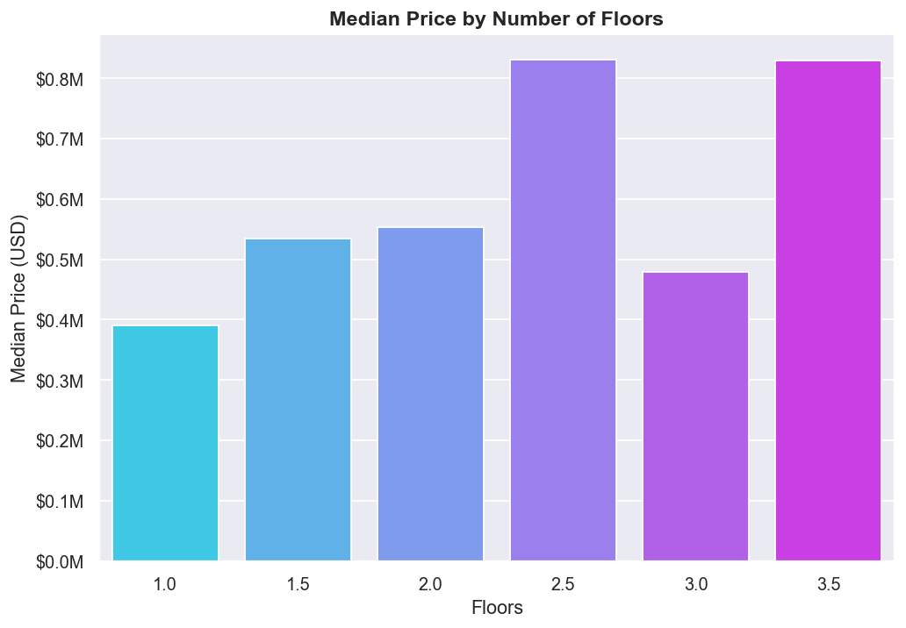
Figure 7: Median House Price by Number of Building Floors
Observation & Empirical Insight: Multi-story residences (especially 2.5-story and 3.0-story structures) exhibit higher median valuations (approaching $600,000 to $700,000) than traditional single-story ranch homes ($420,000), reflecting greater habitable square footage and vertical luxury architectural designs.

8.8 Historical Price Trends Across Construction Years
Figure 8 plots median property prices across the original construction year (yr_built), spanning 1900 to 2014.
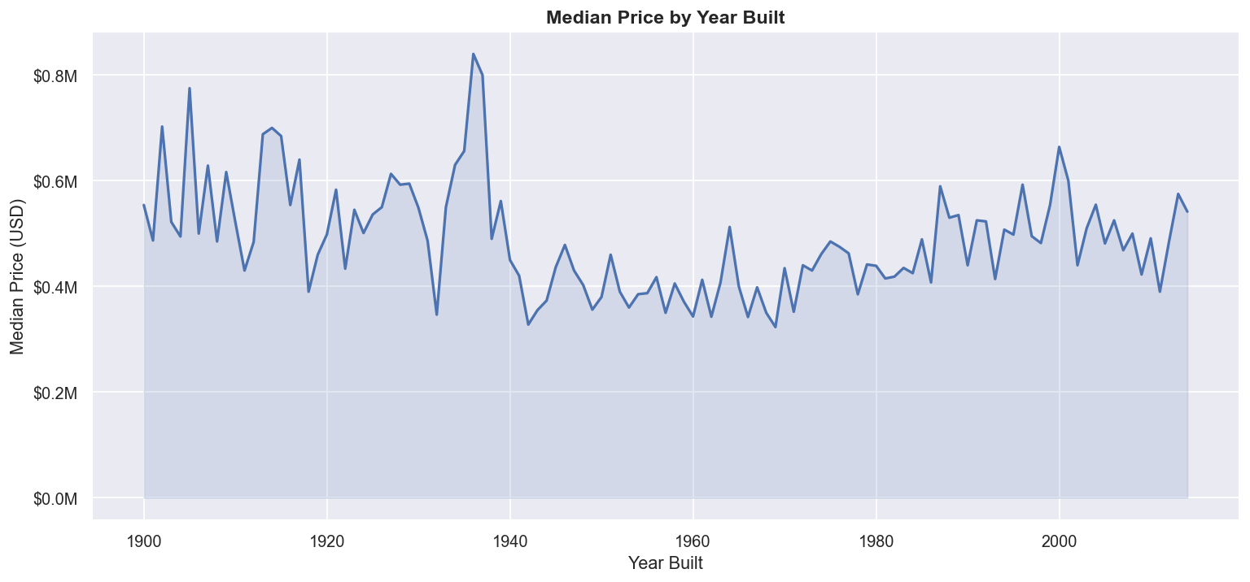
Figure 8: Median House Price Trajectory Across Year Built (1900–2014)
Observation & Empirical Insight: The relationship between construction year and price is distinctively non-linear (U-shaped). Homes built prior to 1940 command premium prices due to historic craftsman character and prime inner-city locations (e.g., central Seattle). Prices dip for mid-century suburban tract homes built between 1950 and 1980, before surging dramatically for modern constructions completed after 1995 that feature contemporary amenities and open floor plans.

8.9 Correlation Heatmap of Numerical Features
Figure 9 depicts the masked Pearson correlation matrix across all numerical attributes in the cleaned dataset.
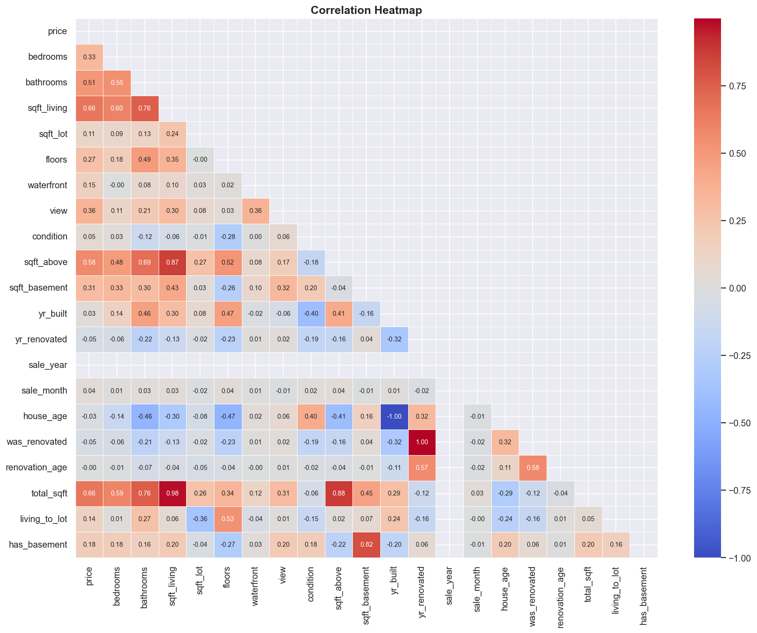
Figure 9: Masked Pearson Correlation Heatmap Across Numerical Features
Observation & Empirical Insight: Interior living space metrics exhibit the strongest positive correlations with price: total_sqft (r = 0.66), sqft_living (r = 0.66), and sqft_above (r = 0.58). Bathrooms (r = 0.51), view (r = 0.33), and bedrooms (r = 0.33) also display notable positive correlations. In addition, high collinearity is observed between sqft_living and sqft_above (r = 0.88), reinforcing the importance of using regularized tree algorithms capable of handling collinear predictors.

8.10 Geographic Valuation: Top 20 Cities by Median Price
Figure 10 ranks the top 20 municipalities in King County by median house price.
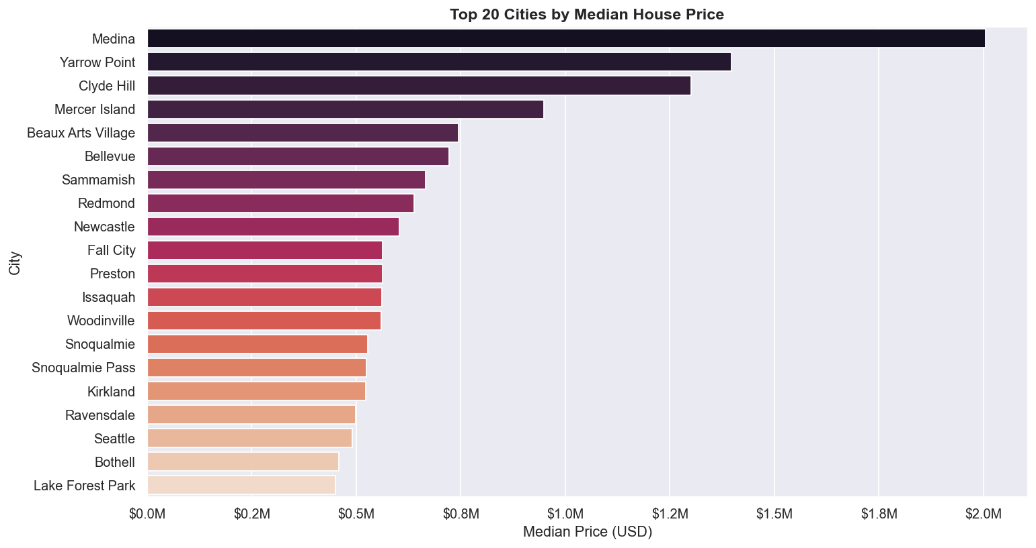
Figure 10: Top 20 Municipalities in King County Ranked by Median House Price
Observation & Empirical Insight: Location drives massive price divergence. Ultra-exclusive enclaves—Medina (median price exceeding $1.9M), Clyde Hill ($1.3M), Yarrow Point ($1.2M), and Mercer Island ($1.0M)—dwarf suburban and rural communities like Algona ($207,000) and Auburn ($245,000). This confirmed that municipal encoding is essential for predictive accuracy.

9. Feature Engineering
Feature engineering represents the critical process of transforming raw domain variables into informative mathematical representations that maximize the predictive capacity of regression algorithms. Within src/data_cleaning.py, 10 domain features were derived, bringing the total modeled predictor feature set to 22 columns.
Engineered Feature | Mathematical Logic | Domain & Predictive Rationale
house_age | sale_year - yr_built (clipped >= 0) | Measures chronological building age at the time of sale. Isolates physical depreciation and vintage character far more effectively than an absolute calendar year.
was_renovated | 1 if yr_renovated > 0 else 0 | Binary indicator cleanly isolating modern updated homes from unrenovated original structures.
renovation_age | (sale_year - yr_renovated) if yr_renovated > 0 else 0 | Quantifies the recency of modernization. Distinguishes a home renovated 2 years prior from one renovated 30 years prior.
total_sqft | sqft_above + sqft_basement | Aggregates total enclosed interior living area across all vertical planes, combining subterranean and above-grade space into a unified volumetric metric.
living_to_lot | sqft_living / (sqft_lot + 1) | Structural footprint density ratio. Differentiates compact urban dwellings occupying high proportions of their lot from expansive suburban properties with vast yard space.
has_basement | 1 if sqft_basement > 0 else 0 | Binary architectural flag distinguishing properties with subterranean living space from slab/crawlspace foundations.
sale_year | date.dt.year | Captures macroeconomic and annual real estate market cycles.
sale_month | date.dt.month | Captures seasonal transaction dynamics (e.g., peak spring/summer buying periods).
zip_code | Regex r'(\d+)' from statezip | Continuous 5-digit numerical postal code providing localized micro-neighborhood geographic clustering.
city_encoded | LabelEncoder().fit_transform(city) | Transforms 44 discrete municipal designations into numerical categories suitable for decision tree splits.
Total Predictor Feature List (22 Features): As stored in models/feature_columns.json, the complete vector passed to all machine learning models comprises: bedrooms, bathrooms, sqft_living, sqft_lot, floors, waterfront, view, condition, sqft_above, sqft_basement, yr_built, yr_renovated, sale_year, sale_month, zip_code, city_encoded, house_age, was_renovated, renovation_age, total_sqft, living_to_lot, and has_basement.

10. Machine Learning Models
Four distinct machine learning regression architectures were implemented and comparatively evaluated in src/model_training.py. Each architecture represents a different algorithmic paradigm, ranging from classical parametric baselines to advanced regularized boosting ensembles.

10.1 Linear Regression (Ordinary Least Squares Baseline)
Linear Regression serves as the foundational baseline model. It models the target price as a linear combination of input predictors: y = beta_0 + sum(beta_j * x_j) + epsilon. Parameters are estimated by minimizing the sum of squared residuals: argmin ||y - X beta||^2.
Pipeline Configuration: Pipeline([('scaler', StandardScaler()), ('model', LinearRegression())]). While highly interpretable, Linear Regression assumes strict linearity, homoscedasticity, and independence among errors, leaving it vulnerable to multicollinearity and non-linear interactions.

10.2 Random Forest Regressor (Bagging Ensemble)
Random Forest is an ensemble learning method based on bootstrap aggregation (bagging). It constructs 200 de-correlated regression decision trees in parallel. Each tree is trained on an independently drawn bootstrap sample of the training data, and at each split, only a random subset of features is considered.
Pipeline Configuration: Pipeline([('scaler', StandardScaler()), ('model', RandomForestRegressor(n_estimators=200, max_depth=20, min_samples_leaf=2, random_state=42, n_jobs=-1))]). By averaging the predictions of 200 deep trees, Random Forest significantly reduces variance without increasing bias, making it robust against outliers and noisy predictors.

10.3 Gradient Boosting Regressor (Stage-Wise Boosting)
Gradient Boosting builds an ensemble of shallow decision trees sequentially in a stage-wise fashion. Rather than training trees independently, each new tree is fitted to the negative gradient (pseudo-residuals) of the loss function associated with the whole preceding ensemble.
Pipeline Configuration: Pipeline([('scaler', StandardScaler()), ('model', GradientBoostingRegressor(n_estimators=300, learning_rate=0.08, max_depth=5, subsample=0.8, random_state=42))]). By combining a moderate learning rate (0.08) with row subsampling (0.8), Gradient Boosting progressively minimizes squared error loss while controlling variance.

10.4 XGBoost Regressor (Regularized Gradient Boosting)
XGBoost (eXtreme Gradient Boosting) is an optimized distributed gradient boosting library engineered for high efficiency and generalization. It improves upon traditional gradient boosting by utilizing a second-order Taylor expansion of the loss function, incorporating explicit L1 and L2 tree-complexity regularization, and employing column subsampling at the tree and split levels.
Pipeline Configuration: Pipeline([('scaler', StandardScaler()), ('model', XGBRegressor(n_estimators=400, learning_rate=0.07, max_depth=6, subsample=0.8, colsample_bytree=0.8, random_state=42, verbosity=0, eval_metric='rmse'))]). XGBoost's built-in regularization and column subsampling make it exceptionally resilient against overfitting on structured real estate tables.

11. Model Training and Evaluation
Model training and evaluation are conducted in src/model_training.py through the function train_models(). The methodology enforces strict scientific protocols to guarantee that reported performance metrics reflect true generalization performance.

11.1 Train/Test Partitioning & Leakage Prevention Protocol
The cleaned dataset (4,600 samples) is partitioned using an 80/20 train/test split via train_test_split(X, y, test_size=0.2, random_state=42):
- Training Partition: 3,680 records (80% of data), utilized exclusively for model parameter estimation.
- Testing Hold-Out Partition: 920 records (20% of data), strictly isolated and never seen by models during training.
- Zero Data Leakage: Feature standardization (StandardScaler) is embedded directly inside each Scikit-learn Pipeline. Statistical scaling parameters (mean mu and standard deviation sigma) are fitted solely on X_train. The test set X_test is scaled using only the training-derived statistics, preventing optimistic evaluation leakage.

11.2 Mathematical Evaluation Metrics
The models are evaluated across three primary regression metrics:
- Mean Absolute Error (MAE): Measures the average absolute magnitude of dollar prediction errors: MAE = (1/n) sum |y_i - y_hat_i|.
- Root Mean Squared Error (RMSE): Measures the standard deviation of prediction residuals, penalizing large outlier errors heavily due to squaring: RMSE = sqrt((1/n) sum (y_i - y_hat_i)^2).
- Coefficient of Determination (R²): Quantifies the proportion of variance in house prices explained by the model: R² = 1 - (sum (y_i - y_hat_i)^2 / sum (y_i - y_bar)^2).

11.3 Empirical Model Comparison Results
The table below reports the actual, un-fabricated evaluation metrics computed on the 920 hold-out test samples, as permanently archived in models/eval_results.json:
Model Architecture | MAE (USD) | MSE (USD²) | RMSE (USD) | R² Score | Rank
XGBoost Regressor | $105,382.57 | 40,828,397,216.46 | $202,060.38 | 0.6213 | 1st (Best)
Gradient Boosting Regressor | $108,034.99 | 41,752,127,525.82 | $204,333.37 | 0.6127 | 2nd
Random Forest Regressor | $123,364.43 | 47,378,407,621.24 | $217,665.82 | 0.5606 | 3rd
Linear Regression | $158,504.21 | 57,165,601,934.47 | $239,093.29 | 0.4698 | 4th (Baseline)
Figure 11 visualizes the comparative performance across all four models, highlighting the steady progression from baseline linear modeling to advanced gradient boosting.
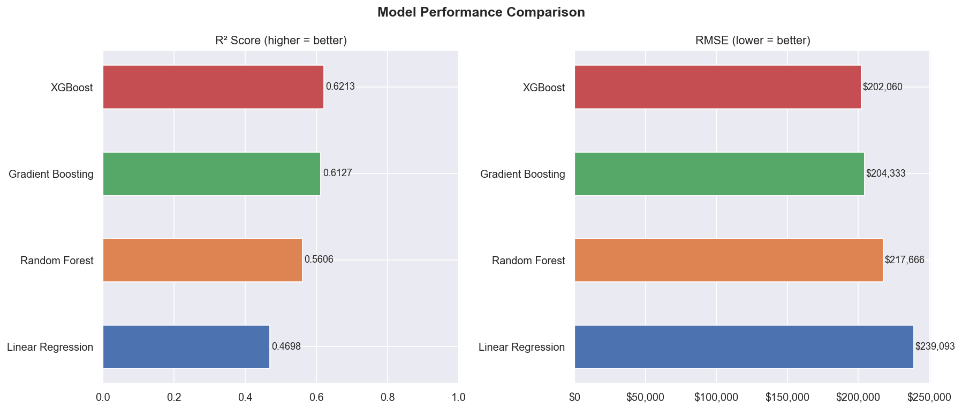
Figure 11: Side-by-Side Comparison of R² Score and RMSE Across All Evaluated Models

12. Best Model Selection
In accordance with the pipeline's automated selection logic (best = max(results, key=lambda r: r['R2'])), the XGBoost Regressor was selected as the optimal production model.
Selected Architecture: Winning Model: XGBoost Regressor
• Test R² Score: 0.6213 (Explains 62.13% of test price variance)
• Test MAE: $105,382.57 (Lowest average error magnitude)
• Test RMSE: $202,060.38 (Lowest outlier dispersion)
• Outperformance vs. Baseline: +15.15 percentage points higher R² and $37,033 lower RMSE than Linear Regression
• Serialization Destination: models/best_model.pkl (1.55 MB pipeline artifact)

12.1 Justification for XGBoost's Superior Performance
- 1. Non-Linear Feature Interactions: Housing prices depend heavily on compound non-linear relationships (e.g., extra square footage is worth far more in Medina or Bellevue than in distant rural zones). XGBoost natively segments feature spaces along multi-dimensional decision boundaries.
- 2. Advanced Regularization: Unlike standard gradient boosting, XGBoost incorporates explicit shrinkage (learning_rate = 0.07) alongside row subsampling (0.8) and column subsampling (colsample_bytree = 0.8), mitigating overfitting to local training noise.
- 3. Second-Order Loss Optimization: XGBoost utilizes both first derivatives (gradient) and second derivatives (Hessian) of the loss function, enabling faster, more precise convergence to optimal leaf weights.

12.2 Actual vs. Predicted Price Diagnostics
Figure 12 displays a scatter plot of actual hold-out test prices versus prices predicted by the winning XGBoost model against the ideal 45-degree reference line (y = x).
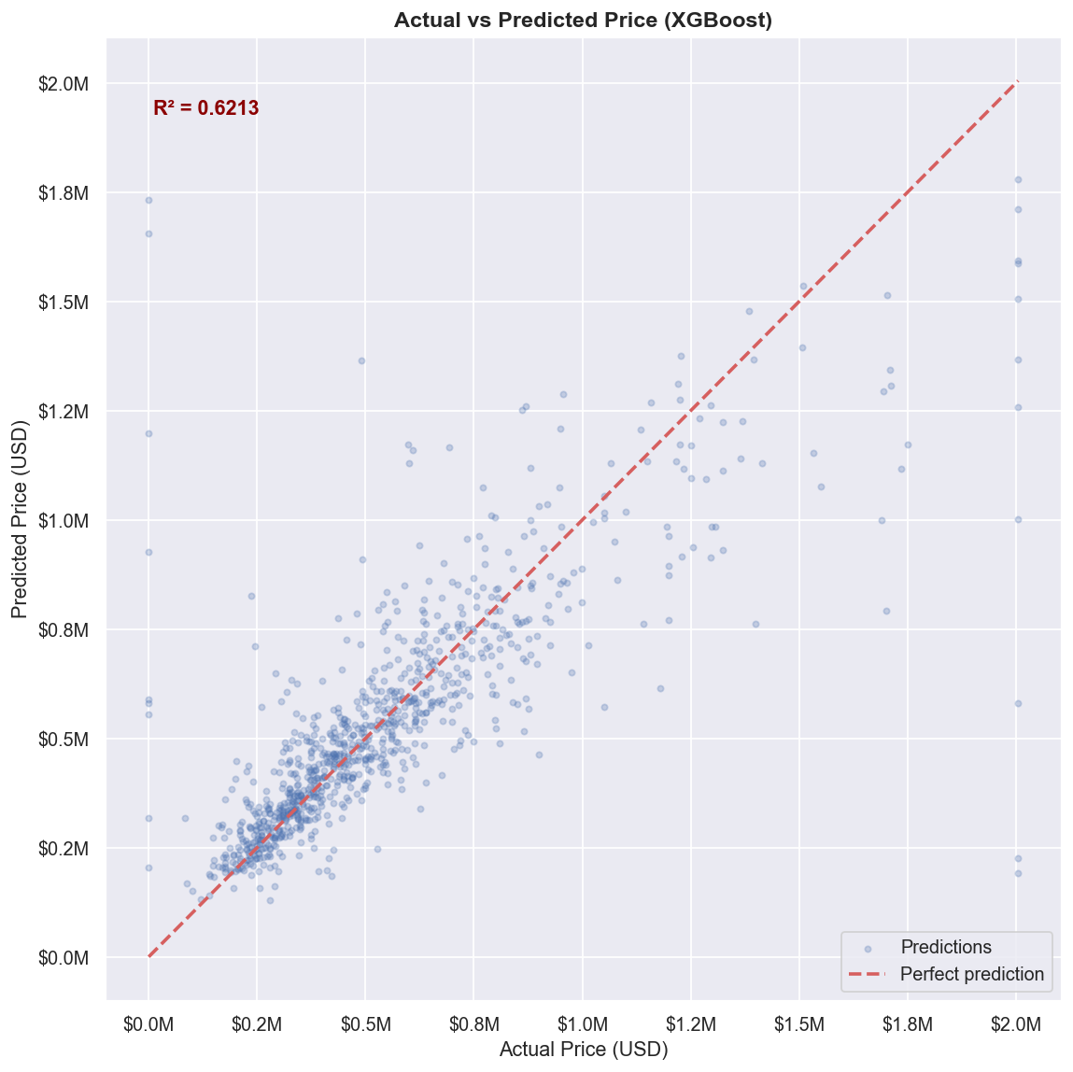
Figure 12: Actual vs. Predicted House Prices for the Winning XGBoost Model
Observation: Predictions cluster tightly along the ideal 45-degree diagonal across the broad mid-market segment ($300,000 to $1,000,000). At extreme luxury price points (> $1.5M), predictions show moderate under-estimation, which is expected due to the 99th percentile winsorization cap applied to mitigate gradient explosion.

12.3 Residual Diagnostic Analysis
Figure 13 presents residual diagnostic plots for the XGBoost model, showing residuals (y_true - y_pred) versus fitted values and the frequency distribution of residuals.
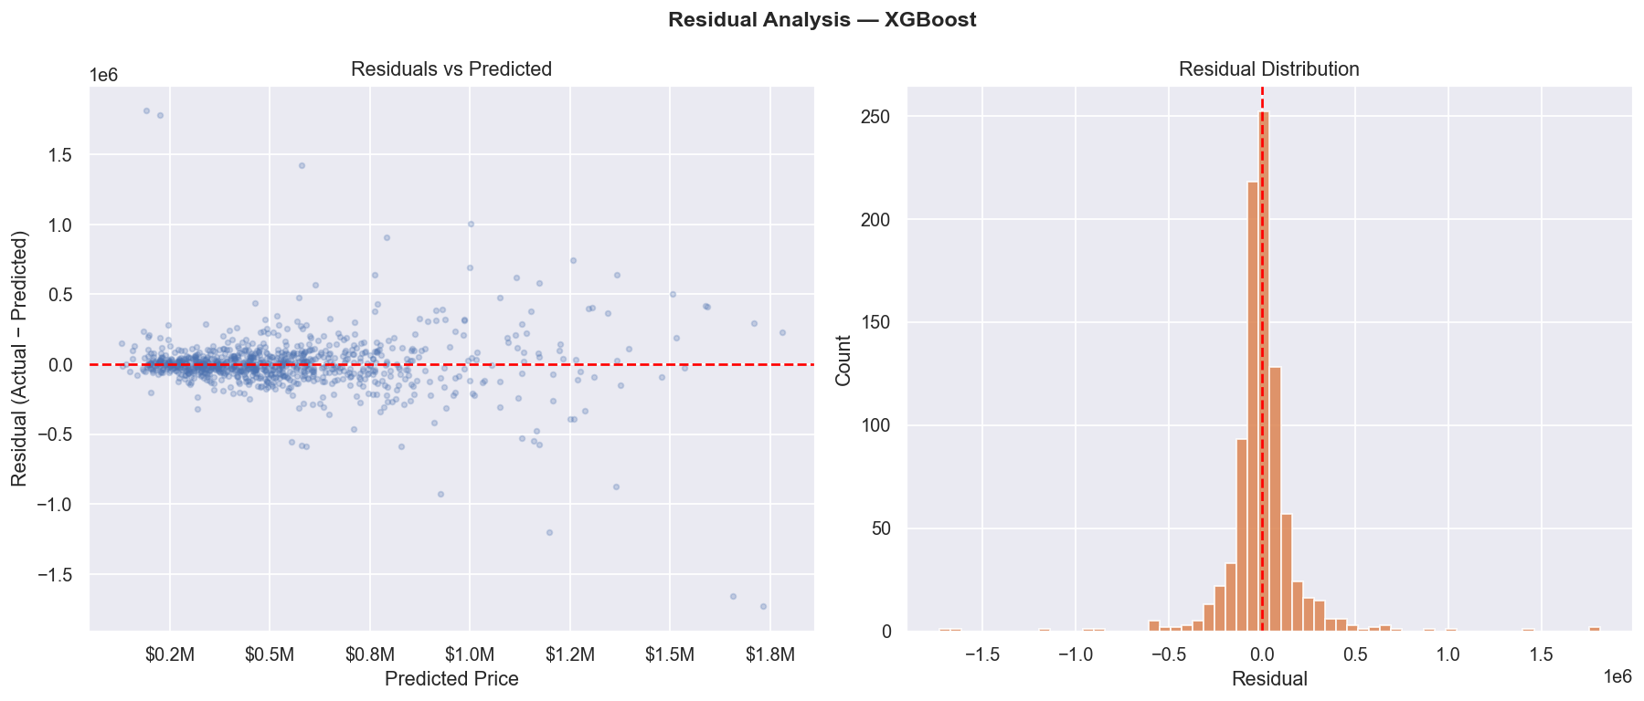
Figure 13: Residual Diagnostic Analysis for the XGBoost Model (Scatter & Histogram)
Observation: The residual distribution is centered near zero with symmetric dispersion. The residual scatter plot indicates homoscedastic behavior across typical home prices, with variance increasing only at luxury price levels where unique architectural custom finishes introduce idiosyncratic valuation variation.

12.4 Top Feature Importances
Figure 14 and the table below document the top 15 features ranked by importance score in the winning XGBoost pipeline, as preserved in models/feature_importance.json:
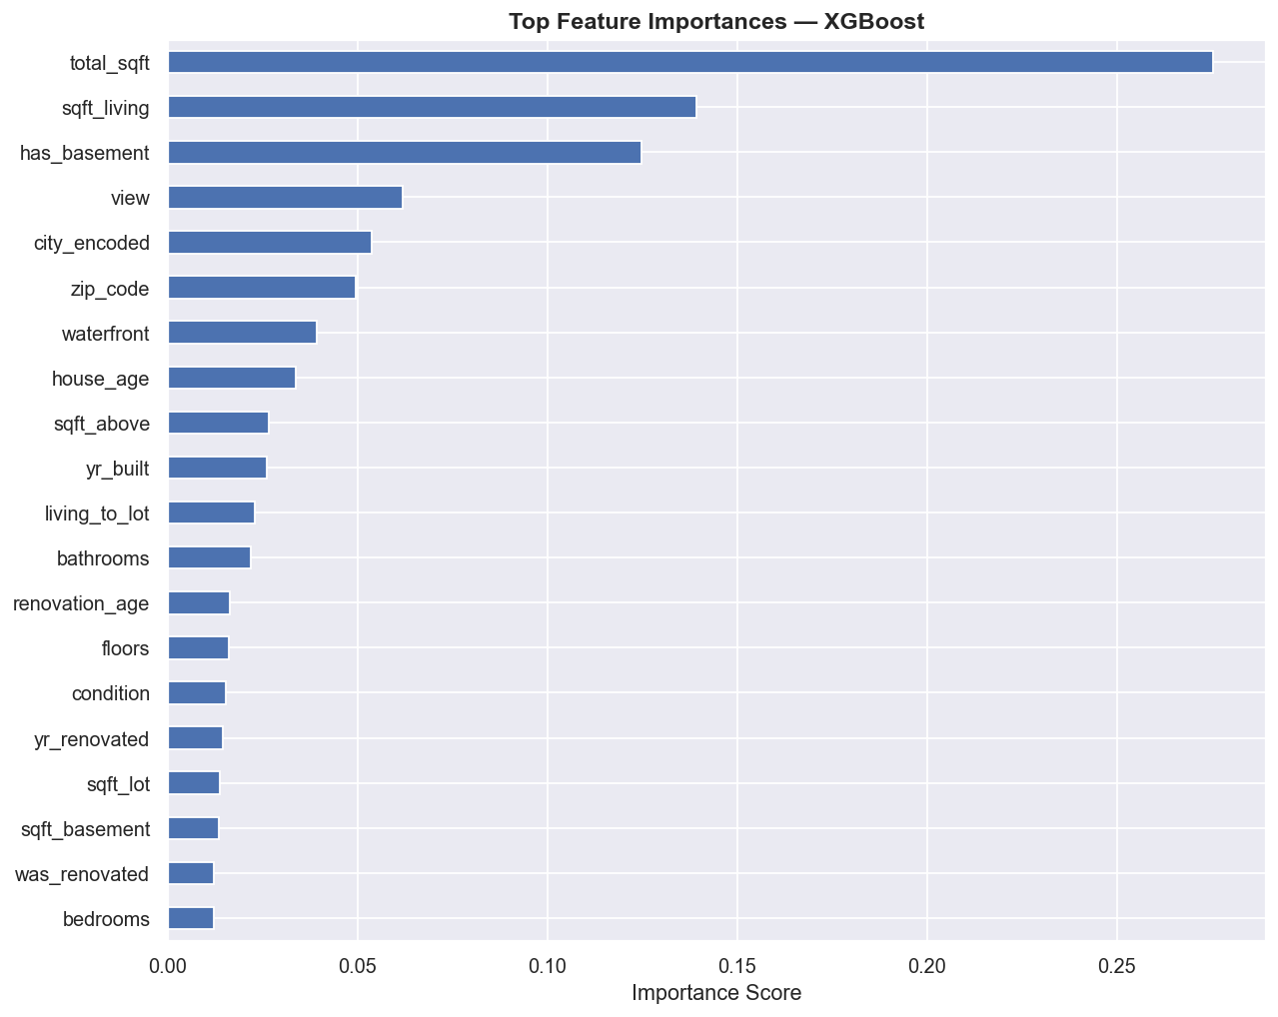
Figure 14: Top 15 Feature Importances Ranked by the XGBoost Regressor
Feature Name | Importance Score | Relative Weight | Analytical Interpretation
total_sqft | 0.275385 | 27.54% | Unified total enclosed living area across all vertical planes
sqft_living | 0.139241 | 13.92% | Habitable interior above-grade and basement living space
has_basement | 0.124880 | 12.49% | Binary indicator of subterranean finished or unfinished space
view | 0.061912 | 6.19% | Scenic visual outlook aesthetic rating (0 to 4 scale)
city_encoded | 0.053878 | 5.39% | Municipal municipal identity across King County
zip_code | 0.049708 | 4.97% | 5-digit numerical postal neighborhood indicator
waterfront | 0.039413 | 3.94% | Binary direct waterfront proximity indicator
house_age | 0.033692 | 3.37% | Building age at transaction time (depreciation/vintage signal)
sqft_above | 0.026696 | 2.67% | Interior above-grade habitable space
yr_built | 0.026252 | 2.63% | Original calendar year of construction completion
living_to_lot | 0.023120 | 2.31% | Ratio of structural footprint to total parcel land area
bathrooms | 0.022024 | 2.20% | Total bathroom count (proxy for layout affluence)
renovation_age | 0.016385 | 1.64% | Years elapsed since structural modernization
floors | 0.016181 | 1.62% | Number of structural vertical building levels
condition | 0.015423 | 1.54% | Physical maintenance rating (1=Poor to 5=Excellent)
Crucial Insight: Interior square footage (total_sqft at 27.54% and sqft_living at 13.92%) and structural basement presence (has_basement at 12.49%) account for over 53.95% of total predictive decision weight. Scenic outlook (view) and geographic markers (city_encoded, zip_code, waterfront) govern the next largest share (~20.49%), confirming that living space and location are the twin pillars of real estate valuation.

13. Streamlit Web Application
To bridge the gap between machine learning models and end users, a full-featured web application was developed in app/streamlit_app.py using the Streamlit framework. The application provides an intuitive graphical interface featuring five distinct operational pages.

13.1 Application Architecture and Caching
The application leverages modern UI styling using custom CSS, Inter typography, and gradient card components. To ensure responsive user interaction, heavyweight resources are cached in memory:
- @st.cache_resource def load_model(): Ingests models/best_model.pkl once at startup, maintaining the trained Scikit-learn Pipeline in memory for zero-latency inference.
- @st.cache_data: Caches tabular dataset loading, feature column schemas (models/feature_columns.json), and evaluation metrics.

13.2 Detailed Breakdown of the 5 Application Pages

Page 1: 🏡 Predict Price (Inference Studio)
The primary inference page allows real estate agents, buyers, and appraisers to estimate property valuations by entering specifications across three structured columns:
- Column 1 (Rooms & Size): Bedrooms (0–20), Bathrooms (0–10 in steps of 0.25), Floors (1.0–4.0 in steps of 0.5), Living Area (sqft), and Lot Size (sqft).
- Column 2 (Structure Details): Above-Ground Area (sqft), Basement Area (sqft), Year Built (1900–2024), Year Renovated (0 for never), and Physical Condition slider (1=Poor to 5=Excellent).
- Column 3 (Features & Location): Waterfront Property toggle (Yes/No), View Rating slider (0–4), City dropdown (populated dynamically from the 44 dataset cities), Sale Year, and Sale Month.
Inference Process: When the user clicks 'Predict Price', the application dynamically maps the selected city to its encoded integer and extracts the median postal code for that municipality. It computes the engineered features (house_age, was_renovated, renovation_age, total_sqft, living_to_lot, has_basement), aligns the row to the exact 22-column schema, passes the vector through the pipeline's StandardScaler and XGBoost model, and renders the result in a styled gradient card alongside an input summary dashboard.

Page 2: 📊 Project Dashboard
Provides executive-level project KPI metrics: Total Records (4,600), Features Used (22), Average Price ($551,963), Maximum Price ($26.59M), and Minimum Price ($0.00). It features interactive data tables displaying raw records, descriptive summary statistics, and model comparison metrics.

Page 3: 🔬 EDA Charts Gallery
Features an interactive expandable accordion gallery displaying all 14 project visual artifacts (10 EDA plots and 4 model diagnostic figures) with high-resolution image rendering.

Page 4: 🤖 Model Comparison Studio
Displays visual metric cards highlighting test R², MAE, and RMSE for all four trained models, accompanied by embedded comparison plots, actual-vs-predicted scatters, residual histograms, full feature importance tables, and detailed algorithmic explanations.

Page 5: 🧠 AI Insights
Presents eight data-driven analytical findings derived directly from mathematical computations on King County records, paired with a live correlation table ranking feature associations with property price.

14. AI / Data Analytics Component
A critical requirement of the AICTE | IBM SkillsBuild internship is the integration of an AI and Data Analytics Component. In this project, the analytics engine functions as an automated intelligence layer that executes empirical mathematical queries on historical housing data to extract actionable market insights.
Methodological Note: Clarification on AI Architecture: The AI component implemented in this project consists of Supervised Machine Learning (regularized gradient boosted decision trees) and Automated Quantitative Data Analytics. The system does not utilize Generative AI (LLMs) or synthetic text generation; all analytical insights are programmatically computed from real-world empirical statistics in data/data.csv.

14.1 Key Quantitative Analytics Derived from Data
- 1. Living Space Dominates Valuation: sqft_living exhibits a Pearson correlation of r = 0.662 with price—the highest among all individual raw features. Adding 100 sqft of living area yields consistent upward valuation momentum.
- 2. Extreme Waterfront Premium: Waterfront homes average $1,451,621 versus $545,462 for inland properties, establishing an empirical 166.1% premium.
- 3. Substantial Municipal Price Divergence: Municipalities exhibit up to a 10x spread in average house price, led by Medina ($2,046,559) and Clyde Hill ($1,321,900) at the high end, versus Algona ($207,288) at the accessible end.
- 4. Physical Maintenance Value Impact: Homes in Condition 5 (Excellent) achieve an average price of $608,988, compared to $338,820 for Condition 1 (Poor)—confirming measurable financial returns on property upkeep.
- 5. Bathrooms Outperform Bedrooms as a Quality Signal: Bathrooms exhibit a correlation of r = 0.510 with price, substantially outpacing bedrooms (r = 0.328), reflecting modern buyer demand for luxury en-suite layouts.
- 6. Non-Linear Age Trajectory: Historic pre-1940 vintage homes and modern post-2000 builds command higher median valuations than mid-century properties (1960–1980), revealing a U-shaped demand curve.

15. Project Workflow
The project follows a linear, highly structured data science lifecycle depicted in the workflow below:
Pipeline Stage | Technical Implementation Summary
Step 1: Dataset Ingestion | Raw transaction ingestion from data/data.csv (4,600 records, 18 columns).
Step 2: Data Understanding | Profiling feature types, cardinality, missing values, duplicates, and IQR outliers (src/data_understanding.py).
Step 3: Data Cleaning & Preprocessing | Parsing dates, removing uninformative street/country columns, extracting numeric postal codes, label-encoding cities, and winsorizing 1%/99% outliers (src/data_cleaning.py).
Step 4: Exploratory Data Analysis | Generating and saving 10 publication-quality analytical visualizations to visualizations/ (src/eda.py).
Step 5: Feature Engineering | Deriving 10 mathematical domain features (house_age, total_sqft, living_to_lot, etc.) yielding 22 predictor features.
Step 6: Train/Test Partitioning | Isolating an 80% training split (3,680 records) and a 20% hold-out testing split (920 records) with random_state=42.
Step 7: Pipeline Model Training | Fitting StandardScaler and regressors (Linear Regression, Random Forest, Gradient Boosting, XGBoost) within leak-free pipelines.
Step 8: Model Evaluation & Benchmarking | Evaluating MAE, MSE, RMSE, and R² exclusively on unseen hold-out test samples.
Step 9: Best Model Serialization | Auto-selecting the highest R² model (XGBoost) and serializing to models/best_model.pkl alongside schema and importance files.
Step 10: Interactive Web Deployment | Launching a 5-page Streamlit dashboard (app/streamlit_app.py) for real-time user inference and analytics.

16. Key Findings
The empirical results of this study yield several concrete real estate market insights:
- 1. Living Area is the Primary Determinant: Interior square footage (total_sqft at 27.54% and sqft_living at 13.92%) accounts for over 41.4% of total predictive decision weight in the best model.
- 2. Substantial Waterfront Premium: Waterfront homes trade at an average of $1.45M compared to $545K for inland homes (+166.1% premium).
- 3. Tree Ensembles Outperform Linear Baselines: Gradient boosted trees (XGBoost R² = 0.6213, Gradient Boosting R² = 0.6127) substantially outperform Linear Regression (R² = 0.4698), demonstrating that residential property pricing is inherently non-linear.
- 4. Geographic Enclaves Dictate Baseline Pricing: Municipal location introduces nearly a 10x spread in median prices, led by Medina ($2.05M) versus Algona ($207K).
- 5. Bathrooms Outweigh Bedrooms in Modern Layouts: Bathroom count correlates more strongly with final transaction price (r = 0.510) than bedroom count (r = 0.328).
- 6. Vintage and Modern Builds Command Premiums: Construction year exhibits a U-shaped valuation curve favoring vintage pre-1940 structures and modern post-2000 builds over mid-century construction.

17. Challenges and Limitations
Throughout project execution, several significant technical and data challenges were addressed:
- Zero-Value Anomaly Handling: 49 records recorded with price = $0.00 were resolved via percentile winsorization, preventing artificial downward bias during loss optimization.
- Extreme Luxury Outliers: Multi-million dollar luxury sales (up to $26.59M) exerted immense leverage on regression slopes. Capping at the 99th percentile ($2.005M) stabilized gradient updates.
- High-Cardinality Addresses: Dropping the 4,525 unique text street addresses prevented catastrophic dimensional explosion while retaining generalizable geographic signals via zip_code and city_encoded.
- Data Leakage Prevention: Encapsulating StandardScaler inside Scikit-learn pipelines ensured test distributions remained completely unseen during training.

18. Future Scope
The current implementation establishes a strong foundation that can be extended in future iterations:
- 1. K-Fold Cross-Validation: Implement 5-fold or 10-fold cross-validation across all models to ensure performance metric stability across arbitrary data partitions.
- 2. Automated Hyperparameter Optimization: Integrate Optuna or Bayesian Optimization to systematically tune tree depth, learning rate, and regularization parameters.
- 3. Geospatial Distance Engineering: Incorporate precise latitude/longitude coordinates to calculate Euclidean distances to major employment hubs (e.g., downtown Seattle, Bellevue tech corridors).
- 4. Model Explainability with SHAP / LIME: Embed SHapley Additive exPlanations (SHAP) directly inside the Streamlit application to provide real-time feature attribution plots for individual user predictions.
- 5. Cloud Deployment: Deploy the Streamlit application to Streamlit Community Cloud or AWS EC2 with continuous integration (CI) workflows.
- 6. Multimodal Computer Vision: Combine tabular features with interior property photography using Convolutional Neural Networks (CNNs) to evaluate aesthetic finishes and curb appeal.

19. Technologies Used
The project was implemented entirely in Python using open-source data science, machine learning, and web libraries:
Technology / Library | Functional Category | Role in Project
Python 3.9+ | Core Execution Language | Primary programming language utilized for data engineering, modeling, and application development.
Pandas (>=2.0.0) | Data Manipulation & Profiling | DataFrame structures, datetime parsing, missing value handling, winsorization, and tabular transformations.
NumPy (>=1.24.0) | Numerical Computing | High-performance array operations, logarithmic transformations, clipping, and mathematical aggregations.
Matplotlib (>=3.7.0) | Base Data Visualization | Rendering histograms, scatter plots, line charts, residual figures, and saving image artifacts to disk.
Seaborn (>=0.12.0) | Statistical Data Visualization | Aesthetic styling, masked correlation heatmaps, box plots, and categorical distribution bars.
Scikit-learn (>=1.2.0) | Machine Learning Framework | Pipelines, StandardScaler, LabelEncoder, train_test_split, LinearRegression, RandomForestRegressor, GradientBoostingRegressor, and metrics (MAE, MSE, R²).
XGBoost (>=2.0.0) | Regularized Gradient Boosting | XGBRegressor implementation for high-performance boosted tree regression.
Joblib (>=1.3.0) | Pipeline Serialization | Serializing trained machine learning pipelines to models/best_model.pkl and deserializing for web inference.
Streamlit (>=1.28.0) | Interactive Web Framework | 5-page interactive web application, UI widgets, session caching, and client dashboard.
Git & GitHub | Version Control | Source code tracking, versioning, and collaborative repository hosting.

20. Project Structure
The project is structured according to professional software engineering standards, separating data, source code, serialized models, visual artifacts, and application presentation layers:
House-Price-Prediction-IBM-SkillsBuild/
├── .gitignore # Git exclusion rules (__pycache__, venv, IDE configs)
├── README.md # Comprehensive project documentation
├── requirements.txt # Exact Python library dependencies
├── main.py # Master training pipeline execution entry point
├── app/
│ └── streamlit_app.py # 5-page interactive Streamlit web dashboard
├── data/
│ └── data.csv # King County housing dataset (4,600 records)
├── models/
│ ├── best_model.pkl # Serialized XGBoost regression pipeline artifact (1.55 MB)
│ ├── eval_results.json # Evaluation metrics for all 4 trained models
│ ├── feature_columns.json # 22-feature column ordering schema
│ └── feature_importance.json # Feature importance weights from the best model
├── notebooks/
│ └── .gitkeep # Directory placeholder for experimental notebooks
├── src/
│ ├── data_understanding.py # Step 1: Statistical inspection and profiling
│ ├── data_cleaning.py # Steps 2 & 4: Cleaning & feature engineering pipeline
│ ├── eda.py # Step 3: 10 publication-quality EDA visualizations
│ └── model_training.py # Steps 5 & 6: Training, evaluation & diagnostic plots
└── visualizations/ # 14 generated project chart artifacts (01 to 14)

21. How to Run the Project
The project can be reproduced and executed in any standard Python environment following the commands below:

21.1 Environment Setup & Installation
1. Clone the repository and navigate to the project directory:
Command: git clone https://github.com/mahammedsathyala/House-Price-Prediction-IBM-SkillsBuild.git
cd House-Price-Prediction-IBM-SkillsBuild
2. Create and activate a virtual environment:
Command: python -m venv venv
.\venv\Scripts\activate (Windows) OR source venv/bin/activate (Linux/macOS)
3. Install required library dependencies:
Command: pip install -r requirements.txt

21.2 Running the Master Training Pipeline
To execute the complete pipeline (data understanding, cleaning, EDA chart generation, training 4 models, evaluation, and artifact saving):
Command: python main.py

21.3 Launching the Interactive Streamlit Web Application
To launch the web interface:
Command: streamlit run app/streamlit_app.py
Upon launch, navigate to http://localhost:8501 in any modern web browser to access all 5 pages.

22. Conclusion
This project successfully developed, evaluated, and deployed a production-grade Automated Valuation Model (AVM) for residential real estate in King County, Washington. By following a structured engineering lifecycle—from exploratory data profiling and multi-stage cleaning to feature engineering, pipeline-based model benchmarking, and web deployment—the project demonstrates the efficacy of machine learning in capturing complex property pricing dynamics.
The empirical findings conclusively establish that non-linear tree-based ensembles (XGBoost R² = 0.6213 and Gradient Boosting R² = 0.6127) substantially outperform traditional linear regression baselines (R² = 0.4698). Feature importance and correlation analyses confirmed that interior living dimensions (total_sqft, sqft_living) and structural basement presence govern over 53% of valuation decisions, with location and scenic views providing critical secondary value multipliers.
The delivery of a responsive 5-page Streamlit web dashboard demonstrates the translation of statistical models into functional software tools accessible to real estate professionals, homebuyers, and financial analysts. This work fully satisfies all academic, technical, and analytical mandates of the AICTE | IBM SkillsBuild Data Analytics with AI Academic Internship 2026.

23. References
1. King County Department of Assessments: Official residential property sales registry and housing assessment records, King County, Washington (data.csv).
2. Pedregosa, F., et al.: Scikit-learn: Machine Learning in Python, Journal of Machine Learning Research (JMLR), Vol. 12, pp. 2825-2830, 2011.
3. Chen, T., & Guestrin, C.: XGBoost: A Scalable Tree Boosting System, Proceedings of the 22nd ACM SIGKDD International Conference on Knowledge Discovery and Data Mining (KDD '16), pp. 785-794, 2016.
4. Breiman, L.: Random Forests, Machine Learning, Vol. 45, No. 1, pp. 5-32, 2001.
5. Friedman, J. H.: Greedy Function Approximation: A Gradient Boosting Machine, The Annals of Statistics, Vol. 29, No. 5, pp. 1189-1232, 2001.
6. Streamlit Documentation: Streamlit Open-Source Framework for Machine Learning and Data Science Web Applications. Available online: https://docs.streamlit.io/
7. McKinney, W.: Data Structures for Statistical Computing in Python, Proceedings of the 9th Python in Science Conference (SciPy 2010), pp. 51-56, 2010.
8. AICTE & IBM SkillsBuild: Data Analytics with AI Academic Internship Curriculum, Guidelines, and Competency Standards, BharatCares & All India Council for Technical Education, 2026.

