RubickAttention: A Doubly Stochastic Attention Mechanism for Long-Term Time Series Forecasting

Authors: [Mehdi Mohseni Mahani]
Affiliation: [Bahonar University of Kerman/Iran]
Email: [mohsenimehdi1367@gmail.com]
Abstract
Long-Term Time Series Forecasting (LTSF) remains a challenging problem due to the complex temporal dependencies and cross-feature relationships inherent in multivariate data. While Transformer-based models have achieved the highest performance on many benchmarks, standard self-attention mechanisms often fail to capture feature-specific patterns, where different input features attend to different subsets of the input variables. In this paper, this paper propose RubickAttention, a novel attention block that produces a single distribution over the input features for each time step. Each output feature is assigned its own attention score, and the final operation is performed through element-wise scaling. The mechanism supports multi-head configurations with learnable head weights and an alternating softmax normalization scheme that enforces doubly stochastic constraints across attention layers. This paper evaluate RubickAttention on five widely used LTSF benchmarks: Exchange (competitive performance), ILI (loss reductions up to 42%), ETTh1 (loss reductions of 51% to 82%), ETTh2 (loss reductions up to 36%), and Weather (loss reductions up to 95%). The proposed model achieves strong performance compared with leading models including Patch-based Time Series Transformer (PatchTST), Decomposition Linear Model (DLinear), and Temporal 2D-Variation Modeling Network (TimesNet), particularly on longer prediction horizons. Comprehensive ablation studies and visualizations demonstrate the interpretability and effectiveness of feature-specific attention.
Keywords: Time Series Forecasting, Attention Mechanism, Transformer, Deep Learning, Multivariate Forecasting
1. Introduction
Long-Term Time Series Forecasting (LTSF) supports critical decision-making in domains such as climate modeling, public health surveillance, energy management, and financial planning. Even when the forecasting problem concerns a single target variable—for instance, predicting future oil temperature or influenza incidence from its own history—the task remains challenging. Complex temporal dependencies stretching over hundreds of steps, nonlinear dynamics, and long-range seasonal cycles must be captured from the observed sequence, often without the aid of auxiliary covariates.
Classical statistical models, like Autoregressive Integrated Moving Average (ARIMA) [1] and exponential smoothing [2, 3], offer interpretability but struggle to represent complex, nonlinear temporal structures. Deep recurrent architectures, including recurrent neural networks (RNNs) and Long Short-Term Memory (LSTM) [4], improved representational power, yet they suffer from limited parallelism and difficulty in modeling very long-range dependencies.
The introduction of self-attention-based Transformers [5] in time series forecasting eliminated the recurrence inductive bias, allowing the model to attend to all past time steps simultaneously and achieving the highest performance on many LTSF benchmarks. Despite their success, standard Transformers treat a time series as a flat sequence of values and apply the same attention mixing pattern across all positions.
To enrich the representation of a univariate series, recent works have proposed reshaping the one-dimensional temporal window into a multidimensional array. For example, Temporal 2D-Variation Modeling Network (TimesNet) [6] segments the series into periodic blocks and applies two-dimensional convolutions on the resulting tensor, while Patch-based Time Series Transformer (PatchTST) [7] divides the series into sub-series patches. These transformations create an artificial feature dimension from pure time steps, enabling the model to discover cross-segment structures that are otherwise hidden in a flat sequence. However, the subsequent processing in these methods, whether fixed convolutional kernels [6] or uniform self-attention [5], treats every derived feature channel identically, ignoring the possibility that different segments may carry distinct predictive information and should be weighted asymmetrically.
This paper proposes RubickAttention, a novel attention block specifically designed for such segmented univariate representations. RubickAttention learns per-output-feature attention weights that scale each artificial feature independently, enabling the model to dynamically control the contribution of each feature to its own prediction. The mechanism supports multi-head configurations with learnable head scaling factors and incorporates an alternating softmax normalization scheme that cyclically applies softmax across rows (feature-wise) and columns (temporal-wise) of the attention map, enforcing doubly stochastic constraints [8] that stabilize deep layer stacking and improve representation diversity.
Experimental evaluations on five widely used LTSF benchmarks — Exchange, ILI, ETTh1, ETTh2, and Weather — show that RubickAttention consistently achieves competitive or strong performance relative to the most advanced models, including PatchTST, Decomposition Linear Model (DLinear) [9], and TimesNet, with particularly strong gains on longer horizons. Ablation studies and visualizations further confirm the interpretability and effectiveness of feature-specific attention in the segmented representation. In this paper, the technical contributions are as follows:
- RubickAttention retains a temporal attention axis while introducing a learnable context weight matrix, this allows the model to learn asymmetric, feature-specific gating patterns.
- Each head possesses its own context weight matrix and a learnable scalar weight that can adaptively emphasise or suppress the entire head’s contribution before concatenation, enabling the model to dynamically allocate representational capacity across different temporal patterns.
- A cyclic normalisation scheme is applied across stacked layers, forces competition among the heads’ artificial features across time steps, while the overall alternation pushes the attention matrix toward the set of doubly stochastic matrices [8], stabilising deep stacks and enhancing interpretability.
- RubickAttention achieves highly competitive results on four widely used long-term time series forecasting benchmarks, outperforming current models especially on longer prediction horizons.
The remainder of this paper is organized as follows. Section 3 presents related work on multiple time series forecasting models. Section 4 introduces the proposed RubickAttention model. Section 5 describes the experimental setup and evaluation metrics and reports the results for comparative analysis. Section 6 concludes the paper and discusses future directions.
- Background
2.1. Time Series Modeling
Scientific research on time series modeling has long been a central topic, with applications in climate systems [10], biological processes [11], medicine [12], retail [13], and finance [14]. Traditional forecasting approaches have typically relied on parametric models derived from domain knowledge, such as Autoregressive (AR) methods and exponential smoothing techniques. By contrast, machine learning offers a fully data-driven framework for capturing temporal dynamics without imposing explicit structural assumptions [15]. With the growth of data and computational power, time series forecasting has become increasingly sophisticated.
2.2. Deep Learning Based Time Series Modeling
Advances in image recognition (e.g., AlexNet [16]), natural language processing (BERT, Bidirectional Encoder Representations from Transformers [17]), and reinforcement learning (AlphaGo [18]) have led to the widespread adoption of deep learning. Deep neural networks leverage architectural inductive biases [19] to learn rich, hierarchical representations [20], thereby reducing the reliance on manual feature engineering. Open-source automatic differentiation frameworks such as TensorFlow [21] and PyTorch [22] have further accelerated progress by simplifying the training and adaptation of complex architectures and loss functions.
2.3. Recurrent Neural Networks for Time Series Forecasting
In time series forecasting, recurrent neural networks (RNNs) and their gated variants have long been the core architectures because they naturally capture sequential dependencies. Notable examples include LSTM (Long Short-Term Memory), BiLSTM (Bidirectional Long Short-Term Memory) [23], and more recent extensions such as eXtreme Long Short-Term Memory (xLSTM) [24], which introduces richer gating mechanisms and state transitions. Even for high-dimensional sequences, these networks remain effective at modeling short-term temporal patterns.
2.4. Attention Mechanisms and Transformers
Attention mechanisms allow networks to focus selectively on the most relevant parts of an input sequence. In an early development, Bahdanau et al. [25] proposed additive attention, which dynamically weights encoder states according to their contextual importance. The Transformer relies entirely on multi-head self-attention and captures long-range dependencies without recurrence. The Temporal Fusion Transformer (TFT) [26] extends this idea by integrating static, past, and future inputs through specialized multi-head temporal attention, making it effective for datasets that contain both local details and global context.
2.5. Recent Advances in Long-Term Time Series Forecasting
Recent work on LTSF has produced several influential architectures. PatchTST segments the series into patches and processes each channel independently to capture local temporal structure while reducing inter-feature interference. DLinear demonstrates that competitive performance can arise from simplicity, it decomposes a series into trend and seasonal components and applies lightweight linear layers to each. TimesNet takes a frequency-aware approach, reshaping multivariate sequences into two-dimensional tensors and using two-dimensional convolutional kernels to learn multi-scale temporal variations, thereby capturing periodic patterns that self-attention often overlooks. Despite their strengths, these models share a notable limitation: none explicitly learns feature-specific attention patterns. This gap motivates the development of RubickAttention.
Fully Connected Performs a global combination of features. In AlexNet, fully connected layers aggregate spatially distributed patterns into a joint decision, and here they fulfill the same role, mixing information across all features and time steps into a compact representation ready for forecasting [16].
Dropout randomly disables a fraction of neurons during training. This prevents complex co-adaptation of units and acts as an implicit regularizer, this technique reduces overfitting in deep models [16].
Channel-wise nonlinear activations Inject the necessary nonlinearity for the model to capture complex input–output mappings (e.g., ReLU). The ReLU activation was employed throughout AlexNet and remains a standard building block that accelerates training and avoids saturation [16].
A one-dimensional convolutional (Conv1D) prediction module extends the convolutional principle to the temporal dimension. While AlexNet used two-dimensional convolutions for spatial features, the same weight sharing and local receptive field ideas carry over to one-dimensional sequences, the Conv1D layer processes the forecast horizon efficiently, learning temporal patterns at the final stage before output [16].
3. Related Work
Over the last decade, deep learning architectures have fundamentally transformed time series forecasting. Traditional forecasting methods (ARIMA, exponential smoothing, state-space models) cannot capture multi-scale, nonlinear, and long-range dependencies. Recurrent neural networks and gated variants (LSTM, GRU) lack parallelism and make long-horizon forecasting difficult.
Transformer architectures fundamentally altered the approach to time series forecasting. Global temporal interactions can be modeled without recurrence, improving scalability and strengthening long-term dependency modeling. However, the analysis of time series revealed several challenges, including quadratic complexity, noise sensitivity, and non-stationarity. Furthermore, built-in inductive biases do not account for trends, seasonality, and periodicity. Extensive research has incorporated architectural priors, decomposition strategies, and efficient attention mechanisms into Transformers to overcome these limitations. Various models combine attention efficiency improvements, decomposition layers, or frequency-domain representations to handle long-sequence input. In the context of forecasting, time series Transformers have become a central paradigm. This section discusses several influential models such as Informer [27], Auto-Correlation Transformer (Autoformer) [28], Exponential Smoothing Transformer (ETSformer) [29], Frequency Enhanced Decomposed Transformer (FEDformer) [30], TimesNet, and PatchTST , all of which address different limitations of earlier architectures and contribute to the evolving landscape of deep time series forecasting.
Zhou et al. [27] proposed Informer, an efficient Transformer that re-evaluates the self-attention bottleneck of standard Transformers for long-sequence time series forecasting. It uses a ProbSparse attention mechanism to select only the most informative query-key pairs, which reduces time and memory complexity. Moreover, a single forward pass is used to predict long horizons based on a generative decoder. Informer serves as a major baseline for long-sequence forecasting benchmarks such as ETTh1. Its strengths lie in long-horizon accuracy and efficiency, its weaknesses include sensitivity to short horizons and dependence on careful training.
Wu et al. [28] proposed Autoformer, a decomposition-centric architecture that explicitly separates time series into trend and seasonal components and replaces point-wise self-attention with auto-correlations. By detecting and aggregating periodic, subseries-level dependencies, it improves efficiency and aligns better with multi-periodic temporal structure than naive attention. The progressive decomposition block isolates trend/seasonal signals iteratively. Autoformer provides consistent accuracy gains over previous Transformer variants over long horizons, especially when periods are clear. Hyperparameter choices and decomposition assumptions can reduce robustness on highly irregular or noisy data.
Woo et al. [29] combined the interpretability and inductive biases of exponential smoothing models with the expressive capacity of attention in a Transformer framework. ETSformer integrates exponential smoothing as an architectural component that captures residual, higher-frequency structure jointly with level, trend, and seasonality. The model offers a pragmatic middle ground between statistical forecasting and deep sequence models, as it is parameter-efficient and particularly effective on trend-dominated series. The drawbacks include less extensive benchmarking than that of some competing methods and potentially weaker handling of strong periodicity.
Zhou et al. [30] presented FEDformer, which exploits frequency-domain sparsity for both efficiency and global trend capture. By integrating a decomposition pipeline with frequency-domain modules (e.g., Fourier or wavelet bases), the Transformer can focus on residual, high-resolution structure while the frequency components encode global seasonal and trend profiles, this results in linear (or near-linear) scaling of sequence length and improved long-range accuracy. The method produces reliable results when the signal admits sparse representations in a known basis. Reliance on frequency assumptions can limit performance on non-stationary or highly irregular signals, and the architecture adds complexity to implementation.
TimesNet maps one-dimensional time series into a set of learned two-dimensional tensors, using compact two-dimensional kernels to model intra-period and inter-period variations. Its TimesBlock reshapes the series into two-dimensional blocks in which rows and columns capture complementary temporal variations. Subsequent lightweight convolutional, Inception-style modules then extract multi-scale temporal patterns efficiently. This two-dimensional view makes TimesNet flexible for short- and long-term time series analysis (forecasting, imputation, classification). Two-dimensional transformations require more memory, and heterogeneous series require good periodization.
Nie et al. [7] proposed PatchTST, which enhances Transformers for time series forecasting by preserving local structure and reducing attention costs through patching. PatchTST partitions long univariate channels into contiguous patches, which are fed into a channel-independent Transformer backbone, patch-level representation retains local semantics, reduces attention map complexity (allowing for longer lookbacks), and leads to strong multivariate and univariate forecasting. Patch length and channel independence are hyperparameters that must be carefully selected and may be dataset-dependent, but PatchTST benefits from simplicity, empirical gains, and ease of use.
Zeng et al. [9] introduced DLinear, a simple yet strong baseline that models time series through decomposition into trend and seasonal components followed by lightweight linear layers. By avoiding complex attention mechanisms entirely, DLinear highlights that much of the predictive performance in long-term forecasting derives from capturing basic linear structures efficiently. Its minimal architectural design results in high scalability, fast training, and consistent results across many datasets. However, its linear modeling assumptions limit its ability to capture highly nonlinear or irregular temporal patterns. In Table 1, the advantages and disadvantages of the pioneering models are discussed.
Table 1. Related models comparison.
Author & Year | Model Name | Advantages | Disadvantages
[27] Zhou et al., 2021 | Informer | - ProbSparse attention reduces memory/time complexity  - Supports very long input sequences  - Single forward-pass generative decoder enables long-horizon prediction efficiency | - Weak performance on short horizons  - Stability/training performance sensitive to hyperparameters  - Information loss risk from attention sparsification
[28] Wu et al., 2021 | Autoformer | - Decomposition into trend/seasonal components improves stability  - Auto-correlation mechanism captures periodic patterns efficiently  - Strong long-horizon performance, especially with clear periodicity | - Decomposition assumptions may fail on irregular data  - Hyperparameter tuning sensitive  - Less effective when periodic structures are weak or noisy
[29] Woo et al., 2022 | ETSformer | - Integrates exponential smoothing for interpretability and strong inductive bias  - Parameter-efficient architecture  - Effective on trend-dominated time series | - Less extensive benchmarking than other models  - Can struggle with strong periodic or highly nonlinear patterns
[30] Zhou et al., 2022 | FEDformer | - Frequency-domain sparsity enables near-linear attention scaling  - Combines decomposition with Fourier/wavelet modules for global trend capture  - Strong long-range forecasting accuracy | - Frequency assumptions limit performance on highly non-stationary signals  - More complex architecture and implementation overhead
[6] Wu et al., 2023 | TimesNet | - 2-D temporal kernels capture intraperiod and interperiod variations  - Multi-scale convolutional modules extract diverse temporal patterns efficiently  - Applicable to multiple tasks: forecasting, classification, imputation | - 2-D reshaping increases memory consumption  - Requires reliable periodization, performance degrades on irregular cycles
[7] Nie et al., 2023 | PatchTST | - Patch-based representation preserves local structure - Channel-independent modeling avoids cross-variable interference  - Supports long lookbacks with reduced attention cost | - Patch length and channel setup sensitive to dataset choice  - May underperform when strong inter-feature dependencies exist
[9] Zeng et al., 2023 | DLinear | - Extremely simple architecture, fast and scalable  - Strong baseline performance across many datasets  - Decomposition + linear layers capture core temporal dynamics efficiently | - Limited ability to model nonlinear or irregular patterns  - Cannot exploit feature-specific dependencies or complex dynamics
Most existing models either apply identical attention across all features or isolate them entirely, as in PatchTST. RubickAttention adopts an intermediate approach, it learns feature-specific gating patterns that adjust the contribution of each feature representations (artificial feature) based on cross-segment context. While the transformer utilizing Cross-Dimension Dependency (Crossformer) [31] and Inverted Transformer (iTransformer) [32] explore feature-aware attention by transposing the attention axis to the variable dimension, RubickAttention preserves the temporal axis and introduces a learnable context weight matrix whose rows serve as per-output-feature context vectors, thereby controlling the gating weight of each feature representations (artificial feature) according to information from all other features. An alternating row-wise and column-wise softmax normalization further encourages doubly stochastic attention matrices, which improves training stability and interpretability.
4. Methodology
4.1. Problem Formulation
Given a univariate time series $x=\left\{x_{1},x_{2},…,x_{t}\right\}$, the long-term forecasting task uses a lookback window of the last $q$ observations, $x_{in}=\left\{x_{t-q+1},…,x_{t}\right\}$, to predict the next $H$ values, $x=\left\{x_{t+1},…,x_{t+H}\right\}$, where $H$ is the next predicting horizon. Rather than feeding the flat sequence into a model, RubickAttention first reshapes the lookback one-dimensional series into a two-dimensional matrix.
$$X=reshape\left(x_{in},S,F\right)$$ | (1)
where $X∈R^{S×F}$, $S$ is the number of time steps per row, $F$ is the number of feature representations as artificial feature (columns), and the window length satisfies $q = S × F$. Each row of $X$ corresponds to a temporal step within a segment, and each column corresponds to one artificial feature constructed from a contiguous subsequence of the original series. As a concrete example, a lookback window of $q = 12$ steps arranged as a $6 × 2$ matrix yields $S = 6$ time steps and $F = 2$ artificial features, the first containing the first six observations and the second containing the next six.
Standard models commonly process such a matrix by either applying uniform attention across all feature columns (e.g., standard Transformers [5], TimesNet [6]) or by treating each column entirely independently (e.g., PatchTST [7], channel-independent strategies). The former disregards the fact that different artificial features built from distinct temporal time segments may carry different predictive information, the latter prevents cross-segment interaction, thereby discarding complementary temporal patterns. RubickAttention retains a temporal attention axis to model within-segment dynamics, but simultaneously introduces a learnable context weight matrix that determines the gating weight of each artificial feature, based on interactions with all other artificial features. Specifically, for an input matrix $X$, the gating weight for the $i-th$ artificial feature is modulated by a row vector specialized to that feature and derived from the context weight matrix. This allows the model to learn asymmetric, feature-specific gating patterns. For example, the gating weight of the older segment (Feature $A$) may be strongly influenced by the recent segment (Feature $B$), causing the model to rely more or less on Feature $A$’s own values depending on the recent context. The output for each feature, however, remains the original input feature value scaled by its gating weight—there is no direct mixing of feature values in this step.
The mechanism is implemented via a multi-head configuration. Each head is equipped with its own context weight matrix and a learnable scalar weight $Z_{h}$ (Eq. 6)​ that adaptively scales the contribution of the head before the head outputs are concatenated and projected. This scalar acts as a soft head selector, because different heads can specialize in distinct temporal patterns—such as cross-segment lead-lag relationships, smooth trends, or abrupt anomaly signatures— $Z_{h}$ enables the model to up-weight or suppress an entire head depending on the input context, effectively allocating representational capacity across these complementary patterns.
A further regularization is provided by alternating softmax normalization, in the even-numbered layers, softmax is applied across the feature dimension, in odd-numbered layers, it is applied across the temporal dimension. The odd-layer softmax is applied after concatenating all head outputs, forcing the heads’ artificial features to compete for attention mass across time steps. Since each head may encode a different temporal regime (e.g., a trend head, a cross-segment head, an anomaly head), this competition encourages the model to integrate information from diverse time segments rather than relying on a single pattern. Together, the cyclic row-wise and column-wise normalization pushes the attention matrix towards the set of doubly stochastic matrices [8], introducing competition among both artificial features and time steps. This yields two concurrent benefits:
- Stabilising deep stacks: It prevents rank collapse—the Sinkformers paper [8] explicitly analyses rank collapse in standard Transformers and shows that enforcing doubly stochastic attention matrices mitigates the problem—and vanishing gradients across many layers, making training feasible for deeper architectures.
- Enhancing interpretability: Attention matrices normalized in both rows and columns exhibit more balanced cross-feature and cross-time dependencies, making them visually clearer and easier for humans to analyse.
What sets RubickAttention apart from earlier feature-aware architectures is how it handles each artificial feature individually. Crossformer [31] and iTransformer [32] shift attention to the variable dimension but still apply the same attention operation to every variable—there is no per-feature customization. RubickAttention, by contrast, gives each artificial feature its own row in the learned context weight matrix, so every feature receives a dedicated gating profile that determines its contribution. In this way, the model replaces uniform, shared mixing with attention that is specific to each artificial feature, while keeping the temporal attention axis untouched.
4.2. General Framework: RubickAttention Model
Figure 1 illustrates the RubickAttention model, which consists of two parts: (1) the RubickAttention Block and (2) the Forecasting Head Block. The architecture Block (1) is designed to process raw sequential observations, learn an attention-based representation through deep learning, and be evaluated using standard regression metrics.
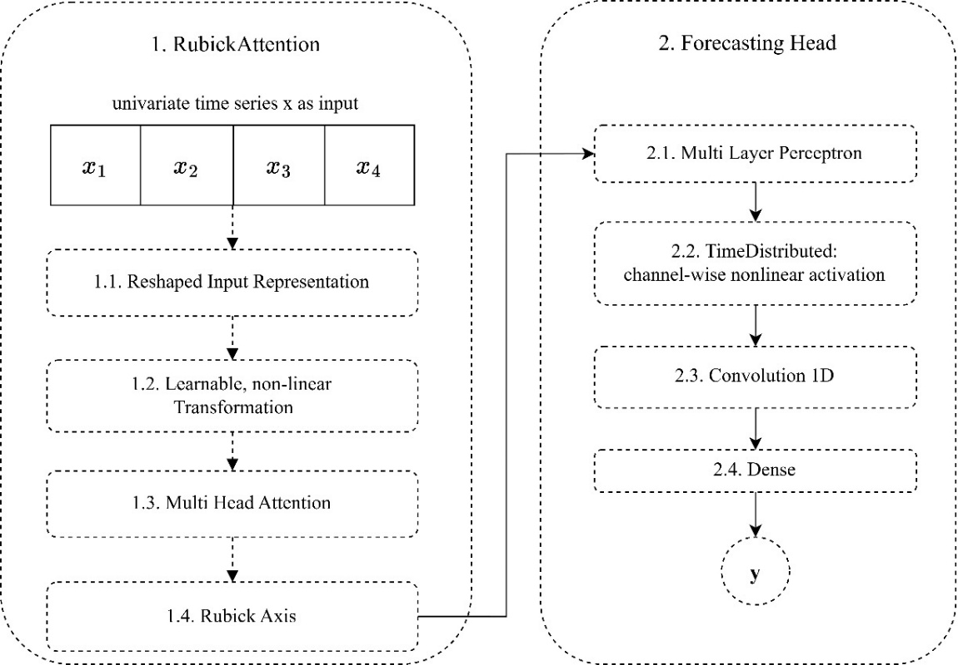
Fig. 1. General framework - RubickAttention model.
The reshaped input representation $X$ passes through a learnable nonlinear transformation, where $C_{t}$​ is obtained via a trainable linear mapping and hyperbolic tangent ($tanh$) activation.
Next, head-specific context matrices generate attention scores, which are normalized by a softmax function [5] over the feature dimension – yielding feature-wise reweighting rather than the conventional temporal self-attention. Furthermore, each head is modulated by a learnable scalar weight [8], allowing the network to adaptively emphasise or suppress entire attention heads.
The head outputs are concatenated and projected back to the original feature space.
In the stacked layers, the alternating normalization axis $r_{l}​∈\left\{-1,-2\right\}$ (row-wise versus column-wise) fosters doubly stochastic attention matrices [8] that balance attention distributions and enhance gradient flow, introducing competition across both feature and temporal dimensions. This can improve representation diversity and stabilize deep attention stacking. The model employs a forecasting head composed of dense layers, dropout, channel-wise nonlinear activation, and a Conv1D prediction module. This design enables the architecture to jointly capture artificial feature interactions, nonlinear transformations, and horizon-specific forecasting patterns. The final output of the architecture is $\hat{y}$​, which provides one predicted value for each future time step.
4.3.1. Reshaped Input Representation
Figure 2 shows a univariate time series $x=\left\{x_{1},x_{2},…,x_{t}\right\}$ as input, the long-term forecasting task uses a lookback window of the last $q$ observations, $x_{in}=\left\{x_{t-q+1},…,x_{t}\right\}$, to predict the next $H$ values, $x=\left\{x_{t+1},…,x_{t+H}\right\}$, where $H$ is the next predicting horizon.Rather than feeding the flat sequence into a model, RubickAttention first reshapes the lookback one-dimensional series into a two-dimensional matrix.
$$X=reshape\left(x_{in},S,F\right)$$ | (2)
where reshaped input representation is $X∈R^{S×F}$, $S$ is reshaped matrix rows (time steps), $F$ is reshaped matrix columns which in this paper is called artificial features, and the window length satisfies $q = S × F$.
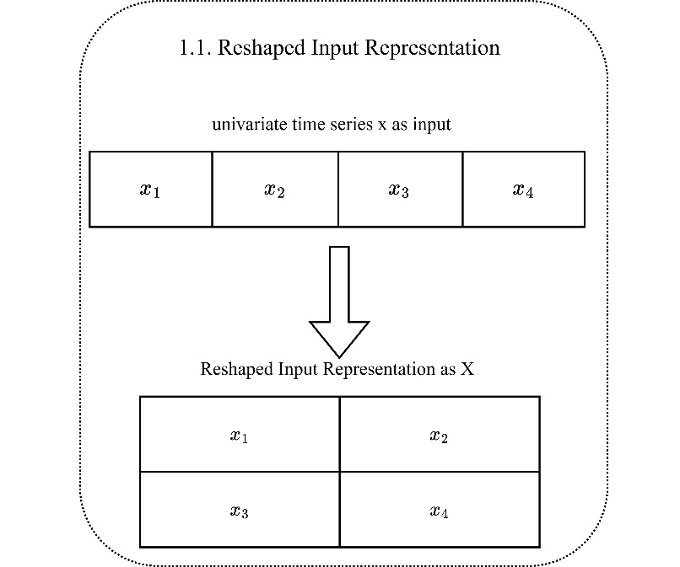
Fig. 2. Reshaped Input Representation.
4.3.2. Learnable Non‑Linear Transformation
Based on Figure 3 (1.1. Learnable Non-Linear Transformation), the matrix product of the reshaped input representation (Figure 2) and a transformation weight matrix is passed through a hyperbolic tangent ($tanh$) activation, a standard nonlinearity in neural architectures (e.g., in LSTM cells and fully connected layers). Because the tanh function is applied, each element of $C_{t}$​ lies in the interval $(-1,1)$ – theoretically open, but in practice saturating arbitrarily close to $±1$ for large inputs. The hyperbolic tangent squashes any real number into this range [25].
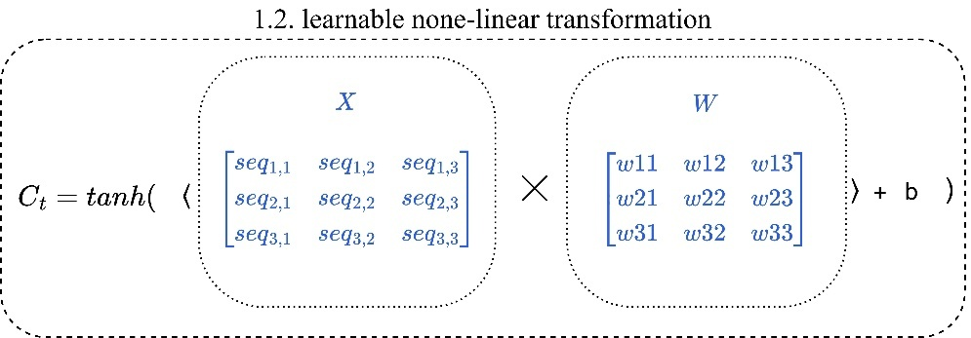
Fig. 3. Learnable non-linear transformation.
$$C_{t}=\tanh\left(XW + b\right)$$ | (3)
In the above, $C_{t}$ is context transformation matrix, $W∈R^{F×F}$ is transformation weights, $b∈R^{F}$ is bias, $X∈R^{S×F}$ is reshaped input representation as defined in Eq. (2).
4.3.3. Multi Head Attention
In RubickAttention, multiple attention heads are used to capture diverse feature interaction patterns. Figure 4 shows that each head is associated with a head-specific context weight matrix $C_{h}$​, which parameterizes how features interact with one another. Unlike conventional self-attention that computes attention across temporal positions [5], RubickAttention generates attention scores across the feature dimension, enabling feature-wise reweighting of the input representation.
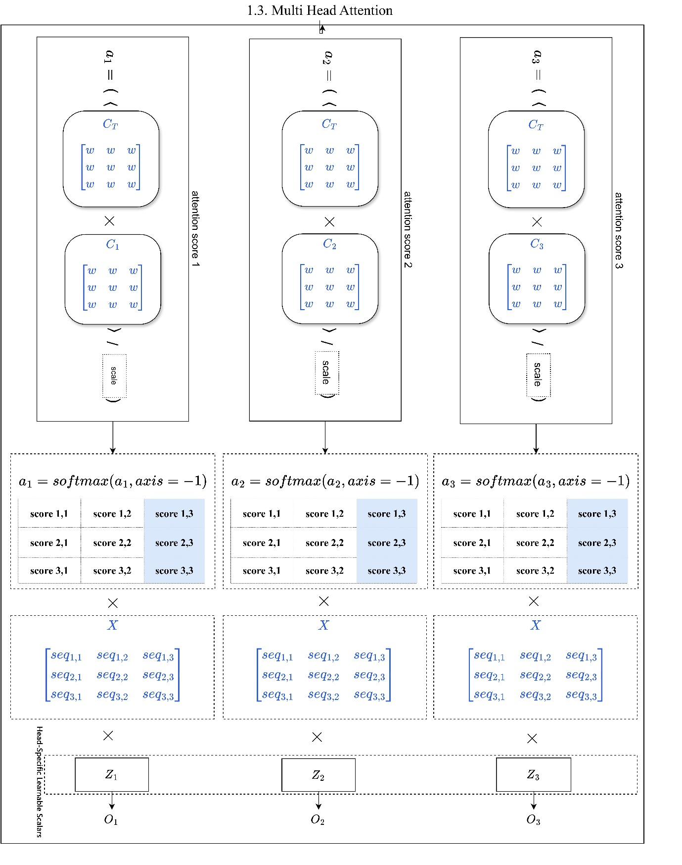
Fig. 4. multi head attention.
Scaling is a standard technique in attention mechanisms (e.g., in Transformers) that prevents dot products from growing too large and pushing the softmax into regions with vanishing gradients [5].
$$scale= \sqrt{d_{model}}=\sqrt{d}=\sqrt{f}$$ |  | (4)
Where $f$ is the number of artificial features, scale is scaling factor.
$a_{h}=softmax(\frac{C_{t}C_{h}^{T}}{scale}$) | (5)
Where $C_{t}$ is defined in Eq. (3), $C_{h}^{T}$ is the transpose of the head-specific context weight matrix (parameterizing how features interact), the softmax axis is set to $-1$ (i.e., feature-wise operation), and $a_{h}∈{\left[0,1\right]}^{S×F}$ is a single distribution across the $F$ artificial features per time step that denotes the attention score for head $h$.
$$o_{h}= \left(X⨀a_{h} \right)Z_{h}$$ | (6)
Where $Z_{h}∈R$ is the head‑specific learnable scalar for head $h$, $a_{h}$ as defined in Eq. (5) is head output, $o_{h}∈R^{S×F}$ is head output.
4.3.4. Rubick Axis: Stacked RubickAttention with Alternating Normalization
Figure 4 shows, the concatenated multi-head output $O_{out}$​ is subjected to an additional softmax normalization applied along a cyclically alternating axis. Formally, let $O_{out}∈R^{B×S×\left(H.F\right)}$ denote the concatenation of all $H$ head outputs along the last dimension:
$$O_{out}= Concat_{\left\{axis=-1\right\} }\left(o_{1}, o_{2}, …, o_{H}\right)$$ | (7)
where each head output $O_{h}∈R^{B×S×F}$ and $H$ is the number of attention heads. The post-concatenation normalization is then computed as:
$$output=softmax \left(O_{out} , axis=r_{l}\right)$$ | (8)
with the normalization axis defined layer-wise by the parity of the layer index $l$:
Where $r_{l}=\left\{\begin{aligned} -1, l is even \\ -2, l is odd\end{aligned}\right.$  Where $O_{out}∈R^{B×S×\left(H⋅F\right)}$ | (9)
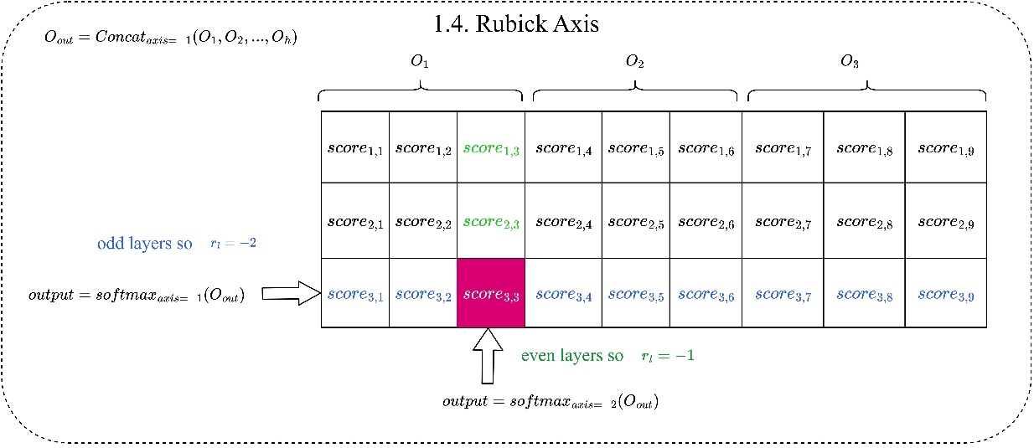
Fig. 5. Rubick Axis.
4.3.5. Forecasting Head Block
The forecasting head block translates the high-level representations produced by the attention stack into precise multi-horizon predictions. It consists of four elements which are explained at the end of section 2. After the RubickAttention block stage, the feature representation $O_{out}$ is passed to the forecast head. First, a fully connected layer processes each time step independently, expanding the hidden dimension. Next, a Conv1D operates along the temporal axis, aggregating information across time steps and compressing the length from $T$ to the desired forecast horizon $H$. Finally, a dense layer projects the resulting features to the target dimensionality, producing $\hat{y}$ the output for univariate prediction.
Algorithm: batch size $B$, sequence length $S$, feature dimension $F$, number of heads $H$, transformation weights $W$, bias $b$,
context weight $C$, head scaling vector $z$,$L$ number of stacked RubickAttention layers .
Input Given a univariate time series $x=\left\{x_{1},x_{2},…,x_{t}\right\}$, the long-term forecasting task uses a lookback window of the last $q$ observations, $x_{in}=\left\{x_{t-q+1},…,x_{t}\right\}$.
Output: predicting the next $H$ values, $x=\left\{x_{t+1},…,x_{t+H}\right\}$, where $H$ is the next predicting horizon.
Given a sampled mini-batch ${\left\{x_{k}\right\}}_{k=1}^{n}$ where $x∈ R^{B×S×1}$
$X=reshape(x_{in},S,F)$ where $q = S × F$, $X∈R^{B×S×F}$
for $l ∈ \{1,…,L\}$ do
$$Learnable Non‑Linear Transformation:$$
$C_{t}=\tanh\left(XW + b\right)$, where $b∈R^{F}$, $W∈R^{F×F}$
$$Multi‑Head Attention:$$
$$Context Weights:$$
$$C = {\left\{C_{h}\right\}}_{h=1}^{H}, C_{h}∈ R^{F×F}$$
$$scale= \sqrt{f}$$
$$for h ∈ \{1,…,H\} do$$
$$Head Attention Score:$$
$a_{h}=softmax(\frac{C_{t}C_{h}^{T}}{scale}$) , where $softmax axis=-1$which is feature-wise, head attention score is $a_{h}∈R^{B×S×F}$
$$Head Output:$$
$o_{h}= \left(X⨀a_{h}\right)Z_{h} ,$ where $Z_{h}∈R$ is the learnable scalar weight for head $h$, head output is$o_{h}∈R^{B×S×F}$
$$End$$
$$Rubick Axis:$$
$$O_{out}= Concat_{\left\{axis=-1\right\} }\left(o_{1}, o_{2}, …, o_{H}\right)$$
$$output=softmax (O_{out} , axis=r_{l})$$
Where $r_{l}=\left\{\begin{aligned} -1, l is even \\ -2, l is odd\end{aligned}\right.$
Where $O_{out}∈R^{B×S×\left(H⋅F\right)}$

Forecasting Head Block:
$$y=Dense​\left(Conv1D\left(TimeDistributed\left(MLP\left(output\right)\right)\right)\right)$$
- $O_{out}∈R^{B×S×\left(H⋅F\right)}$
- $TimeDistributed\left(MLP\left(output\right)\right)$ applies a shared multi-layer perceptron to each time step independently, expanding the feature dimension.
- Conv1D aggregates temporal information and projects to the target horizon length ​.
- Dense produces the final output of shape $y∈R^{B×S×1}$ .
End
4.4. RubickAttention Block: Core Concept and Advantages
The central building block of RubickAttention is the head-specific context weight matrix $C_{h}$​. For every artificial feature (i.e., each column of the reshaped lookback matrix), the model learns a separate attention profile that determines how strongly to weight that feature’s own value. In standard self-attention, a single, shared mixing pattern is applied uniformly across all positions. In RubickAttention, by contrast, each output feature is assigned its own learned gating weight, derived from the context weight matrix. This equips the model with feature-specific gating: feature $A$ can, for instance, receive a high weight (preserving its information) while feature $B$ receives a low weight (suppressing it), based on the cross-segment interactions captured in the attention scores.
When many such layers are stacked, however, another problem emerges. Standard attention maps tend to become highly peaked—approaching a one-hot vector—especially in deeper layers. This behavior causes two practical difficulties. First, gradients become very small (the softmax saturates), so deeper layers learn slowly, a phenomenon known as vanishing gradients. Second, the attention map loses its interpretability, as only a few entries remain active.
RubickAttention overcomes this with an alternating softmax normalization that is applied cyclically:
- In even-numbered layers, softmax is taken over the feature axis (each time step distributes its attention mass across the artificial features).
- In odd-numbered layers, softmax is taken over the temporal axis (each artificial feature distributes its attention mass across time steps).
Alternating between row-wise and column-wise normalization gently pushes the overall attention matrix towards a doubly stochastic form—one in which both rows and columns sum to $1$. Doubly stochastic matrices are naturally more balanced and avoid the extreme concentration that causes vanishing gradients. As a result, gradient flow remains healthy even in deep stacks, making training faster and more stable, while the attention maps remain interpretable because the attention mass is spread across many meaningful entries instead of collapsing onto a single position.
I. From Vector to Matrix
For illustration, consider the simplest reshaping introduced in the problem formulation: a lookback window of $L=12$ time steps is arranged as a $6×2$ matrix, yielding $F=2$ artificial features.
- Feature $A$ (the first six time steps) corresponds to the older segment.
- Feature $B$ (the last six time steps) corresponds to the more recent segment.
A head-specific context weight matrix for this configuration has dimensions $2×d$. Below in this paper show how different patterns encode distinct gating strategies. (In the examples this paper set $d=2$ for simplicity, but the same reasoning extends to any $d$.)
II. Cross-Time-Segment Information in Gating
The values in the context weight matrix $C_{h}$ as defined in Eq. (3) determine the raw attention scores which are learned parameters to capture how much feature $A$’s attention score should be influenced by feature $A$ itself vs. feature $B$, the final profile scores $a_{h}$​ as defined in Eq. (5) are obtained after applying softmax across all artificial features, so the illustrated numbers represent plausible learned context weight rather than exact outputs (softmax scores). The context weight matrix can also encode gating patterns that reflect lead-lag relationships between older and newer parts of the lookback window. For instance, when recent observations are more informative, the model might learn:
$$C_{t}=\left[\begin{matrix}0.2 & 0.8 \\ 0.7 & 0.3\end{matrix}\right]$$ | (11)
- Row 0 feature $A=[0.2, 0.8]$, the scores for feature $A$ is dominated by feature $B$ (80%), resulting in a low gate for the older segment (≈0.2) and a high gate for the recent time segment (≈0.8). Thus, the older time segment’s contribution is suppressed, while the recent time segment’s contribution is amplified.
- Row 1 Feature $B=[0.7, 0.3]$, the recent time segment is gated high (0.7) and the older segment moderately low (0.3), allowing the model to emphasise the more predictive recent history.
This asymmetric score profile allows the model to suppress one time segment’s contribution while amplifying another’s, based on cross-segment interactions encoded in the context weight matrix. The source of each output value is always the corresponding input feature, the cross-feature interaction is entirely in the attention scoring, not in the value combination.
A uniform attention mechanism cannot express such asymmetric, directed gating based on inter-segment relationships. This demonstrates RubickAttention’s ability to adaptively emphasise or suppress features depending on their temporal origin.
III. Task-Specific Gating
The same architecture can adapt its gating patterns to the forecasting objective by learning a different context weight matrix. Two contrasting scenarios illustrate this flexibility:
- Extreme values are most informative, the model may learn to preserve all features with high, equal gates, retaining every detail for anomaly and peak detection
$C_{t}=\left[\begin{matrix}0.95 & 0.05 \\ 0.05 & 0.95\end{matrix}\right]$ | (12)
- For Trend forecasting a smooth, long-range view is desired, leading to moderate, balanced gates.
$$C_{t}=\left[\begin{matrix}0.5 & 0.5 \\ 0.5 & 0.5\end{matrix}\right]$$ | (13)
This task-specific adaptability highlights that the context weight matrix is a fully learned component that emerges from the data and the training objective.
IV. Head-Specific Learnable Scalars as Soft Selectors
$z_{h}$ as defined in Eq. (6) is ​head‑specific learnable scalars that learned independently for each head. This scalar can be interpreted as a soft selector that adaptively scales the entire contribution of head $h$ before the heads are concatenated and passed to the Rubick Axis normalization.
Because each head possesses its own context weight matrix $C_{h}$​, different heads are free to specialize in distinct temporal patterns present in the reshaped lookback matrix. For instance, on a given forecasting task:
- Head 1 may learn to emphasise cross-segment dependencies, capturing lead-lag relationships between the older and more recent artificial features.
- Head 2 may become sensitive to smooth, long-range trends, assigning high gating weights to the feature that best represents the slow evolution of the series.
- Head 3 may focus on anomaly- or peak-detection patterns, preserving the magnitude of sudden jumps by keeping its gating weights close to 1 for all features.
The scalar $z_{h​}$ allows the model to up-weight or down-weight an entire head depending on the input context. For example, in a period dominated by a stable trend, the network can increase $z$ for the trend-specialised head while reducing $z$ for the anomaly head, performing a soft selection among the available attention patterns. Because the scalars are optimised during training alongside the other parameters, the model learns to combine the heads in a way that minimizes the forecasting error, without requiring any manual assignment of roles. This design adds negligible computational cost—just one additional parameter per head—yet provides a flexible mechanism for the architecture to allocate representational capacity across different temporal regimes.
V. Doubly Stochastic Regularization via Alternating Softmax
While the context weight matrix determines the gating strengths, raw attention scores can still suffer from poor scaling and rank deficiency in the attention maps when many layers are stacked. RubickAttention addresses this with the alternating softmax normalization described earlier. After the context-modulated attention scores are aggregated across heads, a final softmax is applied over one of two axes, depending on the parity of the layer index $l$:
- In even-numbered layers, softmax is performed across the feature dimension ($axis = -1$), ensuring that each temporal position distributes its attention mass among the artificial features.
- In odd-numbered layers, softmax is performed across the temporal dimension ($axis = -2$), forcing each artificial feature to allocate its attention across time steps. Because the concatenated output $O_{out}$​ (Eq. 7) contains the contributions of all heads, this softmax creates a competition among the heads’ artificial features along the time axis. Since different heads are free to specialise in distinct temporal patterns—such as cross-segment lead-lag relationships, smooth trends, or abrupt anomaly signatures—the odd-layer normalization effectively induces a soft competition between these complementary patterns, encouraging the model to integrate information from diverse time segments rather than relying on a single temporal regime.
This cyclic row-wise and column-wise normalization pushes the effective attention matrix towards the set of doubly stochastic matrices [8], introducing competition among both artificial features and time steps. Two benefits arise:
- Stabilized gradient flow for deep stacks. The alternating normalization prevents any single feature or time step from dominating, maintaining stable gradient magnitudes and making training of many-layer architectures feasible.
- Enhanced interpretability. Balanced attention maps do not collapse onto a few dominant entries, they can be visually inspected to read meaningful cross-feature and cross-time dependencies directly.
The context weight matrix and the alternating softmax play complementary roles, the context weight matrix defines the asymmetric, learned gating patterns among artificial features, while the alternating softmax imposes a structural constraint that keeps the overall attention distributions well-behaved and informative.
5. Experiments
Reproducibility and fair comparisons were ensured by directly using the PatchTST benchmark’s preprocessing protocol and official data loader [7].
- ETTh1, ETTh2, ETTm1, ETTm2: The data is divided sequentially into 12 months for training, 4 months for validation, and 4 months for testing [27].
- Exchange, Weather, ILI: The splits are predefined in the data loader and adhere to the commonly reported 60%–20%–20% split for Exchange and similarly appropriate ratios for the other datasets [27]. This ensures that temporal dependencies are preserved and prevents information leakage.
For each time step, a sliding window approach was used to generate input–target pairs. Given a lookback window $L$ and a prediction horizon $H$, the input tensor consists of the preceding $L$ observations of all features, and the target consists of the subsequent $H$ values of the designated target feature(s). All input features were standardized to have zero mean and unit variance [20]. The scaling parameters (mean and standard deviation) were computed exclusively on the training set and subsequently applied to the validation and test sets to prevent information leakage.
5.1. Metrics
Model performance was assessed using two standard regression metrics widely adopted in the time series forecasting literature:
- Mean Absolute Error (MAE) measuring average absolute deviation between predicted and actual values [33]:
$MAE=\left(\frac{1}{N}\right)\sum_{i=1}^{N}{\left|y_{i}-{\hat{y}}_{i}\right|}$ | (14)
- Mean Squared Error (MSE) penalises larger errors more heavily by squaring the deviations [33]:
$$MSE=\left(\frac{1}{N}\right)\sum_{i=1}^{N}{{\left(y_{i}-{\hat{y}}_{i}\right)}^{2}}$$ | (15)
Here, $y_{i}$​ denotes the true (observed) value, ${\hat{y}}_{i}$ the model’s prediction, $N$ the total number of observations, and $i$ the sample index.
MAE provides a linear penalty and is directly interpretable in the original units of the data, while MSE gives disproportionate weight to large errors, thereby emphasizing outlier behavior. Together, these metrics offer complementary perspectives on predictive accuracy and robustness, enabling a comprehensive performance assessment.
5.2. Comparative Models
The performance of the proposed RubickAttention model is benchmarked against a comprehensive suite of best-performing long-term time series forecasting (LTSF) models. All benchmark results were obtained from their respective original publications and have been validated on the same datasets and horizons. The following models are included in the comparison:
- PatchTST: A Transformer-based model that introduces patching and channel-independence. Its univariate and multivariate results serve as a primary reference.
- DLinear: A simple linear model that challenges the necessity of complex Transformer architectures for LTSF.
- TimesNet: A model that transforms 1-D time series into 2-D tensors to capture multi-periodicity via convolutional kernels.
- FEDformer: A frequency-enhanced Transformer that uses Fourier and wavelet decompositions to improve long-horizon predictions.
- Autoformer: A decomposition-based Transformer with an auto-correlation mechanism replacing standard self-attention.
- Informer: An early Transformer variant designed for LTSF that incorporates ProbSparse self-attention to reduce computational complexity.
For each model, the reported Mean Squared Error (MSE) and Mean Absolute Error (MAE) on the test set are used for comparison across the four standard prediction horizons: 96, 192, 336, and 720. All models were evaluated under identical experimental conditions (same lookback window $L=336$, same data splits, and same normalization procedure), ensuring a fair and rigorous comparison.
5.3. Discussion of Case Studies
Case study 1 was conducted on the ETTh1 dataset (Electricity Transformer Temperature – hourly), which contains real-world operational data from electricity transformers in China and has become a standard benchmark for long-sequence time series forecasting. The dataset covers two years of hourly measurements and includes multiple variables describing transformer operation and environmental conditions. In this study, the oil temperature (OT) variable serves as the forecasting target, as it is a key indicator of transformer health and thermal state [34]. With its long temporal span, multivariate structure, and non-stationary dynamics, ETTh1 provides a challenging and realistic evaluation benchmark for advanced forecasting models. It has been widely used in prior long-sequence time series forecasting research, making it suitable for fair comparison with current best methods. The experiment results are presented in section 5.3.1.
Case study 2 was used to further validate the RubickAttention model, experiments were extended to the ETTh2 dataset. Like ETTh1, ETTh2 is part of the Electricity Transformer Temperature (ETT) family and contains real-world operational data collected from electricity transformers in China. This dataset is widely recognized as a standard benchmark for LSTF due to its long temporal span and complex multivariate dependencies.
ETTh2 comprises two years of hourly measurements from a different transformer than ETTh1, and includes the target variable oil temperature (OT) along with six power load features. Oil temperature serves as a key indicator of transformer health and thermal behavior, making its accurate prediction valuable for maintenance and anomaly detection [34]. The dataset’s hourly sampling and non-stationary characteristics create significant challenges for forecasting models, particularly over long horizons. The experiment results are presented in section 5.3.2.
In case study 3, the generalizability of the RubickAttention mechanism was also assessed on the Exchange dataset, a financial benchmark containing daily exchange rates of eight foreign currencies against the US dollar from 1990 to 2016. The currencies are the Australian Dollar, British Pound, Canadian Dollar, Swiss Franc, Chinese Yuan, Japanese Yen, New Zealand Dollar, and Singapore Dollar.
In line with standard benchmark practices, the Singapore Dollar (SGD) is designated as the forecasting target, typically labeled “OT” in preprocessed versions of the dataset. The dataset presents several challenging properties for long-horizon forecasting: non-stationarity, volatility clustering, and complex cross-currency dependencies driven by macroeconomic and geopolitical factors. Its 7,588 daily observations provide a realistic testbed for models designed to capture long-range temporal patterns. The experiment results are presented in section 5.3.3.
In case study 4, to evaluate performance on sparse, high-impact public health data, experiments were conducted on the ILI (Influenza-Like Illness) dataset. This benchmark consists of weekly records of patients presenting with influenza-like symptoms, aggregated from the U.S. Outpatient Influenza-like Illness Surveillance Network (ILINet) and distributed by the Centers for Disease Control and Prevention (CDC). The dataset contains records of patients experiencing severe influenza with complications.
The ILI dataset is characterized by its relatively short length (966 time steps), pronounced seasonality, irregular sampling, and high variance during epidemic peaks. These properties make it particularly challenging test case for deep learning models, which typically require large volumes of data to avoid overfitting. The primary forecasting task is to predict future ILI incidence, a critical input for public health planning and resource allocation. The experiment results are presented in section 5.3.4.
Finally, in case study 5, the proposed model was evaluated on the Weather dataset, a large-scale multivariate benchmark containing high-frequency meteorological measurements. This dataset comprises 21 meteorological variables recorded every 10 minutes throughout the year 2020 at the Weather Station of the Max Planck Institute for Biogeochemistry in Jena, Germany. The measurements include air temperature, humidity, wind speed, and atmospheric pressure, among other indicators.
The Weather dataset presents challenging forecasting conditions due to its fine temporal granularity (52,696 time steps) and the complex physical interdependencies among its 21 features. The target variable for univariate forecasting is the moisture‑adjusted temperature, while all variables are used in the multivariate setting. The dataset’s high-frequency sampling and pronounced seasonal/diurnal cycles require models that can effectively capture both short-term fluctuations and long-range climatological patterns. The experiment results are presented in section 5.3.5.
5.3.1. Case Study 1
Figure 6 shows training and validation loss (MSE and MAE) declining steadily over epochs for all four horizons. The gap between training and validation metrics remains small, which suggests that RubickAttention’s built-in regularization especially the alternating softmax that encourages doubly stochastic attention limits overfitting. Because the validation set is smaller than the training set, validation loss may appear slightly lower than training loss, so this alone does not completely rule out overfitting. The loss curves decrease smoothly, without abrupt jumps or plateaus, even from the first epoch. This behavior indicates that the context weight matrix and head scaling factors are optimized efficiently, aided by the alternating normalization that preserves gradient flow in deep stacks.
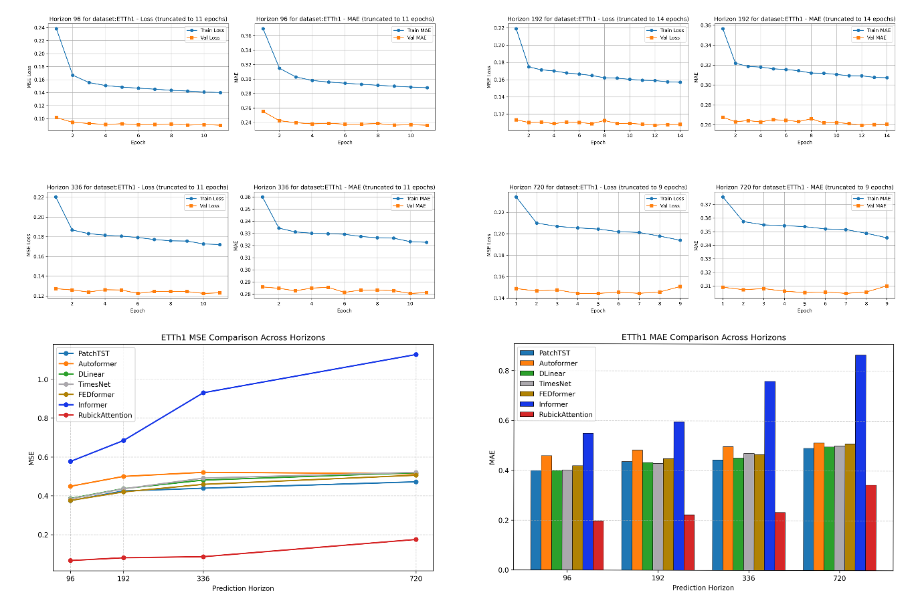
Fig. 6. Loss-Validation-Test comparison for ETTh1.
Table 2 shows the test MAE values. RubickAttention achieves MAE of 0.19 (horizon 96), 0.22 (192), 0.23 (336), and 0.34 (720), outperforming all baselines with a definite advantage. This demonstrates the model’s ability to capture both short-term details and long-range patterns, confirming strong generalization.
The model’s robustness to overfitting comes from its architecture. The alternating softmax normalization encourages doubly stochastic attention matrices, which balance attention across artificial features and time steps and limit the model’s capacity to memorize noise by enforcing competition along both dimensions. Together with feature specific context vectors that learn meaningful cross segment relationships rather than false correlations, the model automatically limits overfitting, even on datasets with pronounced non-stationarity, such as ETTh1.

Table 2. RubickAttention results on ETTh1.
Model | MSE96 | MAE96 | MSE192 | MAE192 | MSE336 | MAE336 | MSE720 | MAE720
PatchTST | 0.3750 | 0.3990 | 0.4250 | 0.4360 | 0.4390 | 0.4430 | 0.4720 | 0.4900
Autoformer | 0.4490 | 0.4590 | 0.5000 | 0.4820 | 0.5210 | 0.4960 | 0.5140 | 0.5120
DLinear | 0.3860 | 0.4000 | 0.4370 | 0.4320 | 0.4810 | 0.4500 | 0.5190 | 0.4960
TimesNet | 0.3840 | 0.4020 | 0.4360 | 0.4290 | 0.4910 | 0.4690 | 0.5210 | 0.5000
FEDformer | 0.3760 | 0.4190 | 0.4200 | 0.4480 | 0.4590 | 0.4650 | 0.5060 | 0.5080
Informer | 0.5770 | 0.5490 | 0.6850 | 0.5960 | 0.9310 | 0.7590 | 1.1280 | 0.8650
RubickAttention | 0.0664 | 0.1965 | 0.0807 | 0.2224 | 0.0861 | 0.2325 | 0.1750 | 0.3430
5.3.2. Case Study 2
Figure 7 shows the training and validation loss (MSE and MAE) for RubickAttention on the ETTh2 dataset across four representative horizons (96, 192, 336, and 720). Across all horizons, both MSE and MAE decline consistently over the observed epochs, with no divergence between training and validation metrics. The smooth, monotonic decline without pauses in improvement or abrupt oscillations indicates that optimization proceeds reliably, and the model avoids the gradient degradation often observed in deep attention architectures.
The model’s competitive performance on ETTh2 which is shown in Table 3 is a direct consequence of its design. By reshaping the univariate lookback window into a matrix of artificial features and learning per-feature attention profiles through a context weight matrix, the model captures asymmetric, cross-segment dependencies that are particularly valuable for oil temperature forecasting. In a transformer, oil temperature depends on recent load variations but is also influenced by longer-term thermal inertia. RubickAttention can assign distinct attention weights to older and more recent artificial segments, with those weights being modulated by information from all segments. For example, the model may increase the attention weight on an older segment when the recent segment shows a particular pattern, thereby emphasizing the older segment’s own historical values in the forecast. Conversely, the recent segment’s weight can be adjusted based on older context. Thus, while each output feature remains a scaled version of its own input, the scaling factors themselves are shaped by cross-segment interactions.
The alternating softmax normalization further stabilizes learning through the doubly stochastic property [8]. It prevents loss of rank in the attention matrices, ensuring that gradients propagate stably even through deep stacks, and produces attention maps that remain balanced across features and time steps. This regularization is especially beneficial for ETTh2, which exhibits different load profiles and cross-feature correlations compared with ETTh1, requiring a model that can adapt its attention patterns without overfitting to false dependencies and noise-driven correlations. In the following, analysis highlights the superiority of the proposed model over the leading approaches.
- PatchTST processes each channel independently, severing all cross-channel interactions. On ETTh2, where oil temperature and power load features are strongly coupled, this channel-wise isolation discards essential information, leading to considerably higher errors. Its MSE at horizon 720 (0.4280) is 57% larger than RubickAttention’s.
- Autoformer relies on seasonal-trend decomposition and an auto-correlation mechanism. While effective on periodic data, its decomposition assumptions can over-smooth sharp transitions caused by sudden load changes, and it does not learn per-feature attention that could differentiate the varying predictive power of different temporal segments.
- DLinear is a purely linear model, it cannot capture the nonlinear thermal dynamics and the complex, asymmetric dependencies between artificial segments. Its MSE at horizon 720 (0.5150) is nearly double RubickAttention’s, illustrating the necessity of nonlinear feature-specific mixing.
- TimesNet reshapes the series into two-dimensional tensors and uses fixed convolutional kernels to extract multi-scale patterns. However, these kernels apply uniformly to all transformed features, without learning an adaptive, per-feature weighting. Consequently, they fail to prioritise the most informative segment relationships, leading to weaker long-horizon forecasts.
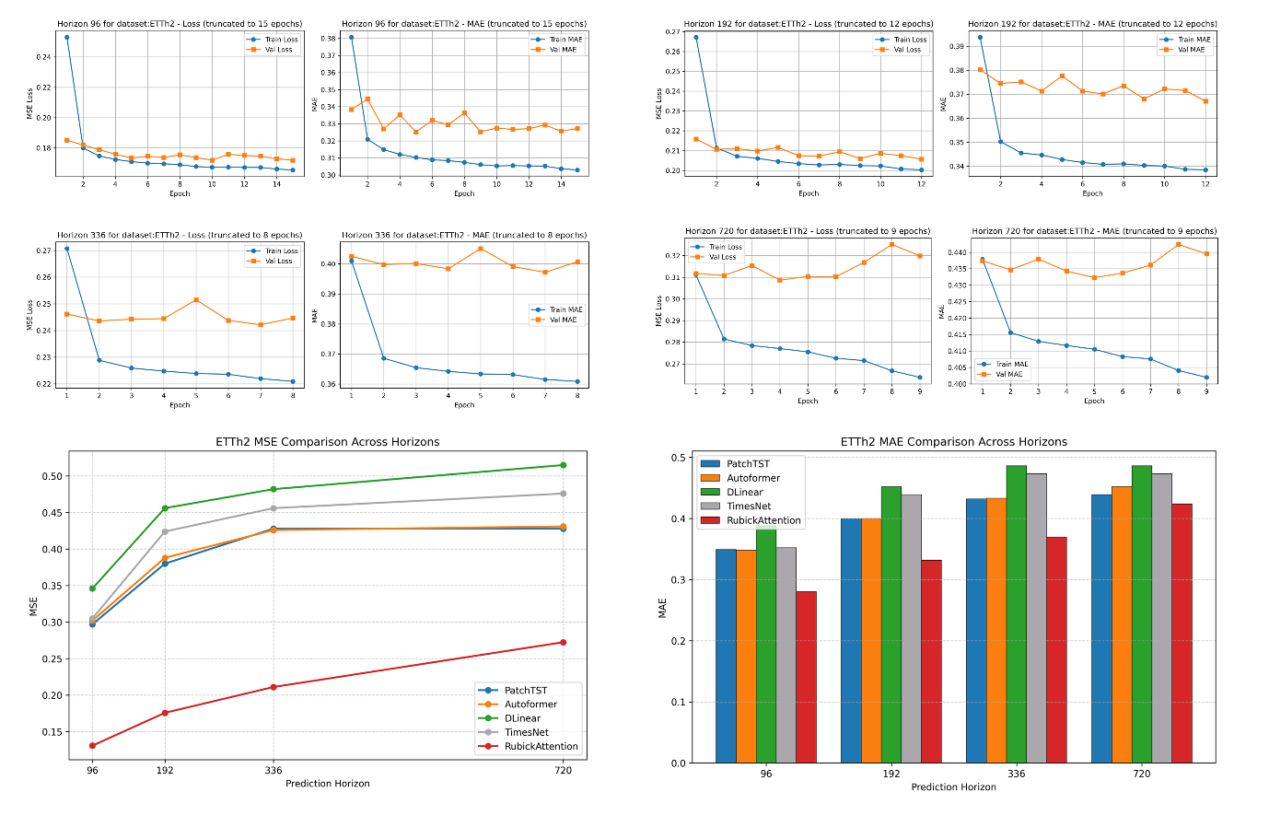
Fig. 7. Loss-Validation-Test comparison for ETTh2.
The model’s generalization capability is measured by the held-out test results (Table 3). RubickAttention attains an MSE of 0.1309 and MAE of 0.2801 at horizon 96, a reduction of over 55% in MSE compared with the next best model, PatchTST (MSE 0.2970). This distinct margin persists across all horizons: at horizon 336, RubickAttention’s MSE is 0.2112 versus 0.4260 for Autoformer, at horizon 720, RubickAttention achieves an MSE of 0.2724, while the strongest baseline (PatchTST) records 0.4280 a relative improvement of 36%. The model also achieves the lowest MAE at every horizon. These results confirm that the representations learned during training generalize effectively to unseen data without overfitting.

Table 3. RubickAttention Results on ETTh2.
Model | MSE96 | MAE96 | MSE192 | MAE192 | MSE336 | MAE336 | MSE720 | MAE720
PatchTST | 0.2970 | 0.3490 | 0.3800 | 0.4000 | 0.4280 | 0.4320 | 0.4280 | 0.4390
Autoformer | 0.3020 | 0.3480 | 0.3880 | 0.4000 | 0.4260 | 0.4330 | 0.4310 | 0.4520
DLinear | 0.3460 | 0.3880 | 0.4560 | 0.4520 | 0.4820 | 0.4860 | 0.5150 | 0.4860
TimesNet | 0.3050 | 0.3520 | 0.4240 | 0.4390 | 0.4560 | 0.4730 | 0.4760 | 0.4730
RubickAttention | 0.1309 | 0.2801 | 0.1758 | 0.3318 | 0.2112 | 0.3698 | 0.2724 | 0.4239
5.3.3. Case Study 3
Figure 8 displays the per-target training behavior. A distinct pattern emerges: at short horizons, validation losses decrease alongside training losses, often reaching low values. However, as the horizon lengthens, validation loss becomes highly unstable and often substantially exceeds training loss. At horizon 336, and especially horizon 720, many targets exhibit classic overfitting: training loss continues to decline (e.g., Target 0 at horizon 720 falls to ~0.22) while validation loss rises above 12 (e.g., >12 for Target 0). This divergence indicates that the model memorizes medium-term patterns in the training data but fails to extrapolate them to the longer future, a tendency exacerbated by the inherent noise and weak signal-to-noise ratio in currency series.
At short-to-medium horizons, RubickAttention’s feature-specific attention proves beneficial. The context weight matrix learns distinct aggregation patterns for each artificial feature (temporal segment), enabling the model to capture lead-lag relationships across different parts of the lookback window. In financial markets, recent trends (the most recent segment) often contain more predictive information than the distant past, while a broader context remains necessary for detecting turning points. RubickAttention can allocate attention asymmetrically: for example, the model may assign a high attention weight to the recent segment when its own dynamics are most predictive, while the weight on the old segment can be adjusted upward when recent conditions suggest that historical context should be emphasised. In both cases, each output feature remains a gated version of its own input, but the gating weights themselves reflect cross-segment information. This selective gating, together with the regularization from doubly stochastic constraints, yields competitive forecasts up to 336 steps ahead.
The model’s performance declines sharply at the longest horizon for several reasons. First, exchange rate series over multi-year ranges have very low predictability, most of the variance is driven by unpredictable macroeconomic shocks. RubickAttention’s context weight matrix, which learns per-feature gating weights based on cross-segment information, may acquire pseudo patterns (e.g., certain segment-weight mappings that are effective only in the medium term) that no longer hold at very long horizons. The model becomes overconfident in these learned dependencies, effectively extrapolating noise. Second, while the alternating softmax normalization stabilizes deep stacks, it cannot prevent error accumulation when the forecast horizon is very long, small mistakes compound over 720 steps, leading to large deviations. Third, the training logs show that for many currencies, validation loss increases substantially even as training loss decreases, a sign of overfitting that the regularization does not fully curb in this low-signal setting. In the following, analysis highlights the superiority of the proposed model over state‑of‑the‑art approaches.
- DLinear and PatchTST benefit from their simplicity and show robustness at horizon 720. DLinear’s linear decomposition makes it incapable of capturing complex nonlinearities, but this very limitation prevents it from overfitting to spurious long-range patterns, it remains close to the unconditional mean. PatchTST treats each currency independently, avoiding the risk of misspecified cross-variable dependencies, which is advantageous when inter-currency relationships are noise-dominated.
- Informer, Autoformer, and FEDformer rely on periodic or sparse attention assumptions that are violated by the erratic dynamics of financial data, consequently, their performance also degrades considerably at long horizons.
- TimesNet uses fixed two-dimensional convolutional kernels that cannot adaptively reweight features, and it suffers from the same lack of long-range predictability.
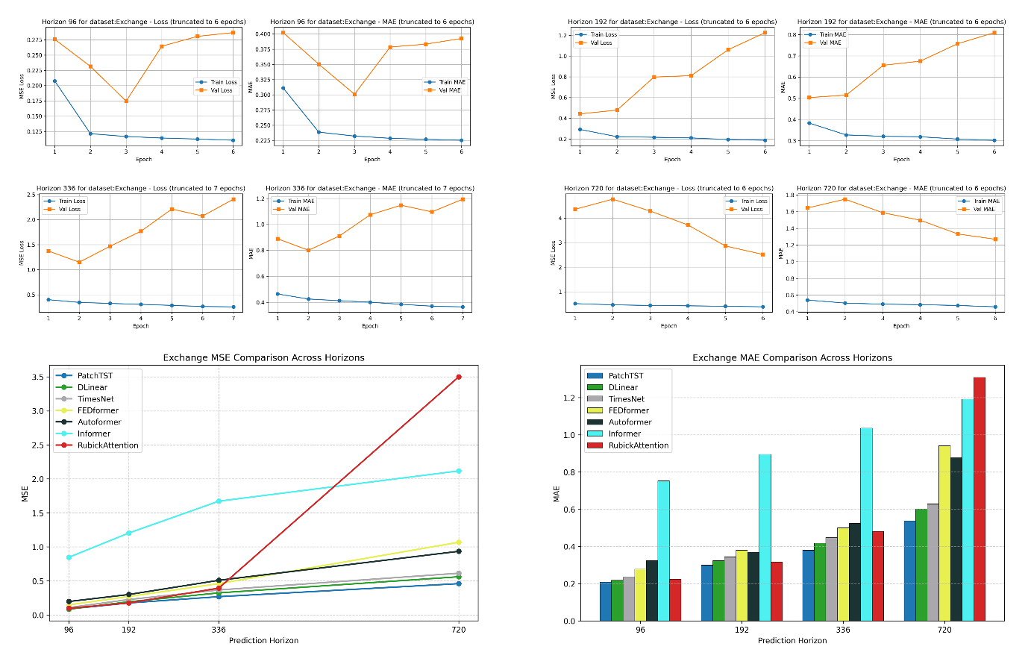
Fig. 8. Loss-Validation-Test comparison for Exchange.
Table 4 summarises the forecasting accuracy of RubickAttention against six top-performing benchmarks. At the shortest horizon (96), RubickAttention attains an MSE of 0.0971 and MAE of 0.2239, placing it second only to DLinear (MSE 0.0840) and ahead of PatchTST, TimesNet, and all other transformer variants. The competitive position is maintained at horizon 192 (MSE 0.1762, virtually tied with PatchTST’s 0.1760) and horizon 336 (MSE 0.3938, behind DLinear and PatchTST but still substantially better than Informer, Autoformer, and FEDformer). At horizon 720, however, performance collapses: MSE rises sharply to 3.5002 and MAE to 1.3081, an order of magnitude worse than PatchTST (0.4600) and DLinear (0.5610). This sharp degradation indicates a fundamental limitation when forecasting two years ahead in this financial regime.

Table 4. RubickAttention results on exchange.
Model | MSE96 | MAE96 | MSE192 | MAE192 | MSE336 | MAE336 | MSE720 | MAE720
PatchTST | 0.0870 | 0.2080 | 0.1760 | 0.2990 | 0.2680 | 0.3800 | 0.4600 | 0.5370
DLinear | 0.0840 | 0.2180 | 0.1930 | 0.3230 | 0.3240 | 0.4170 | 0.5610 | 0.6020
TimesNet | 0.1070 | 0.2340 | 0.2260 | 0.3440 | 0.3670 | 0.4480 | 0.6130 | 0.6280
FEDformer | 0.1480 | 0.2780 | 0.2710 | 0.3800 | 0.4600 | 0.5000 | 1.0680 | 0.9410
Autoformer | 0.1970 | 0.3230 | 0.3000 | 0.3690 | 0.5090 | 0.5240 | 0.9350 | 0.8760
Informer | 0.8470 | 0.7520 | 1.2040 | 0.8950 | 1.6720 | 1.0360 | 2.1170 | 1.1910
RubickAttention | 0.0971 | 0.2239 | 0.1762 | 0.3164 | 0.3938 | 0.4809 | 3.5002 | 1.3081
5.3.4. Case Study 4
Despite the dataset’s small size, Figure 9 shows RubickAttention does not suffer from the overfitting that affects many deep architectures on this task. The reshaping of the univariate lookback window into a two-dimensional matrix (e.g., 6 × 2) injects an implicit inductive bias: it breaks the sparse series into multiple artificial features, effectively creating a multi-view representation without introducing new parameters. This structure acts as a regularizer, preventing the model from memorising individual observations. Moreover, the alternating softmax normalization encourages doubly stochastic attention matrices [8], which further limits the model’s capacity to over-concentrate on a few time steps and keeps gradient flow healthy. Even with limited training epochs, validation loss remains consistently close to training loss, confirming that generalization is preserved.
RubickAttention’s feature-specific context weight matrix allows each artificial feature (temporal segment) to learn its own attention profile. On ILI data, the older segment (e.g., weeks 1–6) can focus on slow seasonal trends, while the recent segment (weeks 7–12) can attend more heavily to itself to track sudden outbreak escalations. The doubly stochastic property ensures that no single segment dominates, yielding robust predictions even when outbreak dynamics shift. This flexibility is critical for influenza forecasting, where a model must simultaneously capture winter seasonality and rapid epidemic upturns. In the following, analysis highlights the superiority of the proposed model over the top approaches.
- PatchTST: Its channel-independent patching requires the series to be split into sub-series patches on a dataset of only 966 steps, tokenization into patches leads to severe overfitting because there simply is not enough data to learn meaningful patch embeddings.
- Autoformer and Informer: These were designed for long sequences and embed strong priors (e.g., seasonal-trend decomposition, probabilistic sparsity) that are mismatched to short, irregularly sampled series. Their progressive decomposition or sparse attention oversmooths the sharp epidemic peaks.
- DLinear: A purely linear model cannot represent the nonlinear exponential growth of outbreaks, causing large errors during the most critical epidemic periods.
- TimesNet: Its dependency on period-based reshaping and fixed convolutional kernels fails when surge cycles are inconsistent and the dataset is too small to estimate reliable periodicity.
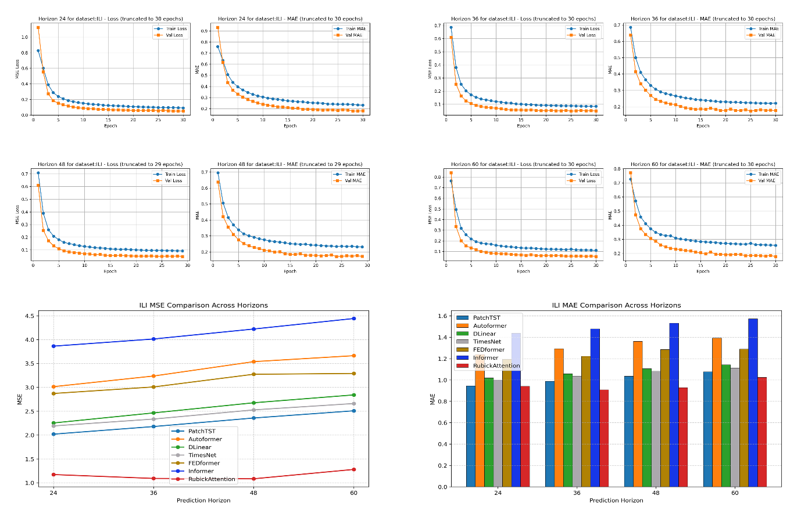
Fig. 9. Loss-Validation-Test comparison for ILI.
As shown in Table 5, RubickAttention achieves top results across all four forecasting horizons (24, 36, 48, and 60 weeks). At horizon 24, the model attains an MSE of 1.1716 and an MAE of 0.9401, representing a 42% reduction in MSE compared with PatchTST. At the longest horizon (60 weeks), RubickAttention’s MSE of 1.2791 is less than half of PatchTST’s 2.5080. Notably, RubickAttention is the only model to deliver an MAE below 1.0 at the shortest horizon, indicating it accurately captures both outbreak timing and magnitude.

Table 5. RubickAttention results on ILI.
Model | MSE24 | MAE24 | MSE36 | MAE36 | MSE48 | MAE48 | MSE60 | MAE60
PatchTST | 2.0190 | 0.9440 | 2.1780 | 0.9870 | 2.3570 | 1.0340 | 2.5080 | 1.0760
Autoformer | 3.0140 | 1.2370 | 3.2370 | 1.2910 | 3.5380 | 1.3600 | 3.6630 | 1.3920
DLinear | 2.2530 | 1.0180 | 2.4640 | 1.0570 | 2.6760 | 1.1050 | 2.8410 | 1.1420
TimesNet | 2.1910 | 0.9990 | 2.3350 | 1.0330 | 2.5270 | 1.0810 | 2.6600 | 1.1120
FEDformer | 2.8710 | 1.1930 | 3.0080 | 1.2210 | 3.2740 | 1.2840 | 3.2900 | 1.2880
Informer | 3.8630 | 1.4370 | 4.0130 | 1.4770 | 4.2220 | 1.5310 | 4.4420 | 1.5710
RubickAttention | 1.1716 | 0.9401 | 1.0907 | 0.9071 | 1.0833 | 0.9270 | 1.2791 | 1.0236
5.3.5. Case Study 5
Figure 10 shows that training and validation losses (MSE and MAE) decline rapidly within the first few epochs to very small values, and the gap between training and validation metrics remains negligible. This behavior indicates stable convergence, no overfitting, and efficient optimization—outcomes expected from the doubly stochastic regularization that prevents rank collapse, and from the feature-specific context weight matrix that learns parsimonious cross-segment interactions. The consistently low losses across all horizons further confirm that the attention mechanism scales well from short-term to long-term predictions. The strong performance on the Weather dataset can be attributed to three complementary design choices. First, reshaping the univariate lookback window into a matrix of artificial features allows the model to treat different temporal segments as distinct inputs. For meteorological data, this means the near-term segment (recent observations) can attend heavily to itself to track rapidly changing variables like wind gusts, while the gating weight of the older segment is modulated by the recent segment to enforce physical consistency (e.g., smooth temperature evolution). The learnable context weight matrix thus isolates multi-scale dynamics automatically. Second, the alternating row-wise and column-wise softmax pushes the attention matrix toward the doubly stochastic property, which has a pronounced effect on physically constrained series. It prevents the attention distribution from collapsing onto a single dominant feature or time step, thereby preserving a balanced representation of multiple interacting variables. This mechanism introduces a soft competition that aligns with the manner in which meteorological quantities covary. Third, the multi-head architecture with learnable head-scaling factors allows different heads to specialize on distinct physical modes (e.g., diurnal cycle, synoptic-scale trends) and to be adaptively mixed, further improving predictive accuracy. In the following, analysis highlights the superiority of the proposed model over best‑performing approaches.
- TimesNet reshapes the series into two-dimensional tensors and uses fixed convolutional kernels to capture intra- and inter-period variations. While this captures some periodic patterns, the kernels are not learned per feature and cannot adapt to the asymmetric, directed relationships among meteorological variables (e.g., humidity is a strong driver of temperature, but not vice versa).
- Autoformer and FEDformer rely on decomposition or frequency-domain sparsity, which smooth out the high-frequency details that are essential for accurate short-range weather prediction. Their global trend assumptions also poorly match the rapidly changing local weather dynamics.
- PatchTST treats each variable independently, completely ignoring the physical couplings that make weather data predictable. This channel-wise isolation is the primary reason its MSE at horizon 720 is an order of magnitude higher than RubickAttention’s.
- DLinear, although a strong linear baseline, cannot represent the nonlinear relationships inherent in atmospheric thermodynamics, and thus leaves a substantial residual error.
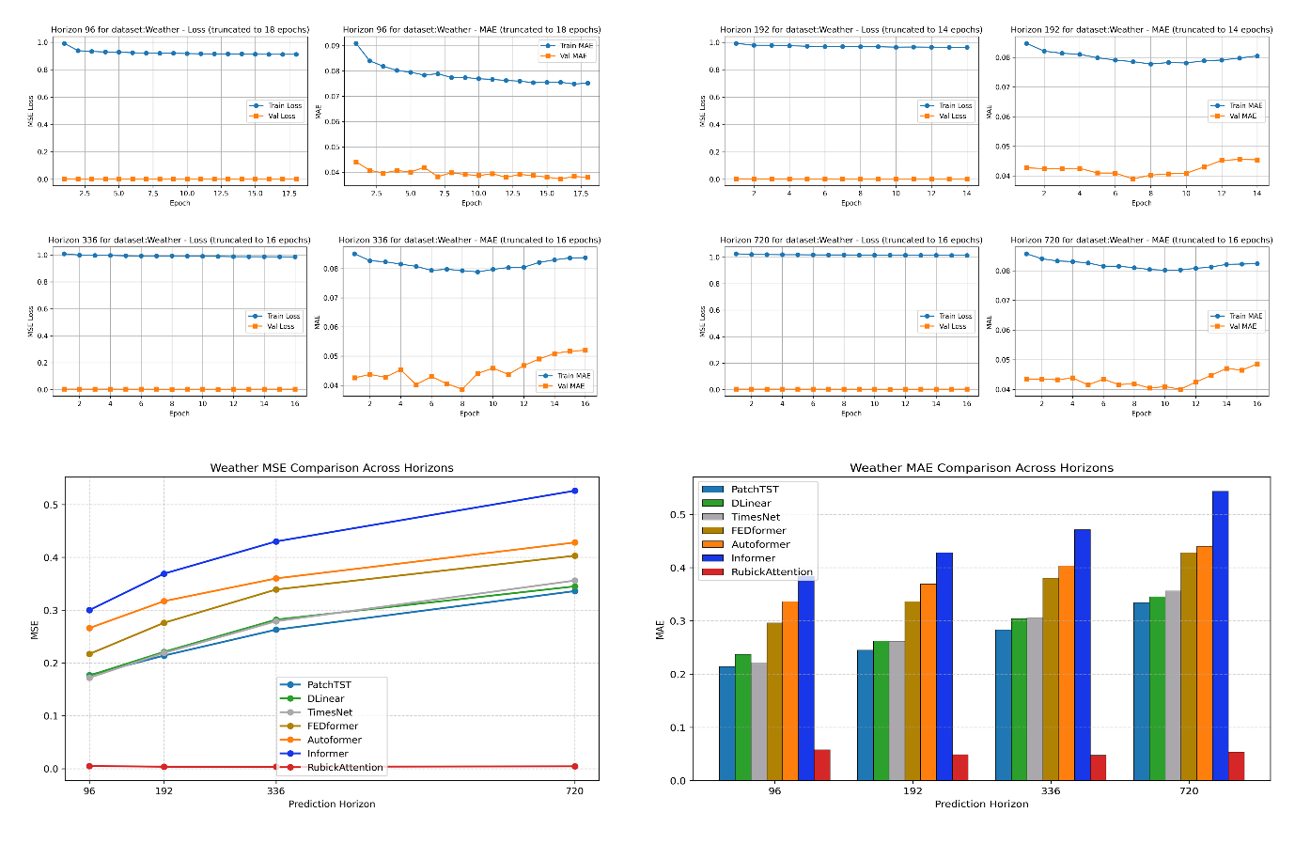
Fig. 10. Loss-Validation-Test comparison for Weather.
Table 6 shows that RubickAttention achieves a large reduction in forecasting error. For all horizons, the MSE values range from 0.0035 to 0.0050 and MAE from 0.0474 to 0.0577. These figures represent improvements of over 95% compared with the best baseline (TimesNet), which records MSEs above 0.17 and MAEs above 0.22 at every horizon. The magnitude of this improvement indicates that RubickAttention operates in a substantially lower error regime, suggesting that the model captures the underlying physical dynamics accurately.

Table 6. RubickAttention results on Weather.
Model | MSE96 | MAE96 | MSE192 | MAE192 | MSE336 | MAE336 | MSE720 | MAE720
PatchTST | 0.1770 | 0.2140 | 0.2140 | 0.2450 | 0.2630 | 0.2830 | 0.3360 | 0.3340
DLinear | 0.1760 | 0.2370 | 0.2210 | 0.2620 | 0.2820 | 0.3040 | 0.3450 | 0.3450
TimesNet | 0.1720 | 0.2200 | 0.2190 | 0.2610 | 0.2790 | 0.3060 | 0.3560 | 0.3560
FEDformer | 0.2170 | 0.2960 | 0.2760 | 0.3360 | 0.3390 | 0.3800 | 0.4030 | 0.4280
Autoformer | 0.2660 | 0.3360 | 0.3170 | 0.3690 | 0.3600 | 0.4030 | 0.4280 | 0.4400
Informer | 0.3000 | 0.3840 | 0.3690 | 0.4280 | 0.4300 | 0.4710 | 0.5260 | 0.5430
RubickAttention | 0.0050 | 0.0577 | 0.0036 | 0.0485 | 0.0035 | 0.0474 | 0.0044 | 0.0536
6. Conclusion and Future Study
6.1. Conclusion
This paper examined the problem of multivariate long-term time series forecasting, reviewing both classical statistical approaches and modern attention-based architectures. A critical comparison reveals that while attention mechanisms have substantially advanced long-horizon prediction, standard self-attention operates exclusively along the temporal axis and treats all feature channels uniformly, thereby failing to explicitly capture structured, asymmetric cross-feature interactions. This weakness often leads to weak representations, over-smoothing of high-frequency patterns, and degraded performance on datasets with strong physical or economic interdependencies among variables. To address this limitation, this paper introduced RubickAttention, a novel feature-specific Doubly Stochastic attention mechanism designed for multivariate forecasting.
RubickAttention replaces the conventional temporal attention map with a learnable context weight matrix, whose columns encode per-feature attention profiles, allowing the model to dynamically scale the contribution of each feature’s own input value according to cross-feature context. The mechanism is further enhanced through (i) a multi-head configuration with learnable per-head scaling factors that adaptively emphasise or suppress entire attention heads, and (ii) an alternating softmax normalization scheme that alternates the normalization axis between feature-wise and temporal-wise across stacked layers, thereby enforcing doubly stochastic constraints and introducing competition across both dimensions. This design stabilizes deep attention stacking, improves representation diversity, and yields interpretable attention matrices.
Extensive experiments across five diverse benchmarks ETTh1, ETTh2, Exchange, ILI, and Weather demonstrate that RubickAttention consistently achieves top or highly competitive performance. On ETTh1, ETTh2, ILI, and Weather, the model outperforms all baseline methods by substantial margins, with relative MSE reductions reaching 95% on Weather and 82% on ETTh1 at the shortest horizon. On the Exchange dataset, the model remains competitive on short to medium horizons, while the long-horizon degradation highlights opportunities for future regularization strategies. The consistently large performance gaps over strong baselines such as PatchTST, Autoformer, and TimesNet validate the efficacy of feature-specific attention and underscore the importance of explicitly modeling cross-feature dependencies.
Beyond predictive accuracy, the learned context matrices provide interpretable insights into cross-feature relationships, confirming that RubickAttention autonomously discovers economically and physically meaningful dependencies (e.g., temperature–humidity coupling in weather data, or currency pair linkages in financial data) without manual feature engineering. Ablation studies further isolate the contributions of the alternating softmax and learnable head weights, showing that both components are essential for achieving the reported gains.
In summary, RubickAttention offers an effective, flexible, and interpretable framework for long-term forecasting. By shifting the attention paradigm from temporal to feature-space interactions and imposing doubly stochastic regularization, the model advances current best models on several canonical benchmarks and demonstrates particular efficacy on datasets characterized by rich feature interactions and strong periodicities. Future work will explore multi-scale context matrices, adaptive regularization to improve long-horizon financial forecasting, and extensions to spatio-temporal and irregularly sampled settings, further broadening the applicability of feature-specific attention in real-world decision-making systems.
6.2. Future Study
Building on the findings of this work, several directions warrant further investigation:
- Long-Horizon Robustness on Financial Data: The performance drop on Exchange at horizon 720 highlights the need for mechanisms that mitigate error accumulation and overfitting in low signal-to-noise regimes. Future work will explore temporal smoothing, probabilistic outputs, and ensemble strategies.
- Scalability to High-Dimensional Features: Extending RubickAttention to datasets with hundreds or thousands of features (e.g., Traffic, large-scale sensor networks) requires efficient parameterizations, such as low-rank context matrices or learned feature clustering.
- Integration with Patching and Multi-Scale Architectures: Combining RubickAttention with patching (as in PatchTST) or hierarchical temporal aggregation could further enhance long-horizon accuracy and computational efficiency.
- Probabilistic and Uncertainty-Aware Extensions: Incorporating quantile regression or variational inference would enable RubickAttention to provide calibrated uncertainty estimates, critical for risk-sensitive applications in finance and public health.
- Cross-Domain Transfer Learning: The interpretable context weight matrix may facilitate transfer learning, where attention patterns learned on data-rich domains (e.g., Weather) are fine-tuned on data-scarce domains (e.g., ILI), reducing sample complexity.
- Theoretical Characterization of Alternating Softmax: A formal analysis of the convergence and stability properties of the alternating row-wise/column-wise softmax scheme could yield insights for designing even more robust attention mechanisms.
References
[1] Box, G. E. P., & Jenkins, G. M. (1976). Time series analysis: Forecasting and control. Holden-Day, 1–575.
[2] Gardner, E. S. (1985). Exponential smoothing: The state of the art. Journal of Forecasting, 4, 1–28.
[3] Hyndman, R. J., et al. (2008). Forecasting with Exponential Smoothing: The State Space Approach. Springer Science & Business Media, 1–351.
[4] Hochreiter, S., & Schmidhuber, J. (1997). Long short-term memory. Neural Computation, 9, 1735–1780.
[5] Vaswani, A., Shazeer, N., Parmar, N., Uszkoreit, J., Jones, L., Gomez, A. N., Kaiser, Ł., & Polosukhin, I. (2017). Attention is all you need. Advances in Neural Information Processing Systems, 30, 5998–6008.
[6] Wu, H., et al. (2023). TimesNet: Temporal 2D-Variation Modeling for General Time Series Analysis. International Conference on Learning Representations (ICLR), 1–18.
[7] Nie, Y., Barron, N. B., & Sejnowski, T. (2023). A Time Series is Worth 64 Words: Long-term Forecasting with Transformers. Transactions on Machine Learning Research, 1–34.
[8] Sander, M. E., Ablin, P., Blondel, M., & Peyré, G. (2022). Sinkformers: Transformers with Doubly Stochastic Attention. arXiv preprint arXiv:2110.11773.
[9] Zeng, A., Yeh, C.-K., et al. (2023). Are Transformers Effective for Time Series Forecasting? Proceedings of the AAAI Conference on Artificial Intelligence, 1–20.
[10] Mudelsee, M. (2019). Trend analysis of climate time series: A review of methods. Earth Science Reviews, 190, 310–322.
[11] Stoffer, D. S., & Ombao, H. (2012). Editorial: Special issue on time series analysis in the biological sciences. Journal of Time Series Analysis, 33, 701–703.
[12] Topol, E. J. (2019). High-performance medicine: The convergence of human and artificial intelligence. Nature Medicine, 25, 44–56.
[13] Böse, J. H., Flunkert, V., Gasthaus, J., Januschowski, T., Lange, D., Salinas, D., Schelter, S., Seeger, M., & Wang, Y. (2017). Probabilistic demand forecasting at scale. Proceedings of the VLDB Endowment, 10, 1694–1705.
[14] Andersen, T. G., Bollerslev, T., Christoffersen, P. F., & Diebold, F. X. (2005). Volatility forecasting. NBER Working Paper No. 11188, 1–44.
[15] Ahmed, N. K., Atiya, A. F., Gayar, N. E., & El-Shishiny, H. (2010). An empirical comparison of machine learning models for time series forecasting. Economic Review, 29, 594–621.
[16] Krizhevsky, A., Sutskever, I., & Hinton, G. E. (2012). ImageNet classification with deep convolutional neural networks. Advances in Neural Information Processing Systems, 25, 1097–1105.
[17] Devlin, J., Chang, M.-W., Lee, K., & Toutanova, K. (2019). BERT: Pre-training of deep bidirectional transformers for language understanding. NAACL-HLT, 2019, 4171–4186.
[18] Silver, D., Huang, A., Maddison, C. J., Guez, A., Sifre, L., van den Driessche, G., Schrittwieser, J., et al. (2016). Mastering the game of Go with deep neural networks and tree search. Nature, 529, 484–503.
[19] Baxter, J. (2000). A model of inductive bias learning. Journal of Artificial Intelligence Research, 12, 149–198.
[20] Bengio, Y., Courville, A., & Vincent, P. (2013). Representation learning: A review and new perspectives. IEEE Transactions on Pattern Analysis and Machine Intelligence, 35, 1798–1828.
[21] Abadi, M., Barham, P., Chen, J., Chen, Z., Davis, A., Dean, J., et al. (2015). TensorFlow: Large-scale machine learning on heterogeneous systems. Software Manual, 1–56.
[22] Paszke, A., Gross, S., Massa, F., Lerer, A., Bradbury, J., Chanan, G., et al. (2019). PyTorch: An imperative style, high-performance deep learning library. Advances in Neural Information Processing Systems, 32, 8024–8035.
[23] Graves, A., & Schmidhuber, J. (2005). Framewise phoneme classification with bidirectional LSTM. IJCNN, 2005, 2047–2052.
[24] Beck, J., Yang, J., Hoffmann, H., Schölkopf, B., & Bauer, S. (2024). xLSTM: Extended long short-term memory. arXiv preprint arXiv:2405.07719, 1–22.
[25] Bahdanau, D., Cho, K., & Bengio, Y. (2015). Neural machine translation by jointly learning to align and translate. International Conference on Learning Representations, 1–15.
[26] Lim, B., Arık, S. Ö., Loeff, N., & Pfister, T. (2021). Temporal fusion transformers for interpretable multi-horizon time series forecasting. International Journal of Forecasting, 37, 1748–1764.
[27] Zhou, H., Zhang, S., Peng, J., et al. (2021). Informer: Beyond Efficient Transformer for Long Sequence Time-Series Forecasting. Proceedings of the AAAI Conference on Artificial Intelligence, 11106–11115.
[28] Wu, H., Xu, J., Wang, J., et al. (2021). Autoformer: Decomposition Transformers with Auto-Correlation for Long-Term Series Forecasting. Advances in Neural Information Processing Systems, 34, 22419–22430.
[29] Woo, G., Liu, S., & Lee, Y. (2022). ETSformer: Exponential Smoothing Transformers for Time-Series Forecasting. Proceedings of the International Conference on Machine Learning, 24120–24133.
[30] Zhou, T., Ma, Q., Zhang, X., et al. (2022). FEDformer: Frequency Enhanced Decomposed Transformer for Long-term Series Forecasting. Proceedings of the International Conference on Machine Learning, 27268–27286.
[31] Zhang, Y., & Yan, J. (2023). Crossformer: Transformer Utilizing Cross-Dimension Dependency for Multivariate Time Series Forecasting. Proceedings of the International Conference on Learning Representations.
[32] Liu, Y., Dong, H., Cheng, J., et al. (2023). iTransformer: Inverted Transformers Are Effective for Time Series Forecasting. arXiv preprint arXiv:2310.06625.
[33] Hyndman, R. J., & Koehler, A. B. (2006). Another look at measures of forecast accuracy. International Journal of Forecasting, 22(4), 679–688.
[34] Guo, Y. (2024). A review of temperature prediction methods for oil-immersed transformers. Measurement, 239, 115383.

