Evo 1.0 Documentation

Evo:
Evo is a GUI application for PTCL Evo Wingle. Evo is a very lightweight (less than 100 KB) application which shows network status and statistics. Evo is designed from ground up to support multi-platform and have hooks for future improvements.
(Default Password: admin)

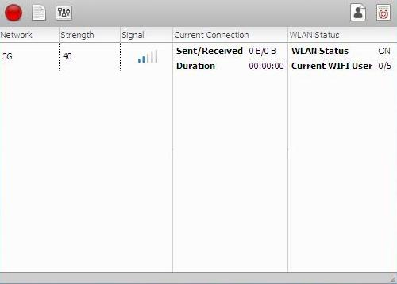

Evo Features:
- Lightweight (less then 100 KB)
- Support multi-platform. (Unix, Linux, Window, Mac)
- Beautiful theme
- Password protection support

Acknowledgments:
Open source world.

Downloading and Installing:
Evo code has been written in Python Programming Language, and its GUI is GTK based.
Therefore, to run Evo, Python Interpreter and PyGi are required.
Follow the below steps, to run Evo:

- First-of-all download Python 3 from http://www.python.org and install it.
- Then download PyGi from https://wiki.gnome.org/Projects/PyGObject and install it.
- After that, download Evo.rar.
- Then extract the Evo.rar and click on Evo.pyw to run it.

* Download the versions of Python Interpreter and PyGi for your OS.
* If you are having any problem in downloading, installing mail me at: evoappdeveloper@gmail.com

Usage:
You can use the toolbar to navigate between different sections.

Red Button:
Red button on the toolbar indicate disconnected. While green, indicate connected. You can also use the red button to get to the main page, like in the above figure. On the main page you can check the network status like signal strength, network type etc.

Info Button:
You can use the info button to view info page. Where you can check the device info and network statistics, like in the below figure.

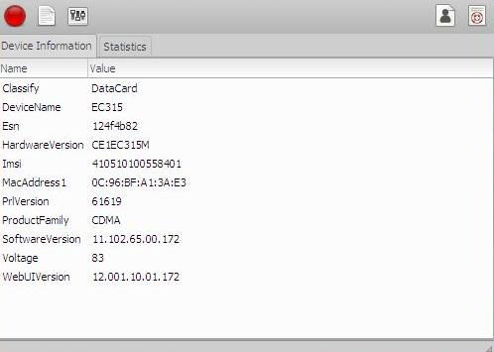

Setting Button:
To change the setting of Evo application you can use this button. See the figure below.

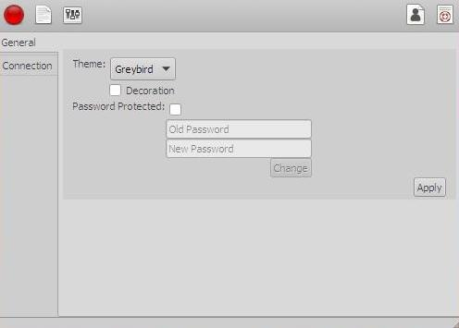

In the connection tab of the above figure, Server is the URL to which Evo will make a request for checking connection. Moreover, Timeout (default: None – is the default timeout, which the underlying package set by itself) is the number of seconds Evo will wait for a response from the server. While Make Request (default: 10) is the number of seconds after which Evo will make another request from the server to check connection.

Copyright:
Copyright © 2014 Mahan Marwat. All rights reserved.

Donation:
As we know that open-source, free-ware software relies on donation. So, if you want to donate mail at: evoappdeveloper@gmail.com

Feedback:
Send your feedback at: evoappdeveloper@gmail.com

Issues, Limitations:
- On clicking on the main page of Evo will result in some layout issues.
- Evo is not draggable, when decoration set to false.
- The project is not tested with any testing framework. So may be this version is buggy.
- Results are not that accurate.
- No explicit way to, check network connection.

* Will fix these issues in second version

Future:
- Metro UI
- SMS support
- Network setting support
- More network checking connection, like pinging, header request etc.
- And many more…

Hire-Me:
If you have any project, whether it is Web-Based, CLI or GUI and wants to hire-me. Please let me know at: mahanmarwat@gmail.com.
I mainly program in Python. Below are the other technologies I know.
HTML5, CSS3, JavaScript (Jquery), Bootstrap (CSS framework), Django (Python framework), PyGi (Python framework) and a-lot more e.g (Regex, Django Template Language) and Python packages like (requests, BeautifulSoup, paths) etc.

FAQ:

Why Evo?
PTCL Evo Wingle does not have its own GUI.

I do not have PTCL Evo Wingle, can I Use Evo with other devices?
Yes, But then Evo will only indicate connection (Green button on toolbar)/disconnection (Red button on toolbar). Evo will not provide other info like statistics etc.

Why the daunting process installing Python, PyGi and Evo?
I am working on it. And very soon release self executable version without installing Python, PyGi.

How to close Evo, when decoration set to False?
Click on Evo application to select it. And press (Alt + F4). This works on window platform. Please check your OS manual for a keyboard shortcut to close an application.

