Given an **m x n** matrix, return all elements of the matrix in **spiral** order.

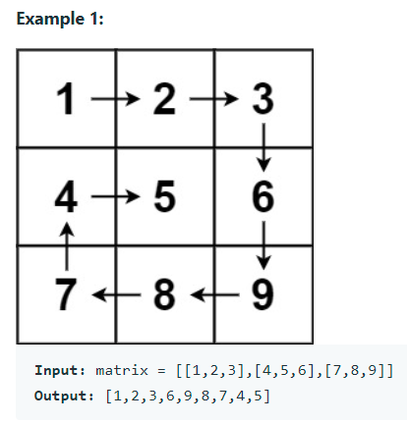

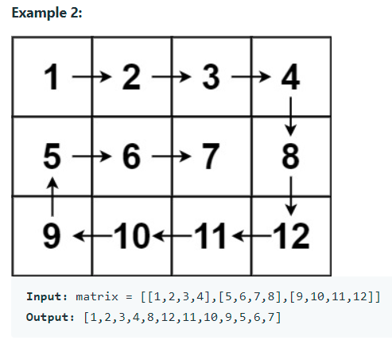

**Constraints:**

m == matrix.length

n == matrix[i].length

1 <= m, n <= 10

-100 <= matrix[i][j] <= 100