Given an m x n grid of characters board and a string word, return **the index of all letters in order** if word exists in the grid. Else Return an empty list.

The word can be constructed from letters of sequentially adjacent cells, where **adjacent cells are horizontally or vertically neighboring**. The same letter cell may not be used more than once.

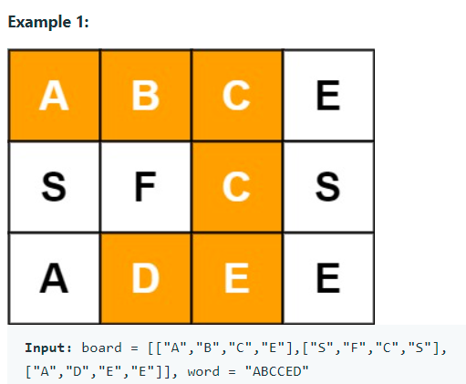

**Output:** [[0,0],[0,1],[0,2],[1,2],[2,1],[2,2]]

**Constraints:**

m == board.length

n = board[i].length

1 <= m < =10, 1<=n <= 6

1 <= word.length <= 15

board and word consists of only lowercase and uppercase English letters.