**research title**

Requirement to pass the course

**COURSE NAME**

By:

# Table of Contents

# List of Tables and Figures

# Abstract

(Abstract; 12 pt Times New Roman, within 50 words). The Abstract section must not be numbered. Authors are requested to follow all the formatting instructions encoded into this word file. An easy way to comply with the research document formatting requirements is to use this document as a template and simply type your text into it. Papers are submitted in English. document should be written in Times New Roman 12 pt format, all margins should be 1.0 inch (2.4 cm) except the top one should be 1.5 inch (3.6 cm).Your document must use a page size corresponding to A4 which is 210mm (8.27") wide and 297mm (11.69") long.

# Introduction

Title of Section (e.g. Introduction) (16 pt Times New Roman Bold). This document is a template. Paragraphs’ font is 12pt Times New Roman. An electronic copy can be downloaded from the whatsapp group. For questions on document guidelines, please contact the group admin local committee as indicated on the whatsapp group website.

In this section, you should illustrate all introduction knowledge about you research point, especially all previous background needed for your research point

# Methodology

In this section the illustration and the theory operation should be stated for your research point especially in formal sequence. All the figures needed and tables should be written and illustrated.

The insertion of figures requires special attention. First, each figure should be inserted where it belongs, as close to the figure reference as possible. Figures should be inserted centered and “in line text” layout format. Figure should be in black and white especially when using different line format. Each figure (group) must include a caption set in 9 pt Times New Roman. The caption is to be centred. Figure numbering and referencing should be done sequentially, e.g. Fig. 1., Fig. 2., etc. for single figures, and Fig. 1(a)., Fig. 1(b)., etc. for figures with multiple parts. Put a blank line before and after the figure, as shown in Fig. 1 and 2.

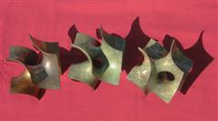

Fig. 1: Short, centered caption, terminated with a full stop.

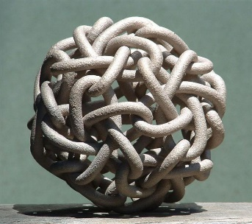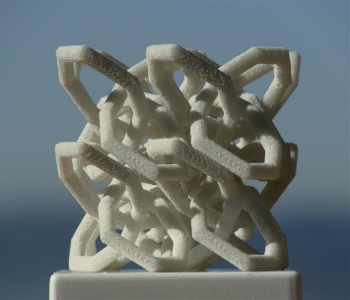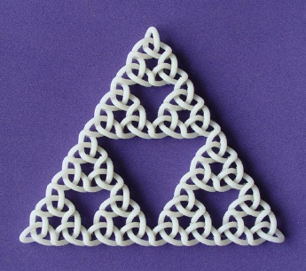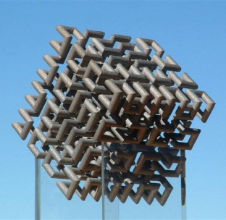

Fig. 2: Here is a longer caption that is left/right justified. It has multiple components that are referred to from left to right. (a) Cube, (b) Dodeca-Pentafoil, (c) Recursive Trefoil Knot, and (d) Lattice of Figure-8 Knots.

Table should be numbered. Table captions should be centered and in 9 pt Times New Roman. Every word in the table caption must be capitalized except for short minor words as listed in Section III. Captions with table numbers must be placed before their associated tables, as shown in Table 1.

Table 1: Short Captions Should be Centered above each Table

| **Table Head** | **Table Column Head** | | |
| --- | --- | --- | --- |
| ***Table column subhead*** | ***Subhead*** | ***Subhead*** |
| copy | More table copya |  |  |

# Results

In this section, the results for your research and the final output should be shown as figures, and even a comparison should be made in tables if found.

# Discussion and conclusion

This section, each student in the group should write on his own his conclusion and discussion as a final decision for what he or she has researched. As a paragraph that is in between 50 to 150 words.

# References

1. S. M. Metev and V. P. Veiko, *Laser Assisted Microtechnology*, 2nd ed., R. M. Osgood, Jr., Ed. Berlin, Germany: Springer-Verlag, 1998.
2. J. Breckling, Ed., *The Analysis of Directional Time Series: Applications to Wind Speed and Direction*, ser. Lecture Notes in Statistics. Berlin, Germany: Springer, 1989, vol. 61.
3. S. Zhang, C. Zhu, J. K. O. Sin, and P. K. T. Mok, “A novel ultrathin elevated channel low-temperature poly-Si TFT,” *IEEE Electron Device Lett.*, vol. 20, pp. 569–571, Nov. 1999.
4. M. Wegmuller, J. P. von der Weid, P. Oberson, and N. Gisin, “High resolution fiber distributed measurements with coherent OFDR,” in *Proc. ECOC’00*, 2000, paper 11.3.4, p. 109.
5. R. E. Sorace, V. S. Reinhardt, and S. A. Vaughn, “High-speed digital-to-RF converter,” U.S. Patent 5 668 842, Sept. 16, 1997.
6. (2002) The IEEE website. [Online]. Available: http://www.ieee.org/
7. M. Shell. (2002) IEEEtran homepage on CTAN. [Online]. Available: http://www.ctan.org/tex-archive/macros/latex/contrib/supported/IEEEtran/
8. *FLEXChip Signal Processor (MC68175/D)*, Motorola, 1996.
9. “PDCA12-70 data sheet,” Opto Speed SA, Mezzovico, Switzerland.
10. A. Karnik, “Performance of TCP congestion control with rate feedback: TCP/ABR and rate adaptive TCP/IP,” M. Eng. thesis, Indian Institute of Science, Bangalore, India, Jan. 1999.
11. J. Padhye, V. Firoiu, and D. Towsley, “A stochastic model of TCP Reno congestion avoidance and control,” Univ. of Massachusetts, Amherst, MA, CMPSCI Tech. Rep. 99-02, 1999.
12. *Wireless LAN Medium Access Control (MAC) and Physical Layer (PHY) Specification*, IEEE Std. 802.11, 1997.