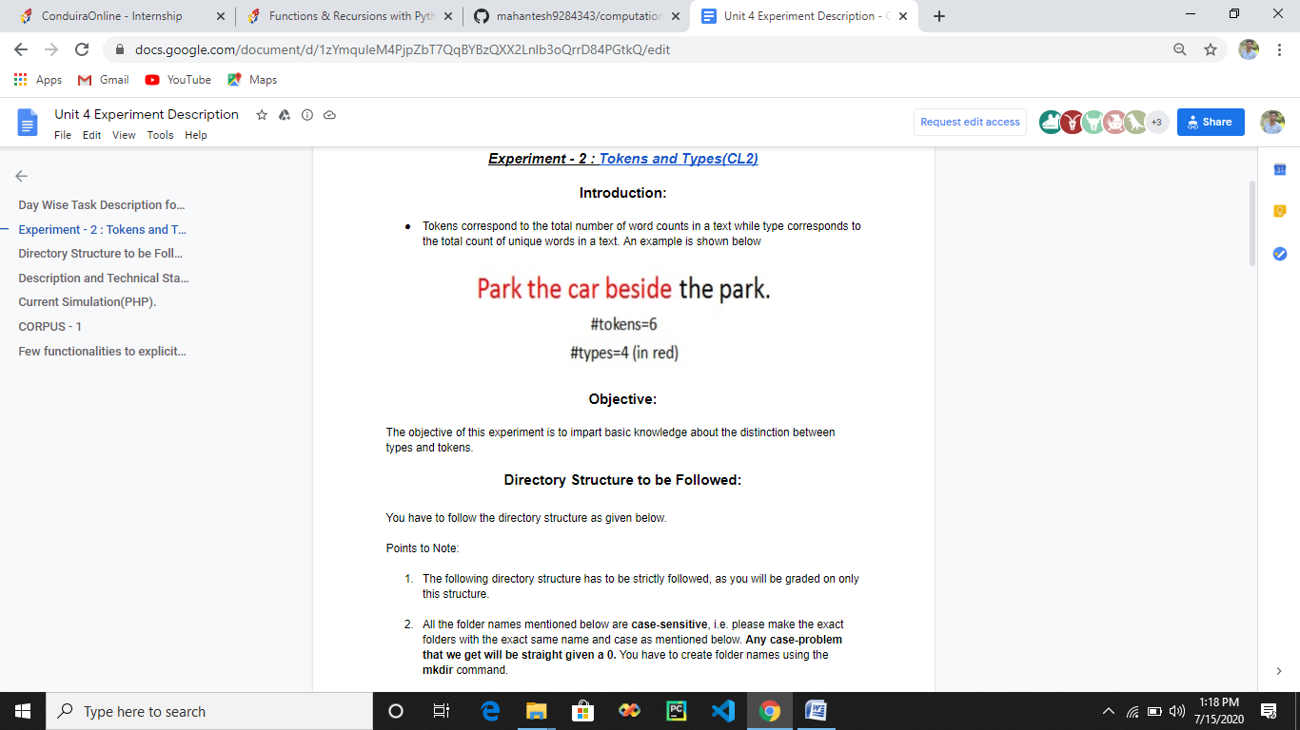

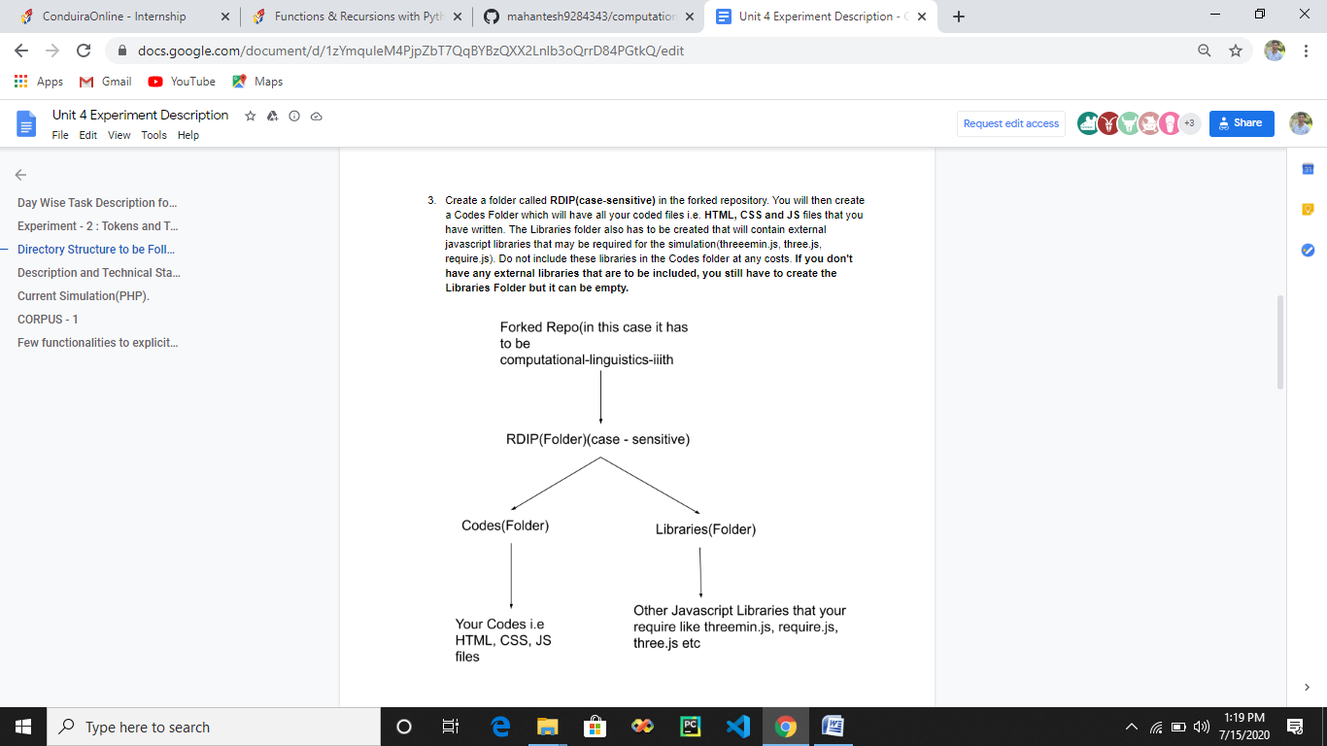

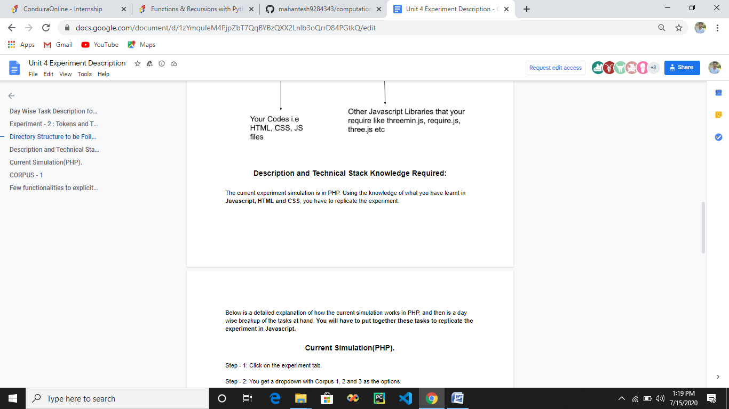

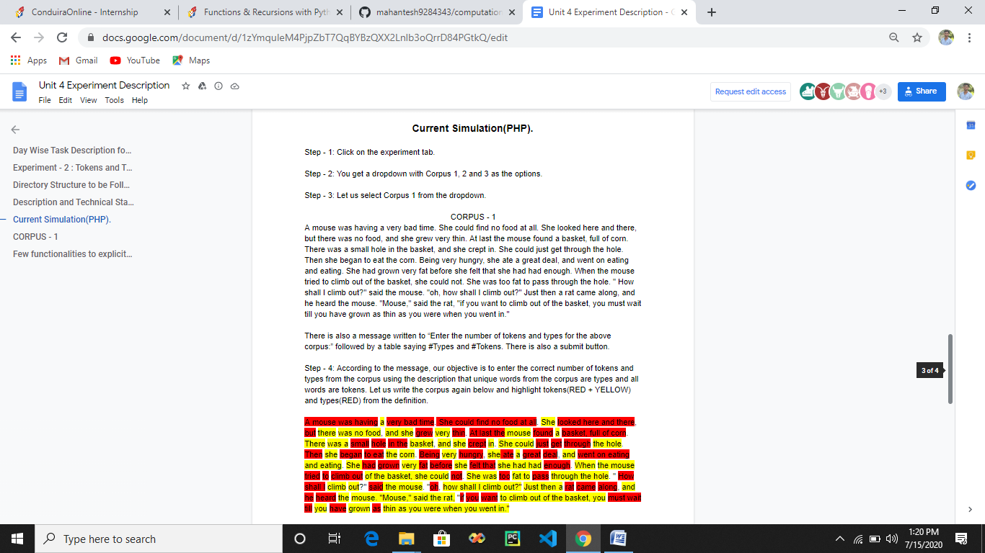

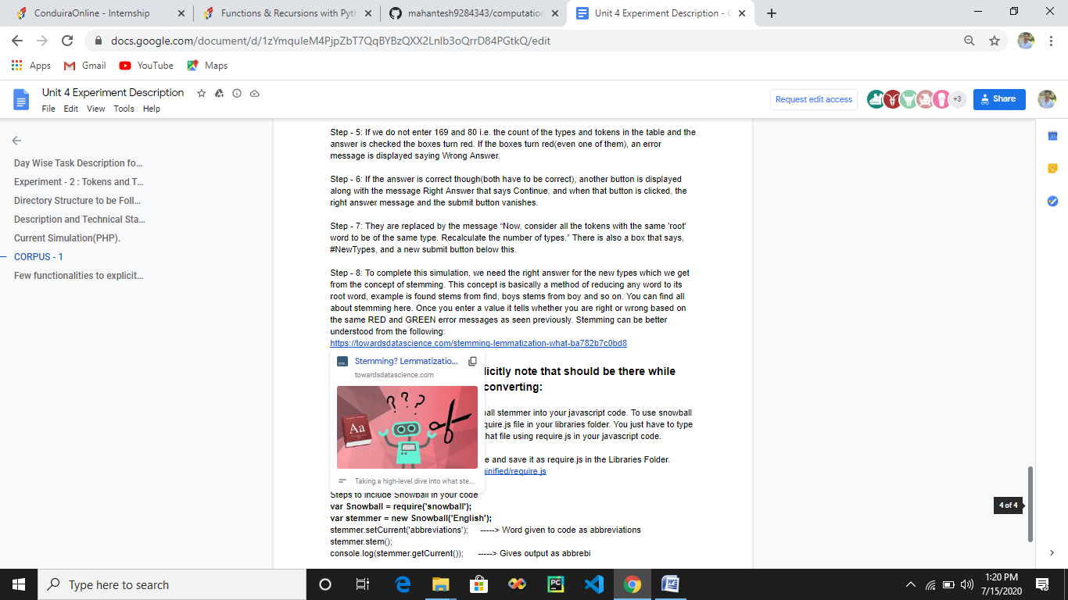

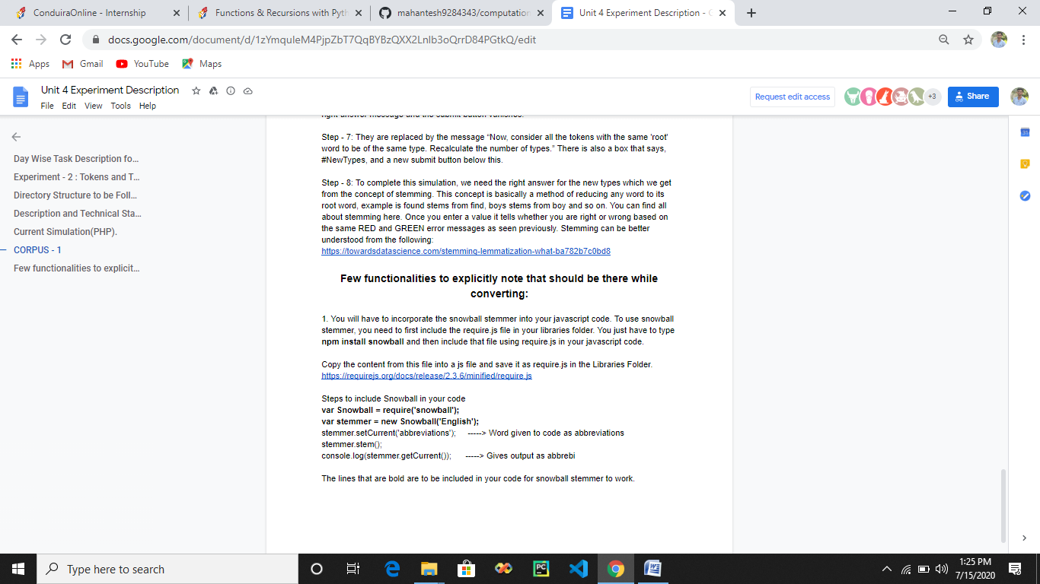

<https://towardsdatascience.com/stemming-lemmatization-what-ba782b7c0bd8>

<https://requirejs.org/docs/release/2.3.6/minified/require.js>

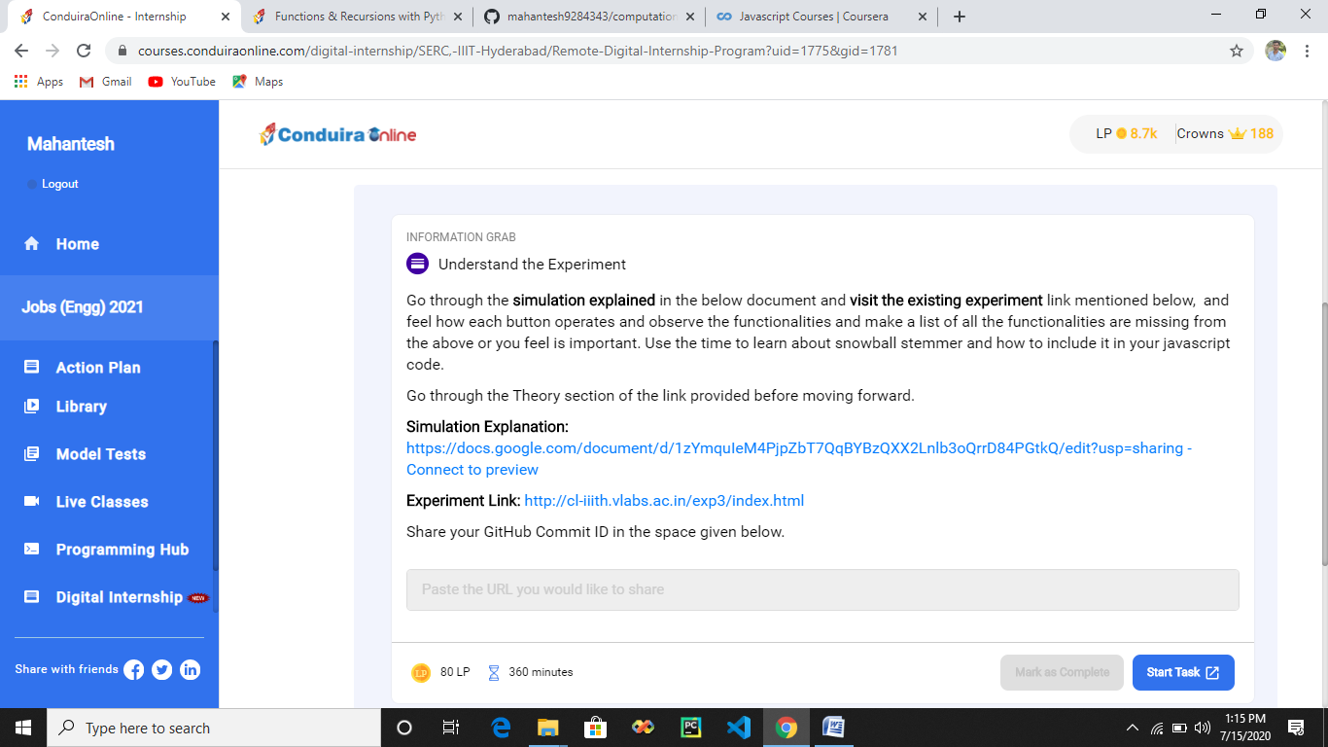

<https://docs.google.com/document/d/1zYmquIeM4PjpZbT7QqBYBzQXX2Lnlb3oQrrD84PGtkQ/edit?usp=sharing>

<http://cl-iiith.vlabs.ac.in/exp3/index.html>

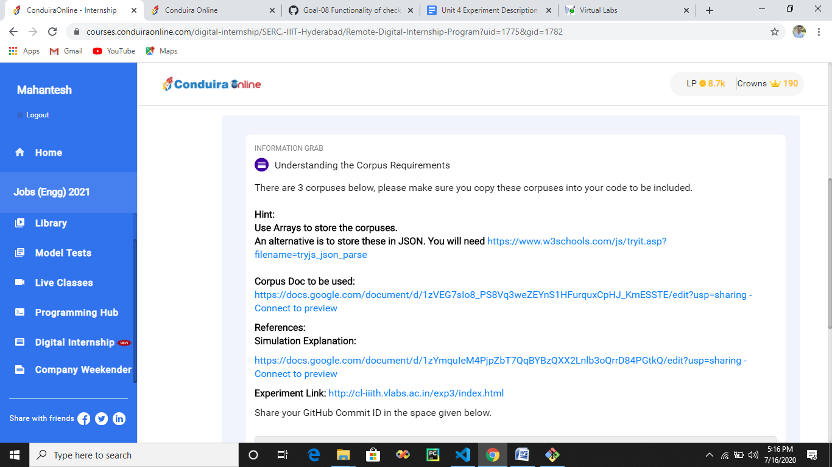

<https://www.w3schools.com/js/tryit.asp?filename=tryjs_json_parse>

<https://docs.google.com/document/d/1zVEG7sIo8_PS8Vq3weZEYnS1HFurquxCpHJ_KmESSTE/edit?usp=sharing>

<https://www.w3schools.com/js/tryit.asp?filename=tryjs_json_parse>

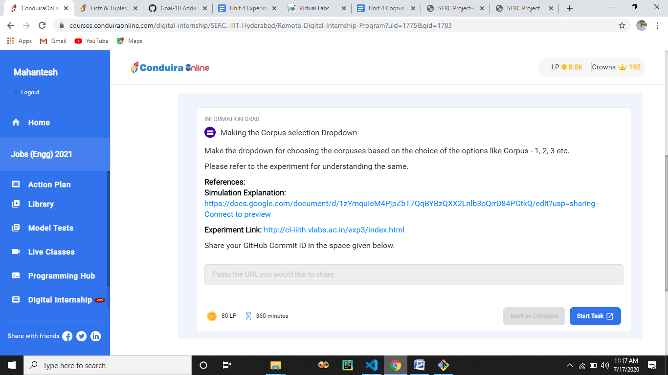

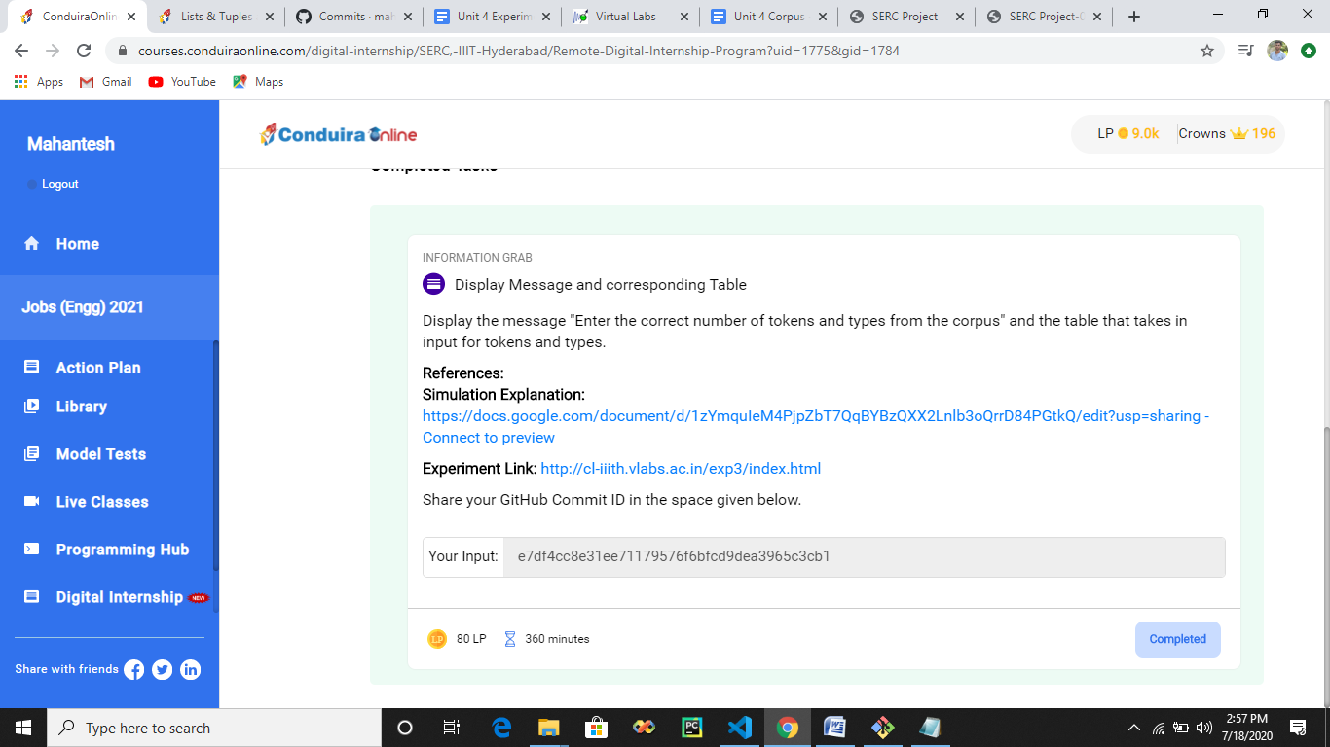

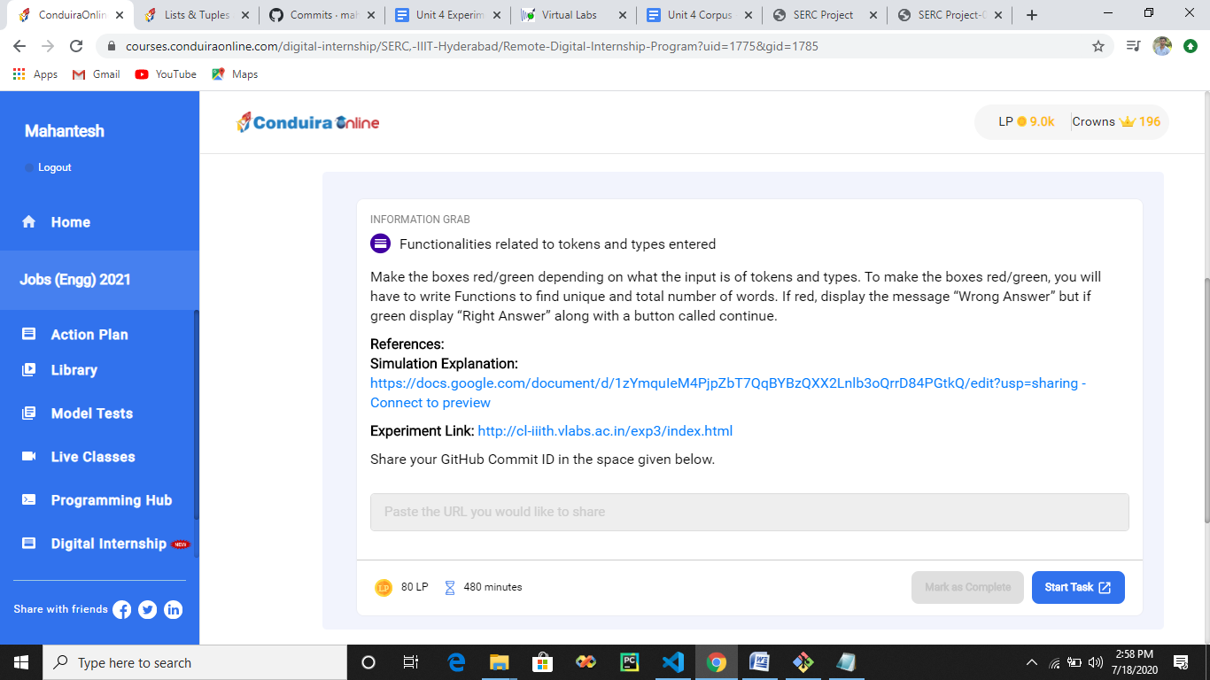

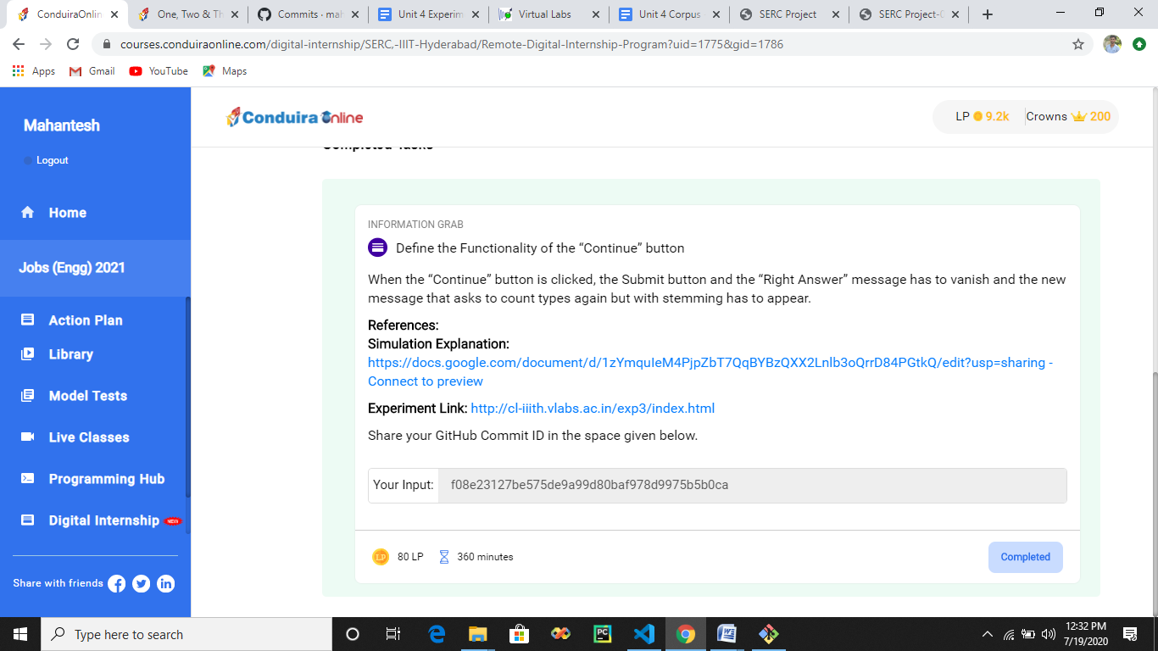

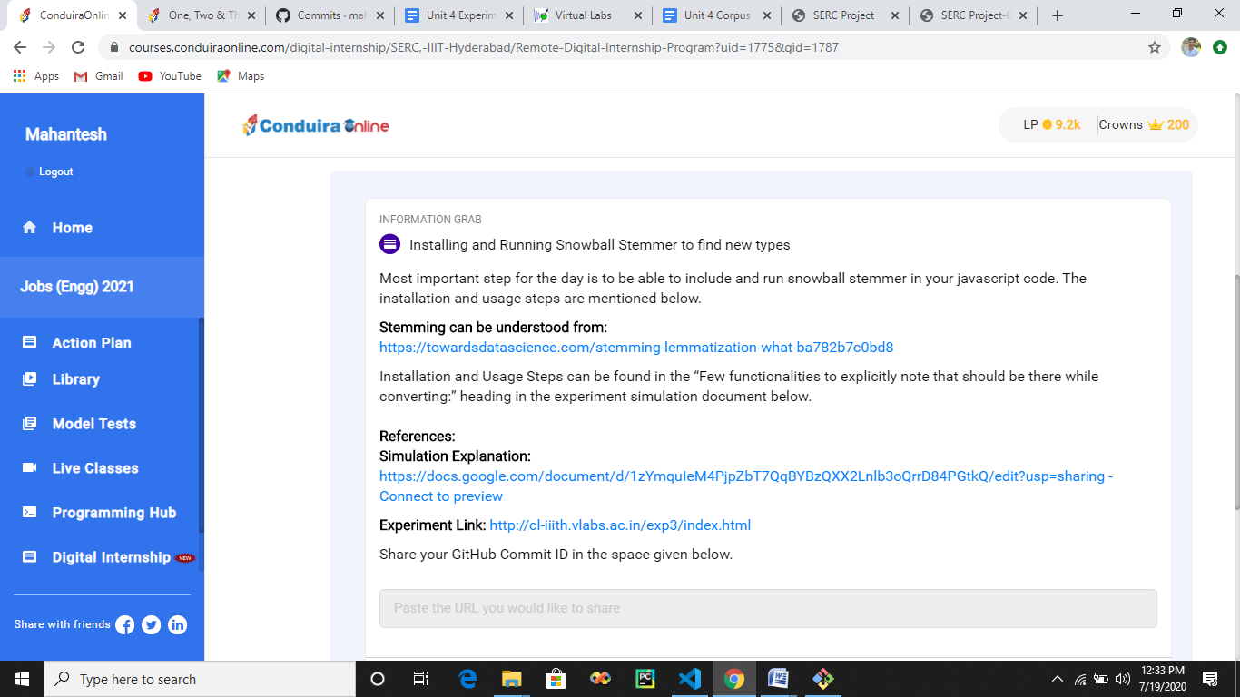

<https://towardsdatascience.com/stemming-lemmatization-what-ba782b7c0bd8>

