

MUTHUMAHA S

**ROAD DAMAGE DETECTION USING UAV IMAGES**



* Introduction to the Project
* Literature Review
* Understanding Deep Learning and YOLO Algorithms
* Study of UAV Image Processing
* Exploration of Datasets
* Implementation and Experimentation
* Performance Evaluation and Analysis



**AGENDA**

# PROBLEM STATEMENT

Manual road damage data collection is labor-intensive and unsafe, hindering effective infrastructure maintenance. An automated system using UAV images and deep learning is needed to enhance detection efficiency and accuracy. Investigating YOLOv4, YOLOv5, and YOLOv7 algorithms, the goal is to achieve high precision in identifying damage types and locations. Testing on RDD2022 and Spanish datasets will validate effectiveness across diverse contexts. Ultimately, the system aims to provide transportation authorities with a reliable solution for timely maintenance interventions, ensuring the safety and sustainability of transportation systems.



# PROJECT OVERVIEW



* Utilizes UAV images & deep learning.
* Solves labor-intensive & unsafe manual inspection.
* YOLOv4/5/7 algorithms for detection.
* Combined Chinese & Spanish datasets.
* Training/testing for accuracy (mAP).
* Enhances infrastructure maintenance.
* Ensures transportation system sustainability.
* Continuous improvement and updates:
* User interface and accessibility
* Deployment and scalability

**WHO ARE THE END USERS?**

* Transportation Authorities
* Civil Engineers and Inspectors
* Road Maintenance Crews
* Urban Planners
* Government Agencies
* Emergency Services
* General Public



## SOLUTION AND ITS VALUE PROPOSITION

**AUTOMATED ROAD DAMAGE DETECTION:**

* Utilizes UAV images and deep learning algorithms for efficient and accurate detection.

**VALUE PROPOSITION:**

* Enhances infrastructure maintenance by enabling timely identification and intervention for road damages.
* Improves road safety and reduces the risk of accidents by addressing potential hazards promptly.
* Optimizes resource allocation and minimizes costs associated with manual inspections and reactive maintenance.
* Provides actionable insights for transportation authorities and stakeholders to make informed decisions and prioritize maintenance efforts effectively.

# THE WOW IN YOUR SOLUTION

* Integration of cutting-edge UAV imagery and deep learning algorithms.
* Seamless identification and localization of road damages with precision.
* Dramatically reduces labor-intensive efforts and enhances safety for inspectors.
* Utilization of YOLOv4, YOLOv5, and YOLOv7 algorithms for heightened accuracy.
* Validation across diverse geographical contexts using RDD2022 and Spanish datasets.
* Sets a new standard for automated road infrastructure management.
* Represents the future of transportation maintenance and safety.

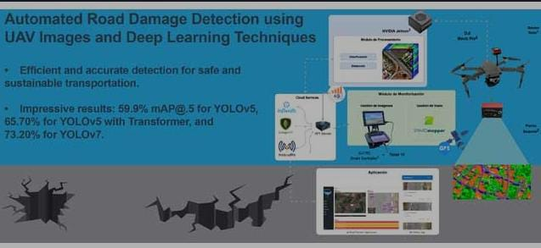



# MODELLING

# RESULTS

* High Precision Detection
* Validation Across Diverse Geographical Contexts
* Improved Efficiency and Accuracy
* Enhanced Safety and Sustainability
* Real-world Applicability
* Future Research Directions
* Overall Impact