**United Institute of Technology**

**7145**

**Cloud Application Development**

Data Warehousing with IBM Cloud Db2 Warehouse

**Phase – 4**

**Submitted by:**

Maha R

Sanjana M

Navin K

Kiran Kumar S

Kavin V

Karthik S

Cloud Application Development

Data Warehousing with IBM Cloud Db2 Warehouse

***Phase 4* To Do:**

*Building the data warehouse by implementing ETL processes and enabling data exploration. Implement ETL processes to extract, transform, and load data into the data warehouse. Enable data architects to explore and analyze data within Db2 Warehouse using SQL queries and analysis techniques.*

**Implementation:**

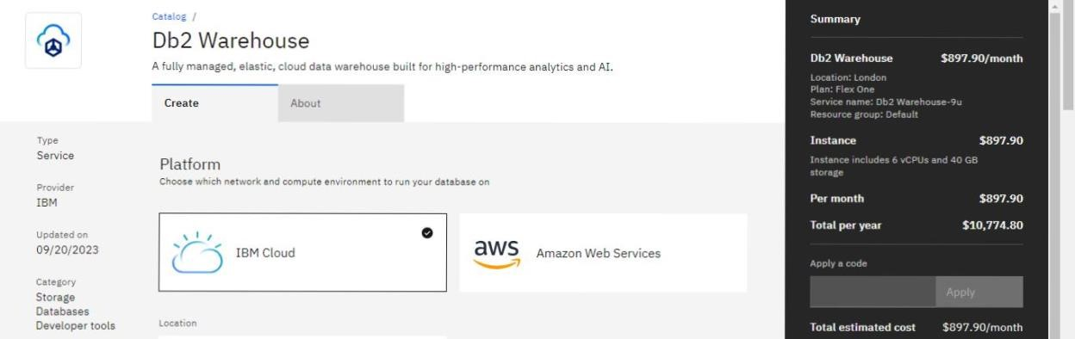

Project Goals

**Building the Data Warehouse:**

The primary goal was to create a data warehouse infrastructure using IBM Db2 Warehouse.

**Implementing ETL Processes:**

We aimed to establish efficient ETL processes to extract, transform, and load data into the data warehouse.

**Eg :**

Extract data from a source (e.g., CSV file)

INSERT INTO TargetTable (Column1, Column2, Column3)

SELECT SourceColumn1, SourceColumn2, SourceColumn3

FROM SourceCSV;

**Enabling Data Exploration:**

The project aimed to provide data architects with the tools and capabilities to explore and analyze data within Db2 Warehouse using SQL queries and analysis techniques.

**Basic SQL Query:**

Retrieve data from a table

SELECT Column1, Column2

FROM WarehouseTable

WHERE Condition = ‘Value’;

**Joining Tables:**

Join multiple tables for more complex queries

SELECT W.ColumnA, T.ColumnX

FROM WarehouseTable W

INNER JOIN AnotherTable T ON W.ID = T.ID;

**Aggregation and Analysis:**

Perform aggregate functions for analysis

SELECT Year, SUM(Sales) AS TotalSales

FROM SalesData

GROUP BY Year;

Project Milestones and Achievements

# Data Warehouse Implementation

Successfully deployed IBM Db2 Warehouse, providing a scalable platform for data storage and management.

# ETL Process Implementation

Designed and implemented ETL processes that automate data extraction from various sources, perform necessary transformations, and load data into the warehouse.

Achieved data integration across different systems, ensuring a unified and consistent data source.

# Enabling Data Exploration

Provided data architects with access to Db2 Warehouse, including necessary permissions and credentials.

Facilitated the use of SQL queries and data analysis techniques, empowering data architects to explore the data effectively.

**Conclusion**

This project successfully accomplished the goals of building a data warehouse, implementing ETL processes, and enabling data exploration using IBM Db2 Warehouse. The result is a robust infrastructure that supports data-driven decision-making and analysis.