PATIENT DIET PLAN RECOMMENDER ENGINE FOR CUDDLES PROJECT

SETUP PROCEDURE

1.Make sure the diet_plan.pkl and similarity.pkl is inside the same directory.

The directory should look like below image.

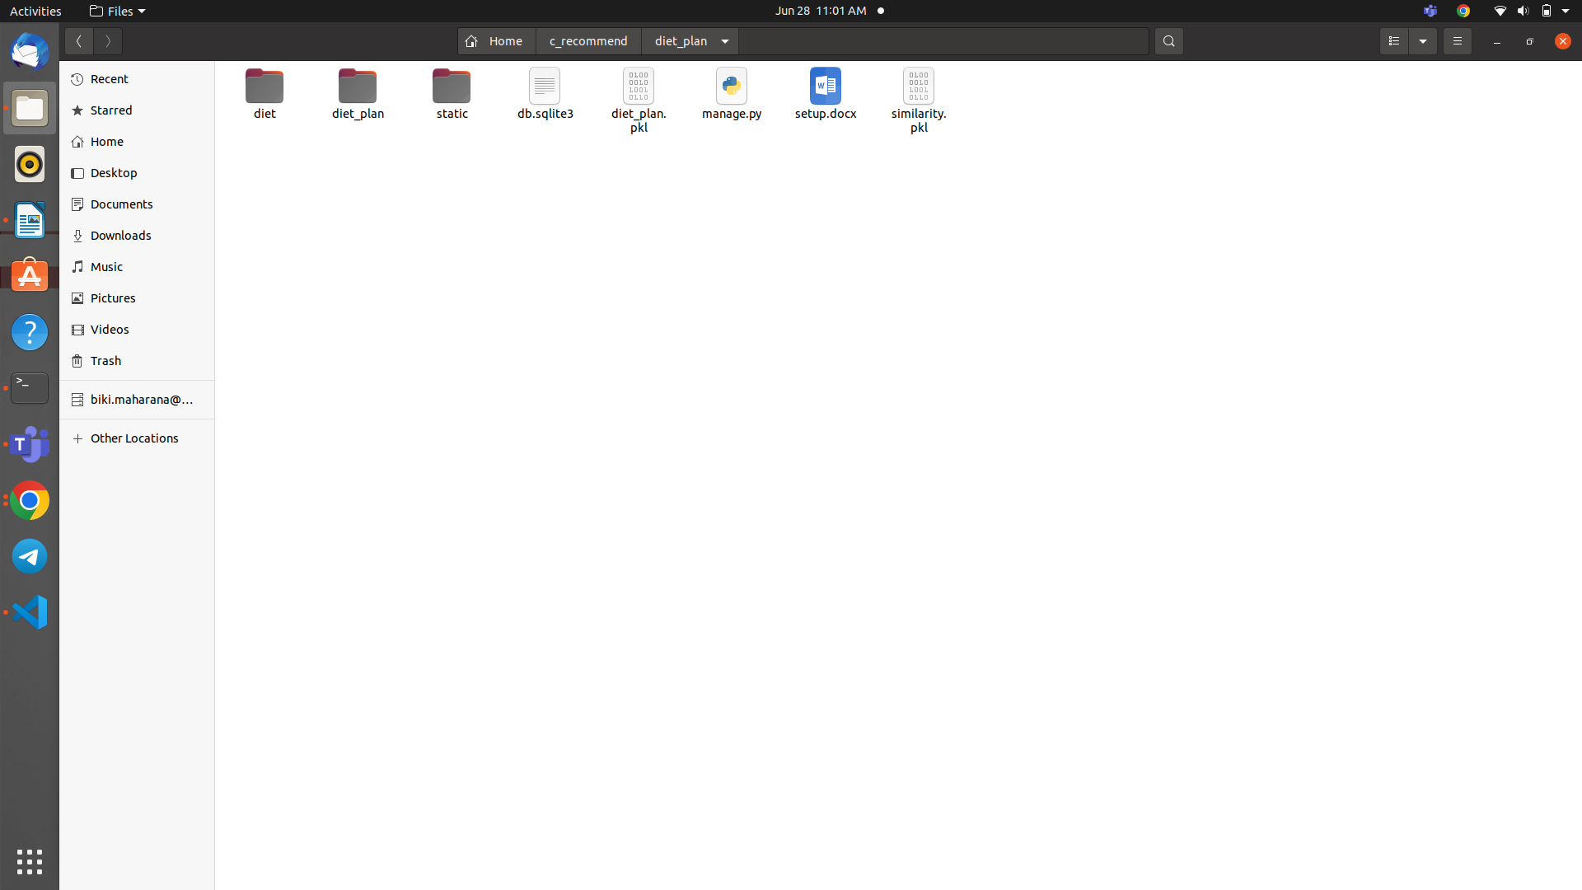

2.List of the packages required to run the project.

* Python latest version recommended.
* Django version 4.
* pandas
* numpy
* sklearn
* iteration-utilities