Multiship - QA Test Report
Local dev (React/Vite UI, /api/v1 proxied to the Java backend); every carrier account in SANDBOX mode | tested 2026-10-11 to 2026-10-12 | prepared by Claude (Cowork) for Manoj

1. Summary
Multiship, Local dev (React/Vite UI, /api/v1 proxied to the Java backend); every carrier account in SANDBOX mode, was tested on 2026-10-11 to 2026-10-12. Of 40 screens mapped, 8 were tested completely, 3 partly and 29 have not been started. On the 11 screens tested so far, 182 elements were listed: 117 passed, 46 failed, 6 blocked, 0 not applicable and 13 not yet tested, so 90% of the testable elements have been exercised. 44 defects were logged: 0 Critical, 4 High, 13 Medium and 27 Low, plus 5 queries and 3 suggestions.
Tester's assessment (R2)
Settings > Organization works, and the parts that can destroy data are the parts that are built best: deleting a client names the record, lists what else goes and warns that it cannot be undone; a client with orders cannot be deleted at all; leaving the client editor with unsaved edits asks first; a double-click on Submit creates one record, not two; and a client code that does not exist is refused when assigning a user. The weaknesses are in two places. First, the address rules are applied unevenly: a client's return address enforces per-carrier limits so strictly that a valid US ZIP+4 cannot be typed (BUG-028), while the warehouse address - the one printed on every label - applies no rules at all and happily saves a state of 'ILLINOIS' that UPS and FedEx will refuse (BUG-040). Second, the Address book is broken outright: its only data call fails and the page draws the failure as an empty list, so a saved address is reported as a server error while it is really sitting in the database (BUG-044, BUG-045). Around those, a cluster of smaller faults share one cause - the interface does not distinguish a user's mistake from the system's. 'Something went wrong' heads a missing required field, a business-rule refusal and a genuine 502 alike; a bad email on the invite form is announced as 'This shipment needs attention'; error toasts never time out; and the user audit trail records nothing at all although the screen is sold on auditing. None of this stops a shipment going out, but it is what makes an admin screen feel unreliable.
Tester's assessment (R1)
International shipping works end to end for all three carriers once the inputs suit each carrier: every one of the 114 carrier x service x packaging combinations produced a label for Canada, the UK and Mexico, and the Order API matches the screens for all 128 orders. What worries me most is that the shipment check passes shipments the carrier then rejects, so problems only surface as ERROR orders: USPS international fails with MKL246's default sender name and when a second box has no customs lines (where box 1 may already be booked), and single-piece FedEx and UPS packagings accept a second box. The FedEx International Priority check also raises a false 'issue to fix' on every IP shipment yet lets the label through, which teaches users to ignore the check. Fix first: BUG-001, BUG-002 and BUG-003, then BUG-004 and BUG-005.

Fix these first
Bug | Severity | Where | Title
BUG-001 | High | Orders > New order > New order form (international) | New shipment (USPS international): label fails for MKL246's default sender name 'MKL'; the shipment check passes it
BUG-002 | High | Orders > New order > New order form (international) | New shipment (USPS international, 2 boxes): with all item lines in box 1, box 2 fails 'Missing customs lines' after box 1 already went to the carrier
BUG-044 | High | Settings > Organization > Address book > Address book list | Settings > Address book never loads: its only data call returns 500 every time, and the page shows the 'No saved addresses yet' empty state as though the book were empty
BUG-045 | High | Settings > Organization > Address book > Address book list | Address book: a saved address is reported as a server failure, because the list reload that follows the save is what actually fails

Limits of this testing
- No SRS / FRD was supplied. Expected behaviour comes from the carrier responses, the app's own messages and tooltips, and consistency between lanes and carriers; findings with weaker footing are logged as Query or Suggestion.
- Combination run, not an element-by-element pass: every carrier x service x packaging the app offers was shipped to Canada, the UK and Mexico (128 orders on 2026-10-11). Controls not needed for that were not exercised and show as Not tested (Duties paid by, Currency, Pickup type, AES ITN, SKU, Tax ID, EORI, Commercial Invoice tab, label downloads, tracking and print).
- Screenshots and network timings come from a validate-only evidence pass on 2026-10-12: forms were validated but never generated, and no orders were created (#934191 does not exist). Console output was not captured. BUG-011 and BUG-016 were seen once during the run and have no screenshot.
- All carrier accounts are in sandbox mode: FedEx rate calls often failed (HTTP 500 / 503, shown as 'No price ... to review') and label documents are sandbox samples, so per-box label content could not be verified.
- R2 covers Settings > Organization only: Clients (list and the 8-step Add/Edit wizard), Warehouses, Address book, Users and Roles, plus the All settings overview. The other 31 Settings screens are mapped in the application map but not yet tested.
- Settings > Address book could not be exercised: its only data call returns 500 every time (BUG-044), so the search, the client filter, the grid and the row actions are recorded as blocked rather than tested.
- On Settings > Users the per-row Role control, Reset password and Deactivate were not exercised. The only accounts are the signed-in admin and one real person's account, and the test invitation sent for the purpose never produced a user row (BUG-050). Deactivate on the admin row was deliberately not clicked at the user's request - it is reported as a risk in BUG-051.
- CSV exports: the user allowed the downloads, and the request, its parameters and the response were checked for each one, but the downloaded files themselves could not be opened from this session, so their contents are unverified.
- 29 screens in the application map have not been tested yet (listed under Coverage).
- 19 elements on the screens tested were blocked or left untested; each is listed with its reason.
- No screenshot file was captured for: BUG-011, BUG-015, BUG-016, BUG-039, BUG-047. The written steps and evidence stand in for it.

2. What was tested
Application | Multiship
URL | http://localhost:5173
Environment | Local dev (React/Vite UI, /api/v1 proxied to the Java backend); every carrier account in SANDBOX mode
Reference documents | No SRS/FRD supplied. Expected behaviour taken from carrier API responses, the app's own messages and labels, and consistency between lanes and carriers
Browser window | 1446x840, 1471x812

Run | Date | Build | Role | Scope
R1 | 2026-10-11 |  | admin (ADMIN) | Orders > New order: international shipments for client MKL246 to Canada, United Kingdom and Mexico, every carrier x service x packaging (FedEx, UPS, USPS); labels and Order API checked afterwards. Order references QA-1011-R13-*
R2 | 2026-10-12 |  | admin (ADMIN) | Settings > Organization (Clients, Warehouses, Address book, Users, Roles): every element of each list, add/edit form and detail view; rest of Settings mapped at menu level

Two runs are covered. R1 (2026-10-11) shipped every carrier, service and packaging the New order form offers for client MKL246 to Canada, the United Kingdom and Mexico through the interface in Chrome - 128 orders - and read every one back through the Order API; its evidence screenshots and network timings come from a validate-only pass on 2026-10-12 that created no orders. R1 was a combination run rather than an element-by-element pass, so the controls each shipment needed were exercised and the rest are listed as Not tested. R2 (2026-10-12) is element-by-element: every control on each screen of Settings > Organization was listed first and then exercised one at a time - each search term, filter, column, sort, row action and form field - with the network and browser console watched throughout. Records were created, edited, activated, deactivated and deleted under the QA-1012- prefix and removed again afterwards; the two existing clients and the existing warehouse and users were put back as they were, and what was touched is listed under Test data. Everything the Coverage sheet of the accompanying workbook marks Pass was actually operated; what each check means is written out there.

3. Coverage
Screen | Status | Elements | Pass | Fail | Blocked | N/A | Not tested
Orders > New order > New order form (international) | Partial | 47 | 29 | 13 | 0 | 0 | 5
Orders > New order > Importer & broker override dialog | Partial | 13 | 11 | 0 | 0 | 0 | 2
Orders > Label > Label documents | Partial | 9 | 2 | 1 | 0 | 0 | 6
API > Orders > Order detail (GET /api/v1/orders/{id}) | Done | 9 | 8 | 1 | 0 | 0 | 0
Settings > All settings > All settings overview | Done | 5 | 5 | 0 | 0 | 0 | 0
Settings > Organization > Clients > Clients list | Done | 21 | 14 | 7 | 0 | 0 | 0
Settings > Organization > Warehouses > Warehouses list | Done | 22 | 16 | 6 | 0 | 0 | 0
Settings > Organization > Address book > Address book list | Done | 10 | 1 | 5 | 4 | 0 | 0
Settings > Organization > Users > Users list | Done | 17 | 9 | 6 | 2 | 0 | 0
Settings > Organization > Roles > Roles list | Done | 5 | 4 | 1 | 0 | 0 | 0
Settings > Organization > Clients > Client wizard (Add / Edit) | Done | 24 | 18 | 6 | 0 | 0 | 0

Blocked or left untested
Screen | Element | Result | Reason
Orders > New order > New order form (international) | Duties paid by | Not tested | Left on its default (Recipient pays / DDU)
Orders > New order > New order form (international) | AES ITN | Not tested | Not needed once an FTR exemption was chosen
Orders > New order > New order form (international) | Currency | Not tested | Left on USD
Orders > New order > New order form (international) | Pickup type (FedEx) | Not tested | Left on Regular pickup
Orders > New order > New order form (international) | Item SKU | Not tested | Left empty
Orders > New order > Importer & broker override dialog | Tax ID (Mexico) | Not tested | Left empty
Orders > New order > Importer & broker override dialog | EORI (UK) | Not tested | Left empty
Orders > Label > Label documents | Commercial Invoice tab | Not tested | Present; not opened
Orders > Label > Label documents | Download PDF | Not tested | Enabled after load; download not exercised
Orders > Label > Label documents | Download .zpl | Not tested | Enabled after load; download not exercised
Orders > Label > Label documents | Copy ZPL | Not tested | Enabled after load; not exercised
Orders > Label > Label documents | Track / Track live | Not tested | Not exercised (sandbox tracking)
Orders > Label > Label documents | Print Label | Not tested | Print not exercised
Settings > Organization > Address book > Address book list | Search any part of the address (name, street, city, ZIP, phone, email, tag) | Blocked | The search sends GET /api/v1/recipients?q=... which returns 502, and the grid shows 'No saved addresses match "QA-1012".' Whether the search itself works cannot be judged until BUG-044 is fixed.
Settings > Organization > Address book > Address book list | Client filter (Every client / a client) | Blocked | The filter sends GET /api/v1/recipients?customerNo=MKL246 which returns 502. Same reason as the search.
Settings > Organization > Address book > Address book list | Grid columns (Name, Address, Contact, Belongs to, Tag, Actions) | Blocked | No row has ever been displayed, because the list call fails (BUG-044).
Settings > Organization > Address book > Address book list | Row actions (edit / delete) | Blocked | No row has ever been displayed, so the row actions could not be reached (BUG-044).
Settings > Organization > Users > Users list | Row action > Role select | Blocked | The dropdown offers USER, TENANT and 'ADMIN (promote)'. Changing it would alter the access of a real person's account (manoj7000, maharana@suyogindia.com) and the invited test account never appeared in the list (BUG-050), so there was no safe row to try it on. The options were read without saving.
Settings > Organization > Users > Users list | Row action > Reset password (emails a link) | Blocked | The button's tooltip is 'Email a password-reset link to this user' and the only candidate is a real person's account. Not clicked.

Not started yet
- Settings (29): Carriers & Services > Carrier Accounts > Carrier Accounts; Carriers & Services > Carriers (platform) > Carriers (platform); Carriers & Services > Shipping Catalog > Shipping Catalog; Carriers & Services > Code Maps > Code Maps; Carriers & Services > Carrier Limits > Carrier Limits; Carriers & Services > Carrier Dropdowns > Carrier Dropdowns; Carriers & Services > Cutoffs & Holidays > Cutoffs & Holidays; Carriers & Services > Pickups & End-of-Day > Pickups & End-of-Day; International > Importer / Broker > Importer / Broker; International > Countries > Countries; International > Reasons for Export > Reasons for Export; International > Currencies > Currencies ... and 17 more

4. Defects
Bug | Severity | Type | Where | Title | Status
BUG-001 | High | Validation | Orders > New order > New order form (international) | New shipment (USPS international): label fails for MKL246's default sender name 'MKL'; the shipment check passes it | Open
BUG-002 | High | Functional | Orders > New order > New order form (international) | New shipment (USPS international, 2 boxes): with all item lines in box 1, box 2 fails 'Missing customs lines' after box 1 already went to the carrier | Open
BUG-044 | High | Functional | Settings > Organization > Address book > Address book list | Settings > Address book never loads: its only data call returns 500 every time, and the page shows the 'No saved addresses yet' empty state as though the book were empty | Open
BUG-045 | High | Data integrity | Settings > Organization > Address book > Address book list | Address book: a saved address is reported as a server failure, because the list reload that follows the save is what actually fails | Open
BUG-003 | Medium | Validation | Orders > New order > New order form (international) | New shipment: single-piece carrier packagings (FedEx Envelope, 10kg, 25kg box; UPS 10KG, 25KG box) accept a second box, then the carrier rejects the label | Open
BUG-004 | Medium | Functional | Orders > New order > New order form (international) | Shipment check (FedEx International Priority): '1 issue to fix: FEDEX did not quote FedEx International Priority' although IP is in the quoted list; Generate stays enabled | Open
BUG-005 | Medium | Usability | Orders > New order > New order form (international) | New shipment (FedEx to Canada): no FTR exemption field; with Export declaration ref empty FedEx rejects 'FTR Exemption or AES Citation ... not valid for EEI' | Open
BUG-006 | Medium | Functional | Orders > New order > New order form (international) | New shipment: 'Add N boxes like the last' copies the weight but leaves Length / Width / Height empty for a carrier box | Open
BUG-007 | Medium | Functional | Orders > Label > Label documents | Label documents #934118: label stored as a FedEx document link instead of the PDF; each label request takes 3-4 s and the page shows 'Loading label document...' for about 8 s | Open
BUG-028 | Medium | Validation | Settings > Organization > Clients > Client wizard (Add / Edit) | Client wizard > Return address: a ZIP+4 cannot be typed - the field stops at 9 characters while its own hint shows the 10-character form 12345-6789 | Open
BUG-030 | Medium | Functional | Settings > Organization > Clients > Client wizard (Add / Edit) | Client wizard > Carriers: Cancel on the carrier account form keeps everything typed, including the client secret, and + Add carrier account reopens the discarded draft | Open
BUG-040 | Medium | Validation | Settings > Organization > Warehouses > Warehouses list | Add warehouse accepts a state of 'ILLINOIS' and a 10-character postal code, although this is the ship-from address printed on every label | Open
BUG-041 | Medium | Functional | Settings > Organization > Warehouses > Warehouses list | Warehouses > Attach clients: the dialog never shows which clients are already attached, and nothing on the screen can detach one | Open
BUG-043 | Medium | Usability | Settings > Organization > Warehouses > Warehouses list | Deactivating a warehouse that clients ship from happens on one click, with no warning - the same action on a client asks first and lists the cascade | Open
BUG-050 | Medium | Functional | Settings > Organization > Users > Users list | A sent invitation leaves no trace: the invited person is not listed, the audit panel stays empty, and the accept link is shown once and then lost | Open
BUG-051 | Medium | Security | Settings > Organization > Users > Users list | The Deactivate button is enabled on the signed-in admin's own row, and that is the only ADMIN account in the system | Open
BUG-052 | Medium | Functional | Settings > Organization > Users > Users list | The user audit trail records nothing: admin changes with a typed reason leave both 'Recent admin actions' and the per-user History empty | Open
BUG-008 | Low | Usability | Orders > New order > New order form (international) | New shipment (ship to Mexico): State / region is required but has no * marker, a US placeholder 'NY', and accepts only ISO codes as free text | Open
BUG-009 | Low | Content | Orders > New order > New order form (international) | Shipment check (Mexico): state message says 'Use the 2-letter code (e.g. CMX, JAL, NLE)' but every example is three letters | Open
BUG-010 | Low | Content | Orders > New order > New order form (international) | New shipment (Mexico): Importer section shows the badge 'RESOLVED FOR MX' next to the warning 'No importer/broker profile covers MX for MKL246' | Open
BUG-011 | Low | Usability | Orders > New order > New order form (international) | New shipment (Canada): HS code lookup suggests the 6-digit 610910, which the form then rejects as too short | Open
BUG-012 | Low | Content | Orders > New order > New order form (international) | Client MKL246 ship-from address: Address line 1 '8191 Logistics Dr,' ends with a stray comma | Open
BUG-013 | Low | Usability | Orders > New order > New order form (international) | New shipment > Items: 'Add item' inserts the new blank line above the existing one | Open
BUG-014 | Low | UI | Orders > New order > New order form (international) | New shipment: the 'Lines spread across 2 boxes' toast covers the Validate shipment and Generate label buttons | Open
BUG-015 | Low | Functional | Orders > Label > Label documents | Label documents: every page load gets HTTP 503 from HEAD /label/preview.png before falling back to the PDF | Open
BUG-016 | Low | Content | Orders > New order > New order form (international) | Validate shipment: a server failure shows the raw toast 'Something went wrong HTTP error! status: 502' | Open
BUG-022 | Low | Functional | Settings > Organization > Clients > Clients list | Clients search: '%' and '_' work as wildcards, so searching for them lists clients that do not contain them | Open
BUG-024 | Low | Usability | Settings > Organization > Clients > Clients list | Importer / Broker dialog (Clients row menu): a click on the dimmed background closes it and throws away what was typed; Esc does nothing | Open
BUG-025 | Low | UI | Settings > Organization > Clients > Clients list | Clients list: the row menu (⋮ Importer / Broker, Edit, Delete) is off-screen at a 1446 px wide window; it is only reachable by scrolling the table sideways | Open
BUG-026 | Low | UI | Settings > Organization > Clients > Clients list | Clients list sorting: after the third click on a header the arrow disappears, but the list is still sorted by Code ascending, so the next click on Code appears to do nothing | Open
BUG-027 | Low | Usability | Settings > Organization > Clients > Client wizard (Add / Edit) | Client wizard > Timezone: searching 'Kolkata' or 'Kyiv' finds nothing; the list only has the old names Asia/Calcutta and Europe/Kiev | Open
BUG-029 | Low | Content | Settings > Organization > Clients > Client wizard (Add / Edit) | Client wizard > Carriers: the UPS account number hint and its error message give different rules ('exactly 6 alphanumerics' vs '6-10 letters or digits') | Open
BUG-031 | Low | Usability | Settings > Organization > Clients > Client wizard (Add / Edit) | Client wizard > Carriers: 'Add to list' greys out with the tooltip 'Fix the highlighted fields to continue' while no field is highlighted | Open
BUG-032 | Low | Content | Settings > Organization > Clients > Client wizard (Add / Edit) | Creating a client shows the raw error code MARKUP_REQUIRED_FOR_CLIENT in the 'Heads up' message | Open
BUG-033 | Low | Content | Settings > Organization > Clients > Client wizard (Add / Edit) | Client wizard > Return address: the State limit is credited to USPS in both modes but changes from 'max 2 chars' to 'max 5 chars' on a client with no USPS account | Open
BUG-034 | Low | Validation | Settings > Organization > Clients > Client wizard (Add / Edit) | Billing markup: a negative or non-numeric value is only refused by the server, as a 'Something went wrong' toast, with nothing marked on the field | Open
BUG-035 | Low | UI | Settings > Organization > Clients > Client wizard (Add / Edit) | Billing markup preview formats a USD amount with Indian digit grouping: $2,50,00,00,00,024.75 instead of $250,000,000,024.75 | Open
BUG-036 | Low | Content | Settings > Organization > Clients > Client wizard (Add / Edit) | Edit client: ordinary validation failures are announced as 'Something went wrong', the same red heading the app uses for server errors | Open
BUG-037 | Low | Usability | Settings > Organization > Clients > Clients list | Error toasts never time out: a failed-delete message was still on screen 38 minutes later, through navigation and other work | Open
BUG-039 | Low | UI | Settings > Organization > Clients > Client wizard (Add / Edit) | Client wizard: the top breadcrumb still reads 'Settings' and the browser tab is always 'multiship-react', so neither says which client is open | Open
BUG-042 | Low | Content | Settings > Organization > Warehouses > Warehouses list | Warehouse address Verify reports the raw status NOT_SUPPORTED, and the green tick icon makes a refusal look like a pass | Open
BUG-047 | Low | Performance | Settings > Organization > Users > Users list | Users search is not debounced: every keystroke sends a search request and a second request that reloads the audit list | Open
BUG-048 | Low | Content | Settings > Organization > Users > Users list | Invite user: a bad email address is reported under the heading 'This shipment needs attention', with the raw field message repeated underneath | Open
BUG-049 | Low | Content | Settings > Organization > Users > Users list | Internal developer notes are printed in the page descriptions users read: sprint numbers, database column names and a to-do | Open

Orders

BUG-001 - New shipment (USPS international): label fails for MKL246's default sender name 'MKL'; the shipment check passes it
Severity / type | High / Validation
Where | Orders > New order > New order form (international) - Ship-from Full name
URL | /orders/new
Reproducibility | Always (4 of 4)
Found | 2026-10-11, run R1, as admin (ADMIN)
Status | Open

Steps to reproduce
1. Open Orders and click + New shipment (/orders/new)
2. Client: MKL246 (ship from 3PL-EAST, the client default); leave Ship from Full name as the profile default 'MKL'
3. Carrier: USPS
4. Ship to: Full name QA Test Recipient, Company QA Test Co, Address line 1 Av Paseo de la Reforma 222, Country Mexico (MX), Phone 5552081234, State / region CMX, City Ciudad de Mexico, Postal code 06600
5. Service level: USPS Priority Mail Intl
6. Packaging THB-PACKAGE, Weight 5; click Add another box, then Apply box 1 to all
7. Customs: Reason of export Sale, FTR exemption NOEEI 30.37(a), Label type PDF, Incoterms DAP
8. Importer of record & customs broker > Add: Type Receiver, Name and Contact QA Test Recipient, same address, city, post code and phone as Ship to > Use for this shipment
9. Items: Description Cotton T-shirt, HS code 61091000, Origin US, Qty 2, Unit value 20.00, Wt 0.5
10. Click Validate shipment
11. Click Generate label
Test data
Ship-from Full name 'MKL' (MKL246 profile default). Orders #934105 (Canada, PMI), #934109 (Canada, PMEI), #934147 (UK, PMI), #934186 (Mexico, PMI)
Expected
Either the label is created, or the shipment check flags before Generate that USPS international needs a sender full name of first and last name (two words of 2+ letters).
Actual
Check said 'Ready to ship — 1 thing to review: USPS normalised the address; review before shipping.' (Canada: 'All checks passed'). Generate label then shows 'The carrier rejected this shipment If provided, fullname must contain at least 2 alphabetic characters, followed by a space, followed by at least another 2 alphabetic characters. (saved as order 934186)' and the order is saved as ERROR. Same result 4 of 4 times (Canada, UK, Mexico; Priority Mail Intl and Priority Mail Express Intl). With Full name changed to 'MKL Shipping' the same shipments generate (#934107, #934108, #934110-#934112, #934148-#934151, #934187-#934190).
Technical evidence
GET /api/v1/orders/934186 -> errorDetails.errorMessage 'STAMPS createShipmentSera[pkg 1/2] HTTP 400 ... fullname must contain at least 2 alphabetic characters ...' (Canada #934105: Stamps code 6619409). Orders list shows ERR with tooltip 'CARRIER If provided, fullname must contain ...'.
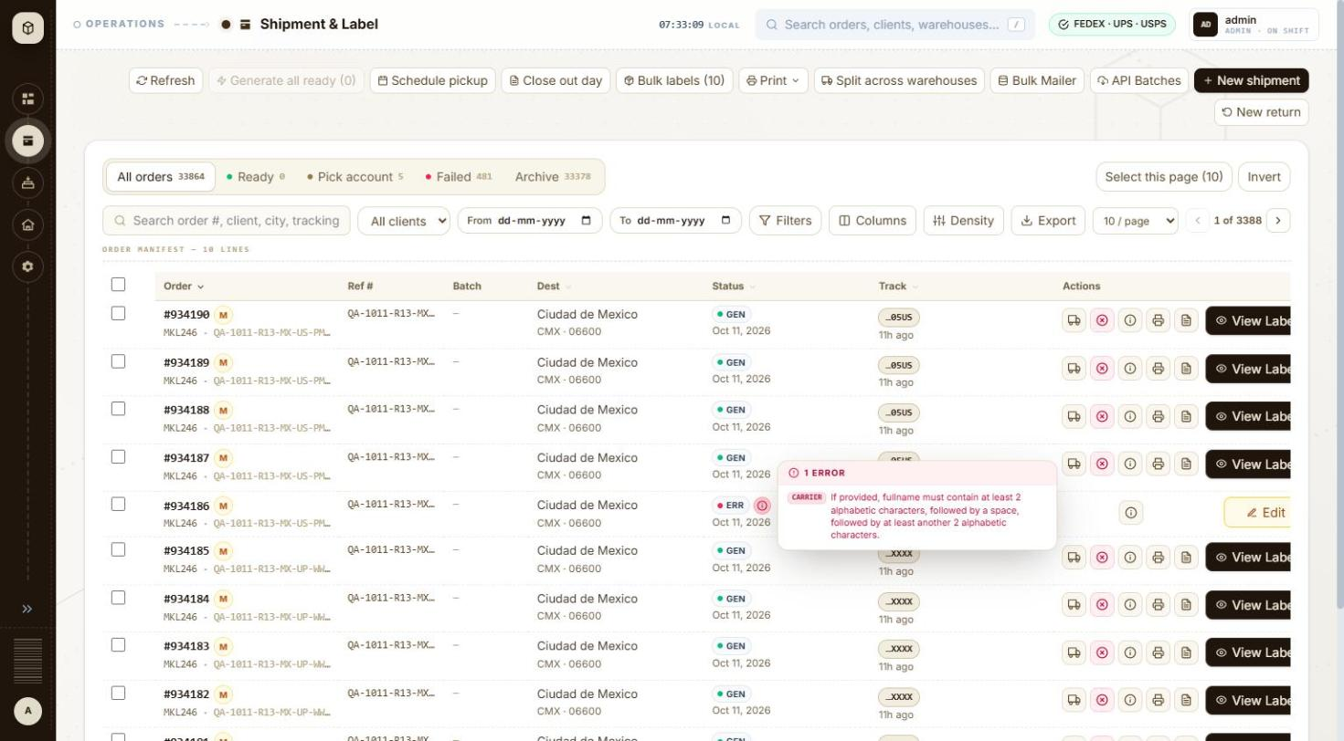
BUG-001 - screenshot (BUG-001.jpg)

BUG-002 - New shipment (USPS international, 2 boxes): with all item lines in box 1, box 2 fails 'Missing customs lines' after box 1 already went to the carrier
Severity / type | High / Functional
Where | Orders > New order > New order form (international) - Item Pkg#
URL | /orders/new
Reproducibility | 1 of 1 (not repeated, to avoid further carrier bookings)
Found | 2026-10-11, run R1, as admin (ADMIN)
Status | Open

Steps to reproduce
1. Open Orders and click + New shipment (/orders/new)
2. Client: MKL246 (ship from 3PL-EAST, the client default); set Ship from Full name to 'MKL Shipping'
3. Carrier: USPS
4. Ship to: QA Test Recipient, QA Test Co, Toronto ON M5V 3L9, Canada (as for the other Canada orders of the run)
5. Service level: USPS Priority Mail Intl
6. Packaging THB-PACKAGE, Weight 5; Add another box; Apply box 1 to all
7. Customs: Reason of export Sale, Label type PDF, Incoterms DAP
8. Importer of record & customs broker > Add: Type Receiver, Name and Contact QA Test Recipient, same address, city, post code and phone as Ship to > Use for this shipment
9. Items: one line Cotton T-shirt, HS 61091000, Origin US, Qty 2, Unit value 20.00, Wt 0.5; leave Boxes on 'All in box 1' (Pkg # 1)
10. Click Validate shipment, then Generate label
Test data
Order #934106 (QA-1011-R13-CA-US-PMI-THB-NM)
Expected
The check warns that USPS needs customs lines on every box (or the lines are split across the boxes automatically) before the label is bought; nothing is booked for part of the shipment.
Actual
Check: 'All checks passed'. Generate label: 'Missing customs lines.'; order #934106 saved as ERROR. The error names package 2 of 2, so package 1 had already passed its carrier call; the app shows nothing about whether package 1 was booked or voided at USPS (not verified). With two lines of Qty 1 spread across the boxes (Spread across 2 boxes) the same shipment generates (#934108, #934110-#934112, #934148-#934151, #934187-#934190).
Technical evidence
GET /api/v1/orders/934106 -> errorDetails.errorMessage 'STAMPS createShipmentSera[pkg 2/2] HTTP 400 ... Missing customs lines.'
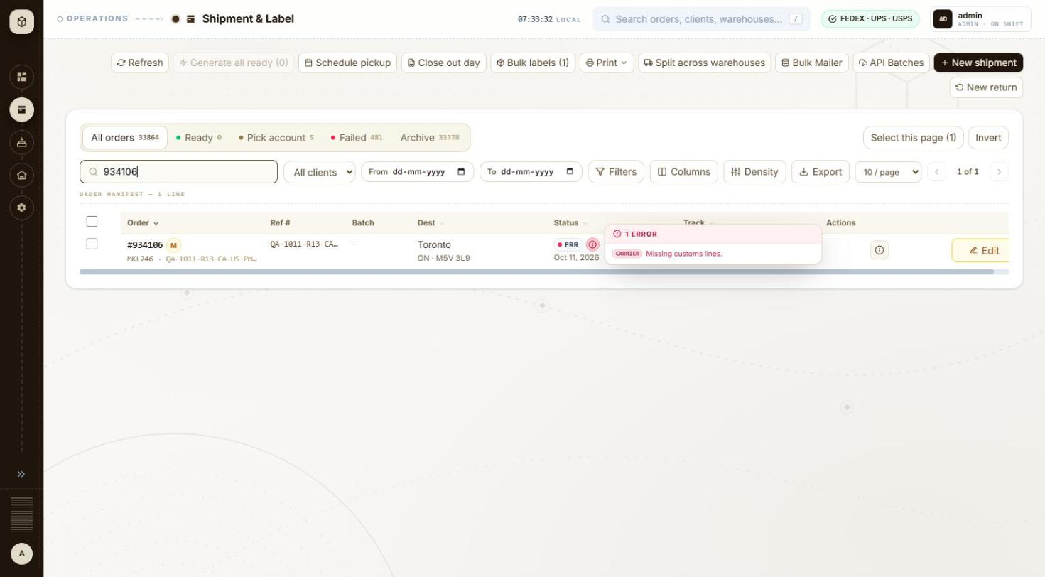
BUG-002 - screenshot (BUG-002.jpg)

BUG-003 - New shipment: single-piece carrier packagings (FedEx Envelope, 10kg, 25kg box; UPS 10KG, 25KG box) accept a second box, then the carrier rejects the label
Severity / type | Medium / Validation
Where | Orders > New order > New order form (international) - Add another box
URL | /orders/new
Reproducibility | Always (8 of 8 two-box attempts; 0 failures as one box)
Found | 2026-10-11, run R1, as admin (ADMIN)
Status | Open

Steps to reproduce
1. Open Orders and click + New shipment (/orders/new)
2. Client: MKL246 (ship from 3PL-EAST, the client default)
3. Carrier: FedEx
4. Ship to: QA Test Recipient, Toronto ON M5V 3L9, Canada
5. Service level: FedEx International Priority
6. Packaging FedEx 10kg Box, Weight 10
7. Click Add another box, then Apply box 1 to all (2 boxes)
8. Customs: Reason of export Sale, Export declaration ref 'NO EEI 30.36', Label type PDF, Label size Paper 4x6, Incoterms DAP
9. Importer of record & customs broker > Add: Type Receiver, Name and Contact QA Test Recipient, same address, city, post code and phone as Ship to > Use for this shipment
10. Items: Description Cotton T-shirt, HS code 61091000, Origin US, Qty 2, Unit value 20.00, Wt 0.5
11. Click Validate shipment, then Generate label
12. Repeat with FedEx Envelope (International Economy and Priority), FedEx 25kg Box, and with carrier UPS, Worldwide Saver and Worldwide Express, UPS 10KG Box (10 lb) and UPS 25KG Box (20 lb)
Test data
FedEx: #934063 (IE Envelope), #934068 (IP 10kg), #934069 (IP 25kg), #934070 (IP Envelope). UPS: #934079, #934080 (Saver 10KG/25KG), #934091, #934092 (Express 10KG/25KG)
Expected
The form allows only one box for these single-piece packagings, or the check blocks Generate with a message about the box count.
Actual
FedEx check: ready to ship with one item to review, the note 'Multi-package validate: FedEx only supports single-piece pre-flight; box 1 validated, boxes 2–2 verified at label create'. Label: 'The package count for this shipment exceeds limit.' UPS check: ready to ship with one item to review (the UPS rate call returned HTTP 400 with the same message as below), Carrier check passed and Generate enabled; label: 'The requested service is not valid for shipments with the requested packaging.', which is misleading because the same service and packaging generate as one box (#934075-#934078, #934093, #934094, #934103, #934104 and every UK/Mexico 1-box order). 8 of 8 two-box attempts failed.
Technical evidence
API errorDetails: 'FEDEX createShipment HTTP 400 ... The package count for this shipment exceeds limit.' (#934063, #934068-#934070); 'UPS createShipment HTTP 400 ... The requested service is not valid for shipments with the requested packaging.' (#934079, #934080, #934091, #934092)
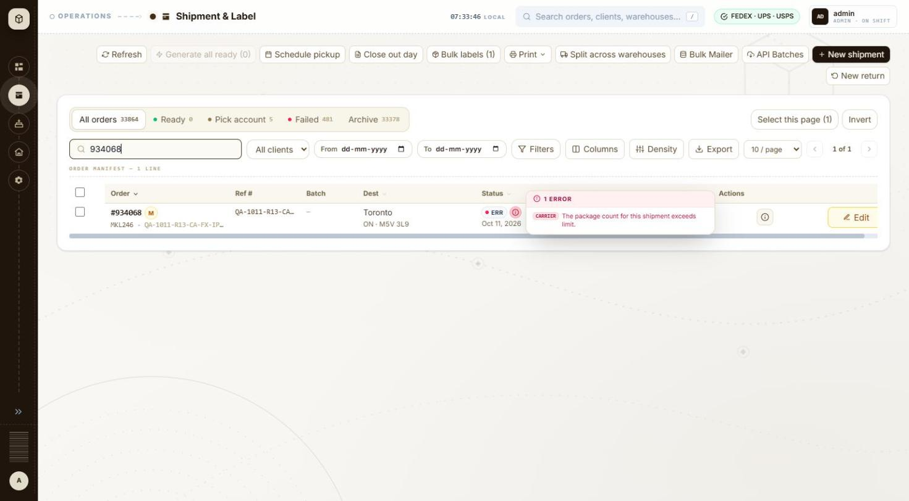
BUG-003 - screenshot 1 (BUG-003.jpg)
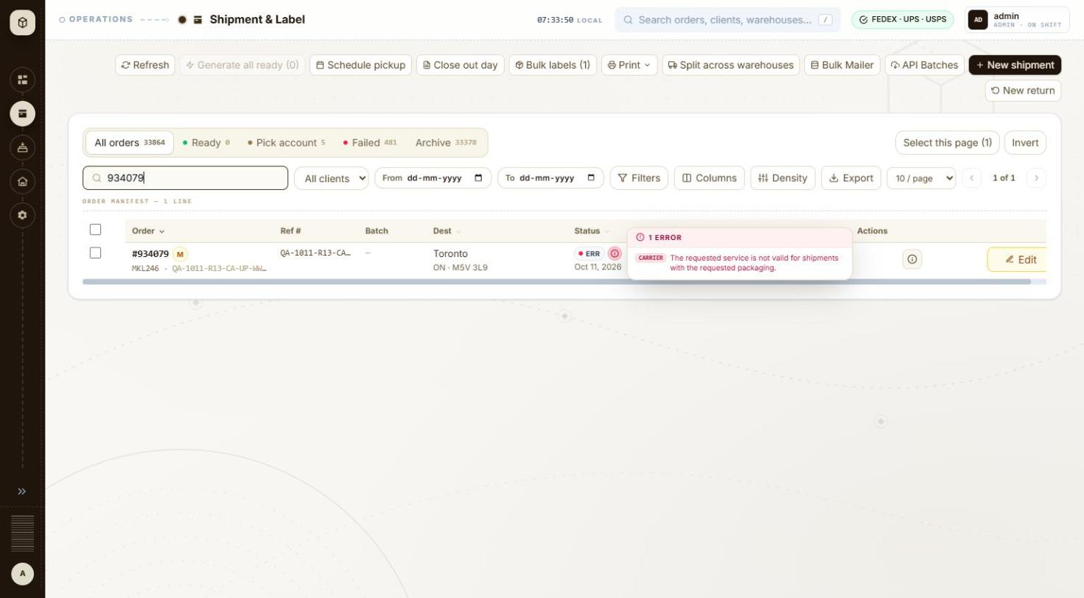
BUG-003 - screenshot 2 (BUG-003-2.jpg)

BUG-004 - Shipment check (FedEx International Priority): '1 issue to fix: FEDEX did not quote FedEx International Priority' although IP is in the quoted list; Generate stays enabled
Severity / type | Medium / Functional
Where | Orders > New order > New order form (international) - Shipment check panel
URL | /orders/new
Reproducibility | Always when the FedEx rate call succeeds
Found | 2026-10-11, run R1, as admin (ADMIN)
Status | Open

Steps to reproduce
1. Open Orders and click + New shipment (/orders/new)
2. Client: MKL246 (ship from 3PL-EAST, the client default)
3. Carrier: FedEx
4. Ship to: Full name QA Test Recipient, Company QA Test Co, Address line 1 Av Paseo de la Reforma 222, Country Mexico (MX), Phone 5552081234, State / region CMX, City Ciudad de Mexico, Postal code 06600
5. Service level: FedEx International Priority
6. Packaging THB-PACKAGE, Weight 5 (one box)
7. Customs: Reason of export Sale, Label type PDF, Incoterms DAP
8. Importer of record & customs broker > Add: Type Receiver, Name and Contact QA Test Recipient, same address, city, post code and phone as Ship to > Use for this shipment
9. Items: Description Cotton T-shirt, HS code 61091000, Origin US, Qty 2, Unit value 20.00, Wt 0.5
10. Click Validate shipment
Test data
Retest 2026-10-12, reference QA-1012-EVID-MX-FX-IP (validated only, not saved), and the same on a UK tube shipment. During the run: every International Priority shipment whose FedEx rate call succeeded, e.g. #934072, #934074, #934118, #934122, #934157, #934161-#934163
Expected
No issue when the selected service is in the quoted list. A check that says an issue must be fixed before the label can be bought should also keep Generate disabled.
Actual
Check header '1 issue to fix before the label can be bought · 1 to review'; Account, service & price '1 to fix': 'FEDEX did not quote FedEx International Priority for this lane — the label may be refused. Quoted instead: FedEx International Connect Plus — USD 159.18; FedEx International Economy® — USD 174.95; FedEx International Priority® — USD 218.58; FedEx International Priority® Express — USD 229.64; FedEx International First® — USD 271.64.' The same sentence is listed twice (as to fix and to review) and again in the price box. Generate label stays enabled and the labels generate. Seen for Canada, UK and Mexico; retested 2026-10-12 for Mexico and UK.
Technical evidence
The quoted list contains 'FedEx International Priority®' (with the registered mark), which may be why the match on the service name fails. No console capture.
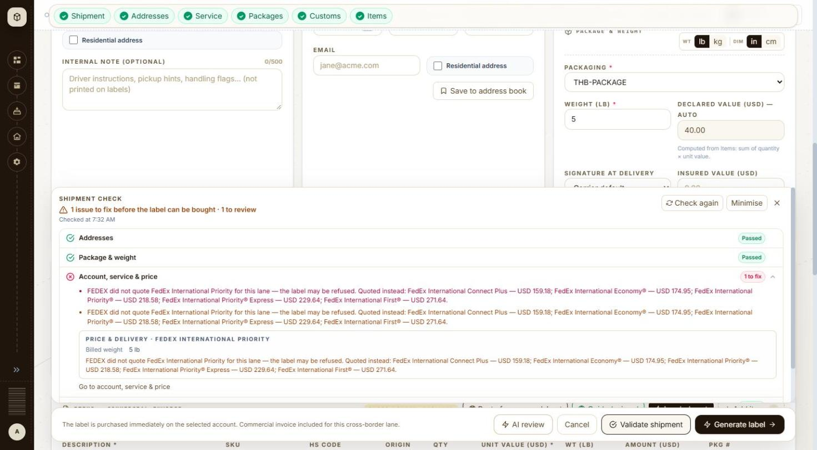
BUG-004 - screenshot 1 (BUG-004.jpg)
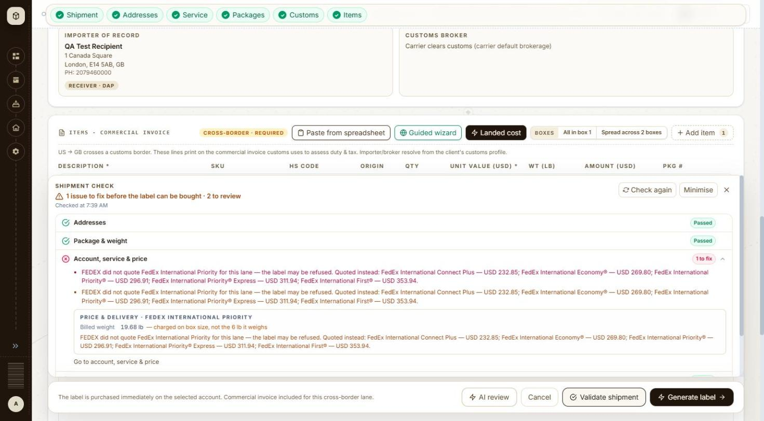
BUG-004 - screenshot 2 (BUG-004-2.jpg)

BUG-005 - New shipment (FedEx to Canada): no FTR exemption field; with Export declaration ref empty FedEx rejects 'FTR Exemption or AES Citation ... not valid for EEI'
Severity / type | Medium / Usability
Where | Orders > New order > New order form (international) - FTR exemption (UK, Mexico)
URL | /orders/new
Reproducibility | Always
Found | 2026-10-11, run R1, as admin (ADMIN)
Status | Open

Steps to reproduce
1. Open Orders and click + New shipment (/orders/new)
2. Client: MKL246 (ship from 3PL-EAST, the client default)
3. Carrier: FedEx
4. Ship to: Full name QA Test Recipient, Company QA Test Co, Address line 1 290 Bremner Blvd, Country Canada (CA), Phone 4165550100, State / region ON, City Toronto, Postal code M5V 3L9
5. Service level: FedEx International Economy
6. Packaging FedEx Pak, Weight 2 (one box)
7. Customs: Reason of export Sale; note there is no FTR exemption or AES ITN field for Canada; leave Export declaration ref empty; Label type PDF; Label size Paper 4x6; Incoterms DAP
8. Importer of record & customs broker > Add: Type Receiver, Name and Contact QA Test Recipient, same address, city, post code and phone as Ship to > Use for this shipment
9. Items: Description Cotton T-shirt, HS code 61091000, Origin US, Qty 2, Unit value 20.00, Wt 0.5
10. Click Validate shipment
Test data
Retest 2026-10-12, reference QA-1012-EVID-CA-FX-IE (validated only, not saved). During the run all Canada FedEx orders (#934063-#934078) needed the workaround
Expected
Canada gets the same FTR exemption dropdown as the UK and Mexico forms (which already list 'NOEEI §30.36 — export to Canada'), or a valid default, so a low-value shipment passes without typing a citation.
Actual
Carrier check '1 to fix': 'FedEx rejected the shipment: The FTR Exemption or AES Citation you provided is not valid for EEI.' Generate label stays disabled, while 'Customs & dangerous goods' shows Passed. Typing 'NO EEI 30.36' into Export declaration ref makes the check pass.
Technical evidence
Canada form selects: Reason of export, Currency, Label type, Label size, Pickup type, Incoterms, Duties paid by - no FTR exemption (UK and Mexico forms have it).
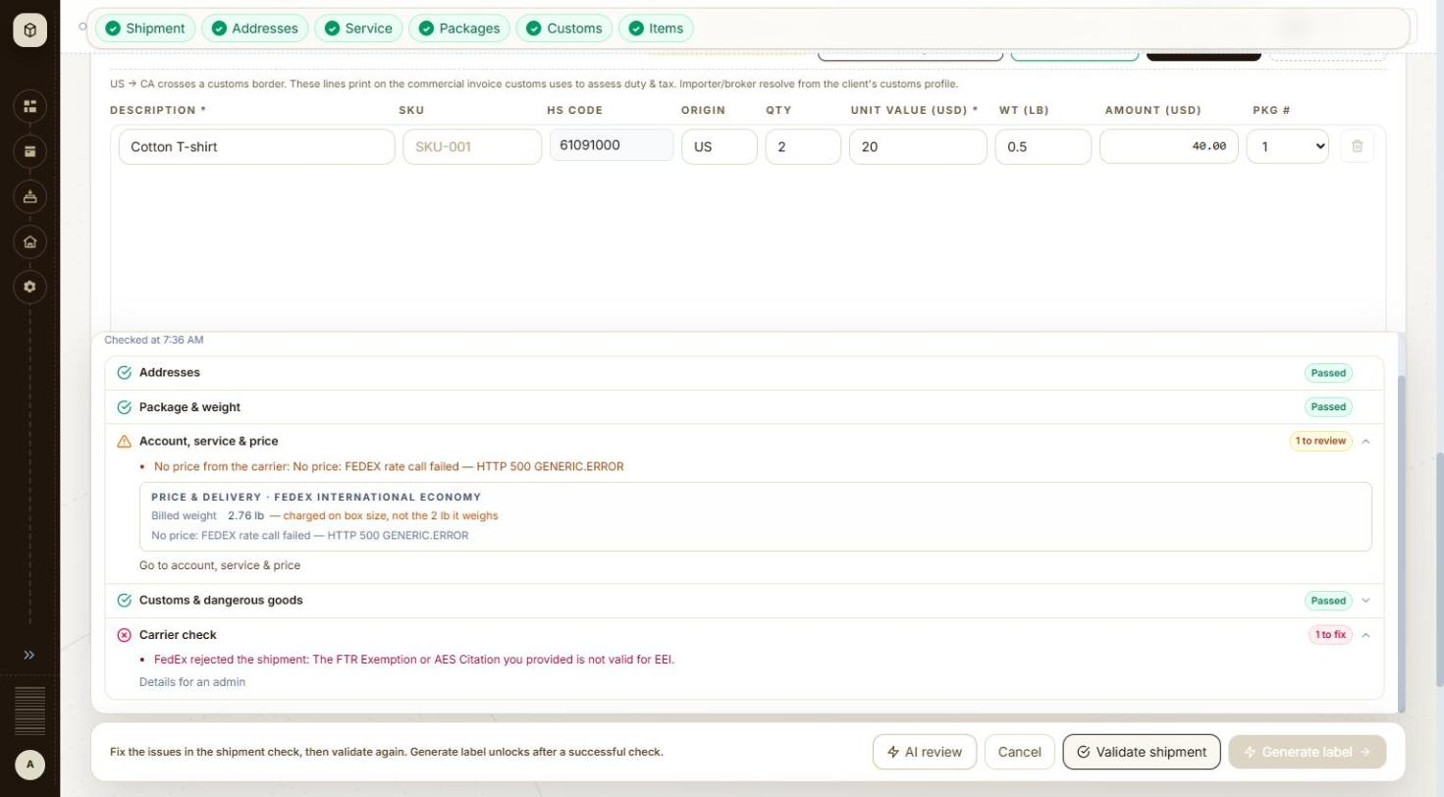
BUG-005 - screenshot (BUG-005.jpg)

BUG-006 - New shipment: 'Add N boxes like the last' copies the weight but leaves Length / Width / Height empty for a carrier box
Severity / type | Medium / Functional
Where | Orders > New order > New order form (international) - Add N boxes like the last
URL | /orders/new
Reproducibility | Always (2 of 2)
Found | 2026-10-11, run R1, as admin (ADMIN)
Status | Open

Steps to reproduce
1. Open Orders and click + New shipment (/orders/new)
2. Client: MKL246 (ship from 3PL-EAST, the client default)
3. Carrier: UPS
4. Ship to country Mexico
5. Service level: UPS Worldwide Saver
6. Packaging UPS Large Express Box, Weight 4
7. Set the box count next to 'boxes like the last' to 1
8. Click 'boxes like the last' (tooltip: 'Adds boxes copying the last box's weight and dimensions (box 1's when there is no extra box yet)')
Test data
Seen on MX-UP-WWS-LBOX (#934168) during the run; retested 2026-10-12 (form not saved)
Expected
Box 2 gets weight 4 lb and the box's dimensions 18 x 13 x 3 in, as the tooltip says.
Actual
Box 2 shows Weight 4 and empty L, W and H fields. Apply box 1 to all fills them (18 x 13 x 3).
Technical evidence
Box card after the click: 'BOX 2 ... Weight (lb) 4, L (in) [empty], W (in) [empty], H (in) [empty]'
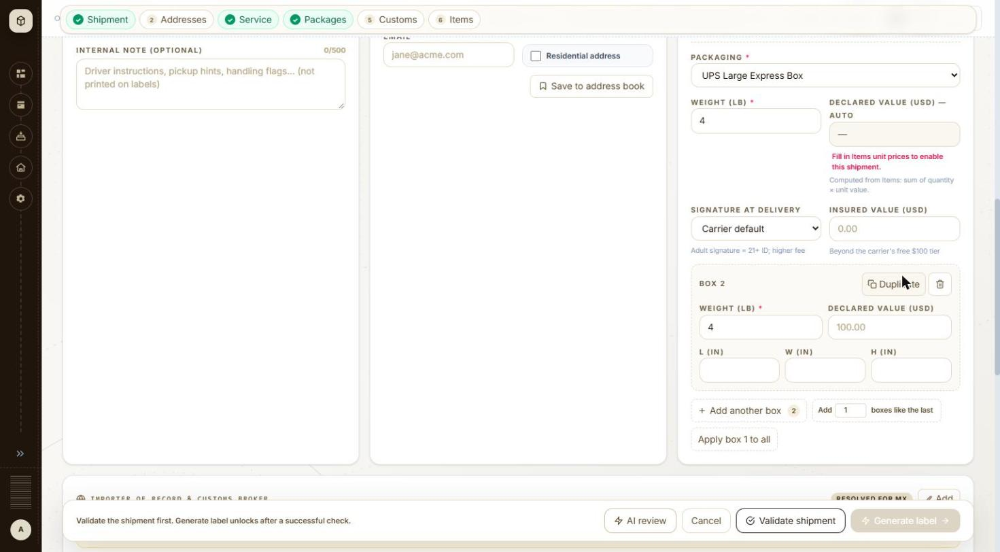
BUG-006 - screenshot (BUG-006.jpg)

BUG-007 - Label documents #934118: label stored as a FedEx document link instead of the PDF; each label request takes 3-4 s and the page shows 'Loading label document...' for about 8 s
Severity / type | Medium / Functional
Where | Orders > Label > Label documents - Label preview
URL | /label/934118
Reproducibility | Always for #934118 (1 of 115 labels)
Found | 2026-10-11, run R1, as admin (ADMIN)
Also affects | API > Orders > Order detail (GET /api/v1/orders/{id})
Status | Open

Steps to reproduce
1. Open /label/934118 (Orders > order #934118 > View label)
2. Watch the label area and the Download / Print buttons
3. Compare with /label/934119 (same carrier, service and lane)
Test data
Order #934118 (QA-1011-R13-GB-FX-IP-10KG-1B), FedEx International Priority to the UK
Expected
The label is stored like the other 114 labels and the page shows it within a second.
Actual
'Loading label document...' with Download PDF, Download .zpl, Copy ZPL and Print Label disabled until about 12 s after opening the page (about 3 s for #934119), then the label renders. The order's labelDetails.labelFilePath holds 'https://wwwtest.fedex.com/document/v1/cache/retrieve/SH...' (124 characters) while the other 114 generated orders hold the base64 PDF. Whether that FedEx link expires was not verified.
Technical evidence
GET /api/v1/orders/934118/label 3.6-4.3 s, GET /api/v1/orders/934118/label/pdf 3.4 s; for #934119: 55-109 ms and 21 ms (browser resource timing, 2026-10-12).
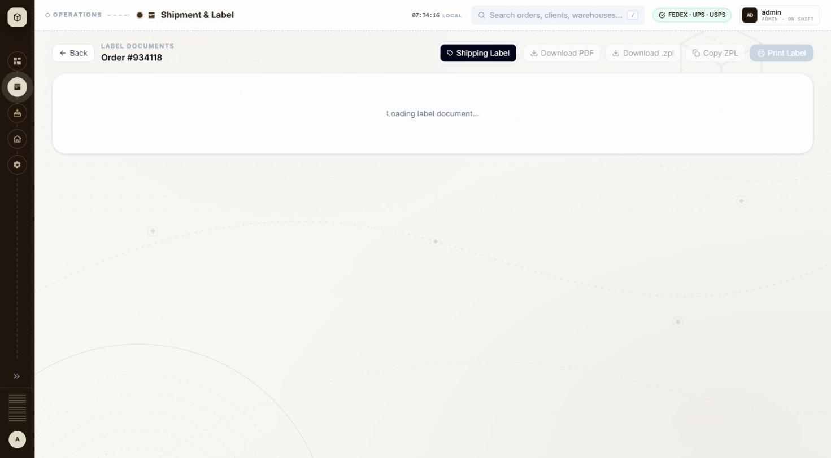
BUG-007 - screenshot (BUG-007.jpg)

BUG-008 - New shipment (ship to Mexico): State / region is required but has no * marker, a US placeholder 'NY', and accepts only ISO codes as free text
Severity / type | Low / Usability
Where | Orders > New order > New order form (international) - State / region (UK, Mexico)
URL | /orders/new
Reproducibility | Always
Found | 2026-10-11, run R1, as admin (ADMIN)
Status | Open

Steps to reproduce
1. Open Orders and click + New shipment (/orders/new)
2. Client: MKL246 (ship from 3PL-EAST, the client default)
3. Carrier: FedEx
4. Ship to country Mexico; fill name, address, city Ciudad de Mexico, postal code 06600; leave State / region empty
5. Complete the rest of the form and click Validate shipment
6. Enter DF in State / region and click Validate shipment again
Test data
Retest 2026-10-12 (QA-1012-EVID-MX-FX-IP, not saved); during the run every Mexico order needed CMX
Expected
Required fields carry the * marker used elsewhere on the form, and Mexico offers a state dropdown like Canada's province list, so a valid code is picked rather than guessed.
Actual
The label 'STATE / REGION' has no * (City * and Postal code * do), and the placeholder is 'NY'. Empty: toast '1 field needs attention — Ship to state: state / region is required' and the field turns red. 'DF' is accepted by the field and only rejected by the check; 'CMX' works. The run notes recorded Validate doing nothing visible; on retest the toast appeared, so that part is not reported.
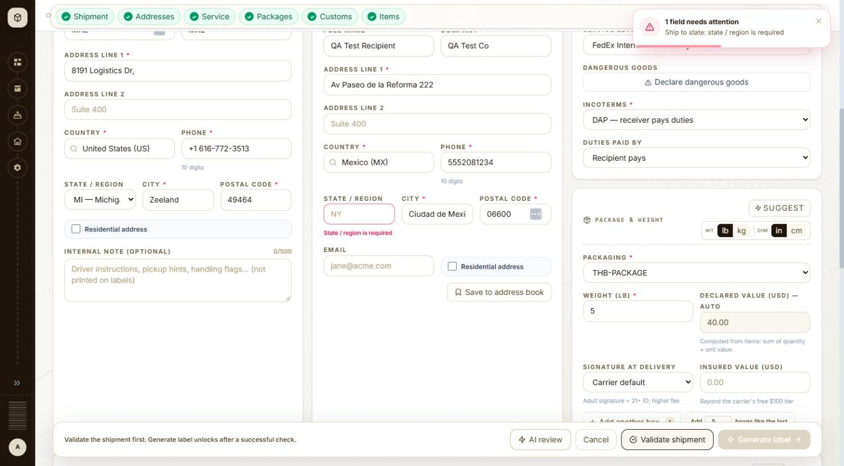
BUG-008 - screenshot (BUG-008.jpg)

BUG-009 - Shipment check (Mexico): state message says 'Use the 2-letter code (e.g. CMX, JAL, NLE)' but every example is three letters
Severity / type | Low / Content
Where | Orders > New order > New order form (international) - Shipment check panel
URL | /orders/new
Reproducibility | Always
Found | 2026-10-12, run R1, as admin (ADMIN)
Status | Open

Steps to reproduce
1. Open Orders and click + New shipment (/orders/new)
2. Client: MKL246 (ship from 3PL-EAST, the client default)
3. Carrier: FedEx
4. Ship to country Mexico with State / region DF
5. Complete the form and click Validate shipment
Test data
QA-1012-EVID-MX-FX-IP (validated only)
Expected
The message asks for the 3-letter state code (CMX, JAL, NLE).
Actual
Addresses '1 to fix': 'State/province "DF" isn't a valid MX code. Use the 2-letter code (e.g. CMX, JAL, NLE), not the full name.'
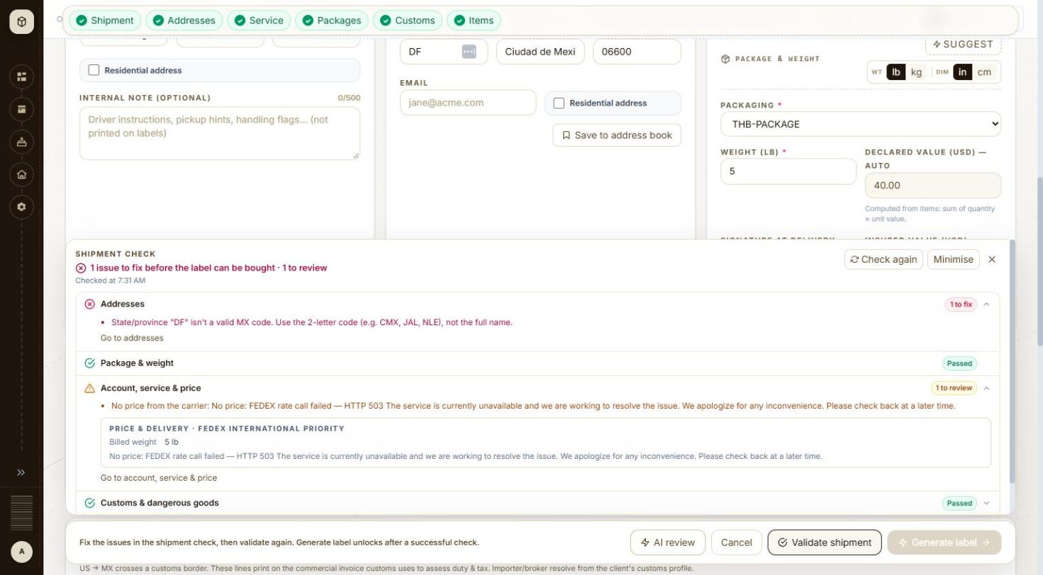
BUG-009 - screenshot (BUG-009.jpg)

BUG-010 - New shipment (Mexico): Importer section shows the badge 'RESOLVED FOR MX' next to the warning 'No importer/broker profile covers MX for MKL246'
Severity / type | Low / Content
Where | Orders > New order > New order form (international) - Importer of record & customs broker: Add
URL | /orders/new
Reproducibility | Always
Found | 2026-10-12, run R1, as admin (ADMIN)
Status | Open

Steps to reproduce
1. Open Orders and click + New shipment (/orders/new)
2. Client: MKL246 (ship from 3PL-EAST, the client default)
3. Carrier: USPS (also seen with FedEx)
4. Ship to country Mexico
5. Look at the Importer of record & customs broker section before adding an override
Test data
Seen 2026-10-12 (forms not saved)
Expected
The badge and the message agree: no profile means no 'resolved' badge (the FedEx ship-to card also shows 'Importer/broker resolved for MX').
Actual
Badge 'RESOLVED FOR MX' and, below it, 'No importer/broker profile covers MX for MKL246. Click Add to enter importer/broker for this shipment only'.
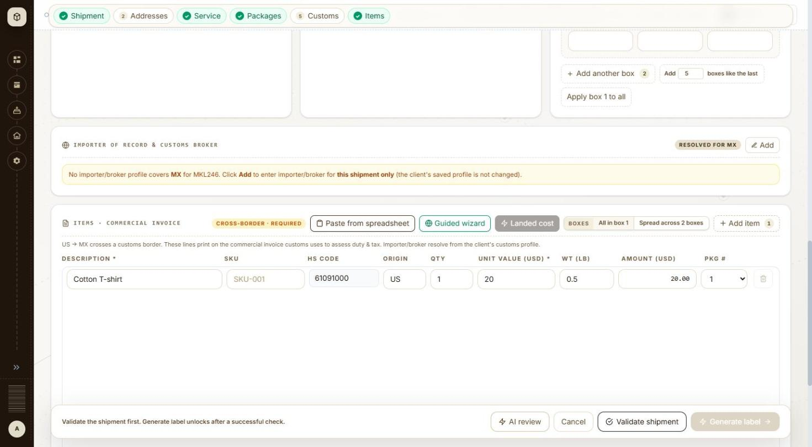
BUG-010 - screenshot (BUG-010.jpg)

BUG-011 - New shipment (Canada): HS code lookup suggests the 6-digit 610910, which the form then rejects as too short
Severity / type | Low / Usability
Where | Orders > New order > New order form (international) - Item HS code and lookup
URL | /orders/new
Reproducibility | Seen once (not retested)
Found | 2026-10-11, run R1, as admin (ADMIN)
Status | Open

Steps to reproduce
1. Open Orders and click + New shipment (/orders/new)
2. Client: MKL246 (ship from 3PL-EAST, the client default)
3. Carrier: FedEx
4. Ship to country Canada
5. Items: Description Cotton T-shirt; take the HS code the lookup suggests
Test data
First Canada shipment of the run (2026-10-11)
Expected
The lookup offers a code long enough for the destination (8+ digits for Canada).
Actual
Lookup gives 610910; inline error 'CA needs at least an 8-digit HS code (you entered 6)'. 61091000 typed by hand is accepted.
No screenshot file was captured for this item.

BUG-012 - Client MKL246 ship-from address: Address line 1 '8191 Logistics Dr,' ends with a stray comma
Severity / type | Low / Content
Where | Orders > New order > New order form (international) - Ship-from address (from client profile)
URL | /orders/new
Reproducibility | Always
Found | 2026-10-11, run R1, as admin (ADMIN)
Status | Open

Steps to reproduce
1. Open Orders and click + New shipment (/orders/new)
2. Client: MKL246 (ship from 3PL-EAST, the client default)
3. Look at Ship from > Address line 1
Test data
MKL246 / 3PL-EAST ship-from profile
Expected
Address line 1 without trailing punctuation; it is printed on labels and sent to the carriers.
Actual
'8191 Logistics Dr,'
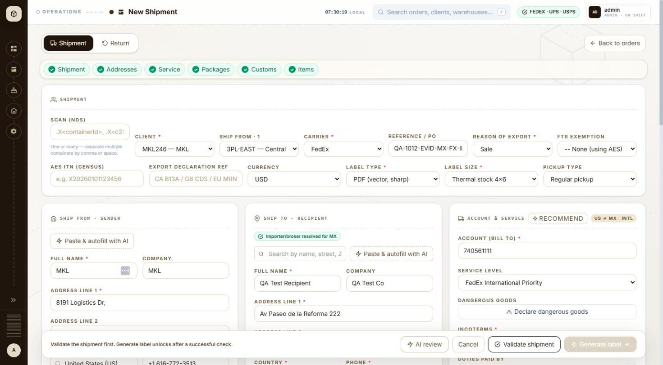
BUG-012 - screenshot (BUG-012.jpg)

BUG-013 - New shipment > Items: 'Add item' inserts the new blank line above the existing one
Severity / type | Low / Usability
Where | Orders > New order > New order form (international) - Add item
URL | /orders/new
Reproducibility | Always
Found | 2026-10-11, run R1, as admin (ADMIN)
Status | Open

Steps to reproduce
1. Open Orders and click + New shipment (/orders/new)
2. Client: MKL246 (ship from 3PL-EAST, the client default)
3. Carrier: USPS; ship to country Mexico
4. Fill item line 1: Cotton T-shirt, 61091000, US, 1, 20.00, 0.5
5. Click + Add item
Test data
Seen during the run (USPS split shipments) and on retest 2026-10-12
Expected
The new line is added below the existing line, or focus moves into the new line.
Actual
A blank line appears as row 1 and the filled line moves to row 2, so the next values typed into the top row go into the new line.
BUG-013 - screenshot 1 (BUG-013.jpg)
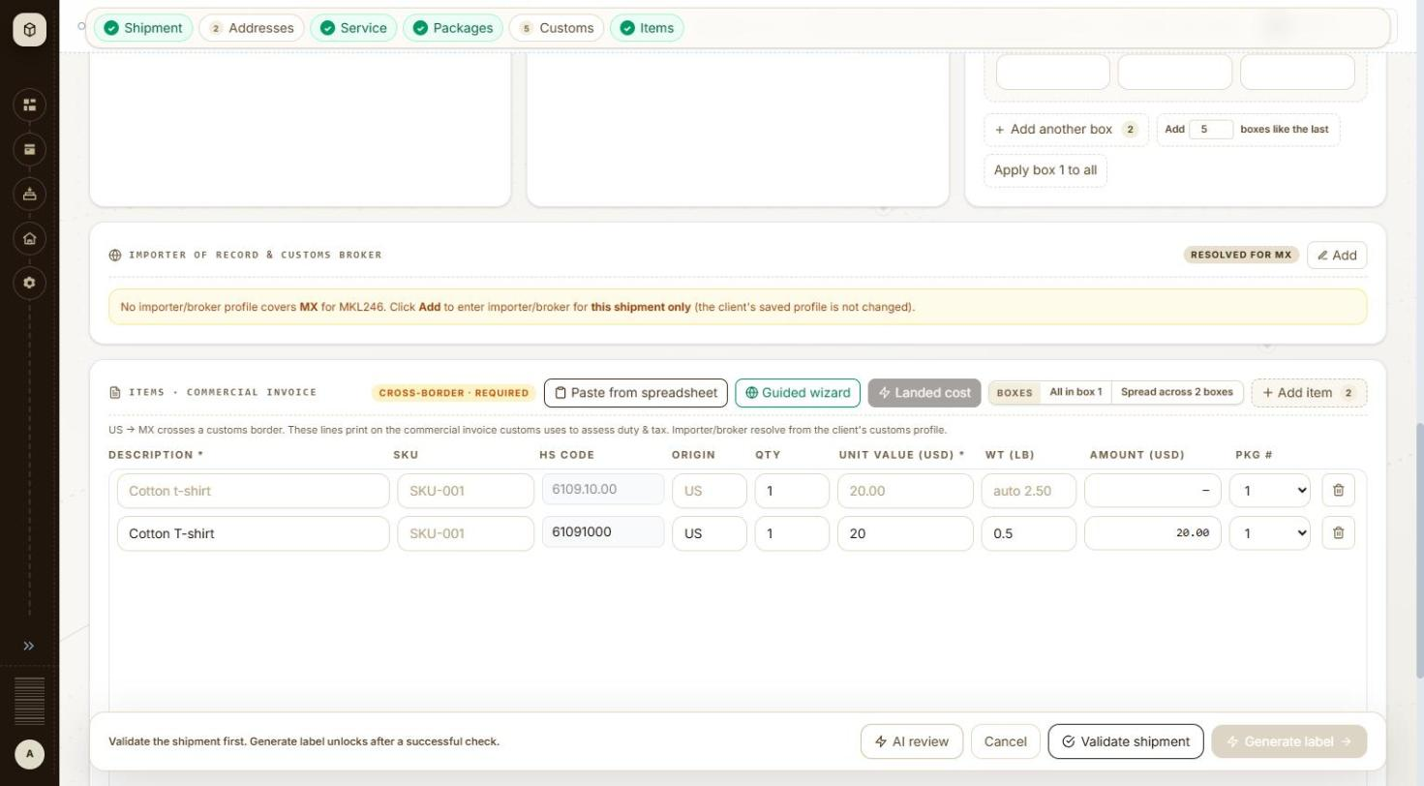
BUG-013 - screenshot 2 (BUG-013-2.jpg)

BUG-014 - New shipment: the 'Lines spread across 2 boxes' toast covers the Validate shipment and Generate label buttons
Severity / type | Low / UI
Where | Orders > New order > New order form (international) - Boxes: Spread across 2 boxes
URL | /orders/new
Reproducibility | Always
Found | 2026-10-11, run R1, as admin (ADMIN)
Status | Open

Steps to reproduce
1. Open Orders and click + New shipment (/orders/new)
2. Client: MKL246 (ship from 3PL-EAST, the client default)
3. Carrier: USPS; ship to country Mexico
4. Add another box (2 boxes)
5. Two item lines (Add item)
6. Click Boxes > Spread across 2 boxes
Test data
Seen during the run and on retest 2026-10-12
Expected
Confirmation toasts do not sit over the footer's main buttons.
Actual
Toast 'Done — Lines spread across 2 boxes in order — adjust any line's Pkg # if needed.' covers Validate shipment and Generate label at the bottom right; during the run the Validate click did not go through until the toast was closed.
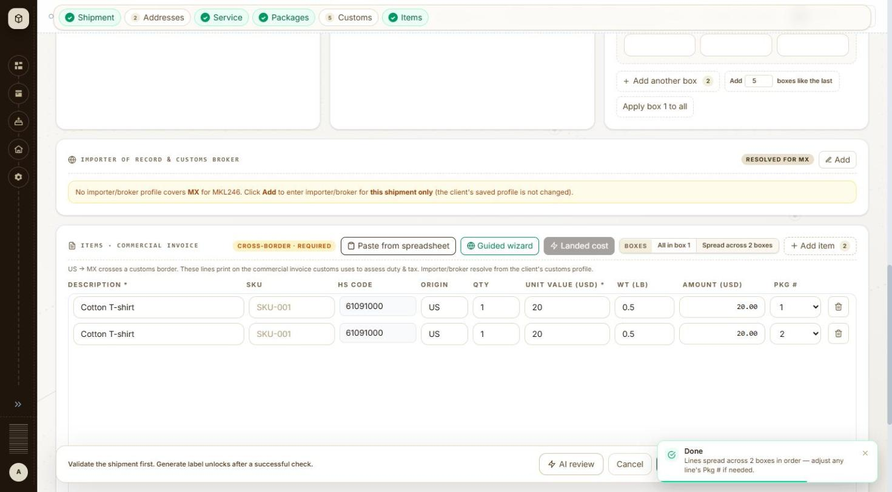
BUG-014 - screenshot (BUG-014.jpg)

BUG-015 - Label documents: every page load gets HTTP 503 from HEAD /label/preview.png before falling back to the PDF
Severity / type | Low / Functional
Where | Orders > Label > Label documents - Label preview
URL | /label/{orderNo}
Reproducibility | Always (3 of 3 pages)
Found | 2026-10-12, run R1, as admin (ADMIN)
Status | Open

Steps to reproduce
1. Open /label/934119 (or any generated order's label page)
2. Read the network requests
Test data
Orders #934118, #934119, #934190 (2026-10-12)
Expected
The preview request succeeds, or the page asks for the PDF directly; no 5xx on a normal page load.
Actual
HEAD /api/v1/orders/{id}/label/preview.png?pkg=1 -> 503, twice per load, then GET /label/pdf -> 200 and the label shows. Each /label request is also sent twice (possibly React StrictMode in the dev build).
Technical evidence
HEAD /api/v1/orders/934119/label/preview.png?pkg=1 -> 503 (x2); GET /api/v1/orders/934119/label -> 200 (x2); GET /api/v1/orders/934119/label/pdf -> 200
No screenshot file was captured for this item.

BUG-016 - Validate shipment: a server failure shows the raw toast 'Something went wrong HTTP error! status: 502'
Severity / type | Low / Content
Where | Orders > New order > New order form (international) - Validate shipment
URL | /orders/new
Reproducibility | 1 of about 40 FedEx validations
Found | 2026-10-11, run R1, as admin (ADMIN)
Status | Open

Steps to reproduce
1. Open Orders and click + New shipment (/orders/new)
2. Client: MKL246 (ship from 3PL-EAST, the client default)
3. Carrier: FedEx
4. Ship to: Full name QA Test Recipient, Company QA Test Co, Address line 1 Av Paseo de la Reforma 222, Country Mexico (MX), Phone 5552081234, State / region CMX, City Ciudad de Mexico, Postal code 06600
5. Service level: FedEx International Economy; Packaging FedEx Pak; 2 boxes
6. Fill customs, importer and items as for the other Mexico FedEx orders
7. Click Validate shipment
Test data
First Validate of MX-FX-IE-PAK (order later created as #934153)
Expected
A plain message that the check could not run and to try again; no HTTP wording.
Actual
Toast 'Something went wrong HTTP error! status: 502'; no check panel and no order. Clicking Validate again worked.
No screenshot file was captured for this item.

Settings

BUG-044 - Settings > Address book never loads: its only data call returns 500 every time, and the page shows the 'No saved addresses yet' empty state as though the book were empty
Severity / type | High / Functional
Where | Settings > Organization > Address book > Address book list - Page header and list load
URL | http://localhost:5173/settings/address-book
Reproducibility | Always
Found | 2026-10-12, run R2, as admin (ADMIN)
Status | Open

Steps to reproduce
1. Open Settings > Address book (/settings/address-book)
2. Wait for the page to settle and read the two red toasts
3. Click Refresh at the top right
4. Watch the request the page makes
Test data
No test data needed - the failure is on page load
Expected
The saved addresses are listed, or, if the call fails, the grid says the list could not be loaded and offers a retry - not a message that says there are none.
Actual
GET /api/v1/recipients?page=0&size=25 returns 500 on every attempt. The grid shows 'No saved addresses yet. Add one here, or use "Save to address book" in Ship to on a new shipment.' On the first load two red toasts appear ('Something went wrong on the server... contact support with reference 4afd47af'), but on Refresh the call fails again with no message at all, so the page quietly claims the address book is empty. There is no way to tell from the screen whether there are no addresses or whether the list failed to load.
Technical evidence
Every read of the address book fails and every failure is drawn as an empty state. GET /api/v1/recipients?page 0&size 25 -> 500 (twice on load, twice on Refresh - the page calls it twice each time). The search sends GET /api/v1/recipients?q QA-1012&page 0&size 25 -> 502 and the grid reads 'No saved addresses match "QA-1012".' The client filter sends GET /api/v1/recipients?customerNo MKL246&page 0&size 25 -> 502 and the grid reads 'No saved addresses yet.' First-load toast text: 'Something went wrong on the server. Please try again in a moment. If this keeps happening, contact support with reference 4afd47af.' Further references seen: 51350c06, 9da70cce. No browser console errors. The whole screen is unusable, so none of its controls could be checked against real rows.
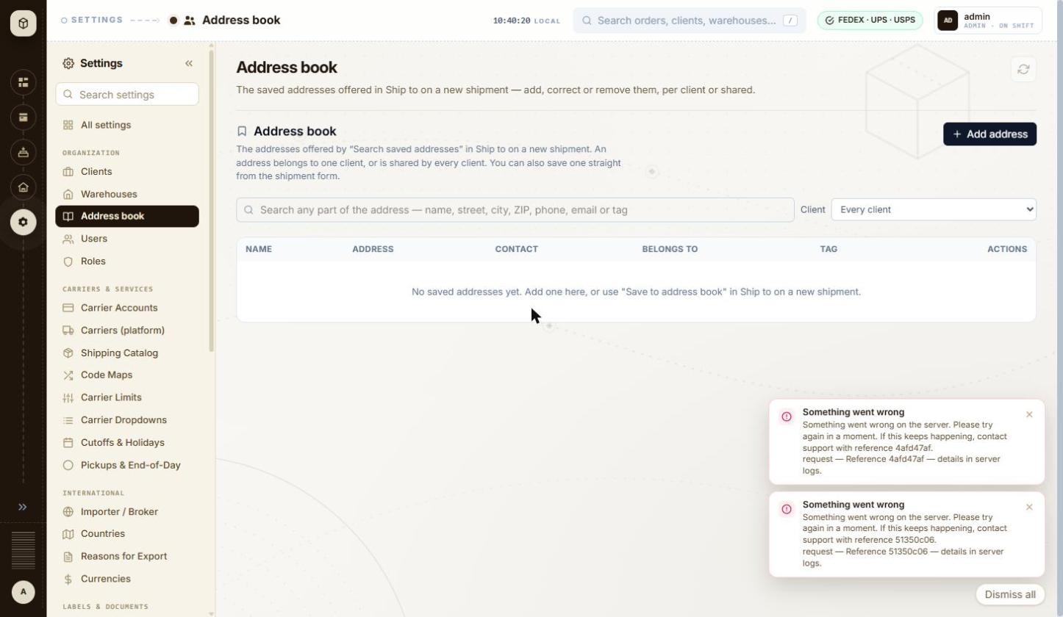
BUG-044 - screenshot 1 (BUG-044.jpg)
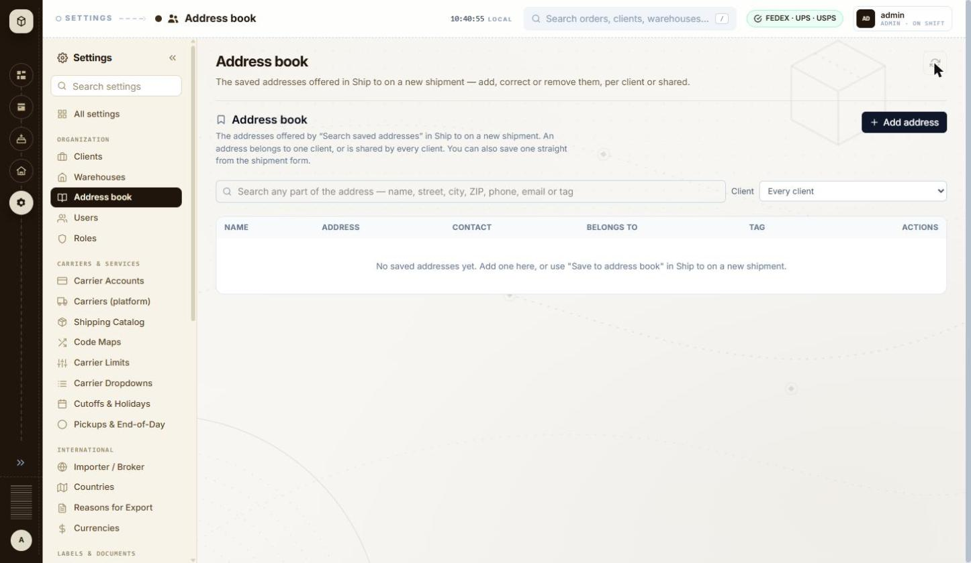
BUG-044 - screenshot 2 (BUG-044-2.jpg)

BUG-045 - Address book: a saved address is reported as a server failure, because the list reload that follows the save is what actually fails
Severity / type | High / Data integrity
Where | Settings > Organization > Address book > Address book list - Add / Edit address form
URL | http://localhost:5173/settings/address-book
Reproducibility | Always
Found | 2026-10-12, run R2, as admin (ADMIN)
Status | Open

Steps to reproduce
1. Open Settings > Address book (/settings/address-book)
2. Click + Add address
3. Fill Name QA-1012 Test Recipient, Street 290 Bremner Blvd, City Chicago, State IL, Postal code 60601, Country United States
4. Click Save address
5. Read the toast and the grid
Test data
Shared address 'QA-1012 Test Recipient', 290 Bremner Blvd, Chicago, IL 60601, US
Expected
A save that succeeded is reported as a success. If the list cannot be reloaded afterwards, that is reported separately and does not cast doubt on the save.
Actual
POST /api/v1/recipients returns 200 - the address is created - but the dialog closes onto a red 'Something went wrong on the server... contact support with reference 9da70cce' and the grid still reads 'No saved addresses yet'. Everything on screen says the save failed. The failure is really the GET that follows it (BUG-044). A user will save again, and again, each time creating another copy they cannot see.
Technical evidence
POST /api/v1/recipients -> 200, then GET /api/v1/recipients?page 0&size 25 -> 500. One address was created during this test and cannot be seen or deleted from the UI while the list call fails: 'QA-1012 Test Recipient', shared with every client.
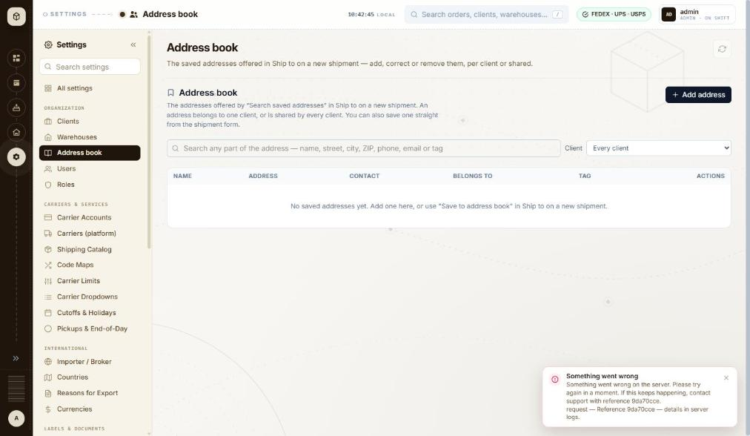
BUG-045 - screenshot (BUG-045.jpg)

BUG-028 - Client wizard > Return address: a ZIP+4 cannot be typed - the field stops at 9 characters while its own hint shows the 10-character form 12345-6789
Severity / type | Medium / Validation
Where | Settings > Organization > Clients > Client wizard (Add / Edit) - Return address: Same as Ship From / own address
URL | http://localhost:5173/settings/clients/new
Reproducibility | Always
Found | 2026-10-12, run R2, as admin (ADMIN)
Status | Open

Steps to reproduce
1. Open Settings > Clients and click + Add Client
2. Fill step 1 Identity and pick a warehouse on step 2 Ship From, then go to step 3 Return address
3. Untick 'Same as Ship From'
4. Type 60601-1234 in ZIP
Test data
ZIP typed: 60601-1234 (10 characters). Hint under the field: 'Format: 12345 or 12345-6789 - max 9 chars - UPS'
Expected
A ZIP+4 in the form the hint shows (12345-6789) can be typed and is accepted; if the carrier limit is 9 digits, the hyphen should not count towards it.
Actual
The input has maxlength 9, so typing stops after '60601-123'. The field then shows the error 'Postal code doesn't match the US format.' and Next stays disabled, so a US ZIP+4 return address cannot be saved at all.
Technical evidence
input maxlength 9, value after typing 60601-1234: '60601-123'. The same 9-character limit is on the ZIP field of the Ship From / Return address block. Phone behaves the same way: maxlength 15 truncates '+1 (312) 555-0100' to '+1 (312) 555-01', but no error is shown for that.
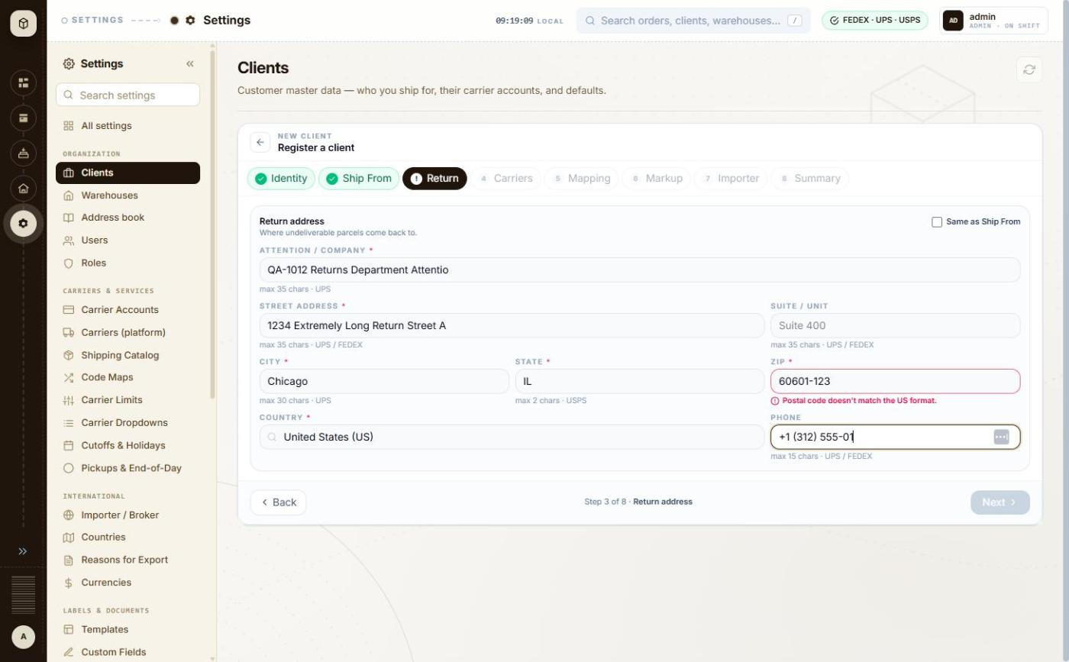
BUG-028 - screenshot (BUG-028.jpg)

BUG-030 - Client wizard > Carriers: Cancel on the carrier account form keeps everything typed, including the client secret, and + Add carrier account reopens the discarded draft
Severity / type | Medium / Functional
Where | Settings > Organization > Clients > Client wizard (Add / Edit) - Carrier accounts grid for the client (+ Add Account, default star)
URL | http://localhost:5173/settings/clients/new
Reproducibility | Always
Found | 2026-10-12, run R2, as admin (ADMIN)
Status | Open

Steps to reproduce
1. Open Settings > Clients and click + Add Client
2. Fill step 1 Identity and pick a warehouse on step 2 Ship From, then go to step 4 Carriers
3. Click + Add carrier account
4. Choose carrier DHL Express, type an account number, a client id and a client secret
5. Click Cancel - the list shows 'No carrier accounts staged yet'
6. Click + Add carrier account again
Test data
Carrier DHL Express, account number QA1012QA1, test client id and client secret created for this run (local SANDBOX placeholders)
Expected
Cancel discards the draft, so the next + Add carrier account opens an empty form on the default carrier - as the empty-state text implies.
Actual
The list is emptied but the form is not: reopening it shows the cancelled carrier, account number, client id and the filled client secret. Typing an account number then appends to the retained one (QA1012 typed into a field already holding QA1012 gives QA1012QA1), so a stale credential can be staged against the wrong carrier without the user noticing.
Technical evidence
Nothing is sent on Cancel; the draft is only held in the page. The retained secret stays masked but is still submitted if the user clicks Add to list.
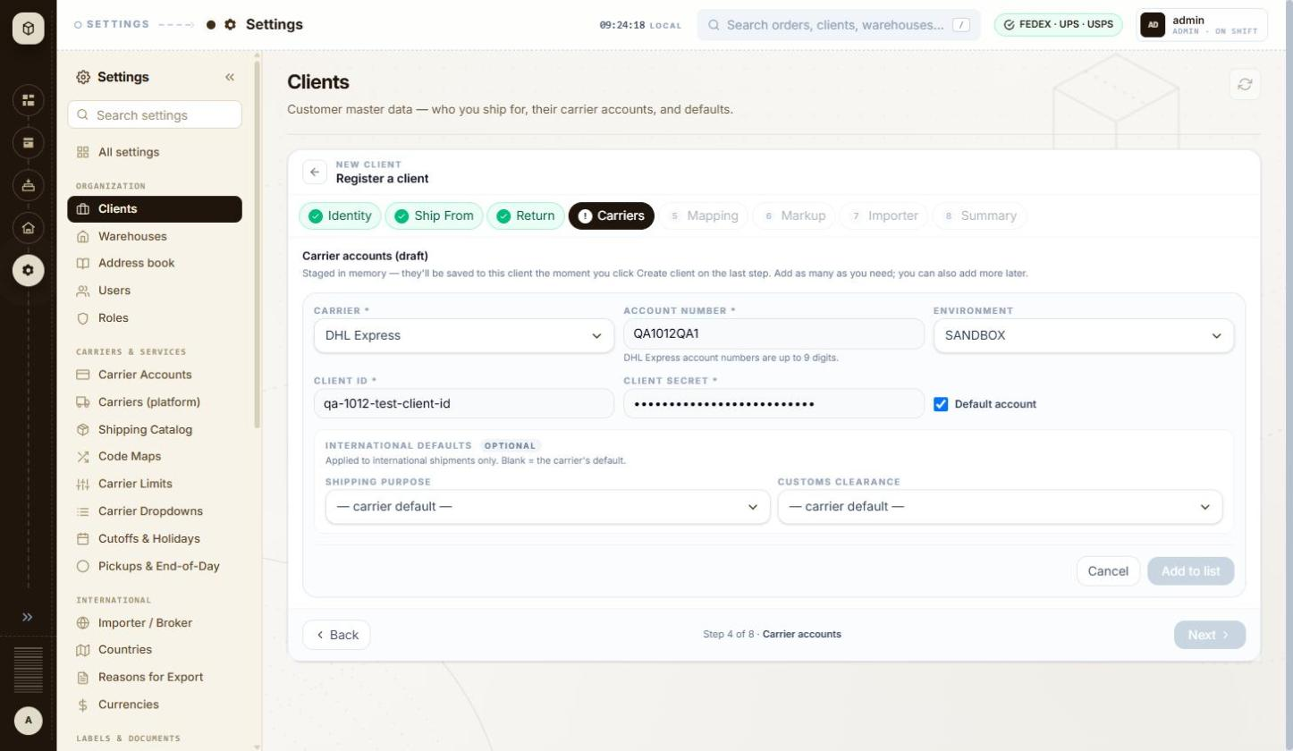
BUG-030 - screenshot (BUG-030.jpg)

BUG-040 - Add warehouse accepts a state of 'ILLINOIS' and a 10-character postal code, although this is the ship-from address printed on every label
Severity / type | Medium / Validation
Where | Settings > Organization > Warehouses > Warehouses list - Add / Edit warehouse panel: address fields and country
URL | http://localhost:5173/settings/warehouses
Reproducibility | Always
Found | 2026-10-12, run R2, as admin (ADMIN)
Status | Open

Steps to reproduce
1. Open Settings > Warehouses and click + Add Warehouse
2. Fill Code QA-1012-WH01 and a name
3. Line 1 742 Evergreen Terrace, City Springfield
4. State / region: type ILLINOIS
5. Postal code: type 62704-1234
6. Phone +1 (217) 555-0100, Country US
7. Click Create warehouse
Test data
Warehouse QA-1012-WH01, state ILLINOIS, postal code 62704-1234, country US
Expected
The ship-from address is checked at least as strictly as the client's return address, which caps State at 2 characters for a US address and checks the postal code format. UPS and FedEx both need a 2-letter state code for US addresses, so 'ILLINOIS' will be refused at label time.
Actual
No check at all. State / region accepts up to 50 characters with no format rule and no carrier hint, Postal code accepts up to 20 with no format rule. The warehouse saves and the list shows 'Springfield, ILLINOIS'. The same window on the client Return address step would have truncated both and shown an error.
Technical evidence
Input maxlengths on this panel: Code 50, Name 255, Line 1 255, Line 2 255, City 100, State 50, Postal code 20, Country 2, Phone 50. No per-carrier hints are shown, unlike the Return address step which shows 'max 2 chars - USPS', 'Format: 12345 or 12345-6789' and so on. Required fields are checked ('State / region is required.'), so only the content rules are missing.
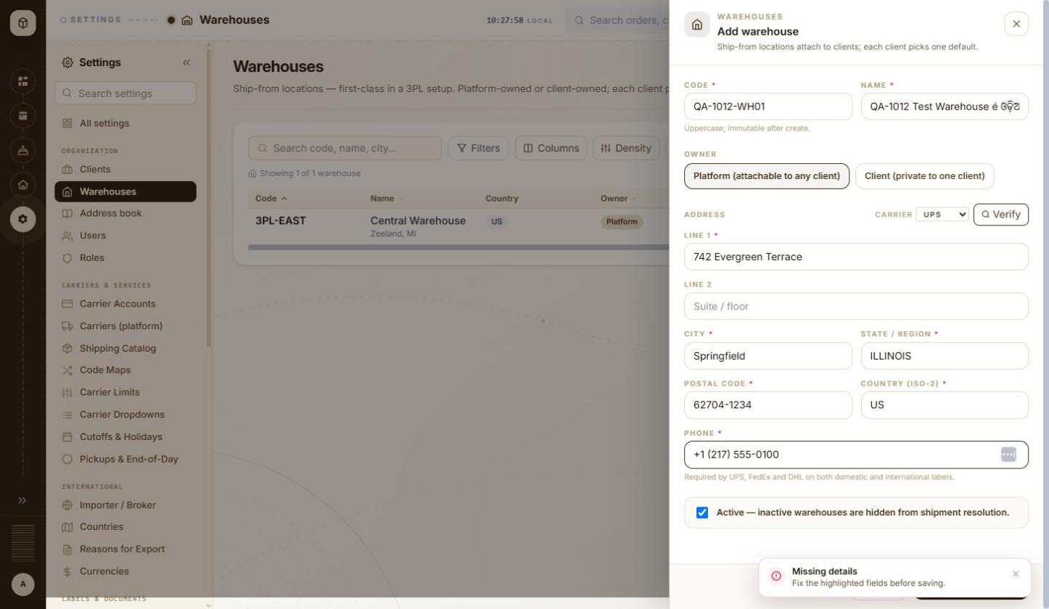
BUG-040 - screenshot 1 (BUG-040.jpg)
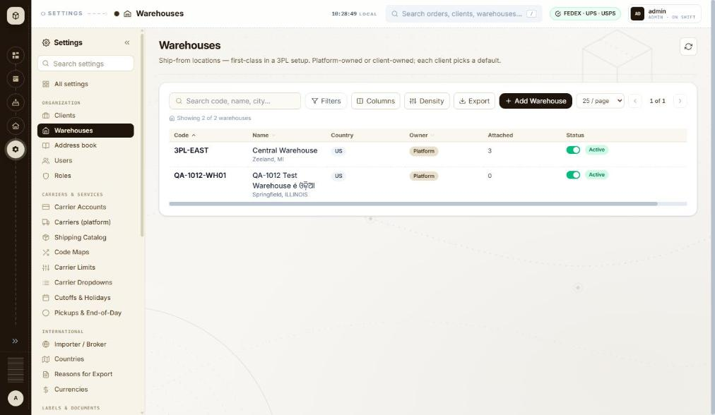
BUG-040 - screenshot 2 (BUG-040-2.jpg)

BUG-041 - Warehouses > Attach clients: the dialog never shows which clients are already attached, and nothing on the screen can detach one
Severity / type | Medium / Functional
Where | Settings > Organization > Warehouses > Warehouses list - Row menu > Attach clients
URL | http://localhost:5173/settings/warehouses
Reproducibility | Always
Found | 2026-10-12, run R2, as admin (ADMIN)
Status | Open

Steps to reproduce
1. Open Settings > Warehouses
2. Scroll the table right, open the row menu on a warehouse and click Attach clients
3. Tick a client and click Attach - the Attached count goes up and 'Attached QA-1012-WH01 to 1 client.' is shown
4. Open the same row menu > Attach clients again
5. Look for a way to undo the attachment anywhere on this screen
Test data
Warehouse QA-1012-WH01 attached to client THB000
Expected
The dialog shows the clients already attached, ticked or marked, so the user can see the current state; and an attachment made by mistake can be undone from the same place.
Actual
Both clients are shown unticked every time, with no sign that THB000 is attached - the only clue is the Attached count in the grid. The subtitle says 'Existing attachments are unaffected', so the dialog only ever adds. The row menu offers Attach clients, Edit and Delete only, and the Edit panel does not list attachments either, so an attachment can be created here but never removed.
Technical evidence
Ticking a client also reveals 'Set as this client's default warehouse', which silently changes that client's default - another reason the current state needs to be visible. The only way found to change it is the client's own Ship From step.
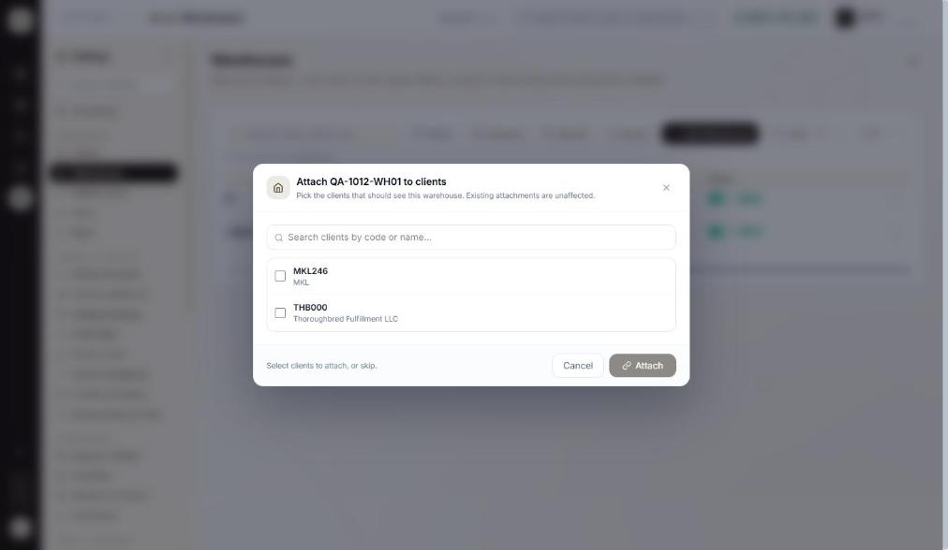
BUG-041 - screenshot (BUG-041.jpg)

BUG-043 - Deactivating a warehouse that clients ship from happens on one click, with no warning - the same action on a client asks first and lists the cascade
Severity / type | Medium / Usability
Where | Settings > Organization > Warehouses > Warehouses list - Status toggle (Activate / Deactivate warehouse)
URL | http://localhost:5173/settings/warehouses
Reproducibility | Always
Found | 2026-10-12, run R2, as admin (ADMIN)
Status | Open

Steps to reproduce
1. Open Settings > Warehouses
2. Pick a warehouse with a number greater than 0 in the Attached column
3. Click its Status toggle
Test data
Warehouse QA-1012-WH01, Attached = 1 (client THB000)
Expected
The same care as on the Clients screen, where Deactivate asks 'Deactivate QA-1012-CL01?' and lists what else it will disable. The panel's own wording - 'inactive warehouses are hidden from shipment resolution' - means this can stop a client shipping.
Actual
One click and it is done: the row turns Inactive and a green toast says 'QA-1012-WH01 is now inactive.' Nothing is asked, and the attached clients are not mentioned even though the Attached column shows 1.
Technical evidence
Re-activating is also a single click. The toast prints the status in lower case here ('is now inactive.') and in upper case on the Clients screen ('is now ACTIVE.').
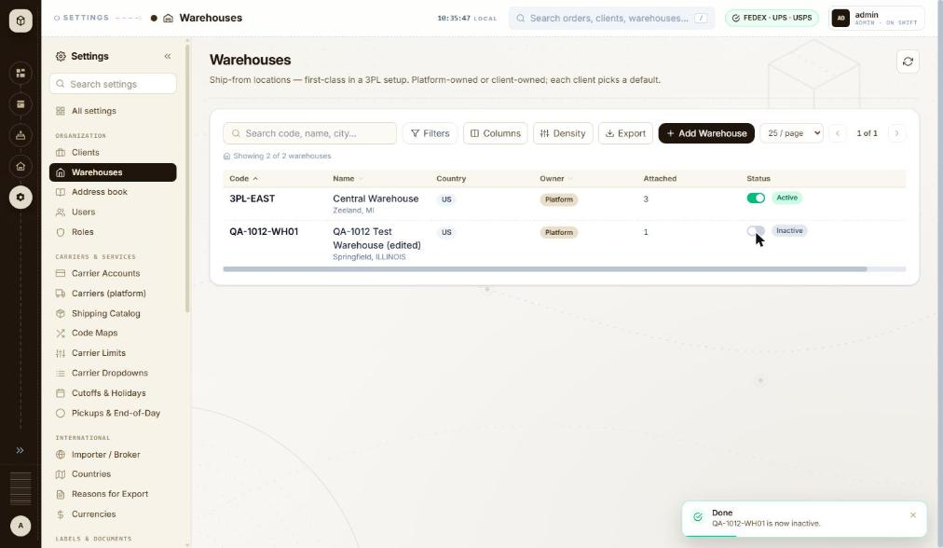
BUG-043 - screenshot (BUG-043.jpg)

BUG-050 - A sent invitation leaves no trace: the invited person is not listed, the audit panel stays empty, and the accept link is shown once and then lost
Severity / type | Medium / Functional
Where | Settings > Organization > Users > Users list - Invite user form (fields, validation, send)
URL | http://localhost:5173/settings/users
Reproducibility | Always
Found | 2026-10-12, run R2, as admin (ADMIN)
Status | Open

Steps to reproduce
1. Open Settings > Users (/settings/users)
2. Click Invite user, enter an address, pick a client and a role, and click Send invite
3. Read the confirmation, then click Done
4. Look at the user list and at 'Recent admin actions'
5. Click Refresh
Test data
Invite to qa-1012-invite@example.com, client THB000, role USER. Accept link shown: http://localhost:5173/invite/8881caf518742688c83dfa1d688cecd03d6c748867028fee
Expected
The invited person appears in the list as pending, with a way to resend or revoke, and the invitation is recorded in 'Recent admin actions' like any other admin change.
Actual
After Done the list still reads 'Showing 2 rows - page 1' with only admin and manoj7000, and 'Recent admin actions' still reads 'No audit entries yet.' A refresh changes nothing. The only copy of the accept link was in the dialog that was just closed, so if the invitation does not arrive there is no way to find it, resend it or cancel it - and no record that it was ever sent.
Technical evidence
GET /api/v1/admin/users?page 0&size 50 and GET /api/v1/admin/users/audit?limit 50 both return 200 after the invite, and neither contains the invited address. This matters more here because Settings > Mail reports 'No provider active - outbound emails are logged only', so in this environment no invitation can reach anyone.
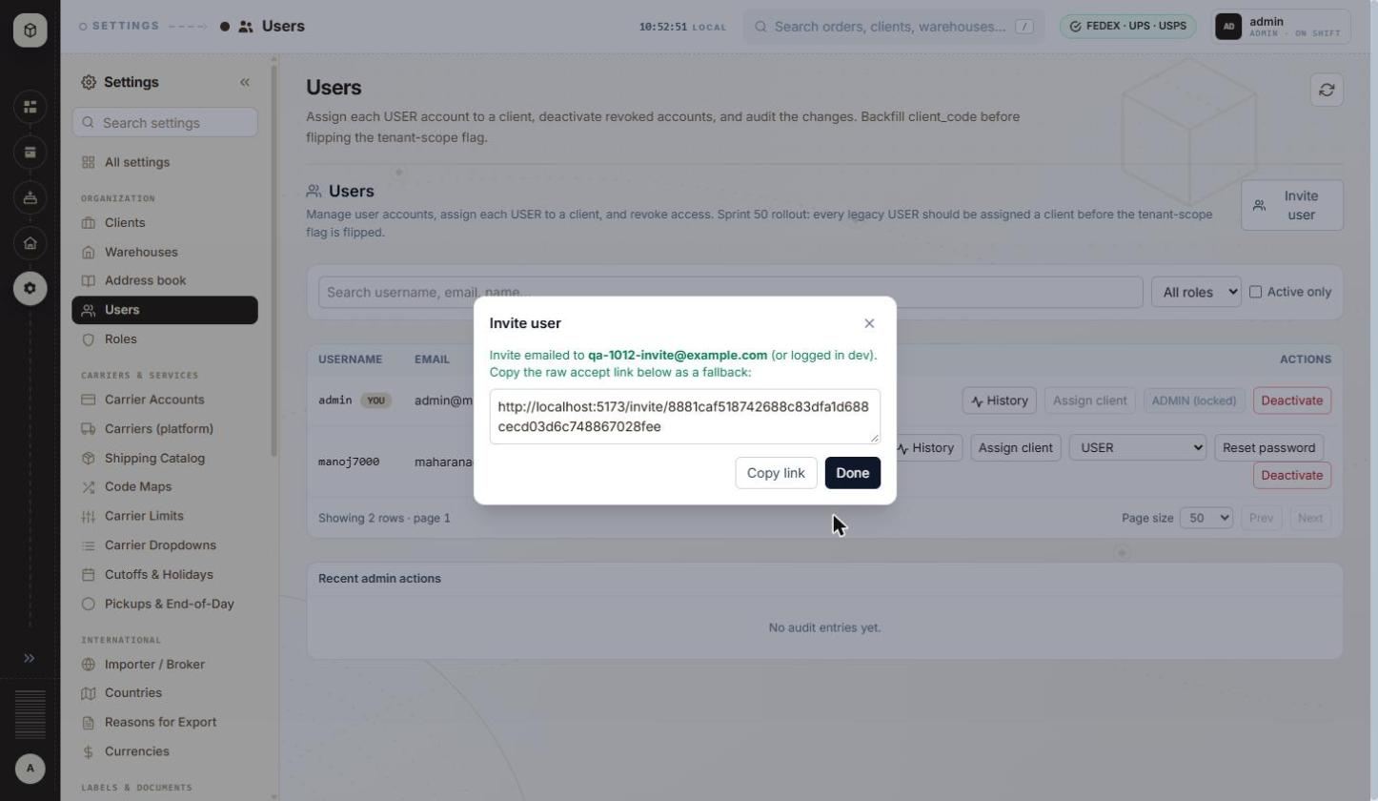
BUG-050 - screenshot 1 (BUG-050.jpg)
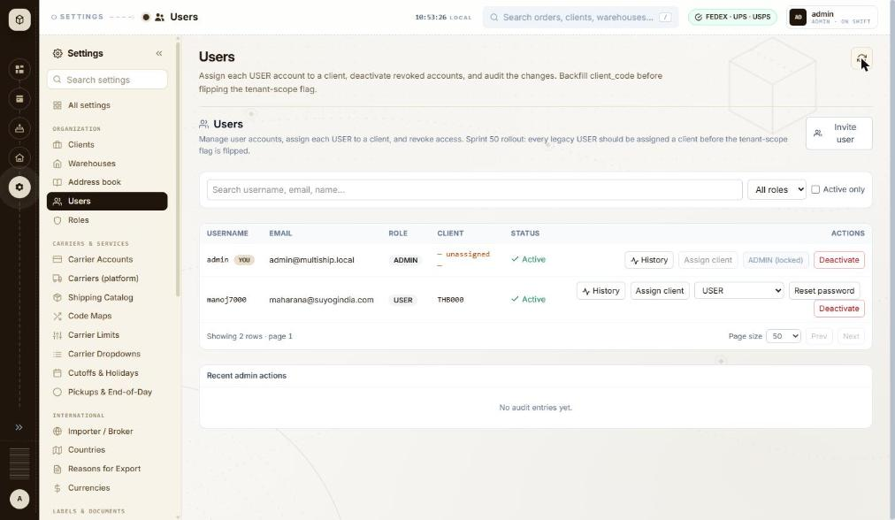
BUG-050 - screenshot 2 (BUG-050-2.jpg)

BUG-051 - The Deactivate button is enabled on the signed-in admin's own row, and that is the only ADMIN account in the system
Severity / type | Medium / Security
Where | Settings > Organization > Users > Users list - Row action > Deactivate / Activate
URL | http://localhost:5173/settings/users
Reproducibility | Not tested
Found | 2026-10-12, run R2, as admin (ADMIN)
Status | Open

Steps to reproduce
1. Open Settings > Users (/settings/users)
2. Look at the admin row, marked YOU
3. Note that Assign client is disabled ('ADMIN is always org-wide') and the role control reads 'ADMIN (locked)', but Deactivate is live
Test data
admin / admin@multiship.local, the only row with role ADMIN
Expected
The last remaining ADMIN, and the account the current session belongs to, cannot be deactivated from the interface - the button is disabled with a reason, the way Assign client and the role control already are on this row.
Actual
The button is not disabled (disabled=false, no tooltip). If the server does not refuse it, one click would deactivate the only administrator and lock everyone out of the application.
Technical evidence
Read from the page, not clicked: the user asked that this not be exercised, because recovery would need database access. Two of the three other controls on the same row are already correctly disabled with explanations, so the guard looks simply to have been missed on this one. Please confirm whether the server refuses it.
BUG-051 - screenshot (BUG-051.jpg)

BUG-052 - The user audit trail records nothing: admin changes with a typed reason leave both 'Recent admin actions' and the per-user History empty
Severity / type | Medium / Functional
Where | Settings > Organization > Users > Users list - Recent admin actions panel
URL | http://localhost:5173/settings/users
Reproducibility | Always
Found | 2026-10-12, run R2, as admin (ADMIN)
Status | Open

Steps to reproduce
1. Open Settings > Users (/settings/users)
2. Click Assign client on a user, change the client code and type something in 'Reason (optional - recorded in audit)'
3. Click Save and wait for 'Done - Updated manoj7000.'
4. Look at the 'Recent admin actions' panel at the bottom of the page
5. Click Refresh, then click History on that user's row
Test data
User manoj7000: client code changed to NOSUCHCLIENT (refused), then saved as THB000 with the reason 'QA-1012 validation check, will be restored'. An invitation to qa-1012-invite@example.com was also sent earlier in the session.
Expected
Each admin change is listed, with who made it, when, what changed and the reason given - the page description promises exactly this ('...deactivate revoked accounts, and audit the changes') and the Reason field says it is 'recorded in audit'.
Actual
'Recent admin actions' reads 'No audit entries yet.' before and after the change, and the per-user dialog reads 'No admin actions recorded for this user.' Nothing is recorded for the successful assignment, nor for the invitation sent earlier.
Technical evidence
GET /api/v1/admin/users/audit?limit 50 returns 200 after each change, so the page is asking for the list and getting nothing back. The reason text the admin types is therefore collected and discarded.
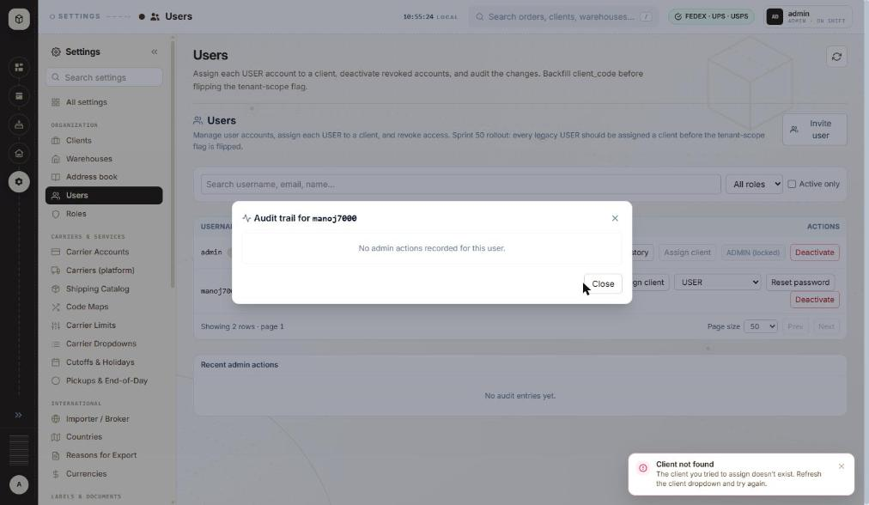
BUG-052 - screenshot (BUG-052.jpg)

BUG-022 - Clients search: '%' and '_' work as wildcards, so searching for them lists clients that do not contain them
Severity / type | Low / Functional
Where | Settings > Organization > Clients > Clients list - Search code, name, city
URL | http://localhost:5173/settings/clients
Reproducibility | Always
Found | 2026-10-12, run R2, as admin (ADMIN)
Also affects | Settings > Organization > Warehouses > Warehouses list
Status | Open

Steps to reproduce
1. Open Settings > Clients (/settings/clients)
2. Type % in the box 'Search code, name, city...' and wait for the list
3. Replace it with _ and wait
4. Replace it with MKL_46 and wait
5. Replace it with M%6 and wait
6. Clear the search, click Filters, type _ in Code contains and wait; clear it and type % in City contains
Test data
Search terms: %, _, MKL_46, M%6. Clients on file: MKL246 (MKL, Zeeland MI), THB000 (Thoroughbred Fulfillment LLC, Zeeland MI)
Expected
The search matches the text typed. No client code, name or city contains % or _, so each of these four searches should show 'No clients match the current filters.' Client codes may contain '_' (the Add Client hint says 'Letters, digits, '-', '_''), so a code search with '_' must not also match other characters in that position.
Actual
'%' and '_' each list both clients ('Showing 2 of 2 clients'). 'MKL_46' and 'M%6' each list MKL246 ('Showing 1 of 1 client'). The Filters panel has the same fault: Code contains '_' and City contains '%' each list both clients.
Technical evidence
GET /api/v1/clients?page=0&size=25&sortBy=code&sortDirection=ASC&search=%25 -> 200, 2 rows
GET /api/v1/clients?...&search=_ -> 200, 2 rows
GET /api/v1/clients?...&search=MKL_46 -> 200, 1 row (MKL246)
The term reaches the server intact, so the server most likely uses it in a SQL LIKE pattern without escaping % and _.
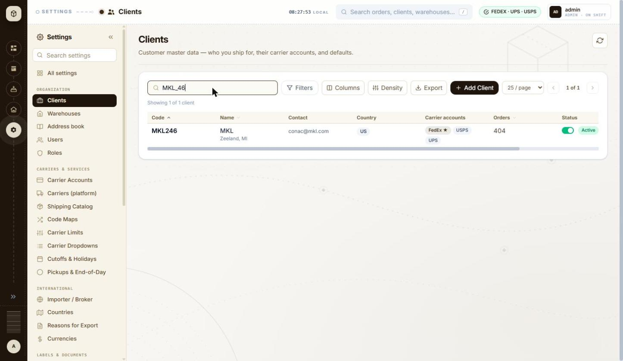
BUG-022 - screenshot (BUG-022.jpg)

BUG-024 - Importer / Broker dialog (Clients row menu): a click on the dimmed background closes it and throws away what was typed; Esc does nothing
Severity / type | Low / Usability
Where | Settings > Organization > Clients > Clients list - Row menu > Importer / Broker
URL | http://localhost:5173/settings/clients
Reproducibility | Always
Found | 2026-10-12, run R2, as admin (ADMIN)
Status | Open

Steps to reproduce
1. Open Settings > Clients (/settings/clients)
2. Scroll the table to the right and open the ⋮ menu on MKL246
3. Click Importer / Broker
4. Type QA-1012-IMP-BACKDROP in Importer name and QA Contact in Contact
5. Press Esc
6. Click on the dimmed background to the right of the dialog
7. Open ⋮ > Importer / Broker on MKL246 again
Test data
Client MKL246; Importer name QA-1012-IMP-BACKDROP; Contact QA Contact (nothing saved)
Expected
Esc and a background click behave the same way, and neither silently discards typed data: either they ask 'Discard changes?' when something has been typed, or only Cancel / X close the dialog. The Filters panel and Columns menu on the same page close on Esc.
Actual
Esc does nothing (the dialog stays open, focus moves to the X button). A single click on the dimmed background closes the dialog at once with no warning; reopening shows an empty form, so everything typed is lost.
Technical evidence
No request is sent on close (nothing saved). The form is long (client and destinations, importer of record, tax identity and further sections), so one stray click loses a lot of typing.
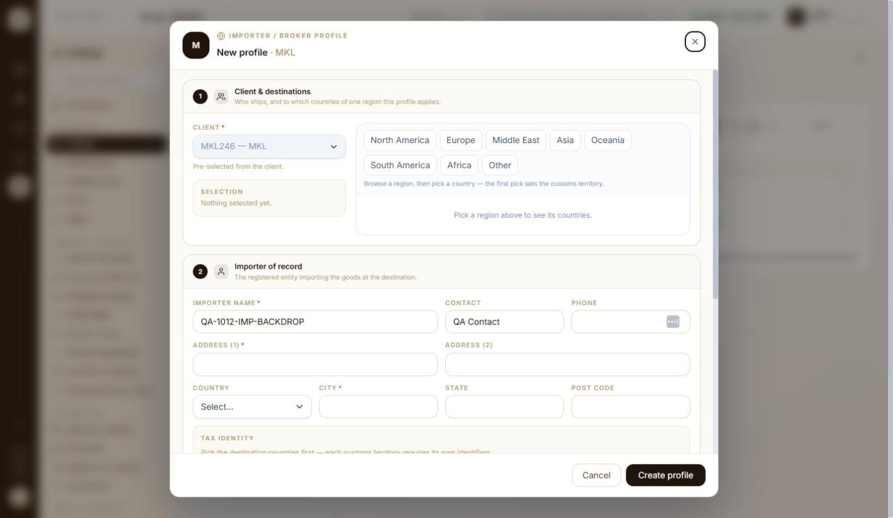
BUG-024 - screenshot (BUG-024.jpg)

BUG-025 - Clients list: the row menu (⋮ Importer / Broker, Edit, Delete) is off-screen at a 1446 px wide window; it is only reachable by scrolling the table sideways
Severity / type | Low / UI
Where | Settings > Organization > Clients > Clients list - Table width / row actions reachable at 1446 px
URL | http://localhost:5173/settings/clients
Reproducibility | Always
Found | 2026-10-12, run R2, as admin (ADMIN)
Status | Open

Steps to reproduce
1. Use a browser window 1446 x 840 with the Settings menu expanded
2. Open Settings > Clients (/settings/clients)
3. Look for the ⋮ menu at the end of each row
4. Scroll the table to the right with the horizontal scrollbar under the rows
Test data
Default column layout and Compact density; 2 clients
Expected
The row actions are visible without sideways scrolling: the seven default columns fit, and the Status column has a wide empty area after the Active badge.
Actual
The rows end at the Status column; the ⋮ menu (the only way to Edit or Delete a client) is hidden past the right edge. A horizontal scrollbar appears under the table, and the ⋮ buttons show only after scrolling right, when Code and Name scroll out of view.
Technical evidence
Window 1446 x 840, Settings menu expanded. With every column hidden (Columns menu) the ⋮ buttons appear at the right edge without scrolling, so the overflow comes from the column widths.
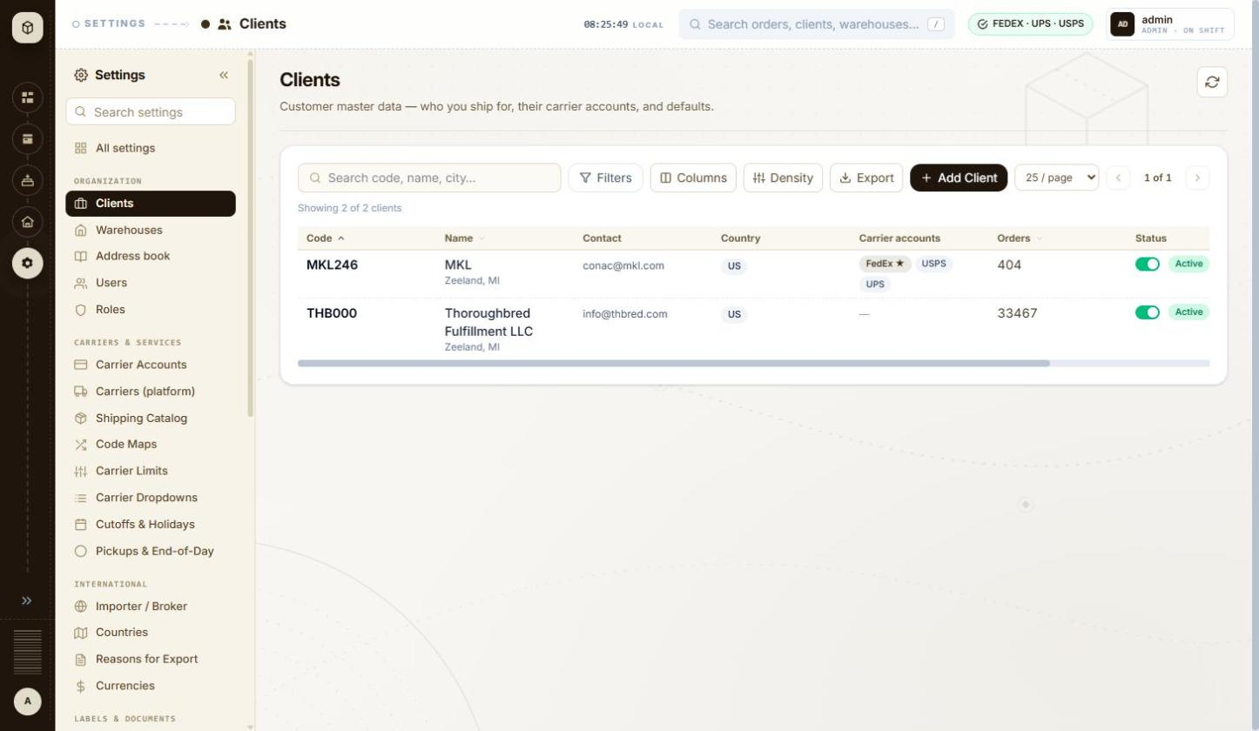
BUG-025 - screenshot 1 (BUG-025.jpg)
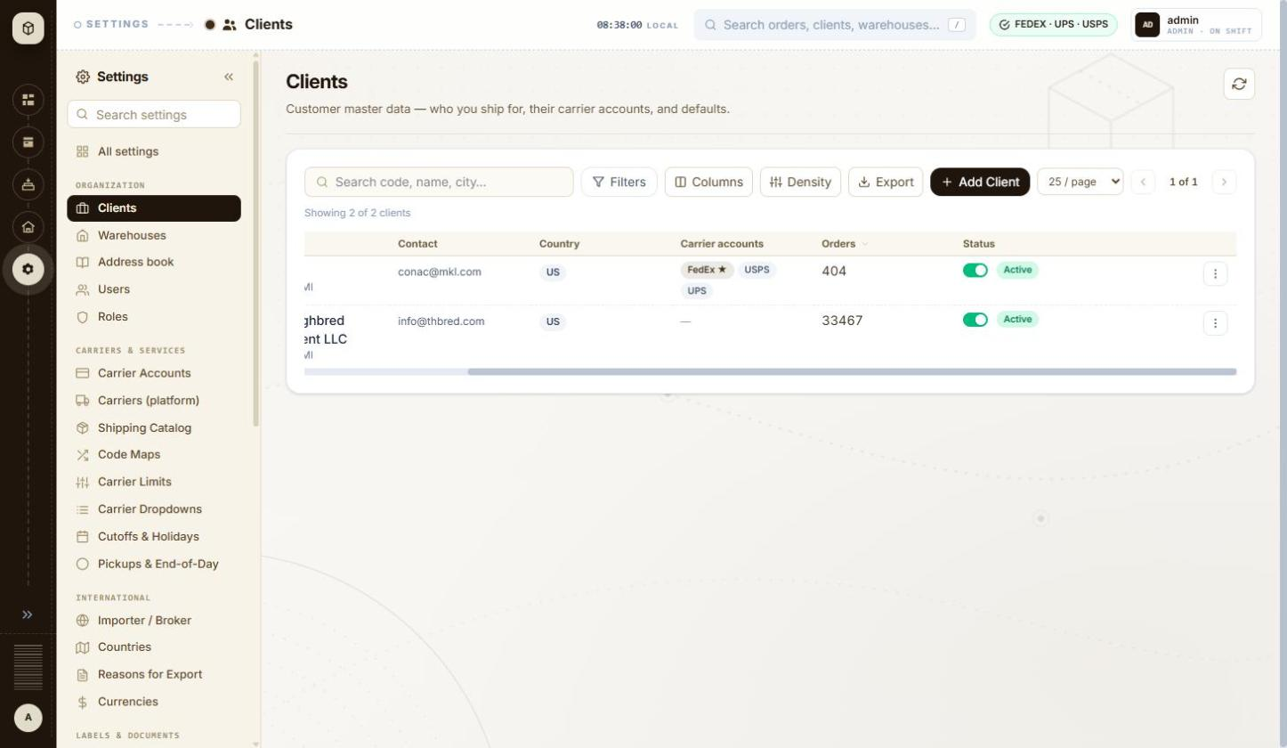
BUG-025 - screenshot 2 (BUG-025-2.jpg)

BUG-026 - Clients list sorting: after the third click on a header the arrow disappears, but the list is still sorted by Code ascending, so the next click on Code appears to do nothing
Severity / type | Low / UI
Where | Settings > Organization > Clients > Clients list - Sort by Code
URL | http://localhost:5173/settings/clients
Reproducibility | Always
Found | 2026-10-12, run R2, as admin (ADMIN)
Status | Open

Steps to reproduce
1. Open Settings > Clients (/settings/clients); the Code header shows an up arrow (Code ascending)
2. Click the Code header (Code descending: THB000 first)
3. Click the Code header again: no arrow is shown and the rows are MKL246, THB000
4. Click the Code header once more
Test data
2 clients (MKL246, THB000)
Expected
Each click visibly changes the sort, and the header arrow always matches the order shown: either the third click returns to 'Code ascending' with its arrow (as on page load), or the 'unsorted' state shows rows in a different, unsorted order.
Actual
After the second click the header shows no arrow although the rows are in Code ascending order (the page-load state, which shows an arrow). The following click only brings the arrow back; the rows do not move. Cycling Orders (descending, ascending, then a third click) ends in the same arrow-less Code ascending state.
Technical evidence
The 'no arrow' state requests GET /api/v1/clients?page=0&size=25&sortBy=code&sortDirection=ASC, the same request as page load and as 'Code ascending'.
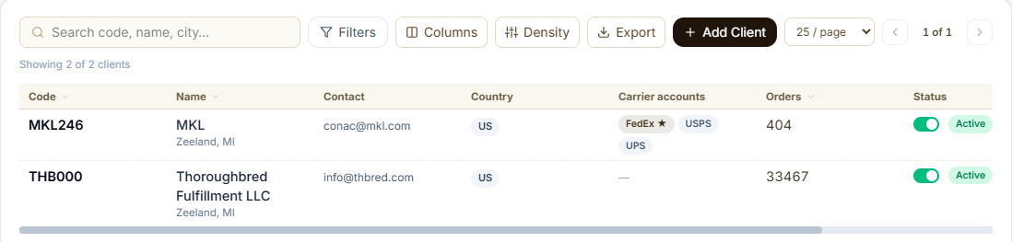
BUG-026 - screenshot (BUG-026.png)

BUG-027 - Client wizard > Timezone: searching 'Kolkata' or 'Kyiv' finds nothing; the list only has the old names Asia/Calcutta and Europe/Kiev
Severity / type | Low / Usability
Where | Settings > Organization > Clients > Client wizard (Add / Edit) - Defaults > Timezone (IANA search and locate button)
URL | http://localhost:5173/settings/clients/new
Reproducibility | Always
Found | 2026-10-12, run R2, as admin (ADMIN)
Status | Open

Steps to reproduce
1. Open Settings > Clients and click + Add Client
2. In Defaults > Timezone type Kolk
3. Replace it with Calcutta
4. Replace it with Kyiv, then with Kiev
5. Click the locate button 'Detect timezone from browser' (browser set to India time)
Test data
Timezone search terms Kolk, Calcutta, Kyiv, Kiev
Expected
The field asks for an IANA name ('IANA (e.g. America/New_York)'); the current IANA names Asia/Kolkata and Europe/Kyiv are offered (old aliases may also match), so a user searching the city's current name finds it.
Actual
'Kolk' and 'Kyiv' show 'No timezone matches ...'. 'Calcutta' offers Asia/Calcutta (UTC+05:30) and 'Kiev' offers Europe/Kiev. The locate button also fills Asia/Calcutta.
Technical evidence
The list appears to come from the browser's own time-zone list, which in Chrome still uses the old aliases.
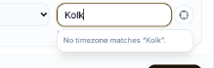
BUG-027 - screenshot 1 (BUG-027.png)
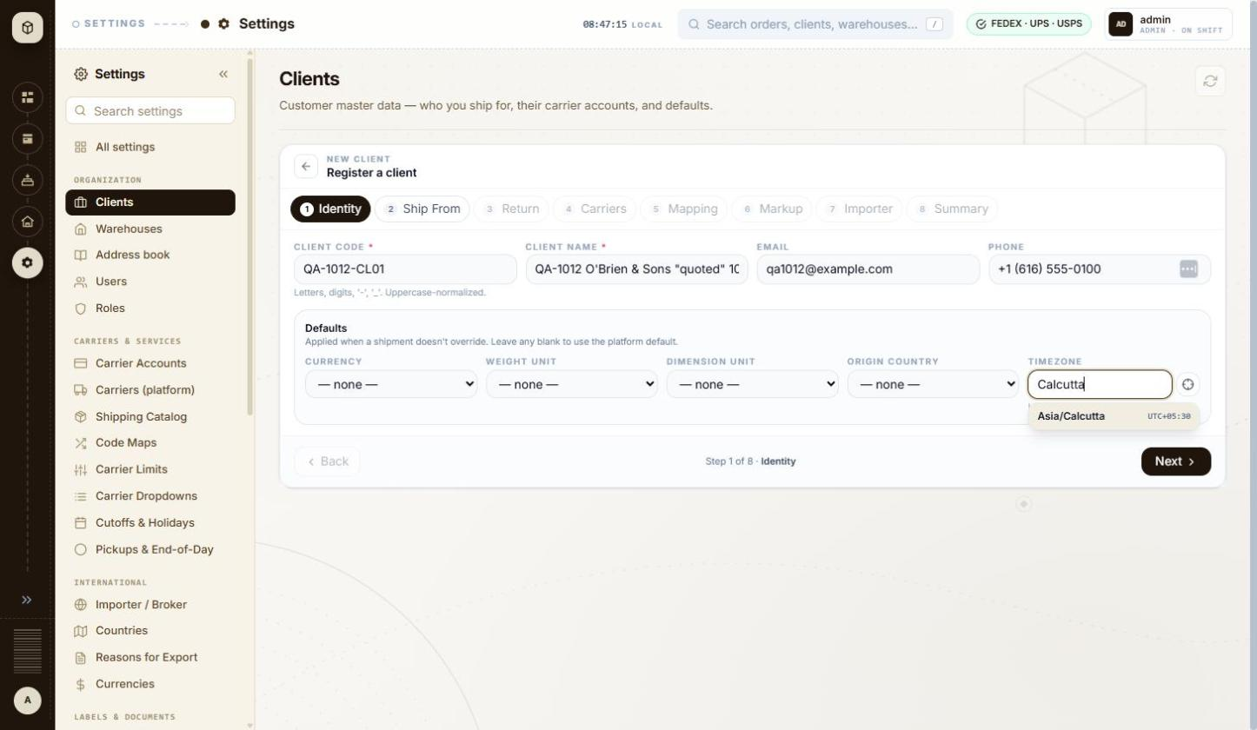
BUG-027 - screenshot 2 (BUG-027-2.jpg)

BUG-029 - Client wizard > Carriers: the UPS account number hint and its error message give different rules ('exactly 6 alphanumerics' vs '6-10 letters or digits')
Severity / type | Low / Content
Where | Settings > Organization > Clients > Client wizard (Add / Edit) - Carrier accounts grid for the client (+ Add Account, default star)
URL | http://localhost:5173/settings/clients/new
Reproducibility | Always
Found | 2026-10-12, run R2, as admin (ADMIN)
Status | Open

Steps to reproduce
1. Open Settings > Clients and click + Add Client
2. Fill step 1, pick a warehouse on step 2, go on to step 4 Carriers
3. Click + Add carrier account; Carrier is UPS
4. Read the grey hint under Account number
5. Type 12 in Account number and click into Client ID
6. Replace it with QA10127890123 and click into Client ID
Test data
Carrier UPS; Account number 12, then QA1012!! (saved as QA1012)
Expected
The hint and the error state the same rule, so the user knows whether a 7-10 character UPS number is allowed.
Actual
The grey hint reads 'UPS shipper numbers are exactly 6 alphanumerics.' while the red error, shown for a shorter value, reads 'UPS shipper number is 6-10 letters or digits'. The field itself stops at 6 characters (typing QA10127890123 leaves QA1012), so the error message is the wrong one and tells the user to try lengths the field will not accept. DHL Express has the same mismatch: hint 'DHL Express account numbers are up to 9 digits.' against error 'DHL Express account number is 9-12 digits', and the field accepts letters (QA1012QA1) although both texts say digits.
Technical evidence
Account number input caps at 6 characters for UPS and strips punctuation as typed (QA1012!! becomes QA1012). Only the error text disagrees with the hint and with the field's own behaviour.
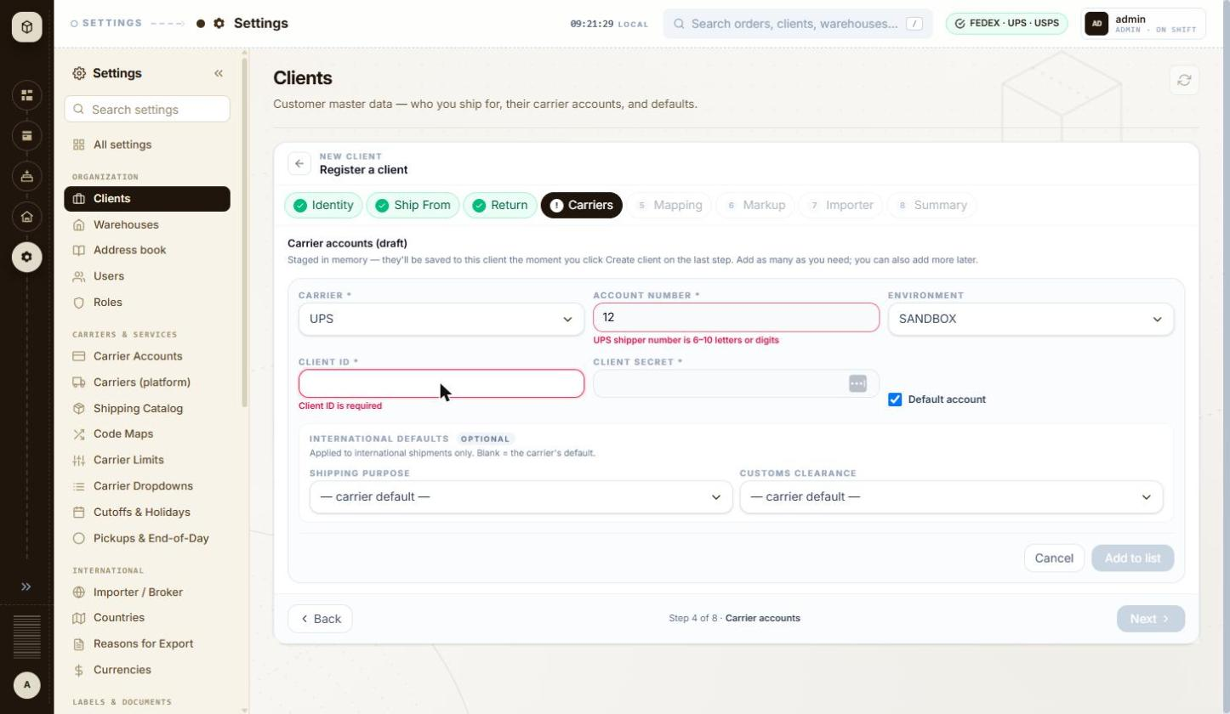
BUG-029 - screenshot 1 (BUG-029.jpg)
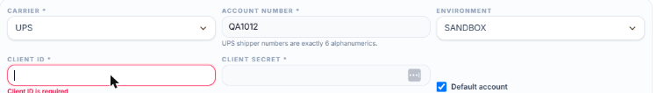
BUG-029 - screenshot 2 (BUG-029-2.png)

BUG-031 - Client wizard > Carriers: 'Add to list' greys out with the tooltip 'Fix the highlighted fields to continue' while no field is highlighted
Severity / type | Low / Usability
Where | Settings > Organization > Clients > Client wizard (Add / Edit) - Carrier accounts grid for the client (+ Add Account, default star)
URL | http://localhost:5173/settings/clients/new
Reproducibility | Always
Found | 2026-10-12, run R2, as admin (ADMIN)
Status | Open

Steps to reproduce
1. Open Settings > Clients and click + Add Client; fill step 1 and step 2
2. On step 4 Carriers click + Add carrier account
3. Choose carrier DHL Express and type the account number QA1012QA1 (letters and digits)
4. Fill Client ID and Client secret
5. Look at the Add to list button and hover over it
Test data
Carrier DHL Express, account number QA1012QA1; hint under the field: 'DHL Express account numbers are up to 9 digits.'
Expected
Either the account number is accepted, or the field that fails is marked in red with its message, so the user can see what to fix.
Actual
Add to list is greyed and its tooltip says 'Fix the highlighted fields to continue', but no field is red and no message is shown. The value only becomes acceptable after the carrier is changed to UPS or the letters are removed, which the user has to work out for themselves.
Technical evidence
The button is not really disabled (disabled=false) - it only looks greyed and carries the tooltip, so a click gives no feedback either.
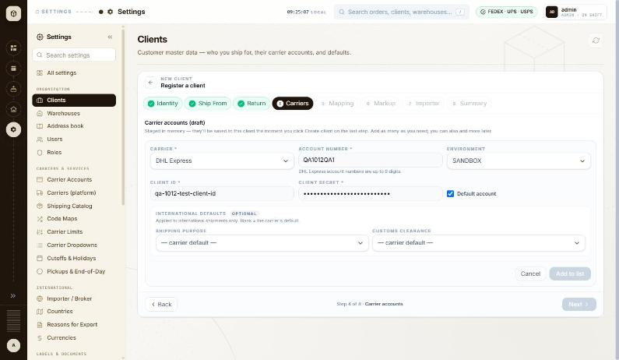
BUG-031 - screenshot (BUG-031.jpg)

BUG-032 - Creating a client shows the raw error code MARKUP_REQUIRED_FOR_CLIENT in the 'Heads up' message
Severity / type | Low / Content
Where | Settings > Organization > Clients > Client wizard (Add / Edit) - Markup: kind (Percent / Flat), Value, Currency, Preview, Save markup
URL | http://localhost:5173/settings/clients/new
Reproducibility | Always
Found | 2026-10-12, run R2, as admin (ADMIN)
Status | Open

Steps to reproduce
1. Create a client through Settings > Clients > + Add Client, skipping the Markup step
2. Read the 'Heads up' toast shown after Submit
Test data
Client QA-1012-CL01 created with no billing markup
Expected
The message explains in words that labels will be refused until a billing markup is set; the internal code belongs in the log, not in the message.
Actual
'Set a billing markup for QA-1012-CL01 on the Markup tab before generating labels - MARKUP_REQUIRED_FOR_CLIENT will otherwise reject every label call for this client.'
Technical evidence
The rest of the sentence already says what happens, so the code adds nothing for the user. The same warning is useful on the Markup step itself, which is only marked amber.
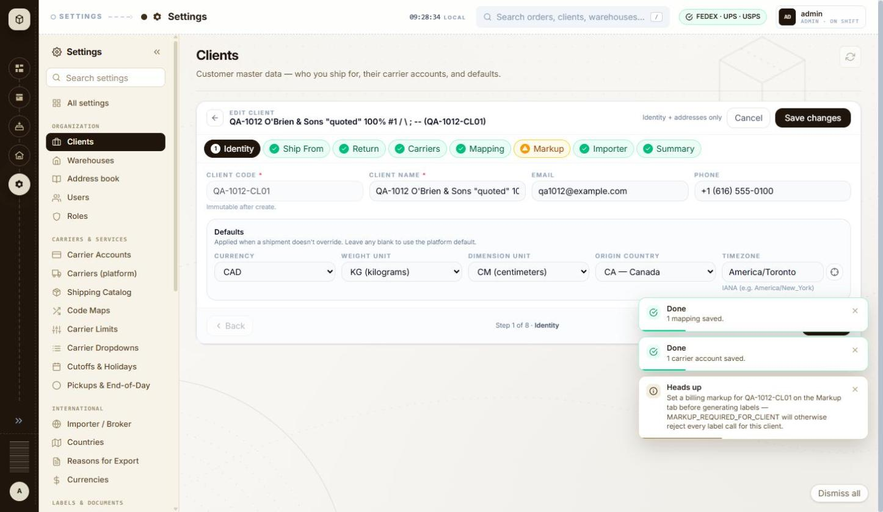
BUG-032 - screenshot (BUG-032.jpg)

BUG-033 - Client wizard > Return address: the State limit is credited to USPS in both modes but changes from 'max 2 chars' to 'max 5 chars' on a client with no USPS account
Severity / type | Low / Content
Where | Settings > Organization > Clients > Client wizard (Add / Edit) - Return address: Same as Ship From / own address
URL | http://localhost:5173/settings/clients/QA-1012-CL01
Reproducibility | Always
Found | 2026-10-12, run R2, as admin (ADMIN)
Status | Open

Steps to reproduce
1. Open Settings > Clients and click + Add Client
2. On step 3 Return address untick 'Same as Ship From' and read the hint under STATE: 'max 2 chars - USPS'
3. Finish the wizard with a single UPS carrier account
4. Open the saved client (Edit) and go to step 3 Return address
5. Read the hint under STATE again
Test data
Client QA-1012-CL01, one carrier account: UPS - QA1012 (SANDBOX)
Expected
The hint names the carrier whose limit is being applied. The other fields do this correctly: with only UPS on the client they read 'max 35 chars - UPS', 'max 9 chars - UPS'.
Actual
STATE reads 'max 2 chars - USPS' in the new-client wizard and 'max 5 chars - USPS' on the saved client, although that client has no USPS account. Two different limits are attributed to the same carrier, and the carrier named is one the client does not use.
Technical evidence
Same page, same field. In the wizard (no carrier staged yet) the limits shown are the strictest across all carriers ('UPS / FEDEX' appears on other fields); on the saved client they narrow to the client's own carriers, and only STATE keeps the USPS label.
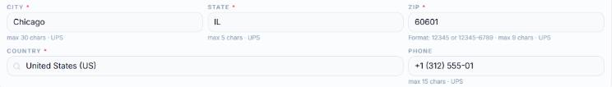
BUG-033 - screenshot (BUG-033.png)

BUG-034 - Billing markup: a negative or non-numeric value is only refused by the server, as a 'Something went wrong' toast, with nothing marked on the field
Severity / type | Low / Validation
Where | Settings > Organization > Clients > Client wizard (Add / Edit) - Markup: kind (Percent / Flat), Value, Currency, Preview, Save markup
URL | http://localhost:5173/settings/clients/QA-1012-CL01
Reproducibility | Always
Found | 2026-10-12, run R2, as admin (ADMIN)
Status | Open

Steps to reproduce
1. Open Settings > Clients, open a client and go to step 6 Markup
2. Choose Percent of rate and type -5 in Value, then click Save markup
3. Replace the value with abc and click Save markup again
Test data
Client QA-1012-CL01; markup values -5 and abc
Expected
The form refuses a negative or non-numeric percentage as the field is typed, the way the Identity and Return steps do, and the field is marked with the reason. A failed save is not reported as an unexpected error.
Actual
Both values are accepted by the field. The live preview simply disappears with no message, Save markup stays active, and the save fails with a red toast headed 'Something went wrong' and the detail 'Value must be a non-negative number.' The field itself is never marked.
Technical evidence
The Value input is type=text with no min, max or step. The preview panel vanishing also moves the Save markup button up by about 80 px, so a click aimed at it can land on Next instead (seen during this test).
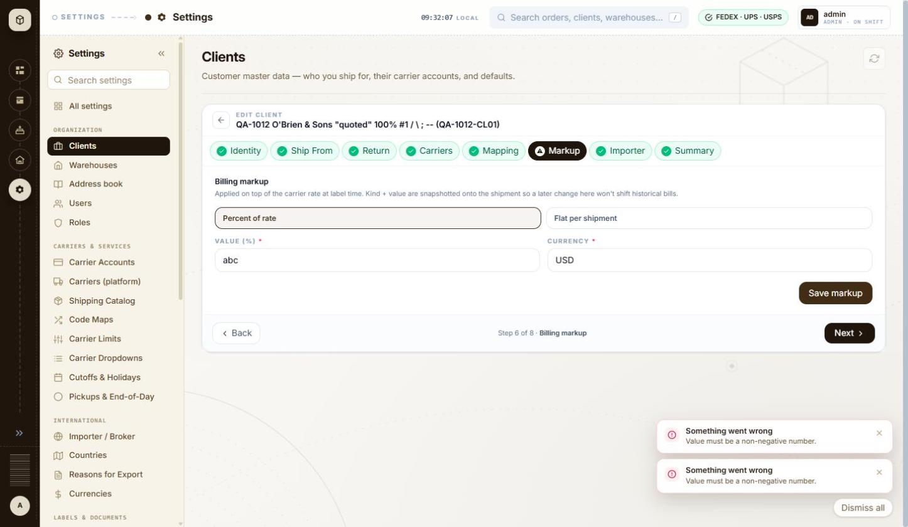
BUG-034 - screenshot (BUG-034.jpg)

BUG-035 - Billing markup preview formats a USD amount with Indian digit grouping: $2,50,00,00,00,024.75 instead of $250,000,000,024.75
Severity / type | Low / UI
Where | Settings > Organization > Clients > Client wizard (Add / Edit) - Markup: kind (Percent / Flat), Value, Currency, Preview, Save markup
URL | http://localhost:5173/settings/clients/QA-1012-CL01
Reproducibility | Always
Found | 2026-10-12, run R2, as admin (ADMIN)
Status | Open

Steps to reproduce
1. Open Settings > Clients, open a client and go to step 6 Markup
2. Choose Percent of rate, currency USD
3. Type 999999999999 in Value
4. Read the PREVIEW line
Test data
Markup: Percent of rate, value 999999999999, currency USD; preview base rate $25.00
Expected
A USD amount is grouped in thousands: $250,000,000,024.75.
Actual
The preview reads 'On a $25.00 carrier rate, this markup produces a billable amount of $2,50,00,00,00,024.75.' - lakh/crore grouping. The amount itself is right; only the grouping is wrong.
Technical evidence
The number appears to be formatted with the browser's own locale rather than a locale chosen for the currency, so the same screen shows $25.00 (US style) and $2,50,00,00,00,024.75 (Indian style) side by side. Worth checking everywhere money is printed, labels and invoices included.
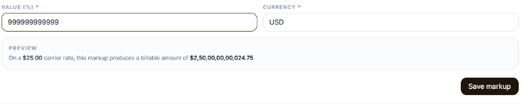
BUG-035 - screenshot (BUG-035.png)

BUG-036 - Edit client: ordinary validation failures are announced as 'Something went wrong', the same red heading the app uses for server errors
Severity / type | Low / Content
Where | Settings > Organization > Clients > Client wizard (Add / Edit) - Edit mode: Cancel and Save changes ('Identity + addresses only')
URL | http://localhost:5173/settings/clients/QA-1012-CL01
Reproducibility | Always
Found | 2026-10-12, run R2, as admin (ADMIN)
Status | Open

Steps to reproduce
1. Open Settings > Clients and open a client (row menu > Edit)
2. Clear Client name on step 1 Identity
3. Click Save changes
4. Go to step 6 Markup, type -5 in Value and click Save markup
Test data
Client QA-1012-CL01; empty Client name; markup value -5
Expected
A field the user has to correct is reported as such ('Fix the highlighted fields to save'), without the heading the app uses when something unexpected has failed.
Actual
Both show a red toast headed 'Something went wrong' with the real message underneath: 'Fix the highlighted fields to save.' and 'Value must be a non-negative number.' The same heading was seen on a genuine 502 during the earlier shipment run (BUG-016), so the user cannot tell a typo from an outage.
Technical evidence
The on-field message 'Name is required.' is shown correctly at the same time, so only the toast heading is at fault.
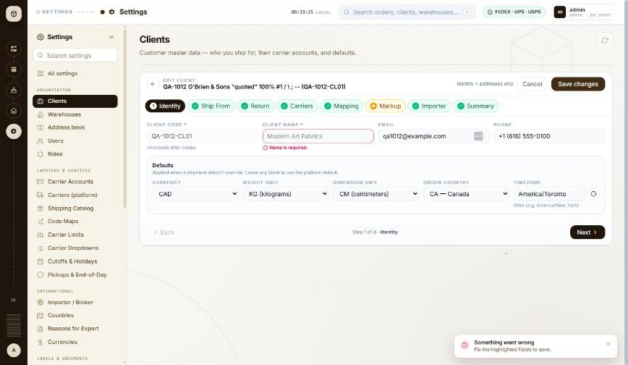
BUG-036 - screenshot (BUG-036.jpg)

BUG-037 - Error toasts never time out: a failed-delete message was still on screen 38 minutes later, through navigation and other work
Severity / type | Low / Usability
Where | Settings > Organization > Clients > Clients list - Toasts and messages (success, validation, server errors)
URL | http://localhost:5173/settings/clients
Reproducibility | Always
Found | 2026-10-12, run R2, as admin (ADMIN)
Status | Open

Steps to reproduce
1. Open Settings > Clients (/settings/clients)
2. Scroll the table right, open the row menu on MKL246 and click Delete (it is refused because the client has orders)
3. Carry on working: open other Settings steps, edit a client, come back
4. Look at the bottom right of the window
Test data
Toast 'Something went wrong - MKL246 has 404 pending order(s). Complete or void them before deleting.' raised at 09:37, still shown at 10:15
Expected
An error message disappears on its own after a short time, like the green 'Done' toasts, or at the latest when the user moves to another screen.
Actual
Red toasts stay until clicked away. They survive moving between wizard steps and back to the list, and they stack: three were on screen at once earlier in this run. Each one covers the bottom-right corner of the page.
Technical evidence
Green success toasts ('Markup saved for QA-1012-CL01.') do disappear by themselves, so only the error ones are affected. A 'Dismiss all' button appears once more than one is open.
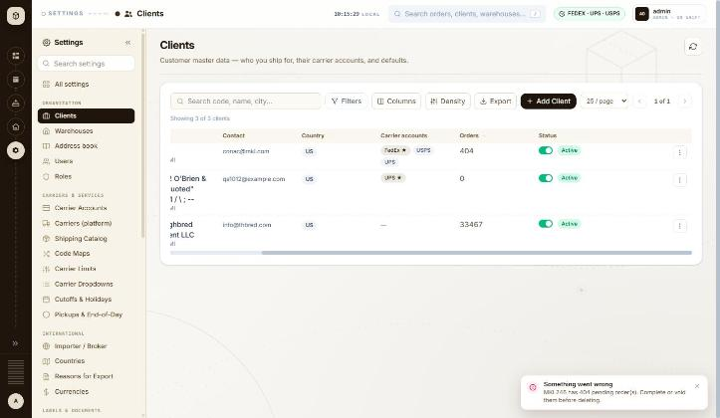
BUG-037 - screenshot (BUG-037.jpg)

BUG-039 - Client wizard: the top breadcrumb still reads 'Settings' and the browser tab is always 'multiship-react', so neither says which client is open
Severity / type | Low / UI
Where | Settings > Organization > Clients > Client wizard (Add / Edit) - Breadcrumb and browser tab title in the wizard
URL | http://localhost:5173/settings/clients/new
Reproducibility | Always
Found | 2026-10-12, run R2, as admin (ADMIN)
Status | Open

Steps to reproduce
1. Open Settings > Clients and click + Add Client (/settings/clients/new)
2. Look at the breadcrumb in the top bar and at the browser tab title
3. Open an existing client with the row menu > Edit (/settings/clients/MKL246) and look again
Test data
Pages /settings/clients, /settings/clients/new and /settings/clients/MKL246
Expected
The breadcrumb follows the page, as it does on the list itself ('Settings > Clients'), and the tab title names the screen and the record, so a user with several tabs open can tell them apart and a bookmark is meaningful.
Actual
On both wizard pages the breadcrumb shows only 'Settings', losing the 'Clients' step and the client, even though the page header shows 'EDIT CLIENT - MKL (MKL246)'. The browser tab reads 'multiship-react' on every page in the application.
Technical evidence
document.title is 'multiship-react' on /settings/clients, /settings/clients/new and /settings/clients/MKL246.
No screenshot file was captured for this item.

BUG-042 - Warehouse address Verify reports the raw status NOT_SUPPORTED, and the green tick icon makes a refusal look like a pass
Severity / type | Low / Content
Where | Settings > Organization > Warehouses > Warehouses list - Add / Edit warehouse panel: carrier address Verify
URL | http://localhost:5173/settings/warehouses
Reproducibility | Always
Found | 2026-10-12, run R2, as admin (ADMIN)
Status | Open

Steps to reproduce
1. Open Settings > Warehouses, open a warehouse with the row menu > Edit
2. Next to ADDRESS pick carrier UPS and click Verify
3. Repeat with FEDEX and with USPS
Test data
Warehouse QA-1012-WH01, 742 Evergreen Terrace, Springfield, ILLINOIS, 62704-1234, US; carriers UPS, FEDEX, USPS
Expected
The result is written for the user, and an address that was not checked does not carry a success tick.
Actual
Each result line reads '<CARRIER> - NOT_SUPPORTED' with a green circled-tick icon in front of it. UPS and FedEx add 'No live credentials for <carrier> - cannot call address validation.'; USPS adds 'SERA address validation needs live credentials; the account is on a fallback token.' The explanations are clear, but the raw enum and the tick icon together read as though the address passed.
Technical evidence
POST /api/v1/addresses/validate/carrier -> 200 for each of the three carriers; no carrier was actually contacted, because the sandbox accounts have no live address-validation credentials. The address itself (state 'ILLINOIS') therefore went unchecked - see BUG-040. Each result has its own Dismiss link.
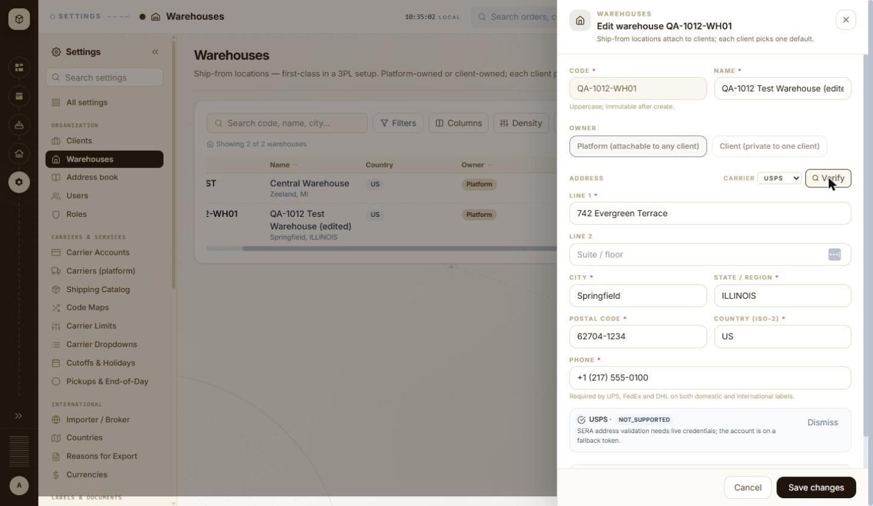
BUG-042 - screenshot (BUG-042.jpg)

BUG-047 - Users search is not debounced: every keystroke sends a search request and a second request that reloads the audit list
Severity / type | Low / Performance
Where | Settings > Organization > Users > Users list - Search username, email, name
URL | http://localhost:5173/settings/users
Reproducibility | Always
Found | 2026-10-12, run R2, as admin (ADMIN)
Status | Open

Steps to reproduce
1. Open Settings > Users (/settings/users)
2. Type manoj into 'Search username, email, name...' at a normal typing speed
3. Watch the requests the page sends
Test data
Search term 'manoj' (5 characters)
Expected
The search waits for a pause before asking the server, the way the Clients and Warehouses lists do - one request per settled term.
Actual
Ten requests for five characters: GET /api/v1/admin/users?search=m, ...search=ma, ...search=man and so on, each followed by GET /api/v1/admin/users/audit?limit=50. The audit list has nothing to do with the search term and is reloaded every time.
Technical evidence
53 requests were captured over a short search session on this screen. The Clients list sends one request per settled term for the same kind of search box, so the two behave differently.
No screenshot file was captured for this item.

BUG-048 - Invite user: a bad email address is reported under the heading 'This shipment needs attention', with the raw field message repeated underneath
Severity / type | Low / Content
Where | Settings > Organization > Users > Users list - Invite user form (fields, validation, send)
URL | http://localhost:5173/settings/users
Reproducibility | Always
Found | 2026-10-12, run R2, as admin (ADMIN)
Status | Open

Steps to reproduce
1. Open Settings > Users (/settings/users)
2. Click Invite user
3. Type not-an-email in Email and pick client THB000
4. Click Send invite
Test data
Email 'not-an-email', client THB000, role USER
Expected
A message about the user being invited, shown once, in words: for example 'Enter a valid email address'. Nothing about shipments.
Actual
A red toast headed 'This shipment needs attention' with two lines: 'Email must be a well-formed email address.' and 'email - must be a well-formed email address'. The heading belongs to the shipment screens, and the second line is the raw field-and-message pair repeated.
Technical evidence
No request is sent, so the check is in the page. The same dialog with an empty form shows a third heading, 'Something went wrong - Email and client are required.' - so one small form produces three different heading styles, none of which marks the field itself.
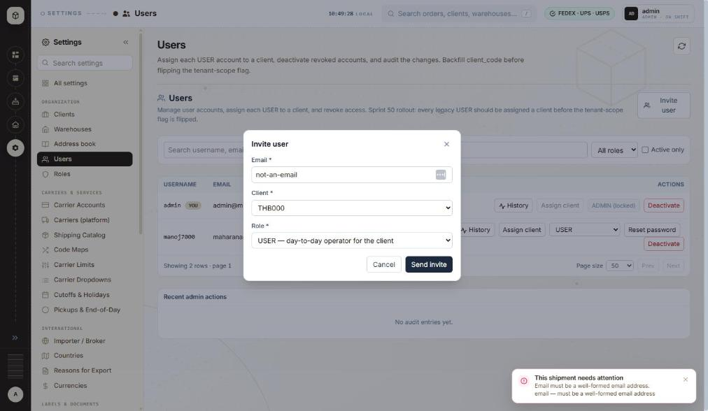
BUG-048 - screenshot (BUG-048.jpg)

BUG-049 - Internal developer notes are printed in the page descriptions users read: sprint numbers, database column names and a to-do
Severity / type | Low / Content
Where | Settings > Organization > Users > Users list - Page header and description
URL | http://localhost:5173/settings/users
Reproducibility | Always
Found | 2026-10-12, run R2, as admin (ADMIN)
Also affects | Settings > Email & Alerts > Mail > Mail; Settings > Organization > Roles > Roles list
Status | Open

Steps to reproduce
1. Open Settings > Users (/settings/users) and read the page description and the panel description
2. Open Settings > Mail (/settings/mail) and read the page description
3. Open Settings > Roles (/settings/roles) and read the page description
Test data
No data needed - the text is part of the page
Expected
The description tells the user what the screen is for. Sprint numbers, column names and internal to-dos belong in the backlog.
Actual
Users, page description: 'Assign each USER account to a client, deactivate revoked accounts, and audit the changes. Backfill client_code before flipping the tenant-scope flag.' Users, panel description: '...Sprint 50 rollout: every legacy USER should be assigned a client before the tenant-scope flag is flipped.' Mail, page description: '...pick SMTP today (SendGrid/SES/Postmark coming), edit host/port/creds, and send a live test message. Config lives in mail_provider + mail_config.' Roles, page description: 'Platform-wide role registry. Read-only; add roles via SQL today.'
Technical evidence
'client_code', 'mail_provider' and 'mail_config' are database identifiers; 'Sprint 50 rollout' and 'SendGrid/SES/Postmark coming' are roadmap notes. Other Settings pages are written for the user ('Customer master data - who you ship for, their carrier accounts, and defaults.'), so this is not the house style.
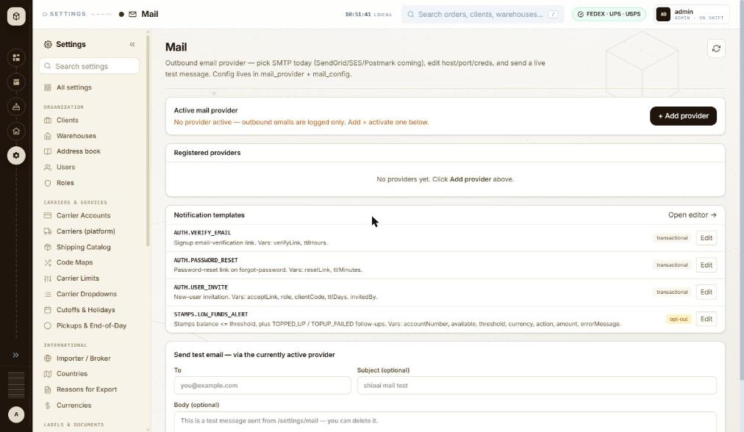
BUG-049 - screenshot (BUG-049.jpg)

5. Queries and suggestions
These are not defects. Queries are behaviours where the intended rule is unclear and a decision is needed; suggestions are possible improvements.

BUG-017 - Order API: shippingDetails.weight holds one box's weight on two-box orders, not the shipment total - intended?
Type | Query
Where | API > Orders > Order detail (GET /api/v1/orders/{id}) - shippingDetails.weight
URL | /api/v1/orders/{id}
Reproducibility | Always (97 of 97)
Found | 2026-10-11, run R1, as admin (ADMIN)
Status | Open

Steps to reproduce
1. GET /api/v1/orders/934190 (2 boxes of 2 lb)
2. Read data.shippingDetails.weight and data.orderDetails.packageCount
Test data
All 97 two-box orders of the run, e.g. #934190 (2 x 2 lb), #934172 (THB 2 x 5 lb)
Expected
If the field is the order weight, it should be the total (4 lb, 10 lb); if it is per box, the name or docs should say so and per-box weights should be available.
Actual
weight 2 for #934190 and 5 for #934172; on all 97 two-box orders it equals one box's weight.

BUG-018 - Shipment check (USPS to UK and Mexico): every check says 'USPS normalised the address; review before shipping' without showing what changed
Type | Query
Where | Orders > New order > New order form (international) - Shipment check panel
URL | /orders/new
Reproducibility | Always (10 of 10 UK/Mexico USPS checks)
Found | 2026-10-11, run R1, as admin (ADMIN)
Status | Open

Steps to reproduce
1. Open Orders and click + New shipment (/orders/new)
2. Client: MKL246 (ship from 3PL-EAST, the client default)
3. Carrier: USPS
4. Ship to the UK (1 Canada Square, London E14 5AB) or Mexico (as above)
5. Complete the form and click Validate shipment
Test data
UK #934147-#934151, Mexico #934186-#934190 (10 of 10); not shown for Canada
Expected
Show the normalised address (or the difference) so it can be reviewed, and only flag it when something changed.
Actual
'Ready to ship — 1 thing to review: USPS normalised the address; review before shipping.' with no address shown.

BUG-019 - Shipment check (FedEx to UK): billed-weight notes of 68, 52 and 22 lb seen during the run, about 3-9 times the figures for the same boxes to Mexico
Type | Query
Where | Orders > New order > New order form (international) - Shipment check panel
URL | /orders/new
Reproducibility | 5 times during the run; 0 of 1 on retest
Found | 2026-10-11, run R1, as admin (ADMIN)
Status | Open

Steps to reproduce
1. Open Orders and click + New shipment (/orders/new)
2. Client: MKL246 (ship from 3PL-EAST, the client default)
3. Carrier: FedEx
4. Ship to: 1 Canada Square, London E14 5AB, United Kingdom
5. Service level: FedEx International Priority
6. Packaging FedEx Tube, Weight 3; Add another box; Apply box 1 to all
7. Complete customs, importer and items; click Validate shipment
Test data
Run: #934115 and #934122 (2 tubes 38x6x6 in): 68 lb; #934121 (2 Paks): 52 lb; #934117 and #934124 (2 boxes 12x9x4 in): 22 lb. Mexico for the same boxes: 19.68, 5.52 and 6.22 lb
Expected
The same boxes give the same billed weight on every lane (19.68 lb for the two tubes).
Actual
During the run the UK checks showed billed weights of 68 lb (two tubes), 52 lb (two Paks) and 22 lb (two 12x9x4 in boxes: '22 lb - charged on box size, not the 4 lb it weighs'). On retest 2026-10-12 the same UK tube shipment showed the expected 19.68 lb, so it did not reproduce. Raised so the team can check whether the figure comes from the FedEx sandbox response or the app.
BUG-019 - screenshot (BUG-019.jpg)

BUG-020 - New shipment (FedEx): Label size stays 'Thermal stock 4×6' when Label type is switched to PDF
Type | Suggestion
Where | Orders > New order > New order form (international) - Label size (FedEx)
URL | /orders/new
Reproducibility | Always
Found | 2026-10-11, run R1, as admin (ADMIN)
Status | Open

Steps to reproduce
1. Open Orders and click + New shipment (/orders/new)
2. Client: MKL246 (ship from 3PL-EAST, the client default)
3. Carrier: FedEx; any international destination
4. Change Label type from ZPLII (Zebra) to PDF
5. Look at Label size
Test data
All FedEx shipments of the run were set to Paper 4x6 by hand
Expected
Switching to PDF moves Label size to a paper size (for example Paper 4x6).
Actual
Label size remains 'Thermal stock 4×6' next to Label type 'PDF (vector, sharp)'.
BUG-020 - screenshot (BUG-020.jpg)

BUG-021 - Importer & broker override: choosing Type 'Receiver · DAP' leaves every field empty instead of using the ship-to details
Type | Suggestion
Where | Orders > New order > Importer & broker override dialog - Type (Business / Receiver)
URL | /orders/new
Reproducibility | Always
Found | 2026-10-11, run R1, as admin (ADMIN)
Status | Open

Steps to reproduce
1. Open Orders and click + New shipment (/orders/new)
2. Client: MKL246 (ship from 3PL-EAST, the client default)
3. Carrier: FedEx
4. Ship to: Full name QA Test Recipient, Company QA Test Co, Address line 1 290 Bremner Blvd, Country Canada (CA), Phone 4165550100, State / region ON, City Toronto, Postal code M5V 3L9
5. Importer of record & customs broker > Add
6. Type: Receiver · DAP
Test data
Every international shipment of the run (MKL246 has no importer profile for CA, GB or MX)
Expected
Receiver fills (or offers to fill) name, address, city, state, post code and phone from Ship to.
Actual
All fields stay empty apart from Country; all 7 values had to be typed for each of the 128 orders.
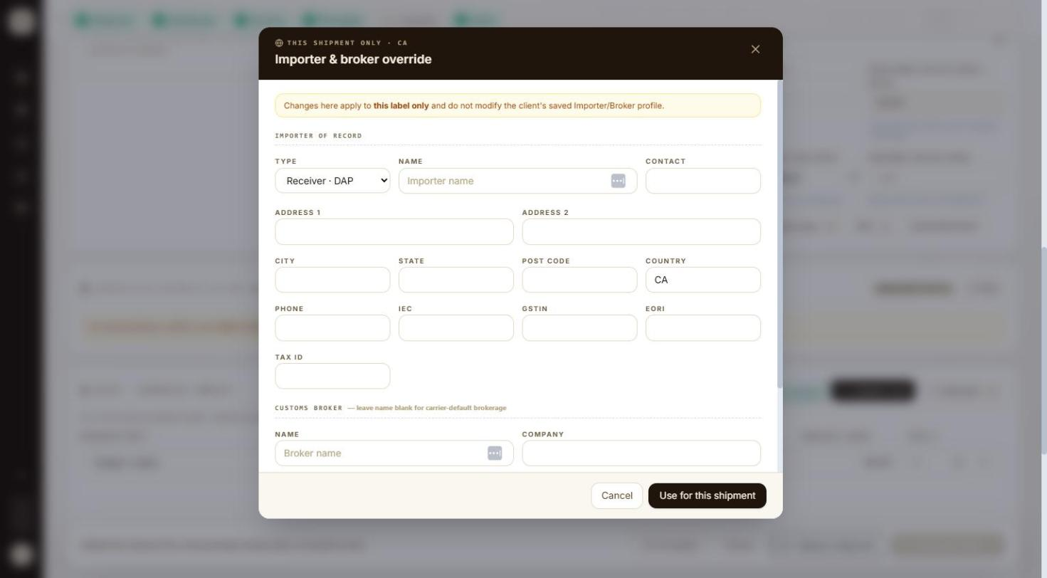
BUG-021 - screenshot (BUG-021.jpg)

BUG-023 - Clients > Columns: every column can be hidden, leaving blank rows with only the row menu (Edit, Delete)
Type | Suggestion
Where | Settings > Organization > Clients > Clients list - Columns (show/hide + pin)
URL | http://localhost:5173/settings/clients
Reproducibility | Always
Found | 2026-10-12, run R2, as admin (ADMIN)
Status | Open

Steps to reproduce
1. Open Settings > Clients (/settings/clients)
2. Click Columns
3. Untick Code, Name, Contact, Country, Carrier accounts, Orders and Status
4. Press Esc to close the menu
Test data
Default column layout; 2 clients (MKL246, THB000)
Expected
At least one identifying column (for example Code) stays visible, or the last ticked column cannot be unticked, so each row still shows which client it is.
Actual
All seven columns can be unticked. The grid then shows an empty header and two blank rows with only the ⋮ row menu, whose Edit and Delete act on a client the user cannot see. 'Reset layout' in the Columns menu brings the columns back.
Technical evidence
Reloading the page keeps the blank grid (column layout is remembered in the browser), so it stays until Columns > Reset layout is used.
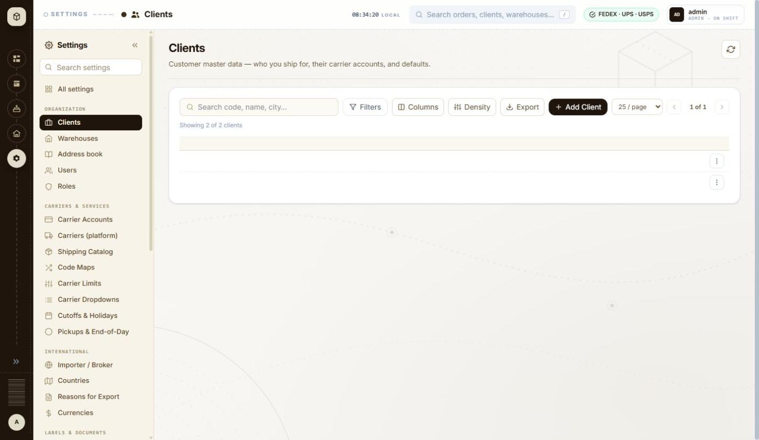
BUG-023 - screenshot (BUG-023.jpg)

BUG-038 - Clients Export: the button promises 'visible columns, filtered rows' but the request carries no column information, so hidden columns are unlikely to be left out
Type | Query
Where | Settings > Organization > Clients > Clients list - Export (CSV of current view)
URL | http://localhost:5173/settings/clients
Reproducibility | Always
Found | 2026-10-12, run R2, as admin (ADMIN)
Status | Open

Steps to reproduce
1. Open Settings > Clients (/settings/clients)
2. Hover over Export and read the tooltip
3. Click Export and look at the request the page sends
4. Type THB in the search box and click Export again
5. Hide the Contact column from the Columns menu and click Export again
Test data
3 clients; search THB; Contact column hidden
Expected
Either the CSV matches the view as the tooltip says, or the tooltip only promises what the export really does.
Actual
The tooltip reads 'Export the current view as CSV - visible columns, filtered rows'. Rows are honoured: the request becomes /api/v1/clients/export.csv?sortBy=code&sortDirection=ASC&search=THB. Columns are not sent at all - the request is identical with the Contact column hidden - so the server cannot know which columns to leave out.
Technical evidence
Requests seen on Clients: .../export.csv?sortBy=code&sortDirection=ASC and .../export.csv?sortBy=code&sortDirection=ASC&search=THB, both 200. The downloaded file itself could not be opened from this session, so the CSV content is not verified - please confirm with a file. The same button on Settings > Warehouses behaves differently: no server call at all, the file is built in the page and fetched from a data: URL, so the two lists do not share an export path even though the tooltip is identical.

BUG-046 - Country lists differ across Settings: the client's default Origin country offers 12 countries, the address book offers 250
Type | Query
Where | Settings > Organization > Clients > Client wizard (Add / Edit) - Defaults > Origin country
URL | http://localhost:5173/settings/clients/new
Reproducibility | Always
Found | 2026-10-12, run R2, as admin (ADMIN)
Status | Open

Steps to reproduce
1. Open Settings > Clients > + Add Client and open the Defaults > Origin country list on step 1
2. Open Settings > Address book > + Add address and open the Country list
Test data
No data needed - the two lists are compared as shown
Expected
One country list, taken from Settings > Countries, so a client whose goods originate outside those 12 can be set up, and the two screens agree.
Actual
Origin country on the client wizard has 13 entries: '- none -' plus US, CA, MX, GB, DE, FR, IN, CN, AU, JP, AE, SG. The address book Country list has 250. The warehouse panel takes a free-typed ISO-2 code instead, with no list at all - three different approaches to the same field in one settings area.
Technical evidence
Counted from the select options on each screen. Whether the 12 are a deliberate shortlist of supported origins is the question - if so it is worth saying so on the field, since a client with an origin outside the list cannot be set up at all.

6. End-to-end flow checks
Flow | Result | What was done and verified | Bugs
Canada · FedEx: International Economy and Priority × every packaging → label | Fail | 1. IE, 2 boxes: Pak, Tube, THB, Custom generated (#934064-#934067); Envelope failed 'package count exceeds limit' (#934063)  2. IP, 2 boxes: Pak, Tube, THB, Custom generated (#934071-#934074); Envelope, 10kg and 25kg box failed (#934068-#934070)  3. Envelope (IE and IP), 10kg and 25kg box as 1 box generated (#934075-#934078)  4. Every check needed 'NO EEI 30.36' typed into Export declaration ref (no FTR exemption field for Canada) | BUG-003, BUG-005, BUG-004
Canada · UPS: Worldwide Saver, Expedited and Express × every packaging → label | Fail | 1. Saver: Pak, Large, Medium, Small Express Box, Tube, THB, Custom (2 boxes) and Letter (1 box) generated (#934081-#934088); 10KG and 25KG Box with 2 boxes failed (#934079, #934080)  2. Expedited: THB and Custom generated (#934089, #934090)  3. Express: same packagings generated (#934095-#934102); 10KG and 25KG Box with 2 boxes failed (#934091, #934092)  4. 10KG and 25KG Box as 1 box generated: Saver #934103, #934104; Express #934093, #934094 | BUG-003
Canada · USPS: Priority Mail Intl and Express Intl × THB, Custom → label | Fail | 1. Default sender 'MKL': PMI THB failed (#934105) and PMEI THB failed (#934109) on the fullname rule  2. Sender 'MKL Shipping', both lines in box 1: package 2 failed 'Missing customs lines' (#934106)  3. Sender fixed, 1 box: generated (#934107)  4. Sender fixed, two lines spread across the 2 boxes: PMI THB, PMI Custom, PMEI THB, PMEI Custom generated (#934108, #934110-#934112) | BUG-001, BUG-002
United Kingdom · FedEx: International Economy and Priority × every packaging → label | Pass | 1. 12 of 12 generated (#934113-#934124); Envelope, 10kg and 25kg box run as 1 box  2. FTR exemption NOEEI 30.37(a) and Label size Paper 4x6 set by hand  3. International Priority checks showed the false 'did not quote' issue; labels still generated  4. Billed-weight notes of 68 / 52 / 22 lb on Tube, Pak and Custom (not reproduced on retest) | BUG-004, BUG-019
United Kingdom · UPS: Worldwide Saver, Expedited and Express × every packaging → label | Pass | 1. 22 of 22 generated (#934125-#934146); 10KG, 25KG Box and Letter as 1 box; every check 'All checks passed'
United Kingdom · USPS: Priority Mail Intl and Express Intl × THB, Custom → label | Fail | 1. Default sender 'MKL': PMI THB failed on the fullname rule (#934147)  2. Sender fixed and lines spread across the boxes: 4 of 4 generated (#934148-#934151)  3. Every check: 'USPS normalised the address; review before shipping.' | BUG-001, BUG-018
Mexico · FedEx: International Economy and Priority × every packaging → label | Pass | 1. 12 of 12 generated (#934152-#934163); Envelope, 10kg and 25kg box as 1 box  2. State / region had to be the ISO code CMX  3. International Priority checks showed the false 'did not quote' issue; labels still generated  4. One Validate returned the raw toast 'HTTP error! status: 502'; the retry worked (#934153) | BUG-004, BUG-008, BUG-016
Mexico · UPS: Worldwide Saver, Expedited and Express × every packaging → label | Pass | 1. 22 of 22 generated (#934164-#934185); 10KG, 25KG Box and Letter as 1 box; every check 'All checks passed'  2. 'Add N boxes like the last' left box 2 without dimensions; Apply box 1 to all used instead | BUG-006
Mexico · USPS: Priority Mail Intl and Express Intl × THB, Custom → label | Fail | 1. Default sender 'MKL': PMI THB failed on the fullname rule (#934186)  2. Sender fixed and lines spread across the boxes: 4 of 4 generated (#934187-#934190) | BUG-001, BUG-018
Order API check of all 128 orders (GET /api/v1/orders/{id}) | Pass | 1. 128 of 128 fetched: reference, status (115 GENERATED, 13 ERROR), package count, destination, label and tracking, and error text all match what the screens showed  2. 13 error messages match the toasts (FedEx package count ×4, UPS service/packaging ×4, USPS fullname ×4, USPS missing customs lines ×1)  3. shippingDetails.weight equals one box's weight on all 97 two-box orders (query)  4. #934118 labelFilePath holds a FedEx document link instead of the PDF | BUG-017, BUG-007
Register a client end to end (Clients > Add Client, 8 steps) | Pass | 1. Settings > Clients > + Add Client  2. Step 1 Identity: code QA-1012-CL01, name with punctuation, email, phone, defaults CAD / KG / CM / CA / America/Toronto  3. Step 2 Ship From: warehouse 3PL-EAST, address card filled from the warehouse  4. Step 3 Return: own address, Chicago IL 60601  5. Step 4 Carriers: one UPS SANDBOX account staged as default  6. Step 5 Mapping: shipvia QA80 -> UPS Ground staged  7. Step 6 Markup: not offered until the client exists  8. Step 7 Importer: skipped  9. Step 8 Summary: every section READY, Submit  10. Client, carrier account and mapping all created by one Submit; the page becomes Edit client  11. Markup 12.5% saved afterwards from the same wizard  12. Client deleted again at the end of the run
Warehouse lifecycle (create, attach a client, verify, deactivate, edit, delete) | Fail | 1. Settings > Warehouses > + Add Warehouse: QA-1012-WH01, Springfield ILLINOIS 62704-1234  2. Created, then the follow-on 'Attach to clients' step skipped  3. Row menu > Attach clients: THB000 ticked and attached, Attached count 0 -> 1  4. Row menu > Edit: name changed and saved  5. Address Verify run once against UPS, FedEx and USPS - all three answered NOT_SUPPORTED  6. Status toggled off and on again  7. Row menu > Delete: dialog named the warehouse and warned the client would be unlinked; deleted  8. THB000 left as it was, with its original default warehouse | BUG-040, BUG-041, BUG-042, BUG-043
Save an address to the address book | Fail | 1. Settings > Address book: the list never loads (GET /api/v1/recipients -> 500) and the page shows 'No saved addresses yet'  2. + Add address: required fields all checked correctly  3. A valid shared address saved: POST /api/v1/recipients -> 200  4. The screen reports 'Something went wrong on the server' and the grid still shows the empty state  5. Searching for the address returns 502 and is drawn as 'No saved addresses match'  6. The address exists in the database but cannot be seen, edited or deleted from the application | BUG-044, BUG-045
Invite a user and administer the account | Fail | 1. Settings > Mail checked first: no active provider, outbound email logged only  2. Settings > Users > Invite user: qa-1012-invite@example.com, client THB000, role USER  3. Invitation created and an accept link shown once  4. Done: the invited person does not appear in the user list and 'Recent admin actions' stays empty  5. Assign client on the existing user: a code that does not exist is refused, the original code saves again  6. The reason typed for the audit is not recorded anywhere  7. Role change, Reset password and Deactivate could not be exercised - no test account exists and the only other row is a real person's | BUG-050, BUG-052, BUG-051

7. Test data created
Records created or changed by the tester. Those not marked deleted or restored are still in the system.
Record type | Identifier | State | Notes
Orders (Canada) | #934063-#934112 | left in system | 50 orders: 39 GENERATED (sandbox labels), 11 ERROR; references QA-1011-R13-CA-*
Orders (United Kingdom) | #934113-#934151 | left in system | 39 orders: 38 GENERATED, 1 ERROR (#934147); references QA-1011-R13-GB-*
Orders (Mexico) | #934152-#934190 | left in system | 39 orders: 38 GENERATED, 1 ERROR (#934186); references QA-1011-R13-MX-*
Client | QA-1012-CL01 | deleted | Created through the 8-step wizard with one UPS sandbox carrier account, one shipvia mapping (QA80 -> UPS Ground), a 12.5% markup and its own return address; deleted at the end of the Clients tests.
Warehouse | QA-1012-WH01 | deleted | Platform warehouse, Springfield ILLINOIS 62704-1234; attached to client THB000 then deleted, which unlinked it. THB000's default warehouse was never changed.
Address book entry | QA-1012 Test Recipient | left in system | Shared address, 290 Bremner Blvd, Chicago, IL 60601, US. Created by POST /api/v1/recipients (200) but cannot be seen or deleted from the UI while GET /api/v1/recipients returns 500 - see BUG-044 and BUG-045. Please remove it once that endpoint is fixed.
Client | MKL246 | restored | Opened in the edit wizard and its steps read; the only typed change (client name) was discarded with Leave. Importer / Broker dialogs were cancelled. No field was saved.
Client | THB000 | restored | Attached to the test warehouse QA-1012-WH01 and unlinked again when that warehouse was deleted. 'Set as this client's default warehouse' was never ticked.
User invitation | qa-1012-invite@example.com | left in system | Invited as role USER for client THB000, with the user's go-ahead, after confirming Settings > Mail has no active provider (outbound email is logged only). The invitation does not appear anywhere in the UI (BUG-050), so it cannot be revoked from the application - please clear it in the database if it matters. Accept link: http://localhost:5173/invite/8881caf518742688c83dfa1d688cecd03d6c748867028fee
User | manoj7000 | restored | Client code was changed to NOSUCHCLIENT (refused by the server, no change), then saved again as its original value THB000. Role, status and password were not touched.
User | admin | restored | Read only. Its audit trail was opened. Password, role and status were never changed; Deactivate was deliberately not clicked (BUG-051).

Appendix: severity scale
Severity | Meaning
Critical | Shipment, order or label data is wrong, lost or corrupted; a core flow (create shipment, validate, generate label) cannot be completed; a crash or server error on a main path; a security hole: a role can see or do what it must not, or text typed into a field runs as script.
High | A feature does not work or gives wrong results but the work can be done another way; a missing check lets bad data into orders, labels or master records; an export or report shows wrong data.
Medium | The feature works with an awkward workaround; a validation gap with limited effect; a wrong, missing or misleading message; sorting, filtering or paging faults.
Low | Cosmetic: spelling, alignment, inconsistent labels or formats, small usability irritations.

