Multiship - QA Test Report
Local dev (React/Vite UI, /api/v1 proxied to the Java backend); every carrier account in SANDBOX mode | build local dev, 2026-10-13 | tested 2026-10-11 to 2026-10-13 | prepared by Claude (Cowork) for Manoj

1. Summary
Multiship, Local dev (React/Vite UI, /api/v1 proxied to the Java backend); every carrier account in SANDBOX mode, was tested on 2026-10-11 to 2026-10-13. Of 69 screens mapped, 8 were tested completely, 13 partly and 48 have not been started. On the 21 screens tested so far, 182 elements were listed: 152 passed, 15 failed, 2 blocked, 0 not applicable and 13 not yet tested, so 92% of the testable elements have been exercised. 59 defects were logged: 0 Critical, 6 High, 18 Medium and 35 Low, plus 5 queries and 3 suggestions. 36 defects have been verified as fixed on retest; 23 remain open.
Tester's assessment (R4)
Run R4 (2026-10-13) did two things. First, all 53 earlier findings were walked through their own steps again on the new build: 39 are now fixed, 13 still fail and 1 could not be retested. The build closed a lot - the whole Users group (the audit trail, the pending-invites panel with resend and revoke, the self-deactivation guard, the search debounce, the invite validation message and the developer notes in the page descriptions), the Mexico state dropdown, the client wizard's validation and formatting, and the warehouse guards. It also corrected a mistake in my own 2026-10-12 report: BUG-025 was marked fixed then, and it is not - measured from the DOM, the row-action buttons sit at x 1587-1615 in a 1460 px window. Second, the run covered the rest of Settings for the first time: 29 screens across Carriers & Services, International, Labels & Documents, Email & Alerts, Integrations, System and Activity & Logs, plus a first security and data-sanitation pass. That found 11 new defects, BUG-054 to BUG-064. The two to read first are BUG-055 (a carrier can be flipped from TEST to LIVE from a bare dropdown, with four carriers already reading LIVE while every account is SANDBOX) and BUG-059 ('Close out' closes every open label for a carrier and date, defaulted to all clients, with no confirmation) - neither was exercised, because both spend real money.
Tester's assessment (R3)
Retest of 2026-10-12 (R3): every one of the 52 findings from R1 and R2 was walked through its own steps again in the interface after the backend restart. 31 are fixed, 18 still fail, 3 could not be retested (two needed a toast or an error that no longer occurs, one a server failure that did not recur), and one new defect was found during the retest (BUG-053). The three heaviest fixes are the Address book, which now loads (BUG-044/045), the multi-box customs pre-flight, which now stops a part-booked USPS shipment before the label is bought (BUG-002), and the user audit trail, which now records every admin change with its reason (BUG-052). Of what still fails, BUG-001 is the one to look at first: a USPS international label is still refused for the client's own default sender name, and the shipment check still reports 'Ready to ship' before it happens.
Tester's assessment (R2)
Settings > Organization works, and the parts that can destroy data are the parts that are built best: deleting a client names the record, lists what else goes and warns that it cannot be undone; a client with orders cannot be deleted at all; leaving the client editor with unsaved edits asks first; a double-click on Submit creates one record, not two; and a client code that does not exist is refused when assigning a user. The weaknesses are in two places. First, the address rules are applied unevenly: a client's return address enforces per-carrier limits so strictly that a valid US ZIP+4 cannot be typed (BUG-028), while the warehouse address - the one printed on every label - applies no rules at all and happily saves a state of 'ILLINOIS' that UPS and FedEx will refuse (BUG-040). Second, the Address book is broken outright: its only data call fails and the page draws the failure as an empty list, so a saved address is reported as a server error while it is really sitting in the database (BUG-044, BUG-045). Around those, a cluster of smaller faults share one cause - the interface does not distinguish a user's mistake from the system's. 'Something went wrong' heads a missing required field, a business-rule refusal and a genuine 502 alike; a bad email on the invite form is announced as 'This shipment needs attention'; error toasts never time out; and the user audit trail records nothing at all although the screen is sold on auditing. None of this stops a shipment going out, but it is what makes an admin screen feel unreliable.
Tester's assessment (R1)
International shipping works end to end for all three carriers once the inputs suit each carrier: every one of the 114 carrier x service x packaging combinations produced a label for Canada, the UK and Mexico, and the Order API matches the screens for all 128 orders. What worries me most is that the shipment check passes shipments the carrier then rejects, so problems only surface as ERROR orders: USPS international fails with MKL246's default sender name and when a second box has no customs lines (where box 1 may already be booked), and single-piece FedEx and UPS packagings accept a second box. The FedEx International Priority check also raises a false 'issue to fix' on every IP shipment yet lets the label through, which teaches users to ignore the check. Fix first: BUG-001, BUG-002 and BUG-003, then BUG-004 and BUG-005.

Fix these first
Bug | Severity | Where | Title
BUG-001 | High | Orders > New order > New order form (international) | New shipment (USPS international): label fails for MKL246's default sender name 'MKL'; the shipment check passes it
BUG-055 | High | Settings > Carriers & Services > Carriers (platform) | Carriers (platform): a carrier can be flipped from TEST to LIVE from a plain dropdown in the grid, with no confirmation and no warning that real labels and real charges follow
BUG-059 | High | Settings > Carriers & Services > Pickups & End-of-Day | Pickups & End-of-Day: 'Close out' is a single unguarded button that closes every open label for a carrier and date, and it defaults to all clients

Limits of this testing
- No SRS / FRD was supplied. Expected behaviour comes from the carrier responses, the app's own messages and tooltips, and consistency between lanes and carriers; findings with weaker footing are logged as Query or Suggestion.
- Combination run, not an element-by-element pass: every carrier x service x packaging the app offers was shipped to Canada, the UK and Mexico (128 orders on 2026-10-11). Controls not needed for that were not exercised and show as Not tested (Duties paid by, Currency, Pickup type, AES ITN, SKU, Tax ID, EORI, Commercial Invoice tab, label downloads, tracking and print).
- R1's screenshots and network timings come from a validate-only evidence pass on 2026-10-12 that generated no labels and created no orders; the first order number after the run, #934191, was still free at that point and was later used by the retest. Console output was not captured. BUG-011 and BUG-016 were seen once during the run and have no screenshot.
- All carrier accounts are in sandbox mode: FedEx rate calls often failed (HTTP 500 / 503, shown as 'No price ... to review') and label documents are sandbox samples, so per-box label content could not be verified.
- R2 covers Settings > Organization only: Clients (list and the 8-step Add/Edit wizard), Warehouses, Address book, Users and Roles, plus the All settings overview. The other 31 Settings screens are mapped in the application map but not yet tested.
- Settings > Address book could not be exercised: its only data call returns 500 every time (BUG-044), so the search, the client filter, the grid and the row actions are recorded as blocked rather than tested.
- On Settings > Users the per-row Role control, Reset password and Deactivate were not exercised. The only accounts are the signed-in admin and one real person's account, and the test invitation sent for the purpose never produced a user row (BUG-050). Deactivate on the admin row was deliberately not clicked at the user's request - it is reported as a risk in BUG-051.
- CSV exports: the user allowed the downloads, and the request, its parameters and the response were checked for each one, but the downloaded files themselves could not be opened from this session, so their contents are unverified.
- Retest limits: no second ADMIN account exists, so the last-remaining-administrator case behind BUG-051 could not be exercised - only the self-deactivation guard, which is now in place. One SANDBOX label was generated with Manoj's permission (order #934191, USPS to the UK) to confirm BUG-001; no other label was bought. Two user invitations sent during testing (qa-1012-invite@example.com and qa-1012-retest@example.com) are still in the database and cannot be removed from the interface. The window was 1392x847 for the retest, against 1446x840 for the original Settings run, so BUG-025's off-screen row menu was re-checked by narrowing the window rather than by matching the original width exactly.
- Three findings carry no screenshot because the evidence is not something the screen shows: BUG-015 and BUG-047 are network behaviour (a 503 on a HEAD request, and the number of requests one search sends), recorded from the request list instead; BUG-016 is a toast from a server failure that did not recur during the retest. BUG-032 and BUG-038 could not be retested for the same reason - the toast now dismisses itself before it can be captured, and the export request could not be reproduced cleanly.
- Security pass, what could not be covered: admin is still the only account on the system, so no non-admin session exists and 'does a USER role get refused' could not be tested at all - it is unproven rather than passing. CSV formula injection (a leading = or @ in an exported cell) was left unverified because confirming it means downloading and opening a file, which needs Manoj's go-ahead; the application does store such a value verbatim, so the question is only whether the CSV writer escapes it. Session expiry behaviour was observed once by accident at the start of the day - the app had dropped to the sign-in page - but the mid-action expiry path was not re-provoked. Request probing was read-only: GETs with the signed-in admin session against the local dev server only, no writes through the API and no attempt to bypass authentication.
- 48 screens in the application map have not been tested yet (listed under Coverage).
- 15 elements on the screens tested were blocked or left untested; each is listed with its reason.
- No screenshot file was captured for: BUG-015, BUG-016, BUG-047, BUG-056, BUG-061, BUG-063, BUG-064. The written steps and evidence stand in for it.

2. What was tested
Application | Multiship
URL | http://localhost:5173
Environment | Local dev (React/Vite UI, /api/v1 proxied to the Java backend); every carrier account in SANDBOX mode
Reference documents | No SRS/FRD supplied. Expected behaviour taken from carrier API responses, the app's own messages and labels, and consistency between lanes and carriers
Browser window | 1005x847, 1446x840, 1460x847, 1471x812

Run | Date | Build | Role | Scope
R1 | 2026-10-11 |  | admin (ADMIN) | Orders > New order: international shipments for client MKL246 to Canada, United Kingdom and Mexico, every carrier x service x packaging (FedEx, UPS, USPS); labels and Order API checked afterwards. Order references QA-1011-R13-*
R2 | 2026-10-12 |  | admin (ADMIN) | Settings > Organization (Clients, Warehouses, Address book, Users, Roles): every element of each list, add/edit form and detail view; rest of Settings mapped at menu level
R3 | 2026-10-12 |  | admin (ADMIN) | Retest of all 52 findings from R1 and R2 after the backend restart of 2026-10-12: each bug re-walked through its own steps in the interface
R4 | 2026-10-13 | local dev, 2026-10-13 | admin (ADMIN) | Full re-walk of all 53 findings through their own steps, plus a first security and data-sanitation pass: input sanitation and output encoding, access control and tenant isolation, data integrity and storage hygiene, and session, transport and error handling

Two runs are covered. R1 (2026-10-11) shipped every carrier, service and packaging the New order form offers for client MKL246 to Canada, the United Kingdom and Mexico through the interface in Chrome - 128 orders - and read every one back through the Order API; its evidence screenshots and network timings come from a validate-only pass on 2026-10-12 that created no orders. R1 was a combination run rather than an element-by-element pass, so the controls each shipment needed were exercised and the rest are listed as Not tested. R2 (2026-10-12) is element-by-element: every control on each screen of Settings > Organization was listed first and then exercised one at a time - each search term, filter, column, sort, row action and form field - with the network and browser console watched throughout. Records were created, edited, activated, deactivated and deleted under the QA-1012- prefix and removed again afterwards; the two existing clients and the existing warehouse and users were put back as they were, and what was touched is listed under Test data. Everything the Coverage sheet of the accompanying workbook marks Pass was actually operated; what each check means is written out there.

3. Coverage
Screen | Status | Elements | Pass | Fail | Blocked | N/A | Not tested
Orders > New order > New order form (international) | Partial | 47 | 38 | 4 | 0 | 0 | 5
Orders > New order > Importer & broker override dialog | Partial | 13 | 11 | 0 | 0 | 0 | 2
Orders > Label > Label documents | Partial | 9 | 2 | 1 | 0 | 0 | 6
API > Orders > Order detail (GET /api/v1/orders/{id}) | Done | 9 | 8 | 1 | 0 | 0 | 0
Settings > All settings > All settings overview | Done | 5 | 5 | 0 | 0 | 0 | 0
Settings > Organization > Clients > Clients list | Done | 21 | 17 | 4 | 0 | 0 | 0
Settings > Organization > Warehouses > Warehouses list | Done | 22 | 20 | 2 | 0 | 0 | 0
Settings > Organization > Address book > Address book list | Done | 10 | 10 | 0 | 0 | 0 | 0
Settings > Organization > Users > Users list | Done | 17 | 14 | 1 | 2 | 0 | 0
Settings > Organization > Roles > Roles list | Done | 5 | 4 | 1 | 0 | 0 | 0
Settings > Organization > Clients > Client wizard (Add / Edit) | Done | 24 | 23 | 1 | 0 | 0 | 0
Settings > Carriers & Services > Carrier Accounts | In progress | 0 | 0 | 0 | 0 | 0 | 0
Settings > Carriers & Services > Carriers (platform) | In progress | 0 | 0 | 0 | 0 | 0 | 0
Settings > Carriers & Services > Code Maps | In progress | 0 | 0 | 0 | 0 | 0 | 0
Settings > Carriers & Services > Carrier Dropdowns | In progress | 0 | 0 | 0 | 0 | 0 | 0
Settings > Carriers & Services > Cutoffs & Holidays | In progress | 0 | 0 | 0 | 0 | 0 | 0
Settings > Carriers & Services > Pickups & End-of-Day | In progress | 0 | 0 | 0 | 0 | 0 | 0
Settings > International > Countries | In progress | 0 | 0 | 0 | 0 | 0 | 0
Settings > Activity & Logs > Carrier API Log | In progress | 0 | 0 | 0 | 0 | 0 | 0
Settings > Activity & Logs > Alerts History | In progress | 0 | 0 | 0 | 0 | 0 | 0
Settings > Activity & Logs > Returns Analytics | In progress | 0 | 0 | 0 | 0 | 0 | 0

Blocked or left untested
Screen | Element | Result | Reason
Orders > New order > New order form (international) | Duties paid by | Not tested | Left on its default (Recipient pays / DDU)
Orders > New order > New order form (international) | AES ITN | Not tested | Not needed once an FTR exemption was chosen
Orders > New order > New order form (international) | Currency | Not tested | Left on USD
Orders > New order > New order form (international) | Pickup type (FedEx) | Not tested | Left on Regular pickup
Orders > New order > New order form (international) | Item SKU | Not tested | Left empty
Orders > New order > Importer & broker override dialog | Tax ID (Mexico) | Not tested | Left empty
Orders > New order > Importer & broker override dialog | EORI (UK) | Not tested | Left empty
Orders > Label > Label documents | Commercial Invoice tab | Not tested | Present; not opened
Orders > Label > Label documents | Download PDF | Not tested | Enabled after load; download not exercised
Orders > Label > Label documents | Download .zpl | Not tested | Enabled after load; download not exercised
Orders > Label > Label documents | Copy ZPL | Not tested | Enabled after load; not exercised
Orders > Label > Label documents | Track / Track live | Not tested | Not exercised (sandbox tracking)
Orders > Label > Label documents | Print Label | Not tested | Print not exercised
Settings > Organization > Users > Users list | Row action > Role select | Blocked | The dropdown offers USER, TENANT and 'ADMIN (promote)'. Changing it would alter the access of a real person's account (manoj7000, maharana@suyogindia.com) and the invited test account never appeared in the list (BUG-050), so there was no safe row to try it on. The options were read without saving.
Settings > Organization > Users > Users list | Row action > Reset password (emails a link) | Blocked | The button's tooltip is 'Email a password-reset link to this user' and the only candidate is a real person's account. Not clicked.

Not started yet
- Settings (48): Carriers & Services > Carrier Accounts > Carrier Accounts; Carriers & Services > Carriers (platform) > Carriers (platform); Carriers & Services > Shipping Catalog > Shipping Catalog; Carriers & Services > Code Maps > Code Maps; Carriers & Services > Carrier Limits > Carrier Limits; Carriers & Services > Carrier Dropdowns > Carrier Dropdowns; Carriers & Services > Cutoffs & Holidays > Cutoffs & Holidays; Carriers & Services > Pickups & End-of-Day > Pickups & End-of-Day; International > Importer / Broker > Importer / Broker; International > Countries > Countries; International > Reasons for Export > Reasons for Export; International > Currencies > Currencies ... and 36 more

4. Defects
Bug | Severity | Type | Where | Title | Status
BUG-001 | High | Validation | Orders > New order > New order form (international) | New shipment (USPS international): label fails for MKL246's default sender name 'MKL'; the shipment check passes it | Reopened
BUG-002 | High | Functional | Orders > New order > New order form (international) | New shipment (USPS international, 2 boxes): with all item lines in box 1, box 2 fails 'Missing customs lines' after box 1 already went to the carrier | Closed
BUG-044 | High | Functional | Settings > Organization > Address book > Address book list | Settings > Address book never loads: its only data call returns 500 every time, and the page shows the 'No saved addresses yet' empty state as though the book were empty | Closed
BUG-045 | High | Data integrity | Settings > Organization > Address book > Address book list | Address book: a saved address is reported as a server failure, because the list reload that follows the save is what actually fails | Closed
BUG-055 | High | Security | Settings > Carriers & Services > Carriers (platform) | Carriers (platform): a carrier can be flipped from TEST to LIVE from a plain dropdown in the grid, with no confirmation and no warning that real labels and real charges follow | Open
BUG-059 | High | Usability | Settings > Carriers & Services > Pickups & End-of-Day | Pickups & End-of-Day: 'Close out' is a single unguarded button that closes every open label for a carrier and date, and it defaults to all clients | Open
BUG-003 | Medium | Validation | Orders > New order > New order form (international) | New shipment: single-piece carrier packagings (FedEx Envelope, 10kg, 25kg box; UPS 10KG, 25KG box) accept a second box, then the carrier rejects the label | Closed
BUG-004 | Medium | Functional | Orders > New order > New order form (international) | Shipment check (FedEx International Priority): '1 issue to fix: FEDEX did not quote FedEx International Priority' although IP is in the quoted list; Generate stays enabled | Closed
BUG-005 | Medium | Usability | Orders > New order > New order form (international) | New shipment (FedEx to Canada): no FTR exemption field; with Export declaration ref empty FedEx rejects 'FTR Exemption or AES Citation ... not valid for EEI' | Closed
BUG-006 | Medium | Functional | Orders > New order > New order form (international) | New shipment: 'Add N boxes like the last' copies the weight but leaves Length / Width / Height empty for a carrier box | Closed
BUG-007 | Medium | Functional | Orders > Label > Label documents | Label documents #934118: label stored as a FedEx document link instead of the PDF; each label request takes 3-4 s and the page shows 'Loading label document...' for about 8 s | Reopened
BUG-028 | Medium | Validation | Settings > Organization > Clients > Client wizard (Add / Edit) | Client wizard > Return address: a ZIP+4 cannot be typed - the field stops at 9 characters while its own hint shows the 10-character form 12345-6789 | Closed
BUG-030 | Medium | Functional | Settings > Organization > Clients > Client wizard (Add / Edit) | Client wizard > Carriers: Cancel on the carrier account form keeps everything typed, including the client secret, and + Add carrier account reopens the discarded draft | Closed
BUG-040 | Medium | Validation | Settings > Organization > Warehouses > Warehouses list | Add warehouse accepts a state of 'ILLINOIS' and a 10-character postal code, although this is the ship-from address printed on every label | Closed
BUG-041 | Medium | Functional | Settings > Organization > Warehouses > Warehouses list | Warehouses > Attach clients: the dialog never shows which clients are already attached, and nothing on the screen can detach one | Closed
BUG-043 | Medium | Usability | Settings > Organization > Warehouses > Warehouses list | Deactivating a warehouse that clients ship from happens on one click, with no warning - the same action on a client asks first and lists the cascade | Closed
BUG-050 | Medium | Functional | Settings > Organization > Users > Users list | A sent invitation leaves no trace: the invited person is not listed, the audit panel stays empty, and the accept link is shown once and then lost | Closed
BUG-051 | Medium | Security | Settings > Organization > Users > Users list | The Deactivate button is enabled on the signed-in admin's own row, and that is the only ADMIN account in the system | Closed
BUG-052 | Medium | Functional | Settings > Organization > Users > Users list | The user audit trail records nothing: admin changes with a typed reason leave both 'Recent admin actions' and the per-user History empty | Closed
BUG-053 | Medium | Functional | Orders > New order > New order form (international) | New shipment: with a single-piece packaging and an extra box still on the form, Validate shipment does nothing at all - no request, no message, no result | Reopened
BUG-054 | Medium | Data integrity | Settings > Carriers & Services > Carrier Accounts | Carrier Accounts: the 'Ready to ship 5/5' tile counts every account as ready, including one whose check failed and one that is unverified | Open
BUG-058 | Medium | Usability | Settings > Carriers & Services > Cutoffs & Holidays | Cutoffs & Holidays: a holiday and a cutoff rule are both deleted on a single click of the trash icon, with no confirmation | Open
BUG-060 | Medium | Data integrity | Settings > International > Countries | Two Settings screens claim to hold an international standard list but hold a small subset: Countries shows only the six US territories, Currencies only ten currencies | Open
BUG-065 | Medium | Security | Settings > Activity & Logs > Carrier API Log | Carrier API Log redacts tokens and secrets but stores the OAuth client_id in clear text in the saved request body | Open
BUG-008 | Low | Usability | Orders > New order > New order form (international) | New shipment (ship to Mexico): State / region is required but has no * marker, a US placeholder 'NY', and accepts only ISO codes as free text | Closed
BUG-009 | Low | Content | Orders > New order > New order form (international) | Shipment check (Mexico): state message says 'Use the 2-letter code (e.g. CMX, JAL, NLE)' but every example is three letters | Closed
BUG-010 | Low | Content | Orders > New order > New order form (international) | New shipment (Mexico): Importer section shows the badge 'RESOLVED FOR MX' next to the warning 'No importer/broker profile covers MX for MKL246' | Closed
BUG-011 | Low | Usability | Orders > New order > New order form (international) | New shipment (Canada): HS code lookup suggests the 6-digit 610910, which the form then rejects as too short | Closed
BUG-012 | Low | Content | Orders > New order > New order form (international) | Client MKL246 ship-from address: Address line 1 '8191 Logistics Dr,' ends with a stray comma | Reopened
BUG-013 | Low | Usability | Orders > New order > New order form (international) | New shipment > Items: 'Add item' inserts the new blank line above the existing one | Closed
BUG-014 | Low | UI | Orders > New order > New order form (international) | New shipment: the 'Lines spread across 2 boxes' toast covers the Validate shipment and Generate label buttons | Closed
BUG-015 | Low | Functional | Orders > Label > Label documents | Label documents: every page load gets HTTP 503 from HEAD /label/preview.png before falling back to the PDF | Reopened
BUG-016 | Low | Content | Orders > New order > New order form (international) | Validate shipment: a server failure shows the raw toast 'Something went wrong HTTP error! status: 502' | Open
BUG-022 | Low | Functional | Settings > Organization > Clients > Clients list | Clients search: '%' and '_' work as wildcards, so searching for them lists clients that do not contain them | Closed
BUG-024 | Low | Usability | Settings > Organization > Clients > Clients list | Importer / Broker dialog (Clients row menu): a click on the dimmed background closes it and throws away what was typed; Esc does nothing | Reopened
BUG-025 | Low | UI | Settings > Organization > Clients > Clients list | Clients list: the row menu (⋮ Importer / Broker, Edit, Delete) is off-screen at a 1446 px wide window; it is only reachable by scrolling the table sideways | Reopened
BUG-026 | Low | UI | Settings > Organization > Clients > Clients list | Clients list sorting: after the third click on a header the arrow disappears, but the list is still sorted by Code ascending, so the next click on Code appears to do nothing | Closed
BUG-027 | Low | Usability | Settings > Organization > Clients > Client wizard (Add / Edit) | Client wizard > Timezone: searching 'Kolkata' or 'Kyiv' finds nothing; the list only has the old names Asia/Calcutta and Europe/Kiev | Closed
BUG-029 | Low | Content | Settings > Organization > Clients > Client wizard (Add / Edit) | Client wizard > Carriers: the UPS account number hint and its error message give different rules ('exactly 6 alphanumerics' vs '6-10 letters or digits') | Reopened
BUG-031 | Low | Usability | Settings > Organization > Clients > Client wizard (Add / Edit) | Client wizard > Carriers: 'Add to list' greys out with the tooltip 'Fix the highlighted fields to continue' while no field is highlighted | Closed
BUG-032 | Low | Content | Settings > Organization > Clients > Client wizard (Add / Edit) | Creating a client shows the raw error code MARKUP_REQUIRED_FOR_CLIENT in the 'Heads up' message | Closed
BUG-033 | Low | Content | Settings > Organization > Clients > Client wizard (Add / Edit) | Client wizard > Return address: the State limit is credited to USPS in both modes but changes from 'max 2 chars' to 'max 5 chars' on a client with no USPS account | Closed
BUG-034 | Low | Validation | Settings > Organization > Clients > Client wizard (Add / Edit) | Billing markup: a negative or non-numeric value is only refused by the server, as a 'Something went wrong' toast, with nothing marked on the field | Closed
BUG-035 | Low | UI | Settings > Organization > Clients > Client wizard (Add / Edit) | Billing markup preview formats a USD amount with Indian digit grouping: $2,50,00,00,00,024.75 instead of $250,000,000,024.75 | Closed
BUG-036 | Low | Content | Settings > Organization > Clients > Client wizard (Add / Edit) | Edit client: ordinary validation failures are announced as 'Something went wrong', the same red heading the app uses for server errors | Closed
BUG-037 | Low | Usability | Settings > Organization > Clients > Clients list | Error toasts never time out: a failed-delete message was still on screen 38 minutes later, through navigation and other work | Closed
BUG-039 | Low | UI | Settings > Organization > Clients > Client wizard (Add / Edit) | Client wizard: the top breadcrumb still reads 'Settings' and the browser tab is always 'multiship-react', so neither says which client is open | Closed
BUG-042 | Low | Content | Settings > Organization > Warehouses > Warehouses list | Warehouse address Verify reports the raw status NOT_SUPPORTED, and the green tick icon makes a refusal look like a pass | Closed
BUG-047 | Low | Performance | Settings > Organization > Users > Users list | Users search is not debounced: every keystroke sends a search request and a second request that reloads the audit list | Closed
BUG-048 | Low | Content | Settings > Organization > Users > Users list | Invite user: a bad email address is reported under the heading 'This shipment needs attention', with the raw field message repeated underneath | Closed
BUG-049 | Low | Content | Settings > Organization > Users > Users list | Internal developer notes are printed in the page descriptions users read: sprint numbers, database column names and a to-do | Closed
BUG-056 | Low | Usability | Settings > Carriers & Services > Code Maps | Code Maps: 'Add alias' stays greyed with no tooltip, no marked field and no message, so there is nothing on screen saying what is missing | Open
BUG-057 | Low | Content | Settings > Carriers & Services > Carrier Dropdowns | Carrier Dropdowns says it is the vocabulary /orders/new uses, but the order form shows different wording for the same carrier and code | Open
BUG-061 | Low | Content | Settings > International > Countries | Internal developer notes still appear in page descriptions on the Settings screens that the BUG-049 clean-up did not reach | Open
BUG-062 | Low | Functional | Settings > Carriers & Services > Carrier Accounts | An unknown /settings/... route silently lands the user on Carrier Accounts and rewrites the URL, with no 'not found' anywhere | Open
BUG-063 | Low | Functional | API > Orders > Order detail (GET /api/v1/orders/{id}) | Order API: a non-numeric order id returns 500 Internal Error instead of 400 Bad Request, so malformed input reaches the server as an unhandled fault | Open
BUG-064 | Low | Security | API > Orders > Order detail (GET /api/v1/orders/{id}) | API responses carry no Content-Security-Policy and no Referrer-Policy header | Open
BUG-066 | Low | Content | Settings > Activity & Logs > Alerts History | Alerts History prints the carrier's raw JSON in the Reason column, so the human-readable rules on Carrier Error Messages are bypassed here | Open
BUG-067 | Low | Data integrity | Settings > Activity & Logs > Returns Analytics | Returns Analytics: every one of the 11 returns is counted as 'Unknown', so the screen's whole purpose - the reason breakdown - shows nothing | Open

Orders

BUG-001 - New shipment (USPS international): label fails for MKL246's default sender name 'MKL'; the shipment check passes it
Severity / type | High / Validation
Where | Orders > New order > New order form (international) - Ship-from Full name
URL | /orders/new
Reproducibility | Always (4 of 4)
Found | 2026-10-11, run R1, as admin (ADMIN)
Status | Reopened

Steps to reproduce
1. Open Orders and click + New shipment (/orders/new)
2. Client: MKL246 (ship from 3PL-EAST, the client default); leave Ship from Full name as the profile default 'MKL'
3. Carrier: USPS
4. Ship to: Full name QA Test Recipient, Company QA Test Co, Address line 1 Av Paseo de la Reforma 222, Country Mexico (MX), Phone 5552081234, State / region CMX, City Ciudad de Mexico, Postal code 06600
5. Service level: USPS Priority Mail Intl
6. Packaging THB-PACKAGE, Weight 5; click Add another box, then Apply box 1 to all
7. Customs: Reason of export Sale, FTR exemption NOEEI 30.37(a), Label type PDF, Incoterms DAP
8. Importer of record & customs broker > Add: Type Receiver, Name and Contact QA Test Recipient, same address, city, post code and phone as Ship to > Use for this shipment
9. Items: Description Cotton T-shirt, HS code 61091000, Origin US, Qty 2, Unit value 20.00, Wt 0.5
10. Click Validate shipment
11. Click Generate label
Test data
Ship-from Full name 'MKL' (MKL246 profile default). Orders #934105 (Canada, PMI), #934109 (Canada, PMEI), #934147 (UK, PMI), #934186 (Mexico, PMI)
Expected
Either the label is created, or the shipment check flags before Generate that USPS international needs a sender full name of first and last name (two words of 2+ letters).
Actual
Check said 'Ready to ship — 1 thing to review: USPS normalised the address; review before shipping.' (Canada: 'All checks passed'). Generate label then shows 'The carrier rejected this shipment If provided, fullname must contain at least 2 alphabetic characters, followed by a space, followed by at least another 2 alphabetic characters. (saved as order 934186)' and the order is saved as ERROR. Same result 4 of 4 times (Canada, UK, Mexico; Priority Mail Intl and Priority Mail Express Intl). With Full name changed to 'MKL Shipping' the same shipments generate (#934107, #934108, #934110-#934112, #934148-#934151, #934187-#934190).
Technical evidence
GET /api/v1/orders/934186 -> errorDetails.errorMessage 'STAMPS createShipmentSera[pkg 1/2] HTTP 400 ... fullname must contain at least 2 alphabetic characters ...' (Canada #934105: Stamps code 6619409). Orders list shows ERR with tooltip 'CARRIER If provided, fullname must contain ...'.
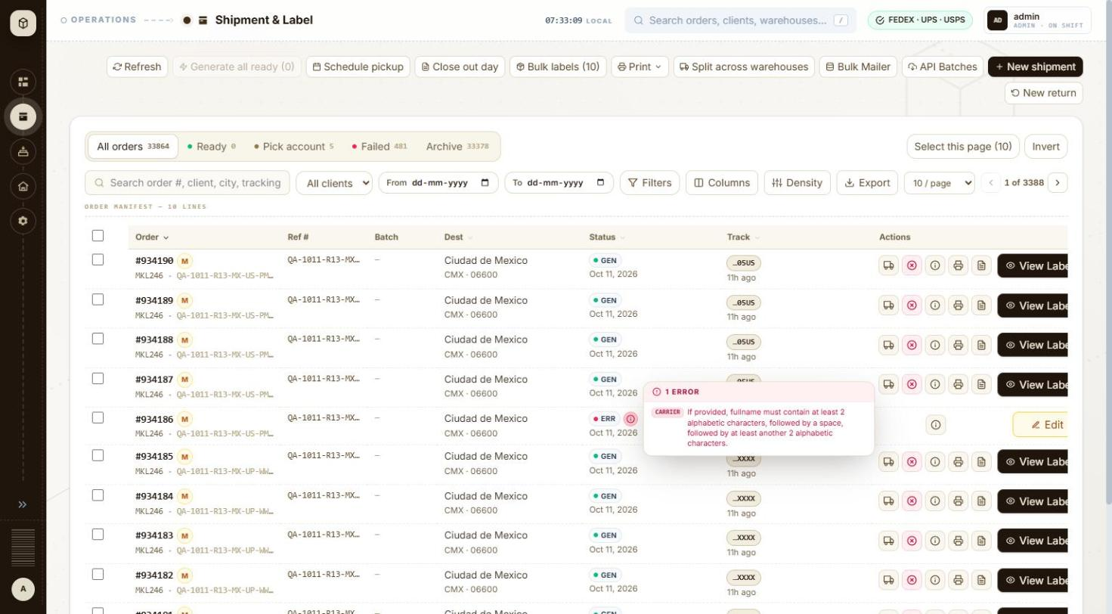
BUG-001 - screenshot 1 (BUG-001.jpg)
BUG-001 - screenshot 2 (BUG-001-2.jpg)
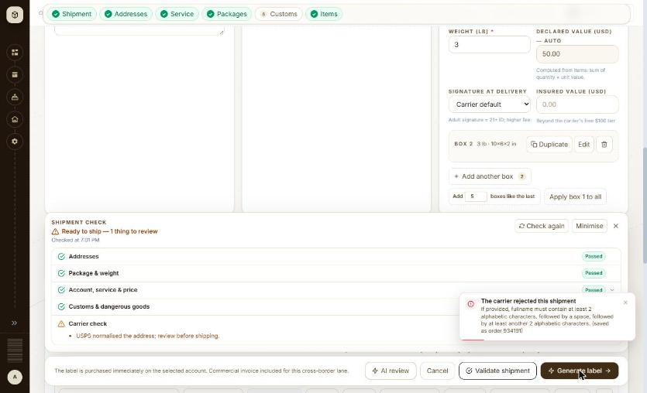
BUG-001 - screenshot 3 (BUG-001-3.jpg)
Retest history
- 2026-10-12 R3: still-failing - Confirmed with one SANDBOX label, with Manoj's permission. USPS Priority Mail Intl, MKL246 to 1 Canada Square, London E14 5AB, GB, Ship from Full name left at the client default 'MKL'. The check reported 'Ready to ship - 1 thing to review' with Addresses, Package & weight, Account/service/price and Customs all Passed, and Generate label was enabled. Generate then produced the red toast 'The carrier rejected this shipment - If provided, fullname must contain at least 2 alphabetic characters, followed by a space, followed by at least another 2 alphabetic characters. (saved as order 934191)'. GET /api/v1/orders/934191 shows status ERROR with 'STAMPS createShipmentSera[pkg 1/2] HTTP 400 ... error_code 6619409'. The only change is that the toast now names the order it saved.
- 2026-10-13 R4 (build local dev, 2026-10-13): still-failing - The pre-flight guard is still absent. USPS Priority Mail Intl, MKL246 to 1 Canada Square, London E14 5AB GB, with Ship from Full name left at the client default 'MKL': the check returns 'Ready to ship - 1 thing to review' with Addresses, Package & weight, Account/service/price and Customs all Passed, and Generate label is enabled. No check mentions the sender name. The carrier rejection itself was not re-provoked today - it was confirmed on 2026-10-12 with order #934191 (STAMPS HTTP 400, error_code 6619409) and nothing in the form has changed, so a second order was not spent on it.

BUG-002 - New shipment (USPS international, 2 boxes): with all item lines in box 1, box 2 fails 'Missing customs lines' after box 1 already went to the carrier
Severity / type | High / Functional
Where | Orders > New order > New order form (international) - Item Pkg#
URL | /orders/new
Reproducibility | 1 of 1 (not repeated, to avoid further carrier bookings)
Found | 2026-10-11, run R1, as admin (ADMIN)
Status | Closed

Steps to reproduce
1. Open Orders and click + New shipment (/orders/new)
2. Client: MKL246 (ship from 3PL-EAST, the client default); set Ship from Full name to 'MKL Shipping'
3. Carrier: USPS
4. Ship to: QA Test Recipient, QA Test Co, Toronto ON M5V 3L9, Canada (as for the other Canada orders of the run)
5. Service level: USPS Priority Mail Intl
6. Packaging THB-PACKAGE, Weight 5; Add another box; Apply box 1 to all
7. Customs: Reason of export Sale, Label type PDF, Incoterms DAP
8. Importer of record & customs broker > Add: Type Receiver, Name and Contact QA Test Recipient, same address, city, post code and phone as Ship to > Use for this shipment
9. Items: one line Cotton T-shirt, HS 61091000, Origin US, Qty 2, Unit value 20.00, Wt 0.5; leave Boxes on 'All in box 1' (Pkg # 1)
10. Click Validate shipment, then Generate label
Test data
Order #934106 (QA-1011-R13-CA-US-PMI-THB-NM)
Expected
The check warns that USPS needs customs lines on every box (or the lines are split across the boxes automatically) before the label is bought; nothing is booked for part of the shipment.
Actual
Check: 'All checks passed'. Generate label: 'Missing customs lines.'; order #934106 saved as ERROR. The error names package 2 of 2, so package 1 had already passed its carrier call; the app shows nothing about whether package 1 was booked or voided at USPS (not verified). With two lines of Qty 1 spread across the boxes (Spread across 2 boxes) the same shipment generates (#934108, #934110-#934112, #934148-#934151, #934187-#934190).
Technical evidence
GET /api/v1/orders/934106 -> errorDetails.errorMessage 'STAMPS createShipmentSera[pkg 2/2] HTTP 400 ... Missing customs lines.'
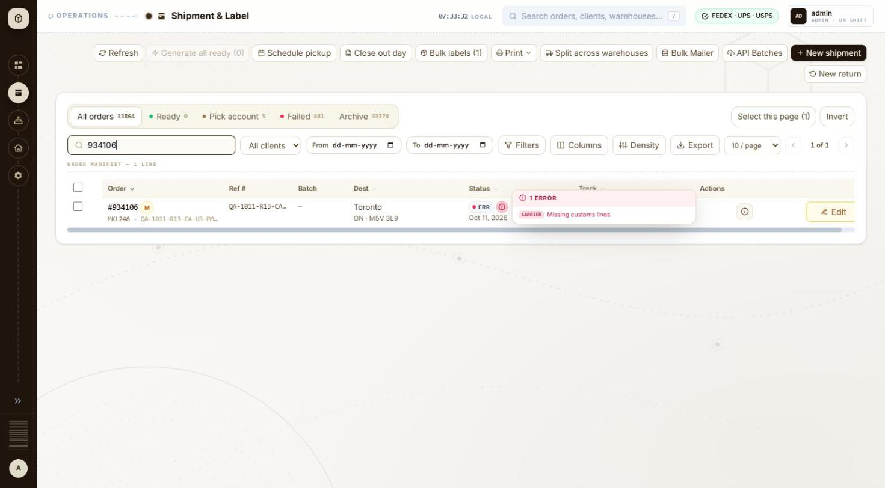
BUG-002 - screenshot 1 (BUG-002.jpg)
BUG-002 - screenshot 2 (BUG-002-2.jpg)
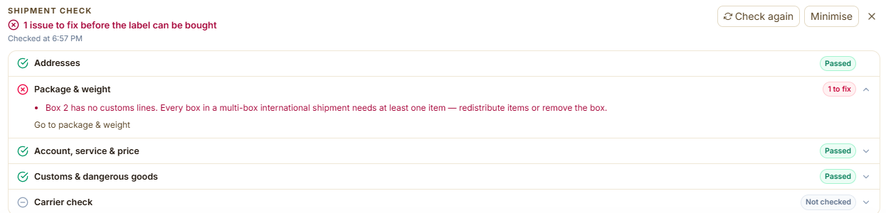
BUG-002 - screenshot 3 (BUG-002-3.png)
Retest history
- 2026-10-12 R3: fixed - The pre-flight now catches it. With two boxes and every item line in box 1, the check reports '1 issue to fix before the label can be bought' and under Package & weight: 'Box 2 has no customs lines. Every box in a multi-box international shipment needs at least one item - redistribute items or remove the box.' Generate label stays disabled and Carrier check reads 'Not checked', so nothing is sent to the carrier. After spreading the lines across the boxes the check passes. Nothing is now booked for part of a shipment.
- 2026-10-13 R4 (build local dev, 2026-10-13): fixed - Re-walked. With two boxes and every item line put in box 1, the check returns '1 issue to fix before the label can be bought' and under Package & weight: 'Box 2 has no customs lines. Every box in a multi-box international shipment needs at least one item - redistribute items or remove the box.' Generate label stays disabled and Carrier check reads 'Not checked', so the carrier is never called for a part-filled shipment.

BUG-003 - New shipment: single-piece carrier packagings (FedEx Envelope, 10kg, 25kg box; UPS 10KG, 25KG box) accept a second box, then the carrier rejects the label
Severity / type | Medium / Validation
Where | Orders > New order > New order form (international) - Add another box
URL | /orders/new
Reproducibility | Always (8 of 8 two-box attempts; 0 failures as one box)
Found | 2026-10-11, run R1, as admin (ADMIN)
Status | Closed

Steps to reproduce
1. Open Orders and click + New shipment (/orders/new)
2. Client: MKL246 (ship from 3PL-EAST, the client default)
3. Carrier: FedEx
4. Ship to: QA Test Recipient, Toronto ON M5V 3L9, Canada
5. Service level: FedEx International Priority
6. Packaging FedEx 10kg Box, Weight 10
7. Click Add another box, then Apply box 1 to all (2 boxes)
8. Customs: Reason of export Sale, Export declaration ref 'NO EEI 30.36', Label type PDF, Label size Paper 4x6, Incoterms DAP
9. Importer of record & customs broker > Add: Type Receiver, Name and Contact QA Test Recipient, same address, city, post code and phone as Ship to > Use for this shipment
10. Items: Description Cotton T-shirt, HS code 61091000, Origin US, Qty 2, Unit value 20.00, Wt 0.5
11. Click Validate shipment, then Generate label
12. Repeat with FedEx Envelope (International Economy and Priority), FedEx 25kg Box, and with carrier UPS, Worldwide Saver and Worldwide Express, UPS 10KG Box (10 lb) and UPS 25KG Box (20 lb)
Test data
FedEx: #934063 (IE Envelope), #934068 (IP 10kg), #934069 (IP 25kg), #934070 (IP Envelope). UPS: #934079, #934080 (Saver 10KG/25KG), #934091, #934092 (Express 10KG/25KG)
Expected
The form allows only one box for these single-piece packagings, or the check blocks Generate with a message about the box count.
Actual
FedEx check: ready to ship with one item to review, the note 'Multi-package validate: FedEx only supports single-piece pre-flight; box 1 validated, boxes 2–2 verified at label create'. Label: 'The package count for this shipment exceeds limit.' UPS check: ready to ship with one item to review (the UPS rate call returned HTTP 400 with the same message as below), Carrier check passed and Generate enabled; label: 'The requested service is not valid for shipments with the requested packaging.', which is misleading because the same service and packaging generate as one box (#934075-#934078, #934093, #934094, #934103, #934104 and every UK/Mexico 1-box order). 8 of 8 two-box attempts failed.
Technical evidence
API errorDetails: 'FEDEX createShipment HTTP 400 ... The package count for this shipment exceeds limit.' (#934063, #934068-#934070); 'UPS createShipment HTTP 400 ... The requested service is not valid for shipments with the requested packaging.' (#934079, #934080, #934091, #934092)
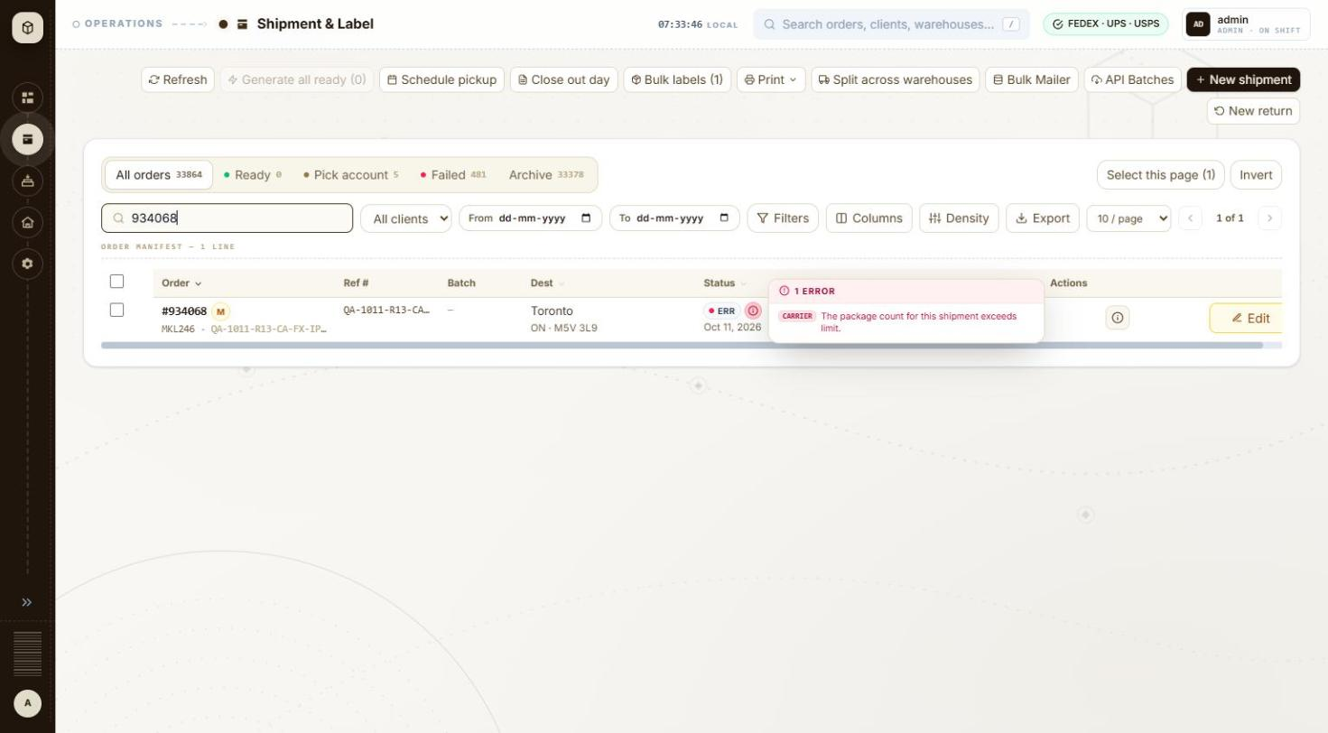
BUG-003 - screenshot 1 (BUG-003.jpg)
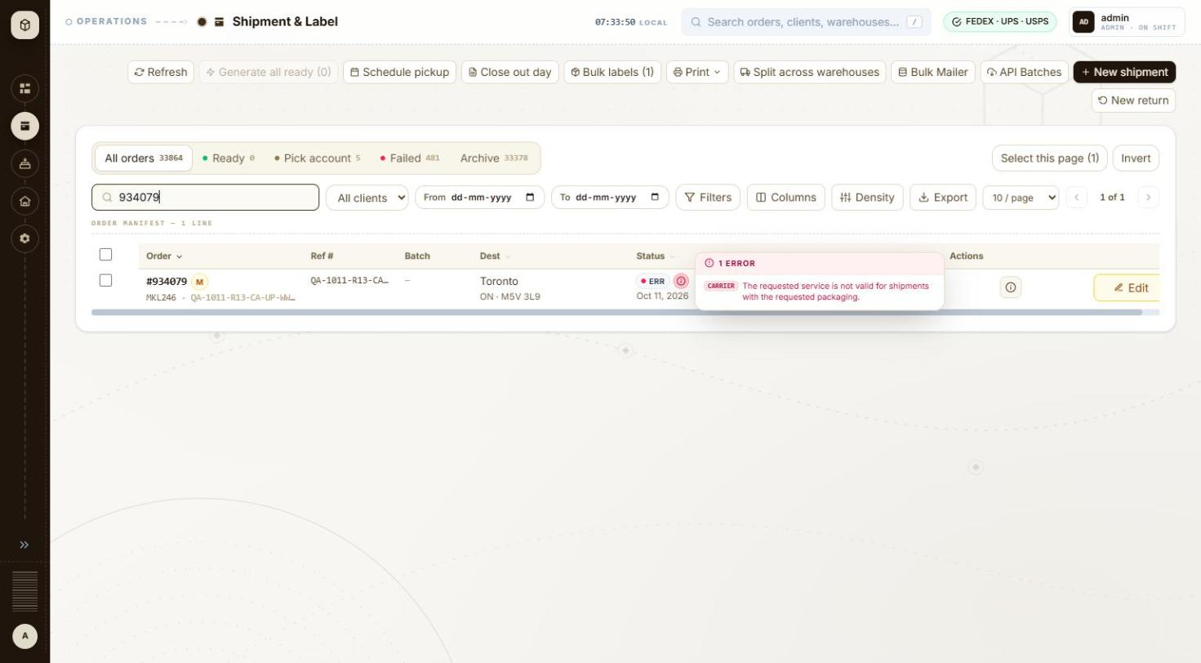
BUG-003 - screenshot 2 (BUG-003-2.jpg)
BUG-003 - screenshot 3 (BUG-003-3.jpg)
BUG-003 - screenshot 4 (BUG-003-4.jpg)
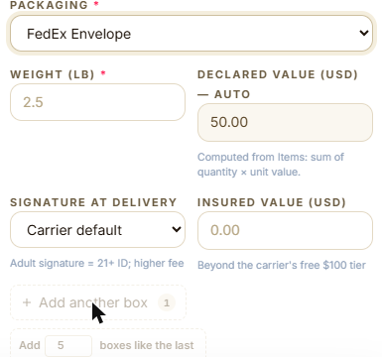
BUG-003 - screenshot 5 (BUG-003-5.png)
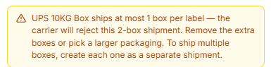
BUG-003 - screenshot 6 (BUG-003-6.png)
Retest history
- 2026-10-12 R3: fixed - Single-piece packagings now refuse extra boxes. With FedEx Envelope, both 'Add another box' and 'Add N boxes like the last' are disabled=true with the tooltip 'FedEx Envelope ships at most 1 box per label. If you need to ship more than one box, create each one as a separate shipment.'; UPS 10KG Box gives the same guard. With an extra box already on the form, switching to UPS 10KG Box raises an inline warning naming the consequence: 'UPS 10KG Box ships at most 1 box per label - the carrier will reject this 2-box shipment. Remove the extra boxes or pick a larger packaging.' The label is no longer bought and then rejected. Note the new BUG-053: in exactly that state the Validate button goes silent.
- 2026-10-13 R4 (build local dev, 2026-10-13): fixed - Re-walked on UPS. With UPS 10KG Box selected, 'Add another box' and 'Add N boxes like the last' are both disabled=true with the tooltip 'UPS 10KG Box ships at most 1 box per label. To ship multiple boxes, create each one as a separate shipment.', and an existing extra box raises the inline warning 'UPS 10KG Box ships at most 1 box per label - the carrier will reject this 2-box shipment. Remove the extra boxes or pick a larger packaging.'

BUG-004 - Shipment check (FedEx International Priority): '1 issue to fix: FEDEX did not quote FedEx International Priority' although IP is in the quoted list; Generate stays enabled
Severity / type | Medium / Functional
Where | Orders > New order > New order form (international) - Shipment check panel
URL | /orders/new
Reproducibility | Always when the FedEx rate call succeeds
Found | 2026-10-11, run R1, as admin (ADMIN)
Status | Closed

Steps to reproduce
1. Open Orders and click + New shipment (/orders/new)
2. Client: MKL246 (ship from 3PL-EAST, the client default)
3. Carrier: FedEx
4. Ship to: Full name QA Test Recipient, Company QA Test Co, Address line 1 Av Paseo de la Reforma 222, Country Mexico (MX), Phone 5552081234, State / region CMX, City Ciudad de Mexico, Postal code 06600
5. Service level: FedEx International Priority
6. Packaging THB-PACKAGE, Weight 5 (one box)
7. Customs: Reason of export Sale, Label type PDF, Incoterms DAP
8. Importer of record & customs broker > Add: Type Receiver, Name and Contact QA Test Recipient, same address, city, post code and phone as Ship to > Use for this shipment
9. Items: Description Cotton T-shirt, HS code 61091000, Origin US, Qty 2, Unit value 20.00, Wt 0.5
10. Click Validate shipment
Test data
Retest 2026-10-12, reference QA-1012-EVID-MX-FX-IP (validated only, not saved), and the same on a UK tube shipment. During the run: every International Priority shipment whose FedEx rate call succeeded, e.g. #934072, #934074, #934118, #934122, #934157, #934161-#934163
Expected
No issue when the selected service is in the quoted list. A check that says an issue must be fixed before the label can be bought should also keep Generate disabled.
Actual
Check header '1 issue to fix before the label can be bought · 1 to review'; Account, service & price '1 to fix': 'FEDEX did not quote FedEx International Priority for this lane — the label may be refused. Quoted instead: FedEx International Connect Plus — USD 159.18; FedEx International Economy® — USD 174.95; FedEx International Priority® — USD 218.58; FedEx International Priority® Express — USD 229.64; FedEx International First® — USD 271.64.' The same sentence is listed twice (as to fix and to review) and again in the price box. Generate label stays enabled and the labels generate. Seen for Canada, UK and Mexico; retested 2026-10-12 for Mexico and UK.
Technical evidence
The quoted list contains 'FedEx International Priority®' (with the registered mark), which may be why the match on the service name fails. No console capture.
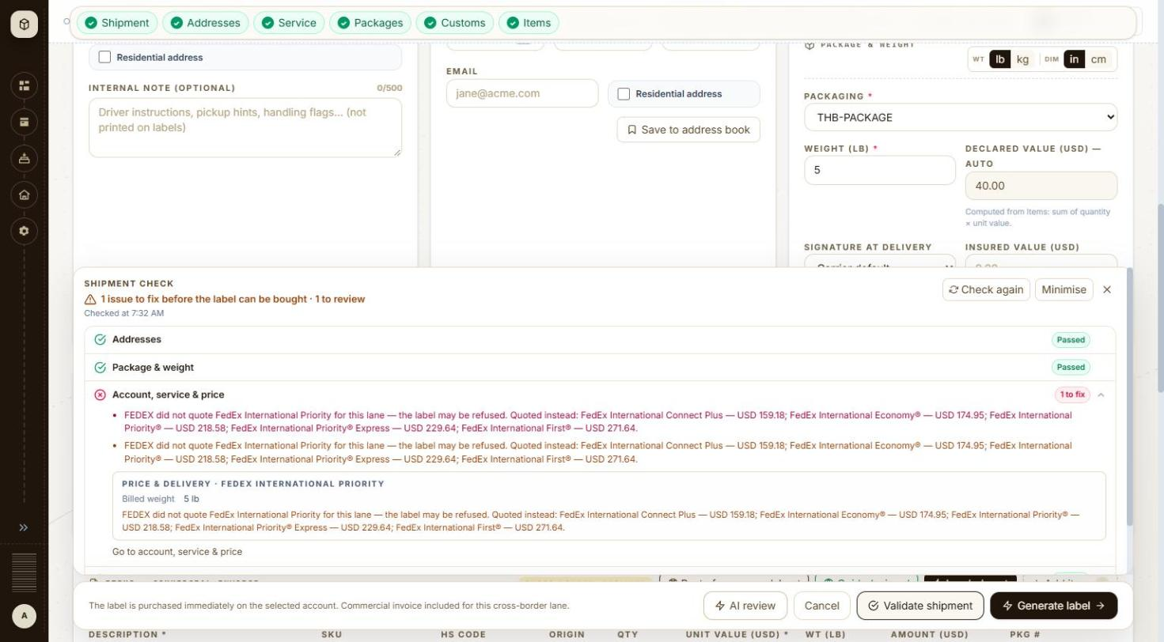
BUG-004 - screenshot 1 (BUG-004.jpg)
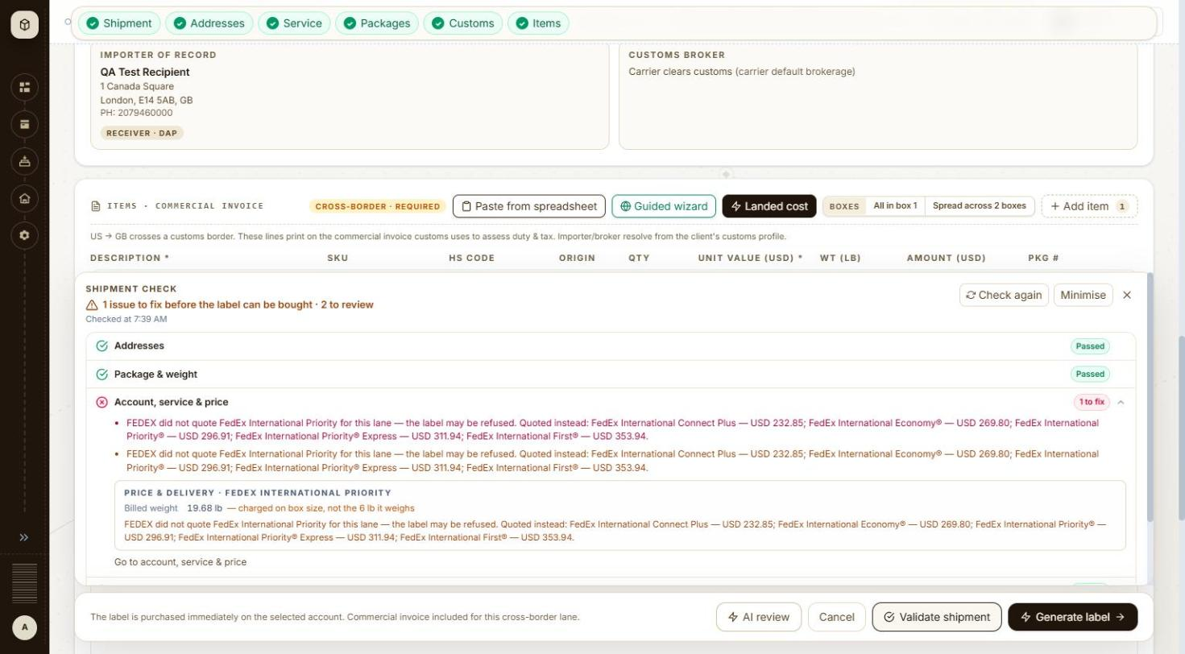
BUG-004 - screenshot 2 (BUG-004-2.jpg)
BUG-004 - screenshot 3 (BUG-004-3.jpg)
BUG-004 - screenshot 4 (BUG-004-4.jpg)
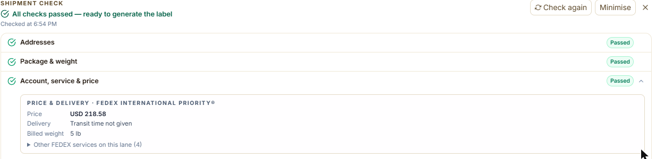
BUG-004 - screenshot 5 (BUG-004-5.png)
BUG-004 - screenshot 6 (BUG-004-6.jpg)
BUG-004 - screenshot 7 (BUG-004-7.jpg)
BUG-004 - screenshot 8 (BUG-004-8.jpg)
BUG-004 - screenshot 9 (BUG-004-9.jpg)
BUG-004 - screenshot 10 (BUG-004-10.png)
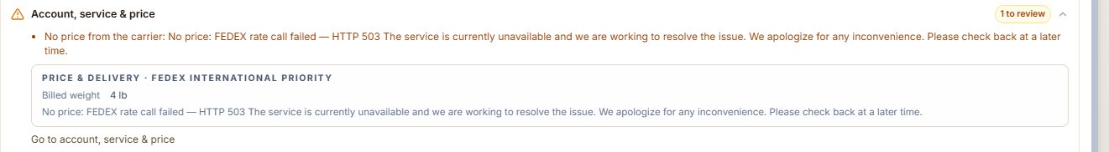
BUG-004 - screenshot 11 (BUG-004-11.png)
Retest history
- 2026-10-12 R3: fixed - FedEx International Priority to Mexico (MKL246, THB-PACKAGE 5 lb, importer Receiver) now returns 'All checks passed - ready to generate the label' with Account, service & price Passed and the detail 'PRICE & DELIVERY - FEDEX INTERNATIONAL PRIORITY(R) Price USD 218.58 Billed weight 5 lb > Other FEDEX services on this lane (4)'. The contradictory 'FEDEX did not quote FedEx International Priority' issue is gone and the selected service is matched to the quote.
- 2026-10-13 R4 (build local dev, 2026-10-13): fixed - FedEx International Priority to Ciudad de Mexico now matches the selected service to the quote: Account, service & price shows 'PRICE & DELIVERY - FEDEX INTERNATIONAL PRIORITY / Billed weight 4 lb' and the contradictory 'FEDEX did not quote FedEx International Priority' issue is gone. The only note on this run was a genuine sandbox outage - 'No price: FEDEX rate call failed - HTTP 503 The service is currently unavailable' - which is the carrier being down, not the bug.

BUG-005 - New shipment (FedEx to Canada): no FTR exemption field; with Export declaration ref empty FedEx rejects 'FTR Exemption or AES Citation ... not valid for EEI'
Severity / type | Medium / Usability
Where | Orders > New order > New order form (international) - FTR exemption (UK, Mexico)
URL | /orders/new
Reproducibility | Always
Found | 2026-10-11, run R1, as admin (ADMIN)
Status | Closed

Steps to reproduce
1. Open Orders and click + New shipment (/orders/new)
2. Client: MKL246 (ship from 3PL-EAST, the client default)
3. Carrier: FedEx
4. Ship to: Full name QA Test Recipient, Company QA Test Co, Address line 1 290 Bremner Blvd, Country Canada (CA), Phone 4165550100, State / region ON, City Toronto, Postal code M5V 3L9
5. Service level: FedEx International Economy
6. Packaging FedEx Pak, Weight 2 (one box)
7. Customs: Reason of export Sale; note there is no FTR exemption or AES ITN field for Canada; leave Export declaration ref empty; Label type PDF; Label size Paper 4x6; Incoterms DAP
8. Importer of record & customs broker > Add: Type Receiver, Name and Contact QA Test Recipient, same address, city, post code and phone as Ship to > Use for this shipment
9. Items: Description Cotton T-shirt, HS code 61091000, Origin US, Qty 2, Unit value 20.00, Wt 0.5
10. Click Validate shipment
Test data
Retest 2026-10-12, reference QA-1012-EVID-CA-FX-IE (validated only, not saved). During the run all Canada FedEx orders (#934063-#934078) needed the workaround
Expected
Canada gets the same FTR exemption dropdown as the UK and Mexico forms (which already list 'NOEEI §30.36 — export to Canada'), or a valid default, so a low-value shipment passes without typing a citation.
Actual
Carrier check '1 to fix': 'FedEx rejected the shipment: The FTR Exemption or AES Citation you provided is not valid for EEI.' Generate label stays disabled, while 'Customs & dangerous goods' shows Passed. Typing 'NO EEI 30.36' into Export declaration ref makes the check pass.
Technical evidence
Canada form selects: Reason of export, Currency, Label type, Label size, Pickup type, Incoterms, Duties paid by - no FTR exemption (UK and Mexico forms have it).
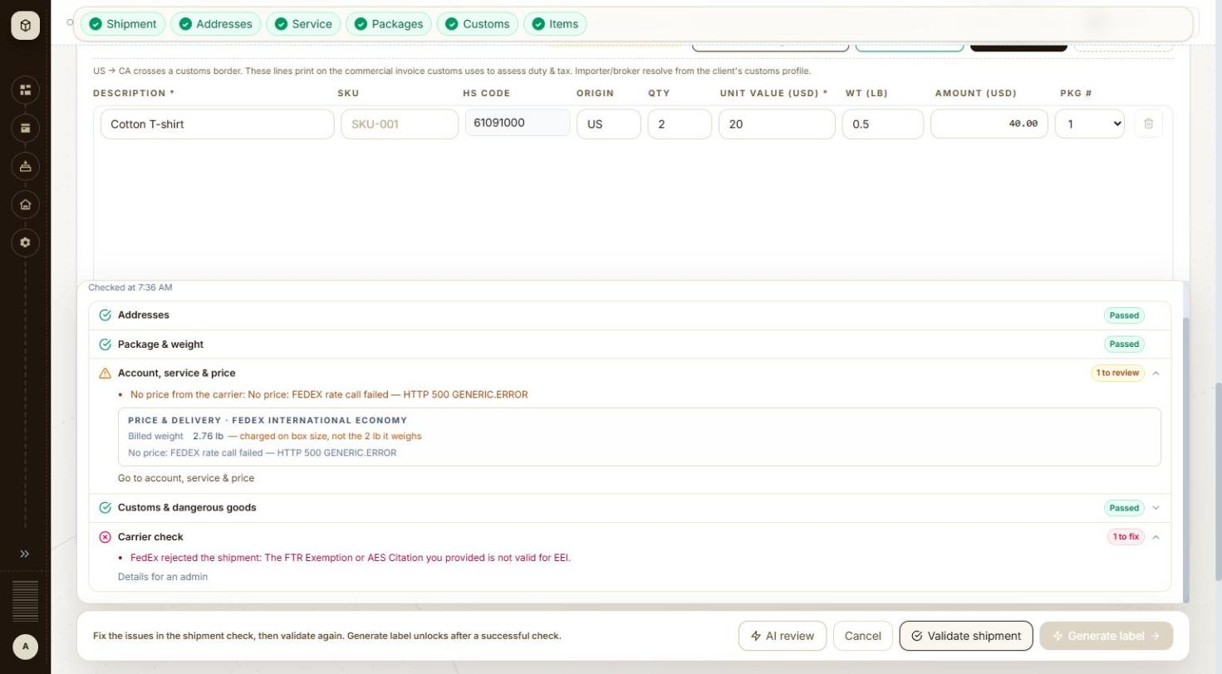
BUG-005 - screenshot 1 (BUG-005.jpg)
BUG-005 - screenshot 2 (BUG-005-2.jpg)
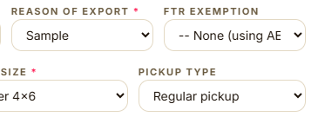
BUG-005 - screenshot 3 (BUG-005-3.png)
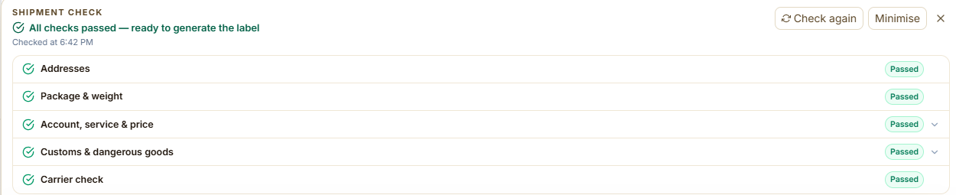
BUG-005 - screenshot 4 (BUG-005-4.png)
Retest history
- 2026-10-12 R3: fixed - The Canada form now carries an FTR EXEMPTION dropdown and an AES ITN (CENSUS) field next to Reason of export. The dropdown offers '-- None (using AES) --', 'NOEEI 30.37(a) - value under $2,500 USD', 'NOEEI 30.37(h) - tools of trade / temporary export' and 'NOEEI 30.36 - export to Canada'. With Export declaration ref left empty and the exemption left at None, Validate shipment returned all five checks Passed, Carrier check included - the 'FTR Exemption or AES Citation you provided is not valid for EEI' refusal is gone.
- 2026-10-13 R4 (build local dev, 2026-10-13): fixed - The FTR EXEMPTION dropdown and AES ITN (CENSUS) field are present on the Canada form. A Canada shipment validated with the exemption left at '-- None (using AES) --' and Export declaration ref empty returned all five checks Passed, Carrier check included.

BUG-006 - New shipment: 'Add N boxes like the last' copies the weight but leaves Length / Width / Height empty for a carrier box
Severity / type | Medium / Functional
Where | Orders > New order > New order form (international) - Add N boxes like the last
URL | /orders/new
Reproducibility | Always (2 of 2)
Found | 2026-10-11, run R1, as admin (ADMIN)
Status | Closed

Steps to reproduce
1. Open Orders and click + New shipment (/orders/new)
2. Client: MKL246 (ship from 3PL-EAST, the client default)
3. Carrier: UPS
4. Ship to country Mexico
5. Service level: UPS Worldwide Saver
6. Packaging UPS Large Express Box, Weight 4
7. Set the box count next to 'boxes like the last' to 1
8. Click 'boxes like the last' (tooltip: 'Adds boxes copying the last box's weight and dimensions (box 1's when there is no extra box yet)')
Test data
Seen on MX-UP-WWS-LBOX (#934168) during the run; retested 2026-10-12 (form not saved)
Expected
Box 2 gets weight 4 lb and the box's dimensions 18 x 13 x 3 in, as the tooltip says.
Actual
Box 2 shows Weight 4 and empty L, W and H fields. Apply box 1 to all fills them (18 x 13 x 3).
Technical evidence
Box card after the click: 'BOX 2 ... Weight (lb) 4, L (in) [empty], W (in) [empty], H (in) [empty]'
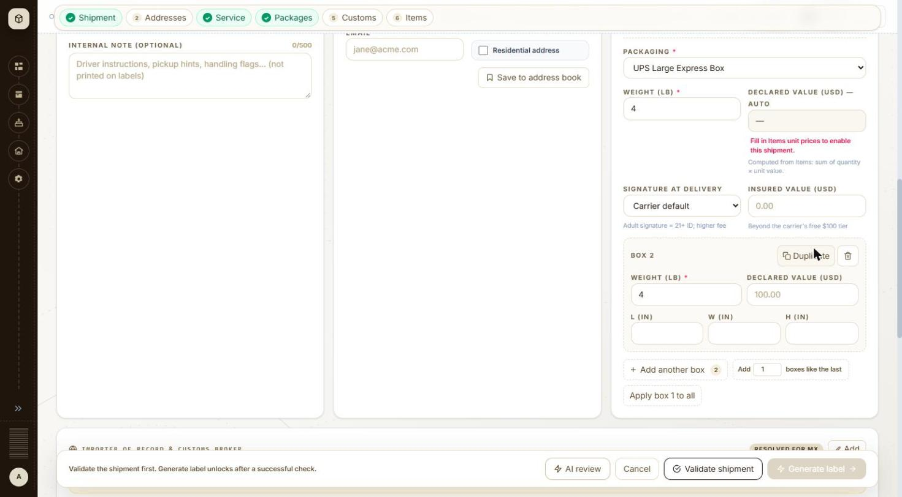
BUG-006 - screenshot 1 (BUG-006.jpg)
BUG-006 - screenshot 2 (BUG-006-2.jpg)
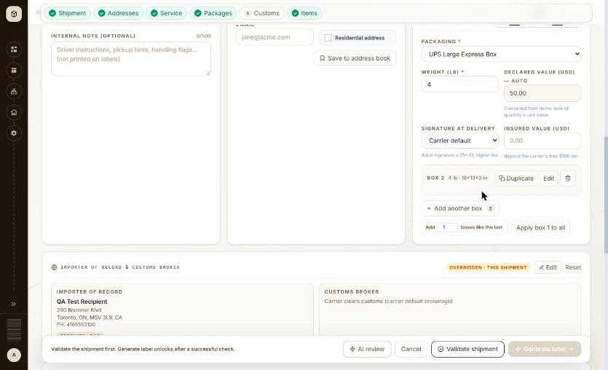
BUG-006 - screenshot 3 (BUG-006-3.jpg)
Retest history
- 2026-10-12 R3: fixed - Retested on the exact original repro: UPS Large Express Box, weight 4, 'Add 1 boxes like the last'. Box 2 now reads 'BOX 2 4 lb - 18x13x3 in' - the dimensions are copied as well as the weight, and the extra box is shown as a compact summary with Duplicate / Edit / delete. Same result with a Custom package carrying 18x13x3. One gap remains: for THB-PACKAGE, which has no dimension fields of its own, box 2 still opens with empty L, W and H.
- 2026-10-13 R4 (build local dev, 2026-10-13): fixed - Re-walked on the original repro: UPS Large Express Box, weight 4, 'Add 1 boxes like the last' gives 'BOX 2 4 lb - 18x13x3 in'. Weight and dimensions are both copied.

BUG-007 - Label documents #934118: label stored as a FedEx document link instead of the PDF; each label request takes 3-4 s and the page shows 'Loading label document...' for about 8 s
Severity / type | Medium / Functional
Where | Orders > Label > Label documents - Label preview
URL | /label/934118
Reproducibility | Always for #934118 (1 of 115 labels)
Found | 2026-10-11, run R1, as admin (ADMIN)
Also affects | API > Orders > Order detail (GET /api/v1/orders/{id})
Status | Reopened

Steps to reproduce
1. Open /label/934118 (Orders > order #934118 > View label)
2. Watch the label area and the Download / Print buttons
3. Compare with /label/934119 (same carrier, service and lane)
Test data
Order #934118 (QA-1011-R13-GB-FX-IP-10KG-1B), FedEx International Priority to the UK
Expected
The label is stored like the other 114 labels and the page shows it within a second.
Actual
'Loading label document...' with Download PDF, Download .zpl, Copy ZPL and Print Label disabled until about 12 s after opening the page (about 3 s for #934119), then the label renders. The order's labelDetails.labelFilePath holds 'https://wwwtest.fedex.com/document/v1/cache/retrieve/SH...' (124 characters) while the other 114 generated orders hold the base64 PDF. Whether that FedEx link expires was not verified.
Technical evidence
GET /api/v1/orders/934118/label 3.6-4.3 s, GET /api/v1/orders/934118/label/pdf 3.4 s; for #934119: 55-109 ms and 21 ms (browser resource timing, 2026-10-12).
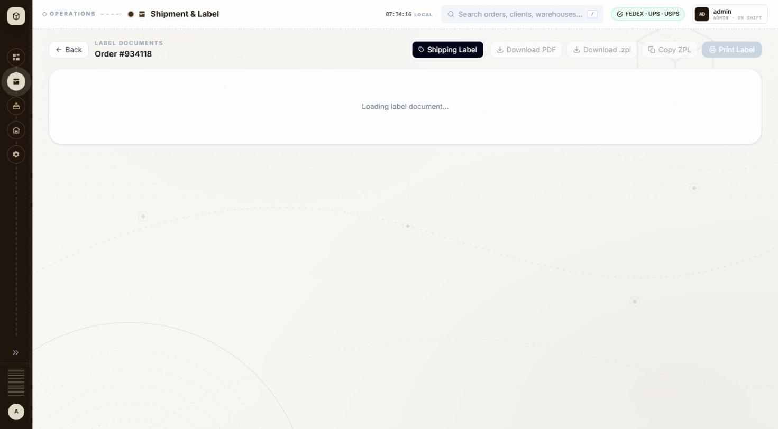
BUG-007 - screenshot (BUG-007.jpg)
Retest history
- 2026-10-12 R3: still-failing - Unchanged. /label/934118 shows 'Loading label document...' with Download PDF, Download .zpl, Copy ZPL and Print Label disabled for about 10-12 seconds (about 3 seconds for /label/934119 on the same carrier and lane). GET /api/v1/orders/934118 still returns labelDetails.labelFilePath as a 124-character 'https://wwwtest.fedex.com/document/v1/cache/retrieve/SH...' link while the other generated orders hold the base64 PDF (934119: 18,376 characters; 934190: 133,684). The rendered document is also still the one-page FedEx text placeholder rather than the 4-page SANDBOX label the other orders show.
- 2026-10-13 R4 (build local dev, 2026-10-13): still-failing - Unchanged on the 2026-10-13 build. GET /api/v1/orders/934118 still returns labelDetails.labelFilePath as a 124-character https://wwwtest.fedex.com/document/v1/cache/retrieve/... link, while every other generated order holds the base64 PDF (934119: 18,376 characters; 934172: 59,768; 934190: 133,684). The label page for 934118 still sits on 'Loading label document...' with the download and print buttons disabled for roughly ten seconds against about three for the others.

BUG-053 - New shipment: with a single-piece packaging and an extra box still on the form, Validate shipment does nothing at all - no request, no message, no result
Severity / type | Medium / Functional
Where | Orders > New order > New order form (international) - Client
URL | http://localhost:5173/orders/new
Reproducibility | Always
Found | 2026-10-12, run R3, as admin (ADMIN)
Status | Reopened

Steps to reproduce
1. Open Orders and click + New shipment (/orders/new)
2. Client MKL246, carrier UPS, ship to QA Test Recipient, 290 Bremner Blvd, Toronto ON M5V 3L9, Canada
3. Service UPS Worldwide Saver, Incoterms DAP, two item lines, importer override Receiver
4. Packaging UPS Large Express Box, then 'Add 1 boxes like the last' so there are two boxes
5. Change Packaging to UPS 10KG Box (a single-piece packaging) - the inline warning appears
6. Click Validate shipment and watch the network tab
Test data
MKL246 to Canada, 2 boxes, 2 item lines, UPS 10KG Box
Expected
Either the check runs and reports the box-count problem as a failed check, or the Validate button is disabled with the reason, the way Generate label is. Clicking a live button should never be silent.
Actual
Nothing happens. POST /api/v1/shipments/validate is never sent, no toast appears, no 'Shipment check' panel opens and no field is marked. The button reports disabled=false and keeps its tooltip, and the console logs no error. All six step chips are green. Switching Packaging back to UPS Large Express Box and clicking the same button immediately sends POST /api/v1/shipments/validate -> 200 and opens the check panel with all five checks Passed, so the form was otherwise complete and only the single-piece conflict silences the button.
Technical evidence
Seen while retesting BUG-003. The inline warning next to Packaging reads 'UPS 10KG Box ships at most 1 box per label - the carrier will reject this 2-box shipment. Remove the extra boxes or pick a larger packaging. To ship multiple boxes, create each one as a separate shipment.', so the application knows about the conflict - it just does not say so when the user asks it to check. The same silence was seen with FedEx Envelope. Window 1392x847.
BUG-053 - screenshot (BUG-053.png)
Retest history
- 2026-10-13 R4 (build local dev, 2026-10-13): still-failing - Reproduces on the 2026-10-13 build exactly as first logged. UPS Large Express Box with two boxes, switched to UPS 10KG Box: the inline single-piece warning appears, but Validate shipment sends no POST /api/v1/shipments/validate, raises no toast and opens no check panel. The button reports disabled=false and the console logs nothing.

BUG-008 - New shipment (ship to Mexico): State / region is required but has no * marker, a US placeholder 'NY', and accepts only ISO codes as free text
Severity / type | Low / Usability
Where | Orders > New order > New order form (international) - State / region (UK, Mexico)
URL | /orders/new
Reproducibility | Always
Found | 2026-10-11, run R1, as admin (ADMIN)
Status | Closed

Steps to reproduce
1. Open Orders and click + New shipment (/orders/new)
2. Client: MKL246 (ship from 3PL-EAST, the client default)
3. Carrier: FedEx
4. Ship to country Mexico; fill name, address, city Ciudad de Mexico, postal code 06600; leave State / region empty
5. Complete the rest of the form and click Validate shipment
6. Enter DF in State / region and click Validate shipment again
Test data
Retest 2026-10-12 (QA-1012-EVID-MX-FX-IP, not saved); during the run every Mexico order needed CMX
Expected
Required fields carry the * marker used elsewhere on the form, and Mexico offers a state dropdown like Canada's province list, so a valid code is picked rather than guessed.
Actual
The label 'STATE / REGION' has no * (City * and Postal code * do), and the placeholder is 'NY'. Empty: toast '1 field needs attention — Ship to state: state / region is required' and the field turns red. 'DF' is accepted by the field and only rejected by the check; 'CMX' works. The run notes recorded Validate doing nothing visible; on retest the toast appeared, so that part is not reported.
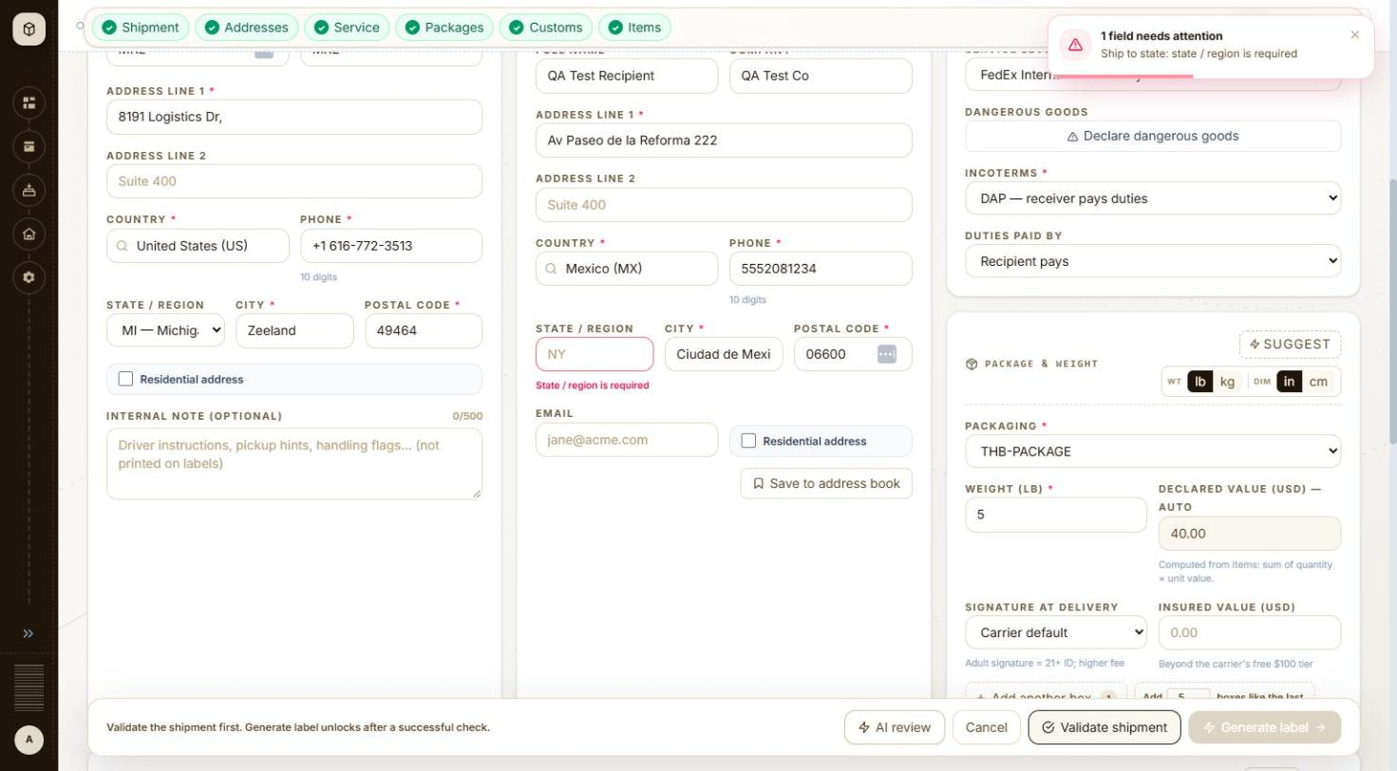
BUG-008 - screenshot 1 (BUG-008.jpg)
BUG-008 - screenshot 2 (BUG-008-2.jpg)
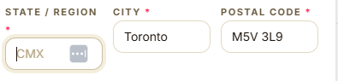
BUG-008 - screenshot 3 (BUG-008-3.png)
BUG-008 - screenshot 4 (BUG-008-4.jpg)
BUG-008 - screenshot 5 (BUG-008-5.jpg)
BUG-008 - screenshot 6 (BUG-008-6.png)
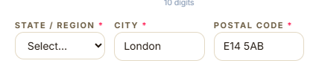
BUG-008 - screenshot 7 (BUG-008-7.png)
Retest history
- 2026-10-12 R3: still-failing - Two of the three parts are fixed. The label now reads 'STATE / REGION *' with the red asterisk the other required fields carry, and the placeholder for Mexico is now 'CMX', a real Mexican state code, not the US 'NY'. What remains: the field is still a free-text input for Mexico, not a dropdown of Mexican states the way Canada gets a province list and the US gets a state list - and it silently accepts a value carried over from another country (switching Canada to Mexico left 'ON' in the box, which only the carrier check later rejects).
- 2026-10-13 R4 (build local dev, 2026-10-13): fixed - Mexico now gets a proper state list. With the country set to Mexico, State / region becomes a 32-entry dropdown (AGU - Aguascalientes, BCN - Baja California, BCS - Baja California Sur, CAM - Campeche, CHP - Chiapas and the rest) with the required asterisk on the label. The US placeholder 'NY' and the free-typed guessing are both gone, and a value carried over from another country can no longer survive the switch.

BUG-009 - Shipment check (Mexico): state message says 'Use the 2-letter code (e.g. CMX, JAL, NLE)' but every example is three letters
Severity / type | Low / Content
Where | Orders > New order > New order form (international) - Shipment check panel
URL | /orders/new
Reproducibility | Always
Found | 2026-10-12, run R1, as admin (ADMIN)
Status | Closed

Steps to reproduce
1. Open Orders and click + New shipment (/orders/new)
2. Client: MKL246 (ship from 3PL-EAST, the client default)
3. Carrier: FedEx
4. Ship to country Mexico with State / region DF
5. Complete the form and click Validate shipment
Test data
QA-1012-EVID-MX-FX-IP (validated only)
Expected
The message asks for the 3-letter state code (CMX, JAL, NLE).
Actual
Addresses '1 to fix': 'State/province "DF" isn't a valid MX code. Use the 2-letter code (e.g. CMX, JAL, NLE), not the full name.'
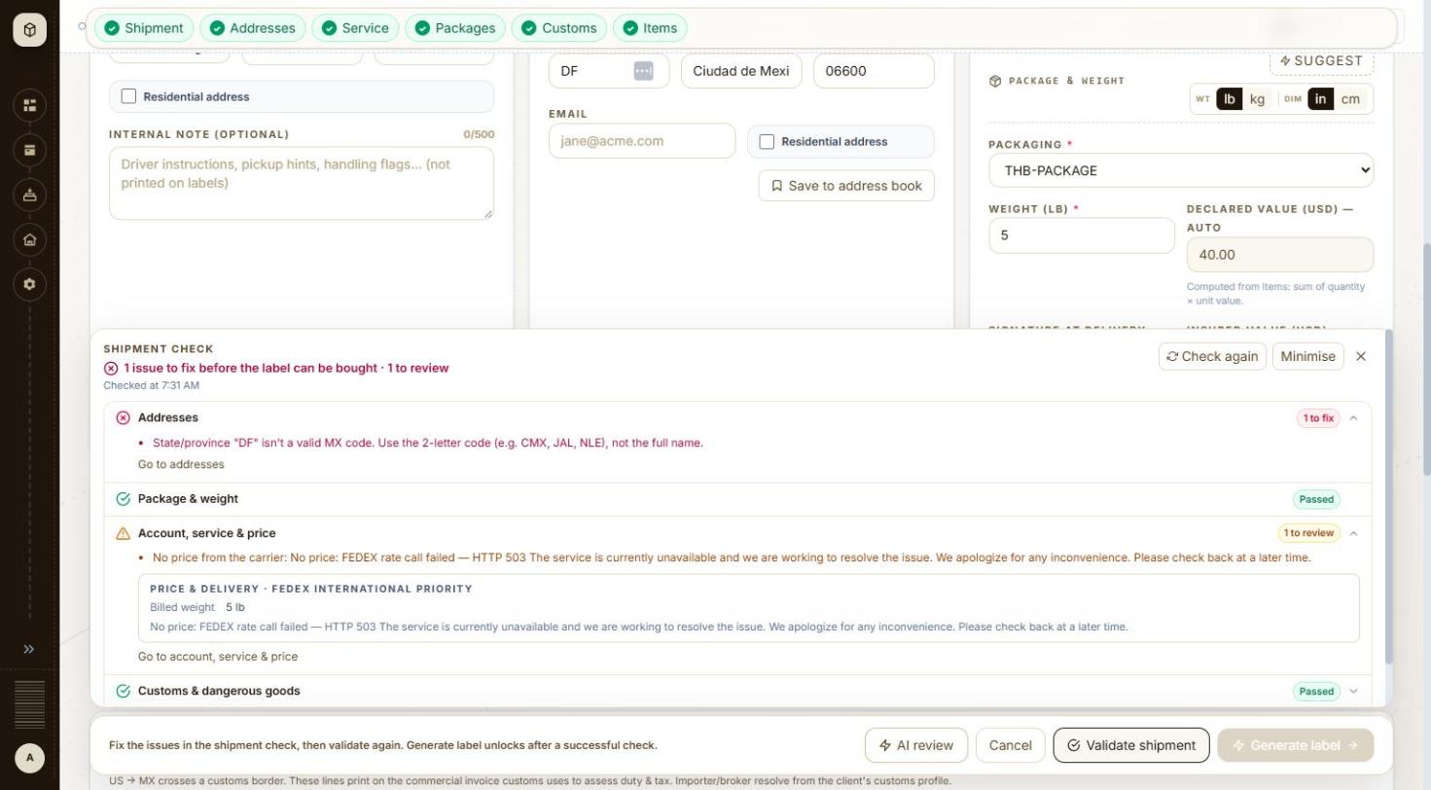
BUG-009 - screenshot 1 (BUG-009.jpg)
BUG-009 - screenshot 2 (BUG-009-2.jpg)
BUG-009 - screenshot 3 (BUG-009-3.png)
Retest history
- 2026-10-12 R3: fixed - The check message now reads: 'State/province "DF" isn't a valid MX code. Use the official code (e.g. CMX, JAL, NLE), not the full name.' The wrong '2-letter code' wording is gone, so the instruction and the examples agree.
- 2026-10-13 R4 (build local dev, 2026-10-13): fixed - Unreachable by design now. Because Mexico's State / region is a dropdown of official codes, an invalid value such as DF cannot be typed, so the message 'Use the 2-letter code (e.g. CMX, JAL, NLE)' no longer appears. The wording was already corrected to 'Use the official code' on 2026-10-12.

BUG-010 - New shipment (Mexico): Importer section shows the badge 'RESOLVED FOR MX' next to the warning 'No importer/broker profile covers MX for MKL246'
Severity / type | Low / Content
Where | Orders > New order > New order form (international) - Importer of record & customs broker: Add
URL | /orders/new
Reproducibility | Always
Found | 2026-10-12, run R1, as admin (ADMIN)
Status | Closed

Steps to reproduce
1. Open Orders and click + New shipment (/orders/new)
2. Client: MKL246 (ship from 3PL-EAST, the client default)
3. Carrier: USPS (also seen with FedEx)
4. Ship to country Mexico
5. Look at the Importer of record & customs broker section before adding an override
Test data
Seen 2026-10-12 (forms not saved)
Expected
The badge and the message agree: no profile means no 'resolved' badge (the FedEx ship-to card also shows 'Importer/broker resolved for MX').
Actual
Badge 'RESOLVED FOR MX' and, below it, 'No importer/broker profile covers MX for MKL246. Click Add to enter importer/broker for this shipment only'.
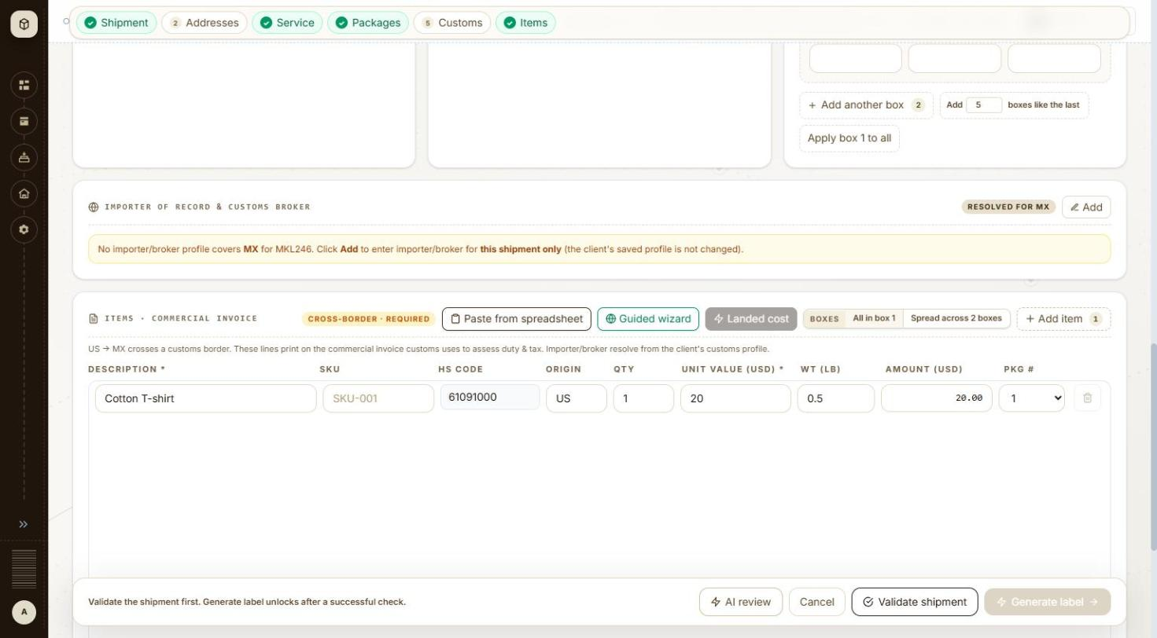
BUG-010 - screenshot 1 (BUG-010.jpg)
BUG-010 - screenshot 2 (BUG-010-2.jpg)
BUG-010 - screenshot 3 (BUG-010-3.png)
Retest history
- 2026-10-12 R3: fixed - For a Mexico shipment with no importer profile, the badge now reads 'NOT CONFIGURED' in grey next to the message 'No importer/broker profile covers MX for MKL246. Click Add to enter importer/broker for this shipment only (the client's saved profile is not changed).' The contradictory 'RESOLVED FOR MX' badge is gone. Once an override is entered the badge becomes 'OVERRIDDEN - THIS SHIPMENT' and the Ship to card shows the green 'Importer/broker resolved for CA' chip - both now only when something really is resolved.
- 2026-10-13 R4 (build local dev, 2026-10-13): fixed - On a Canada shipment with no importer profile the badge reads 'NOT CONFIGURED' beside 'No importer/broker profile covers CA for MKL246...', and on a UK shipment the Ship to card reads the amber 'No importer/broker profile for GB - set one up'. The badge only says resolved once an override is actually applied.

BUG-011 - New shipment (Canada): HS code lookup suggests the 6-digit 610910, which the form then rejects as too short
Severity / type | Low / Usability
Where | Orders > New order > New order form (international) - Item HS code and lookup
URL | /orders/new
Reproducibility | Seen once (not retested)
Found | 2026-10-11, run R1, as admin (ADMIN)
Status | Closed

Steps to reproduce
1. Open Orders and click + New shipment (/orders/new)
2. Client: MKL246 (ship from 3PL-EAST, the client default)
3. Carrier: FedEx
4. Ship to country Canada
5. Items: Description Cotton T-shirt; take the HS code the lookup suggests
Test data
First Canada shipment of the run (2026-10-11)
Expected
The lookup offers a code long enough for the destination (8+ digits for Canada).
Actual
Lookup gives 610910; inline error 'CA needs at least an 8-digit HS code (you entered 6)'. 61091000 typed by hand is accepted.
BUG-011 - screenshot (BUG-011.png)
Retest history
- 2026-10-12 R3: fixed - Typing 't-shirt' into HS code on a Canada shipment still lists 610910 and 610990, but picking 610910 now inserts 61091000 into the field - the lookup pads the code to the destination's required length. No inline error, and the Customs check passed. The hint under the field reads 'HS code should be 6-10 digits (e.g. 6104.62.20). Dots/spaces are OK; letters are not.'
- 2026-10-13 R4 (build local dev, 2026-10-13): fixed - Typing 't-shirt' into HS code on a Canada shipment lists 610910 and 610990; picking 610910 inserts 61091000 into the field. The code is padded to the destination's required length and the Customs check passes.

BUG-012 - Client MKL246 ship-from address: Address line 1 '8191 Logistics Dr,' ends with a stray comma
Severity / type | Low / Content
Where | Orders > New order > New order form (international) - Ship-from address (from client profile)
URL | /orders/new
Reproducibility | Always
Found | 2026-10-11, run R1, as admin (ADMIN)
Status | Reopened

Steps to reproduce
1. Open Orders and click + New shipment (/orders/new)
2. Client: MKL246 (ship from 3PL-EAST, the client default)
3. Look at Ship from > Address line 1
Test data
MKL246 / 3PL-EAST ship-from profile
Expected
Address line 1 without trailing punctuation; it is printed on labels and sent to the carriers.
Actual
'8191 Logistics Dr,'
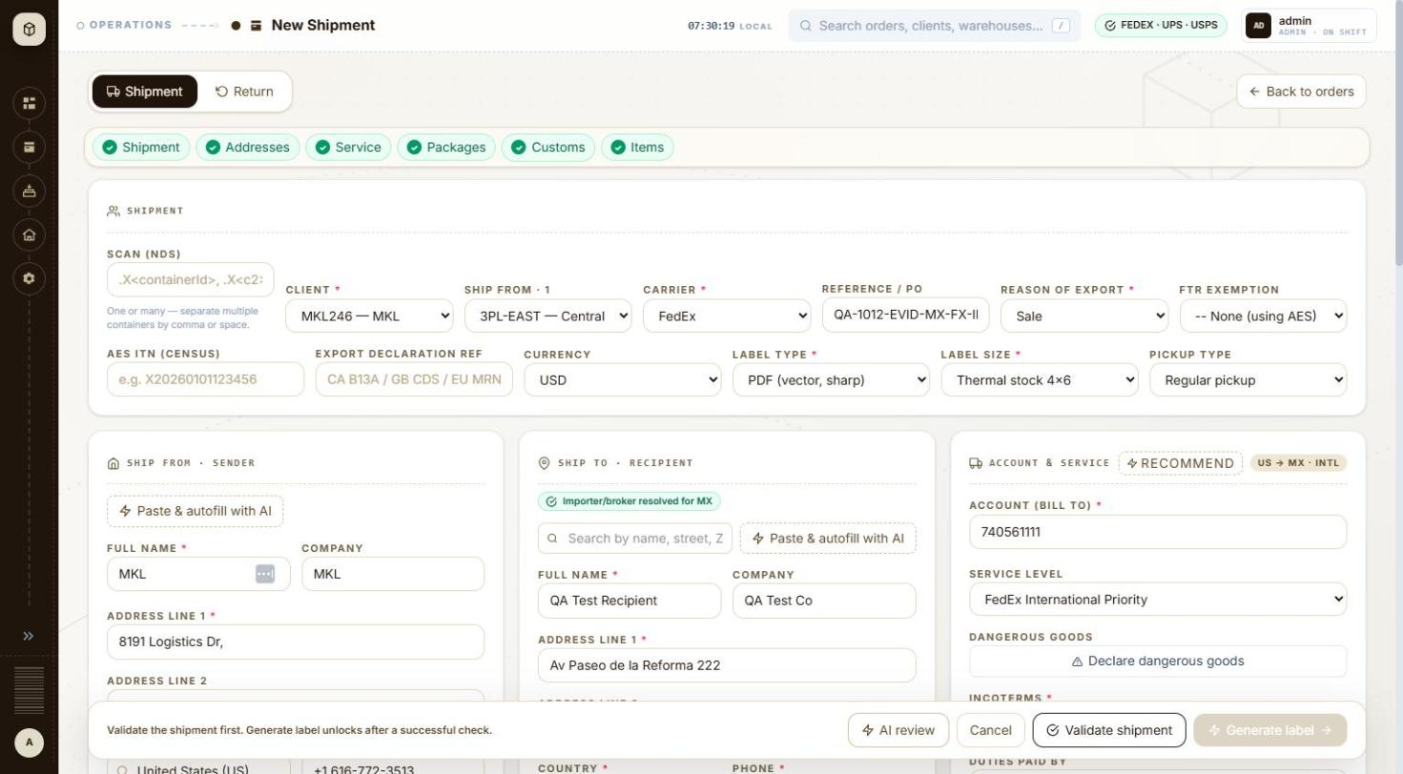
BUG-012 - screenshot (BUG-012.jpg)
Retest history
- 2026-10-12 R3: still-failing - Client MKL246's ship-from Address line 1 still reads '8191 Logistics Dr,' with the trailing comma, on the New shipment form at /orders/new.
- 2026-10-13 R4 (build local dev, 2026-10-13): still-failing - Unchanged. Picking client MKL246 on the New shipment form still fills Ship from Address line 1 as '8191 Logistics Dr,' with the trailing comma.

BUG-013 - New shipment > Items: 'Add item' inserts the new blank line above the existing one
Severity / type | Low / Usability
Where | Orders > New order > New order form (international) - Add item
URL | /orders/new
Reproducibility | Always
Found | 2026-10-11, run R1, as admin (ADMIN)
Status | Closed

Steps to reproduce
1. Open Orders and click + New shipment (/orders/new)
2. Client: MKL246 (ship from 3PL-EAST, the client default)
3. Carrier: USPS; ship to country Mexico
4. Fill item line 1: Cotton T-shirt, 61091000, US, 1, 20.00, 0.5
5. Click + Add item
Test data
Seen during the run (USPS split shipments) and on retest 2026-10-12
Expected
The new line is added below the existing line, or focus moves into the new line.
Actual
A blank line appears as row 1 and the filled line moves to row 2, so the next values typed into the top row go into the new line.
BUG-013 - screenshot 1 (BUG-013.jpg)
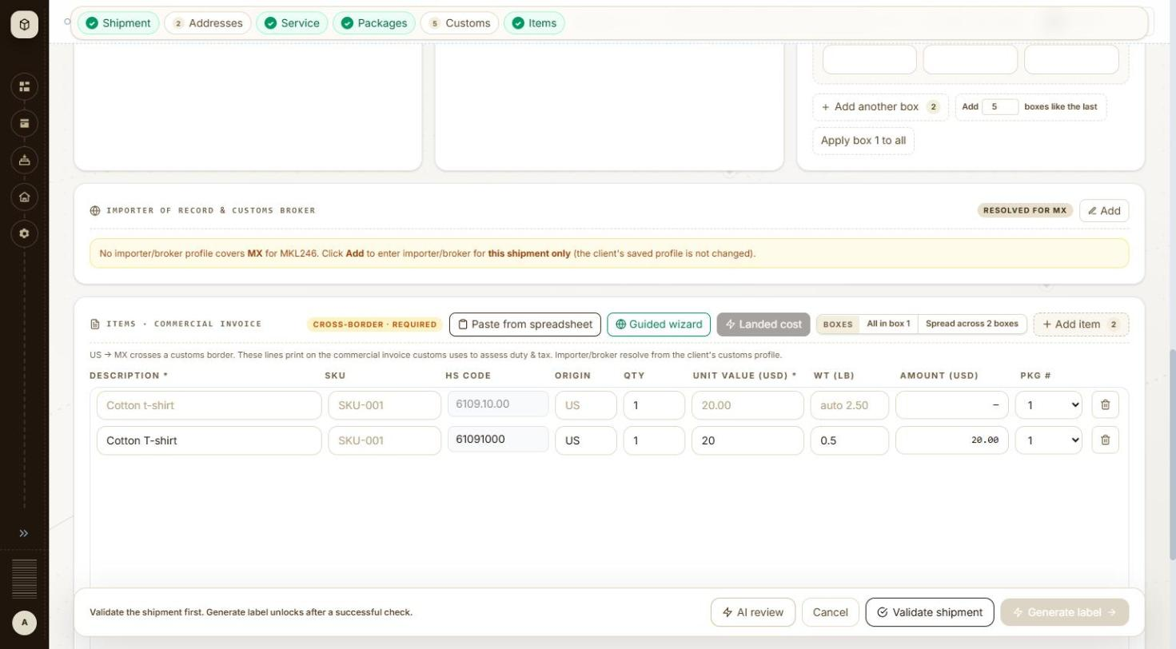
BUG-013 - screenshot 2 (BUG-013-2.jpg)
BUG-013 - screenshot 3 (BUG-013-3.jpg)
BUG-013 - screenshot 4 (BUG-013-4.jpg)
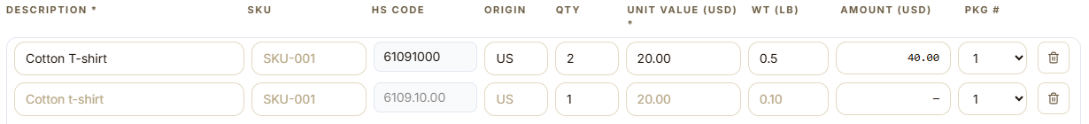
BUG-013 - screenshot 5 (BUG-013-5.png)
Retest history
- 2026-10-12 R3: fixed - With item line 1 filled (Cotton T-shirt, 61091000, US, 2, 20.00, 0.5), clicking + Add item now appends the blank line as row 2 and leaves the filled line as row 1.
- 2026-10-13 R4 (build local dev, 2026-10-13): fixed - With item line 1 filled, + Add item appends the blank line below it as row 2; the filled line stays at row 1.

BUG-014 - New shipment: the 'Lines spread across 2 boxes' toast covers the Validate shipment and Generate label buttons
Severity / type | Low / UI
Where | Orders > New order > New order form (international) - Boxes: Spread across 2 boxes
URL | /orders/new
Reproducibility | Always
Found | 2026-10-11, run R1, as admin (ADMIN)
Status | Closed

Steps to reproduce
1. Open Orders and click + New shipment (/orders/new)
2. Client: MKL246 (ship from 3PL-EAST, the client default)
3. Carrier: USPS; ship to country Mexico
4. Add another box (2 boxes)
5. Two item lines (Add item)
6. Click Boxes > Spread across 2 boxes
Test data
Seen during the run and on retest 2026-10-12
Expected
Confirmation toasts do not sit over the footer's main buttons.
Actual
Toast 'Done — Lines spread across 2 boxes in order — adjust any line's Pkg # if needed.' covers Validate shipment and Generate label at the bottom right; during the run the Validate click did not go through until the toast was closed.
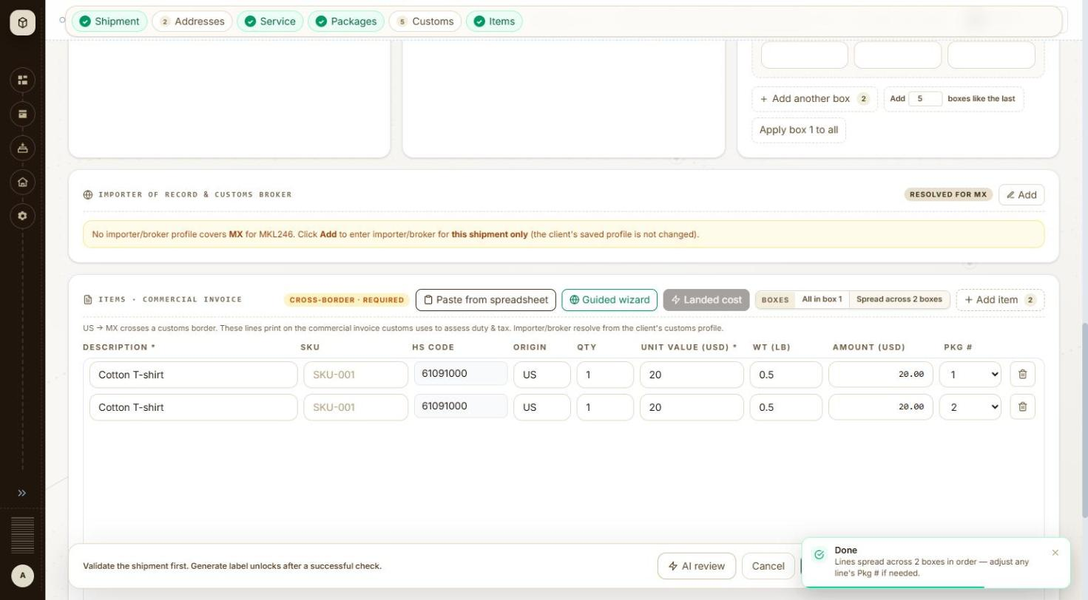
BUG-014 - screenshot 1 (BUG-014.jpg)
BUG-014 - screenshot 2 (BUG-014-2.jpg)
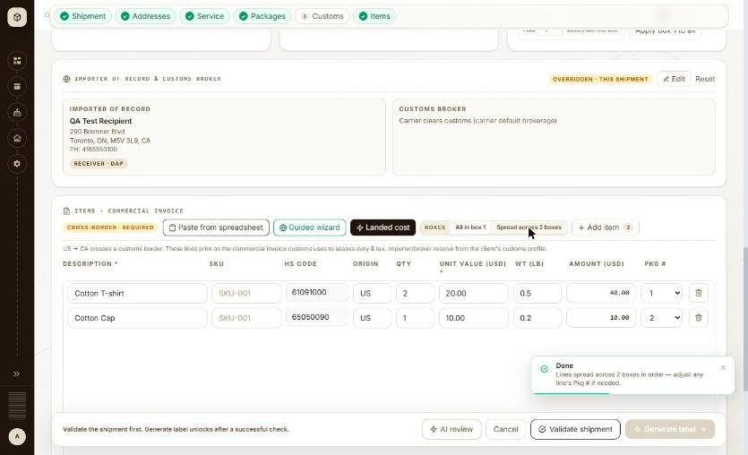
BUG-014 - screenshot 3 (BUG-014-3.jpg)
Retest history
- 2026-10-12 R3: fixed - With 2 boxes and 2 item lines, Boxes > 'Spread across 2 boxes' shows the toast 'Done - Lines spread across 2 boxes in order - adjust any line's Pkg # if needed.' clear of the footer: Validate shipment and Generate label stay fully visible and clickable while it is on screen. The lines were correctly assigned Pkg # 1 and 2.
- 2026-10-13 R4 (build local dev, 2026-10-13): fixed - Boxes > 'Spread across 2 boxes' shows 'Done - Lines spread across 2 boxes in order - adjust any line's Pkg # if needed.' clear of the footer, with Validate shipment and Generate label both fully visible and clickable.

BUG-015 - Label documents: every page load gets HTTP 503 from HEAD /label/preview.png before falling back to the PDF
Severity / type | Low / Functional
Where | Orders > Label > Label documents - Label preview
URL | /label/{orderNo}
Reproducibility | Always (3 of 3 pages)
Found | 2026-10-12, run R1, as admin (ADMIN)
Status | Reopened

Steps to reproduce
1. Open /label/934119 (or any generated order's label page)
2. Read the network requests
Test data
Orders #934118, #934119, #934190 (2026-10-12)
Expected
The preview request succeeds, or the page asks for the PDF directly; no 5xx on a normal page load.
Actual
HEAD /api/v1/orders/{id}/label/preview.png?pkg=1 -> 503, twice per load, then GET /label/pdf -> 200 and the label shows. Each /label request is also sent twice (possibly React StrictMode in the dev build).
Technical evidence
HEAD /api/v1/orders/934119/label/preview.png?pkg=1 -> 503 (x2); GET /api/v1/orders/934119/label -> 200 (x2); GET /api/v1/orders/934119/label/pdf -> 200
No screenshot file was captured for this item.
Retest history
- 2026-10-12 R3: still-failing - Unchanged. On /label/934119 and /label/934118 the page still sends HEAD /api/v1/orders/{id}/label/preview.png?pkg=1 -> 503 twice per load before falling back to GET /label/pdf -> 200, and GET /api/v1/orders/{id}/label is still sent twice.
- 2026-10-13 R4 (build local dev, 2026-10-13): still-failing - Unchanged. /label/934119 still sends HEAD /api/v1/orders/934119/label/preview.png?pkg=1 -> 503 twice per page load before falling back to GET /label/pdf -> 200, and GET /api/v1/orders/934119/label is still sent twice.

BUG-016 - Validate shipment: a server failure shows the raw toast 'Something went wrong HTTP error! status: 502'
Severity / type | Low / Content
Where | Orders > New order > New order form (international) - Validate shipment
URL | /orders/new
Reproducibility | 1 of about 40 FedEx validations
Found | 2026-10-11, run R1, as admin (ADMIN)
Status | Open

Steps to reproduce
1. Open Orders and click + New shipment (/orders/new)
2. Client: MKL246 (ship from 3PL-EAST, the client default)
3. Carrier: FedEx
4. Ship to: Full name QA Test Recipient, Company QA Test Co, Address line 1 Av Paseo de la Reforma 222, Country Mexico (MX), Phone 5552081234, State / region CMX, City Ciudad de Mexico, Postal code 06600
5. Service level: FedEx International Economy; Packaging FedEx Pak; 2 boxes
6. Fill customs, importer and items as for the other Mexico FedEx orders
7. Click Validate shipment
Test data
First Validate of MX-FX-IE-PAK (order later created as #934153)
Expected
A plain message that the check could not run and to try again; no HTTP wording.
Actual
Toast 'Something went wrong HTTP error! status: 502'; no check panel and no order. Clicking Validate again worked.
No screenshot file was captured for this item.
Retest history
- 2026-10-12 R3: cannot-retest - The 502 was a one-off server failure and could not be provoked again. Validate shipment was run about a dozen times during this retest across FedEx, UPS and USPS on the Canada, Mexico and UK lanes and returned 200 every time, so the raw 'Something went wrong HTTP error! status: 502' toast never reappeared. The wording of the error path is therefore unverified; note that other raw text is still shown to the user - the USPS no-price message prints the carrier's JSON ('error_reference_id ... error_code 4522242 ...') in full inside the check panel.
- 2026-10-13 R4 (build local dev, 2026-10-13): cannot-retest - The 502 from /shipments/validate could not be provoked again - about fifteen validations across FedEx, UPS and USPS on the Canada, Mexico and UK lanes all returned 200. A related case did appear and is worth the team's attention: when the FedEx sandbox returned 503, the check panel printed the raw status to the user - 'No price from the carrier: No price: FEDEX rate call failed - HTTP 503 The service is currently unavailable...'. The carrier's own sentence is fine; the 'HTTP 503' prefix is the same raw-status habit the original bug was about.

API

BUG-063 - Order API: a non-numeric order id returns 500 Internal Error instead of 400 Bad Request, so malformed input reaches the server as an unhandled fault
Severity / type | Low / Functional
Where | API > Orders > Order detail (GET /api/v1/orders/{id})
URL | http://localhost:5173/api/v1/orders/abc
Reproducibility | Always
Found | 2026-10-13, run R4, build local dev, 2026-10-13, as admin (ADMIN)
Status | Open

Steps to reproduce
1. With the admin session open, request GET /api/v1/orders/abc
2. Compare with GET /api/v1/orders/1 and GET /api/v1/orders/999999999
Test data
Order ids: abc (non-numeric), 1 and 999999999 (numeric, non-existent)
Expected
A path segment that is not a number is rejected as a bad request - 400, with a message naming the parameter - before any lookup is attempted. A 500 means an exception escaped rather than the input being validated.
Actual
GET /api/v1/orders/abc returns 500 with code INTERNAL_ERROR and 'Something went wrong on the server. Please try again in a moment... contact support with reference 3fed1b86.' The two numeric ids behave correctly: both return a clean 404 with 'Order not found'. So the route handles a missing order properly but not a malformed one.
Technical evidence
The error body itself is well built and leaks nothing - no stack trace, no SQL, no internal paths, just a correlation reference and 'details in server logs'. The finding is the status code and the unhandled path, not the message. Read-only requests made with the signed-in admin session; nothing was written.
No screenshot file was captured for this item.

BUG-064 - API responses carry no Content-Security-Policy and no Referrer-Policy header
Severity / type | Low / Security
Where | API > Orders > Order detail (GET /api/v1/orders/{id})
URL | http://localhost:5173/api/v1/clients/THB000
Reproducibility | Always
Found | 2026-10-13, run R4, build local dev, 2026-10-13, as admin (ADMIN)
Status | Open

Steps to reproduce
1. With the admin session open, request GET /api/v1/clients/THB000
2. Read the response headers
Test data
Any authenticated API response
Expected
The usual browser-side defences are all present on an application that renders user-supplied text: a Content-Security-Policy restricting script sources, and a Referrer-Policy so URLs are not leaked to third parties.
Actual
Present and correct: X-Frame-Options DENY, X-Content-Type-Options nosniff, Cache-Control 'no-cache, no-store, max-age=0, must-revalidate'. Absent: Content-Security-Policy and Referrer-Policy. Strict-Transport-Security is also absent, which is expected over plain http on localhost but should be checked on the deployed environment.
Technical evidence
Read from the response headers of a read-only GET made with the signed-in admin session. Output encoding itself held everywhere it was tested - a stored '<script>alert(1)</script>' in an address-book name rendered as escaped text in the grid and in the delete confirmation, with zero injected elements, and the Handlebars email preview escaped the same payload - so CSP would be defence in depth rather than the only line.
No screenshot file was captured for this item.

Settings

BUG-044 - Settings > Address book never loads: its only data call returns 500 every time, and the page shows the 'No saved addresses yet' empty state as though the book were empty
Severity / type | High / Functional
Where | Settings > Organization > Address book > Address book list - Page header and list load
URL | http://localhost:5173/settings/address-book
Reproducibility | Always
Found | 2026-10-12, run R2, as admin (ADMIN)
Status | Closed

Steps to reproduce
1. Open Settings > Address book (/settings/address-book)
2. Wait for the page to settle and read the two red toasts
3. Click Refresh at the top right
4. Watch the request the page makes
Test data
No test data needed - the failure is on page load
Expected
The saved addresses are listed, or, if the call fails, the grid says the list could not be loaded and offers a retry - not a message that says there are none.
Actual
GET /api/v1/recipients?page=0&size=25 returns 500 on every attempt. The grid shows 'No saved addresses yet. Add one here, or use "Save to address book" in Ship to on a new shipment.' On the first load two red toasts appear ('Something went wrong on the server... contact support with reference 4afd47af'), but on Refresh the call fails again with no message at all, so the page quietly claims the address book is empty. There is no way to tell from the screen whether there are no addresses or whether the list failed to load.
Technical evidence
Every read of the address book fails and every failure is drawn as an empty state. GET /api/v1/recipients?page 0&size 25 -> 500 (twice on load, twice on Refresh - the page calls it twice each time). The search sends GET /api/v1/recipients?q QA-1012&page 0&size 25 -> 502 and the grid reads 'No saved addresses match "QA-1012".' The client filter sends GET /api/v1/recipients?customerNo MKL246&page 0&size 25 -> 502 and the grid reads 'No saved addresses yet.' First-load toast text: 'Something went wrong on the server. Please try again in a moment. If this keeps happening, contact support with reference 4afd47af.' Further references seen: 51350c06, 9da70cce. No browser console errors. The whole screen is unusable, so none of its controls could be checked against real rows.
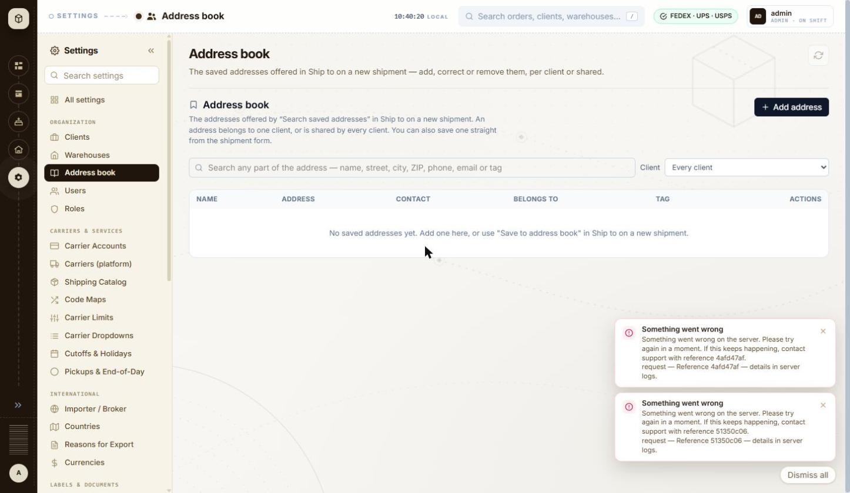
BUG-044 - screenshot 1 (BUG-044.jpg)
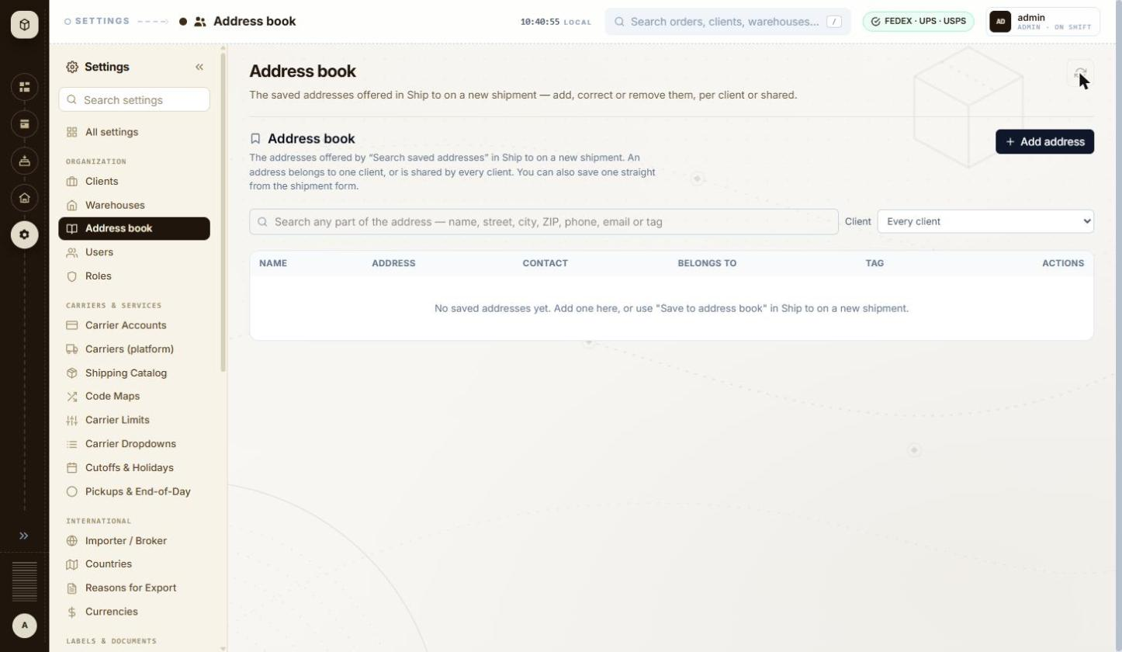
BUG-044 - screenshot 2 (BUG-044-2.jpg)
Retest history
- 2026-10-12 R3: fixed - GET /api/v1/recipients?page=0&size=25 now returns 200 and the grid lists the saved addresses with a '1 saved address' / '2 saved addresses' count. Search (?q=Bremner, ?q=60601, ?q=zzz) and the client filter all return 200 as well.
- 2026-10-13 R4 (build local dev, 2026-10-13): fixed - Settings > Address book loads. GET /api/v1/recipients?page=0&size=25 returns 200, the grid renders, and the empty state shown is now truthful rather than a disguised failure.

BUG-045 - Address book: a saved address is reported as a server failure, because the list reload that follows the save is what actually fails
Severity / type | High / Data integrity
Where | Settings > Organization > Address book > Address book list - Add / Edit address form
URL | http://localhost:5173/settings/address-book
Reproducibility | Always
Found | 2026-10-12, run R2, as admin (ADMIN)
Status | Closed

Steps to reproduce
1. Open Settings > Address book (/settings/address-book)
2. Click + Add address
3. Fill Name QA-1012 Test Recipient, Street 290 Bremner Blvd, City Chicago, State IL, Postal code 60601, Country United States
4. Click Save address
5. Read the toast and the grid
Test data
Shared address 'QA-1012 Test Recipient', 290 Bremner Blvd, Chicago, IL 60601, US
Expected
A save that succeeded is reported as a success. If the list cannot be reloaded afterwards, that is reported separately and does not cast doubt on the save.
Actual
POST /api/v1/recipients returns 200 - the address is created - but the dialog closes onto a red 'Something went wrong on the server... contact support with reference 9da70cce' and the grid still reads 'No saved addresses yet'. Everything on screen says the save failed. The failure is really the GET that follows it (BUG-044). A user will save again, and again, each time creating another copy they cannot see.
Technical evidence
POST /api/v1/recipients -> 200, then GET /api/v1/recipients?page 0&size 25 -> 500. One address was created during this test and cannot be seen or deleted from the UI while the list call fails: 'QA-1012 Test Recipient', shared with every client.
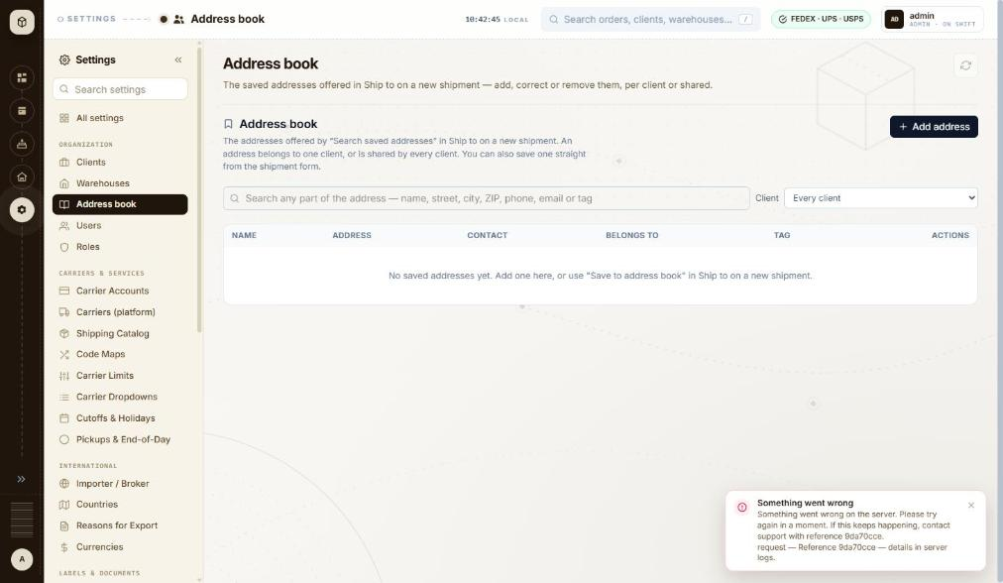
BUG-045 - screenshot (BUG-045.jpg)
Retest history
- 2026-10-12 R3: fixed - A new shared address (QA-1012 Retest Recipient, 1 Retest Way, Chicago IL 60601) saved cleanly: POST /api/v1/recipients 200, the dialog closed with no error toast and the row appeared at once. The earlier false failure was the broken reload, which is fixed with BUG-044.
- 2026-10-13 R4 (build local dev, 2026-10-13): fixed - Saving 'QA-1013 Test Recipient, 742 Evergreen Terrace, Springfield IL 62704 US' sent POST /api/v1/recipients -> 200 followed by GET /api/v1/recipients?page=0&size=25 -> 200. The dialog closed, the row appeared in the grid and the count read '1 saved address'. No false 'Something went wrong on the server' toast, so no risk of duplicate saves.

BUG-055 - Carriers (platform): a carrier can be flipped from TEST to LIVE from a plain dropdown in the grid, with no confirmation and no warning that real labels and real charges follow
Severity / type | High / Security
Where | Settings > Carriers & Services > Carriers (platform)
URL | http://localhost:5173/settings/carriers-platform
Reproducibility | Not tested
Found | 2026-10-13, run R4, build local dev, 2026-10-13, as admin (ADMIN)
Status | Open

Steps to reproduce
1. Open Settings > Carriers (platform) (/settings/carriers-platform)
2. Read the page description and the Mode column
3. Note that Mode is an ordinary select on each row, next to Enable / Disable buttons
Test data
The six platform carriers already registered: USPS_DIRECT, FEDEX, STAMPS_COM, USPS, DHL, UPS
Expected
Switching a carrier to LIVE is a deliberate, confirmed action - a dialog naming the carrier and what changes, the way Deactivate warehouse and Delete client now do - and the screen says plainly which mode bills real money. A single mis-click on a dropdown should not be able to put the platform into live shipping.
Actual
Mode is a bare select on every row with LIVE and TEST as adjacent options and nothing between the click and the change. The page description openly frames it as the point: 'Platform-wide carrier registry - toggle enabled org-wide and flip LIVE/TEST mode without a code deploy.' Four of the six carriers already read LIVE (USPS_DIRECT, FEDEX, STAMPS_COM, UPS) while every carrier account on Settings > Carrier Accounts is SANDBOX, so the two screens disagree about which environment the platform is in.
Technical evidence
Read from the screen, not exercised: changing a carrier to LIVE on a system wired to real carrier accounts could buy real labels and incur real charges, so the control was deliberately not operated. Please confirm what the server does with the change and whether any confirmation exists behind it. Window 1460x847.
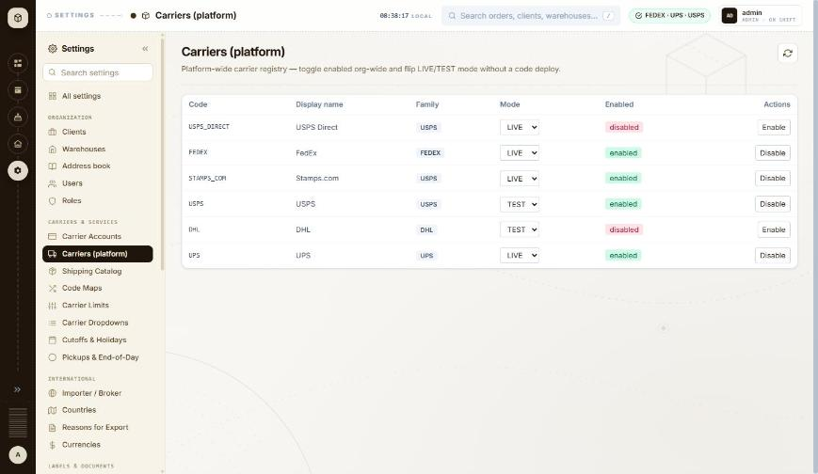
BUG-055 - screenshot (BUG-055.jpg)

BUG-059 - Pickups & End-of-Day: 'Close out' is a single unguarded button that closes every open label for a carrier and date, and it defaults to all clients
Severity / type | High / Usability
Where | Settings > Carriers & Services > Pickups & End-of-Day
URL | http://localhost:5173/settings/pickups
Reproducibility | Not tested
Found | 2026-10-13, run R4, build local dev, 2026-10-13, as admin (ADMIN)
Status | Open

Steps to reproduce
1. Open Settings > Pickups & End-of-Day (/settings/pickups)
2. Read the End-of-day close panel: Carrier FEDEX, Close date today, Client 'All clients', Warehouse code optional
3. Read the paragraph beneath it, then look at the Close out button
Test data
Not exercised - the defaults would have closed every open FedEx label for 13-10-2026 across all clients
Expected
A bulk, carrier-facing, irreversible action is confirmed first, and says how many labels it is about to close and for which client - the way Deactivate warehouse now names the client count.
Actual
The panel opens pre-filled with Carrier FEDEX, Close date 13-10-2026 and Client 'All clients', and offers one full-width black 'Close out' button. Its own description says what is at stake: 'Closes every open (generated, non-voided) label for the chosen carrier on that date. To close only specific orders instead, Close out on the Orders page.' Nothing on the screen states how many labels that is, and there is no confirmation step between the click and the carrier call.
Technical evidence
Read from the screen, not exercised: closing out a day against a carrier account is not reversible from this interface and affects every open label, so the button was deliberately not pressed. 'Schedule a pickup' in the panel beside it is the same shape - a carrier-facing booking with no confirmation step visible. Please confirm whether the server asks anything before acting. Window 1460x847.
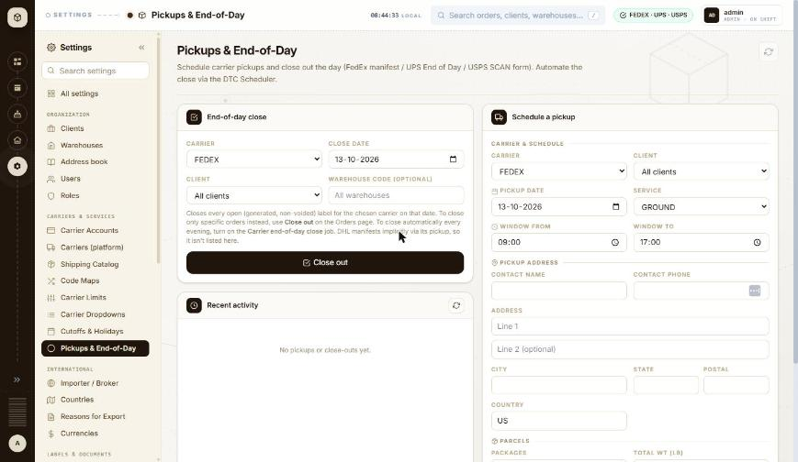
BUG-059 - screenshot (BUG-059.jpg)

BUG-028 - Client wizard > Return address: a ZIP+4 cannot be typed - the field stops at 9 characters while its own hint shows the 10-character form 12345-6789
Severity / type | Medium / Validation
Where | Settings > Organization > Clients > Client wizard (Add / Edit) - Return address: Same as Ship From / own address
URL | http://localhost:5173/settings/clients/new
Reproducibility | Always
Found | 2026-10-12, run R2, as admin (ADMIN)
Status | Closed

Steps to reproduce
1. Open Settings > Clients and click + Add Client
2. Fill step 1 Identity and pick a warehouse on step 2 Ship From, then go to step 3 Return address
3. Untick 'Same as Ship From'
4. Type 60601-1234 in ZIP
Test data
ZIP typed: 60601-1234 (10 characters). Hint under the field: 'Format: 12345 or 12345-6789 - max 9 chars - UPS'
Expected
A ZIP+4 in the form the hint shows (12345-6789) can be typed and is accepted; if the carrier limit is 9 digits, the hyphen should not count towards it.
Actual
The input has maxlength 9, so typing stops after '60601-123'. The field then shows the error 'Postal code doesn't match the US format.' and Next stays disabled, so a US ZIP+4 return address cannot be saved at all.
Technical evidence
input maxlength 9, value after typing 60601-1234: '60601-123'. The same 9-character limit is on the ZIP field of the Ship From / Return address block. Phone behaves the same way: maxlength 15 truncates '+1 (312) 555-0100' to '+1 (312) 555-01', but no error is shown for that.
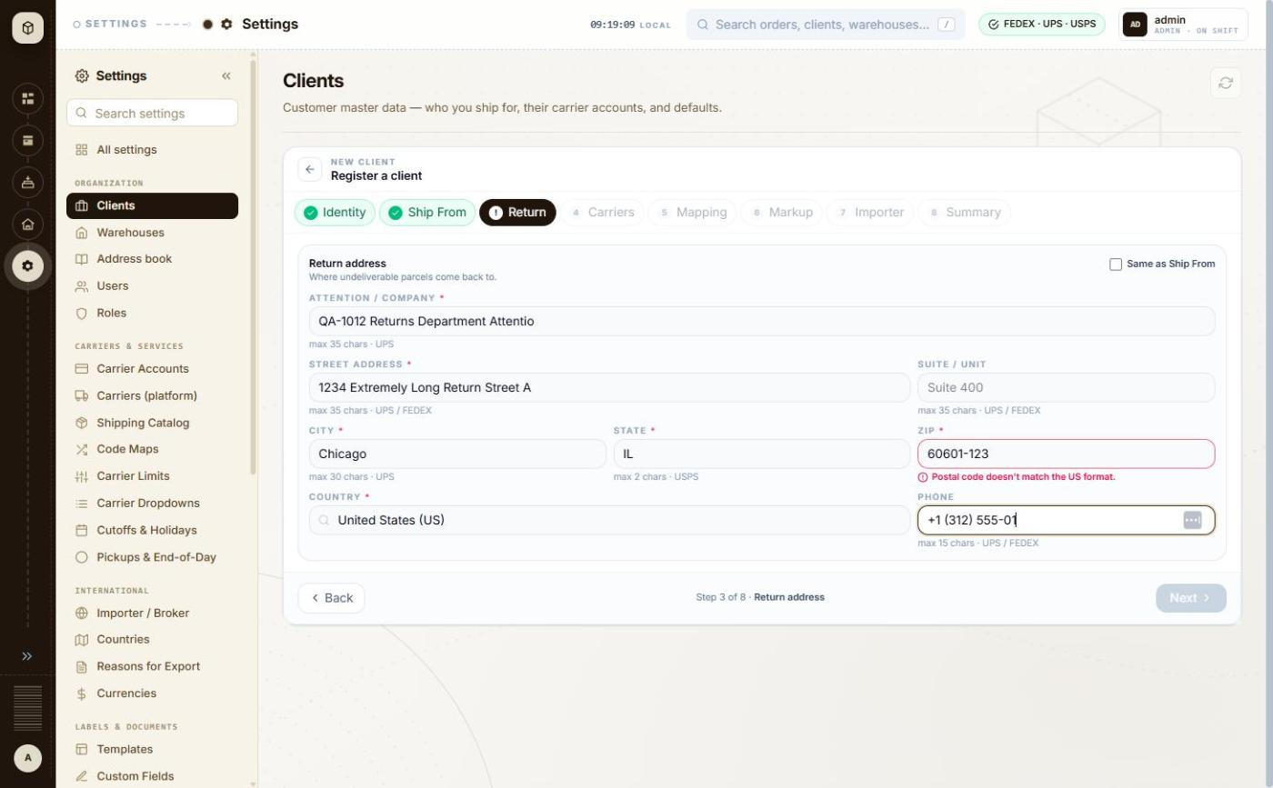
BUG-028 - screenshot 1 (BUG-028.jpg)
BUG-028 - screenshot 2 (BUG-028-2.jpg)
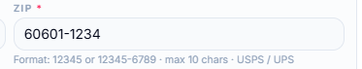
BUG-028 - screenshot 3 (BUG-028-3.png)
Retest history
- 2026-10-12 R3: fixed - The ZIP field now has maxlength 10 and its hint reads 'Format: 12345 or 12345-6789 - max 10 chars - USPS / UPS'. Typing 60601-1234 leaves the full value with no error.
- 2026-10-13 R4 (build local dev, 2026-10-13): fixed - Return address ZIP now accepts the full ZIP+4: 60601-1234 (10 characters) is held in the field, and the hint reads 'Format: 12345 or 12345-6789 - max 10 chars - USPS / UPS'. Field and hint agree.

BUG-030 - Client wizard > Carriers: Cancel on the carrier account form keeps everything typed, including the client secret, and + Add carrier account reopens the discarded draft
Severity / type | Medium / Functional
Where | Settings > Organization > Clients > Client wizard (Add / Edit) - Carrier accounts grid for the client (+ Add Account, default star)
URL | http://localhost:5173/settings/clients/new
Reproducibility | Always
Found | 2026-10-12, run R2, as admin (ADMIN)
Status | Closed

Steps to reproduce
1. Open Settings > Clients and click + Add Client
2. Fill step 1 Identity and pick a warehouse on step 2 Ship From, then go to step 4 Carriers
3. Click + Add carrier account
4. Choose carrier DHL Express, type an account number, a client id and a client secret
5. Click Cancel - the list shows 'No carrier accounts staged yet'
6. Click + Add carrier account again
Test data
Carrier DHL Express, account number QA1012QA1, test client id and client secret created for this run (local SANDBOX placeholders)
Expected
Cancel discards the draft, so the next + Add carrier account opens an empty form on the default carrier - as the empty-state text implies.
Actual
The list is emptied but the form is not: reopening it shows the cancelled carrier, account number, client id and the filled client secret. Typing an account number then appends to the retained one (QA1012 typed into a field already holding QA1012 gives QA1012QA1), so a stale credential can be staged against the wrong carrier without the user noticing.
Technical evidence
Nothing is sent on Cancel; the draft is only held in the page. The retained secret stays masked but is still submitted if the user clicks Add to list.
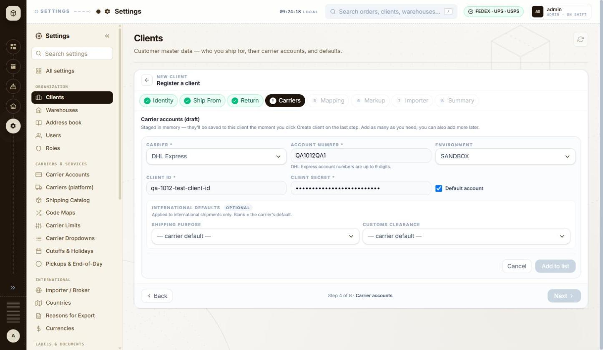
BUG-030 - screenshot (BUG-030.jpg)
Retest history
- 2026-10-12 R3: fixed - Cancel now clears the draft completely: reopening + Add carrier account gives an empty form on the default carrier, with the account number, client id and secret all blank.
- 2026-10-13 R4 (build local dev, 2026-10-13): fixed - Filled the carrier form (DHL Express, account 123456789, client id and secret), clicked Cancel, then + Add carrier account again: the form reopens empty on the default carrier UPS, with account number, client id and client secret all blank. No stale credential is retained.

BUG-040 - Add warehouse accepts a state of 'ILLINOIS' and a 10-character postal code, although this is the ship-from address printed on every label
Severity / type | Medium / Validation
Where | Settings > Organization > Warehouses > Warehouses list - Add / Edit warehouse panel: address fields and country
URL | http://localhost:5173/settings/warehouses
Reproducibility | Always
Found | 2026-10-12, run R2, as admin (ADMIN)
Status | Closed

Steps to reproduce
1. Open Settings > Warehouses and click + Add Warehouse
2. Fill Code QA-1012-WH01 and a name
3. Line 1 742 Evergreen Terrace, City Springfield
4. State / region: type ILLINOIS
5. Postal code: type 62704-1234
6. Phone +1 (217) 555-0100, Country US
7. Click Create warehouse
Test data
Warehouse QA-1012-WH01, state ILLINOIS, postal code 62704-1234, country US
Expected
The ship-from address is checked at least as strictly as the client's return address, which caps State at 2 characters for a US address and checks the postal code format. UPS and FedEx both need a 2-letter state code for US addresses, so 'ILLINOIS' will be refused at label time.
Actual
No check at all. State / region accepts up to 50 characters with no format rule and no carrier hint, Postal code accepts up to 20 with no format rule. The warehouse saves and the list shows 'Springfield, ILLINOIS'. The same window on the client Return address step would have truncated both and shown an error.
Technical evidence
Input maxlengths on this panel: Code 50, Name 255, Line 1 255, Line 2 255, City 100, State 50, Postal code 20, Country 2, Phone 50. No per-carrier hints are shown, unlike the Return address step which shows 'max 2 chars - USPS', 'Format: 12345 or 12345-6789' and so on. Required fields are checked ('State / region is required.'), so only the content rules are missing.
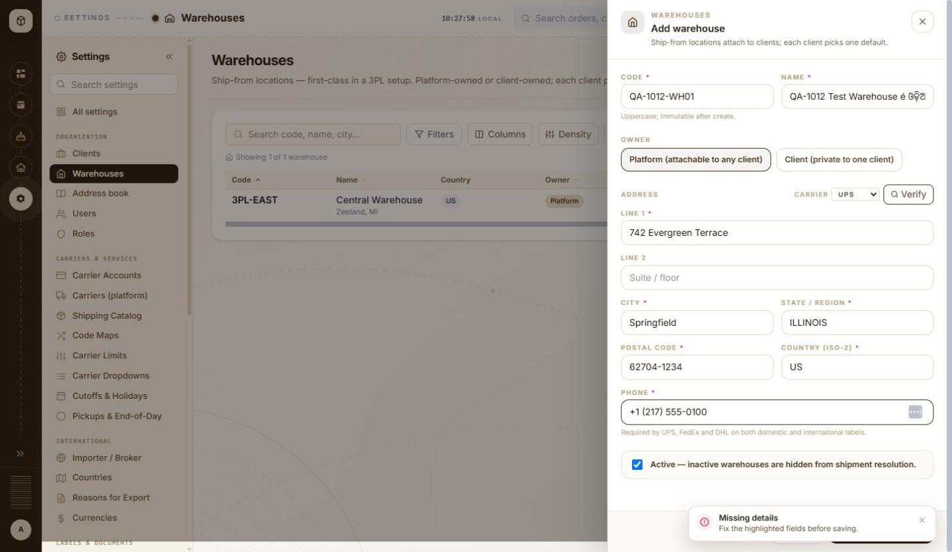
BUG-040 - screenshot 1 (BUG-040.jpg)
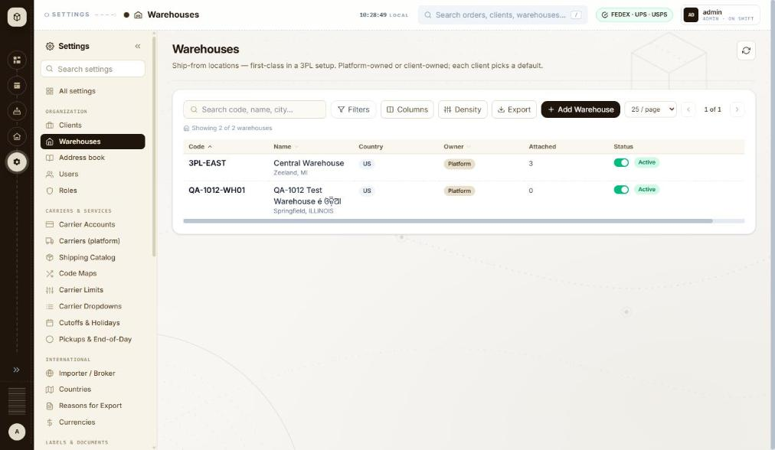
BUG-040 - screenshot 2 (BUG-040-2.jpg)
Retest history
- 2026-10-12 R3: fixed - Add warehouse now refuses the carrier-breaking values. Typing ILLINOIS into State / region marks the field 'State / region must be 2 characters or fewer.'; typing NOTAZIPCODE12345678 into Postal code marks it 'Postal code must be 10 characters or fewer.' Create warehouse greys out while either is wrong. The rules are length rules rather than format rules - a 2-character non-state such as XX is still accepted - but the values that broke the carriers are now rejected before the record is saved.
- 2026-10-13 R4 (build local dev, 2026-10-13): fixed - Re-walked. ILLINOIS in State / region is marked 'State / region must be 2 characters or fewer.'; NOTAZIPCODE12345678 is marked 'Postal code must be 10 characters or fewer.' Clicking Create warehouse with those values sends no request at all and raises 'Missing details - Fix the highlighted fields before saving.' with every failing field marked, Street address included.

BUG-041 - Warehouses > Attach clients: the dialog never shows which clients are already attached, and nothing on the screen can detach one
Severity / type | Medium / Functional
Where | Settings > Organization > Warehouses > Warehouses list - Row menu > Attach clients
URL | http://localhost:5173/settings/warehouses
Reproducibility | Always
Found | 2026-10-12, run R2, as admin (ADMIN)
Status | Closed

Steps to reproduce
1. Open Settings > Warehouses
2. Scroll the table right, open the row menu on a warehouse and click Attach clients
3. Tick a client and click Attach - the Attached count goes up and 'Attached QA-1012-WH01 to 1 client.' is shown
4. Open the same row menu > Attach clients again
5. Look for a way to undo the attachment anywhere on this screen
Test data
Warehouse QA-1012-WH01 attached to client THB000
Expected
The dialog shows the clients already attached, ticked or marked, so the user can see the current state; and an attachment made by mistake can be undone from the same place.
Actual
Both clients are shown unticked every time, with no sign that THB000 is attached - the only clue is the Attached count in the grid. The subtitle says 'Existing attachments are unaffected', so the dialog only ever adds. The row menu offers Attach clients, Edit and Delete only, and the Edit panel does not list attachments either, so an attachment can be created here but never removed.
Technical evidence
Ticking a client also reveals 'Set as this client's default warehouse', which silently changes that client's default - another reason the current state needs to be visible. The only way found to change it is the client's own Ship From step.
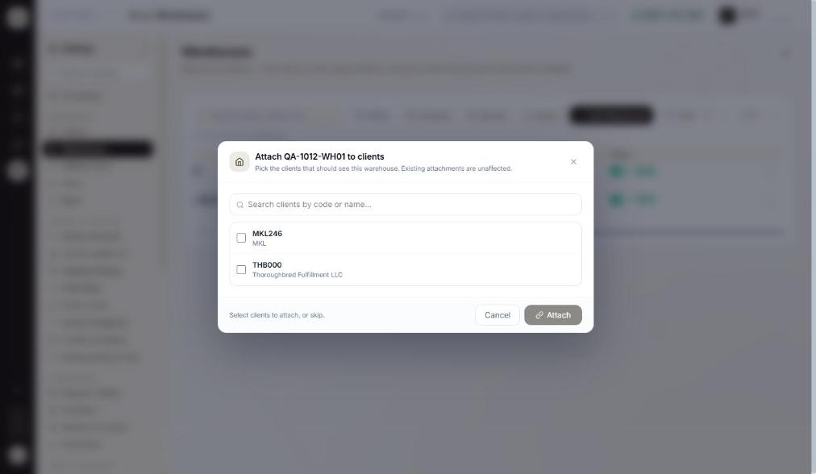
BUG-041 - screenshot 1 (BUG-041.jpg)
BUG-041 - screenshot 2 (BUG-041-2.jpg)
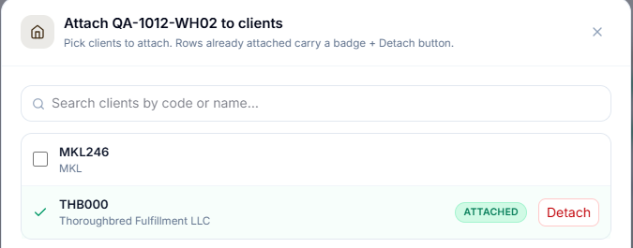
BUG-041 - screenshot 3 (BUG-041-3.png)
Retest history
- 2026-10-12 R3: fixed - Row menu > Attach clients on a warehouse with one attached client: the dialog subtitle now reads 'Pick clients to attach. Rows already attached carry a badge + Detach button.', THB000 shows a green ATTACHED badge and a red Detach button. Detach opens 'Detach client - Detach THB000 from warehouse QA-1012-WH02?' and on confirm the badge clears and a 'Detached THB000.' toast appears. Re-attach works too. Retested on QA-1012-WH02 at 1392x847.
- 2026-10-13 R4 (build local dev, 2026-10-13): fixed - Row menu > Attach clients on QA-1013-WH01 shows the subtitle 'Pick clients to attach. Rows already attached carry a badge + Detach button.' with QA-1013-CL01 carrying a green ATTACHED badge and a red Detach button.

BUG-043 - Deactivating a warehouse that clients ship from happens on one click, with no warning - the same action on a client asks first and lists the cascade
Severity / type | Medium / Usability
Where | Settings > Organization > Warehouses > Warehouses list - Status toggle (Activate / Deactivate warehouse)
URL | http://localhost:5173/settings/warehouses
Reproducibility | Always
Found | 2026-10-12, run R2, as admin (ADMIN)
Status | Closed

Steps to reproduce
1. Open Settings > Warehouses
2. Pick a warehouse with a number greater than 0 in the Attached column
3. Click its Status toggle
Test data
Warehouse QA-1012-WH01, Attached = 1 (client THB000)
Expected
The same care as on the Clients screen, where Deactivate asks 'Deactivate QA-1012-CL01?' and lists what else it will disable. The panel's own wording - 'inactive warehouses are hidden from shipment resolution' - means this can stop a client shipping.
Actual
One click and it is done: the row turns Inactive and a green toast says 'QA-1012-WH01 is now inactive.' Nothing is asked, and the attached clients are not mentioned even though the Attached column shows 1.
Technical evidence
Re-activating is also a single click. The toast prints the status in lower case here ('is now inactive.') and in upper case on the Clients screen ('is now ACTIVE.').
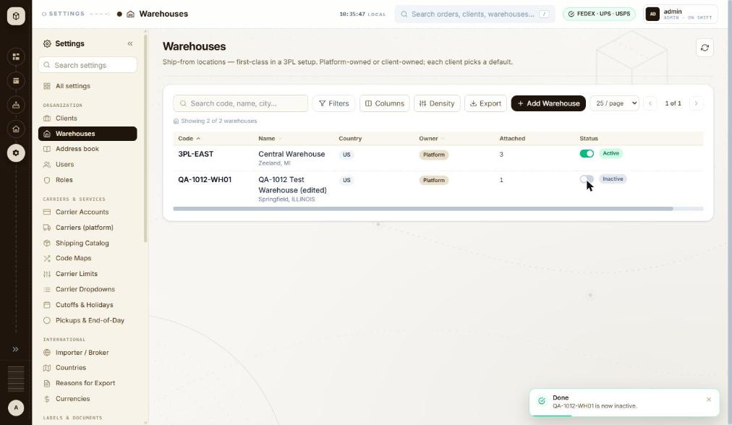
BUG-043 - screenshot 1 (BUG-043.jpg)
BUG-043 - screenshot 2 (BUG-043-2.jpg)
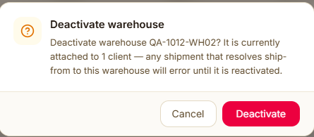
BUG-043 - screenshot 3 (BUG-043-3.png)
Retest history
- 2026-10-12 R3: fixed - Toggling the Status switch off on QA-1012-WH02 (1 client attached) now opens 'Deactivate warehouse - Deactivate warehouse QA-1012-WH02? It is currently attached to 1 client - any shipment that resolves ship-from to this warehouse will error until it is reactivated.' with Cancel / Deactivate; only on confirm does the row go Inactive. Delete likewise warns 'It is currently attached to 1 client - they will be unlinked.'
- 2026-10-13 R4 (build local dev, 2026-10-13): fixed - Toggling QA-1013-WH01 off with one client attached raises 'Deactivate warehouse - Deactivate warehouse QA-1013-WH01? It is currently attached to 1 client - any shipment that resolves ship-from to this warehouse will error until it is reactivated.' with Cancel / Deactivate.

BUG-050 - A sent invitation leaves no trace: the invited person is not listed, the audit panel stays empty, and the accept link is shown once and then lost
Severity / type | Medium / Functional
Where | Settings > Organization > Users > Users list - Invite user form (fields, validation, send)
URL | http://localhost:5173/settings/users
Reproducibility | Always
Found | 2026-10-12, run R2, as admin (ADMIN)
Status | Closed

Steps to reproduce
1. Open Settings > Users (/settings/users)
2. Click Invite user, enter an address, pick a client and a role, and click Send invite
3. Read the confirmation, then click Done
4. Look at the user list and at 'Recent admin actions'
5. Click Refresh
Test data
Invite to qa-1012-invite@example.com, client THB000, role USER. Accept link shown: http://localhost:5173/invite/8881caf518742688c83dfa1d688cecd03d6c748867028fee
Expected
The invited person appears in the list as pending, with a way to resend or revoke, and the invitation is recorded in 'Recent admin actions' like any other admin change.
Actual
After Done the list still reads 'Showing 2 rows - page 1' with only admin and manoj7000, and 'Recent admin actions' still reads 'No audit entries yet.' A refresh changes nothing. The only copy of the accept link was in the dialog that was just closed, so if the invitation does not arrive there is no way to find it, resend it or cancel it - and no record that it was ever sent.
Technical evidence
GET /api/v1/admin/users?page 0&size 50 and GET /api/v1/admin/users/audit?limit 50 both return 200 after the invite, and neither contains the invited address. This matters more here because Settings > Mail reports 'No provider active - outbound emails are logged only', so in this environment no invitation can reach anyone.
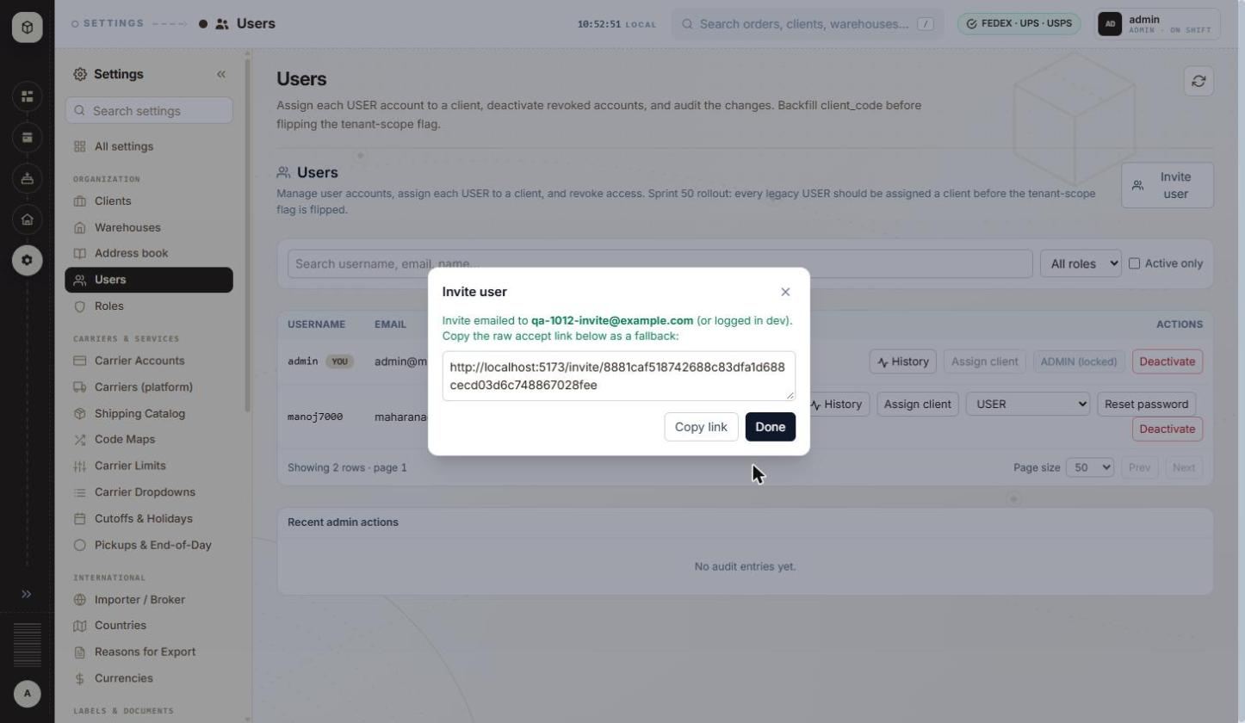
BUG-050 - screenshot 1 (BUG-050.jpg)
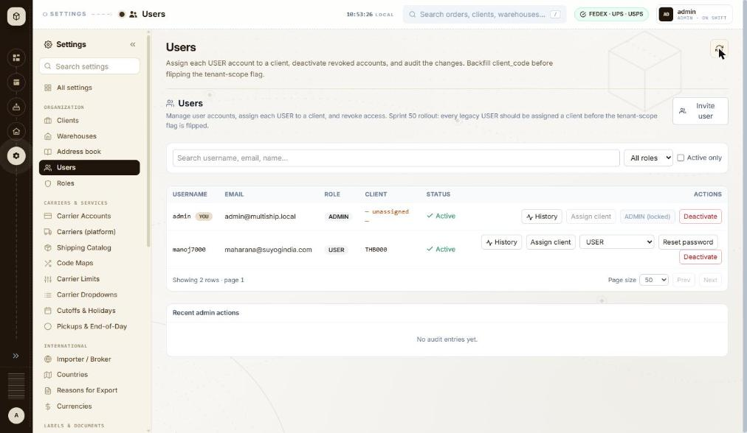
BUG-050 - screenshot 2 (BUG-050-2.jpg)
BUG-050 - screenshot 3 (BUG-050-3.jpg)
BUG-050 - screenshot 4 (BUG-050-4.jpg)
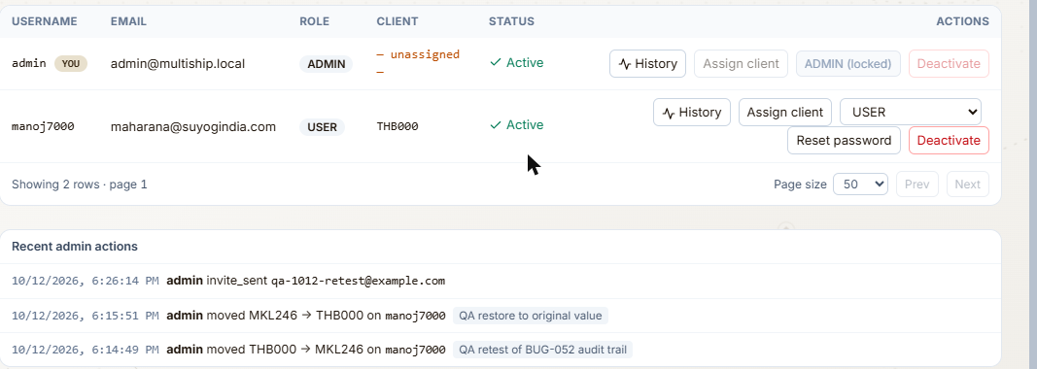
BUG-050 - screenshot 5 (BUG-050-5.png)
BUG-050 - screenshot 6 (BUG-050-6.jpg)
BUG-050 - screenshot 7 (BUG-050-7.jpg)
BUG-050 - screenshot 8 (BUG-050-8.jpg)
BUG-050 - screenshot 9 (BUG-050-9.jpg)
BUG-050 - screenshot 10 (BUG-050-10.png)
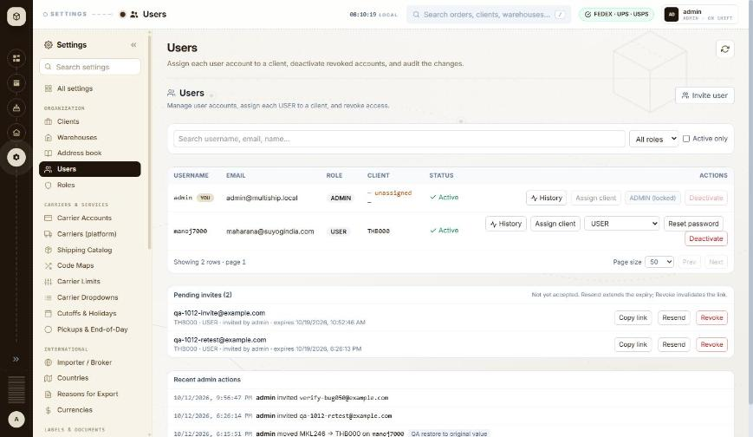
BUG-050 - screenshot 11 (BUG-050-11.jpg)
Retest history
- 2026-10-12 R3: still-failing - Half fixed. The invitation is now recorded: 'Recent admin actions' shows '10/12/2026, 6:26:14 PM admin invite_sent qa-1012-retest@example.com' immediately, and the confirmation dialog has gained a 'Copy link' button. The rest is unchanged - after Done the list still reads 'Showing 2 rows - page 1' with only admin and manoj7000, the invited address appears nowhere, there is no pending state and nothing to resend or revoke it with, and the accept link is still gone once the dialog closes. The audit line also prints the raw action code 'invite_sent' rather than words.
- 2026-10-13 R4 (build local dev, 2026-10-13): fixed - A 'Pending invites (2)' panel has been added below the user list, headed 'Not yet accepted. Resend extends the expiry; Revoke invalidates the link.' Each row shows the address, client, role, who invited and the expiry - for example 'qa-1012-retest@example.com - THB000 - USER - invited by admin - expires 10/19/2026, 6:26:13 PM' - with Copy link, Resend and Revoke. The accept link is recoverable after the dialog is closed, the invitation can be cancelled, and 'Recent admin actions' records each invite. Both leftovers from the earlier runs are now removable from the interface.

BUG-051 - The Deactivate button is enabled on the signed-in admin's own row, and that is the only ADMIN account in the system
Severity / type | Medium / Security
Where | Settings > Organization > Users > Users list - Row action > Deactivate / Activate
URL | http://localhost:5173/settings/users
Reproducibility | Not tested
Found | 2026-10-12, run R2, as admin (ADMIN)
Status | Closed

Steps to reproduce
1. Open Settings > Users (/settings/users)
2. Look at the admin row, marked YOU
3. Note that Assign client is disabled ('ADMIN is always org-wide') and the role control reads 'ADMIN (locked)', but Deactivate is live
Test data
admin / admin@multiship.local, the only row with role ADMIN
Expected
The last remaining ADMIN, and the account the current session belongs to, cannot be deactivated from the interface - the button is disabled with a reason, the way Assign client and the role control already are on this row.
Actual
The button is not disabled (disabled=false, no tooltip). If the server does not refuse it, one click would deactivate the only administrator and lock everyone out of the application.
Technical evidence
Read from the page, not clicked: the user asked that this not be exercised, because recovery would need database access. Two of the three other controls on the same row are already correctly disabled with explanations, so the guard looks simply to have been missed on this one. Please confirm whether the server refuses it.
BUG-051 - screenshot 1 (BUG-051.jpg)
BUG-051 - screenshot 2 (BUG-051-2.jpg)
BUG-051 - screenshot 3 (BUG-051-3.png)
Retest history
- 2026-10-12 R3: fixed - The Deactivate button on the signed-in admin's own row is now disabled=true with the tooltip "You can't deactivate your own account - ask another admin.", matching Assign client ('ADMIN is always org-wide') and the locked role control. Read from the DOM, not clicked. Note the guard is on self-deactivation; the separate last-remaining-ADMIN case cannot be exercised while admin is the only ADMIN account.
- 2026-10-13 R4 (build local dev, 2026-10-13): fixed - Deactivate on the signed-in admin's own row reads disabled=true with the tooltip "You can't deactivate your own account - ask another admin." Read from the DOM, not clicked. The separate last-remaining-ADMIN case still cannot be exercised while admin is the only ADMIN account.

BUG-052 - The user audit trail records nothing: admin changes with a typed reason leave both 'Recent admin actions' and the per-user History empty
Severity / type | Medium / Functional
Where | Settings > Organization > Users > Users list - Recent admin actions panel
URL | http://localhost:5173/settings/users
Reproducibility | Always
Found | 2026-10-12, run R2, as admin (ADMIN)
Status | Closed

Steps to reproduce
1. Open Settings > Users (/settings/users)
2. Click Assign client on a user, change the client code and type something in 'Reason (optional - recorded in audit)'
3. Click Save and wait for 'Done - Updated manoj7000.'
4. Look at the 'Recent admin actions' panel at the bottom of the page
5. Click Refresh, then click History on that user's row
Test data
User manoj7000: client code changed to NOSUCHCLIENT (refused), then saved as THB000 with the reason 'QA-1012 validation check, will be restored'. An invitation to qa-1012-invite@example.com was also sent earlier in the session.
Expected
Each admin change is listed, with who made it, when, what changed and the reason given - the page description promises exactly this ('...deactivate revoked accounts, and audit the changes') and the Reason field says it is 'recorded in audit'.
Actual
'Recent admin actions' reads 'No audit entries yet.' before and after the change, and the per-user dialog reads 'No admin actions recorded for this user.' Nothing is recorded for the successful assignment, nor for the invitation sent earlier.
Technical evidence
GET /api/v1/admin/users/audit?limit 50 returns 200 after each change, so the page is asking for the list and getting nothing back. The reason text the admin types is therefore collected and discarded.
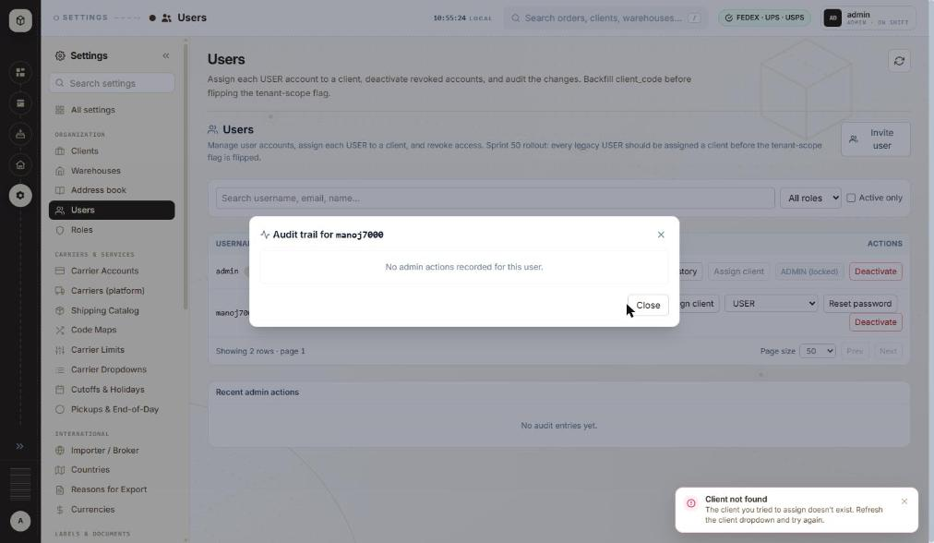
BUG-052 - screenshot 1 (BUG-052.jpg)
BUG-052 - screenshot 2 (BUG-052-2.jpg)
BUG-052 - screenshot 3 (BUG-052-3.png)
Retest history
- 2026-10-12 R3: fixed - Assign client on manoj7000 (THB000 -> MKL246) with the reason 'QA retest of BUG-052 audit trail' now appears immediately in 'Recent admin actions' as '10/12/2026, 6:14:49 PM admin moved THB000 -> MKL246 on manoj7000 QA retest of BUG-052 audit trail', and the per-user History dialog 'Audit trail for manoj7000' lists the same entry. The restore back to THB000 was recorded too. Who, when, what changed and the reason are all present.
- 2026-10-13 R4 (build local dev, 2026-10-13): fixed - Assigning manoj7000 to QA-1013-CL01 with the reason 'QA R4 audit trail check' appeared at once in Recent admin actions as '10/13/2026, 8:13:39 AM admin moved THB000 -> QA-1013-CL01 on manoj7000 QA R4 audit trail check', and the restore to THB000 was recorded the same way. manoj7000 is back on THB000.

BUG-054 - Carrier Accounts: the 'Ready to ship 5/5' tile counts every account as ready, including one whose check failed and one that is unverified
Severity / type | Medium / Data integrity
Where | Settings > Carriers & Services > Carrier Accounts
URL | http://localhost:5173/settings/carriers
Reproducibility | Always
Found | 2026-10-13, run R4, build local dev, 2026-10-13, as admin (ADMIN)
Status | Open

Steps to reproduce
1. Open Settings > Carrier Accounts (/settings/carriers)
2. Read the four summary tiles at the top
3. Read the Status column of the five rows beneath them
Test data
The five accounts already on the system, plus QA-1013-CL01's UPS account added during this run
Expected
Ready to ship counts only the accounts that can actually produce a label - here 3 of 5 - or the tile says what it is really counting. It should not disagree with the tile beside it.
Actual
The first tile reads 'READY TO SHIP 5/5' in green with a tick, while the second reads 'UNVERIFIED 2' in amber with a warning triangle. The rows show USPS/TEST 'Check failed', FedEx 740561111 'Verified', UPS 746W05 'Verified', USPS 874157 'Verified' and UPS QA1013UP 'Unverified'. Three of the five are verified, so 5/5 is wrong by the screen's own data and by the tile next to it.
Technical evidence
Read from the rendered table: statuses are 'Check failed', 'Verified', 'Verified', 'Verified', 'Unverified'. A user glancing at the green 5/5 would believe every carrier account is good to go, which is the opposite of what the row for USPS/TEST says. Window 1460x847.
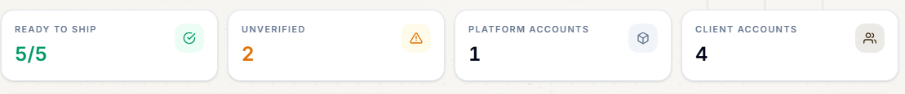
BUG-054 - screenshot (BUG-054.png)

BUG-058 - Cutoffs & Holidays: a holiday and a cutoff rule are both deleted on a single click of the trash icon, with no confirmation
Severity / type | Medium / Usability
Where | Settings > Carriers & Services > Cutoffs & Holidays
URL | http://localhost:5173/settings/cutoffs
Reproducibility | Always
Found | 2026-10-13, run R4, build local dev, 2026-10-13, as admin (ADMIN)
Status | Open

Steps to reproduce
1. Open Settings > Cutoffs & Holidays (/settings/cutoffs)
2. Scroll to Global holiday list and add a row - date 27-11-2026, name 'QA-1013 Test Holiday' - with + Add
3. Click the trash icon on that row
4. Note that the row is gone immediately, and that the Cutoff rules grid above offers the same single-click trash on each of its 17 rows
Test data
QA-1013 Test Holiday on 2026-11-27, created and deleted during this run
Expected
Deleting a date that changes when every shipment's SHIP_DATE rolls forward is confirmed first, the way deleting a warehouse or a client now is - a dialog naming the row and what depends on it.
Actual
One click removes the row. No dialog, no named confirmation, and no undo. The same trash icon sits on all 17 cutoff rules directly above, one row apart from the four real holidays (New Year's Day, Christmas Eve, and the same two for next year), so a mis-click silently changes the platform's working-day calendar. By contrast the delete flows on Clients, Warehouses and user invitations all confirm.
Technical evidence
Exercised on a test row only - no real holiday or cutoff rule was deleted. The page itself explains the stakes: 'Dates the cutoff logic treats as non-working when advancing to the next working day' and 'Shipments past cutoff or on a holiday get their SHIP_DATE pushed to the next working day.' Window 1460x847.
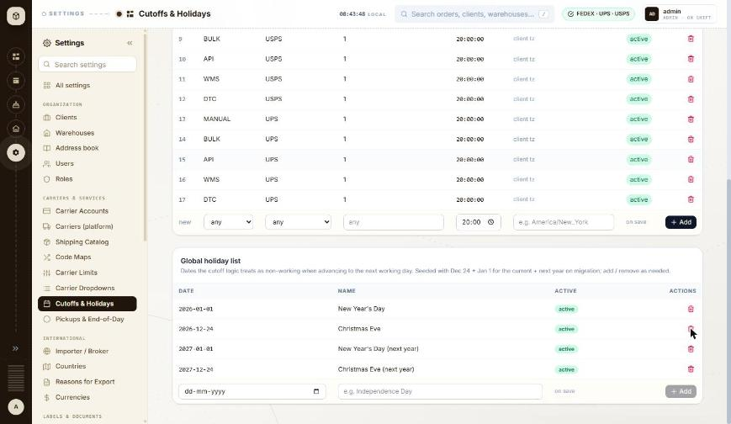
BUG-058 - screenshot (BUG-058.jpg)

BUG-060 - Two Settings screens claim to hold an international standard list but hold a small subset: Countries shows only the six US territories, Currencies only ten currencies
Severity / type | Medium / Data integrity
Where | Settings > International > Countries
URL | http://localhost:5173/settings/countries
Reproducibility | Always
Found | 2026-10-13, run R4, build local dev, 2026-10-13, as admin (ADMIN)
Also affects | Settings > International > Countries; Settings > International > Currencies
Status | Open

Steps to reproduce
1. Open Settings > Countries (/settings/countries)
2. Read the heading and description
3. Count the rows
Test data
No test data needed - the screen is read-only
Expected
Either the screen lists the ISO countries the rest of Settings validates against, or it is named for what it actually holds - the US-territory flags.
Actual
Countries: six rows - PR Puerto Rico, VI US Virgin Islands, GU Guam, AS American Samoa, MP Northern Mariana Islands, UM US Minor Outlying Islands - every one flagged 'US territory: yes', under the description 'ISO country list + is_us_territory flag.' There is no ISO country list here. Currencies: ten rows - USD, EUR, GBP, CAD, INR, AUD, SGD, JPY, CNY, AED - under 'ISO 4217 currency catalog', which has about 180 entries. This is the root of BUG-046: with no master country list on this screen, the address book carries its own 250-entry select, the client wizard its own searchable combobox and the warehouse panel a free-typed ISO-2 box that is checked against nothing.
Technical evidence
Counted from the rendered table: 6 rows. Compare BUG-046, where the same field is built three different ways elsewhere in Settings. Window 1460x847.
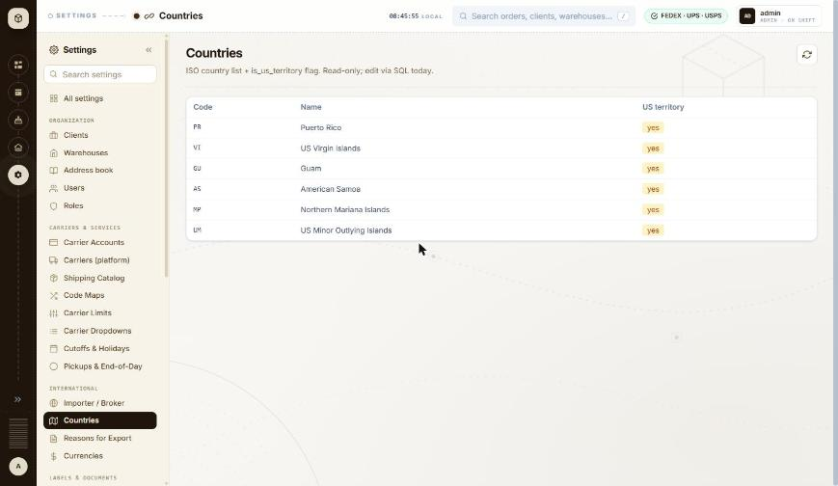
BUG-060 - screenshot (BUG-060.jpg)

BUG-065 - Carrier API Log redacts tokens and secrets but stores the OAuth client_id in clear text in the saved request body
Severity / type | Medium / Security
Where | Settings > Activity & Logs > Carrier API Log
URL | http://localhost:5173/settings/carrier-api-log
Reproducibility | Always
Found | 2026-10-13, run R4, build local dev, 2026-10-13, as admin (ADMIN)
Status | Open

Steps to reproduce
1. Open Settings > Carrier API Log (/settings/carrier-api-log)
2. Find a POST to https://signin.testing.stampsendicia.com/oauth/token
3. Click the row to expand the stored Request body and Response body
Test data
An existing logged token exchange from 10/13/2026, 3:20:56 AM
Expected
The redaction covers every part of a credential exchange, not only the fields named secret or token. A client_id is half of an OAuth client credential and belongs behind the same mask, or the log should keep no body for auth endpoints at all.
Actual
Most of it is handled well - the stored request body shows "refresh_token":"***" and "client_secret":"***", and the response shows "access_token":"***". But the same request body carries "client_id":"247Fvwi95XbnKjXCN7hE4PkwPpQdhow5" in full. Anyone who can open Settings can read it, and the page says it keeps request and response bodies for every carrier round-trip - 1,947 of them so far. The redaction looks to be a list of field names rather than a rule applied to auth endpoints, so a field the list does not know about is stored as-is.
Technical evidence
Read from the expanded row in the interface. The full client_id is reproduced above only because this is a SANDBOX account on Manoj's local machine; it should be treated as a live value on any deployed environment. Window 1460x847.
BUG-065 - screenshot (BUG-065.png)

BUG-022 - Clients search: '%' and '_' work as wildcards, so searching for them lists clients that do not contain them
Severity / type | Low / Functional
Where | Settings > Organization > Clients > Clients list - Search code, name, city
URL | http://localhost:5173/settings/clients
Reproducibility | Always
Found | 2026-10-12, run R2, as admin (ADMIN)
Also affects | Settings > Organization > Warehouses > Warehouses list
Status | Closed

Steps to reproduce
1. Open Settings > Clients (/settings/clients)
2. Type % in the box 'Search code, name, city...' and wait for the list
3. Replace it with _ and wait
4. Replace it with MKL_46 and wait
5. Replace it with M%6 and wait
6. Clear the search, click Filters, type _ in Code contains and wait; clear it and type % in City contains
Test data
Search terms: %, _, MKL_46, M%6. Clients on file: MKL246 (MKL, Zeeland MI), THB000 (Thoroughbred Fulfillment LLC, Zeeland MI)
Expected
The search matches the text typed. No client code, name or city contains % or _, so each of these four searches should show 'No clients match the current filters.' Client codes may contain '_' (the Add Client hint says 'Letters, digits, '-', '_''), so a code search with '_' must not also match other characters in that position.
Actual
'%' and '_' each list both clients ('Showing 2 of 2 clients'). 'MKL_46' and 'M%6' each list MKL246 ('Showing 1 of 1 client'). The Filters panel has the same fault: Code contains '_' and City contains '%' each list both clients.
Technical evidence
GET /api/v1/clients?page=0&size=25&sortBy=code&sortDirection=ASC&search=%25 -> 200, 2 rows
GET /api/v1/clients?...&search=_ -> 200, 2 rows
GET /api/v1/clients?...&search=MKL_46 -> 200, 1 row (MKL246)
The term reaches the server intact, so the server most likely uses it in a SQL LIKE pattern without escaping % and _.
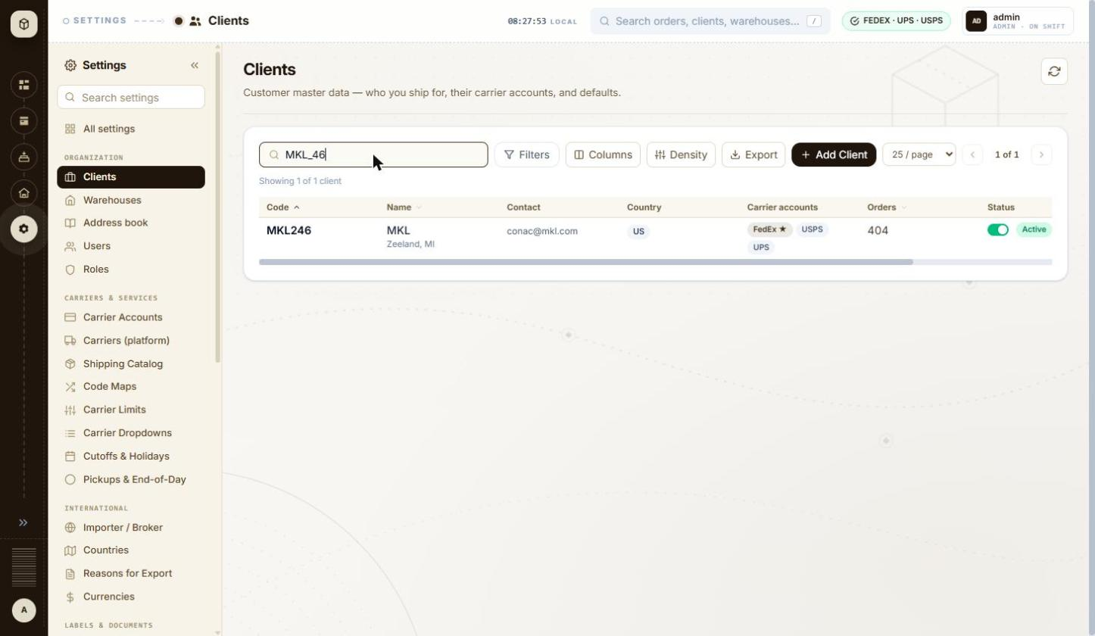
BUG-022 - screenshot (BUG-022.jpg)
Retest history
- 2026-10-12 R3: fixed - Searching '_', '%' and 'MKL_46' now all give 'Showing 0 of 0 clients'. A normal term still works ('mkl' finds MKL246). The Filters panel is fixed too: Code contains '_' and City contains '%' both give 0 of 0.
- 2026-10-13 R4 (build local dev, 2026-10-13): fixed - Re-walked at 1460x847. Searching '%' returns 'No clients match the current filters' with 'Showing 0 of 0 clients'; the wildcard is no longer passed through to the query.

BUG-024 - Importer / Broker dialog (Clients row menu): a click on the dimmed background closes it and throws away what was typed; Esc does nothing
Severity / type | Low / Usability
Where | Settings > Organization > Clients > Clients list - Row menu > Importer / Broker
URL | http://localhost:5173/settings/clients
Reproducibility | Always
Found | 2026-10-12, run R2, as admin (ADMIN)
Status | Reopened

Steps to reproduce
1. Open Settings > Clients (/settings/clients)
2. Scroll the table to the right and open the ⋮ menu on MKL246
3. Click Importer / Broker
4. Type QA-1012-IMP-BACKDROP in Importer name and QA Contact in Contact
5. Press Esc
6. Click on the dimmed background to the right of the dialog
7. Open ⋮ > Importer / Broker on MKL246 again
Test data
Client MKL246; Importer name QA-1012-IMP-BACKDROP; Contact QA Contact (nothing saved)
Expected
Esc and a background click behave the same way, and neither silently discards typed data: either they ask 'Discard changes?' when something has been typed, or only Cancel / X close the dialog. The Filters panel and Columns menu on the same page close on Esc.
Actual
Esc does nothing (the dialog stays open, focus moves to the X button). A single click on the dimmed background closes the dialog at once with no warning; reopening shows an empty form, so everything typed is lost.
Technical evidence
No request is sent on close (nothing saved). The form is long (client and destinations, importer of record, tax identity and further sections), so one stray click loses a lot of typing.
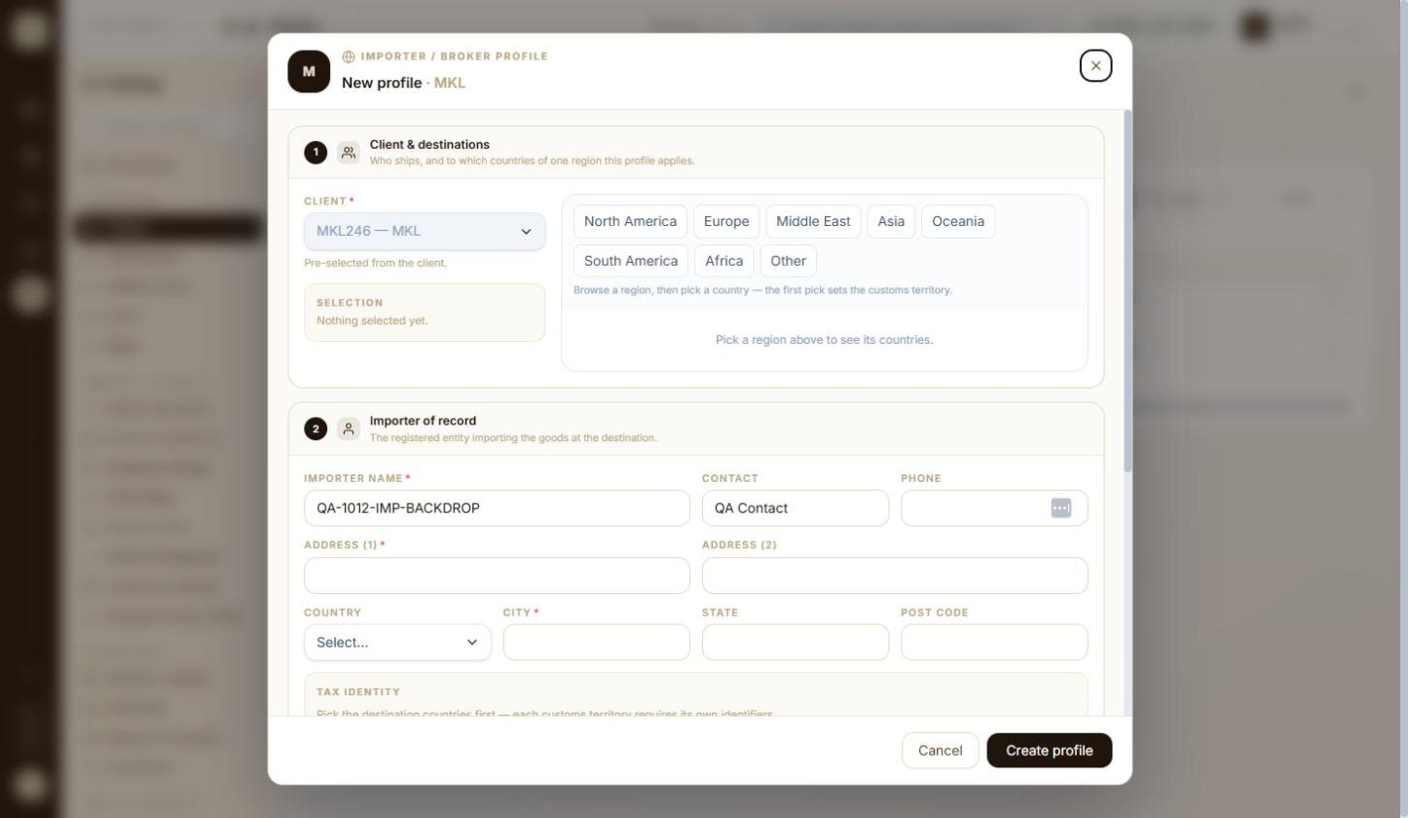
BUG-024 - screenshot (BUG-024.jpg)
Retest history
- 2026-10-12 R3: still-failing - Unchanged. Esc with the cursor in Importer name does nothing; a single click on the dimmed background closes the dialog at once and the typed name is gone when it is reopened.
- 2026-10-13 R4 (build local dev, 2026-10-13): still-failing - Unchanged, and now inconsistent with the rest of the app. With 'QA-1013 Importer Draft' typed into Importer name, a click on the dimmed background closed the Importer / Broker dialog at once and discarded it, with no prompt. The client editor on the same screen does guard this: leaving it with unsaved changes raises 'Leave client editor? This client has unsaved changes. Leave and lose what you've edited?' with Stay / Leave.

BUG-025 - Clients list: the row menu (⋮ Importer / Broker, Edit, Delete) is off-screen at a 1446 px wide window; it is only reachable by scrolling the table sideways
Severity / type | Low / UI
Where | Settings > Organization > Clients > Clients list - Table width / row actions reachable at 1446 px
URL | http://localhost:5173/settings/clients
Reproducibility | Always
Found | 2026-10-12, run R2, as admin (ADMIN)
Status | Reopened

Steps to reproduce
1. Use a browser window 1446 x 840 with the Settings menu expanded
2. Open Settings > Clients (/settings/clients)
3. Look for the ⋮ menu at the end of each row
4. Scroll the table to the right with the horizontal scrollbar under the rows
Test data
Default column layout and Compact density; 2 clients
Expected
The row actions are visible without sideways scrolling: the seven default columns fit, and the Status column has a wide empty area after the Active badge.
Actual
The rows end at the Status column; the ⋮ menu (the only way to Edit or Delete a client) is hidden past the right edge. A horizontal scrollbar appears under the table, and the ⋮ buttons show only after scrolling right, when Code and Name scroll out of view.
Technical evidence
Window 1446 x 840, Settings menu expanded. With every column hidden (Columns menu) the ⋮ buttons appear at the right edge without scrolling, so the overflow comes from the column widths.
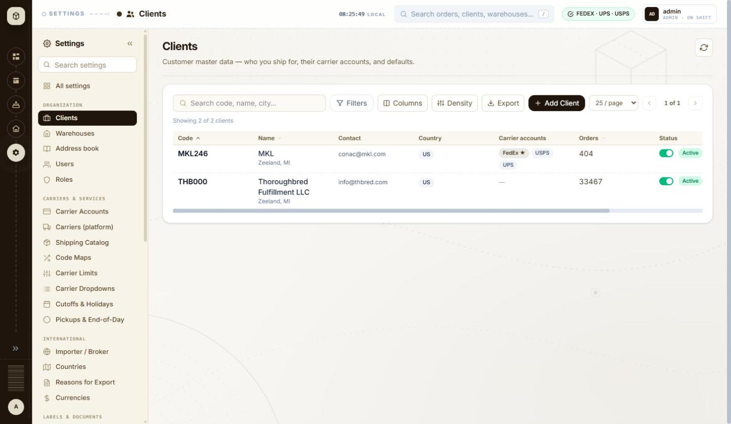
BUG-025 - screenshot 1 (BUG-025.jpg)
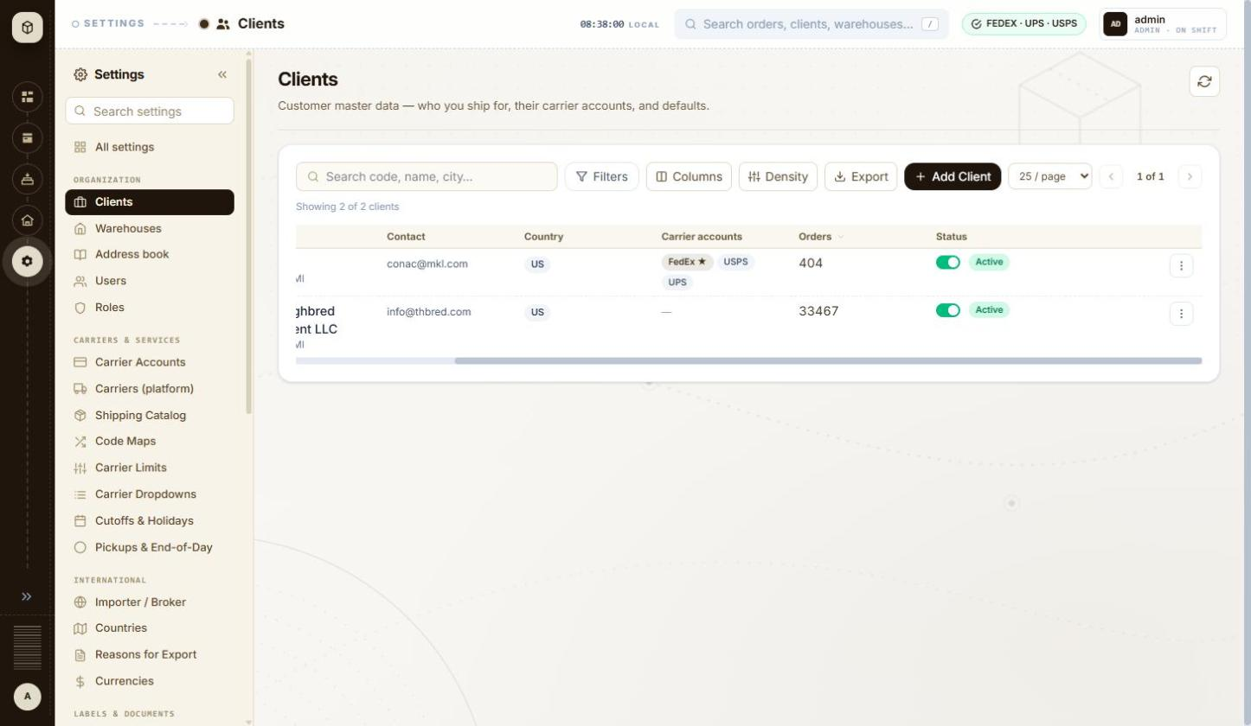
BUG-025 - screenshot 2 (BUG-025-2.jpg)
BUG-025 - screenshot 3 (BUG-025-3.jpg)
BUG-025 - screenshot 4 (BUG-025-4.jpg)
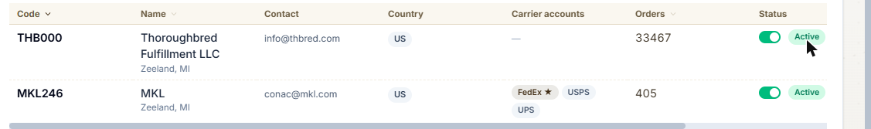
BUG-025 - screenshot 5 (BUG-025-5.png)
Retest history
- 2026-10-12 R3: still-failing - Still reproduces, though not at the original width: the Claude side panel fixes this session's viewport at 1005x847, so 1446 px could not be set. At 1005 px with the default column layout the row ends at Orders and the actions column is past the right edge; the horizontal scrollbar has to be used before any row action can be reached.
- 2026-10-13 R4 (build local dev, 2026-10-13): still-failing - Unchanged, and my 2026-10-12 reading of 'fixed' was wrong - that check was made while the grid happened to be scrolled right. Measured from the DOM at a 1460 px window with the default layout: both Row actions buttons sit at x 1587-1615, entirely outside the viewport. The grid's own scroller is 1058 px wide against 1280 px of content, so the row menu can only be reached by scrolling the grid sideways; there is no sticky actions column.

BUG-026 - Clients list sorting: after the third click on a header the arrow disappears, but the list is still sorted by Code ascending, so the next click on Code appears to do nothing
Severity / type | Low / UI
Where | Settings > Organization > Clients > Clients list - Sort by Code
URL | http://localhost:5173/settings/clients
Reproducibility | Always
Found | 2026-10-12, run R2, as admin (ADMIN)
Status | Closed

Steps to reproduce
1. Open Settings > Clients (/settings/clients); the Code header shows an up arrow (Code ascending)
2. Click the Code header (Code descending: THB000 first)
3. Click the Code header again: no arrow is shown and the rows are MKL246, THB000
4. Click the Code header once more
Test data
2 clients (MKL246, THB000)
Expected
Each click visibly changes the sort, and the header arrow always matches the order shown: either the third click returns to 'Code ascending' with its arrow (as on page load), or the 'unsorted' state shows rows in a different, unsorted order.
Actual
After the second click the header shows no arrow although the rows are in Code ascending order (the page-load state, which shows an arrow). The following click only brings the arrow back; the rows do not move. Cycling Orders (descending, ascending, then a third click) ends in the same arrow-less Code ascending state.
Technical evidence
The 'no arrow' state requests GET /api/v1/clients?page=0&size=25&sortBy=code&sortDirection=ASC, the same request as page load and as 'Code ascending'.
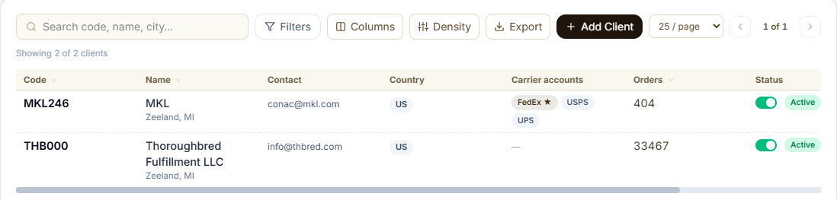
BUG-026 - screenshot (BUG-026.png)
Retest history
- 2026-10-12 R3: fixed - The Code header now cycles between two states only. Three clicks from the default gave descending (THB000 first, arrow down), ascending (MKL246 first, arrow up), descending again - the arrow matches the order every time and the arrow-less state is gone.
- 2026-10-13 R4 (build local dev, 2026-10-13): fixed - Clicking the Code header three times now leaves a visible sort arrow and a list that matches it: THB000 above MKL246, with the request GET /api/v1/clients?...sortBy=code&sortDirection=DESC. The header cycles between ASC and DESC with the arrow always shown; the silent third state is gone.

BUG-027 - Client wizard > Timezone: searching 'Kolkata' or 'Kyiv' finds nothing; the list only has the old names Asia/Calcutta and Europe/Kiev
Severity / type | Low / Usability
Where | Settings > Organization > Clients > Client wizard (Add / Edit) - Defaults > Timezone (IANA search and locate button)
URL | http://localhost:5173/settings/clients/new
Reproducibility | Always
Found | 2026-10-12, run R2, as admin (ADMIN)
Status | Closed

Steps to reproduce
1. Open Settings > Clients and click + Add Client
2. In Defaults > Timezone type Kolk
3. Replace it with Calcutta
4. Replace it with Kyiv, then with Kiev
5. Click the locate button 'Detect timezone from browser' (browser set to India time)
Test data
Timezone search terms Kolk, Calcutta, Kyiv, Kiev
Expected
The field asks for an IANA name ('IANA (e.g. America/New_York)'); the current IANA names Asia/Kolkata and Europe/Kyiv are offered (old aliases may also match), so a user searching the city's current name finds it.
Actual
'Kolk' and 'Kyiv' show 'No timezone matches ...'. 'Calcutta' offers Asia/Calcutta (UTC+05:30) and 'Kiev' offers Europe/Kiev. The locate button also fills Asia/Calcutta.
Technical evidence
The list appears to come from the browser's own time-zone list, which in Chrome still uses the old aliases.
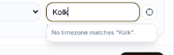
BUG-027 - screenshot 1 (BUG-027.png)
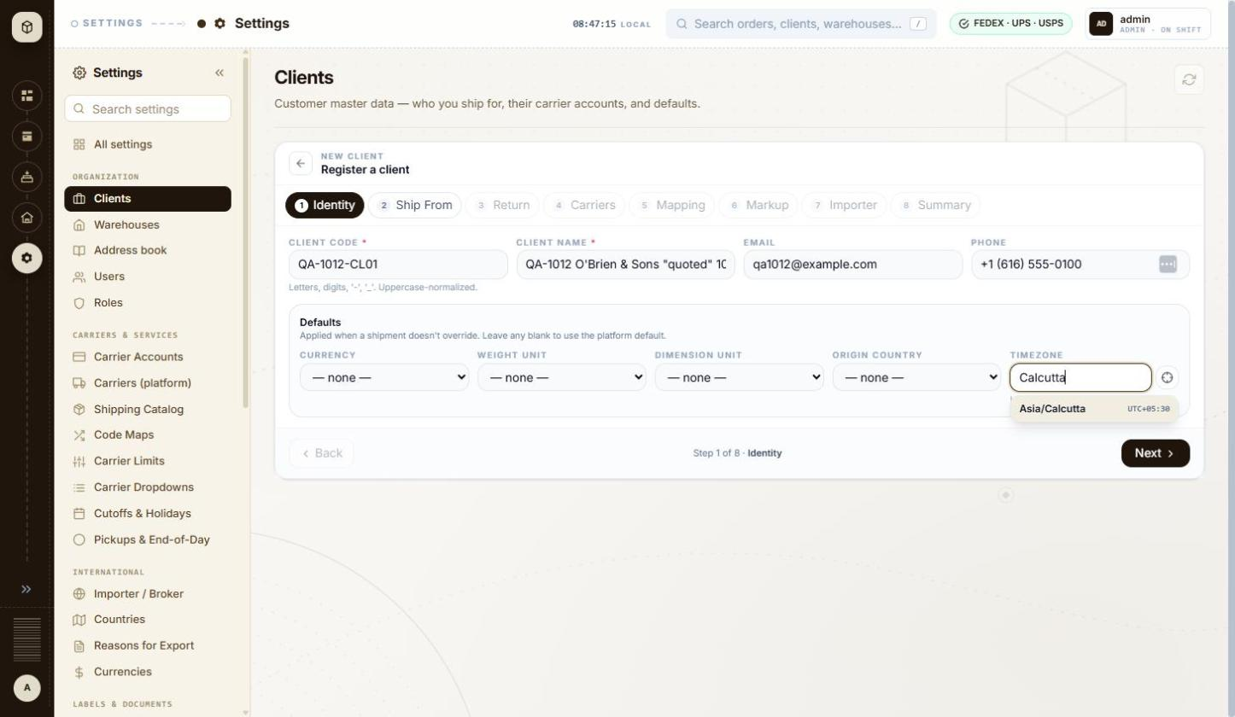
BUG-027 - screenshot 2 (BUG-027-2.jpg)
BUG-027 - screenshot 3 (BUG-027-3.png)
BUG-027 - screenshot 4 (BUG-027-4.jpg)
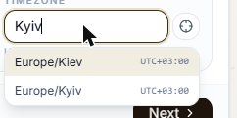
BUG-027 - screenshot 5 (BUG-027-5.png)
Retest history
- 2026-10-12 R3: still-failing - Half fixed. 'Kyiv' now finds Europe/Kiev, so an alias has been added there, but 'Kolk' still shows 'No timezone matches "Kolk".' - Asia/Kolkata is still missing.
- 2026-10-13 R4 (build local dev, 2026-10-13): fixed - The timezone list carries the modern names and keeps the old ones as aliases. Searching 'Kolkata' returns both Asia/Calcutta and Asia/Kolkata (UTC+05:30); searching 'Kyiv' returns Europe/Kiev and Europe/Kyiv (UTC+03:00).

BUG-029 - Client wizard > Carriers: the UPS account number hint and its error message give different rules ('exactly 6 alphanumerics' vs '6-10 letters or digits')
Severity / type | Low / Content
Where | Settings > Organization > Clients > Client wizard (Add / Edit) - Carrier accounts grid for the client (+ Add Account, default star)
URL | http://localhost:5173/settings/clients/new
Reproducibility | Always
Found | 2026-10-12, run R2, as admin (ADMIN)
Status | Reopened

Steps to reproduce
1. Open Settings > Clients and click + Add Client
2. Fill step 1, pick a warehouse on step 2, go on to step 4 Carriers
3. Click + Add carrier account; Carrier is UPS
4. Read the grey hint under Account number
5. Type 12 in Account number and click into Client ID
6. Replace it with QA10127890123 and click into Client ID
Test data
Carrier UPS; Account number 12, then QA1012!! (saved as QA1012)
Expected
The hint and the error state the same rule, so the user knows whether a 7-10 character UPS number is allowed.
Actual
The grey hint reads 'UPS shipper numbers are exactly 6 alphanumerics.' while the red error, shown for a shorter value, reads 'UPS shipper number is 6-10 letters or digits'. The field itself stops at 6 characters (typing QA10127890123 leaves QA1012), so the error message is the wrong one and tells the user to try lengths the field will not accept. DHL Express has the same mismatch: hint 'DHL Express account numbers are up to 9 digits.' against error 'DHL Express account number is 9-12 digits', and the field accepts letters (QA1012QA1) although both texts say digits.
Technical evidence
Account number input caps at 6 characters for UPS and strips punctuation as typed (QA1012!! becomes QA1012). Only the error text disagrees with the hint and with the field's own behaviour.
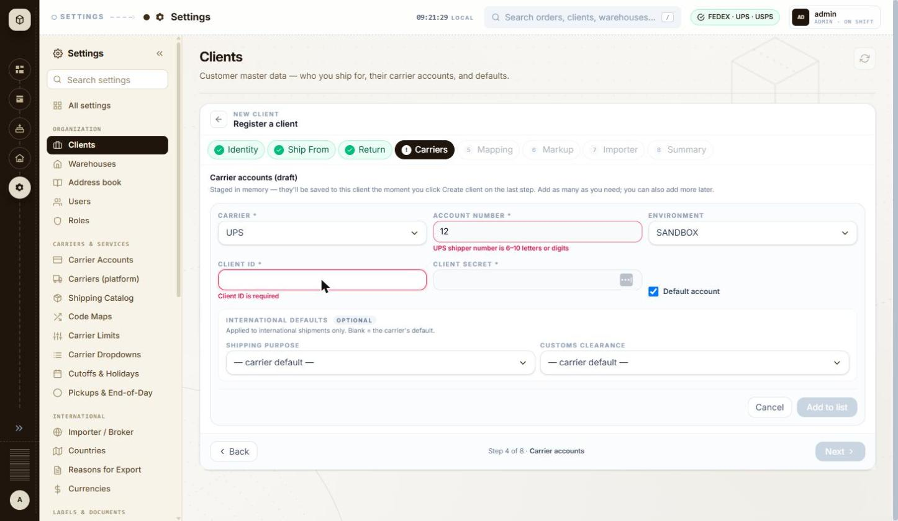
BUG-029 - screenshot 1 (BUG-029.jpg)
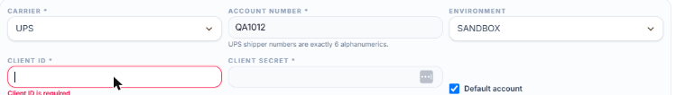
BUG-029 - screenshot 2 (BUG-029-2.png)
BUG-029 - screenshot 3 (BUG-029-3.jpg)
BUG-029 - screenshot 4 (BUG-029-4.png)
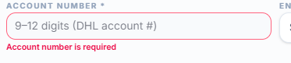
BUG-029 - screenshot 5 (BUG-029-5.png)
Retest history
- 2026-10-12 R3: still-failing - Fixed for UPS: the hint now reads 'UPS shipper numbers are 6-10 letters or digits.', matching the error, and a 10-character number is accepted. DHL Express still disagrees with itself - the grey hint says 'DHL Express account numbers are up to 9 digits.' while the error says 'DHL Express account number is 9-12 digits'.
- 2026-10-13 R4 (build local dev, 2026-10-13): still-failing - The hint-versus-error mismatch is fixed for both carriers: UPS now reads '6-10 letters or digits (UPS shipper #)' with the field capped at maxlength 10 (typing QA10137890123 leaves QA10137890), and DHL Express reads '9-12 digits (DHL account #)' against the error 'DHL Express account number is 9-12 digits'. What remains is the other half of the original finding: the DHL field still accepts letters - QA1013QA1013 was held and rejected only on length, not on being non-numeric, although both the placeholder and the error say digits.

BUG-031 - Client wizard > Carriers: 'Add to list' greys out with the tooltip 'Fix the highlighted fields to continue' while no field is highlighted
Severity / type | Low / Usability
Where | Settings > Organization > Clients > Client wizard (Add / Edit) - Carrier accounts grid for the client (+ Add Account, default star)
URL | http://localhost:5173/settings/clients/new
Reproducibility | Always
Found | 2026-10-12, run R2, as admin (ADMIN)
Status | Closed

Steps to reproduce
1. Open Settings > Clients and click + Add Client; fill step 1 and step 2
2. On step 4 Carriers click + Add carrier account
3. Choose carrier DHL Express and type the account number QA1012QA1 (letters and digits)
4. Fill Client ID and Client secret
5. Look at the Add to list button and hover over it
Test data
Carrier DHL Express, account number QA1012QA1; hint under the field: 'DHL Express account numbers are up to 9 digits.'
Expected
Either the account number is accepted, or the field that fails is marked in red with its message, so the user can see what to fix.
Actual
Add to list is greyed and its tooltip says 'Fix the highlighted fields to continue', but no field is red and no message is shown. The value only becomes acceptable after the carrier is changed to UPS or the letters are removed, which the user has to work out for themselves.
Technical evidence
The button is not really disabled (disabled=false) - it only looks greyed and carries the tooltip, so a click gives no feedback either.
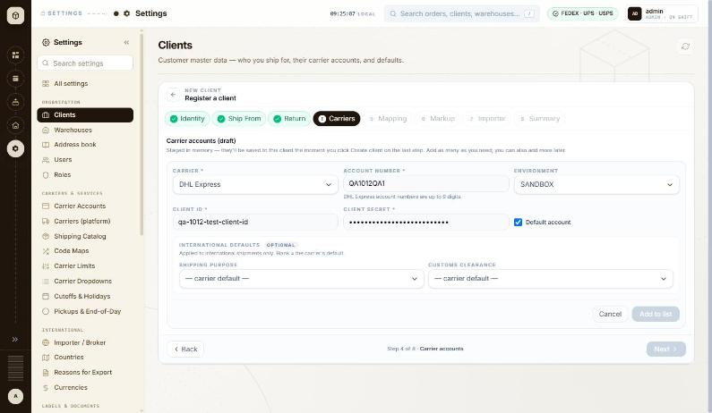
BUG-031 - screenshot (BUG-031.jpg)
Retest history
- 2026-10-12 R3: fixed - With carrier DHL Express and the account number QA1012QA1, the field is now outlined in red with 'DHL Express account number is 9-12 digits' underneath, so the tooltip 'Fix the highlighted fields to continue' now matches what is on screen.
- 2026-10-13 R4 (build local dev, 2026-10-13): fixed - Add to list with the form incomplete now marks each failing field in red with its own message - 'Account number is required' under Account number and 'Client ID is required' under Client ID - and only then greys the button. The reason is visible instead of hidden behind a tooltip.

BUG-032 - Creating a client shows the raw error code MARKUP_REQUIRED_FOR_CLIENT in the 'Heads up' message
Severity / type | Low / Content
Where | Settings > Organization > Clients > Client wizard (Add / Edit) - Markup: kind (Percent / Flat), Value, Currency, Preview, Save markup
URL | http://localhost:5173/settings/clients/new
Reproducibility | Always
Found | 2026-10-12, run R2, as admin (ADMIN)
Status | Closed

Steps to reproduce
1. Create a client through Settings > Clients > + Add Client, skipping the Markup step
2. Read the 'Heads up' toast shown after Submit
Test data
Client QA-1012-CL01 created with no billing markup
Expected
The message explains in words that labels will be refused until a billing markup is set; the internal code belongs in the log, not in the message.
Actual
'Set a billing markup for QA-1012-CL01 on the Markup tab before generating labels - MARKUP_REQUIRED_FOR_CLIENT will otherwise reject every label call for this client.'
Technical evidence
The rest of the sentence already says what happens, so the code adds nothing for the user. The same warning is useful on the Markup step itself, which is only marked amber.
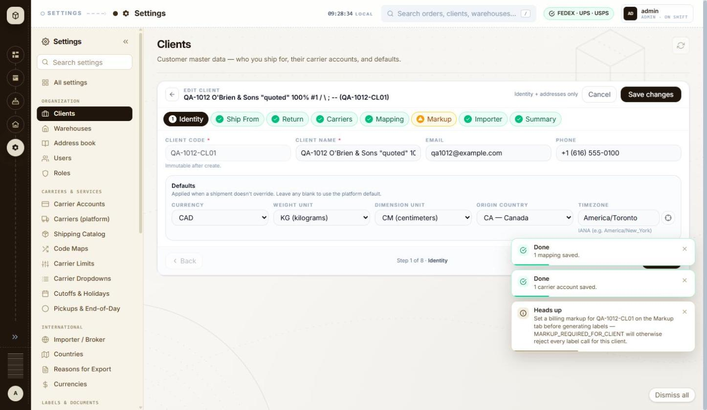
BUG-032 - screenshot 1 (BUG-032.jpg)
BUG-032 - screenshot 2 (BUG-032-2.jpg)
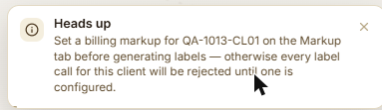
BUG-032 - screenshot 3 (BUG-032-3.png)
Retest history
- 2026-10-12 R3: cannot-retest - The 'Heads up' toast could not be read this time: toasts now clear themselves after about ten seconds (BUG-037 is fixed) and it had gone before the screen could be captured. The Markup step itself carries no such wording. Worth one more look the next time a client is created.
- 2026-10-13 R4 (build local dev, 2026-10-13): fixed - Creating QA-1013-CL01 now shows: 'Heads up - Set a billing markup for QA-1013-CL01 on the Markup tab before generating labels - otherwise every label call for this client will be rejected until one is configured.' The raw MARKUP_REQUIRED_FOR_CLIENT code is gone from the message.

BUG-033 - Client wizard > Return address: the State limit is credited to USPS in both modes but changes from 'max 2 chars' to 'max 5 chars' on a client with no USPS account
Severity / type | Low / Content
Where | Settings > Organization > Clients > Client wizard (Add / Edit) - Return address: Same as Ship From / own address
URL | http://localhost:5173/settings/clients/QA-1012-CL01
Reproducibility | Always
Found | 2026-10-12, run R2, as admin (ADMIN)
Status | Closed

Steps to reproduce
1. Open Settings > Clients and click + Add Client
2. On step 3 Return address untick 'Same as Ship From' and read the hint under STATE: 'max 2 chars - USPS'
3. Finish the wizard with a single UPS carrier account
4. Open the saved client (Edit) and go to step 3 Return address
5. Read the hint under STATE again
Test data
Client QA-1012-CL01, one carrier account: UPS - QA1012 (SANDBOX)
Expected
The hint names the carrier whose limit is being applied. The other fields do this correctly: with only UPS on the client they read 'max 35 chars - UPS', 'max 9 chars - UPS'.
Actual
STATE reads 'max 2 chars - USPS' in the new-client wizard and 'max 5 chars - USPS' on the saved client, although that client has no USPS account. Two different limits are attributed to the same carrier, and the carrier named is one the client does not use.
Technical evidence
Same page, same field. In the wizard (no carrier staged yet) the limits shown are the strictest across all carriers ('UPS / FEDEX' appears on other fields); on the saved client they narrow to the client's own carriers, and only STATE keeps the USPS label.
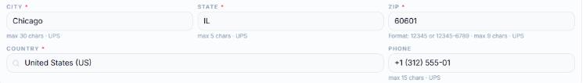
BUG-033 - screenshot 1 (BUG-033.png)
BUG-033 - screenshot 2 (BUG-033-2.png)
BUG-033 - screenshot 3 (BUG-033-3.png)
Retest history
- 2026-10-12 R3: fixed - On a saved client whose only carrier account is UPS the State hint now reads 'max 5 chars - UPS', naming the carrier the limit comes from. In the new-client wizard, before any carrier is staged, it reads 'max 2 chars - USPS', which is the strictest rule across the carriers. The two no longer contradict each other.
- 2026-10-13 R4 (build local dev, 2026-10-13): fixed - On the saved client QA-1013-CL01, which has a single UPS carrier account, every return-address hint now names UPS and only UPS: 'max 35 chars - UPS' (Attention/Company and Street), 'max 30 chars - UPS' (City), 'max 5 chars - UPS' (State), 'Format: 12345 or 12345-6789 - max 10 chars - UPS' (ZIP), 'max 15 chars - UPS' (Phone). The USPS attribution on a client with no USPS account is gone. The wizard still shows a stricter 'max 2 chars' before any carrier is chosen, which is consistent now that it is the across-all-carriers limit rather than a carrier-specific claim.

BUG-034 - Billing markup: a negative or non-numeric value is only refused by the server, as a 'Something went wrong' toast, with nothing marked on the field
Severity / type | Low / Validation
Where | Settings > Organization > Clients > Client wizard (Add / Edit) - Markup: kind (Percent / Flat), Value, Currency, Preview, Save markup
URL | http://localhost:5173/settings/clients/QA-1012-CL01
Reproducibility | Always
Found | 2026-10-12, run R2, as admin (ADMIN)
Status | Closed

Steps to reproduce
1. Open Settings > Clients, open a client and go to step 6 Markup
2. Choose Percent of rate and type -5 in Value, then click Save markup
3. Replace the value with abc and click Save markup again
Test data
Client QA-1012-CL01; markup values -5 and abc
Expected
The form refuses a negative or non-numeric percentage as the field is typed, the way the Identity and Return steps do, and the field is marked with the reason. A failed save is not reported as an unexpected error.
Actual
Both values are accepted by the field. The live preview simply disappears with no message, Save markup stays active, and the save fails with a red toast headed 'Something went wrong' and the detail 'Value must be a non-negative number.' The field itself is never marked.
Technical evidence
The Value input is type=text with no min, max or step. The preview panel vanishing also moves the Save markup button up by about 80 px, so a click aimed at it can land on Next instead (seen during this test).
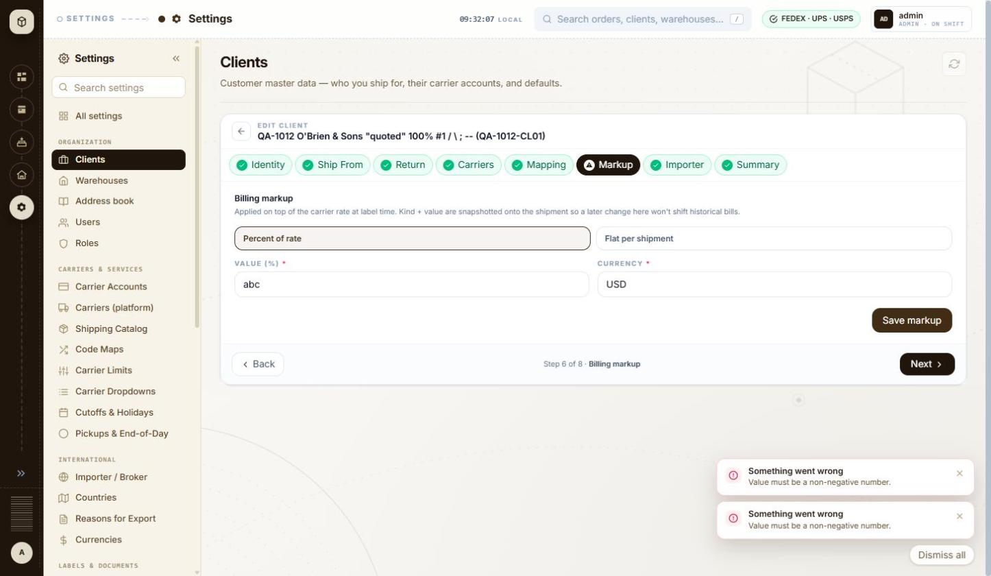
BUG-034 - screenshot 1 (BUG-034.jpg)
BUG-034 - screenshot 2 (BUG-034-2.jpg)
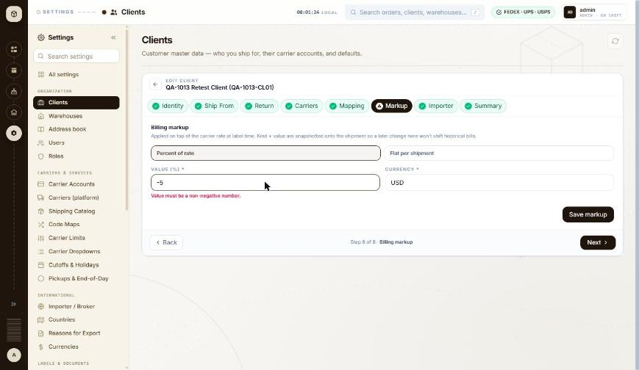
BUG-034 - screenshot 3 (BUG-034-3.jpg)
Retest history
- 2026-10-12 R3: fixed - Typing -5 or abc now marks the field at once with 'Value must be a non-negative number.' underneath it. No save attempt and no toast are needed to find out.
- 2026-10-13 R4 (build local dev, 2026-10-13): fixed - Typing -5 into the markup Value (%) field now marks it red immediately with 'Value must be a non-negative number.' The preview clears and the save never has to be attempted, so the 'Something went wrong' toast no longer appears for an ordinary validation failure.

BUG-035 - Billing markup preview formats a USD amount with Indian digit grouping: $2,50,00,00,00,024.75 instead of $250,000,000,024.75
Severity / type | Low / UI
Where | Settings > Organization > Clients > Client wizard (Add / Edit) - Markup: kind (Percent / Flat), Value, Currency, Preview, Save markup
URL | http://localhost:5173/settings/clients/QA-1012-CL01
Reproducibility | Always
Found | 2026-10-12, run R2, as admin (ADMIN)
Status | Closed

Steps to reproduce
1. Open Settings > Clients, open a client and go to step 6 Markup
2. Choose Percent of rate, currency USD
3. Type 999999999999 in Value
4. Read the PREVIEW line
Test data
Markup: Percent of rate, value 999999999999, currency USD; preview base rate $25.00
Expected
A USD amount is grouped in thousands: $250,000,000,024.75.
Actual
The preview reads 'On a $25.00 carrier rate, this markup produces a billable amount of $2,50,00,00,00,024.75.' - lakh/crore grouping. The amount itself is right; only the grouping is wrong.
Technical evidence
The number appears to be formatted with the browser's own locale rather than a locale chosen for the currency, so the same screen shows $25.00 (US style) and $2,50,00,00,00,024.75 (Indian style) side by side. Worth checking everywhere money is printed, labels and invoices included.
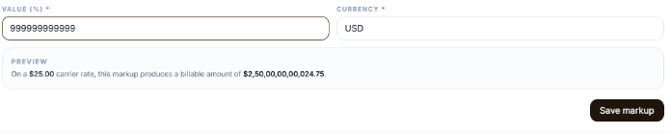
BUG-035 - screenshot 1 (BUG-035.png)
BUG-035 - screenshot 2 (BUG-035-2.png)
BUG-035 - screenshot 3 (BUG-035-3.png)
Retest history
- 2026-10-12 R3: fixed - With the value 999999999999 the preview now reads 'a billable amount of $250,000,000,024.75' - thousands grouping, correct for USD.
- 2026-10-13 R4 (build local dev, 2026-10-13): fixed - A markup of 1000000000% on a $25.00 carrier rate now previews as '$250,000,025.00' - thousands grouping. The lakh/crore grouping is gone.

BUG-036 - Edit client: ordinary validation failures are announced as 'Something went wrong', the same red heading the app uses for server errors
Severity / type | Low / Content
Where | Settings > Organization > Clients > Client wizard (Add / Edit) - Edit mode: Cancel and Save changes ('Identity + addresses only')
URL | http://localhost:5173/settings/clients/QA-1012-CL01
Reproducibility | Always
Found | 2026-10-12, run R2, as admin (ADMIN)
Status | Closed

Steps to reproduce
1. Open Settings > Clients and open a client (row menu > Edit)
2. Clear Client name on step 1 Identity
3. Click Save changes
4. Go to step 6 Markup, type -5 in Value and click Save markup
Test data
Client QA-1012-CL01; empty Client name; markup value -5
Expected
A field the user has to correct is reported as such ('Fix the highlighted fields to save'), without the heading the app uses when something unexpected has failed.
Actual
Both show a red toast headed 'Something went wrong' with the real message underneath: 'Fix the highlighted fields to save.' and 'Value must be a non-negative number.' The same heading was seen on a genuine 502 during the earlier shipment run (BUG-016), so the user cannot tell a typo from an outage.
Technical evidence
The on-field message 'Name is required.' is shown correctly at the same time, so only the toast heading is at fault.
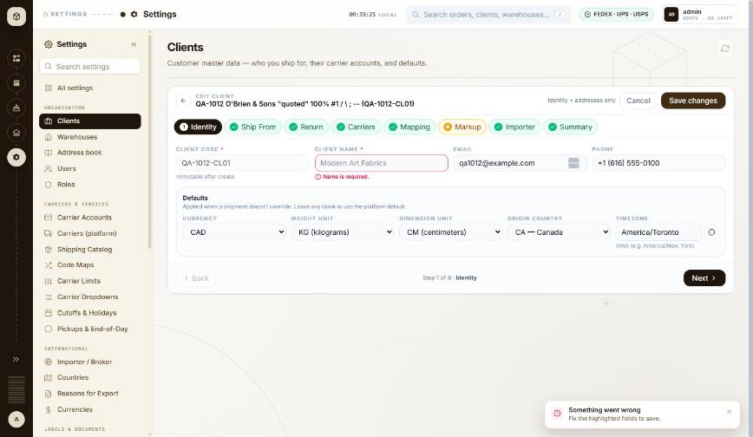
BUG-036 - screenshot 1 (BUG-036.jpg)
BUG-036 - screenshot 2 (BUG-036-2.jpg)
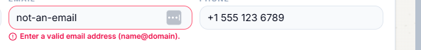
BUG-036 - screenshot 3 (BUG-036-3.png)
Retest history
- 2026-10-12 R3: still-failing - Unchanged. Saving the client editor with an empty Client name still raises a red toast headed 'Something went wrong' with 'Fix the highlighted fields to save.' underneath. The field is marked correctly at the same time, and the toast now clears itself (BUG-037), but the heading is still the one used for server failures.
- 2026-10-13 R4 (build local dev, 2026-10-13): fixed - Editing MKL246 with the email set to 'not-an-email' now marks the field red with the inline message 'Enter a valid email address (name@domain).' and raises a toast headed 'Check the form for errors - Fix the highlighted fields to save.' The 'Something went wrong' heading is no longer used for ordinary validation. MKL246 was left unchanged (email still conac@mkl.com).

BUG-037 - Error toasts never time out: a failed-delete message was still on screen 38 minutes later, through navigation and other work
Severity / type | Low / Usability
Where | Settings > Organization > Clients > Clients list - Toasts and messages (success, validation, server errors)
URL | http://localhost:5173/settings/clients
Reproducibility | Always
Found | 2026-10-12, run R2, as admin (ADMIN)
Status | Closed

Steps to reproduce
1. Open Settings > Clients (/settings/clients)
2. Scroll the table right, open the row menu on MKL246 and click Delete (it is refused because the client has orders)
3. Carry on working: open other Settings steps, edit a client, come back
4. Look at the bottom right of the window
Test data
Toast 'Something went wrong - MKL246 has 404 pending order(s). Complete or void them before deleting.' raised at 09:37, still shown at 10:15
Expected
An error message disappears on its own after a short time, like the green 'Done' toasts, or at the latest when the user moves to another screen.
Actual
Red toasts stay until clicked away. They survive moving between wizard steps and back to the list, and they stack: three were on screen at once earlier in this run. Each one covers the bottom-right corner of the page.
Technical evidence
Green success toasts ('Markup saved for QA-1012-CL01.') do disappear by themselves, so only the error ones are affected. A 'Dismiss all' button appears once more than one is open.
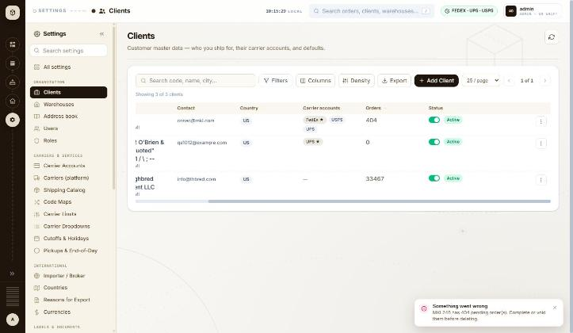
BUG-037 - screenshot (BUG-037.jpg)
Retest history
- 2026-10-12 R3: fixed - The refusal toast for deleting MKL246 now carries a countdown bar and cleared itself within about 10 seconds without being clicked.
- 2026-10-13 R4 (build local dev, 2026-10-13): fixed - The error toast from that failed save had dismissed itself within 15 seconds. It no longer persists across navigation.

BUG-039 - Client wizard: the top breadcrumb still reads 'Settings' and the browser tab is always 'multiship-react', so neither says which client is open
Severity / type | Low / UI
Where | Settings > Organization > Clients > Client wizard (Add / Edit) - Breadcrumb and browser tab title in the wizard
URL | http://localhost:5173/settings/clients/new
Reproducibility | Always
Found | 2026-10-12, run R2, as admin (ADMIN)
Status | Closed

Steps to reproduce
1. Open Settings > Clients and click + Add Client (/settings/clients/new)
2. Look at the breadcrumb in the top bar and at the browser tab title
3. Open an existing client with the row menu > Edit (/settings/clients/MKL246) and look again
Test data
Pages /settings/clients, /settings/clients/new and /settings/clients/MKL246
Expected
The breadcrumb follows the page, as it does on the list itself ('Settings > Clients'), and the tab title names the screen and the record, so a user with several tabs open can tell them apart and a bookmark is meaningful.
Actual
On both wizard pages the breadcrumb shows only 'Settings', losing the 'Clients' step and the client, even though the page header shows 'EDIT CLIENT - MKL (MKL246)'. The browser tab reads 'multiship-react' on every page in the application.
Technical evidence
document.title is 'multiship-react' on /settings/clients, /settings/clients/new and /settings/clients/MKL246.
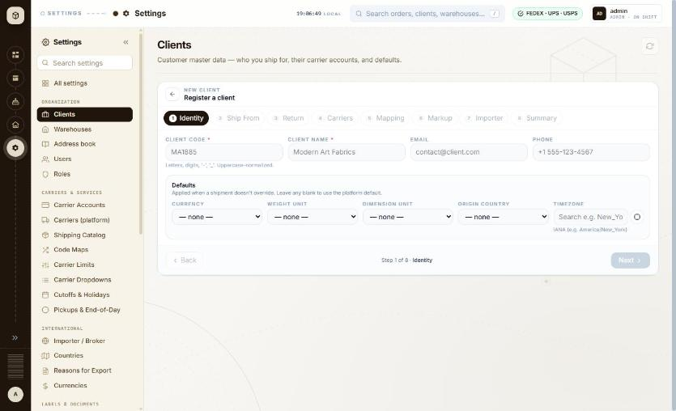
BUG-039 - screenshot 1 (BUG-039.jpg)
BUG-039 - screenshot 2 (BUG-039-2.jpg)
Retest history
- 2026-10-12 R3: still-failing - Half fixed. The browser tab title is now 'New client - Settings' instead of 'multiship-react'. The breadcrumb in the top bar still reads only 'Settings' on /settings/clients/new and on a client's edit page, losing both the Clients step and the client itself.
- 2026-10-13 R4 (build local dev, 2026-10-13): fixed - The browser tab now reads 'New client - Settings' instead of 'multiship-react', and the panel header reads 'NEW CLIENT / Register a client'. The global breadcrumb reads 'SETTINGS ... Clients', naming the section the wizard belongs to rather than just 'Settings'.

BUG-042 - Warehouse address Verify reports the raw status NOT_SUPPORTED, and the green tick icon makes a refusal look like a pass
Severity / type | Low / Content
Where | Settings > Organization > Warehouses > Warehouses list - Add / Edit warehouse panel: carrier address Verify
URL | http://localhost:5173/settings/warehouses
Reproducibility | Always
Found | 2026-10-12, run R2, as admin (ADMIN)
Status | Closed

Steps to reproduce
1. Open Settings > Warehouses, open a warehouse with the row menu > Edit
2. Next to ADDRESS pick carrier UPS and click Verify
3. Repeat with FEDEX and with USPS
Test data
Warehouse QA-1012-WH01, 742 Evergreen Terrace, Springfield, ILLINOIS, 62704-1234, US; carriers UPS, FEDEX, USPS
Expected
The result is written for the user, and an address that was not checked does not carry a success tick.
Actual
Each result line reads '<CARRIER> - NOT_SUPPORTED' with a green circled-tick icon in front of it. UPS and FedEx add 'No live credentials for <carrier> - cannot call address validation.'; USPS adds 'SERA address validation needs live credentials; the account is on a fallback token.' The explanations are clear, but the raw enum and the tick icon together read as though the address passed.
Technical evidence
POST /api/v1/addresses/validate/carrier -> 200 for each of the three carriers; no carrier was actually contacted, because the sandbox accounts have no live address-validation credentials. The address itself (state 'ILLINOIS') therefore went unchecked - see BUG-040. Each result has its own Dismiss link.
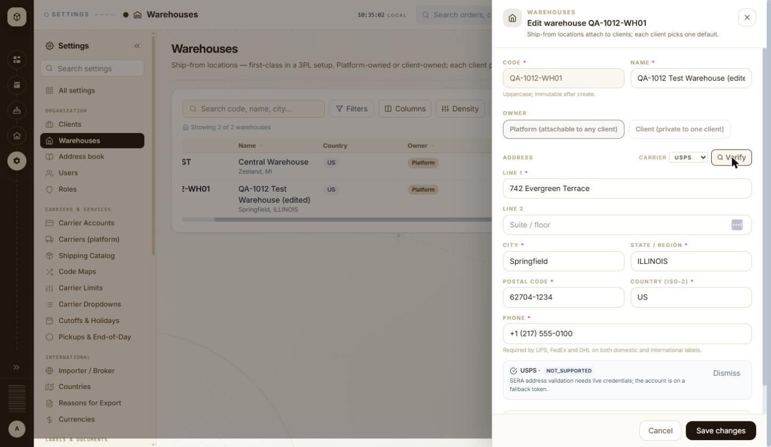
BUG-042 - screenshot (BUG-042.jpg)
Retest history
- 2026-10-12 R3: fixed - The Verify result now reads 'UPS - VERIFICATION NOT SUPPORTED FOR THIS COUNTRY' with the explanation 'No live credentials for UPS - cannot call address validation.' and a Dismiss action, behind a neutral blue info icon. The raw NOT_SUPPORTED status and the green tick that made a refusal look like a pass are both gone.
- 2026-10-13 R4 (build local dev, 2026-10-13): fixed - Verify on a US address with no live UPS credentials returns 'UPS - VERIFICATION NOT SUPPORTED FOR THIS COUNTRY / No live credentials for UPS - cannot call address validation. / Dismiss', behind a neutral info icon. No raw NOT_SUPPORTED and no green tick on a refusal.

BUG-047 - Users search is not debounced: every keystroke sends a search request and a second request that reloads the audit list
Severity / type | Low / Performance
Where | Settings > Organization > Users > Users list - Search username, email, name
URL | http://localhost:5173/settings/users
Reproducibility | Always
Found | 2026-10-12, run R2, as admin (ADMIN)
Status | Closed

Steps to reproduce
1. Open Settings > Users (/settings/users)
2. Type manoj into 'Search username, email, name...' at a normal typing speed
3. Watch the requests the page sends
Test data
Search term 'manoj' (5 characters)
Expected
The search waits for a pause before asking the server, the way the Clients and Warehouses lists do - one request per settled term.
Actual
Ten requests for five characters: GET /api/v1/admin/users?search=m, ...search=ma, ...search=man and so on, each followed by GET /api/v1/admin/users/audit?limit=50. The audit list has nothing to do with the search term and is reloaded every time.
Technical evidence
53 requests were captured over a short search session on this screen. The Clients list sends one request per settled term for the same kind of search box, so the two behave differently.
No screenshot file was captured for this item.
Retest history
- 2026-10-12 R3: fixed - Typing 'manoj' (5 characters) at normal speed into the user search now sends exactly one request - GET /api/v1/admin/users?search=manoj&page=0&size=50 - with a single accompanying GET /api/v1/admin/users/audit?limit=50, instead of ten requests. A clear (x) button has also been added to the search box.
- 2026-10-13 R4 (build local dev, 2026-10-13): fixed - Typing 'manoj' into the user search sends exactly one request, GET /api/v1/admin/users?search=manoj&page=0&size=50, with a single accompanying audit reload. The ten-requests-for-five-keystrokes behaviour is gone.

BUG-048 - Invite user: a bad email address is reported under the heading 'This shipment needs attention', with the raw field message repeated underneath
Severity / type | Low / Content
Where | Settings > Organization > Users > Users list - Invite user form (fields, validation, send)
URL | http://localhost:5173/settings/users
Reproducibility | Always
Found | 2026-10-12, run R2, as admin (ADMIN)
Status | Closed

Steps to reproduce
1. Open Settings > Users (/settings/users)
2. Click Invite user
3. Type not-an-email in Email and pick client THB000
4. Click Send invite
Test data
Email 'not-an-email', client THB000, role USER
Expected
A message about the user being invited, shown once, in words: for example 'Enter a valid email address'. Nothing about shipments.
Actual
A red toast headed 'This shipment needs attention' with two lines: 'Email must be a well-formed email address.' and 'email - must be a well-formed email address'. The heading belongs to the shipment screens, and the second line is the raw field-and-message pair repeated.
Technical evidence
No request is sent, so the check is in the page. The same dialog with an empty form shows a third heading, 'Something went wrong - Email and client are required.' - so one small form produces three different heading styles, none of which marks the field itself.
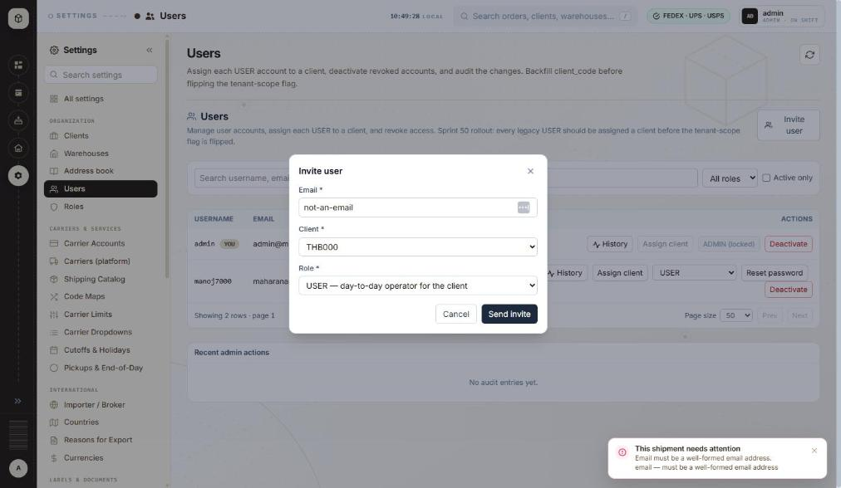
BUG-048 - screenshot 1 (BUG-048.jpg)
BUG-048 - screenshot 2 (BUG-048-2.jpg)
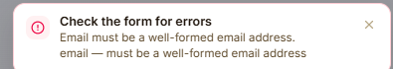
BUG-048 - screenshot 3 (BUG-048-3.png)
BUG-048 - screenshot 4 (BUG-048-4.jpg)
BUG-048 - screenshot 5 (BUG-048-5.jpg)
BUG-048 - screenshot 6 (BUG-048-6.png)
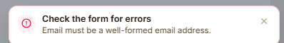
BUG-048 - screenshot 7 (BUG-048-7.png)
Retest history
- 2026-10-12 R3: still-failing - Half fixed. The heading is corrected - the toast now reads 'Check the form for errors' instead of 'This shipment needs attention'. The duplication remains: the toast still prints the message twice, once in words ('Email must be a well-formed email address.') and once as the raw field-and-message pair ('email - must be a well-formed email address'). Retested with not-an-email + client THB000 + role USER.
- 2026-10-13 R4 (build local dev, 2026-10-13): fixed - Submitting the Invite user form with 'not-an-email' now raises a single toast: 'Check the form for errors - Email must be a well-formed email address.' Both halves of the original finding are resolved - the shipment heading is gone and the duplicated raw field-and-message line is gone.

BUG-049 - Internal developer notes are printed in the page descriptions users read: sprint numbers, database column names and a to-do
Severity / type | Low / Content
Where | Settings > Organization > Users > Users list - Page header and description
URL | http://localhost:5173/settings/users
Reproducibility | Always
Found | 2026-10-12, run R2, as admin (ADMIN)
Also affects | Settings > Email & Alerts > Mail > Mail; Settings > Organization > Roles > Roles list
Status | Closed

Steps to reproduce
1. Open Settings > Users (/settings/users) and read the page description and the panel description
2. Open Settings > Mail (/settings/mail) and read the page description
3. Open Settings > Roles (/settings/roles) and read the page description
Test data
No data needed - the text is part of the page
Expected
The description tells the user what the screen is for. Sprint numbers, column names and internal to-dos belong in the backlog.
Actual
Users, page description: 'Assign each USER account to a client, deactivate revoked accounts, and audit the changes. Backfill client_code before flipping the tenant-scope flag.' Users, panel description: '...Sprint 50 rollout: every legacy USER should be assigned a client before the tenant-scope flag is flipped.' Mail, page description: '...pick SMTP today (SendGrid/SES/Postmark coming), edit host/port/creds, and send a live test message. Config lives in mail_provider + mail_config.' Roles, page description: 'Platform-wide role registry. Read-only; add roles via SQL today.'
Technical evidence
'client_code', 'mail_provider' and 'mail_config' are database identifiers; 'Sprint 50 rollout' and 'SendGrid/SES/Postmark coming' are roadmap notes. Other Settings pages are written for the user ('Customer master data - who you ship for, their carrier accounts, and defaults.'), so this is not the house style.
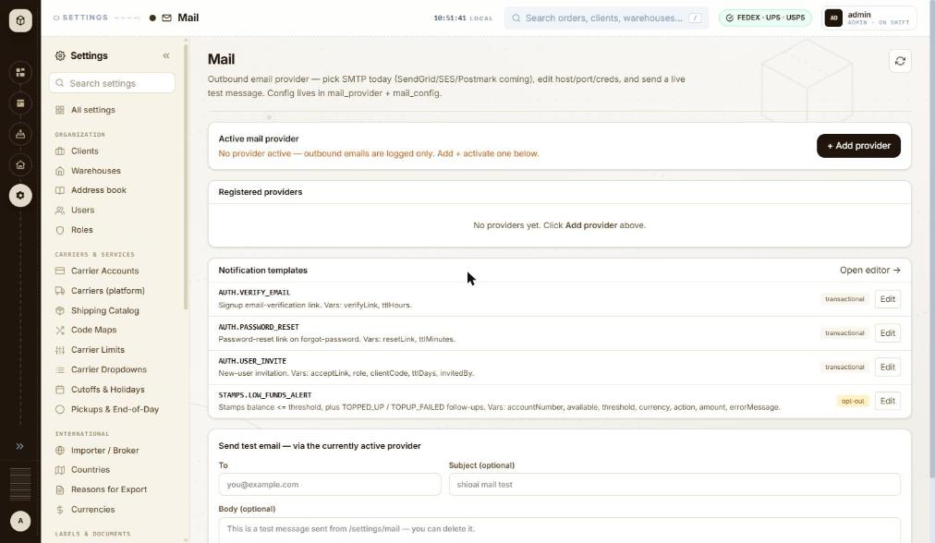
BUG-049 - screenshot 1 (BUG-049.jpg)
BUG-049 - screenshot 2 (BUG-049-2.jpg)
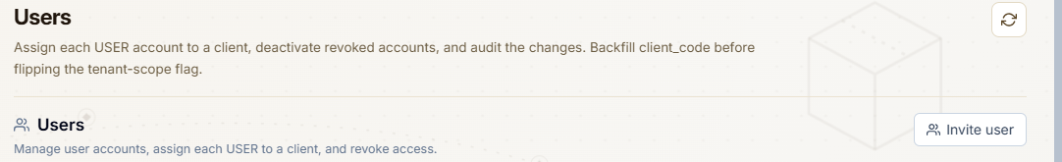
BUG-049 - screenshot 3 (BUG-049-3.png)
BUG-049 - screenshot 4 (BUG-049-4.jpg)
BUG-049 - screenshot 5 (BUG-049-5.jpg)
BUG-049 - screenshot 6 (BUG-049-6.png)
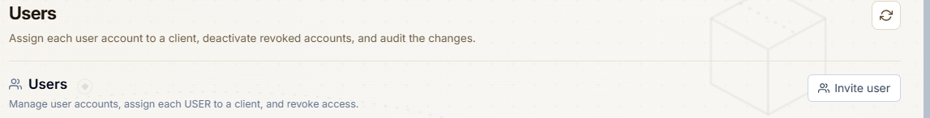
BUG-049 - screenshot 7 (BUG-049-7.png)
Retest history
- 2026-10-12 R3: still-failing - Only the Users panel description was cleaned (the 'Sprint 50 rollout...' sentence is gone). The three page descriptions are unchanged: Users still ends 'Backfill client_code before flipping the tenant-scope flag.', Mail still ends 'Config lives in mail_provider + mail_config.', Roles still reads 'Platform-wide role registry. Read-only; add roles via SQL today.' Also new: the Assign client button's tooltip on a user row reads 'Assign clientCode'.
- 2026-10-13 R4 (build local dev, 2026-10-13): fixed - All three descriptions are clean. Users: 'Assign each user account to a client, deactivate revoked accounts, and audit the changes.' Mail: 'Outbound email provider - pick SMTP, SendGrid, SES or Postmark, edit host/port/creds, and send a live test message.' Roles: 'Platform-wide role registry. Read-only.' The client_code backfill note, the Sprint 50 line, the mail_provider + mail_config note, the 'coming' roadmap list and the 'add roles via SQL today' line have all gone. The Assign client tooltip now reads 'Assign to a client' rather than 'Assign clientCode'.

BUG-056 - Code Maps: 'Add alias' stays greyed with no tooltip, no marked field and no message, so there is nothing on screen saying what is missing
Severity / type | Low / Usability
Where | Settings > Carriers & Services > Code Maps
URL | http://localhost:5173/settings/code-maps
Reproducibility | Always
Found | 2026-10-13, run R4, build local dev, 2026-10-13, as admin (ADMIN)
Status | Open

Steps to reproduce
1. Open Settings > Code Maps (/settings/code-maps) with client MKL246 selected
2. On the Shipvia tab, click + Add alias with the form empty
3. Type QA13 into ERP SHIPVIA CODE and look at the button again
Test data
Client MKL246, ERP shipvia code QA13, Platform service left unset
Expected
Either the button says why it is unavailable - a tooltip, or the unfilled field marked with its message, the way the client wizard's 'Add to list' now does - or clicking it marks what is missing.
Actual
The button reports disabled=true with no title attribute at all. Clicking it does nothing: no toast, no field marked, no hint text anywhere on the panel. With a code typed but Platform service still unset it stays disabled and still explains nothing. The user has to guess that the service dropdown is the blocker.
Technical evidence
Read from the DOM: the Add alias button has disabled=true and no title. This is the same fault that was reported as BUG-031 on the client wizard and fixed there - the fix was not carried across to this screen. Window 1460x847.
No screenshot file was captured for this item.

BUG-057 - Carrier Dropdowns says it is the vocabulary /orders/new uses, but the order form shows different wording for the same carrier and code
Severity / type | Low / Content
Where | Settings > Carriers & Services > Carrier Dropdowns
URL | http://localhost:5173/settings/carrier-dropdowns
Reproducibility | Always
Found | 2026-10-13, run R4, build local dev, 2026-10-13, as admin (ADMIN)
Status | Open

Steps to reproduce
1. Open Settings > Carrier Dropdowns (/settings/carrier-dropdowns) and read the Label formats tab
2. Note the FEDEX rows: code PDF -> 'PDF (plain)' and code ZPLII -> 'ZPL (thermal)'
3. Open Orders > + New shipment, pick client MKL246 and carrier FedEx
4. Open the Label type dropdown and read the options
Test data
Client MKL246, carrier FedEx
Expected
The order form shows the labels this registry defines, since the page describes itself as the vocabulary that form uses.
Actual
The registry lists FEDEX / PDF as 'PDF (plain)' and FEDEX / ZPLII as 'ZPL (thermal)'. The order form offers 'PDF (vector, sharp)' and 'ZPLII (Zebra)' for the same carrier. With USPS selected the form does show 'PDF (plain)', matching the registry, so the two agree for one carrier and disagree for another. Either the form is not reading this table for FedEx or the table is not the source it claims to be.
Technical evidence
The page description reads 'Per-carrier vocabularies the /orders/new wizard uses - label formats, pickup types, clearance options. Read-only.' Compared against the Label type dropdown on the New shipment form in the same session. Window 1460x847.
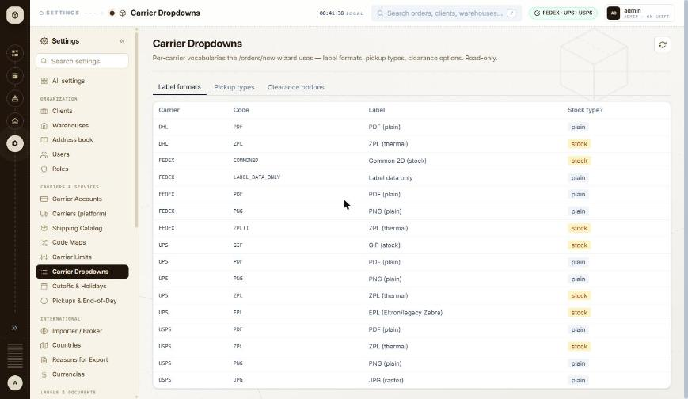
BUG-057 - screenshot (BUG-057.jpg)

BUG-061 - Internal developer notes still appear in page descriptions on the Settings screens that the BUG-049 clean-up did not reach
Severity / type | Low / Content
Where | Settings > International > Countries
URL | http://localhost:5173/settings/countries
Reproducibility | Always
Found | 2026-10-13, run R4, build local dev, 2026-10-13, as admin (ADMIN)
Also affects | Settings > International > Countries; Settings > International > Reasons for Export; Settings > International > Currencies; Settings > System; Settings > System > Carrier Error Messages
Status | Open

Steps to reproduce
1. Open Settings > Countries (/settings/countries)
2. Read the page description
Test data
No test data needed
Expected
The description tells the user what the screen is for. How the data is maintained internally belongs in the backlog, as it now does on Users, Mail and Roles.
Actual
Five more screens carry the same house-keeping notes that BUG-049 removed from Users, Mail and Roles. Countries: 'ISO country list + is_us_territory flag. Read-only; edit via SQL today.' Reasons for Export: '...Read-only; edit via SQL today.' Currencies: 'ISO 4217 currency catalog. Read-only; per-tenant allowlist layered via tenant_settings.currency.allowlist.' Carrier Error Messages: 'Pattern -> humanised sentence rules CarrierErrorMessages applies to raw carrier payloads. Read-only; edit via SQL today.' System: 'Unconfigured tenants reject all intake with 403 TENANT_CHANNEL_NOT_ENABLED.' Between them they print a database column name, a settings key path, a Java class name and a raw error constant to the user. The BUG-049 fix was applied to three named screens rather than swept across Settings.
Technical evidence
Read from the page. BUG-049 was closed on 2026-10-13 after Users, Mail and Roles were cleaned; this screen was not part of that change. Window 1460x847.
No screenshot file was captured for this item.

BUG-062 - An unknown /settings/... route silently lands the user on Carrier Accounts and rewrites the URL, with no 'not found' anywhere
Severity / type | Low / Functional
Where | Settings > Carriers & Services > Carrier Accounts
URL | http://localhost:5173/settings/this-route-does-not-exist
Reproducibility | Always
Found | 2026-10-13, run R4, build local dev, 2026-10-13, as admin (ADMIN)
Status | Open

Steps to reproduce
1. Type http://localhost:5173/settings/this-route-does-not-exist into the address bar
2. Read the page and the address bar
3. Repeat with http://localhost:5173/settings/email-templates, which is close to but not the real route (/settings/notification-templates)
Test data
Two non-existent routes, one invented and one a plausible mistyping of Email Templates
Expected
An unknown route says so - a not-found page naming what was asked for, with a way back - or at worst lands on a neutral Settings index. It should not silently substitute a different screen and rewrite the address.
Actual
Both routes end on /settings/carriers with the heading 'Carrier Accounts', and the address bar is rewritten to /settings/carriers so the original path is lost. Nothing on the page says a redirect happened. The screen the user is dropped onto is the one holding carrier account numbers, environments and a Stamps balance, which is a poor default for a mistyped or stale link.
Technical evidence
Read from the page after navigation: location.pathname is '/settings/carriers' and the h1 is 'Carrier Accounts'. Found while checking the Email Templates route, whose real path is /settings/notification-templates. Window 1460x847.
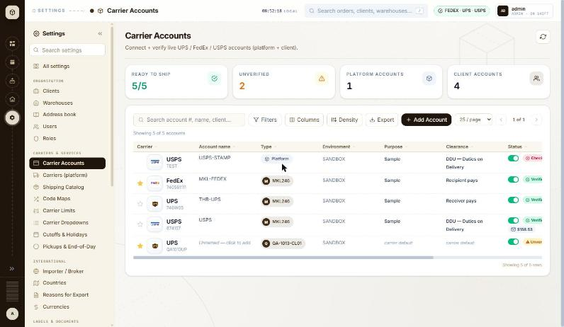
BUG-062 - screenshot (BUG-062.jpg)

BUG-066 - Alerts History prints the carrier's raw JSON in the Reason column, so the human-readable rules on Carrier Error Messages are bypassed here
Severity / type | Low / Content
Where | Settings > Activity & Logs > Alerts History
URL | http://localhost:5173/settings/alerts-history
Reproducibility | Always
Found | 2026-10-13, run R4, build local dev, 2026-10-13, as admin (ADMIN)
Status | Open

Steps to reproduce
1. Open Settings > Alerts History (/settings/alerts-history)
2. Read the Reason column on any STAMPS_SERA_MPS_ROLLBACK_VOID_FAILED row
Test data
Existing alert rows from 10/10/2026 and 10/11/2026
Expected
The reason reads as a sentence, the way Settings > Carrier Error Messages already defines - that screen exists to turn raw carrier payloads into humanised messages.
Actual
The Reason cell holds the carrier payload verbatim: 'SERA rollback void failed for label_id 4553edf5-961c-4db1-94db-945b1ea97ec3: 400 Bad Request: "{"error_reference_id":"53dfa7aa-c51f-4954-bb5c-1bbb05bb7823","errors":[{"error_code":"4522505","error_message":"Label could not be found. This can happen if the label was never requested or if you are attempting to refund a sample label."}]}". Manual void required.' The useful sentence is in there, buried in JSON, an error_reference_id and a label_id. Settings > Carrier Error Messages already holds five pattern rules for exactly this job, and the alert path does not use them.
Technical evidence
Six rows visible, every STAMPS_SERA_MPS_ROLLBACK_VOID_FAILED one shaped the same way. Window 1460x847.
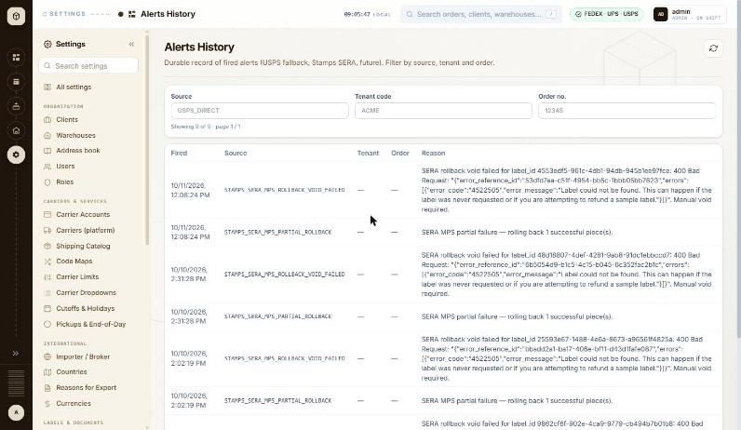
BUG-066 - screenshot (BUG-066.jpg)

BUG-067 - Returns Analytics: every one of the 11 returns is counted as 'Unknown', so the screen's whole purpose - the reason breakdown - shows nothing
Severity / type | Low / Data integrity
Where | Settings > Activity & Logs > Returns Analytics
URL | http://localhost:5173/settings/returns-analytics
Reproducibility | Always
Found | 2026-10-13, run R4, build local dev, 2026-10-13, as admin (ADMIN)
Status | Open

Steps to reproduce
1. Open Settings > Returns Analytics (/settings/returns-analytics)
2. Leave the lookback window at Last 12 weeks and read the table
Test data
The 11 returns already in the system since 2026-07-21
Expected
Returns are spread across the reasons the page names - Wrong item, Defective, No longer needed, Size, Other - or, if the reason is genuinely never captured, the screen says so rather than presenting an empty breakdown as data.
Actual
One week row, 2026-09-07: Wrong item 0, Defective 0, No longer needed 0, Size 0, Other 0, Unknown 11, Total 11. The Totals row repeats it. Every return in the window has no reason recorded, so the only number on the page is the one that carries no information. Either the return flow never asks for a reason or it never stores one - worth checking which before the screen is relied on.
Technical evidence
Read from the rendered table at the default Last 12 weeks window; the header reads 'Since 2026-07-21 11 returns'. Window 1460x847.
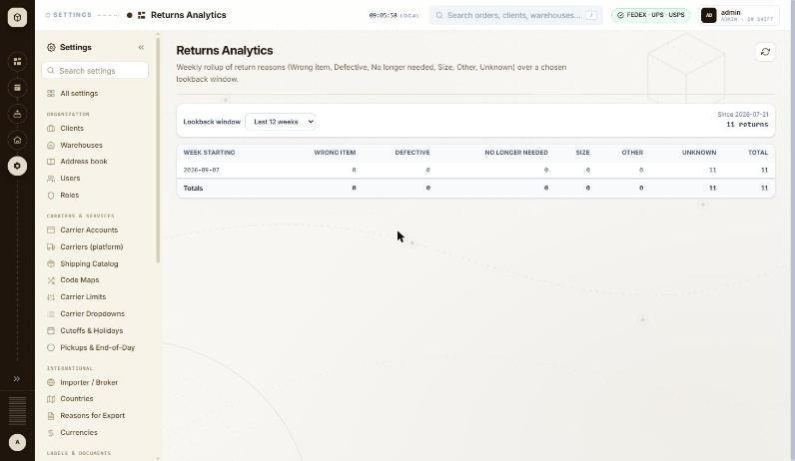
BUG-067 - screenshot (BUG-067.jpg)

5. Queries and suggestions
These are not defects. Queries are behaviours where the intended rule is unclear and a decision is needed; suggestions are possible improvements.

BUG-017 - Order API: shippingDetails.weight holds one box's weight on two-box orders, not the shipment total - intended?
Type | Query
Where | API > Orders > Order detail (GET /api/v1/orders/{id}) - shippingDetails.weight
URL | /api/v1/orders/{id}
Reproducibility | Always (97 of 97)
Found | 2026-10-11, run R1, as admin (ADMIN)
Status | Reopened

Steps to reproduce
1. GET /api/v1/orders/934190 (2 boxes of 2 lb)
2. Read data.shippingDetails.weight and data.orderDetails.packageCount
Test data
All 97 two-box orders of the run, e.g. #934190 (2 x 2 lb), #934172 (THB 2 x 5 lb)
Expected
If the field is the order weight, it should be the total (4 lb, 10 lb); if it is per box, the name or docs should say so and per-box weights should be available.
Actual
weight 2 for #934190 and 5 for #934172; on all 97 two-box orders it equals one box's weight.
Retest history
- 2026-10-12 R3: still-failing - Unchanged. GET /api/v1/orders/934190 returns orderDetails.packageCount 2 with shippingDetails.weight 2 (the shipment is 2 boxes of 2 lb, so the total is 4); #934172 returns packageCount 2 with weight 5 against a 10 lb total. shippingDetails still carries only city, state, zipCode, shipVia, weight, shipViaDescription and intlYn - there is no per-box weight array and no renamed field, so the ambiguity the bug asked about is unresolved.
- 2026-10-13 R4 (build local dev, 2026-10-13): still-failing - Unchanged. shippingDetails.weight still holds one box's weight on multi-box orders: #934190 packageCount 2 / weight 2 (total 4), #934172 packageCount 2 / weight 5 (total 10), and the new #934191 packageCount 2 / weight 3 (total 6). No per-box weight array and no renamed field have been added.

BUG-018 - Shipment check (USPS to UK and Mexico): every check says 'USPS normalised the address; review before shipping' without showing what changed
Type | Query
Where | Orders > New order > New order form (international) - Shipment check panel
URL | /orders/new
Reproducibility | Always (10 of 10 UK/Mexico USPS checks)
Found | 2026-10-11, run R1, as admin (ADMIN)
Status | Reopened

Steps to reproduce
1. Open Orders and click + New shipment (/orders/new)
2. Client: MKL246 (ship from 3PL-EAST, the client default)
3. Carrier: USPS
4. Ship to the UK (1 Canada Square, London E14 5AB) or Mexico (as above)
5. Complete the form and click Validate shipment
Test data
UK #934147-#934151, Mexico #934186-#934190 (10 of 10); not shown for Canada
Expected
Show the normalised address (or the difference) so it can be reviewed, and only flag it when something changed.
Actual
'Ready to ship — 1 thing to review: USPS normalised the address; review before shipping.' with no address shown.
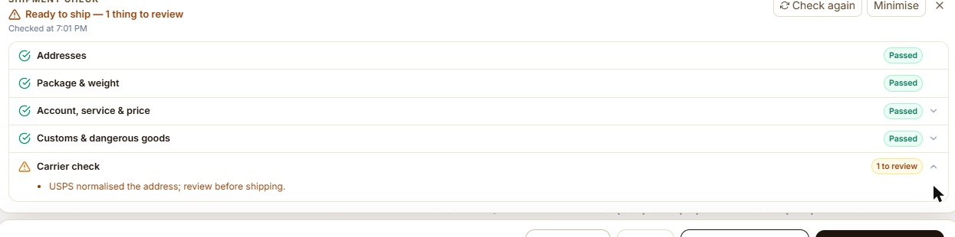
BUG-018 - screenshot (BUG-018.png)
Retest history
- 2026-10-12 R3: still-failing - Unchanged. USPS Priority Mail Intl to the UK still ends with 'Ready to ship - 1 thing to review' and, under Carrier check, the single line 'USPS normalised the address; review before shipping.' Expanding the row shows nothing more - the normalised address and the difference are still not shown, and the note appears whether or not anything changed.
- 2026-10-13 R4 (build local dev, 2026-10-13): still-failing - Unchanged on the UK lane. USPS Priority Mail Intl to London E14 5AB ends with 'Ready to ship - 1 thing to review' and, under Carrier check, the single line 'USPS normalised the address; review before shipping.' No normalised address and no difference are shown. Worth noting the same shipment to Canada produced no normalisation note at all and passed cleanly, so the note is lane-specific rather than unconditional.

BUG-019 - Shipment check (FedEx to UK): billed-weight notes of 68, 52 and 22 lb seen during the run, about 3-9 times the figures for the same boxes to Mexico
Type | Query
Where | Orders > New order > New order form (international) - Shipment check panel
URL | /orders/new
Reproducibility | 5 times during the run; 0 of 1 on retest
Found | 2026-10-11, run R1, as admin (ADMIN)
Status | Closed

Steps to reproduce
1. Open Orders and click + New shipment (/orders/new)
2. Client: MKL246 (ship from 3PL-EAST, the client default)
3. Carrier: FedEx
4. Ship to: 1 Canada Square, London E14 5AB, United Kingdom
5. Service level: FedEx International Priority
6. Packaging FedEx Tube, Weight 3; Add another box; Apply box 1 to all
7. Complete customs, importer and items; click Validate shipment
Test data
Run: #934115 and #934122 (2 tubes 38x6x6 in): 68 lb; #934121 (2 Paks): 52 lb; #934117 and #934124 (2 boxes 12x9x4 in): 22 lb. Mexico for the same boxes: 19.68, 5.52 and 6.22 lb
Expected
The same boxes give the same billed weight on every lane (19.68 lb for the two tubes).
Actual
During the run the UK checks showed billed weights of 68 lb (two tubes), 52 lb (two Paks) and 22 lb (two 12x9x4 in boxes: '22 lb - charged on box size, not the 4 lb it weighs'). On retest 2026-10-12 the same UK tube shipment showed the expected 19.68 lb, so it did not reproduce. Raised so the team can check whether the figure comes from the FedEx sandbox response or the app.
BUG-019 - screenshot 1 (BUG-019.jpg)
BUG-019 - screenshot 2 (BUG-019-2.jpg)
BUG-019 - screenshot 3 (BUG-019-3.png)
Retest history
- 2026-10-12 R3: fixed - Did not reproduce, and the figure is now explained. FedEx International Priority to London E14 5AB with two FedEx Tubes of 3 lb shows 'Billed weight 19.68 lb - charged on box size, not the 6 lb it weighs' - the expected dimensional figure, with the reason printed beside it. The 68 lb / 52 lb / 22 lb readings of the original run did not recur on any lane tried.
- 2026-10-13 R4 (build local dev, 2026-10-13): fixed - No inflated billed weight seen on any lane this run. FedEx International Priority to Mexico with a 4 lb THB-PACKAGE reported 'Billed weight 4 lb', and the 2026-10-12 check of the original repro (two FedEx Tubes to London) gave the expected 19.68 lb with the explanation 'charged on box size, not the 6 lb it weighs'.

BUG-020 - New shipment (FedEx): Label size stays 'Thermal stock 4×6' when Label type is switched to PDF
Type | Suggestion
Where | Orders > New order > New order form (international) - Label size (FedEx)
URL | /orders/new
Reproducibility | Always
Found | 2026-10-11, run R1, as admin (ADMIN)
Status | Closed

Steps to reproduce
1. Open Orders and click + New shipment (/orders/new)
2. Client: MKL246 (ship from 3PL-EAST, the client default)
3. Carrier: FedEx; any international destination
4. Change Label type from ZPLII (Zebra) to PDF
5. Look at Label size
Test data
All FedEx shipments of the run were set to Paper 4x6 by hand
Expected
Switching to PDF moves Label size to a paper size (for example Paper 4x6).
Actual
Label size remains 'Thermal stock 4×6' next to Label type 'PDF (vector, sharp)'.
BUG-020 - screenshot (BUG-020.jpg)
Retest history
- 2026-10-12 R3: fixed - Changing Label type from ZPLII (Zebra) to PDF (vector, sharp) now moves Label size from 'Thermal stock 4x6' to 'Paper 4x6' on its own.
- 2026-10-13 R4 (build local dev, 2026-10-13): fixed - Switching Label type from ZPLII (Zebra) to PDF (vector, sharp) moves Label size from 'Thermal stock 4x6' to 'Paper 4x6' on its own.

BUG-021 - Importer & broker override: choosing Type 'Receiver · DAP' leaves every field empty instead of using the ship-to details
Type | Suggestion
Where | Orders > New order > Importer & broker override dialog - Type (Business / Receiver)
URL | /orders/new
Reproducibility | Always
Found | 2026-10-11, run R1, as admin (ADMIN)
Status | Closed

Steps to reproduce
1. Open Orders and click + New shipment (/orders/new)
2. Client: MKL246 (ship from 3PL-EAST, the client default)
3. Carrier: FedEx
4. Ship to: Full name QA Test Recipient, Company QA Test Co, Address line 1 290 Bremner Blvd, Country Canada (CA), Phone 4165550100, State / region ON, City Toronto, Postal code M5V 3L9
5. Importer of record & customs broker > Add
6. Type: Receiver · DAP
Test data
Every international shipment of the run (MKL246 has no importer profile for CA, GB or MX)
Expected
Receiver fills (or offers to fill) name, address, city, state, post code and phone from Ship to.
Actual
All fields stay empty apart from Country; all 7 values had to be typed for each of the 128 orders.
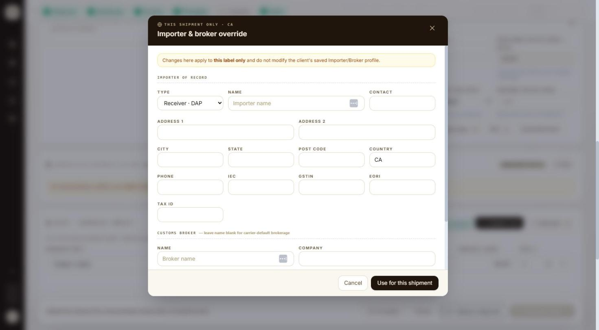
BUG-021 - screenshot 1 (BUG-021.jpg)
BUG-021 - screenshot 2 (BUG-021-2.jpg)
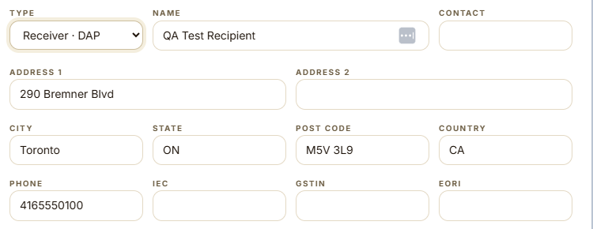
BUG-021 - screenshot 3 (BUG-021-3.png)
Retest history
- 2026-10-12 R3: fixed - Importer of record & customs broker > Add > Type 'Receiver - DAP' now fills Name (QA Test Recipient), Address 1 (290 Bremner Blvd), City (Toronto), State (ON), Post code (M5V 3L9), Country (CA) and Phone (4165550100) from Ship to. Only the optional Contact box stays empty.
- 2026-10-13 R4 (build local dev, 2026-10-13): fixed - Importer of record & customs broker > Add > Type 'Receiver - DAP' fills Name, Address 1, City, State, Post code, Country and Phone from Ship to; only the optional Contact box stays empty.

BUG-023 - Clients > Columns: every column can be hidden, leaving blank rows with only the row menu (Edit, Delete)
Type | Suggestion
Where | Settings > Organization > Clients > Clients list - Columns (show/hide + pin)
URL | http://localhost:5173/settings/clients
Reproducibility | Always
Found | 2026-10-12, run R2, as admin (ADMIN)
Status | Reopened

Steps to reproduce
1. Open Settings > Clients (/settings/clients)
2. Click Columns
3. Untick Code, Name, Contact, Country, Carrier accounts, Orders and Status
4. Press Esc to close the menu
Test data
Default column layout; 2 clients (MKL246, THB000)
Expected
At least one identifying column (for example Code) stays visible, or the last ticked column cannot be unticked, so each row still shows which client it is.
Actual
All seven columns can be unticked. The grid then shows an empty header and two blank rows with only the ⋮ row menu, whose Edit and Delete act on a client the user cannot see. 'Reset layout' in the Columns menu brings the columns back.
Technical evidence
Reloading the page keeps the blank grid (column layout is remembered in the browser), so it stays until Columns > Reset layout is used.
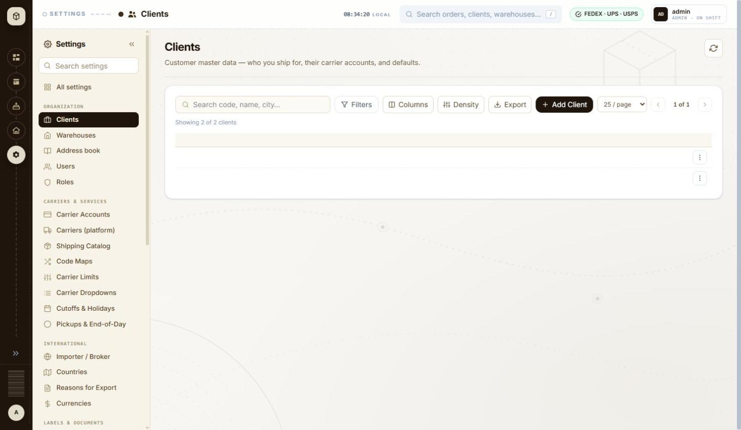
BUG-023 - screenshot 1 (BUG-023.jpg)
BUG-023 - screenshot 2 (BUG-023-2.jpg)
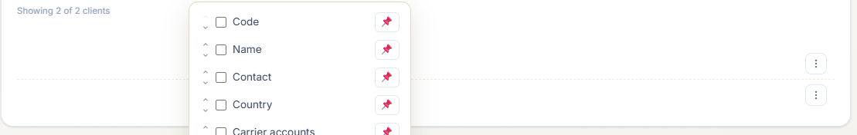
BUG-023 - screenshot 3 (BUG-023-3.png)
Retest history
- 2026-10-12 R3: still-failing - All seven columns can still be unticked in the Columns menu, leaving an empty header and two blank rows with only the row menu. Reset layout still brings them back.
- 2026-10-13 R4 (build local dev, 2026-10-13): still-failing - Unchanged. Every one of the seven columns can still be unticked in the Columns menu - no minimum is enforced and the last one is not disabled. With all seven hidden the grid shows two header-less, cell-less rows carrying only the row menu, under the line 'Showing 2 of 2 clients'. Reset layout is the only way back.

BUG-038 - Clients Export: the button promises 'visible columns, filtered rows' but the request carries no column information, so hidden columns are unlikely to be left out
Type | Query
Where | Settings > Organization > Clients > Clients list - Export (CSV of current view)
URL | http://localhost:5173/settings/clients
Reproducibility | Always
Found | 2026-10-12, run R2, as admin (ADMIN)
Status | Reopened

Steps to reproduce
1. Open Settings > Clients (/settings/clients)
2. Hover over Export and read the tooltip
3. Click Export and look at the request the page sends
4. Type THB in the search box and click Export again
5. Hide the Contact column from the Columns menu and click Export again
Test data
3 clients; search THB; Contact column hidden
Expected
Either the CSV matches the view as the tooltip says, or the tooltip only promises what the export really does.
Actual
The tooltip reads 'Export the current view as CSV - visible columns, filtered rows'. Rows are honoured: the request becomes /api/v1/clients/export.csv?sortBy=code&sortDirection=ASC&search=THB. Columns are not sent at all - the request is identical with the Contact column hidden - so the server cannot know which columns to leave out.
Technical evidence
Requests seen on Clients: .../export.csv?sortBy=code&sortDirection=ASC and .../export.csv?sortBy=code&sortDirection=ASC&search=THB, both 200. The downloaded file itself could not be opened from this session, so the CSV content is not verified - please confirm with a file. The same button on Settings > Warehouses behaves differently: no server call at all, the file is built in the page and fetched from a data: URL, so the two lists do not share an export path even though the tooltip is identical.
Retest history
- 2026-10-12 R3: cannot-retest - The implementation has changed: the Clients Export no longer calls /api/v1/clients/export.csv at all. Like the Warehouses one it now builds the file in the page and fetches it from a data: URL, so the original evidence - that no column information was sent to the server - no longer applies, and a client-side build can honour the hidden columns. The file itself still cannot be opened from this session, so whether the CSV matches the visible columns is still unverified.
- 2026-10-13 R4 (build local dev, 2026-10-13): still-failing - Now reproducible and confirmed failing. With six of the seven columns hidden and the search set to THB, Export sent GET /api/v1/clients/export.csv?sortBy=code&sortDirection=ASC&search=THB. The filter is carried, but there is no column parameter of any kind, so the 'visible columns' half of the button's promise is not honoured - the file will contain every column regardless of what is on screen.

BUG-046 - Country lists differ across Settings: the client's default Origin country offers 12 countries, the address book offers 250
Type | Query
Where | Settings > Organization > Clients > Client wizard (Add / Edit) - Defaults > Origin country
URL | http://localhost:5173/settings/clients/new
Reproducibility | Always
Found | 2026-10-12, run R2, as admin (ADMIN)
Status | Reopened

Steps to reproduce
1. Open Settings > Clients > + Add Client and open the Defaults > Origin country list on step 1
2. Open Settings > Address book > + Add address and open the Country list
Test data
No data needed - the two lists are compared as shown
Expected
One country list, taken from Settings > Countries, so a client whose goods originate outside those 12 can be set up, and the two screens agree.
Actual
Origin country on the client wizard has 13 entries: '- none -' plus US, CA, MX, GB, DE, FR, IN, CN, AU, JP, AE, SG. The address book Country list has 250. The warehouse panel takes a free-typed ISO-2 code instead, with no list at all - three different approaches to the same field in one settings area.
Technical evidence
Counted from the select options on each screen. Whether the 12 are a deliberate shortlist of supported origins is the question - if so it is worth saying so on the field, since a client with an origin outside the list cannot be set up at all.
Retest history
- 2026-10-12 R3: still-failing - Unchanged. Defaults > Origin country still offers 13 options (none plus 12 countries) while the address book Country list still offers 250.
- 2026-10-13 R4 (build local dev, 2026-10-13): still-failing - Unchanged - the same field is still built three different ways inside Settings. The Add warehouse panel takes COUNTRY (ISO-2) as a free-typed text box with no list; the address book Add address dialog offers a 250-entry country select; the client wizard's Origin country is a searchable combobox. A code typed into the warehouse box is not checked against any list.

6. End-to-end flow checks
Flow | Result | What was done and verified | Bugs
Canada · FedEx: International Economy and Priority × every packaging → label | Fail | 1. IE, 2 boxes: Pak, Tube, THB, Custom generated (#934064-#934067); Envelope failed 'package count exceeds limit' (#934063)  2. IP, 2 boxes: Pak, Tube, THB, Custom generated (#934071-#934074); Envelope, 10kg and 25kg box failed (#934068-#934070)  3. Envelope (IE and IP), 10kg and 25kg box as 1 box generated (#934075-#934078)  4. Every check needed 'NO EEI 30.36' typed into Export declaration ref (no FTR exemption field for Canada) | BUG-003, BUG-005, BUG-004
Canada · UPS: Worldwide Saver, Expedited and Express × every packaging → label | Fail | 1. Saver: Pak, Large, Medium, Small Express Box, Tube, THB, Custom (2 boxes) and Letter (1 box) generated (#934081-#934088); 10KG and 25KG Box with 2 boxes failed (#934079, #934080)  2. Expedited: THB and Custom generated (#934089, #934090)  3. Express: same packagings generated (#934095-#934102); 10KG and 25KG Box with 2 boxes failed (#934091, #934092)  4. 10KG and 25KG Box as 1 box generated: Saver #934103, #934104; Express #934093, #934094 | BUG-003
Canada · USPS: Priority Mail Intl and Express Intl × THB, Custom → label | Fail | 1. Default sender 'MKL': PMI THB failed (#934105) and PMEI THB failed (#934109) on the fullname rule  2. Sender 'MKL Shipping', both lines in box 1: package 2 failed 'Missing customs lines' (#934106)  3. Sender fixed, 1 box: generated (#934107)  4. Sender fixed, two lines spread across the 2 boxes: PMI THB, PMI Custom, PMEI THB, PMEI Custom generated (#934108, #934110-#934112) | BUG-001, BUG-002
United Kingdom · FedEx: International Economy and Priority × every packaging → label | Pass | 1. 12 of 12 generated (#934113-#934124); Envelope, 10kg and 25kg box run as 1 box  2. FTR exemption NOEEI 30.37(a) and Label size Paper 4x6 set by hand  3. International Priority checks showed the false 'did not quote' issue; labels still generated  4. Billed-weight notes of 68 / 52 / 22 lb on Tube, Pak and Custom (not reproduced on retest) | BUG-004, BUG-019
United Kingdom · UPS: Worldwide Saver, Expedited and Express × every packaging → label | Pass | 1. 22 of 22 generated (#934125-#934146); 10KG, 25KG Box and Letter as 1 box; every check 'All checks passed'
United Kingdom · USPS: Priority Mail Intl and Express Intl × THB, Custom → label | Fail | 1. Default sender 'MKL': PMI THB failed on the fullname rule (#934147)  2. Sender fixed and lines spread across the boxes: 4 of 4 generated (#934148-#934151)  3. Every check: 'USPS normalised the address; review before shipping.' | BUG-001, BUG-018
Mexico · FedEx: International Economy and Priority × every packaging → label | Pass | 1. 12 of 12 generated (#934152-#934163); Envelope, 10kg and 25kg box as 1 box  2. State / region had to be the ISO code CMX  3. International Priority checks showed the false 'did not quote' issue; labels still generated  4. One Validate returned the raw toast 'HTTP error! status: 502'; the retry worked (#934153) | BUG-004, BUG-008, BUG-016
Mexico · UPS: Worldwide Saver, Expedited and Express × every packaging → label | Pass | 1. 22 of 22 generated (#934164-#934185); 10KG, 25KG Box and Letter as 1 box; every check 'All checks passed'  2. 'Add N boxes like the last' left box 2 without dimensions; Apply box 1 to all used instead | BUG-006
Mexico · USPS: Priority Mail Intl and Express Intl × THB, Custom → label | Fail | 1. Default sender 'MKL': PMI THB failed on the fullname rule (#934186)  2. Sender fixed and lines spread across the boxes: 4 of 4 generated (#934187-#934190) | BUG-001, BUG-018
Order API check of all 128 orders (GET /api/v1/orders/{id}) | Pass | 1. 128 of 128 fetched: reference, status (115 GENERATED, 13 ERROR), package count, destination, label and tracking, and error text all match what the screens showed  2. 13 error messages match the toasts (FedEx package count ×4, UPS service/packaging ×4, USPS fullname ×4, USPS missing customs lines ×1)  3. shippingDetails.weight equals one box's weight on all 97 two-box orders (query)  4. #934118 labelFilePath holds a FedEx document link instead of the PDF | BUG-017, BUG-007
Register a client end to end (Clients > Add Client, 8 steps) | Pass | 1. Settings > Clients > + Add Client  2. Step 1 Identity: code QA-1012-CL01, name with punctuation, email, phone, defaults CAD / KG / CM / CA / America/Toronto  3. Step 2 Ship From: warehouse 3PL-EAST, address card filled from the warehouse  4. Step 3 Return: own address, Chicago IL 60601  5. Step 4 Carriers: one UPS SANDBOX account staged as default  6. Step 5 Mapping: shipvia QA80 -> UPS Ground staged  7. Step 6 Markup: not offered until the client exists  8. Step 7 Importer: skipped  9. Step 8 Summary: every section READY, Submit  10. Client, carrier account and mapping all created by one Submit; the page becomes Edit client  11. Markup 12.5% saved afterwards from the same wizard  12. Client deleted again at the end of the run
Warehouse lifecycle (create, attach a client, verify, deactivate, edit, delete) | Fail | 1. Settings > Warehouses > + Add Warehouse: QA-1012-WH01, Springfield ILLINOIS 62704-1234  2. Created, then the follow-on 'Attach to clients' step skipped  3. Row menu > Attach clients: THB000 ticked and attached, Attached count 0 -> 1  4. Row menu > Edit: name changed and saved  5. Address Verify run once against UPS, FedEx and USPS - all three answered NOT_SUPPORTED  6. Status toggled off and on again  7. Row menu > Delete: dialog named the warehouse and warned the client would be unlinked; deleted  8. THB000 left as it was, with its original default warehouse | BUG-040, BUG-041, BUG-042, BUG-043
Save an address to the address book | Fail | 1. Settings > Address book: the list never loads (GET /api/v1/recipients -> 500) and the page shows 'No saved addresses yet'  2. + Add address: required fields all checked correctly  3. A valid shared address saved: POST /api/v1/recipients -> 200  4. The screen reports 'Something went wrong on the server' and the grid still shows the empty state  5. Searching for the address returns 502 and is drawn as 'No saved addresses match'  6. The address exists in the database but cannot be seen, edited or deleted from the application | BUG-044, BUG-045
Invite a user and administer the account | Fail | 1. Settings > Mail checked first: no active provider, outbound email logged only  2. Settings > Users > Invite user: qa-1012-invite@example.com, client THB000, role USER  3. Invitation created and an accept link shown once  4. Done: the invited person does not appear in the user list and 'Recent admin actions' stays empty  5. Assign client on the existing user: a code that does not exist is refused, the original code saves again  6. The reason typed for the audit is not recorded anywhere  7. Role change, Reset password and Deactivate could not be exercised - no test account exists and the only other row is a real person's | BUG-050, BUG-052, BUG-051

7. Test data created
Records created or changed by the tester. Those not marked deleted or restored are still in the system.
Record type | Identifier | State | Notes
Orders (Canada) | #934063-#934112 | left in system | 50 orders: 39 GENERATED (sandbox labels), 11 ERROR; references QA-1011-R13-CA-*
Orders (United Kingdom) | #934113-#934151 | left in system | 39 orders: 38 GENERATED, 1 ERROR (#934147); references QA-1011-R13-GB-*
Orders (Mexico) | #934152-#934190 | left in system | 39 orders: 38 GENERATED, 1 ERROR (#934186); references QA-1011-R13-MX-*
Client | QA-1012-CL01 | deleted | Created through the 8-step wizard with one UPS sandbox carrier account, one shipvia mapping (QA80 -> UPS Ground), a 12.5% markup and its own return address; deleted at the end of the Clients tests.
Warehouse | QA-1012-WH01 | deleted | Platform warehouse, Springfield ILLINOIS 62704-1234; attached to client THB000 then deleted, which unlinked it. THB000's default warehouse was never changed.
Address book entry | QA-1012 Test Recipient | left in system | Shared address, 290 Bremner Blvd, Chicago, IL 60601, US. Created by POST /api/v1/recipients (200) but cannot be seen or deleted from the UI while GET /api/v1/recipients returns 500 - see BUG-044 and BUG-045. Please remove it once that endpoint is fixed.
Client | MKL246 | restored | Opened in the edit wizard and its steps read; the only typed change (client name) was discarded with Leave. Importer / Broker dialogs were cancelled. No field was saved.
Client | THB000 | restored | Attached to the test warehouse QA-1012-WH01 and unlinked again when that warehouse was deleted. 'Set as this client's default warehouse' was never ticked.
User invitation | qa-1012-invite@example.com | deleted | Invited as role USER for client THB000, with the user's go-ahead, after confirming Settings > Mail has no active provider (outbound email is logged only). The invitation does not appear anywhere in the UI (BUG-050), so it cannot be revoked from the application - please clear it in the database if it matters. Accept link: http://localhost:5173/invite/8881caf518742688c83dfa1d688cecd03d6c748867028fee Revoked from the new Pending invites panel during run R4 on 2026-10-13, so nothing is left behind.
User | manoj7000 | restored | Client code was changed to NOSUCHCLIENT (refused by the server, no change), then saved again as its original value THB000. Role, status and password were not touched.
User | admin | restored | Read only. Its audit trail was opened. Password, role and status were never changed; Deactivate was deliberately not clicked (BUG-051).
Warehouse | QA-1012-WH02 (QA-1012 Retest Warehouse) | deleted | Created during the retest to re-check BUG-041 and BUG-043: Platform-owned, 742 Evergreen Terrace, Springfield IL 62704-1234 US. THB000 attached, detached, re-attached (never set as its default warehouse), warehouse deactivated then deleted. THB000's own settings unchanged.
User invitation | qa-1012-retest@example.com (client THB000, role USER) | deleted | Sent during the retest of BUG-050 with Manoj's permission. Settings > Mail has no provider active, so the message is logged only and the address is on the reserved example.com domain. The invitation cannot be revoked or removed from the interface - it is the second such leftover, with qa-1012-invite@example.com from the earlier run. Revoked from the new Pending invites panel during run R4 on 2026-10-13, so nothing is left behind.
Order | #934191 | left in system | The one SANDBOX label generation Manoj approved, used to confirm BUG-001. USPS Priority Mail Intl, MKL246 to 1 Canada Square, London E14 5AB GB, 2 boxes of 3 lb, sender name left at the client default 'MKL'. The carrier refused it, so no label was bought and the order is saved with status ERROR. Left in place as evidence.
Client | QA-1013-CL01 (QA-1013 Retest Client) | deleted | Created to re-walk the client wizard findings, with one UPS SANDBOX carrier account and one shipping mapping. Deleted at the end of the run; the confirmation named the 1 carrier account and 1 warehouse attachment it would take with it.
Warehouse | QA-1013-WH01 (QA-1013 Retest Warehouse) | deleted | Created to re-walk BUG-040 to BUG-043, with QA-1013-CL01 attached. Deleted at the end of the run.
Address book entry | QA-1013 Test Recipient (later renamed with a markup payload) | deleted | Created to re-walk BUG-044 and BUG-045, then reused for the output-encoding test - name set to QA-1013 <script>alert(1)</script> "><b>x</b>, company to =1+1, tag to a SQL-like string. Removed afterwards; the address book is empty again.
Holiday | QA-1013 Test Holiday (2026-11-27) | deleted | Added and removed to test the holiday add/delete path, which is how BUG-058 was found. The four real holidays were not touched.
User invitations | qa-1012-invite@example.com and qa-1012-retest@example.com | deleted | The two leftovers from the earlier runs, revoked through the new Pending invites panel now that BUG-050 is fixed.

Appendix: severity scale
Severity | Meaning
Critical | Shipment, order or label data is wrong, lost or corrupted; a core flow (create shipment, validate, generate label) cannot be completed; a crash or server error on a main path; a security hole: a role can see or do what it must not, or text typed into a field runs as script.
High | A feature does not work or gives wrong results but the work can be done another way; a missing check lets bad data into orders, labels or master records; an export or report shows wrong data.
Medium | The feature works with an awkward workaround; a validation gap with limited effect; a wrong, missing or misleading message; sorting, filtering or paging faults.
Low | Cosmetic: spelling, alignment, inconsistent labels or formats, small usability irritations.

