Week 1 Task: Data Acquisition, Cleaning, and Preprocessing

Objective
To acquire a publicly available dataset, perform thorough data cleaning, and execute preprocessing steps using Python, accompanied by rationale and reflective commentary.

1. Data Acquisition
For this task, I selected the Titanic Passenger Survival Dataset, publicly available on Kaggle. This dataset was chosen because it represents real-world data collection issues, containing a mix of numerical and categorical variables, significant missing values, and outliers.
Method: The dataset was downloaded as a CSV file and loaded into a Pandas DataFrame for analysis.
import pandas as pd
import numpy as np
import matplotlib.pyplot as plt
import seaborn as sns
from sklearn.preprocessing import StandardScaler, OneHotEncoder
# Load the dataset
url = "titanic.csv" # Local path after downloading from Kaggle
df = pd.read_csv(url)
# Display the first 5 rows
display(df.head())
Output [Screenshot of DataFrame]:
PassengerId | Survived | Pclass | Name | Sex | Age
1 | 0 | 3 | Braund, Mr. Owen Harris | male | 22.0
2 | 1 | 1 | Cumings, Mrs. John Bradley | female | 38.0
3 | 1 | 3 | Heikkinen, Miss. Laina | female | 26.0
4 | 1 | 1 | Futrelle, Mrs. Jacques Heath | female | 35.0
5 | 0 | 3 | Allen, Mr. William Henry | male | 35.0

2. Initial Data Exploration
Before altering the data, I conducted an initial exploration to understand its structure, data types, and overall quality.
# Check data types and non-null counts
print(df.info())
# Summary statistics for numerical columns
print(df.describe())
# Check for exact missing value counts
print(df.isnull().sum())
Commentary: The info() output revealed that the dataset has 891 entries and 12 columns. Three columns stood out for having missing values: Age (177 missing), Cabin (687 missing), and Embarked (2 missing). The describe() function highlighted a potential outlier issue in the Fare column, where the maximum value (512.32) is significantly higher than the 75th percentile (31.00).

3. Data Cleaning Procedures

3.1 Handling Missing Values
# 1. Cabin: Drop column due to excessive missing data (77% missing)
df.drop(columns=['Cabin'], inplace=True)
# 2. Age: Impute missing values with the median to avoid skewing data
median_age = df['Age'].median()
df['Age'].fillna(median_age, inplace=True)
# 3. Embarked: Impute the 2 missing values with the mode
mode_embarked = df['Embarked'].mode()[0]
df['Embarked'].fillna(mode_embarked, inplace=True)
# Verify missing values are resolved
print(df.isnull().sum())
Rationale: The Cabin column was dropped entirely. With over 77% of its data missing, attempting to impute it would introduce massive synthetic bias. For Age, I chose the median rather than the mean. Age distributions can be slightly skewed, and the median is more robust to outliers. Since Embarked is categorical and only missing 2 values, imputing with the mode was the safest and most statistically sound approach.

3.2 Addressing Inconsistencies
# Drop structurally unhelpful columns
df.drop(columns=['PassengerId', 'Name', 'Ticket'], inplace=True)

3.3 Handling Outliers
During initial exploration, the Fare column showed extreme outliers. I used the Interquartile Range (IQR) method to cap these outliers rather than deleting the rows, which would result in a loss of valuable data.
# Calculate IQR for Fare
Q1 = df['Fare'].quantile(0.25)
Q3 = df['Fare'].quantile(0.75)
IQR = Q3 - Q1
# Define bounds
lower_bound = Q1 - 1.5 * IQR
upper_bound = Q3 + 1.5 * IQR
# Cap the outliers (Clipping)
df['Fare'] = np.where(df['Fare'] > upper_bound, upper_bound, df['Fare'])
df['Fare'] = np.where(df['Fare'] < lower_bound, lower_bound, df['Fare'])
Output [Screenshot of Outlier Visualization]:
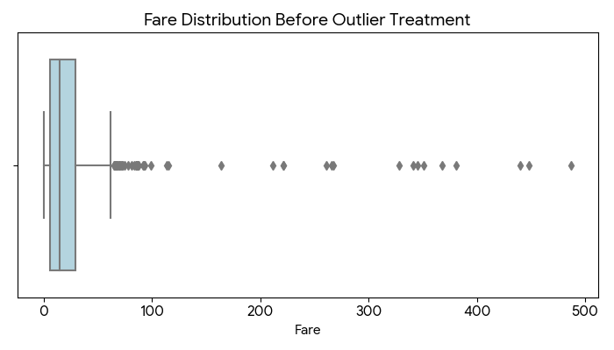
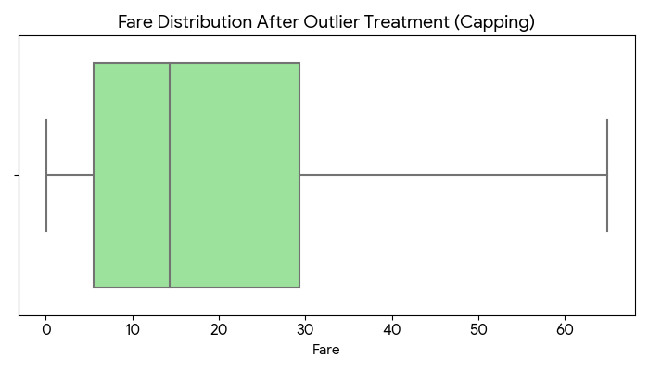
Rationale: Capping (Winsorization) limits the extreme values to a defined upper bound without deleting the passenger records entirely. This prevents extreme ticket prices from disproportionately skewing future regression models or distance-based algorithms.

4. Data Preprocessing Steps

4.1 Categorical Encoding
# Convert categorical text into numerical format using One-Hot Encoding
df = pd.get_dummies(df, columns=['Sex', 'Embarked'], drop_first=True)
Rationale: I used One-Hot Encoding (via pd.get_dummies) for Sex and Embarked. I used drop_first=True to avoid the dummy variable trap, converting Sex into a single Sex_male binary column.

4.2 Feature Scaling
# Scale numerical features for uniformity
scaler = StandardScaler()
df[['Age', 'Fare']] = scaler.fit_transform(df[['Age', 'Fare']])
Rationale: Algorithms that compute distances (like KNN or SVM) or utilize gradient descent are highly sensitive to the scale of data. By applying StandardScaler, I transformed Age and Fare so they both have a mean of 0 and a standard deviation of 1.

5. Challenges Faced and Overcome
1. The Cabin Feature Dilemma: The biggest challenge was deciding whether to extract the deck letter from the Cabin column (which could indicate socioeconomic status) or drop it entirely. Ultimately, I determined that inferring 77% of the data would cause unmanageable bias. I overcame this by accepting the data loss and dropping the column, relying on Pclass (passenger class) and Fare as proxies for socioeconomic status instead.
2. Identifying the Right Outlier Strategy: Initially, I considered removing rows where the Fare was an outlier. However, this would have deleted over 10% of the dataset, including data of survivors that is critical for analysis. I overcame this by employing the IQR capping technique, retaining the rows while neutralizing the outlier impact.

6. Impact of Preprocessing on Subsequent Analyses
- No Algorithm Failures: By eliminating all NaN values, we ensure that standard machine learning libraries, which cannot process missing data, will run seamlessly.
- Balanced Feature Importance: By standardizing Age and Fare, we guarantee that Fare will not artificially dominate distance calculations in predictive modeling.
- Reduced Noise: Capping the Fare outliers ensures that our models will look for generalizable patterns rather than over-fitting to extreme anomalies.

