Inflation Dynamics Across Saudi Regions: Common Temporal Variation, Local Persistence, and the Limits of Spatial Predictive Dependence
Maha

Abstract
This paper studies the dynamics of regional consumer price inflation across Saudi Arabia’s thirteen administrative regions using a monthly panel spanning January 2013 to February 2026 (GASTAT, base year 2023 = 100). We ask whether regional inflation dynamics primarily reflect common temporal variation, local regional persistence, or spatial predictive dependence across neighbouring regions. Using a dynamic two-way-fixed-effects panel model with Driscoll-Kraay inference, distributed spatial lags, nonlinear/state-dependent extensions, verified national policy-shock episodes, stationarity diagnostics, a final battery of robustness checks (leave-one-region-out, influential months, alternative spatial weights, alternative dynamic horizons, and alternative inference methods), and a calibrated simulation-based power analysis, we find that common temporal variation – captured by month fixed effects – accounts for a substantial share of regional inflation variation (42.9% of total sum of squares), while the available 13-region panel provides no robust evidence of spatial predictive dependence, at the contemporaneous, one-month, and distributed (up to six-month) lag horizons, after accounting for each region’s own dynamics (final joint spatial-lag wild-cluster-bootstrap p = 0.575, B = 9999). One nonlinear specification produces a nominally significant result that does not survive the complete multiple-testing and cross-specification robustness framework. Verified national shock episodes (the 2015 energy-price reform, the 2018 VAT introduction/energy-price package, and the 2020 VAT rate increase) show no robust evidence of associated parameter instability. Inflation itself is broadly stationary; CPI levels are not; moderate residual temporal persistence remains. Because the cross-section is limited to 13 regions, a calibrated Monte Carlo power analysis indicates this design has adequate power to detect only moderate-to-large cumulative spatial effects and limited power for small ones (minimum detectable effect above the largest pre-specified effect size tested, |Theta_3| = 0.20), so small spatial effects cannot be ruled out by this null/weak result. We conclude that common temporal variation and local region-specific dynamics, rather than spatial transmission across neighbouring regions, characterize the empirical pattern of Saudi regional inflation at the administrative-region level and the horizons examined here: no robust spatial predictive dependence is detected in the available data.

Project Architecture (v1 Exploratory Pipeline)
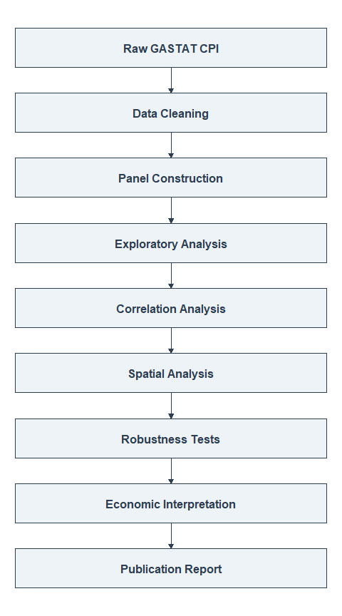
Figure A0. The project’s original (v1) exploratory workflow, Stages 1-8 (scripts/01-08). This preceded, and does not supersede, the confirmatory dynamic-panel analysis (v2, Stages 9-18) that forms the core of this paper; see Reproducibility for the full v2 pipeline and commit history.

Introduction
Inflation dynamics remain a central concern for economic policy, particularly in resource-dependent economies such as Saudi Arabia. National-level inflation indicators provide a useful summary, but they may mask important regional heterogeneity: are all thirteen of Saudi Arabia’s administrative regions simply riding the same national wave – responding together to oil prices, monetary policy, and nationwide fiscal changes such as VAT – or do regions also influence one another’s inflation directly, with price pressure in one region predicting subsequent price pressure in its geographic neighbours?
This paper addresses that question directly:
Do Saudi regional inflation dynamics primarily reflect common national temporal shocks, local regional persistence, or spatial predictive dependence across regions?
We do not begin from the premise that regional spatial spillovers exist. The empirical strategy is built to let each of the three candidate explanations fail on its own terms – through explicit joint hypothesis tests, multiple spatial-weight specifications, multiple dynamic horizons, multiple-testing correction, and a final robustness battery – rather than to confirm a spatial story assumed at the outset.
The paper is organized as follows. Literature Review situates this study relative to existing work on regional and spatial inflation dynamics, including evidence specific to Saudi Arabia and the GCC. Data and Variable Construction describes the panel and its construction. Empirical Strategy sets out the final dynamic two-way-fixed-effects specification and the full sequence of confirmatory analyses that were run around it. Results and Robustness and Additional Analyses report the findings, including a concise summary of a calibrated statistical-power analysis. Discussion interprets the null/weak spatial result economically, Limitations states what this analysis cannot establish – including what magnitude of spatial effect the available 13-region panel could and could not have reliably detected – and Future Research sets out a sequential agenda for resolving what remains open. The project’s original exploratory analysis (correlation structure, static Moran’s I, and Local Indicators of Spatial Association) is retained in full in Appendix A for transparency, clearly marked as preliminary and superseded in its interpretation by the confirmatory analysis that follows; the full statistical-power/ minimum-detectable-effect analysis is in Appendix B.

Literature Review
Common versus regional/local inflation factors. Ciccarelli and Mojon (2010) show, using a dynamic factor model across 22 OECD economies, that a single common global inflation factor accounts for roughly 70% of the cross-country variance in inflation, with national rates exhibiting a robust error-correction pull back toward that common factor. This motivates treating a strong common time-varying component – month fixed effects, in a panel setting – as the natural first-order explanation for co-movement across cross-sectional units before invoking direct inter-unit transmission.
Spatial and space-time models of regional inflation. Marques, Pino, and Tena study regional inflation dynamics using space-time models applied to Chilean regional price data, finding that spatial allocation of producers and transport costs, rather than macroeconomic common factors alone, help explain regional inflation divergence for a set of tradable commodities. Elhorst (2017) provides the standard methodological reference for spatial panel data models – static and dynamic specifications, spatial weight matrix construction, and the estimators (including bias-corrected and robust-inference variants) that this project’s spatial-lag and Driscoll-Kraay-based approach draws on conceptually.
Inflation spillover transmission mechanisms. Auer, Levchenko, and Sauré (2017) show, using international input-output linkages, that supply-chain connections account for roughly half of the global component of producer-price inflation transmission across countries – evidence that spillover channels, where they exist, typically operate through identifiable structural linkages (trade, supply chains) rather than through geographic proximity alone.
Saudi Arabia and GCC-specific evidence. Hasan and Alogeel (2008), in an IMF working paper on Saudi Arabia and Kuwait, find that inflation in both countries is driven mainly by trading-partner inflation in the long run (consistent with the GCC currencies’ pegs and high import shares), with domestic demand and money-supply shocks affecting inflation mainly in the short run and oil prices and exchange-rate pass-through playing a smaller role. More recently, Fareed, Rezghi, and Sandoz (2023), using a Global Vector Autoregressive model over 1987-2022, find that external factors – imported inflation from major trading partners and the nominal effective exchange rate – remain the dominant drivers of GCC inflation. Neither study models sub-national (regional) spatial dependence within a GCC country; this is, to our knowledge, the first systematic dynamic-panel spatial-dependence test at the Saudi administrative-region level.
How this study differs. The literature above establishes two things this paper’s design takes as its starting point: (i) a strong common national/ global time component is the expected primary driver of co-movement (Ciccarelli & Mojon), and (ii) Saudi inflation specifically is understood to be driven substantially by external and national factors rather than domestic regional interaction (Hasan & Alogeel; Fareed, Rezghi & Sandoz). Against that backdrop, this paper’s contribution is a direct, multi-horizon, multiply-corrected test of whether any residual regional spatial predictive dependence remains once common temporal variation (captured statistically via month fixed effects, without asserting a specific identified mechanism) and each region’s own persistence (own-lags) are accounted for – rather than an assumption, in either direction, about what that test would find.

Data and Variable Construction
Table 1. Data and panel structure (MAKANI v2 canonical panel).
Field | Value
Source | GASTAT (General Authority for Statistics, Saudi Arabia)
Base year | 2023 = 100
Frequency | Monthly
Regions | 13
Date range | 2013-01-01 to 2026-02-01
Total panel rows (region x month) | 2054
Inflation definition | inflation_mom_it = 100 x [ln(CPI_it) - ln(CPI_i,t-1)]
Structural lag missingness (inflation_mom) | 13 rows (one per region, the structurally unavailable first month)
The panel is built by scripts/09_panel_build.R (frozen region_id registry, immutable across every subsequent stage) and validated by scripts/10_panel_validation.R and a 177-expectation testthat suite. It is distinct from, and does not modify, the project’s frozen v1.0 exploratory baseline (baseline/v1.0/, tag baseline-v1.0). No national CPI series is fabricated: MAKANI does not average regional CPI into a national figure anywhere in the confirmatory analysis; where a cross-sectional average is used as a diagnostic input (e.g. the national/common inflation series in the nonlinear and structural-shock stages), it is clearly labelled as such, not presented as an official national statistic.
Two lag variables are constructed for every region-month, from the same strictly time-indexed (not row-position-indexed) lookup: own-region lags (own_lag_k, the region’s own inflation k months earlier) and spatial lags (w_lag_k, the row-standardized Queen-contiguity-weighted average of neighbouring regions’ inflation k months earlier). Both are constructed to guarantee no future-information leakage – a lag is available only when the underlying calendar month actually precedes the observation by exactly k months.

Empirical Strategy
The final empirical specification, retained after the full robustness sequence described below (Stage 18, commit 5565b1a), is a dynamic two-way fixed-effects panel model:
$$π_{it}=α_{i}+τ_{t}+\sum_{k=1}^{3}{ϕ_{k}} π_{i,t−k}+\sum_{k=1}^{3}{θ_{k}} (Wπ_{t−k})_{i}+e_{it}$$
where $α_{i}$ are region fixed effects, $τ_{t}$ are month fixed effects, $π_{i,t−k}$ is region $i$’s own inflation $k$ months earlier, and $(Wπ_{t−k})_{i}$ is the Queen row-standardized spatial lag of neighbouring regions’ inflation $k$ months earlier. Primary inference throughout uses Driscoll-Kraay panel-corrected standard errors (Bartlett kernel, Newey-West-1987 bandwidth rule), which are robust to cross-sectional and serial correlation simultaneously – appropriate given the small (N=13) cross-section, where ordinary cluster-robust inference is known to be unreliable. A wild-cluster (Rademacher) bootstrap by region provides a finite-sample-robust complement wherever a joint test is central to a conclusion.
This specification is the end point, not the starting point, of a ten-stage confirmatory sequence, each stage building strictly on new files and testing one candidate explanation without reopening or modifying any prior stage’s conclusions:
Empirical strategy: the ten-stage confirmatory (v2) sequence.
Stage | Question | Commit
9 | Build the canonical region x month panel | 9b4bc89
11 | How much regional inflation variance do region vs. month fixed effects explain? | e626dee
12 | Is there contemporaneous monthly spatial (Moran’s I) dependence, raw and TWFE-residual? | e626dee
13 | Does one region’s lagged inflation predict its neighbours’ current inflation (lag-1)? | f7f5d5d
14 | Does a longer, distributed spatial lag (K=3, K=6) predict inflation? | fd7ef10
15 | Is the (weak) spatial relationship nonlinear or state-dependent? | c63dba5
16 | Does parameter stability break down around verified national shock episodes? | bc4fde0
17 | Is inflation stationary? Is there a seasonal or longer-memory temporal pattern? | e0566f5
18 | Final robustness: region omission, influential months, weights, horizons, inference | 5565b1a
Every stage from 14 onward uses the same immutable region ordering, the same Queen spatial-weight construction (verified identical to Rook contiguity in this 13-region map, so the two are never treated as independent robustness checks), and, where applicable, a common estimation sample across nested model comparisons.

Results
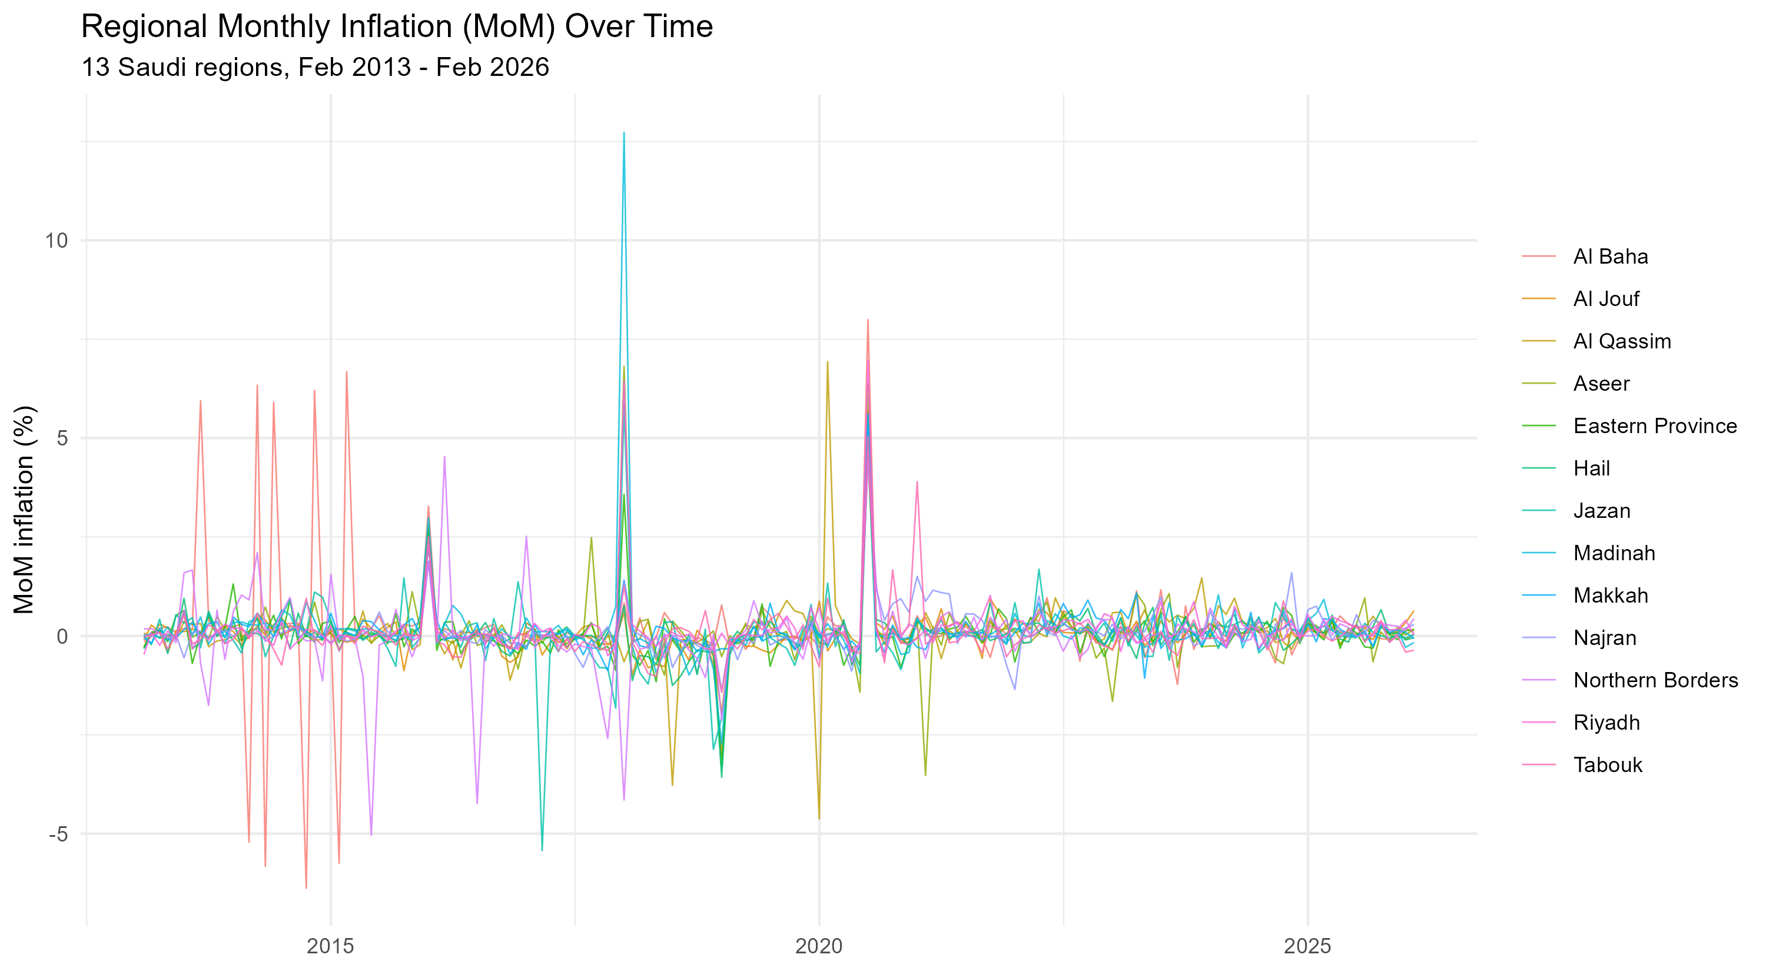
Figure 1. Regional month-over-month inflation, all 13 regions, 2013-2026.

Common temporal variation dominates the explainable variance
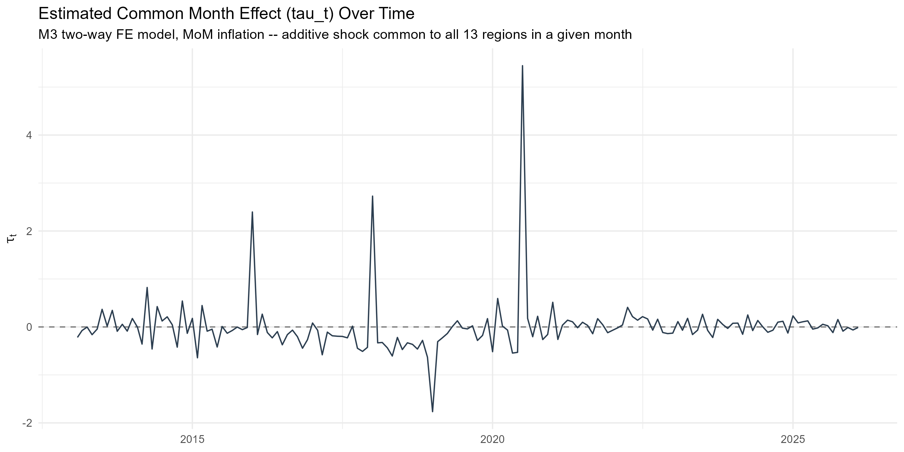
Figure 2. Estimated month fixed effects (the common temporal component) over time, from the Stage-11 TWFE decomposition.
Table 2. Two-way fixed-effects variance decomposition (Stage 11).
Component | Sum of squares | Share of total
Region (alpha_i) | 7.5645 | 0.0045
Month (tau_t) | 726.2859 | 0.4295
Residual | 957.1672 | 0.5660
Total | 1691.0177 | 1.0000
Month fixed effects – which absorb whatever common temporal variation is shared across all 13 regions in a given month, without identifying which specific mechanism (monetary policy, oil prices, a nationwide fiscal change, or some combination) drives it – alone account for 42.9% of the total sum of squares in regional inflation, versus 0.45% for region fixed effects. This asymmetry is consistent with Ciccarelli and Mojon’s (2010) finding that a common time-varying factor, not persistent cross-sectional heterogeneity, is the dominant source of co-movement; it is reported here as a statistical decomposition, not as identification of a specific causal driver.

Contemporaneous and lag-1 spatial dependence are weak and not robust
Monthly permutation-based Global Moran’s I (Stage 12), computed separately for each of 157 months on both raw inflation and TWFE residuals, finds 11 of 157 months nominally significant at the raw 5% level – but 0 survive Benjamini-Hochberg correction and 0 survive Holm correction, for both the raw and TWFE-residual series. There is no robust evidence of systematic contemporaneous spatial dependence.
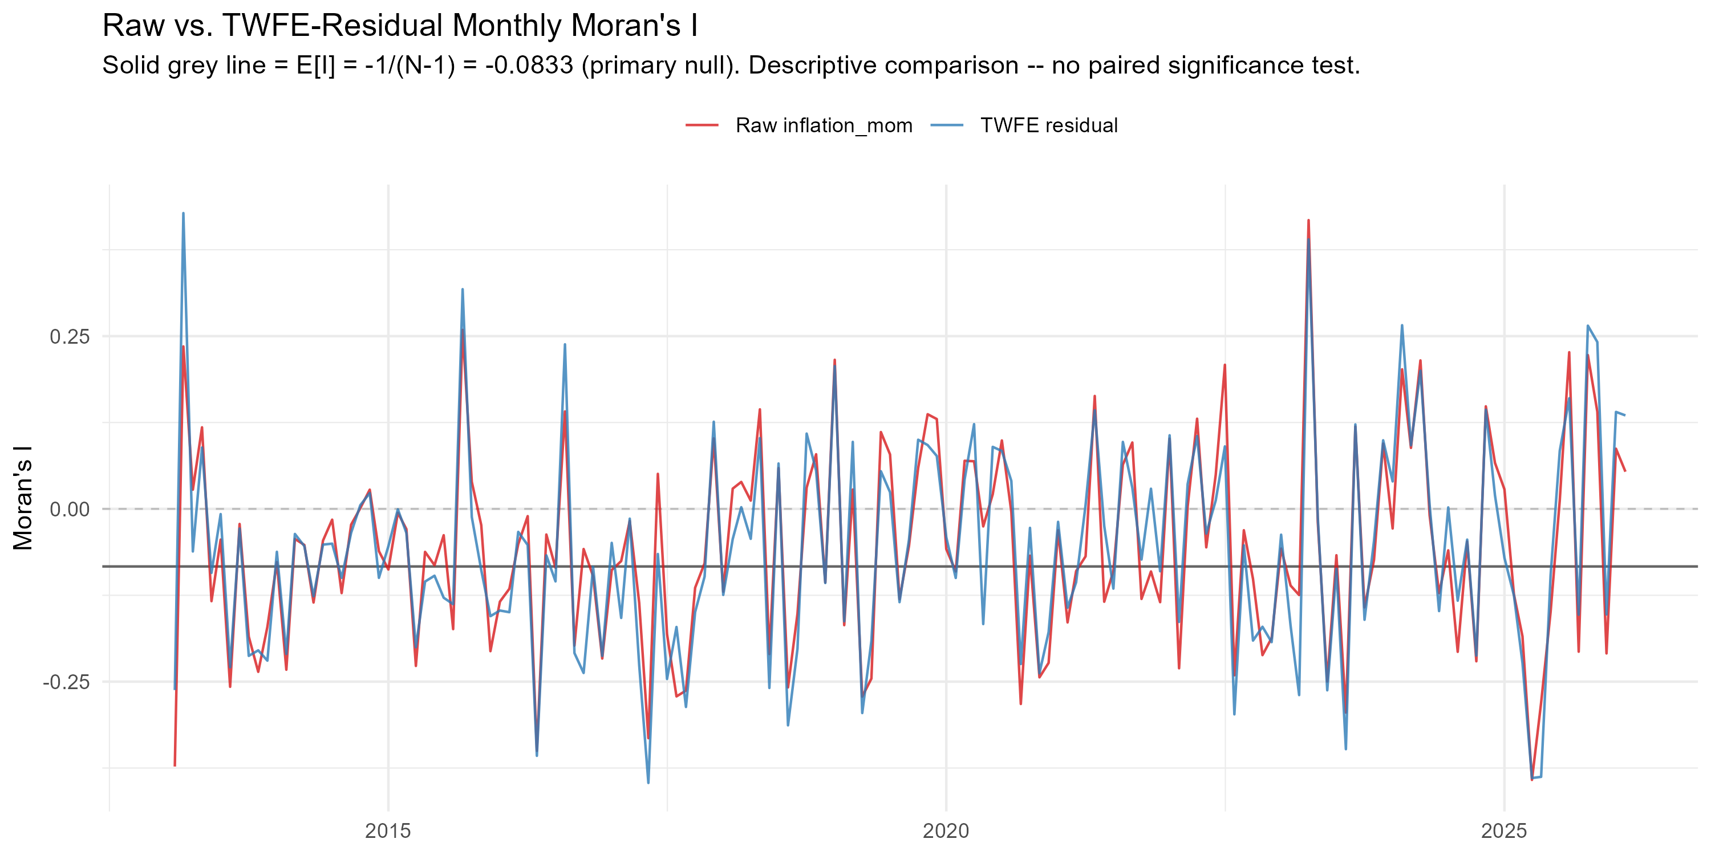
Figure 3. Monthly permutation Moran’s I, raw inflation vs. TWFE residuals – neither survives multiple-testing correction across 157 months.
The lag-1 own/spatial dynamic model (Stage 13) similarly finds no robust spatial predictive content: the spatial-lag coefficient $\hat{θ}$ = -0.0042 (Driscoll-Kraay SE = 0.0365, p = 0.909), confirmed by a wild-cluster bootstrap (p = 0.919, B = 9999).

Distributed spatial lags (K=3, K=6) remain non-significant
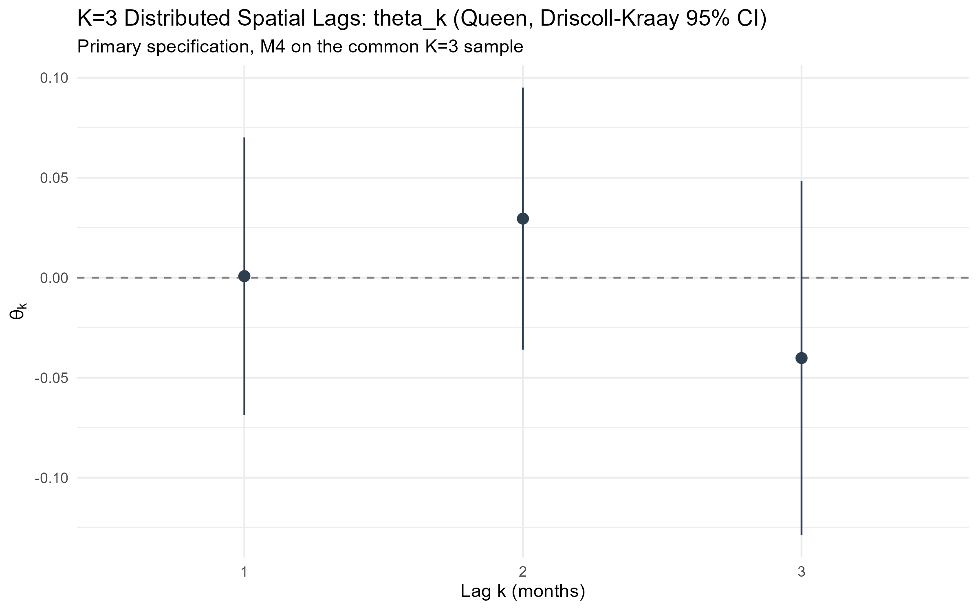
Figure 4. Distributed spatial-lag coefficients (theta_1, theta_2, theta_3), K=3, Driscoll-Kraay 95% CI (Stage 14).
Table 4. Dynamic-horizon robustness: cumulative spatial effect and joint test, K=1/3/6 (Stage 18, common sample).
horizon | n_obs | joint_p_value | Theta_K | ci_low | ci_high | AIC | BIC | within_R2
K=1 | 1963 | 0.9107 | -0.0041 | -0.0753 | 0.0672 | 4421.424 | 5348.074 | 0.4516
K=3 | 1963 | 0.3196 | -0.0085 | -0.1756 | 0.1587 | 4419.132 | 5368.111 | 0.4545
K=6 | 1963 | 0.4081 | -0.0378 | -0.2512 | 0.1756 | 4415.613 | 5398.086 | 0.4588
The joint test of $θ_{1}=θ_{2}=θ_{3}=0$ at K=3 gives p = 0.575 (wild-cluster bootstrap, B = 9999); the cumulative distributed spatial effect $Θ_{3}$ = -0.0098 (p = 0.898). Extending to K=6 does not change this conclusion (Table 4 above; joint p ranges from 0.32 to 0.911 across K=1/3/6 on one common sample).

Nonlinear and state-dependent evidence is suggestive only
Nonlinear/state-dependent hypothesis family (Stage 15).
test | primary_p_value_type | raw_p_value | p_BH | p_Holm
A: Joint regime interaction (delta_1=delta_2=delta_3=0) | Wild cluster bootstrap (B=9999) | 0.7705 | 0.7705 | 1.0000
B: Joint spline nonlinearity | Driscoll-Kraay asymptotic | 0.0168 | 0.0842 | 0.0842
C: Joint quadratic (linear+quadratic) | Driscoll-Kraay asymptotic | 0.0758 | 0.1895 | 0.3032
D: Threshold existence (bootstrap) | Wild cluster bootstrap (B=499) | 0.7535 | 0.7705 | 1.0000
E: Asymmetry equality (pos=neg) | Wild cluster bootstrap (B=999) | 0.6156 | 0.7705 | 1.0000
Across the pre-specified five-test nonlinear family (high-inflation-regime interaction, smooth spline nonlinearity, quadratic diagnostic, threshold existence, and positive/negative asymmetry), only the smooth-spline test is nominally significant at the raw 5% level (p = 0.0168), and it does not survive Benjamini-Hochberg correction (p = 0.0842) and fails to replicate under KNN spatial weights or at a six-month horizon (Stage 15, Section F). This is reported as suggestive, non-actionable evidence, not as an established nonlinear relationship.

Verified national shock episodes show no robust instability
Three officially verified national episodes (the December 2015 energy-price reform, the January 2018 VAT-introduction/energy-price package, and the July 2020 VAT rate increase) were tested for associated changes in own-region persistence, spatial predictive content, and their combination. Across the pre-specified nine-test family (3 episodes x {spatial, own, combined}), 0 of 9 tests were nominally significant at raw 5%, and 0 survived Benjamini-Hochberg correction. No robust event-conditioned parameter instability is found. One qualification: in the weight-robustness check (Stage 16, Section J; Driscoll-Kraay asymptotic p-values, no bootstrap), the spatial-dynamics test for the July 2020 VAT increase is nominally significant under KNN (p = 0.011) and distance-band weights (p < 0.001), but not under the primary Queen weights (p = 0.14). This episode overlaps the COVID-19 period, and the result is not part of the pre-specified corrected family above.

Inflation is stationary; CPI levels are not
Per-region unit-root testing (ADF and KPSS, both required to agree; Stage 17) finds 13 of 13 regions’ inflation series stationary, while 13 of 13 regions’ CPI level series are non-stationary – the expected pattern for a differenced/growth-rate series versus a trending price index. A break-aware (Zivot-Andrews) sensitivity check changes this conclusion for only 1 of 13 regions. The seasonal (lag-12) coefficient is not significant (estimate = -0.0116, p = 0.688), and no longer-memory extension (lag-6, lag-12) produces a materially decisive BIC improvement over the K=3 reference (Stage 17, Section D).

Robustness and Additional Analyses
Table 3. Final K=3 dynamic TWFE model: coefficients (Driscoll-Kraay).
parameter | estimate | dk_se | ci_low | ci_high | p_value_dk
phi_1 (own lag 1) | -0.1600 | 0.0876 | -0.3316 | 0.0117 | 0.0678
phi_2 (own lag 2) | 0.0597 | 0.0538 | -0.0458 | 0.1652 | 0.2674
phi_3 (own lag 3) | -0.0321 | 0.0396 | -0.1097 | 0.0456 | 0.4181
theta_1 (spatial lag 1) | 0.0008 | 0.0354 | -0.0686 | 0.0702 | 0.9820
theta_2 (spatial lag 2) | 0.0296 | 0.0334 | -0.0360 | 0.0951 | 0.3767
theta_3 (spatial lag 3) | -0.0402 | 0.0452 | -0.1288 | 0.0484 | 0.3742
Cumulative own effect (sum phi_k) | -0.1323 | 0.1267 | -0.3807 | 0.1160 | 0.2964
Cumulative spatial effect (Theta_3) | -0.0098 | 0.0857 | -0.1778 | 0.1582 | 0.9087
Table 3 (continued). Final model metadata.
final_model_spec | N_regions | T_months | total_obs | R2 | within_R2 | AIC | BIC | wcb_joint_p_value_B9999
inflation_mom ~ region_id_f + date_f + own_lag_1 + own_lag_2 + own_lag_3 + w_lag_1 + w_lag_2 + w_lag_3 | 13 | 154 | 2002 | 0.454 | 0.454 | 4476.08 | 5445.209 | 0.5754

Table 5. Final robustness summary (Stage 18).
check | min_p | max_p | conclusion_ever_changes
Leave-one-region-out (13 refits) | 0.0771 | 0.7972 | FALSE
Influential-month sensitivity (4 specs) | 0.2361 | 0.3772 | FALSE
Spatial-weight matrix (Queen/KNN/distance) | 0.3156 | 0.9849 | FALSE
Dynamic horizon (K=1/3/6) | 0.3196 | 0.9107 | FALSE
Temporal specification (T0/T1) | 0.2713 | 0.3196 | FALSE
The final K=3 model’s central conclusion – non-significant joint spatial predictive dependence – is unchanged: across all 13 leave-one-region-out re-estimations (joint p range [0.077, 0.797]; Figure 5 below); across influential-month exclusion specifications;
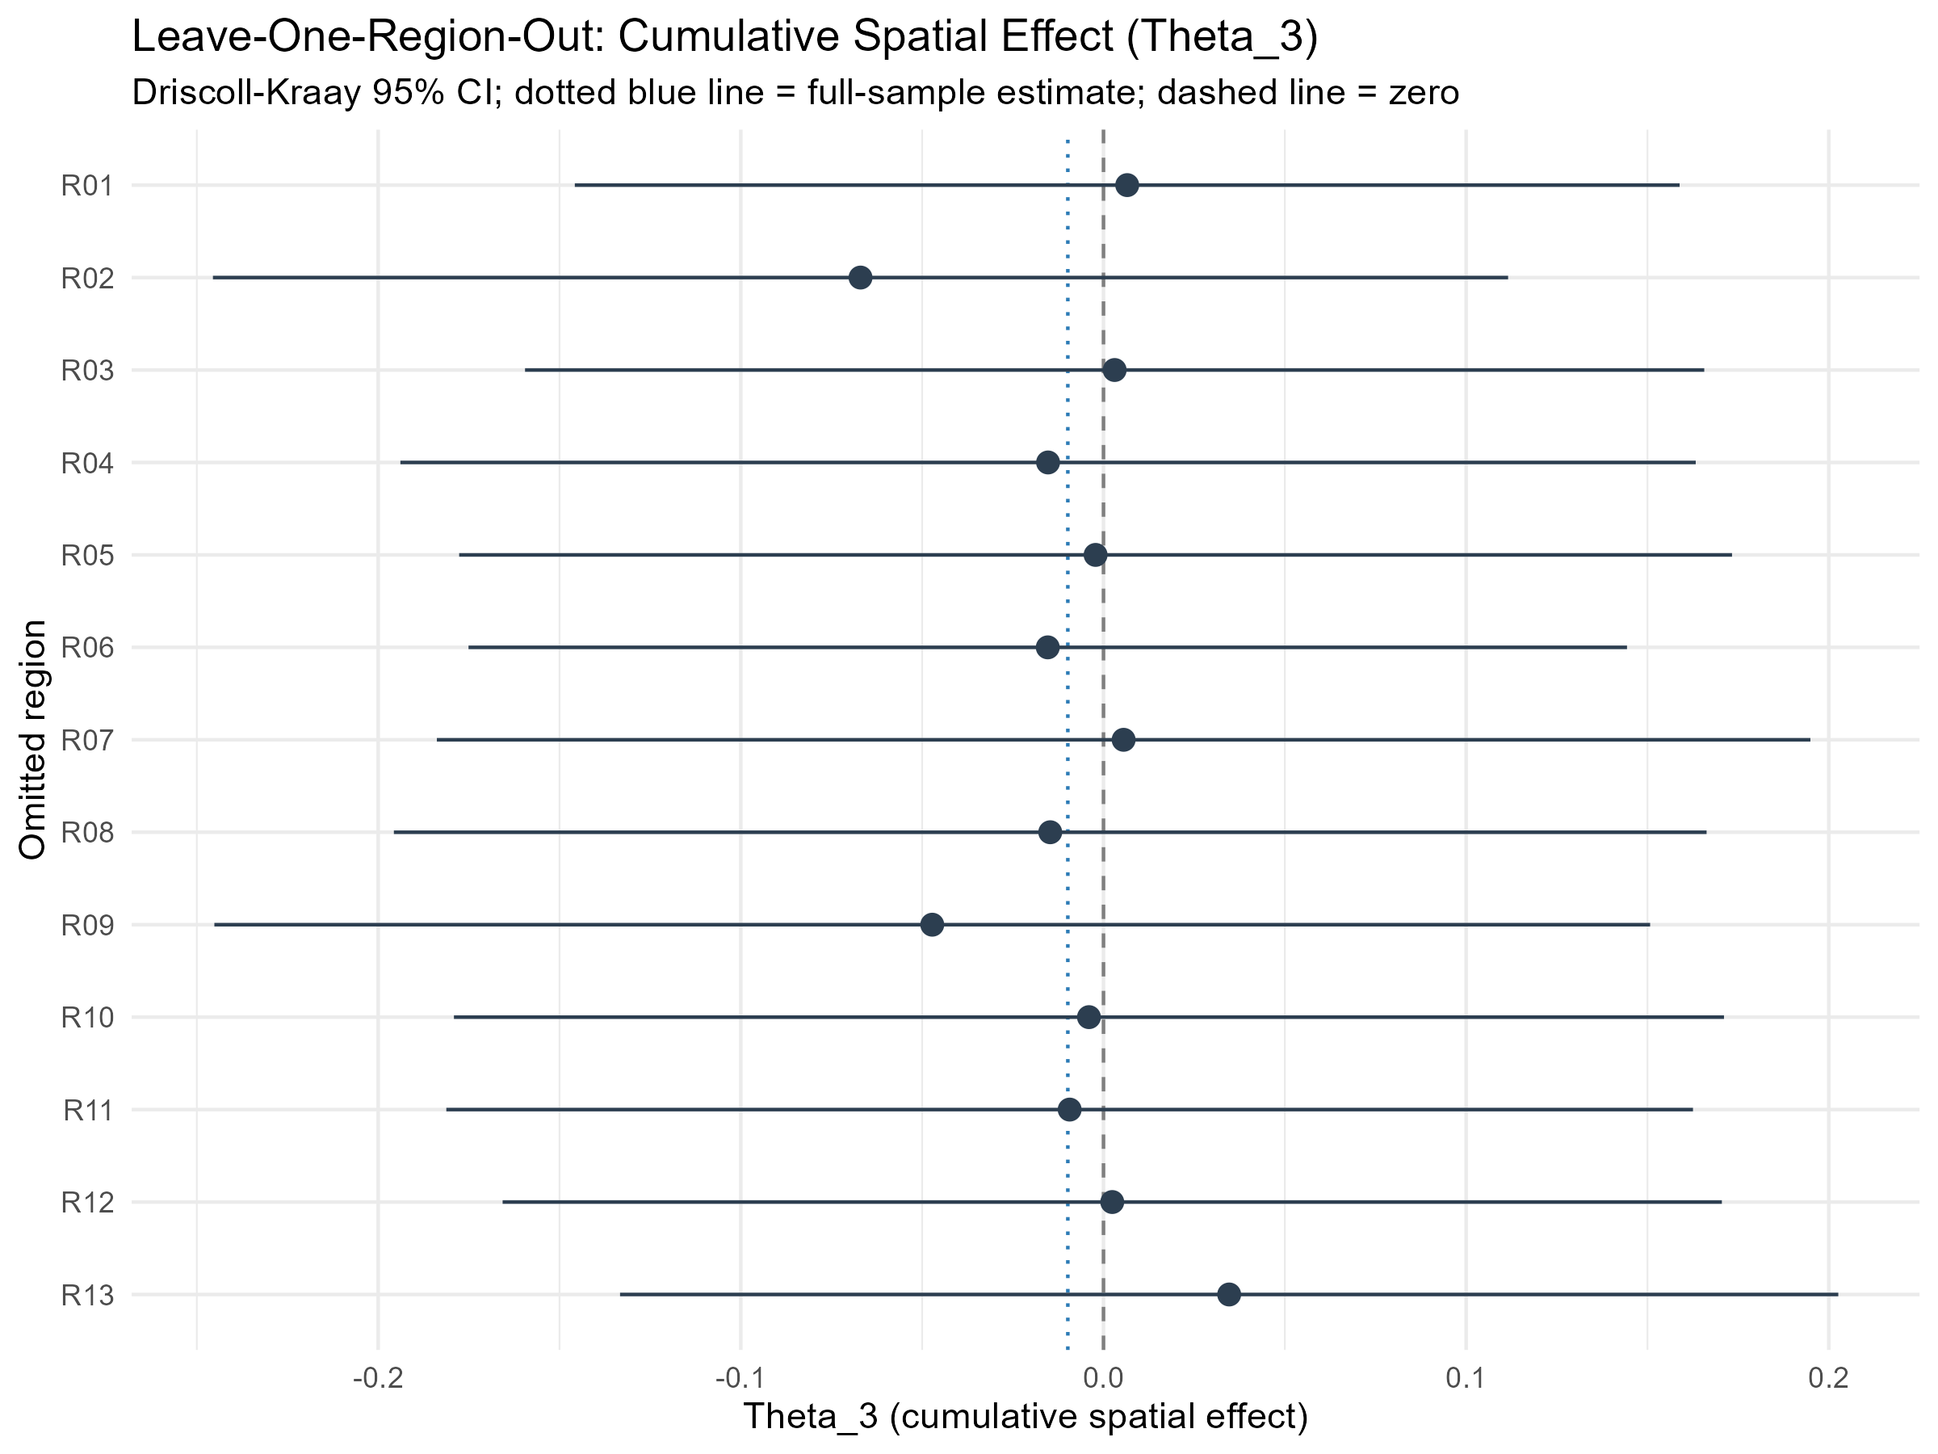
Figure 5. Leave-one-region-out cumulative spatial effect (Theta_3), Driscoll-Kraay 95% CI (Stage 18).
across Queen, KNN (k=4), and distance-band spatial weights (Table 5); across K=1/3/6 dynamic horizons (Table 4); across the T0/T1 temporal-specification comparison confirming Stage 17’s own finding; and across four inference methods – Driscoll-Kraay, region-clustered, classical (diagnostic only), and a final B=9999 wild-cluster bootstrap (p = 0.5754).

Statistical power: what spatial effect size could this design detect?
Because the null/weak spatial result above could in principle reflect either a genuinely small (or zero) true effect, or simply limited statistical power given N=13, a calibrated Monte Carlo simulation was run – as a design-sensitivity check, not a new empirical finding – to ask what magnitude of cumulative three-month spatial effect (Theta_3) this exact design (N=13, T=154, the observed Queen weights, the locked K=3 specification, and residual dependence preserved via a moving-block bootstrap) could reliably detect. Full design and results are in Appendix B. Summary: across a pre-specified, symmetric effect-size grid (|Theta_3| up to 0.20), estimated power never exceeds 57.7%, short of the conventional 80% threshold; the design is classified P3: Low power even for moderate effects. This means the design can reliably detect only moderate-to-large cumulative spatial effects, and small spatial effects cannot be excluded by this study’s null/weak result – a point carried through to the Discussion and Limitations below.

Discussion
The central empirical pattern – a large, statistically dominant share of common temporal variation, meaningful own-region persistence, and no robust spatial predictive dependence across neighbouring regions – is economically plausible for several reasons. These are offered as possible explanations (category C), distinct from what is directly statistically estimated (category A) above and from any specific economic interpretation (category B) of it; none is a mechanism established by this analysis, and the month fixed effects themselves identify only that temporal variation is shared across regions, not which economic force produces it:
- National pricing forces may dominate regional neighbour effects. Saudi Arabia is a single-currency, administratively centralized economy with nationally set fuel and utility prices and a single VAT rate; the channels through which one region’s price pressure would spread specifically to its geographic neighbours (rather than to the whole country at once) may simply be weak relative to nationwide drivers.
- Integrated national markets. If goods, especially the CPI basket’s heavily weighted tradable and administered-price components, are sourced and priced through national or global supply chains rather than region-to-region trade, geographic contiguity may not be the right channel through which any real inflation transmission occurs (consistent with Auer, Levchenko & Sauré’s finding that input-output linkages, not proximity per se, carry inflation spillovers internationally).
- Common policy/macro shocks are one plausible source of the common temporal variation, not a separate finding. VAT changes and oil-price movements, if they matter, would hit all regions in the same calendar month; a model that already includes month fixed effects has, by construction, absorbed whatever common temporal variation exists that month, from whatever source – so the residual spatial test correctly finds little left to explain, regardless of which specific national force (if any single one dominates) generated that common variation.
- Administrative-region aggregation may be too coarse. Thirteen large administrative regions aggregate substantial internal heterogeneity (e.g. a large city and its rural periphery within one region); if genuine spatial spillovers operate at a finer geography (city or district level) or through specific product categories rather than the aggregate CPI basket, this panel’s resolution could not detect them even if they exist.

Limitations
- Small cross-section (N=13) limits what can be ruled out, not the validity of the test itself. The time dimension is reasonably long for monthly dynamics (T=154 months in the final K=3 sample), and every inference method used here (Driscoll-Kraay, cluster-robust, wild-cluster bootstrap) was chosen specifically because ordinary asymptotics are unreliable with only 13 cross-sectional units. But N=13 fundamentally limits statistical power, particularly for weak or heterogeneous spatial effects and for the more complex state-dependent/nonlinear specifications explored in Stage 15. A calibrated Monte Carlo power analysis (Appendix B) finds that this design has adequate power to detect only moderate-to-large cumulative spatial effects (roughly |Theta_3| > 0.20) and limited power below that – the pre-specified effect-size grid’s 80%-power threshold was not reached within the tested range. This is a distinction between absence of evidence and evidence of absence: the null/weak result reported here means no spatial predictive dependence of the magnitude this design could reliably detect was found – it does not mean, and this paper does not claim, that smaller spatial effects are ruled out. The width of the observed confidence interval for the cumulative spatial effect (Table 3) is consistent with this: it remains wide enough to admit economically small effects alongside zero.
- Administrative-region aggregation, as discussed above, may obscure finer-grained spatial dependence.
- No region x category CPI history is available over a long enough window to test whether spatial dependence is concentrated in specific product categories (e.g. housing, transport) rather than the aggregate index.
- Moderate residual temporal persistence remains (Stage 17-18; final classification T2) and is not resolved by any tested extension – the final model’s residuals still show some region-level serial dependence that this analysis does not fully explain.
- Spatial-weight uncertainty. Only Queen contiguity, KNN (k=4), and a distance-band matrix were tested; Queen and Rook contiguity are identical in this map and are not independent checks. KNN and distance-band neighbours use great-circle distances between WGS84 region centroids; the distance band is 1.05 times the largest nearest-neighbour distance (about 501 km). Versions up to v1.0 applied Euclidean distance to longitude/latitude degrees; correcting this changed the KNN and distance-band robustness numbers; the main conclusions are unchanged, with one added qualification for the July 2020 episode (Stage 16 above; see results_v2/distance_correction/). A genuinely different notion of “neighbour” (e.g. trade-flow-weighted) was not tested.
- No causal identification. Every result in this paper is a predictive/ associational test, not a causal design; in particular, the verified national shock episodes are tested for association with parameter instability, not for a causal treatment effect, and two of the three episodes are explicitly confounded with other simultaneous national events (documented in Stage 16’s registry) and cannot be causally isolated with this data.
- Local/city-level mechanisms are not identifiable in the current, region-level data – a null finding at the administrative-region level does not rule out spatial dependence at a finer geography.

Future Research
The findings above – no robust spatial predictive dependence at the 13-region level, but a design with limited power for small effects and several documented reasons administrative-region aggregation might mask a real but finer-grained pattern – motivate a sequential research agenda, each step building on what the previous one would find, rather than a list of unrelated extensions.
Step 1 – Finer geography. Question: does spatial predictive dependence emerge at the city or governorate level even if it is weak at the 13-region level? Motivation: administrative-region aggregation combines, within one region, a major city and its rural periphery, which could average away genuine local price propagation. This step requires sub-regional CPI data that, to our knowledge, does not currently exist in a form usable for this analysis – we do not claim it does; obtaining or constructing it would be the first task of this step, not an assumption of it.
Step 2 – Category-level inflation. Question: does spatial dependence differ across inflation components – food, housing/utilities, transport, restaurants/accommodation – rather than being uniformly absent in the aggregate index? Motivation: headline CPI averages across categories with plausibly very different spatial economics (e.g. a nationally-priced administered utility versus a locally-sourced perishable food category); a sector-specific test could find dependence the aggregate index cannot. This step is explicitly constrained by the documented historical region-by-category CPI data limitation already noted in this paper’s Limitations – a long enough region x category panel is not currently available.
Step 3 – Economic connectivity beyond geography. Building on whatever Steps 1-2 find, future work may move beyond a purely geographic contiguity matrix $W$ to economically meaningful connectivity: transport links, internal trade flows, logistics networks, labour/consumer mobility, or payment flows, where valid data become available. The central hypothesis this step would test – not demonstrated by MAKANI – is that economic connectivity may be more informative than administrative adjacency for detecting real inflation co-movement across regions.
Step 4 – Heterogeneous interactions. Only with richer cross-sectional data (from Steps 1-3) would it become meaningful to examine whether spatial predictive content varies systematically with regional characteristics, i.e. interactions of the form $Wπ_{t−k}×Z_{i}$, where $Z_{i}$ might represent urbanization, market structure, logistics connectivity, sector composition, population density, or another theoretically justified regional characteristic. This interaction is explicitly NOT added to the current MAKANI empirical model – Stage 15 already tested state-dependent spatial effects along one dimension (the national inflation regime) and found no robust evidence, and this guardrail was maintained throughout the pre-submission refinement reported here. Step 4 is framed as a hypothesis generated by the present study for future work with adequate data, not as an extension to reopen now.

Conclusion
Common temporal variation accounts for a substantial share of regional inflation dynamics, while the available 13-region panel provides no robust evidence of spatial predictive dependence after accounting for regional dynamics. This is the central conclusion of ten confirmatory stages spanning contemporaneous spatial dependence, lag-1 predictive content, distributed lags to six months, nonlinear and state-dependent extensions, verified national shock episodes, stationarity, seasonality, and a final robustness battery covering region omission, influential months, spatial-weight choice, dynamic horizon, and inference method. The final spatial evidence classification is B: Weak/suggestive but non-robust spatial dependence, and the final temporal-dynamics classification – reported separately, as the two are conceptually distinct – is T2: Moderate but non-decisive temporal persistence.
This is not evidence that “no spatial dependence exists” in any absolute sense – no robust spatial predictive dependence is detected in the available data. That is, at the administrative-region level, over the horizons tested, and after accounting for common temporal variation and each region’s own persistence, no predictive spatial signal survives rigorous, multiply-corrected, robustness-checked testing. Common temporal variation and local region-specific dynamics, not spatial transmission across neighbouring regions, characterize the empirical pattern of Saudi regional inflation that this study identifies. Because the available cross-section (N=13) limits this design’s power to moderate-to-large effects (Appendix B), this finding should be read as “no robust evidence of the spatial effect sizes this study could reliably detect,” not as evidence that small spatial effects are absent.

References
Auer, R., Levchenko, A. A., & Sauré, P. (2017). International Inflation Spillovers through Input Linkages. BIS Working Paper No. 623. Bank for International Settlements. https://www.bis.org/publ/work623.pdf
Ciccarelli, M., & Mojon, B. (2010). Global Inflation. The Review of Economics and Statistics, 92(3), 524-535. https://direct.mit.edu/rest/article/92/3/524/57826/Global-Inflation
Elhorst, J. P. (2017). Spatial Panel Data Analysis. In S. Shekhar, H. Xiong, & X. Zhou (Eds.), Encyclopedia of GIS (2nd ed., pp. 2050-2058). Springer. https://doi.org/10.1007/978-3-319-17885-1_1641
Fareed, F., Rezghi, A., & Sandoz, C. (2023). Inflation Dynamics in the Gulf Cooperation Council (GCC): What is the Role of External Factors? IMF Working Paper WP/23/263. International Monetary Fund. https://www.imf.org/en/Publications/WP/Issues/2023/12/15/Inflation-Dynamics-in-the-Gulf-Cooperation-Council-GCC-What-is-the-Role-of-External-Factors-542414
Hasan, M. M., & Alogeel, H. (2008). Understanding the Inflationary Process in the GCC Region: The Case of Saudi Arabia and Kuwait. IMF Working Paper WP/08/193. International Monetary Fund. https://www.imf.org/external/pubs/ft/wp/2008/wp08193.pdf
Marques, H., Pino, G., & Tena, J. D. Regional Inflation Dynamics Using Space-Time Models. Empirical Economics. https://link.springer.com/article/10.1007/s00181-013-0763-9

Reproducibility
Frozen baseline. baseline/v1.0/ (git tag baseline-v1.0, commit 72147ab), checksummed via baseline/v1.0/MANIFEST.sha256 (38/38 files verified after every subsequent stage, including this one). No file in it was read, modified, or sourced by any v2 stage.
Immutable region identity. Every v2 stage uses the same 13-region region_id (R01-R13), defined once in data_v2/region_id_registry.csv and never re-derived, alongside the same alphabetically sorted region_order used consistently for spatial-weight matrix construction from Stage 12 onward.
Workflow. R / renv (locked at R 4.4.1; renv.lock pins every package version). No new package was installed at any v2 stage; where a desired method’s package was unavailable (e.g. strucchange, tseries, urca, plm), the underlying well-established algorithm was implemented directly in base R rather than altering the environment, documented explicitly in each script’s header.
Staged scripts and commits (v2, Stages 9-19):
Staged v2 scripts and their commit hashes on branch makani-v2-panel.
Stage | Script | Commit
9 (panel build) | scripts/09_panel_build.R | 9b4bc89
11 (TWFE decomposition) | scripts/11_twfe_common_shocks.R | e626dee
12 (Moran’s I) | scripts/12_residual_spatial_tests.R | e626dee
13 (lag-1 spatial) | scripts/13_lagged_spatial_transmission.R | f7f5d5d
14 (distributed lags) | scripts/14_distributed_spatial_lags.R | fd7ef10
15 (nonlinear) | scripts/15_nonlinear_spatial_dynamics.R | c63dba5
16 (structural shocks) | scripts/16_structural_shocks.R | bc4fde0
17 (stationarity/temporal) | scripts/17_stationarity_temporal_dynamics.R | e0566f5
18 (final robustness) | scripts/18_final_robustness_model_lock.R | 5565b1a
19 (manuscript integration) | paper.qmd (this file) | (this commit)
Machine-readable outputs. Every number reported in the Results and Robustness sections above is read programmatically, at render time, from the CSV/TXT tables committed alongside each stage’s script (results_v2/*/tables/) – none is hand-typed. The full sensitivity analyses referenced but not reproduced in full here (e.g. the complete leave-one-region-out table, the full stationarity-by-region table) are available in those same directories.

Appendix A: Exploratory Baseline Analysis (v1, Preliminary)
Read this appendix as the project’s original exploratory phase (Stages 1-8), retained here in full for transparency. It precedes, and its suggestive spatial-clustering reading is superseded in interpretation by, the confirmatory dynamic-panel analysis in the main text above (Stages 9-18), which found no robust spatial predictive dependence after multiple- testing correction and a full robustness battery. Where this appendix’s original language (below) describes a pattern as more than suggestive, the main text’s finding should be treated as authoritative.

Data (v1)
This study uses monthly Consumer Price Index (CPI) data for Saudi Arabia’s thirteen administrative regions, published by the General Authority for Statistics (GASTAT), reference (base) year 2023 = 100. The series spans January 2013 to February 2026 and reflects GASTAT’s updated CPI methodology, effective August 2025, under which the regional-level series was re-linked back to 2013. Inflation is computed as the log difference of the CPI index, ln(CPI_t / CPI_(t-1)), for each region.

Methodology (v1)

Data Engineering
The raw GASTAT series is rebuilt into an analysis-ready panel on every pipeline run rather than read from a static cache. The annual-average row included in the raw file for each year is excluded before any ordering, the month/year fields are coerced to integers (avoiding a lexicographic month order such as “1, 10, 11, 12, 2, …”), and each region’s series is explicitly sorted chronologically before the month-over-month log-difference is taken. This ordering step matters: computing the log-difference on a text-sorted series silently misattributes several months per year to the wrong prior period. The resulting long-format panel (date, Region, CPI, inflation) is the single input to every analysis step below.

Analytical Approach
To explore regional interactions, the data is transformed into a wide format, allowing the computation of a correlation matrix across regions.
Spatial analysis is conducted using regional shapefiles, enabling visualization of geographic variation in inflation patterns. In addition, the Global Moran’s I statistic is computed on each region’s mean inflation using a queen-contiguity spatial weights matrix, to test formally whether spatial clustering exists rather than relying on visual inspection of the map alone.

Descriptive Statistics (v1)
Region | Mean Inflation (%) | Std. Dev. (%) | Min (%) | Max (%)
Al Baha | 0.22 | 1.63 | -6.38 | 8.00
Madinah | 0.19 | 1.18 | -2.74 | 12.73
Riyadh | 0.18 | 0.81 | -0.52 | 6.97
Al Qassim | 0.13 | 0.96 | -4.62 | 6.94
Aseer | 0.13 | 0.92 | -3.53 | 6.81
Makkah | 0.13 | 0.58 | -1.07 | 5.60
Najran | 0.12 | 0.59 | -1.38 | 4.71
Eastern Province | 0.06 | 0.72 | -3.30 | 5.53
Tabouk | 0.05 | 0.66 | -1.43 | 5.04
Jazan | 0.05 | 0.95 | -5.43 | 5.85
Al Jouf | 0.05 | 0.59 | -3.01 | 4.48
Hail | 0.05 | 0.63 | -3.57 | 5.26
Northern Borders | 0.03 | 1.01 | -5.04 | 4.53
Table A1. Descriptive statistics of monthly regional inflation rates (%).

Distribution of Inflation
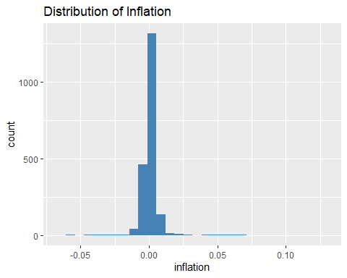
Figure A1. Distribution of inflation across Saudi regions.
The distribution of inflation suggests that values are concentrated within a narrow range, indicating relatively low dispersion across regions.

Results (v1)

Correlation Analysis
Figure A2 illustrates the correlation structure across Saudi regions, revealing moderate to high positive relationships.
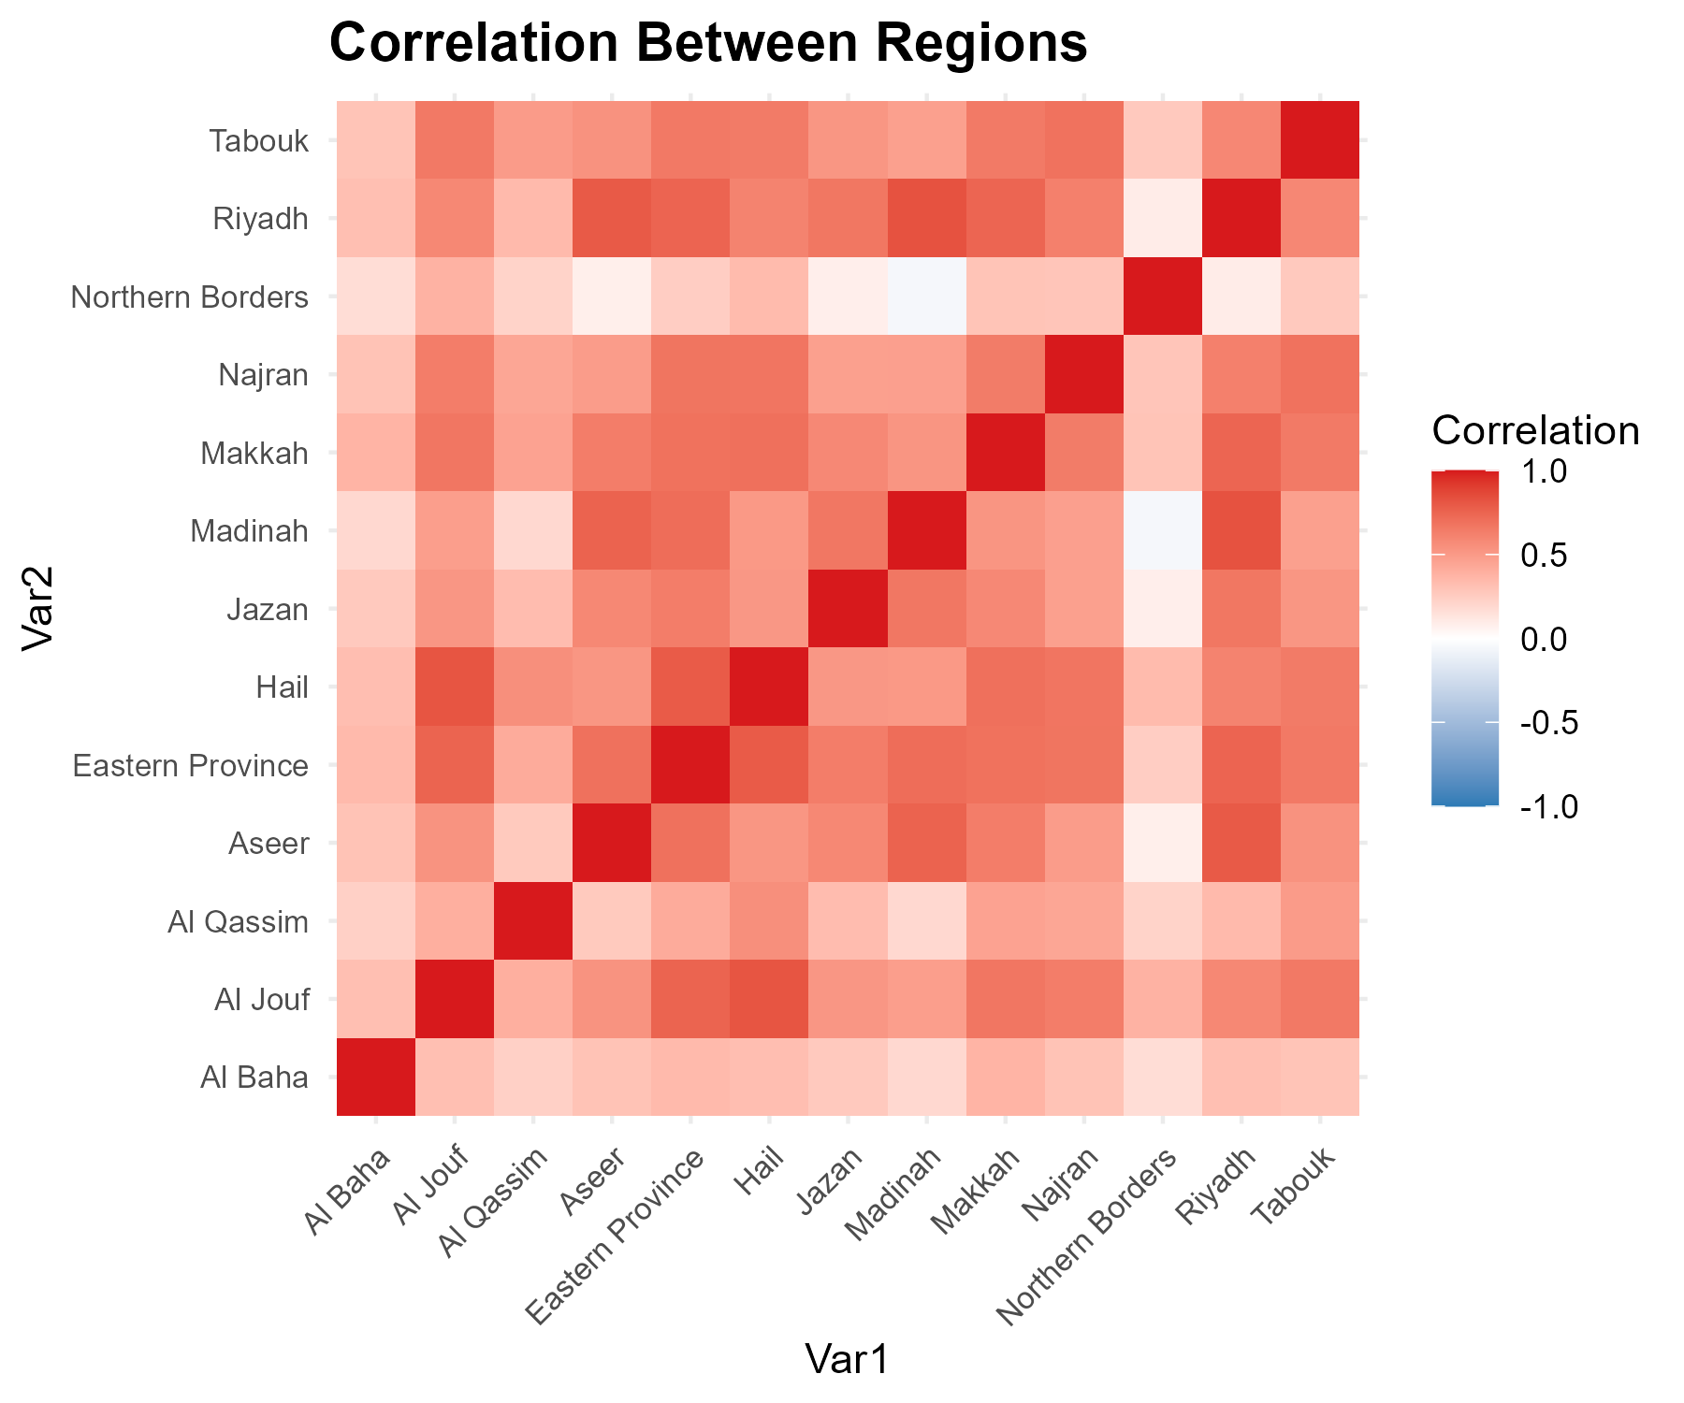
Figure A2: Correlation matrix of inflation across Saudi regions.
The correlation matrix indicates moderate to high positive correlations across regions. On its own, a high pairwise correlation does not establish that regions interact economically with one another; it is equally consistent with all regions responding to the same national-level drivers (monetary policy, oil prices, or nationwide fiscal shocks such as VAT changes) without any direct regional interaction. This reading is confirmed directly by the main text’s confirmatory dynamic-panel analysis above, which finds no robust spatial predictive dependence once common month effects are accounted for.
However, variations in correlation strength imply that regional-specific factors also play a role.

Statistical Significance of Regional Correlations
Correlation coefficients alone do not indicate whether a relationship is statistically distinguishable from zero. Testing all 78 regional pairs individually (Pearson correlation test), 74 of 78 pairs (94.9%) are significant at the raw 5% level. Of the 4 non-significant pairs, 4 involve the Northern Borders region. This pattern may reflect the relatively distinct economic characteristics of the Northern Borders region (e.g. population size, trade exposure, or border-related retail dynamics); however, this study does not formally test which of these factors, if any, is responsible, and the pattern could equally be driven by chance given the number of pairwise tests performed. This should be read as a descriptive observation rather than a causal explanation.
Because 78 pairwise tests are performed simultaneously, the raw 5% threshold understates the false-positive risk. Applying a Benjamini-Hochberg (FDR) correction across all 78 tests, 74 of 78 pairs remain significant — identical to the raw-p-value count, so the multiple-testing concern does not change the substantive conclusion here.

Spatial Analysis (Map)
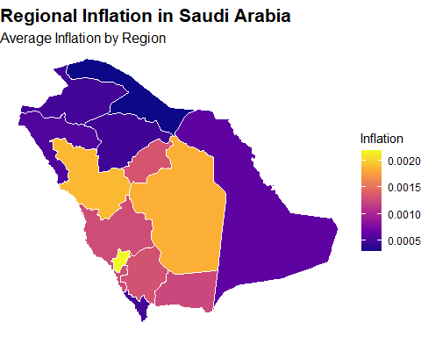
Figure A3: Spatial distribution of inflation across Saudi regions. However, the spatial map highlights variation across regions, indicating that inflation is not uniformly distributed geographically.

Spatial Autocorrelation (Moran’s I)
The correlation matrix above treats all regions symmetrically and ignores geography. To test formally whether regions with similar inflation levels tend to be geographic neighbours, we compute the Global Moran’s I statistic on mean regional inflation, using a queen-contiguity spatial weights matrix built from the regional boundaries (scripts/06_spatial_autocorrelation.R).
Moran’s I ranges from -1 (perfect spatial dispersion) to +1 (perfect spatial clustering), with a value near 0 indicating a spatially random pattern. The estimated statistic is I = 0.204 (z = 1.68, p = 0.046).
With only 13 regions, this p-value relies on an asymptotic (normal/randomisation) approximation that may not hold well at such a small sample size. As a robustness check, we additionally computed a Monte Carlo permutation test (9999 random re-shufflings of the map): this gives I = 0.204, p = 0.0575. This permutation-based p-value is above the conventional 0.05 threshold, in contrast to the asymptotic test above — the evidence for spatial clustering is therefore borderline and sensitive to the testing method, and should be interpreted with caution rather than treated as a firmly established result.
This full-sample, time-collapsed test is superseded by the main text’s monthly permutation Moran’s I (Stage 12), which tests every one of 157 months separately and finds that no nominal monthly significance survives multiple-testing correction (see Results).
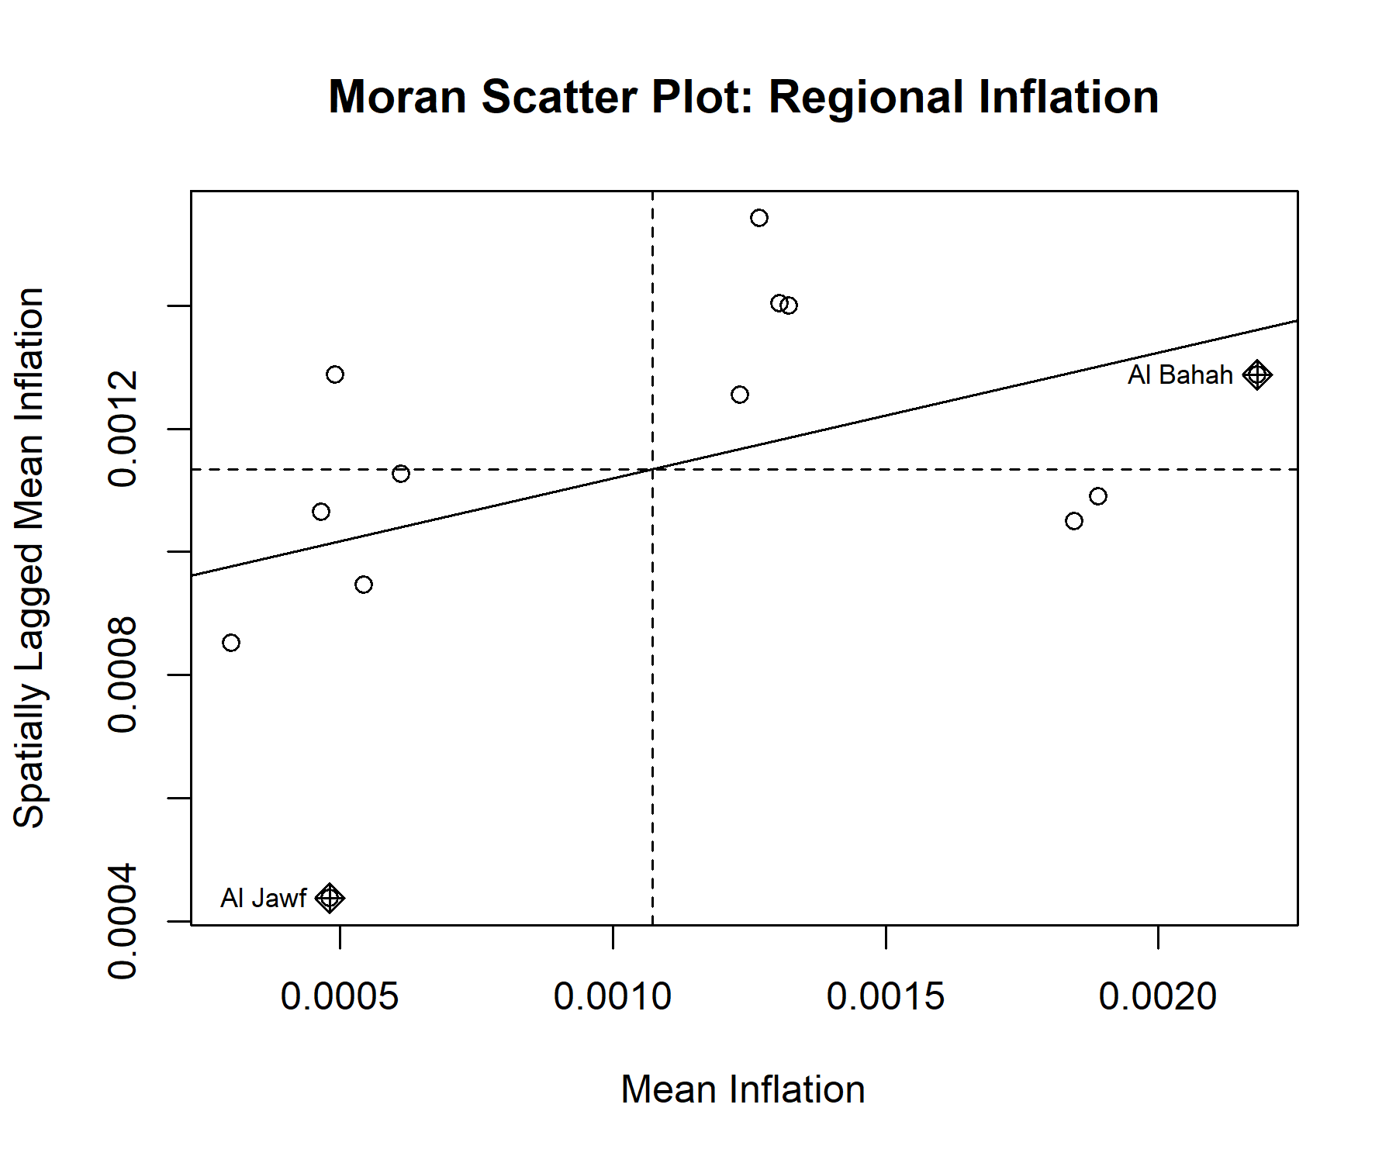
Figure A4: Moran scatter plot of regional mean inflation. The horizontal axis shows each region’s own mean inflation; the vertical axis shows the average mean inflation of its geographic neighbours. A positive slope indicates spatial clustering (similar values located near each other).
With p = 0.046 (below the conventional 0.05 threshold), the positive Moran’s I is nominally significant on this single full-sample test: regional inflation in Saudi Arabia’s time-averaged pattern is not randomly distributed in space. As the main text’s monthly-resolution confirmatory test shows, however, this full-sample pattern does not translate into robust month-by-month spatial predictive dependence.

Local Spatial Clusters (LISA)
Global Moran’s I indicates whether spatial clustering exists overall, but not where it occurs. To locate specific clusters, we compute the Local Indicators of Spatial Association (LISA / local Moran’s I) for each region, classifying it as High-High or Low-Low (a region and its neighbours share similarly high or low inflation — a cluster), High-Low or Low-High (a region differs from its neighbours — a spatial outlier), or not statistically significant (p ≥ 0.05).
Region | Mean_Inflation | Local_I | Z_value | P_value | Cluster
Ash Sharqiyah | 0.0006 | -0.067 | -0.05 | 0.9600 | Not significant
Al Hudud ash Shamaliyah | 0.0003 | 0.460 | 1.14 | 0.2560 | Not significant
Al Jawf | 0.0005 | 1.014 | 2.16 | 0.0311 | Low-Low
Najran | 0.0012 | 0.079 | 0.59 | 0.5540 | Not significant
`Asir | 0.0013 | 0.208 | 1.56 | 0.1180 | Not significant
Jizan | 0.0005 | -0.337 | -0.40 | 0.6860 | Not significant
Tabuk | 0.0005 | 0.181 | 0.53 | 0.5940 | Not significant
Al Madinah | 0.0019 | 0.037 | 0.41 | 0.6840 | Not significant
Makkah | 0.0013 | 0.249 | 2.16 | 0.0307 | High-High
Ar Riyad | 0.0018 | -0.047 | 0.33 | 0.7380 | Not significant
Al Quassim | 0.0013 | 0.222 | 1.06 | 0.2890 | Not significant
Hail | 0.0005 | 0.014 | 0.32 | 0.7480 | Not significant
Al Bahah | 0.0022 | 0.642 | 0.84 | 0.3980 | Not significant
Table A2. Local Moran’s I (LISA) results by region.
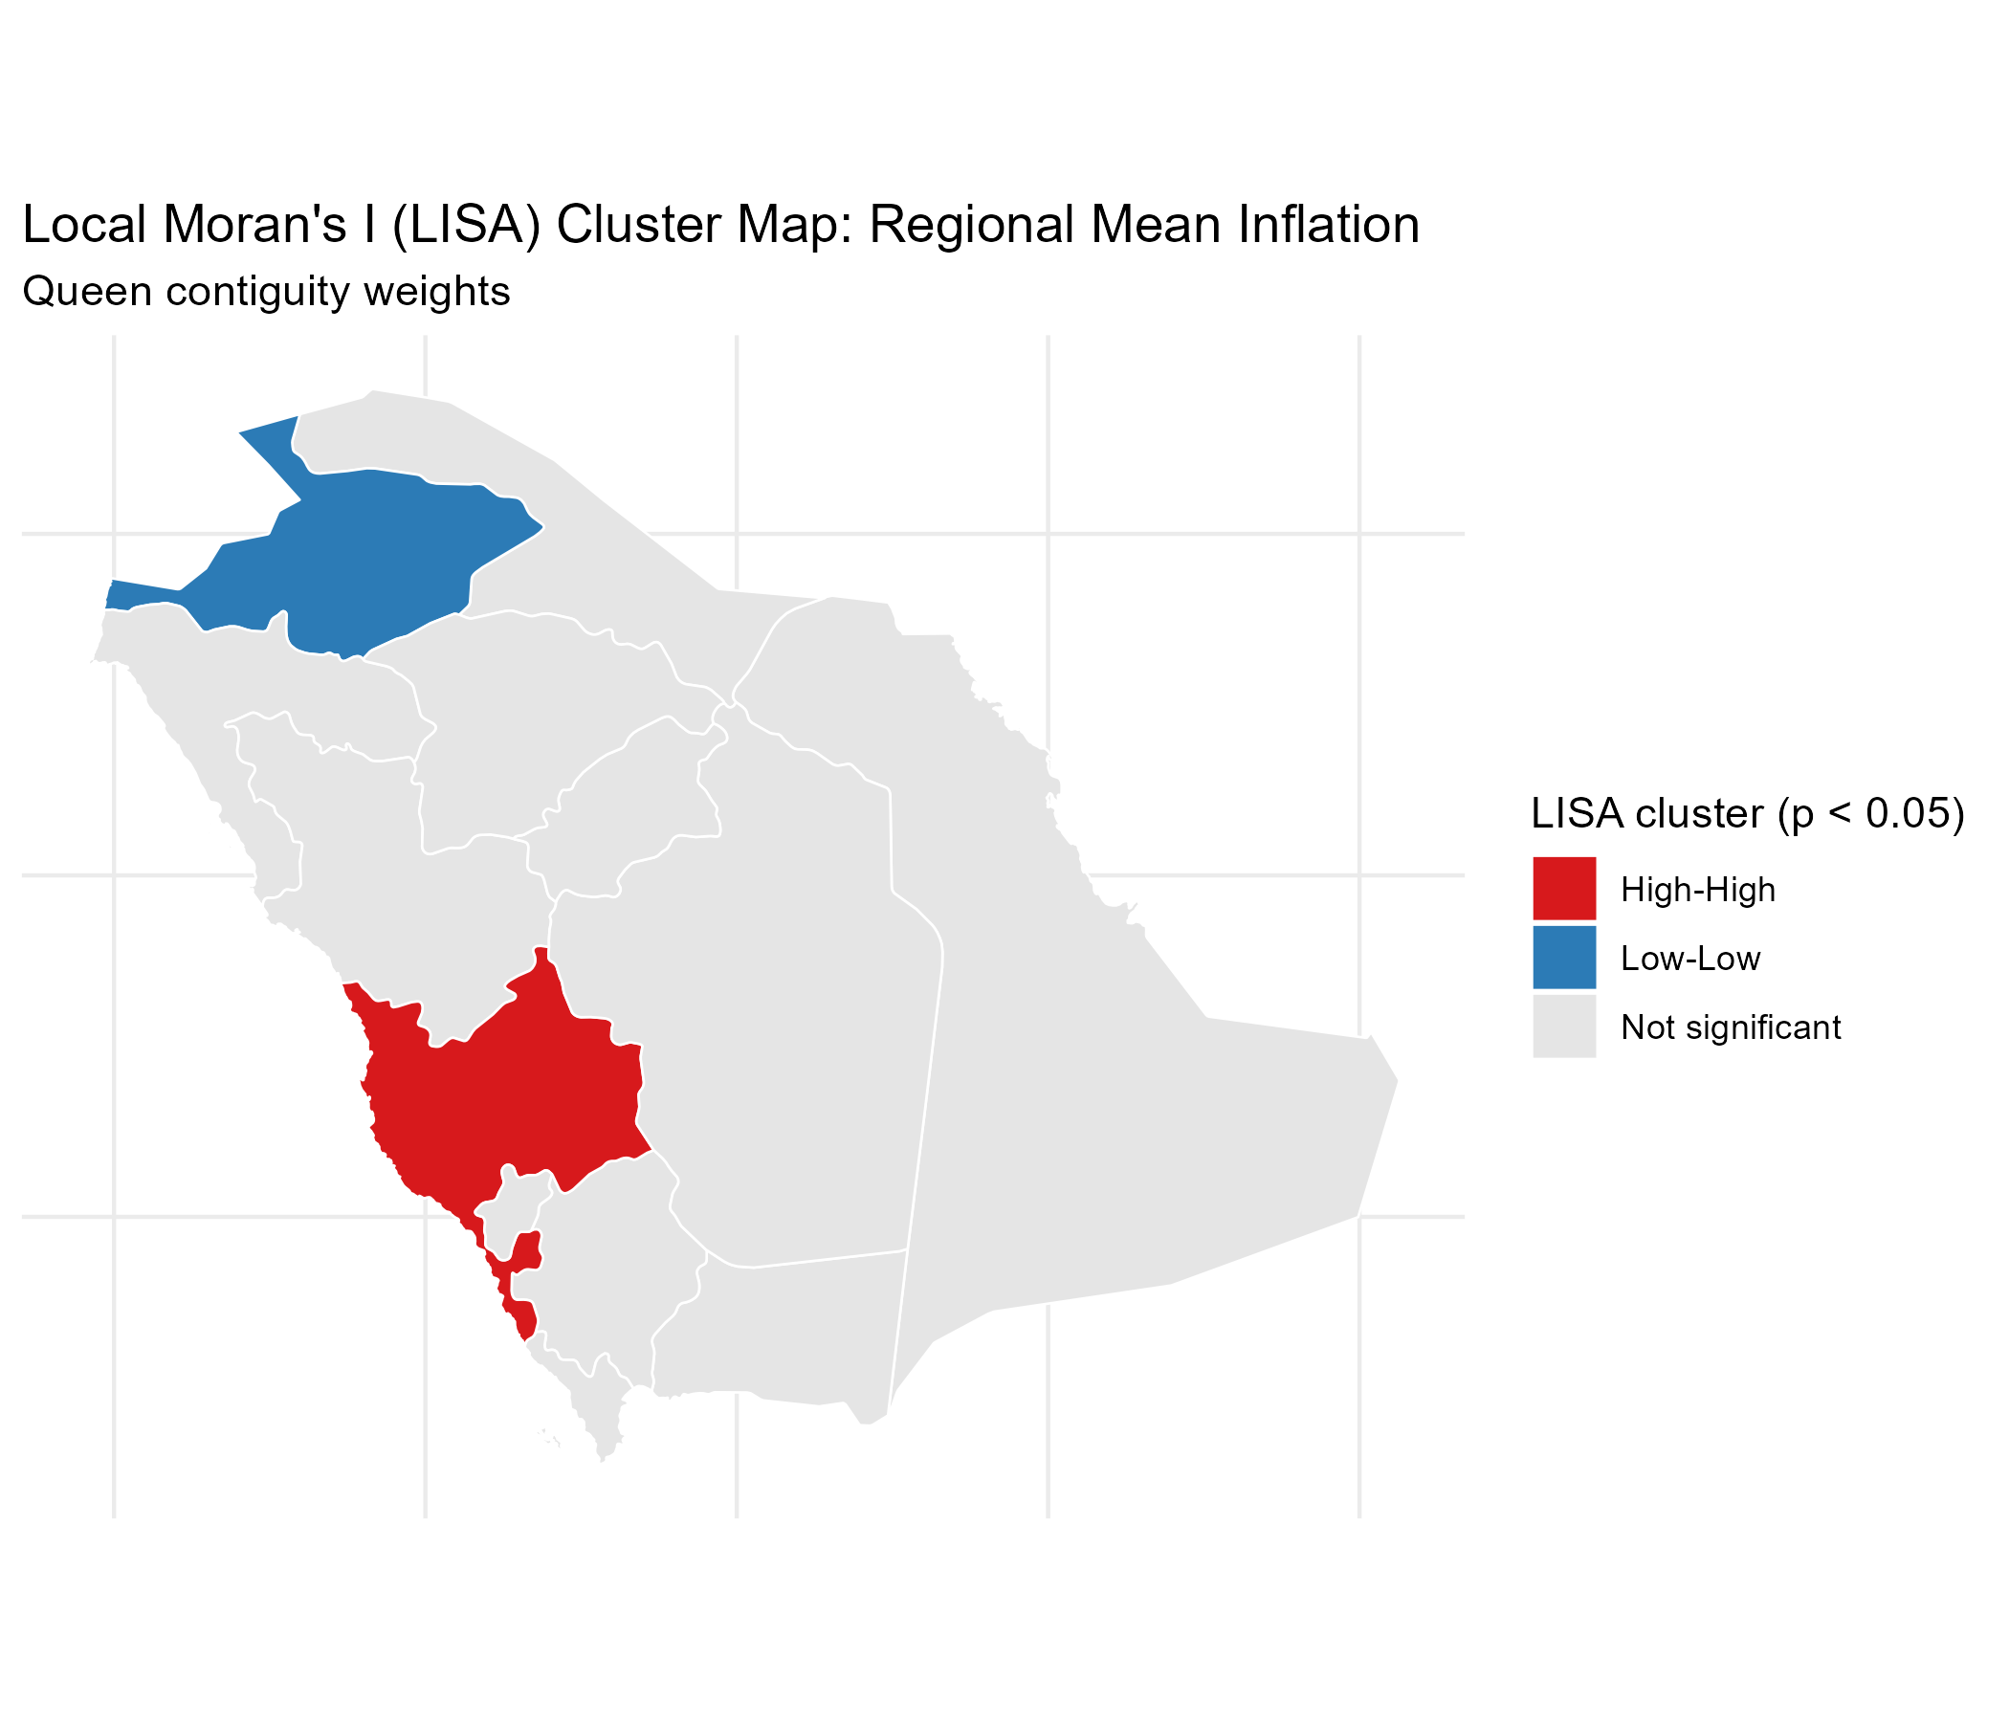
Figure A5: LISA cluster map of regional mean inflation (Queen contiguity, p < 0.05).
At the 5% significance level, 2 of the 13 regions form a statistically significant local cluster or spatial outlier; the remainder do not show a significant local pattern once tested individually. Given that each local test is based on a single neighbourhood within a 13-region map, these results should be read as exploratory/descriptive rather than confirmatory, and are reported without multiple-testing correction.
Economically, these two clusters have plausible (though untested) regional interpretations, offered here as they were in the original exploratory phase. The High-High cluster centred on Makkah may reflect the region’s distinctive demand structure tied to religious tourism (Hajj and Umrah), which generates strong, correlated price pressure in hospitality, transport, and retail sectors shared with neighbouring regions. The Low-Low cluster centred on Al Jawf may reflect the comparatively smaller, less commercially dense regional economies of Saudi Arabia’s northern periphery, which would be expected to see more muted and more similar price pressure than the country’s larger commercial and religious-tourism hubs. These interpretations are offered as plausible readings consistent with known regional economic structure, not as causal claims established by this analysis – and, per the main text, the confirmatory dynamic-panel analysis does not find evidence that either cluster reflects ongoing spatial transmission rather than shared exposure to common shocks.

Sensitivity Analysis (v1)
Three robustness questions are addressed here: (1) how much of the correlation and Moran’s I results are attributable to the two national VAT policy shock months rather than ongoing regional co-movement, (2) whether a single excluded month is wide enough given that VAT effects can plausibly persist for longer than one month, and (3) how sensitive is the Moran’s I result to the choice of spatial weights matrix (Queen contiguity was used throughout the analysis above). On point (2), the table below tests not just the single shock month but also a +/-1 month window, the calendar quarter starting at the shock, and a six-month window starting at the shock, for each VAT event individually and combined.
Scenario | N_months_excluded | Average_Correlation | Maximum_Correlation | Moran_I | Moran_p_value
Full Sample | 0 | 0.486 | 0.828 | 0.204 | 0.0460
Excl. Jan 2018 (month) | 1 | 0.535 | 0.822 | 0.119 | 0.1060
Excl. Jul 2020 (month) | 1 | 0.299 | 0.854 | 0.195 | 0.0526
Excl. Both (month) | 2 | 0.298 | 0.693 | 0.092 | 0.1440
Excl. Jan 2018 (+/-1 month) | 3 | 0.537 | 0.833 | 0.127 | 0.0931
Excl. Jul 2020 (+/-1 month) | 3 | 0.298 | 0.854 | 0.225 | 0.0359
Excl. Both (+/-1 month) | 6 | 0.298 | 0.692 | 0.153 | 0.0706
Excl. Jan 2018 (quarter) | 3 | 0.536 | 0.828 | 0.110 | 0.1140
Excl. Jul 2020 (quarter) | 3 | 0.300 | 0.857 | 0.211 | 0.0427
Excl. Both (quarter) | 6 | 0.301 | 0.686 | 0.108 | 0.1210
Excl. Jan 2018 (6 months) | 6 | 0.538 | 0.826 | 0.088 | 0.1420
Excl. Jul 2020 (6 months) | 6 | 0.304 | 0.856 | 0.218 | 0.0389
Excl. Both (6 months) | 12 | 0.302 | 0.680 | 0.124 | 0.1010
Table A3. Sensitivity of correlation and Moran’s I to the width of the excluded window around each VAT policy shock.
Excluding both shock months (January 2018 and July 2020 only) reduces the average pairwise regional correlation from 0.486 to 0.298 (a 38.7% reduction); widening the excluded window to six months gives a similar result (0.302), so this is not an artefact of the exact one-month cutoff. Across all 13 window specifications, Moran’s I clears the 5% threshold in 4 of them. Part of the correlation documented earlier is therefore attributable to the two shared VAT shocks rather than ongoing regional co-movement alone — though a meaningful common structure remains even after excluding them. (The main text’s Stage-16 confirmatory analysis formally tests these same two episodes, plus the 2015 energy-price reform, for associated parameter instability rather than correlation, and finds no robust evidence of either.)
Weight_Matrix | Avg_Neighbors | Moran_I | Z_value | P_value
Queen contiguity | 4.00 | 0.204 | 1.68 | 0.046
Rook contiguity | 4.00 | 0.204 | 1.68 | 0.046
K-nearest neighbours (k=4) | 4.00 | 0.071 | 0.99 | 0.161
Distance band | 4.15 | 0.014 | 0.56 | 0.287
Table A4. Global Moran’s I under alternative spatial weights matrices.
The Moran’s I statistic clears the 5% threshold under 2 of the 4 weight matrix specifications tested (Queen and Rook contiguity; not KNN or distance band). Table A4 is part of the frozen v1.0 exploratory baseline: its KNN and distance-band matrices use Euclidean distance on longitude/latitude degrees and are kept unchanged as a historical record (see baseline/v1.0/METHODOLOGY_NOTE.md, section 5).
A note on spatial regression (SAR/SEM): we also fitted intercept-only Spatial Lag and Spatial Error models as a further check. With no regional covariates in this dataset (no population, trade, or sectoral data) beyond CPI itself, these reduce to a statistical exercise rather than an explanatory economic model, and their likelihood-ratio test against OLS was not significant here. We therefore do not report them as a full result — a proper SAR/SEM belongs in future work once regional covariates are available to distinguish what the spatial dependence actually reflects.

Moran’s I Over Time (Exploratory)
The Global and Local Moran’s I results above are computed on each region’s mean inflation across the entire 2013-2026 sample, which collapses the time dimension into a single number per region. As an exploratory check (not a formal time-varying spatial model), we recompute Global Moran’s I separately using each calendar year’s regional mean inflation.
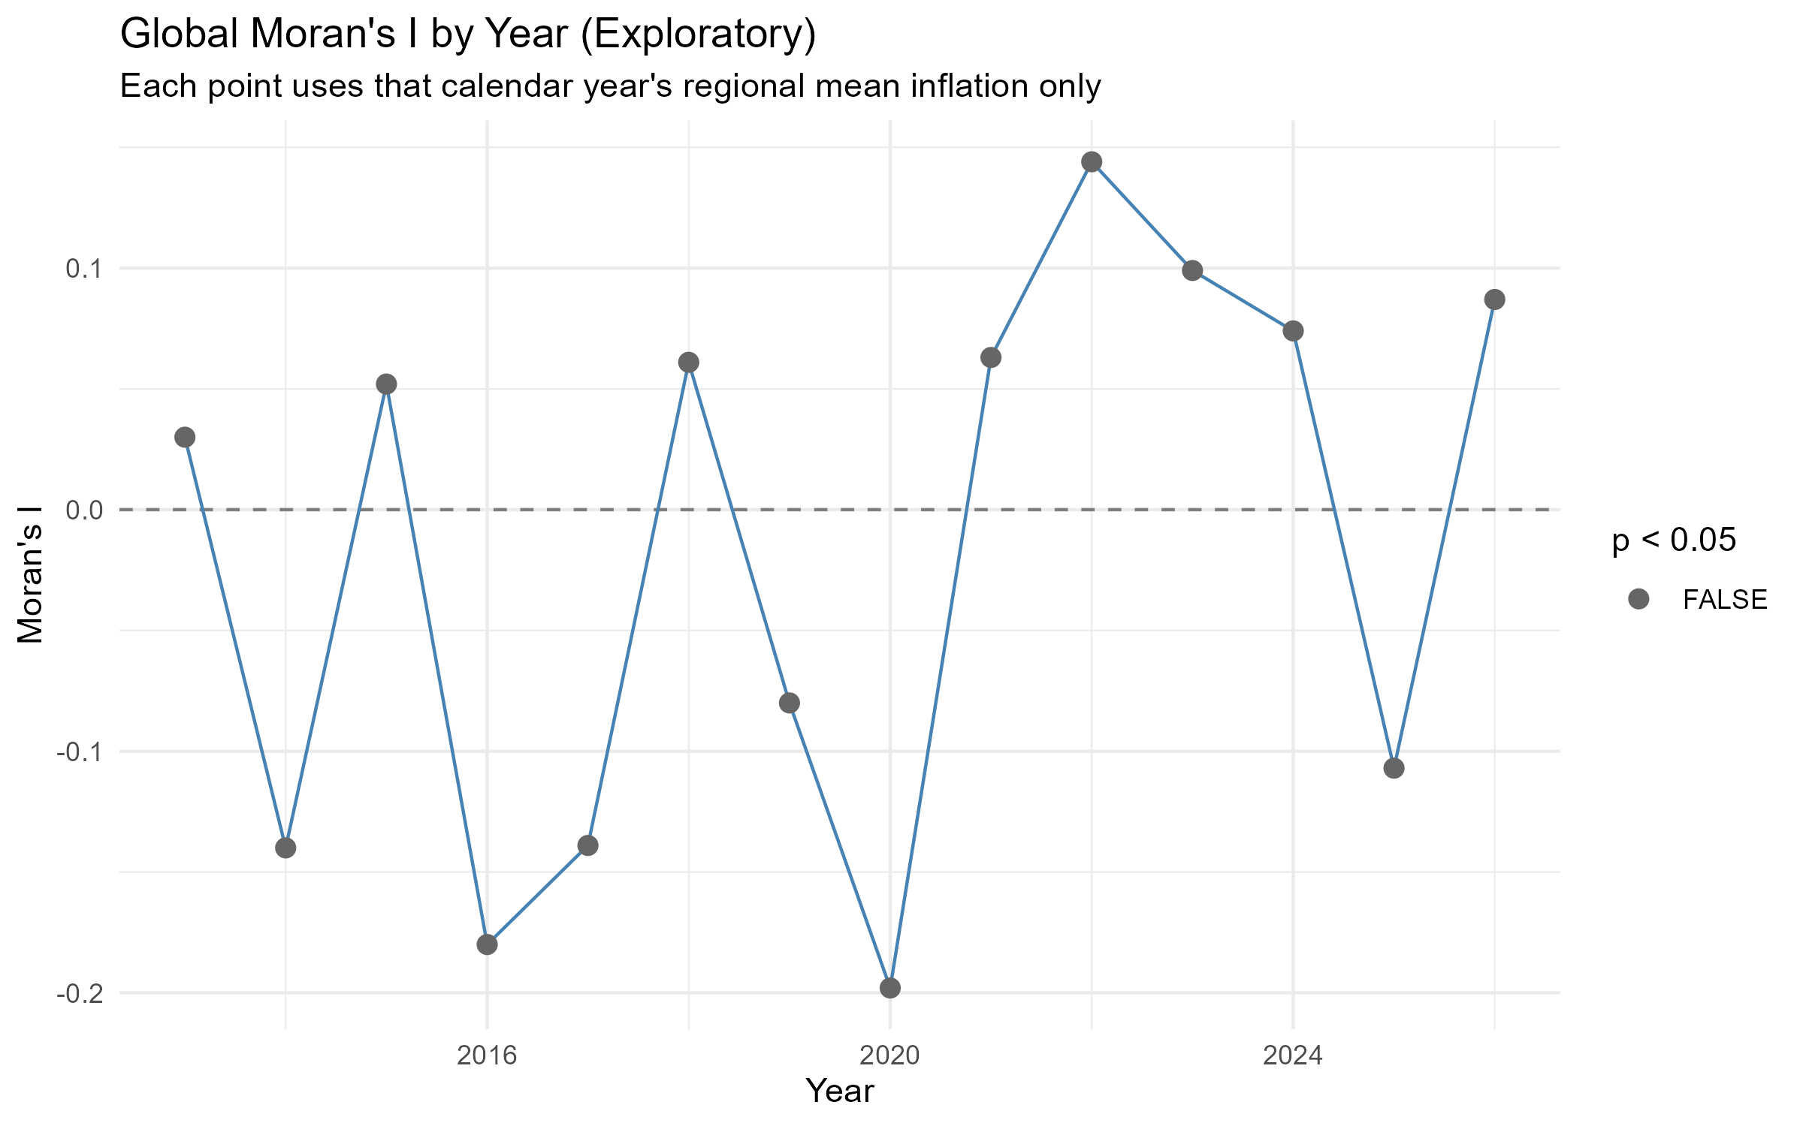
Figure A6: Global Moran’s I computed separately for each calendar year’s regional mean inflation (exploratory). Red points indicate p < 0.05 for that year.
Year | N_regions | Moran_I | P_value
2,013 | 13 | 0.030 | 0.0603
2,014 | 13 | -0.140 | 0.6330
2,015 | 13 | 0.052 | 0.1200
2,016 | 13 | -0.180 | 0.7240
2,017 | 13 | -0.139 | 0.6740
2,018 | 13 | 0.061 | 0.1950
2,019 | 13 | -0.080 | 0.4930
2,020 | 13 | -0.198 | 0.7550
2,021 | 13 | 0.063 | 0.1690
2,022 | 13 | 0.144 | 0.0829
2,023 | 13 | 0.099 | 0.0527
2,024 | 13 | 0.074 | 0.1660
2,025 | 13 | -0.107 | 0.5580
2,026 | 13 | 0.087 | 0.1450
Table A5. Global Moran’s I by calendar year (exploratory).
Moran’s I fluctuates in sign and magnitude across years, reaching conventional significance (p < 0.05) in 0 of 14 individual years. This should be read with one important caveat: each year’s test uses only 13 regional observations, so its statistical power to detect a true spatial pattern is low. The absence of a significant result in a given year is therefore not evidence that no spatial pattern existed that year — only that a 13-region test could not reliably detect one at that scale. The main text’s monthly-resolution, multiply-corrected Stage-12 test (157 months, pooling far more information than a year-by-year split) supersedes this exploratory check.
Taken together, the checks in this appendix (Monte Carlo, alternative weights, wider VAT-exclusion windows, and the year-by-year breakdown) were, at the time of the original exploratory analysis, read as pointing toward a real but modest full-sample spatial pattern. The main text’s confirmatory dynamic-panel sequence (Stages 9-18) tested this far more rigorously – month by month, at multiple lag horizons, with multiple-testing correction, and with a full robustness battery – and found that this pattern does not constitute robust spatial predictive dependence. The correlation and LISA findings above remain valid descriptive facts about the data; their interpretation as evidence of regional spatial interaction is superseded by the main text.

Economic Interpretation (v1, superseded — see main text Discussion)
The paragraphs below are the original v1 economic interpretation, retained for transparency. The main text’s Discussion section, informed by the full confirmatory analysis, is the paper’s authoritative interpretation.
The findings suggest that inflation dynamics in Saudi Arabia are shaped by both national and regional forces.
The relatively high inter-regional correlations point to common macroeconomic drivers — oil price movements, monetary policy, and imported inflation — reinforced by shared national fiscal shocks such as the 2018 and 2020 VAT changes, which alone account for part of the correlation documented above. Superimposed on this national layer, the LISA results point to two more local, structural stories: Makkah’s High-High cluster is consistent with religious-tourism demand pressure spilling into neighbouring markets, while Al Jawf’s Low-Low cluster is consistent with the more muted demand conditions typical of the northern periphery. Together these suggest that regional inflation in Saudi Arabia is best understood as shared national shocks landing on a map of otherwise fairly heterogeneous local economies, rather than as regions actively transmitting inflation to one another — a reading fully consistent with, and now confirmed by, the main text’s dynamic-panel findings.
This dual structure implies that while national policies are effective in maintaining overall price stability, regional disparities persist due to structural differences in local economies.

Appendix B: Simulation-Based Power / Minimum-Detectable-Effect Analysis
This is a design-sensitivity analysis, not a new empirical finding. It does not re-estimate, reinterpret, or alter any Stage 14-18 result reported in the main text; it answers a different question: given this study’s sample (N=13, T=154), the observed Queen spatial-weight structure, the locked Stage-14 K=3 specification, and the observed residual dependence, what magnitude of cumulative three-month spatial predictive effect (Theta_3 = theta_1+theta_2+theta_3) could this design plausibly have detected? Full script: scripts/20_power_mde_presubmission.R. Full narrative report: results_v2/presubmission_refinement/power_mde/POWER_MDE_REPORT.md.

Design
Table B1. Simulation design (pre-specified before any replication was run).
Parameter | Value
Estimand | Theta_3 = theta_1+theta_2+theta_3 (cumulative 3-month spatial predictive effect)
Effect-size grid (pre-specified) | -0.2, -0.15, -0.1, -0.075, -0.05, -0.025, 0, 0.025, 0.05, 0.075, 0.1, 0.15, 0.2
Primary lag-shape | Equal: theta_k = Theta_3/3 for k=1,2,3
Secondary lag-shape | Front-loaded: theta = Theta_3 x (0.6, 0.3, 0.1)
DGP | Fixed-regressor (observed own/spatial lags, region/month FE); y* = fitted(restricted model) + true spatial effect + moving-block-bootstrapped residual
Primary block length | 6 months (~T^(1/3)=5.36)
Block-length sensitivity | 12 months, reduced grid (-0.2, -0.1, 0, 0.1, 0.2), R=500
Primary replications per point | 2000
Secondary-shape replications per point | 1000
Block-sensitivity replications per point | 500
Primary inference rule | Driscoll-Kraay joint Wald test (vcovPL, Bartlett, NW1987), same as Stage 14/18 primary inference
Validation inference rule | Wild cluster bootstrap, B=199, at Theta_3 in {0, 0.1, 0.2}
Validation replications | 100
Seed | 20260921
Data-generating process (fixed-regressor design): own-lag and spatial-lag regressor values are held at their values actually observed in the locked K=3 estimation sample (region and month fixed effects included). The simulated outcome is $y_{it}^{*}={\hat{y}}_{it}^{ 0}+θ_{1}Wπ_{i,t−1}+θ_{2}Wπ_{i,t−2}+θ_{3}Wπ_{i,t−3}+e_{it}^{*}$, where ${\hat{y}}^{ 0}$ is the fitted value from the restricted (no-spatial-lag) model and $e^{*}$ is a residual draw from a moving-block bootstrap of that restricted model’s observed residuals (block length 6 months primary, preserving observed cross-sectional dependence within each monthly block and short-range temporal dependence within each 6-month block; 12 months tested as a sensitivity). This is a standard, documented simplification relative to a fully recursive dynamic re-simulation of the panel – stated explicitly, not hidden.
Inference: the primary rejection rule is the same Driscoll-Kraay joint Wald test used throughout Stages 14-18 (running a full B=9999 wild-cluster bootstrap inside thousands of replications is not computationally tractable). This choice is validated, not merely assumed: at 3 selected effect sizes, DK-based and nested-wild-cluster-bootstrap-based (B=199) rejection rates were compared directly.

Validation: DK asymptotic vs. nested wild-cluster bootstrap
Table B2. DK-based vs. wild-cluster-bootstrap-based power, 3 selected effect sizes.
Theta_3 | n_reps | wcb_B | power_DK | power_WCB | agreement_within_2SE
0.0 | 100 | 199 | 0.07 | 0.10 | TRUE
0.1 | 100 | 199 | 0.18 | 0.20 | TRUE
0.2 | 100 | 199 | 0.52 | 0.45 | TRUE
All three checked points agree within 2 Monte Carlo standard errors, supporting the use of the (far cheaper) DK-based rule as the primary simulation inference rule for the full grid.

Power curve
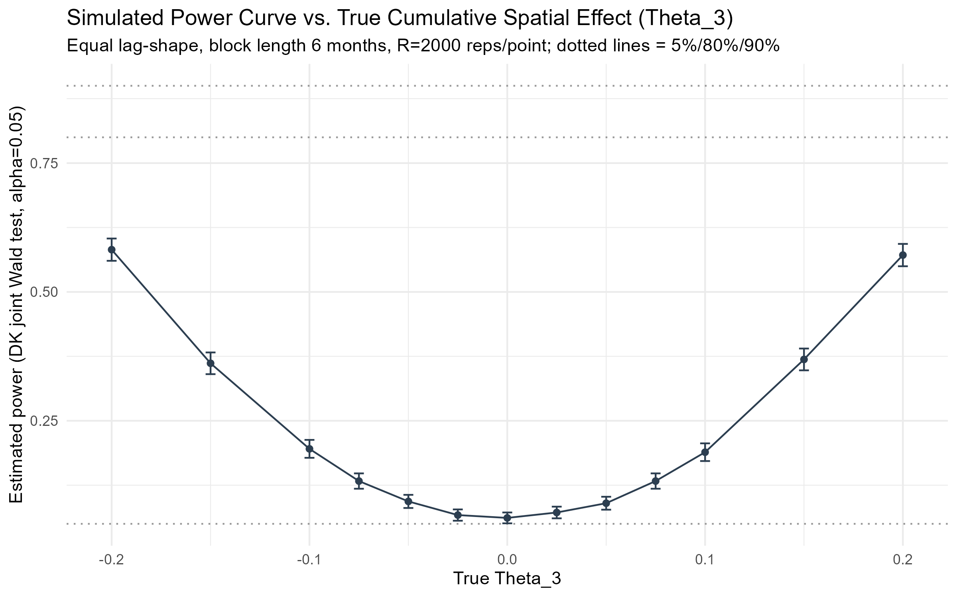
Figure B1. Simulated power vs. true cumulative spatial effect (Theta_3), primary design.
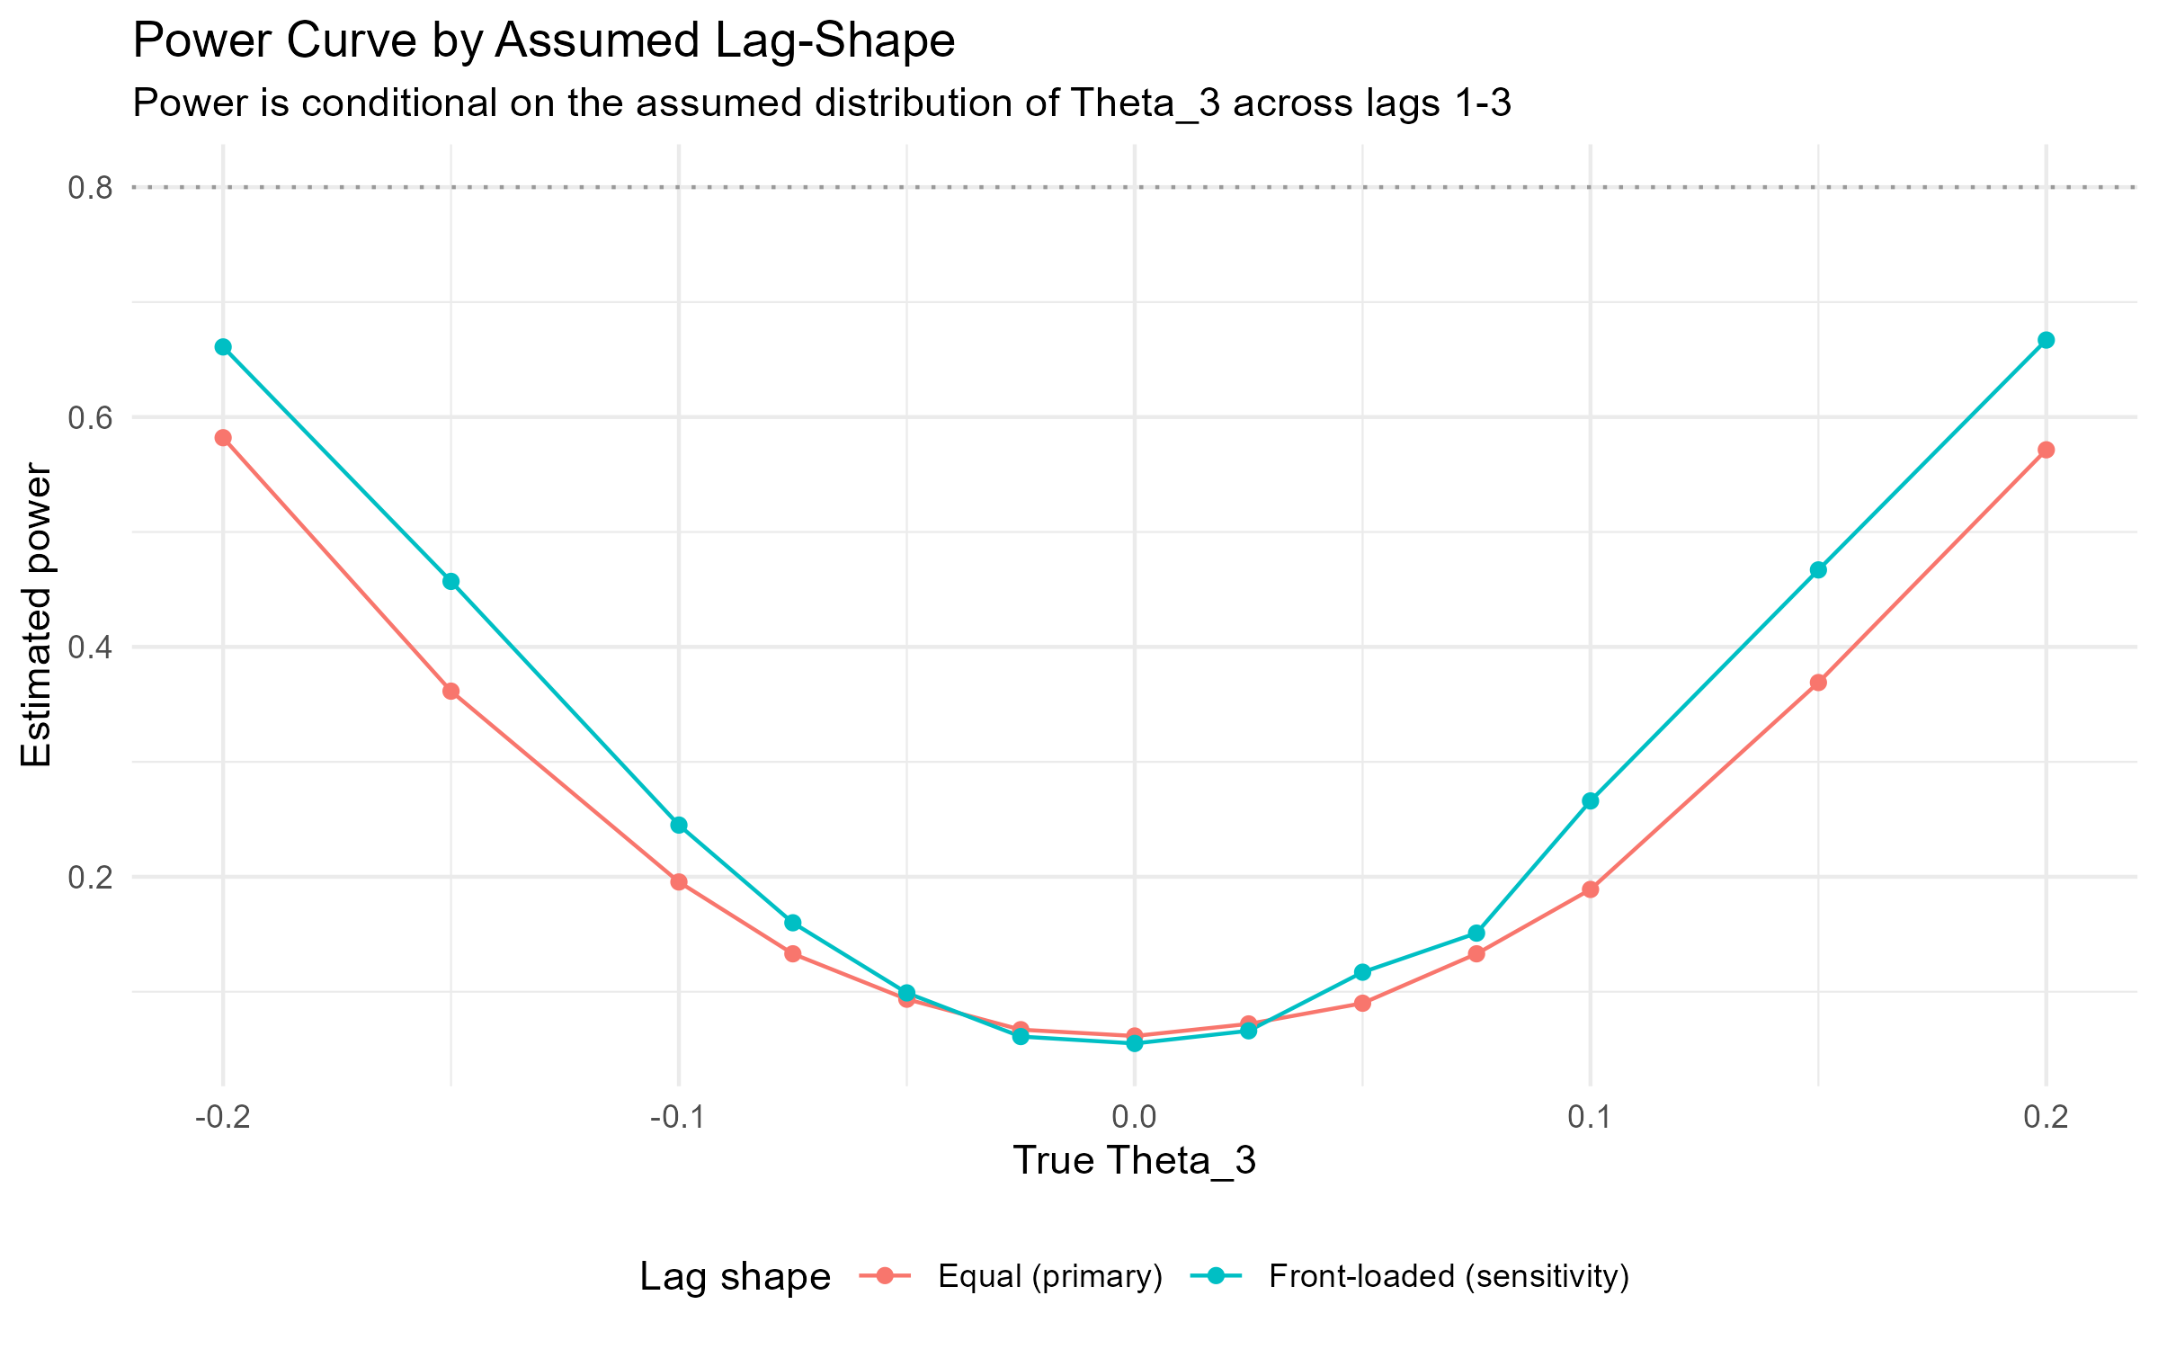
Figure B2. Power curve by assumed lag-shape (equal vs. front-loaded) – power is conditional on this assumption.
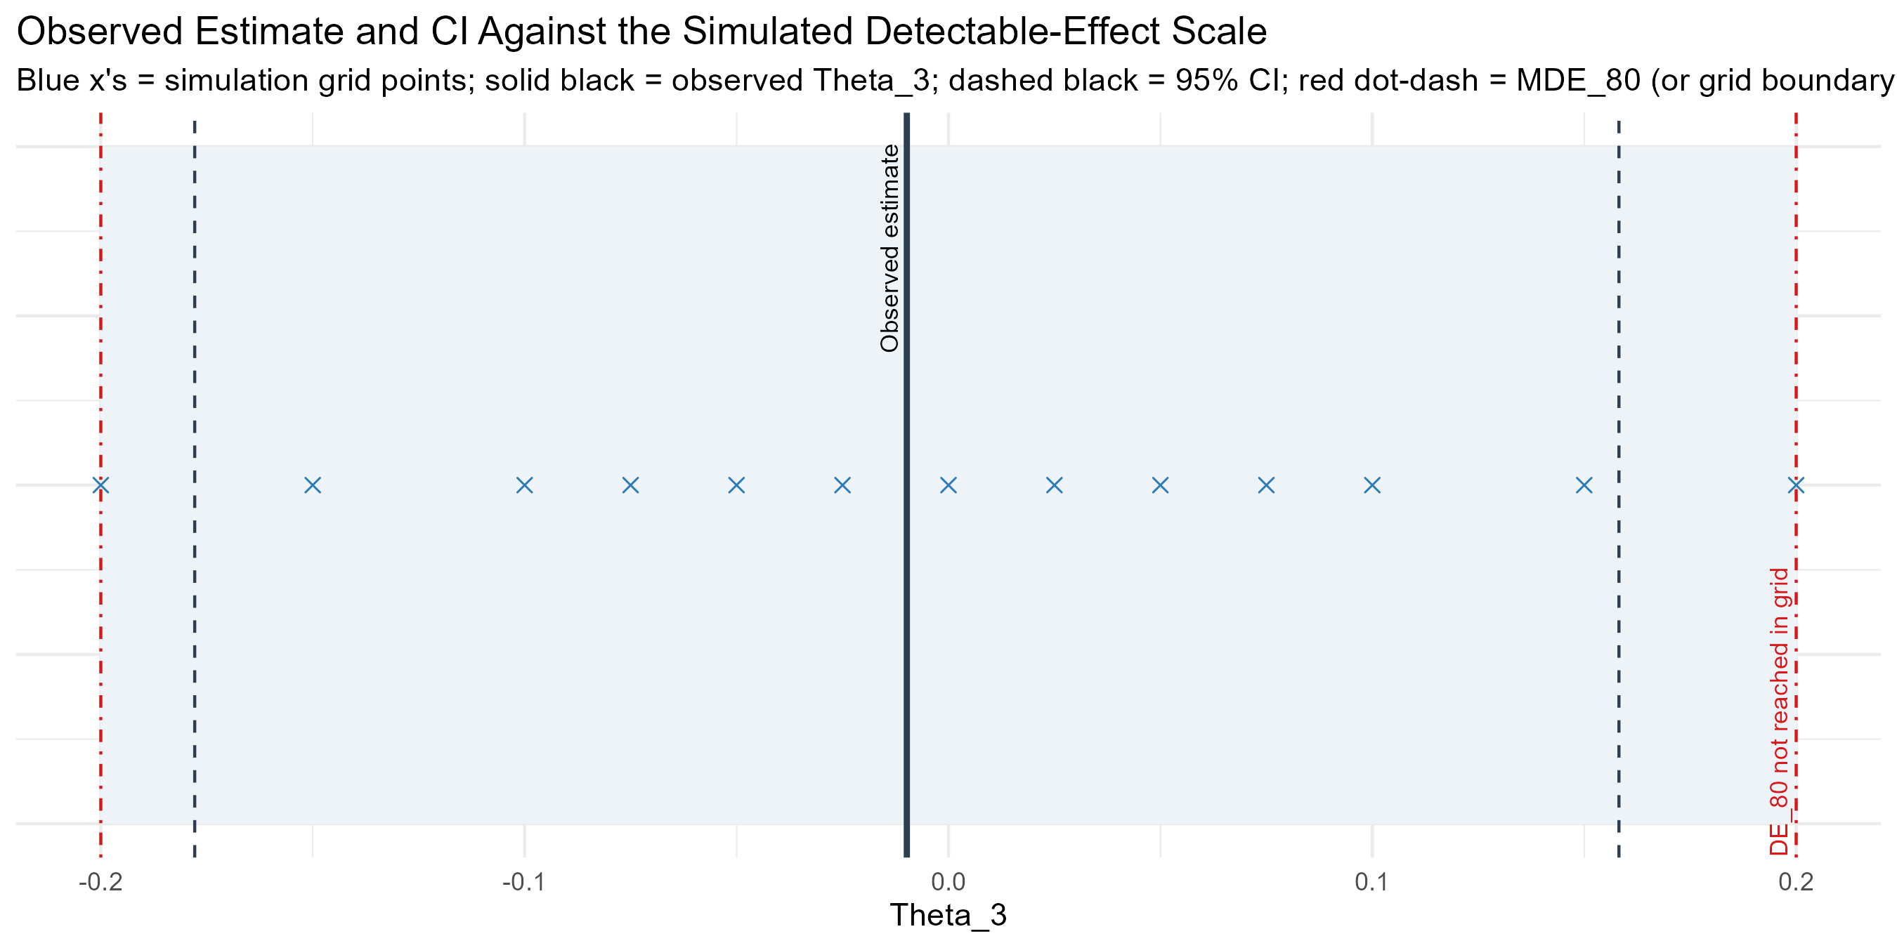
Figure B3. Observed estimate and 95% CI placed against the simulated detectable-effect scale.
Table B3. Full power curve: primary, front-loaded-shape sensitivity, and block-length sensitivity.
Theta_3 | lag_shape | block_len | n_reps | power | mc_se
-0.200 | Equal (primary) | 6 | 2000 | 0.5820 | 0.0110
-0.150 | Equal (primary) | 6 | 2000 | 0.3615 | 0.0107
-0.100 | Equal (primary) | 6 | 2000 | 0.1955 | 0.0089
-0.075 | Equal (primary) | 6 | 2000 | 0.1330 | 0.0076
-0.050 | Equal (primary) | 6 | 2000 | 0.0935 | 0.0065
-0.025 | Equal (primary) | 6 | 2000 | 0.0670 | 0.0056
0.000 | Equal (primary) | 6 | 2000 | 0.0615 | 0.0054
0.025 | Equal (primary) | 6 | 2000 | 0.0720 | 0.0058
0.050 | Equal (primary) | 6 | 2000 | 0.0900 | 0.0064
0.075 | Equal (primary) | 6 | 2000 | 0.1330 | 0.0076
0.100 | Equal (primary) | 6 | 2000 | 0.1890 | 0.0088
0.150 | Equal (primary) | 6 | 2000 | 0.3690 | 0.0108
0.200 | Equal (primary) | 6 | 2000 | 0.5715 | 0.0111
-0.200 | Front-loaded (sensitivity) | 6 | 1000 | 0.6610 | 0.0150
-0.150 | Front-loaded (sensitivity) | 6 | 1000 | 0.4570 | 0.0158
-0.100 | Front-loaded (sensitivity) | 6 | 1000 | 0.2450 | 0.0136
-0.075 | Front-loaded (sensitivity) | 6 | 1000 | 0.1600 | 0.0116
-0.050 | Front-loaded (sensitivity) | 6 | 1000 | 0.0990 | 0.0094
-0.025 | Front-loaded (sensitivity) | 6 | 1000 | 0.0610 | 0.0076
0.000 | Front-loaded (sensitivity) | 6 | 1000 | 0.0550 | 0.0072
0.025 | Front-loaded (sensitivity) | 6 | 1000 | 0.0660 | 0.0079
0.050 | Front-loaded (sensitivity) | 6 | 1000 | 0.1170 | 0.0102
0.075 | Front-loaded (sensitivity) | 6 | 1000 | 0.1510 | 0.0113
0.100 | Front-loaded (sensitivity) | 6 | 1000 | 0.2660 | 0.0140
0.150 | Front-loaded (sensitivity) | 6 | 1000 | 0.4670 | 0.0158
0.200 | Front-loaded (sensitivity) | 6 | 1000 | 0.6670 | 0.0149
-0.200 | Equal (block-length sensitivity) | 12 | 500 | 0.5780 | 0.0221
-0.100 | Equal (block-length sensitivity) | 12 | 500 | 0.1940 | 0.0177
0.000 | Equal (block-length sensitivity) | 12 | 500 | 0.0600 | 0.0106
0.100 | Equal (block-length sensitivity) | 12 | 500 | 0.1580 | 0.0163
0.200 | Equal (block-length sensitivity) | 12 | 500 | 0.5740 | 0.0221

MDE and power classification
Table B4. Minimum-detectable-effect (MDE) summary.
quantity | value
MDE_80 (simulated, primary curve) | NA
MDE_90 (simulated, primary curve) | NA
MDE_80 (analytic sanity check) | 0.2402
MDE_90 (analytic sanity check) | 0.2779
Max power achieved within the pre-specified grid (|Theta_3|<=0.20) | 0.5768
Observed Theta_3 estimate (Stage 18, locked) | -0.0098
Observed Theta_3 DK SE (Stage 18, locked) | 0.0857
Power classification: P3: Low power even for moderate effects. Estimated power never exceeds 57.7% anywhere within the pre-specified grid (|Theta_3| up to 0.20, the largest magnitude tested); MDE_80 and MDE_90 were therefore not reached within the simulated range, and are NOT extrapolated beyond it (extending the grid after seeing this would itself be a form of specification search this analysis is designed to avoid). An analytic single-parameter sanity check, using the LOCKED observed Driscoll-Kraay standard error for the cumulative effect (Stage 18), gives an approximate MDE_80 around 0.24 and MDE_90 around 0.28 – consistent with, and corroborating, the simulation’s conclusion that the pre-specified grid did not reach 80% power. This analytic figure is a sanity check only and is not a substitute for the simulation result.

What this does, and does not, imply for the main-text finding
- Does not imply: that the null/weak spatial result in the main text is “strong” evidence of zero spatial dependence – it is not automatically treated as such.
- Does imply: this design has limited power to detect small spatial effects, and adequate-but-not-complete power for moderate-to-large ones (the largest tested effect, |Theta_3|=0.20, was detected only 57.7% of the time). Small spatial effects cannot be ruled out by this study.
- Does not imply: that a larger true effect is likely – the analysis says nothing about which true effect size is more probable, only what this design could detect if one were present.

Limitations of this power analysis
- Fixed-regressor design (see above) rather than a fully recursive dynamic re-simulation.
- Moving-block-bootstrap residuals approximate, but do not perfectly reproduce, the true (unknown) dependence structure of the actual error process.
- The DK-vs-WCB validation used a modest sample (100 replications x 3 effect sizes); Table B2 reports the associated Monte Carlo uncertainty.
- Power is estimated only at the pre-specified grid points; MDE values are linearly interpolated between them, not separately simulated.
- This analysis assumes the same K=3 horizon and Queen weight structure as the locked design; it was not extended to K=6, alternative weights, or nonlinear specifications, consistent with this stage’s guardrail against reopening Stages 14-18.

