# **MIU-Seminar-2025-05-Homework1**

**Leonardo Medina #619571**

# **Requirements**

1. Set up an AWS Free Tier Account:

* If you haven’t done so, create an AWS Free Tier account at AWS Sign-Up.
* Use an email not associated with another AWS account.

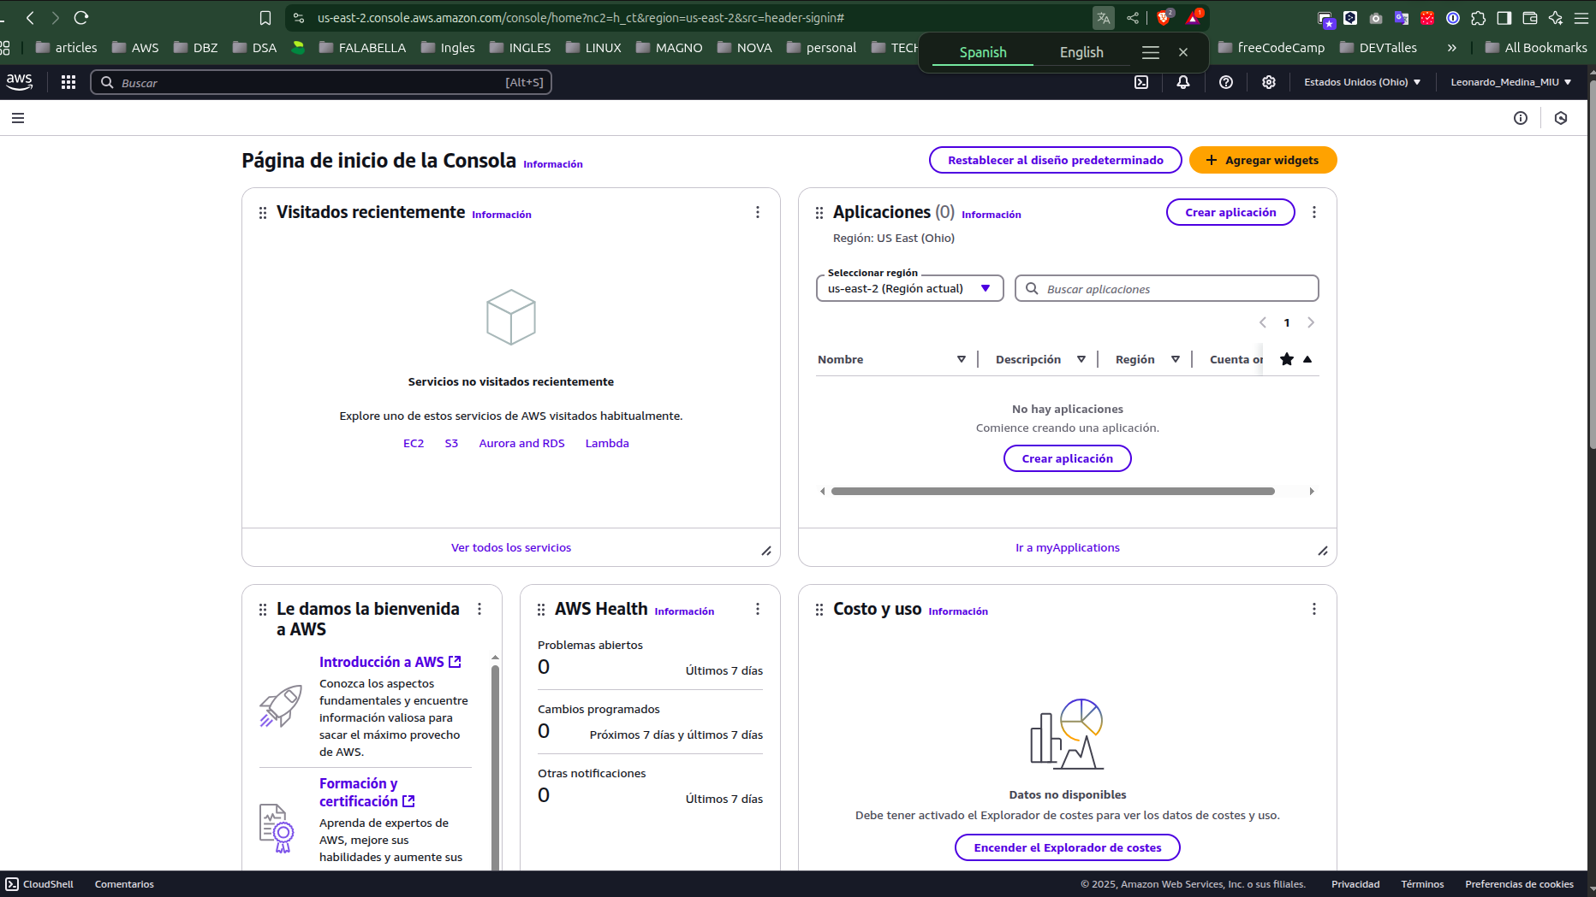

2. Add MFA for the root account:

* Go to: AWS Console → IAM → Security Credentials.
* Enable MFA: Choose "Virtual MFA" and use Google Authenticator/Authy.
* Take a screenshot of the MFA setup confirmation.

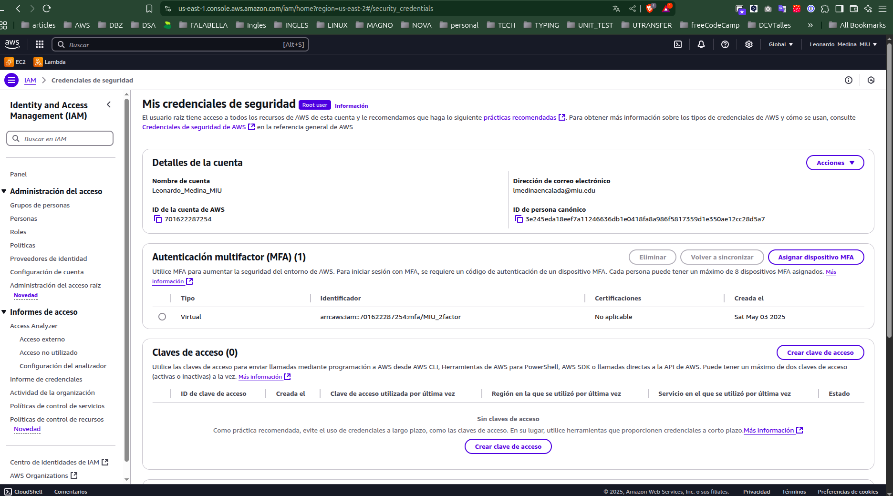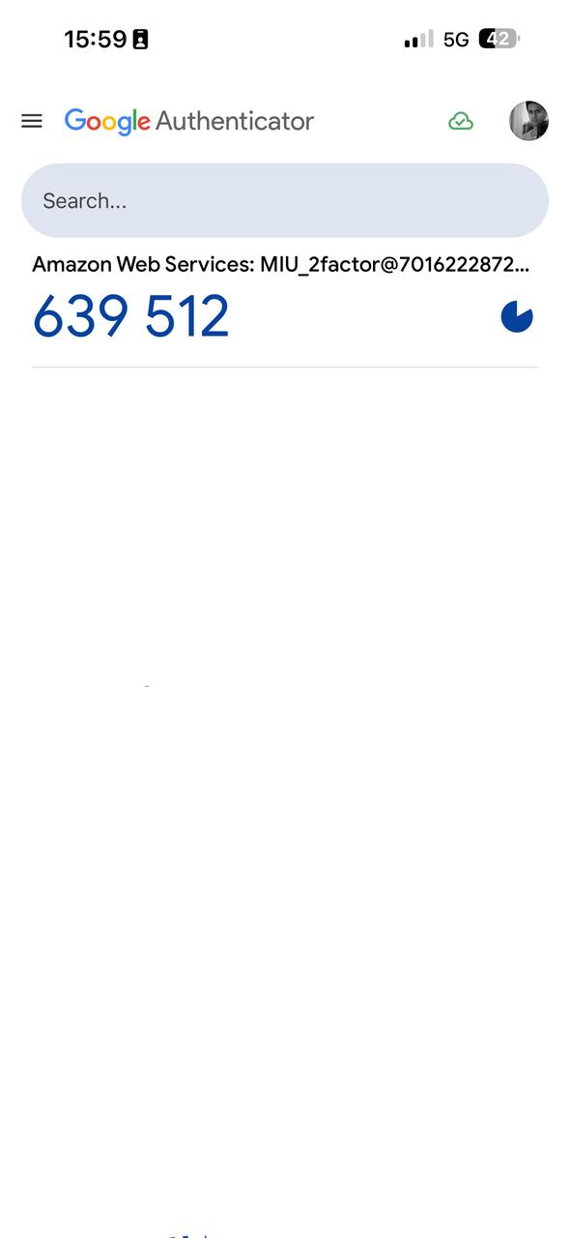

3. Create another account and work in this account from now on:

* Go to: IAM → Users → Add User.
* Username: your-name-id.
* Attach Policy: AdministratorAccess.
* Set Console Access: Enable sign-in for this user.
* Log out from the root account and only use this IAM user from now on.
* Take a screenshot of the IAM user list.

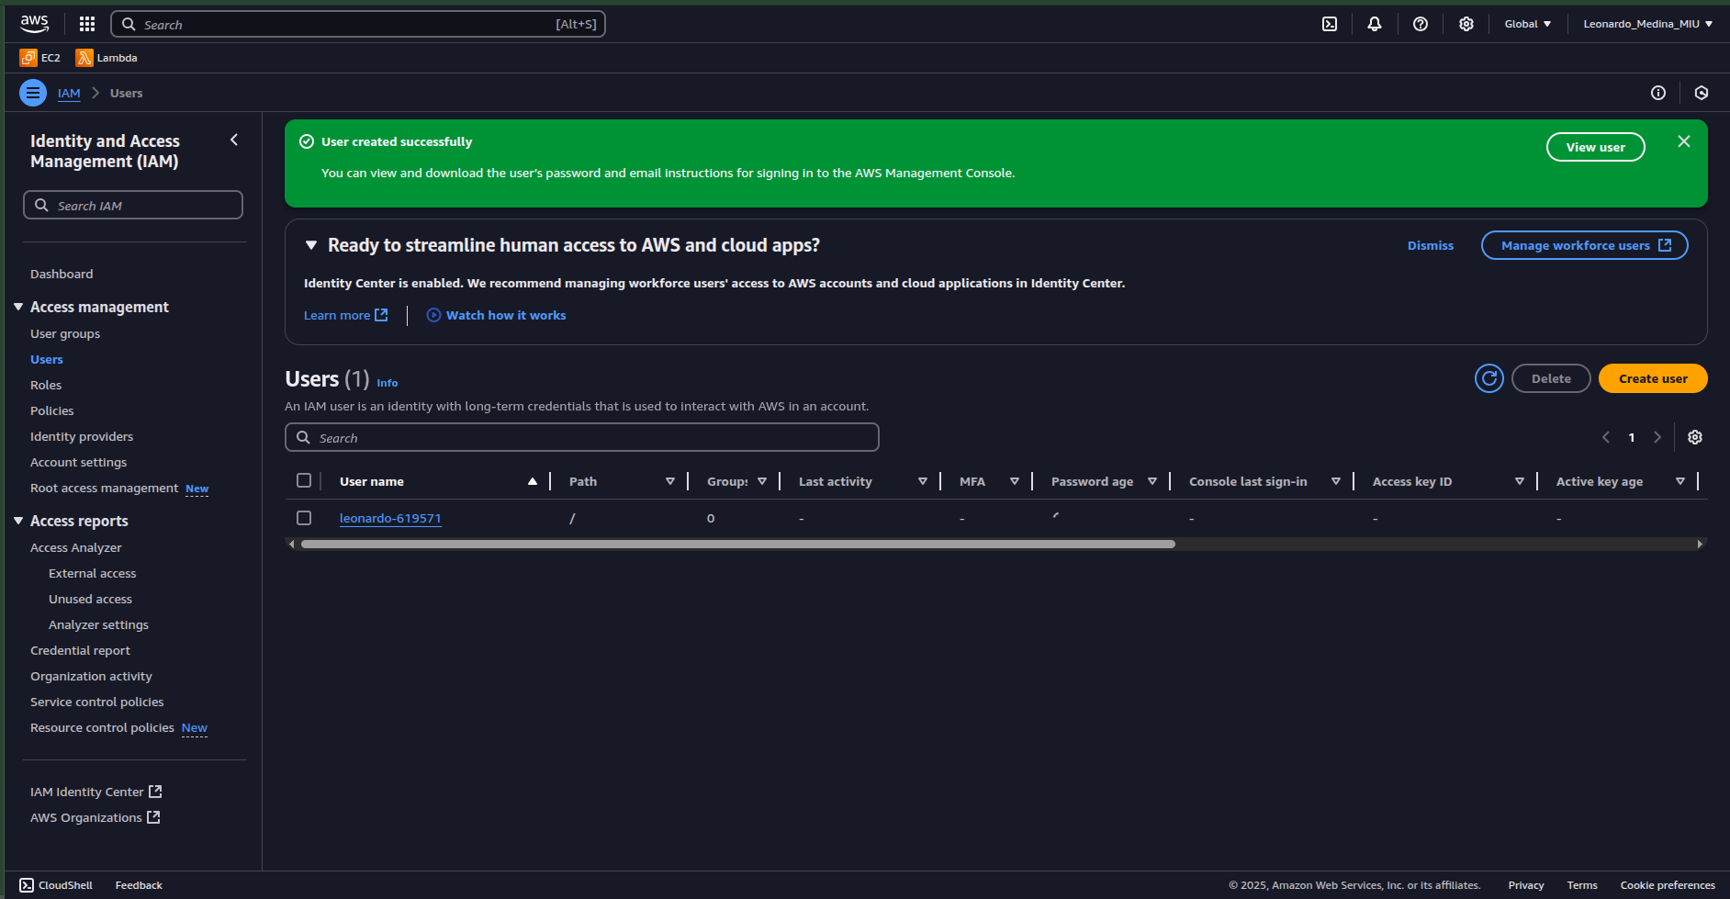

4. Use your root account to create Billing Alert:

* Go to: Billing Dashboard → Preferences.
* Enable billing alerts and set up an email notification.
* Take a screenshot of the billing alert settings.

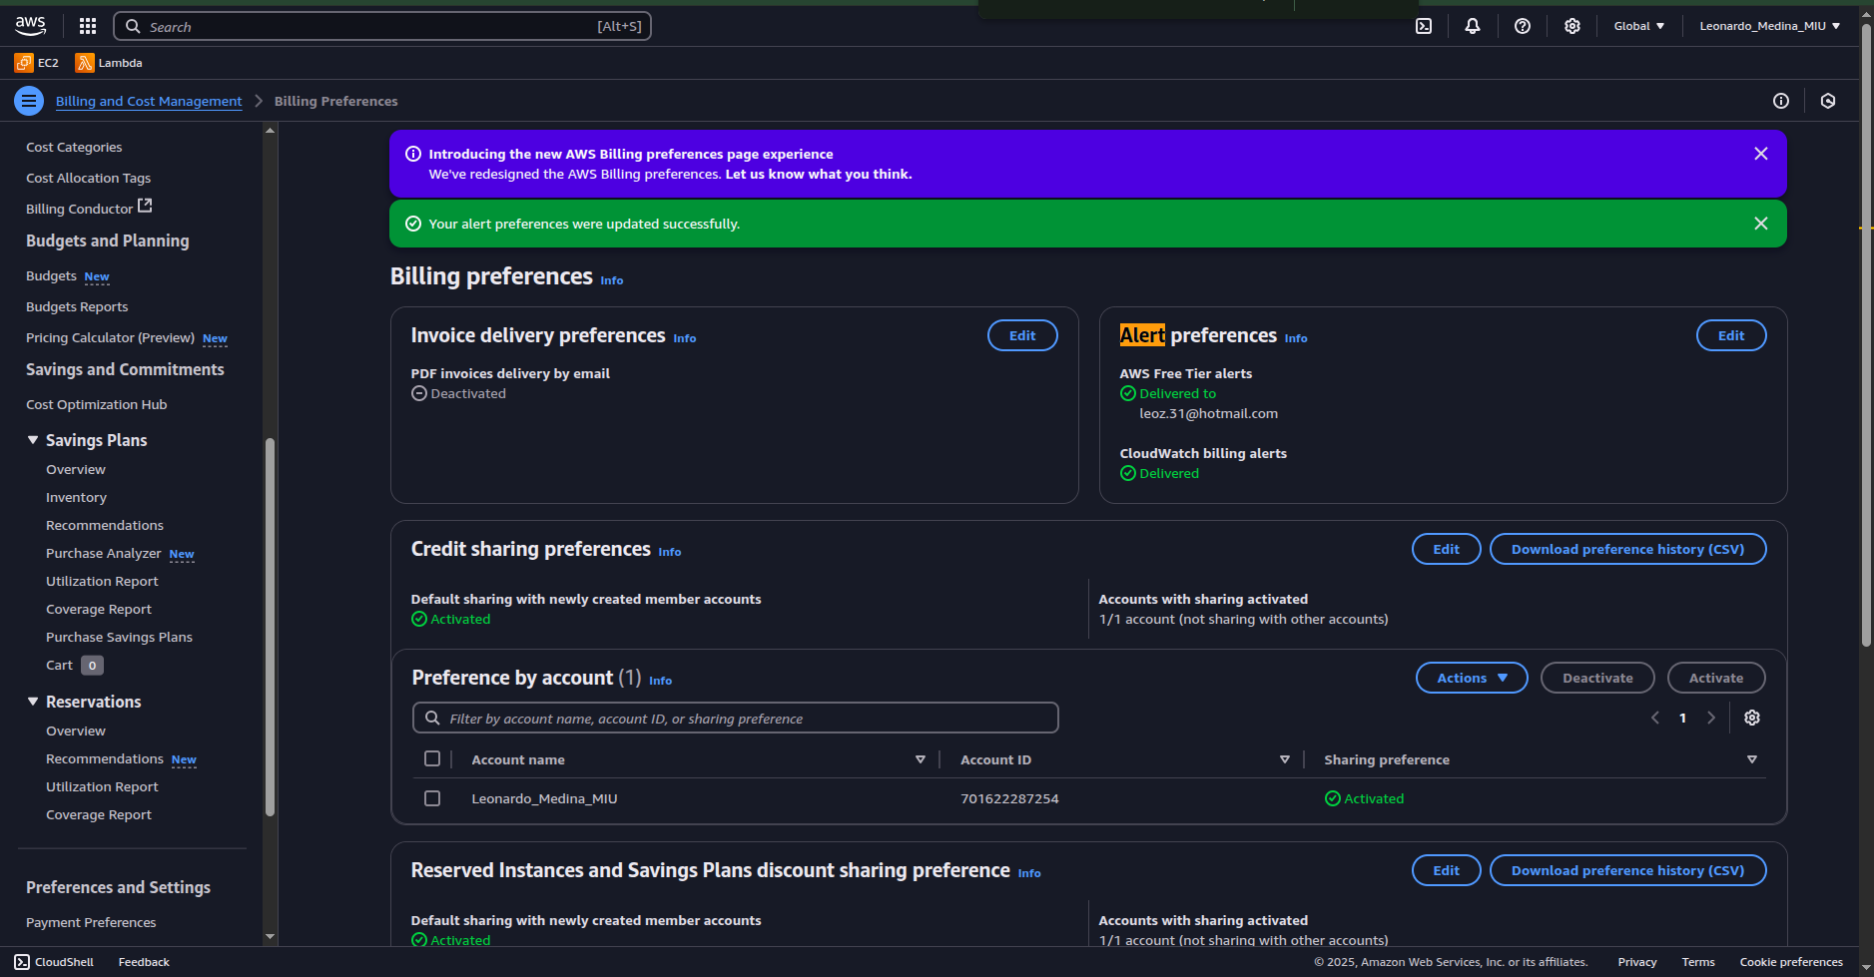

5. Use your root account to create Budget Alert:

* Go to: AWS Budgets → Create Budget.
* Type: Cost Budget.
* Threshold: $1 (or Free Tier limit).
* Notification: Send email alerts when spending approaches the limit.
* Take a screenshot of the budget alert setup.

