Leonardo Medina #619571

\* VPC

\* Subnets

\* Route Table

\* Internet Gateway

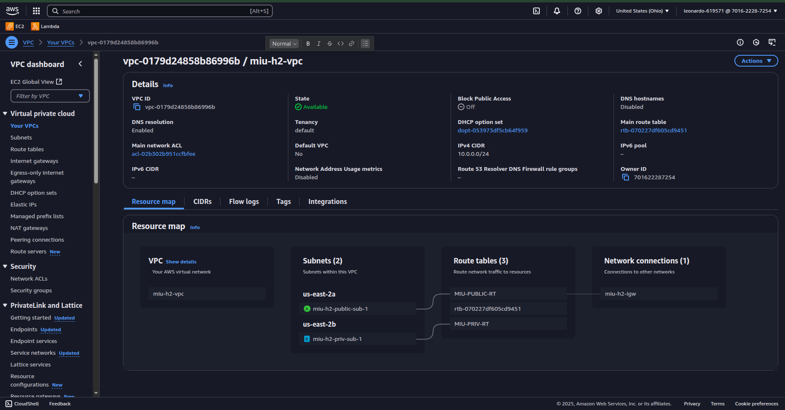

\* EC2 instance

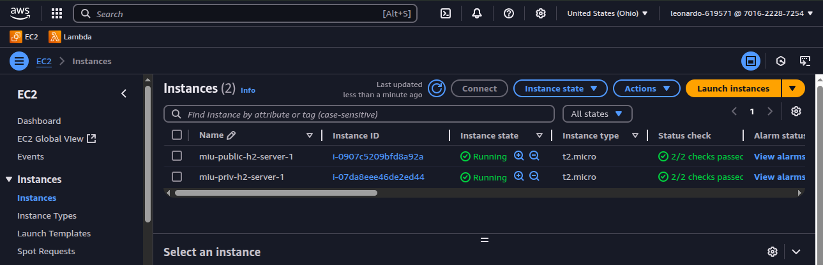

\* Connections to EC2 using SSH

Public server  
  
Public server connected to a private subnet

