1. RDS MySQL Queries.  
   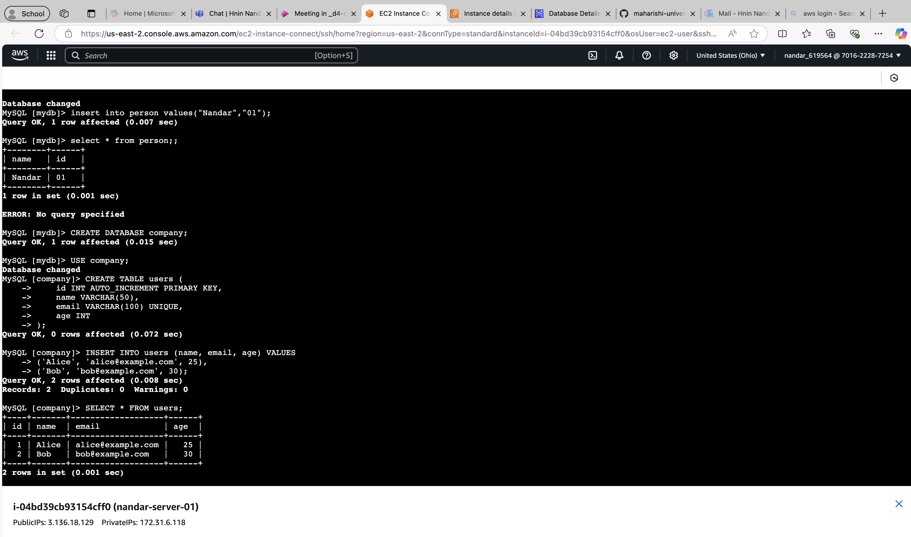
2. DocumentDB MongoDB Queries.

