* Create and deploy AWS Lambda functions.

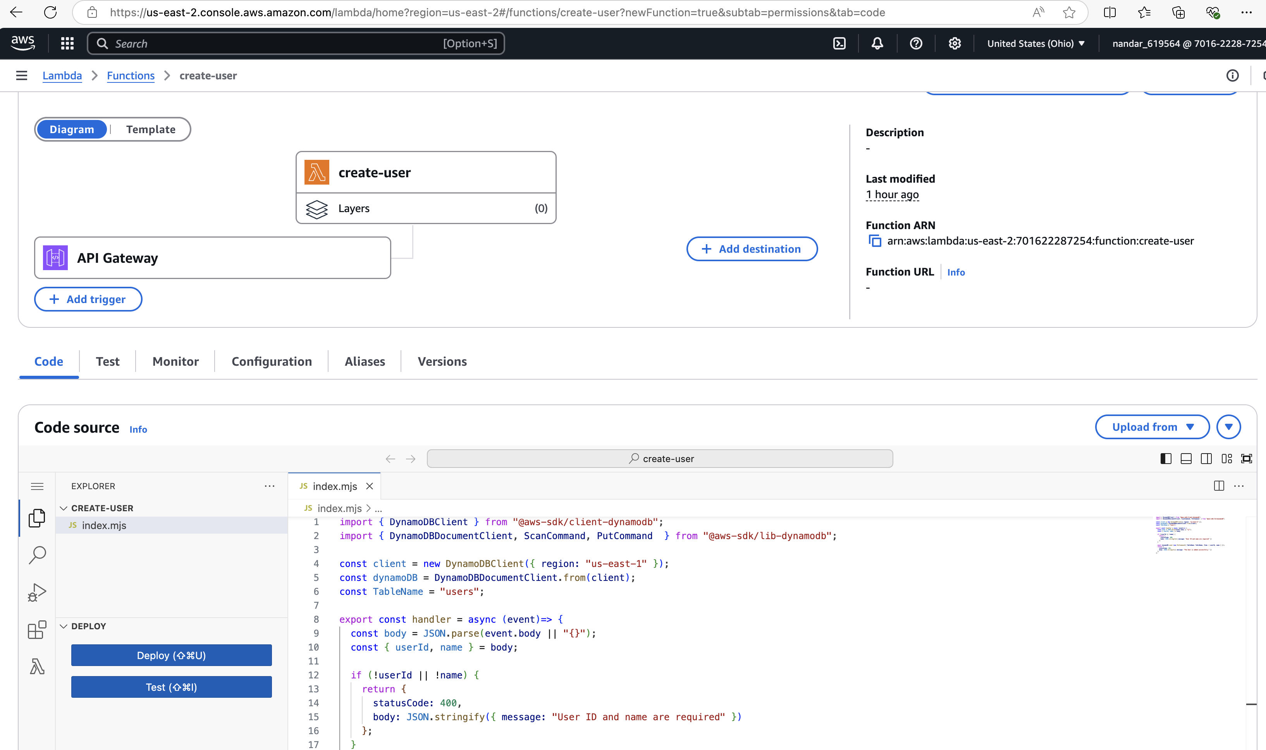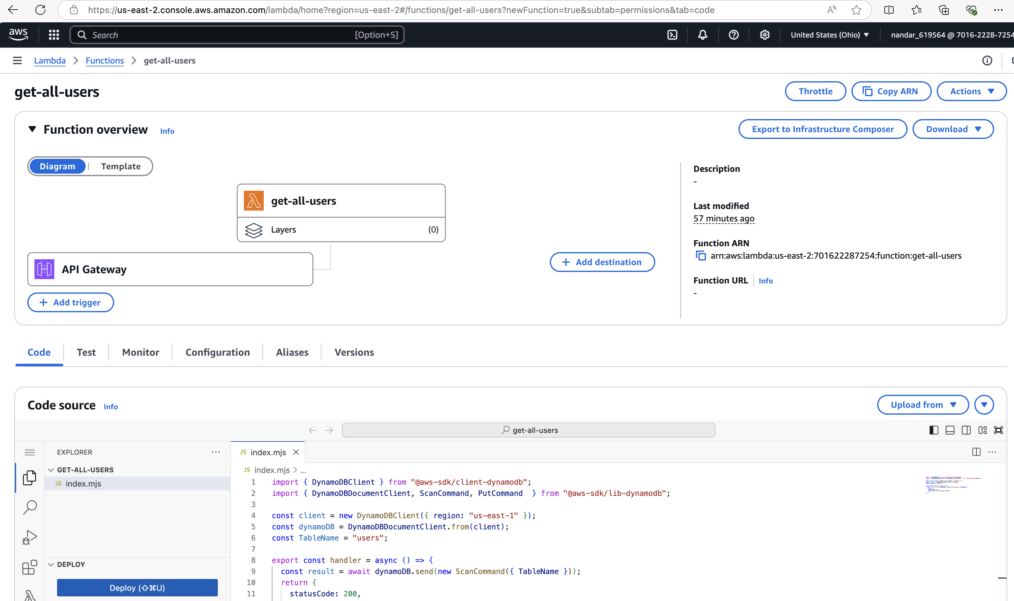

* Expose APIs using API Gateway.  
  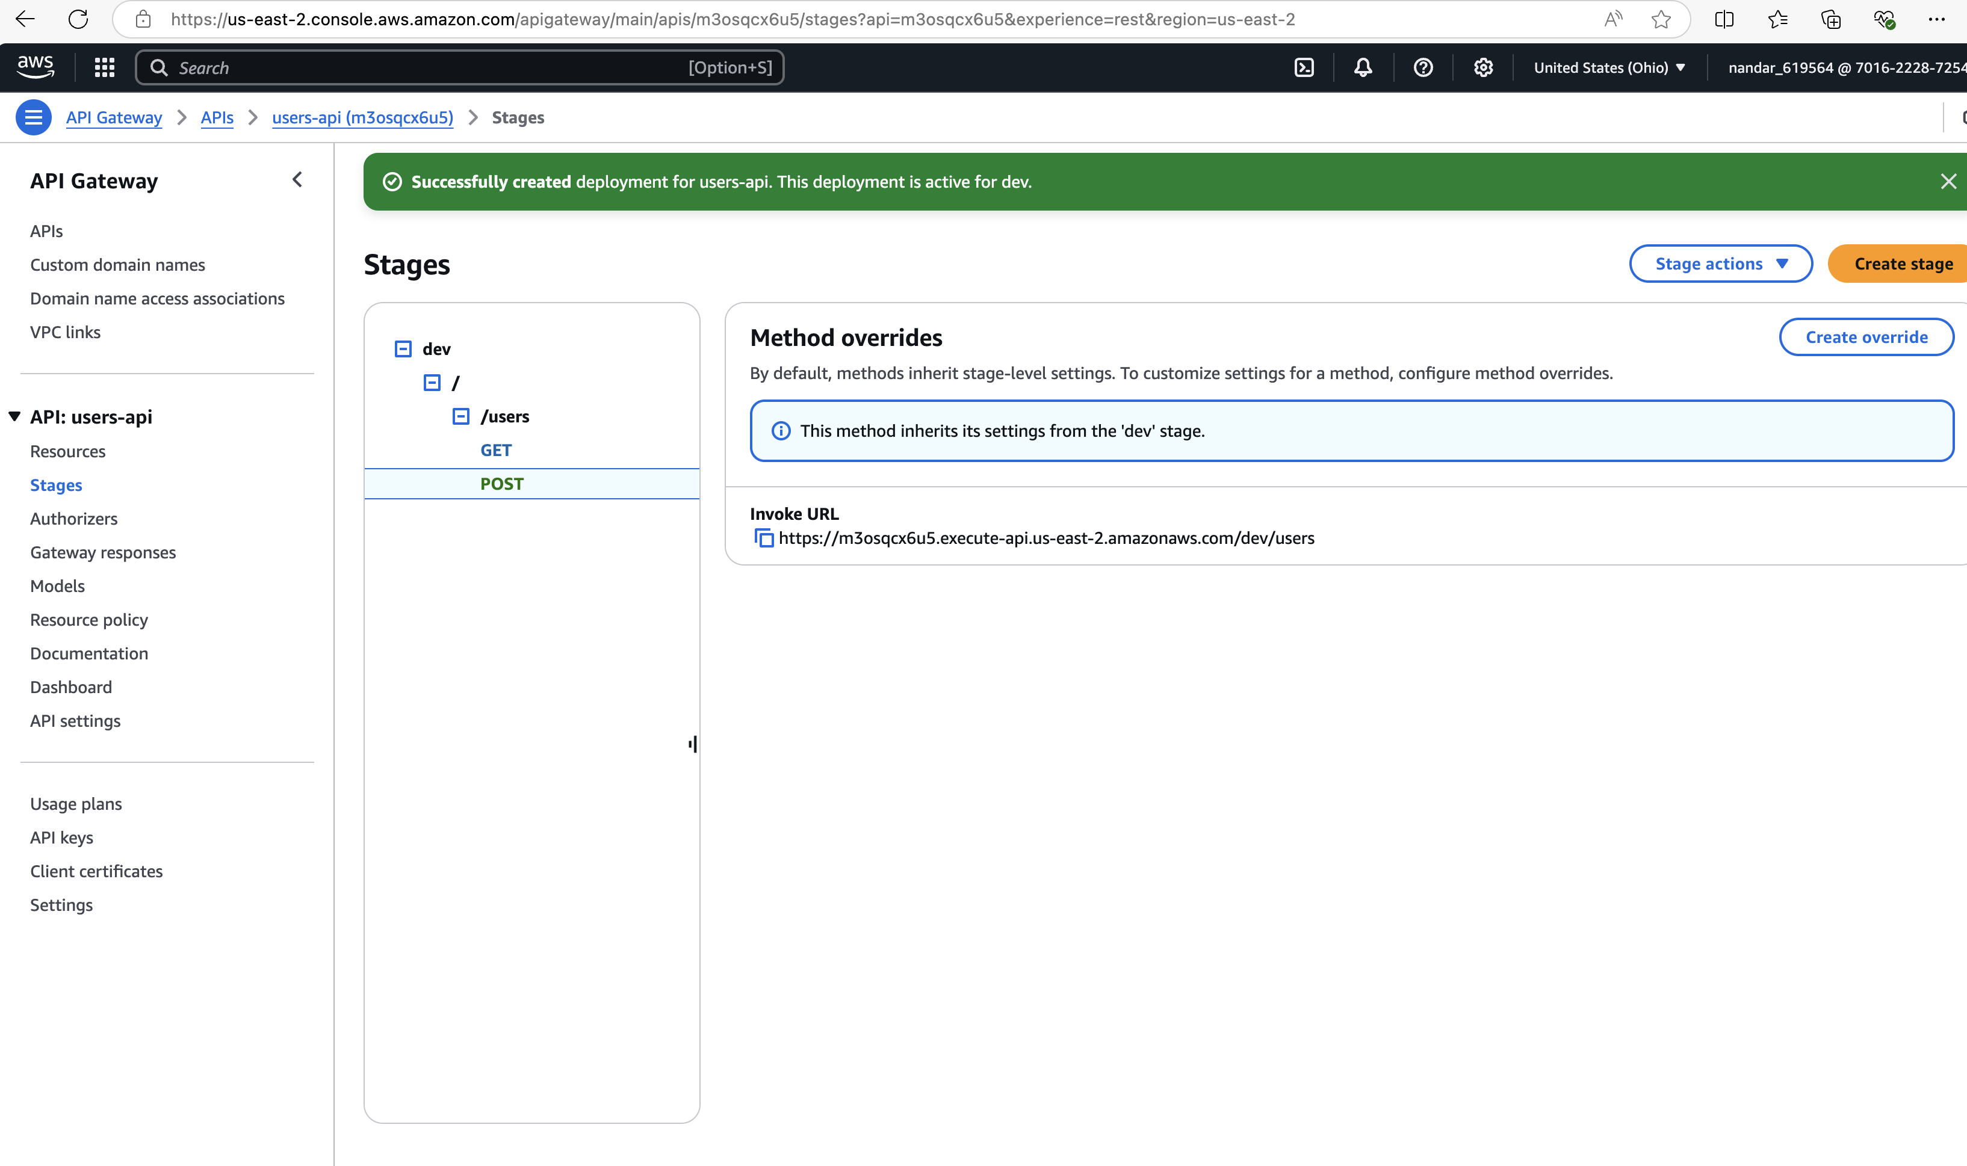
* Store and retrieve data from DynamoDB.

