Leonardo Medina #619571

## Submit screenshots demonstrating:

* Create and deploy AWS Lambda functions.  
Create new users

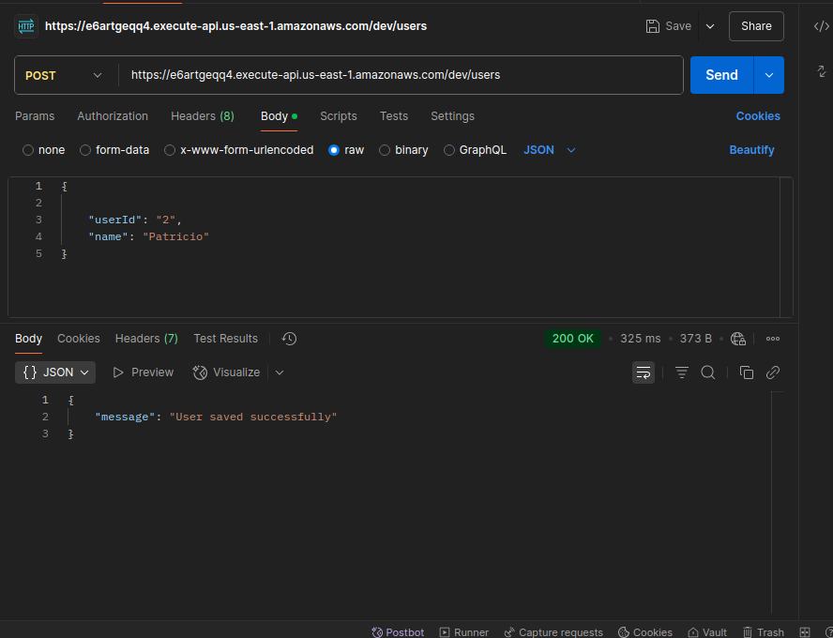

Get all users

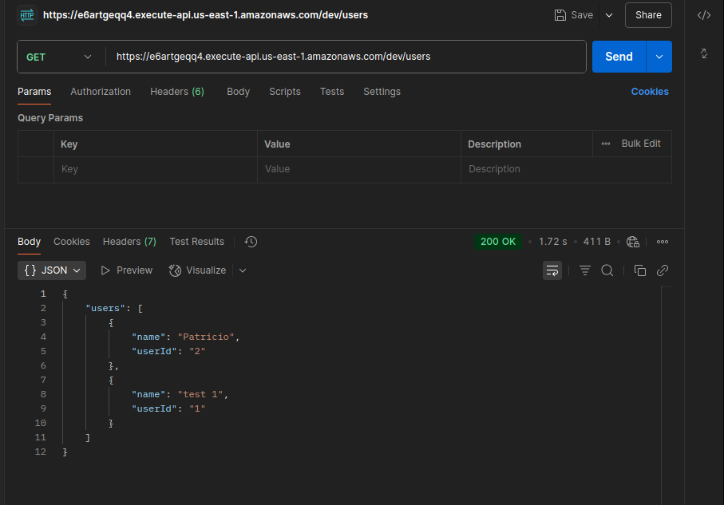

Get User by Id

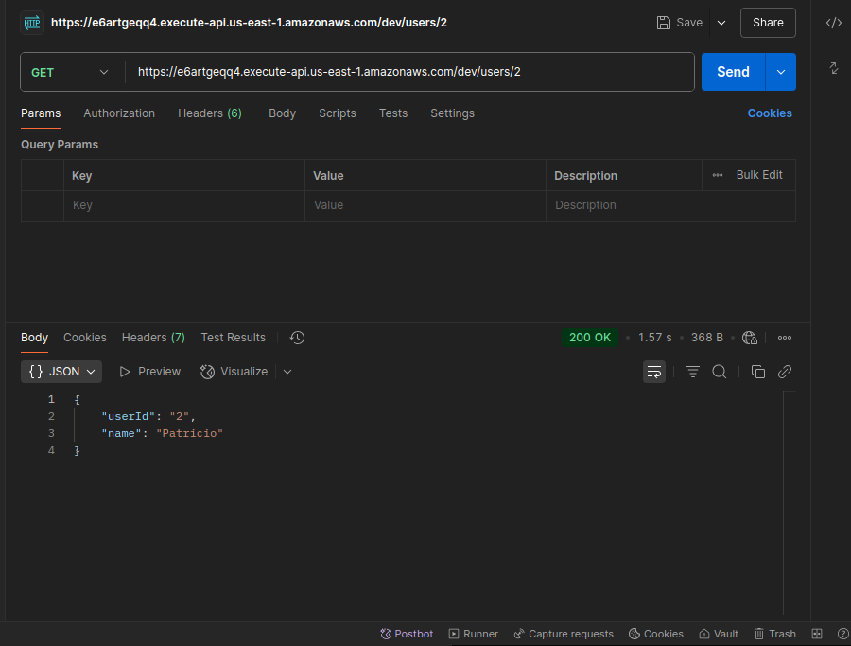

Update user by Id

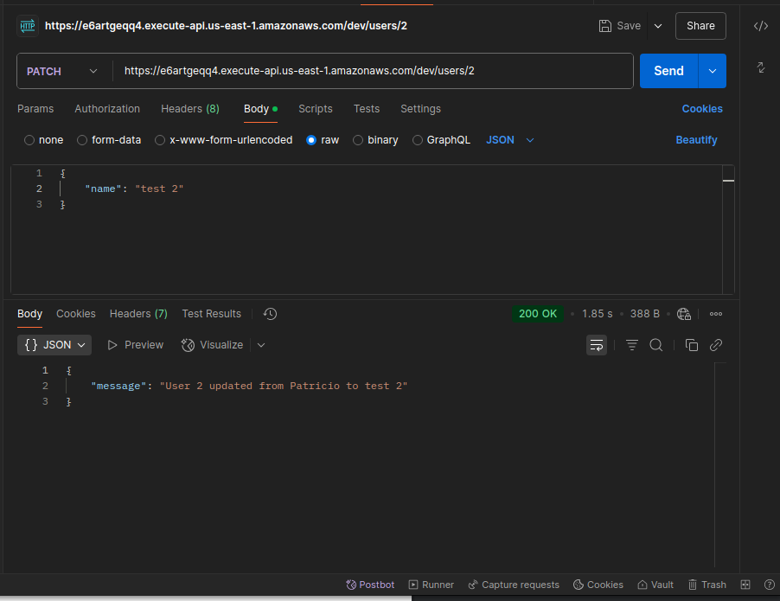

Delete user by Id

