# **Chapter 2: Analysis**

## **2.1 Introduction of Analysis**

Analysis refers to study of something in more detail for discovering or knowing more about it. Project analysis is done to learn background information of the project and also to make its predictions in the future. Analysis is the step that we do during the development of project. It provides understanding, quality and efficacy about the problem of the project, the functions that client requires and the need of this system.

Gathering/collecting requirements is the main thing in the phase of analyze. But analysis also helps in following points:

1. It collects and analyzes information and helps in future predictions of the system.
2. It helps in defining the requirements and improve aim of the system.
3. It helps in making the system stable for long period of time.

## **2.2 Analysis Methodology**

Analysis Methodology is a method or procedure that analyzes problems, applies data analysis system functionality and also interprets result of data analysis. As there are various methodology for software development and some of them are soft system methodology, hard system methodology and so on. I am going to use soft system methodology.

**Soft System Methodology (SSM)**

Soft System Methodology is an approach that can be used to solve general problem and manage changing in the organization. These methodology learns and appreciate the problem and gives soft analysis on the process that system should operate and the way system should do it. This helps in improving the processes when the time comes to making decision.

There are several stages that carry out the processes of Soft System Methodology. The six stages are shown below:

**Stage 1: Finding out**

It tries to understand the problem situation content and context as write as possible by using interviews, observations and workshops.

A group of people were interviewed with the following questions

* What is their methods for getting their airline tickets?
* Do they use applications or websites for booking airline tickets? Why?
* How often do they make airline ticket reservation online?

From the above survey following information were found.

* Most people manually make reservation to airline ticket either by vising the ticket department at the airlines or by making a verbal communication.
* Among the people who make online reservation, most people use android application.
* Websites are often slow in processing or always down in case of some people.
* People often waste a lot of time by manually visiting the local airlines.

**Stage 2: Expressing the problem situation**

This stage includes the validation and communication of the problem situation. A different tool can be used for achieving the problem. But the main technique to achieve it is “Rich Picture”.

**Rich Pictures** are the unstructured pictures which communicates every idea we think of the problem situation that we are analyzing.

The Rich Picture of the situation is shown below:

* Admin

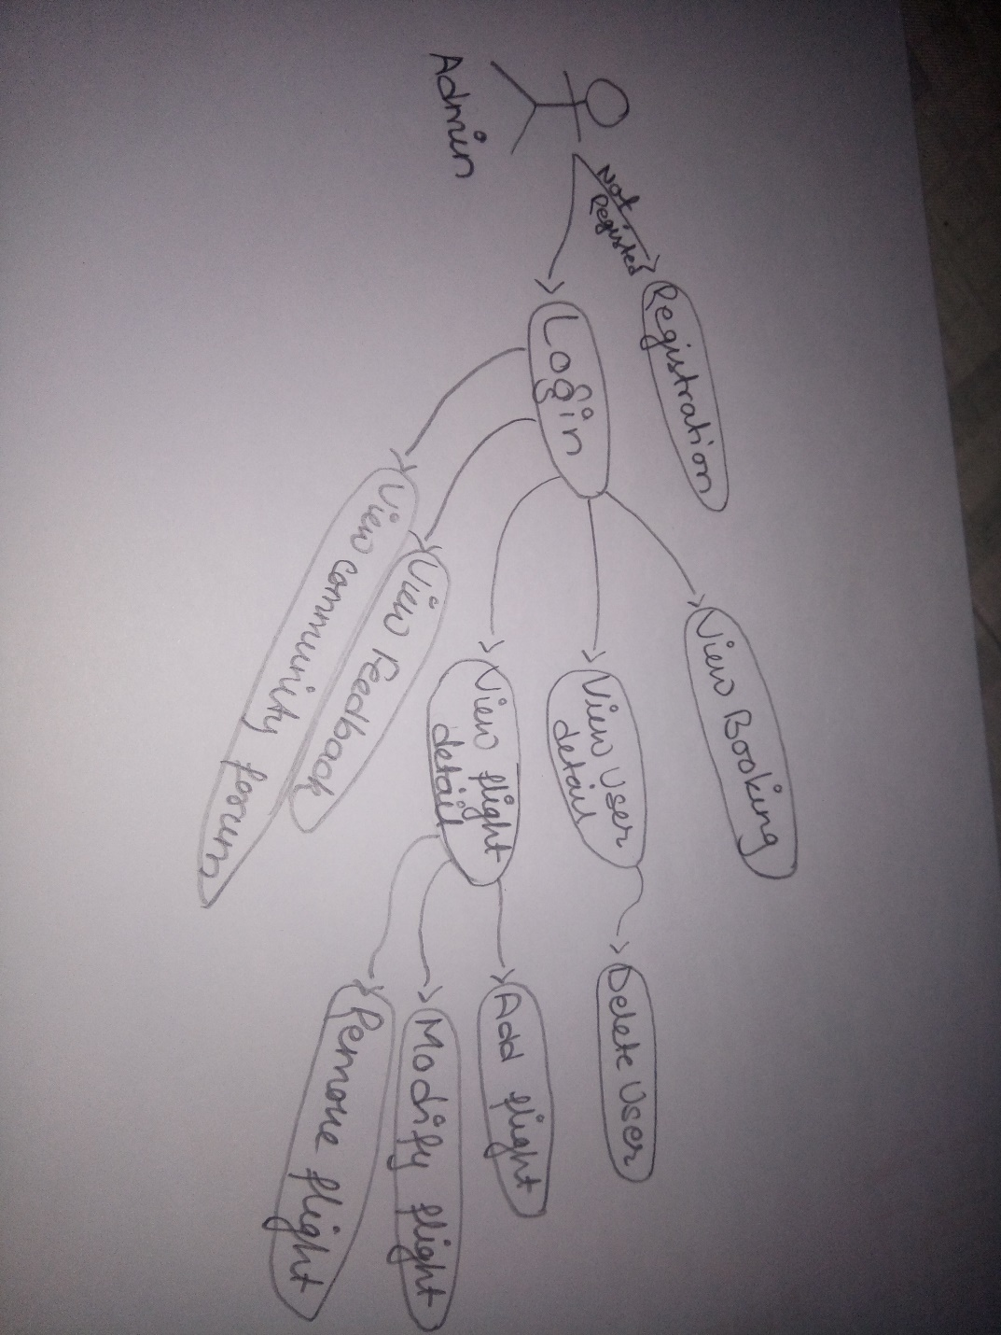

* User

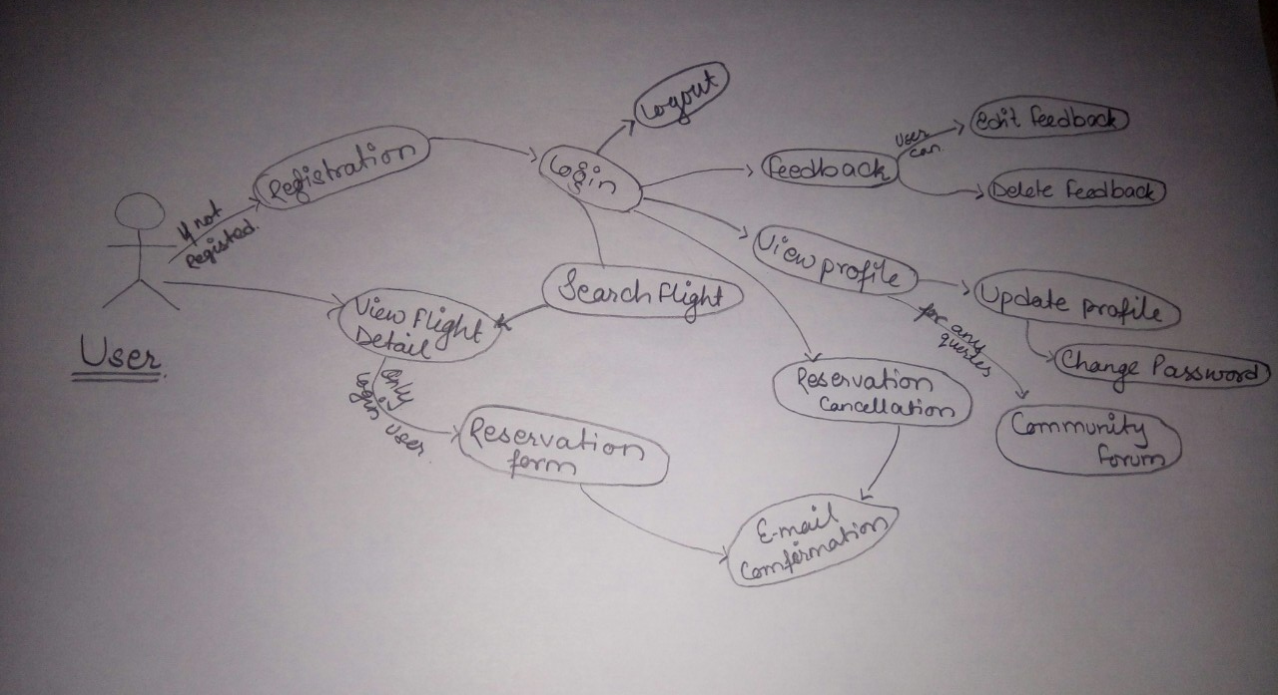

**Stage 3: Deriving Root Definitions:**

Root definition is the definition of the definition of the purpose that names a system. These are of short statements that explains the functions and aims of the system needed for its development.

For producing root definitions two steps are included:

1. Input-Output transformation diagrams.

It separates the different purposes of the system and reflects many perspectives.

1. CATWOE framework.

The CATWOE is a checklist for discovering solutions to the problems. It stands for **C**ustomer, **A**ctors, **T**ransformation, **W**orldview, **O**wner and **E**nvironmental. CATWOE Framework is used for producing a root definition for each transformation.

CATWOE analysis have been conducted in my project to give the following result.

**C**= Customers or flight attendees

**A**=Airlines Staffs

**T**=Flight Attendees can directly reserve their flight tickets and communicate with airlines staffs.

**W**=People can save their time of manually going to book their tickets and can spend that time on resourceful tasks

**O**=Airlines System

**E**=Educational Environment

**Root Definition**

A system owned by the Airlines where customers or flight attendees can make reservation of their required tickets online and communicate with airlines staffs gradually saving their time as well as costs that may occur by manually making reservations.

**Stage 4: Deriving Conceptual Models:**

A conceptual model can be defined as a method of analyzing activities that helps in knowing what the actors are needed to perform for the achievement of the transformation. Different activities are listed and related graphically for designing a conceptual model.

The conceptual model for my project is given below.

* Admin

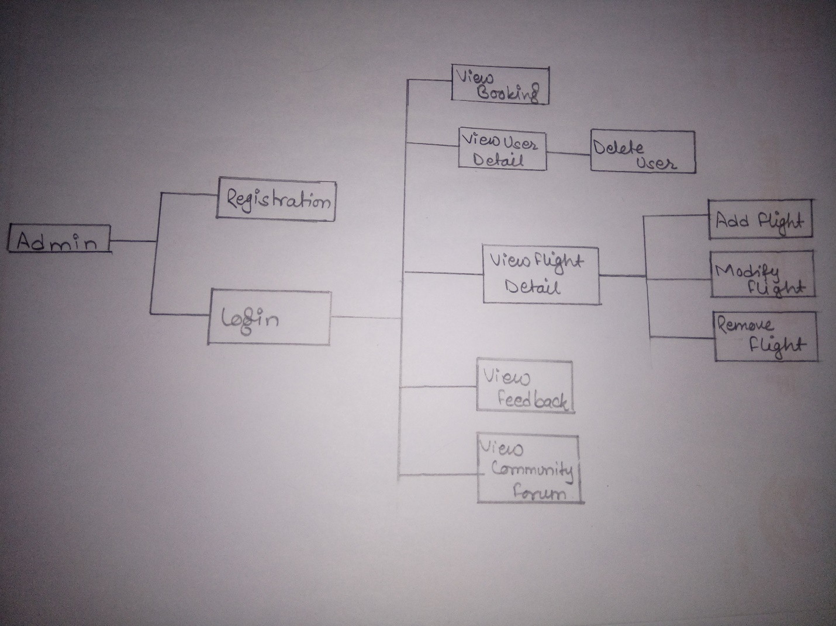

* User

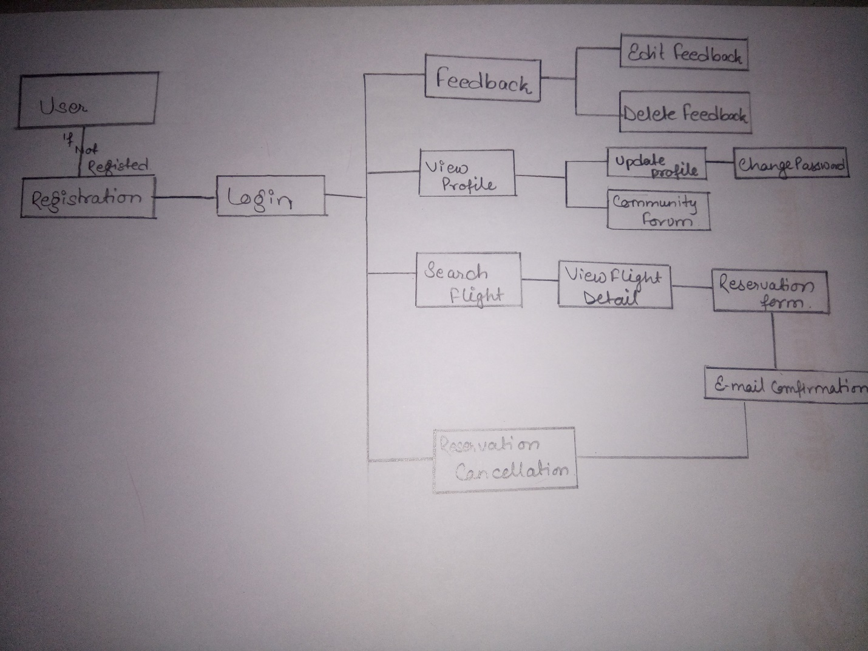

**Stage 5: Comparing Conceptual Models with the Real World:**

In this stages Conceptual model is compared with real world as not all the things are perfect this stage provides a feedback on changes that are needed to be made to existing system.

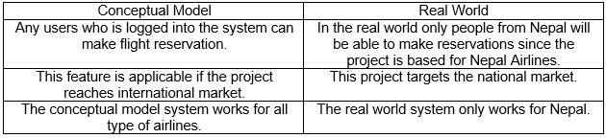

**Stage 6: Analyzing Feasible and Derivable change**

This stage follows the activities to represent the conceptual diagram and rich picture to the stakeholder of the project and some other users who can give helping hand in analyzing the system model with the diagrams shown above. The project has not yet included any features of providing advantages to users who have used the system for a long time. A desirable change that is brought up is to provide feasible facilities to users who are constant users of the online system.

## **2.3 Feasibility Study**

Feasibility study is the initial design step in every project, that combines the elements of knowledge which shows whether the project is possible or not. The gathered knowledge can be determined by understanding the benefits, times and costs related to the project should always have benefits higher than the required cost for the project.

I have performed the varieties of feasibility study in my project. They are shown below in tabular form:

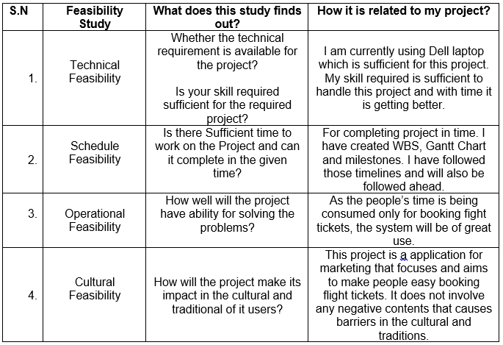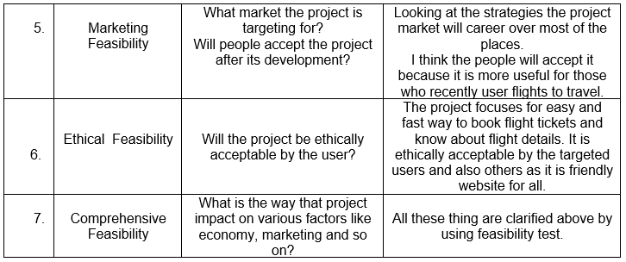

## **2.4 Requirement Analysis**

It is the way of determine the needs of users for the new or modified system so it can satisfy the overall need.

### **2.4.1 Functional Requirement**

Functional requirement are those requirement which are related to systems technical functionality, hard-software for operating as per the system user needs. It helps the users in performing their task easily up to the business requirement.

Functional Requirement of my project is presented below in tabular form including its dependencies and rational.

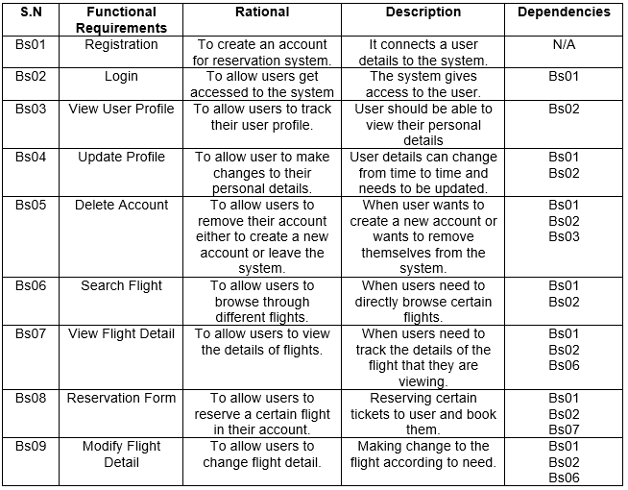

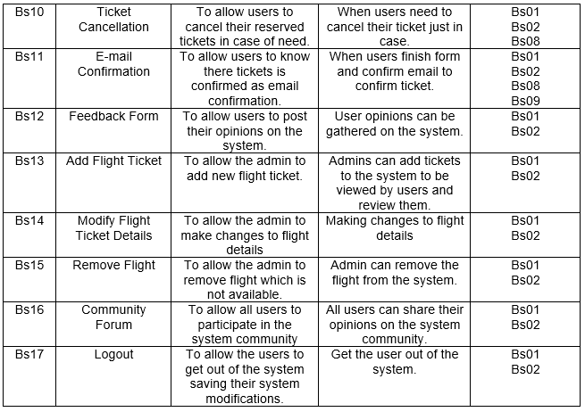

### **2.4.2 Non-Functional Requirement**

Non-Functional requirement are those requirement that specifies criteria which can be used for judging the system’s operation in particular conditions. It is also called “quality attributes” of the system. It determines particular conditions rather than some specific behaviors.

Non-Functional Requirement of my project is presented below in tabular form.

### 

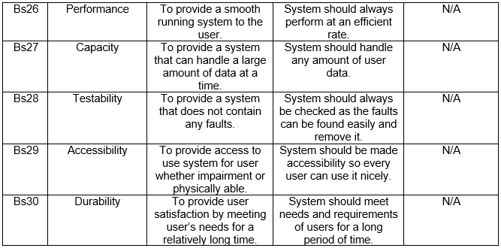

### **2.4.3MoSCoW Prioritization**

MoSCoW prioritization is a prioritization technique which letter stands for must have, should have, could have and won’t have this time. It helps in understanding and managing priorities. Those priorities that are associated with simpler prioritization approaches which are based on relative priorities can be overcome by these techniques.

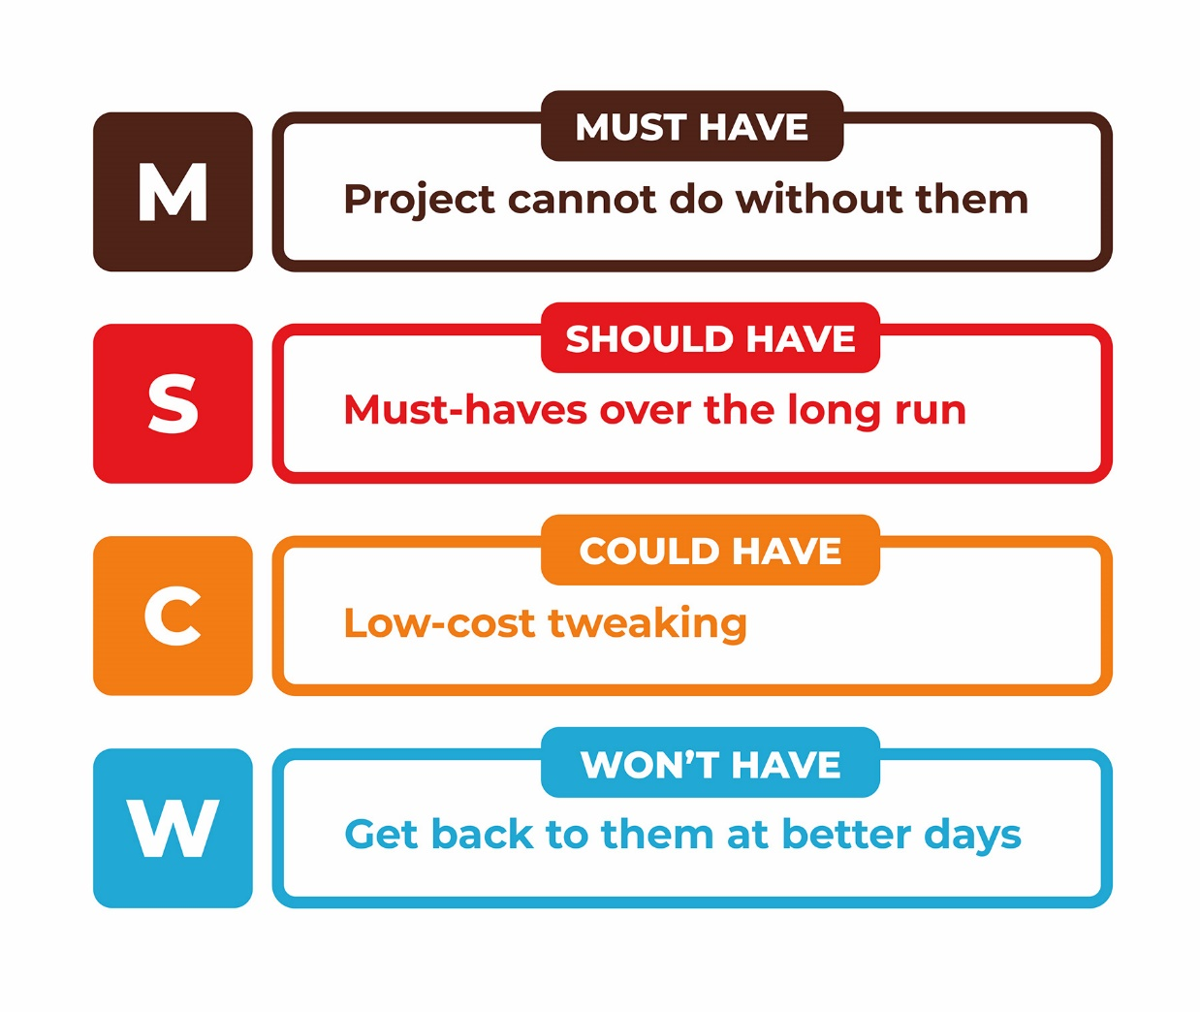

Fig: MoSCoW Prioritization

* Must Have: It plays a vital role in the project by making it legal, delivering it on the date that is targeted and makes the project secure.
* Should Have: It fixes the minor bug, improves performances but it is not added as without it the project can still run.
* Could Have: Its importance is low but it is the needed requirement for the project.
* Won’t Have: It helps in maintaining expectations about what will not be included in the release of the system.

The prioritization of various functional requirement is listed below in table:

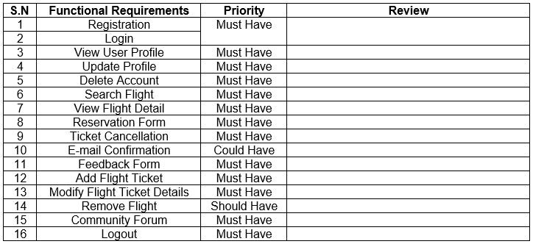

The prioritization of various non-functional requirement is listed below in table:

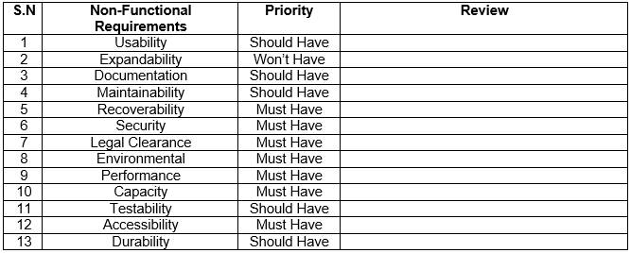

### **2.4.4 Software Hardware Requirement (SHP)**

A system requirement specification is a document that is used for capturing the entire complete description on how the system is to be developed. Description about the requirement of software and hardware is given that is need to develop software and it is all produce in response to the requirements of the user.

The hardware and software requirement for this project are listed below:

* Pre-Project Requirements

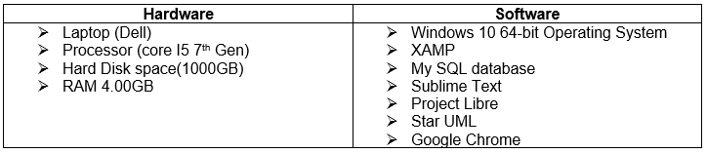

* Post Project Requirements

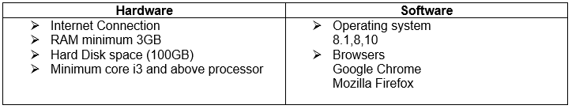

## **2.5 Use Case Diagram**

A use case diagram is a graphic representation of the communication or interactions among the system’s element. UML is to show various ways that a user is likely to have interaction with a system.

The purpose of creating use case diagram in my project are listed below:

1. It makes easier and more understandable to represent a system.
2. It helps in identifying any factors which may make the system influence and must be taken into consideration.
3. It shows the relationship of the entities with different functionalities.

The various use case diagrams generated are as follows.

1. Admin Login System

For the use of application and to maintain it an admin must have admin account. They will be able to create a new account by providing their personal details and can login to the system. Registration form can also be opened from the login page as it includes a function for guiding the users to register function. A password can be changed or reset incase if they forgot their password. For all this function the system will guide them to use it.

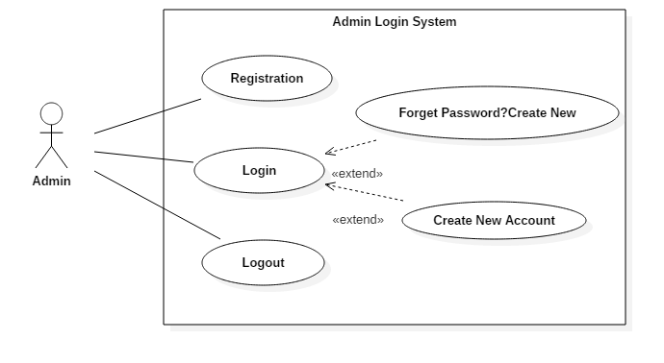

1. User Login System

User will be able to create a new account. If they open login account page without having an account the login page has a function that guides user to the register function so they can login and use the application. If user forgets their password they will be guided for creating a new password.

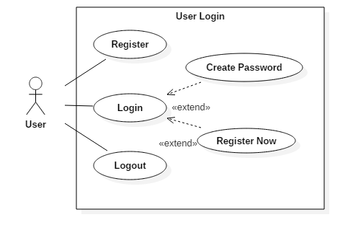

1. User Flights System

Once the users are login they will be able to tickets. Before booking the tickets the users can view flight details, search the flight that they want to view flight available and then book flight tickets. The users can also cancel their booking if they are willing to do it.

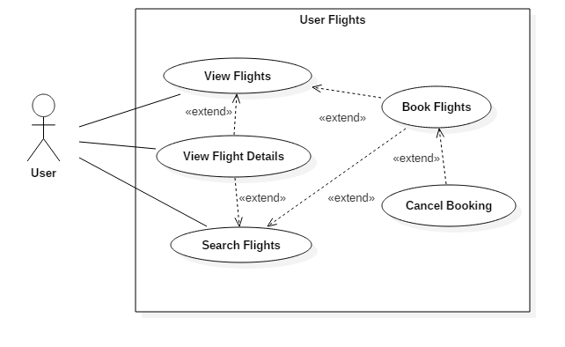

1. User and Admin Profile

Both admin and user will be able to view their profile. They can make changes in their account profile. They can update their any personal details as well. But admin only can be able to delete their account which will remove from the system.

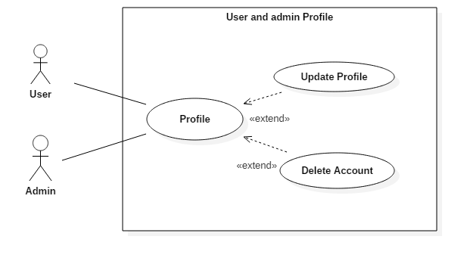

## **2.6 Natural Language Analysis**

Airline Reservation System is a project that focuses on marketing the companies of airlines related to its best facilities on booking flights. Statistics shows that air way is one of the most used transportation in this 21st century. Whether it be a short distance or a long distance air way is chosen by many people.

The companies are looking ahead for some better Airline Reservation System. The system should permit admin and users to register their new account inserting their personal details and after that they can login into the system. Incase if any of the user are facing the problem in technologies, the admin can add users and help them in reservation flights. User should have ability to manage their account by editing or updating in their account only after login. Admin should also have that ability to manage their account and also have to view all the user that are registered and can delete users account in case they act in a vulnerable way to the company. The feature of creating new password must be available so that if the password is forgot a new can be created easily and can be logged in to the system.

Once the user is login into the system it must allow the user to update profile, search flight, view flight details and book flights tickets. More importantly the user must also have the ability to cancel their reservation. For payment it is done after receiving the ticket.

For the system to be highly efficient some details are needed. They are given below:

* Admin and User username, password.
* Flights name, departure time, arrival time, seats number.

This project will be online based which will solve the problems mentioned above and provide better Airline Reservation System to the computer.



**Initial Class Diagram**

Initial class diagram is a standardized model that explain an object oriented programming approach. It shows data models for information system whether it is simple or complex. It representing system’s attributes, classes, operations and the relationships between objects. It can be used by business analyst to model system from business thoughts.

