# **Chapter: 3 Design**

## **3.1 Introduction to Design**

Design is one of the step that is completed which developing a software which has a user’s perspective and drives development that is based on specific needs of customer. Every process of design is different in various projects and fields of design. In software the design transforms every requirements of used into suitable form so the programmer could find it easy in the software coding and implementation.

For this project, I have used five different models which are explain below:

### **3.1.1 Class Diagram**

A class diagram is an illustration that describes the system’s structure by representing classes, attributes, operation/methods of systems and the relationships among object.

The importance of performing class diagram in my project are:

* It helps in modelling the static view of an application.
* It can be used in time of construction and explains system’s responsibilities.
* It helps the programmer in the software coding and implementation.

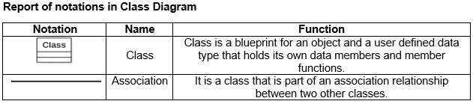

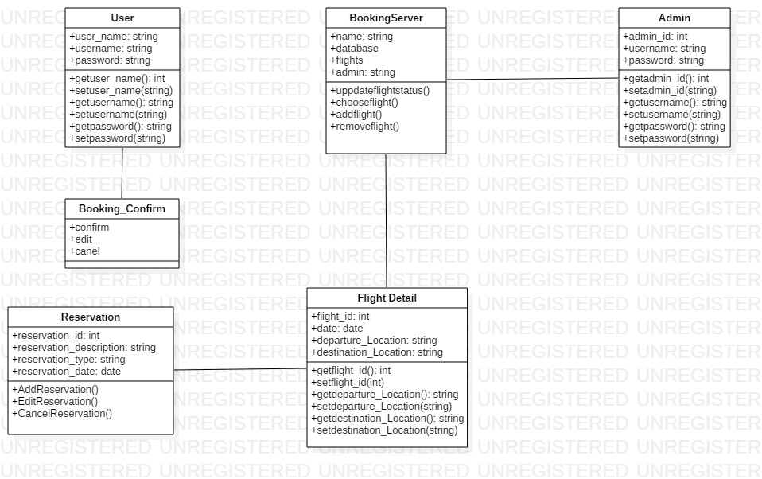

### **3.1.2 Data Flow Diagram**

A Data Flow Diagram is a visual description which represents the information that flows between various processes within a system. A neat, clear and nice data flow diagram can show a good amount of the system requirements graphically. The diagram can be automated, manual or the combination of both.

The importance of performing data flow diagram in my project are as follows:

* It helps in explaining the boundaries of the system.
* It helps to show the users how the data moves within a system.
* It is easy to understand for both technical and non-technical people.

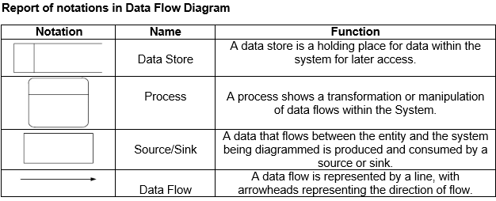

**Login and Registration Data Flow Diagram**

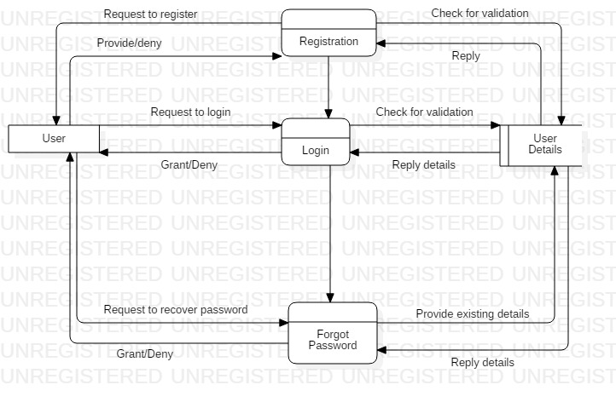

In the above Data Flow Diagram users are firstly requested to register for creating an account linked with the system by giving users details. Now they can get access into the system by providing the registered details and needed details. If the users forget the password, the system will help them in creating a new password, but only after the validation of their account ownership.

**Admin Action Data Flow Diagram**

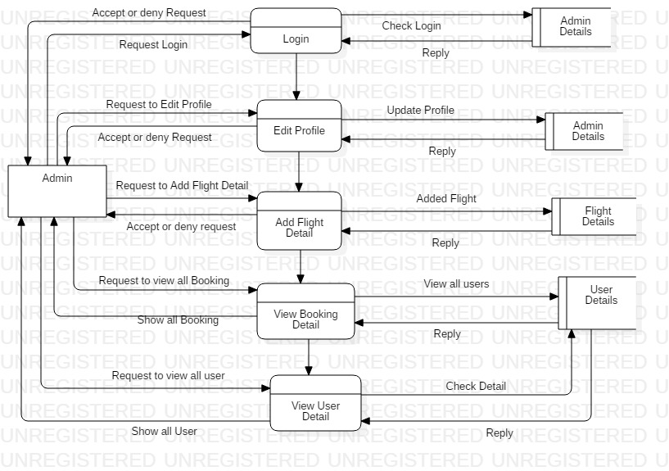

In the above DFD diagram, same like of the users, admin will also have the ability to login into the system, view admin details, flight details, and edit their profile. But the admin will have more additional ability than of the users. Admin will be able to add flight detail, view the booking details of the users, and also view the user details.

**User Action Data Flow Diagram**

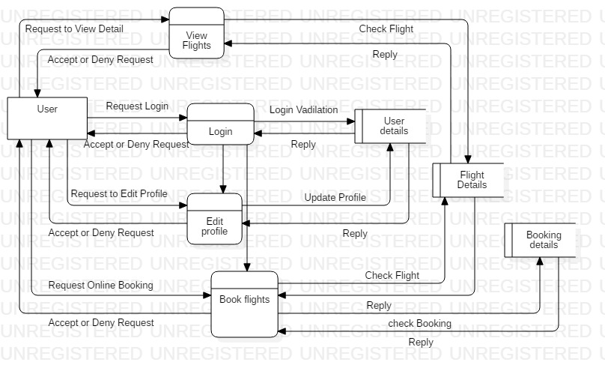

In the above DFD diagram, every users will be able to view the flights details. After the access to the system users can view their details, and they will also have the ability to edit their profile. They can also book the flights and view the booking details. For the successful complete of the function the users request has to be accepted in each process.

## **3.2 Behavior Modelling**

Behavioral Model refers to the use of data that are available and the use of data spend relevant by consumer and business for the estimation of future behavior.

### **3.2.1 Activity Diagram**

Activity diagram is a flowchart that represents actions and flow of control in a system. This diagram can also explain the steps that are in use case diagram.

The importance of performing activity diagram in my project are as follows:

* It helps in describing the logic of an operation.
* It records the logic of business in a simple way that makes easy in communicating the complexity of business logic with all the stake holders.
* It is simple in understanding for all the end users.

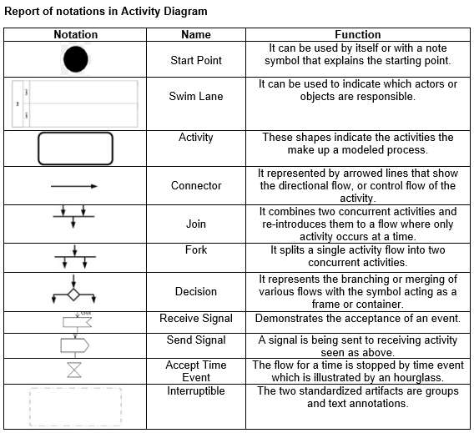

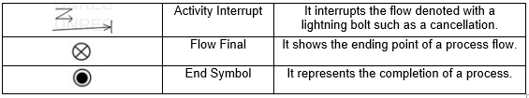

**Login and Registration**

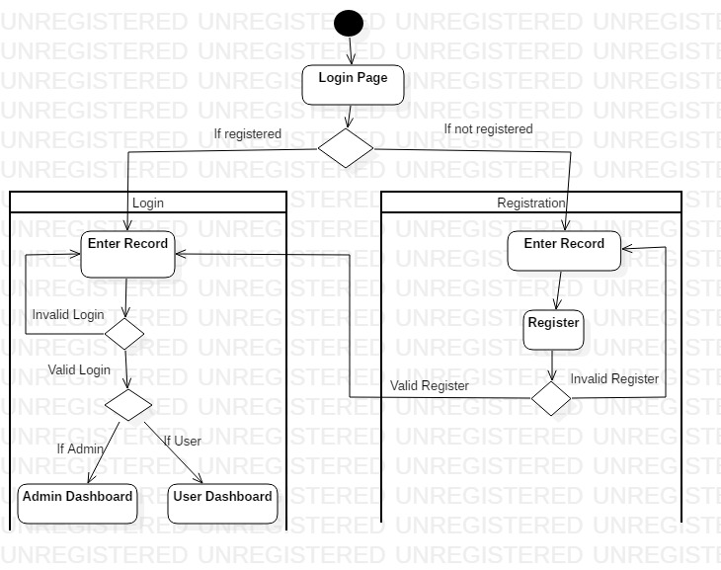

In the above activity diagram, the activity of the users starts from the login page. After entering the login page a decision notation will separate two different conditions for the registered and unregistered users. If the user is not registered, a registration form will be opened where the details will be provided by users, and if in case there is error in the registration form the user will be taken back to beginning and if the registration is valid the user will be taken to the login page. After the completion of the registration and if the user is registered from the first the user will enter the login page where the successful login will take the user to the admin or user dashboard according to the role they have in the database and the login is unsuccessful the user will be taken back to the beginning of the login page.

**Admin Dashboard**

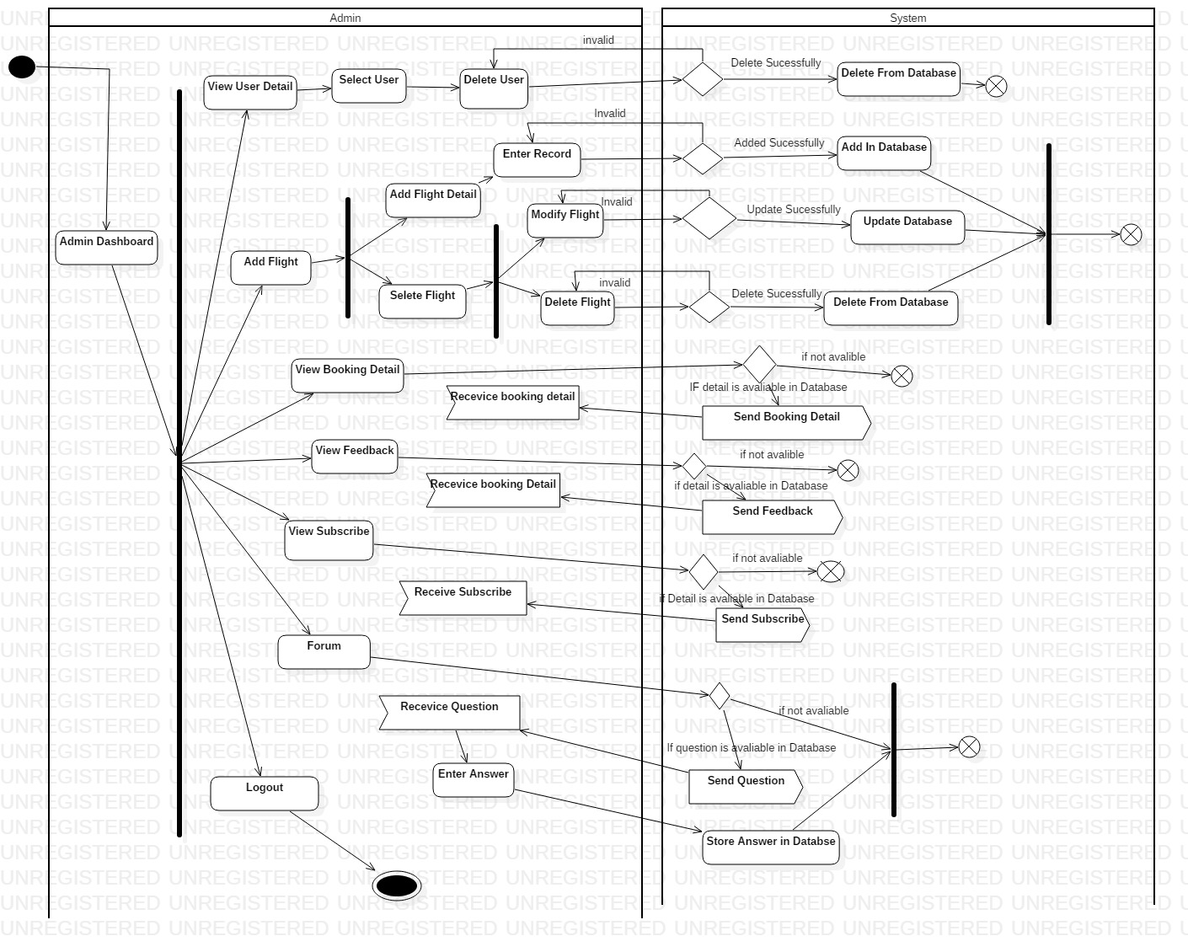

When the user is taken into the admin dashboard after the successful login, admin can perform various tasks as illustrated by the fork notation. Briefly, admin can change the profile of the user and can make changes in the database with permission from the system. Admin can view booking detail, feedback, subscribe, receive questions and enter answers.

**User Dashboard**

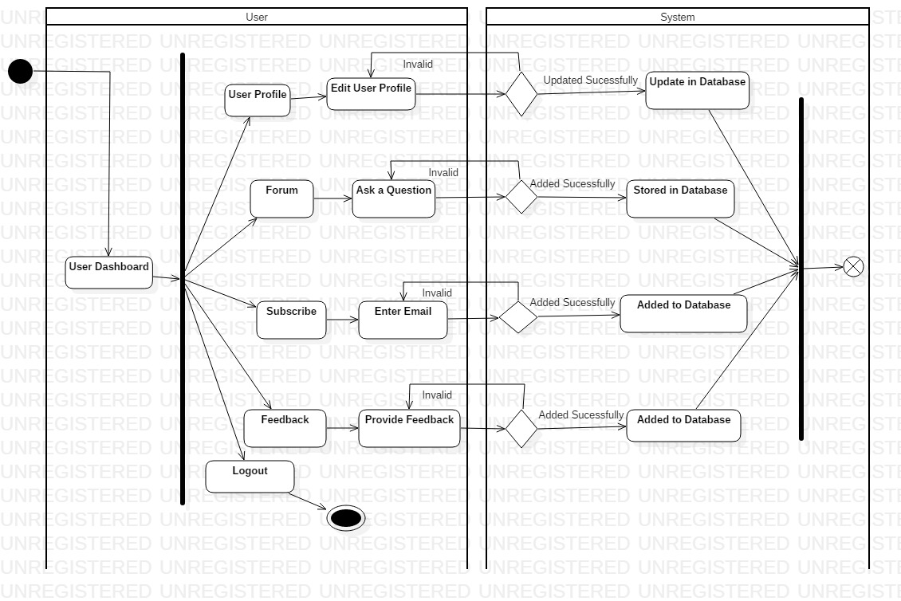

With the user already being logged into the system, the user will be able to edit their profile which will be update in database. They can ask question. The user can subscribe the application by entering their email, and also they can provide feedback.

**lUser Booking Flight**

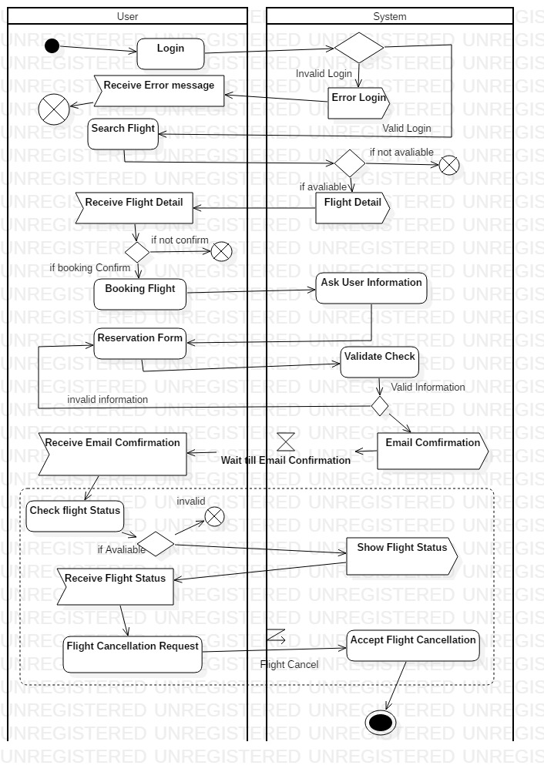

Now the user login into the system with incorrect detail will provide them error message and if the login is correct the user will be taken to their homepage. In homepage they can search for the flight and receive flight detail if it is available. In the booking term, the user can booking flight but for its confirmation the user is asked for their information, fill reservation form where the system will check whether it is valid or not which will provide email confirmation to the user. They can also check flight status if available and also request the system for the flight cancellation.

### **3.2.2 Sequence Diagram**

Sequence diagram is commonly used interaction diagram. It shows the interaction between objects in a sequential order in which the interaction takes place. It also describes how and in what order the objects in a system function.

The importance of performing sequential diagram in my project are as follows:

* It is used to document a requirements of the system and for flushing out the design of system.
* It helps in modelling the flow of logic within a system in a visual manner.
* It also represents the messages that are exchanged between the objects needed for carrying out the functionality.

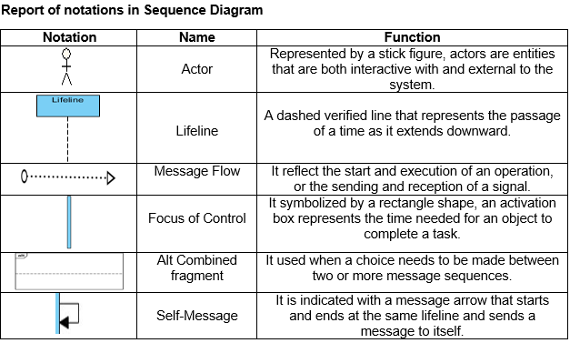

**Login and Registration**

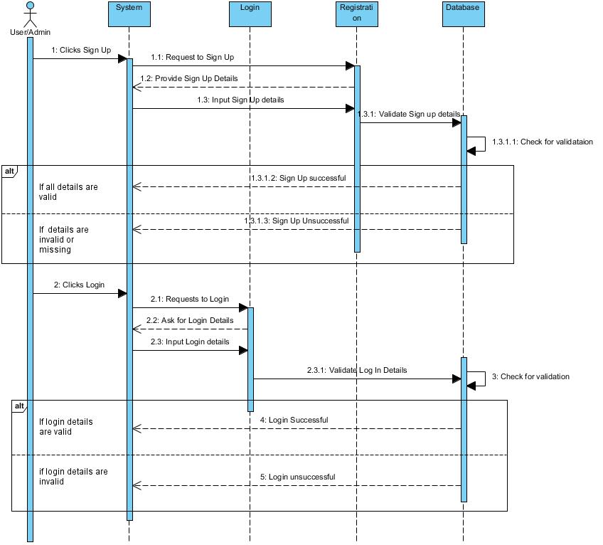

Here, the user will firstly reach for the signup/login form in which after a click on it the system will provide them a form where the user will be filling their details. After the form is filled and submitted, the system will check for the validation in the database. If the validation is correct, the system will sent a message of successful login or successful signup, otherwise the system will sent a message of unsuccessful login or unsuccessful signup if the validation is incorrect.

**Admin Dashboard**

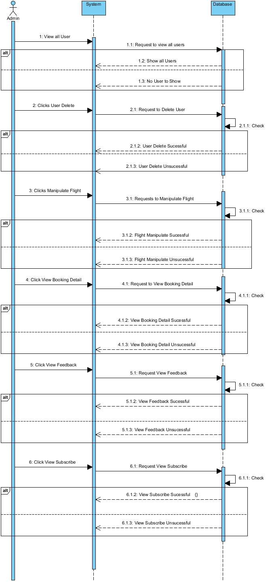

The actions or functions that the admin performed will first be requested by the system to the particular page of the database. And if the page is validate the database will carry out the requested actions and sent the message of actions completed successful else the message of actions completed unsuccessful. All the actions that admin can do is manipulate the flights, view users details and even delete their details, view booking details, view subscribe and view feedback.

**User Dashboard**

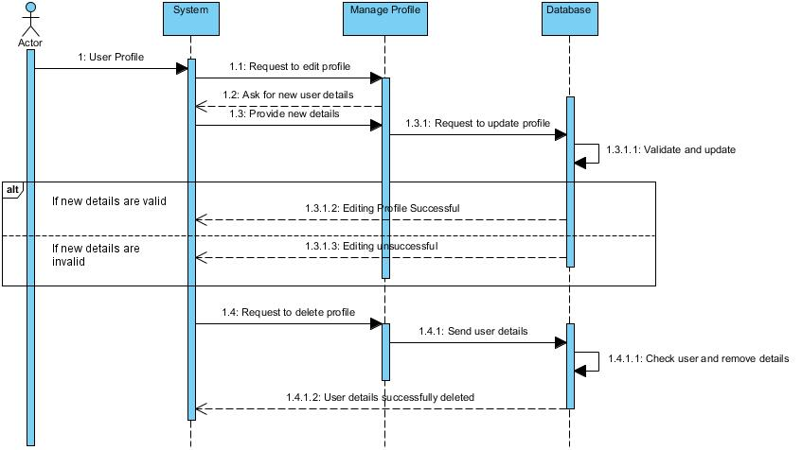

If the user want to perform the action in their profile on editing and deleting then in beginning the users action will be requested by the system to manage profile where the user will be asked for a new user details to enter. The entered details will be sent to database which will be checked for validation and after that the message will be sent as editing profile successful if the validation is correct else editing profile unsuccessful. And in case of deleting the user profile the system will request to the manage profile which will sent user details to the database where user detail will be checked and removed. After the action is completed a message will be sent as user details successfully deleted.

**Booking**

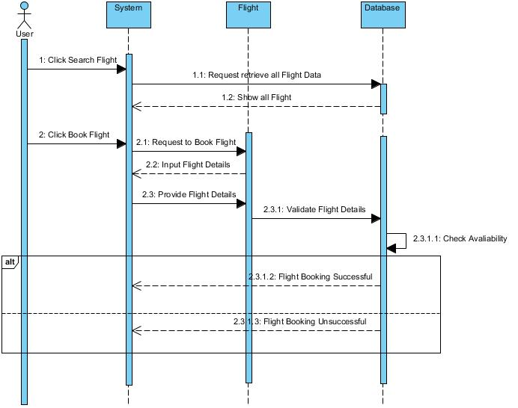

In the booking term, the user will be able to search for a flight and book their flight. The user action will be requested by the system to the flight and then to the database. All the flights will be shown if there is any flight available. When booking the flight system will request to the flight where the user will be asked to input the flight details and the provided flight details will be sent in the database for the validation. If the validation is correct a message will be sent as flight booking successful else flight booking unsuccessful.

## **3.3 Database Modelling**

A database model illustrates to the logical structure, layout of a database which also includes relationships that decides how can the data be stored, managed and accessed within it.

### **3.3.1 Data Dictionary**

Data dictionary is a set of file containing a metadata of database. It holds the records likewise, ownership of data, relationship of data to other objects etc.

The importance of performing data dictionary in my project are as follows:

* It enables every available users to share common opinion of the data resource.
* It provides clear understanding of data elements.
* It helps in understanding the requirement and design of the system of the great extent

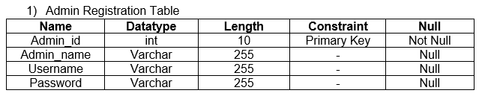

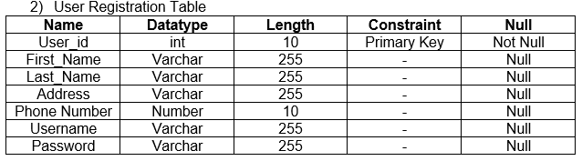

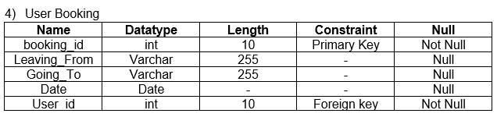

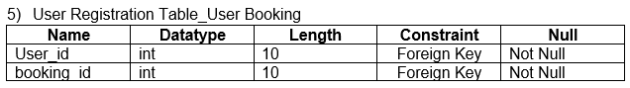

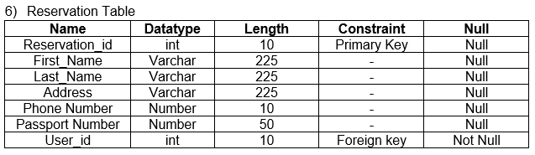

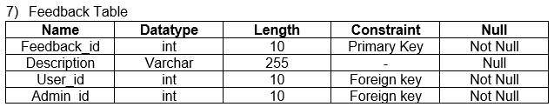

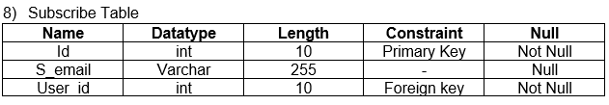

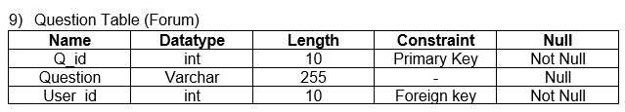

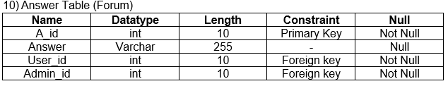

### **3.3.2 ER Diagram**

An entity-relationship diagram (ER diagram) is extremely important to develop a database design and is a visual representation of the system’s database. It shows the entities of the system and the relationship between those entities.

The importance of performing ER diagram in my project are as follows:

* It is helpful for doing documentation of the database design.
* It is easy to understand
* It helps in communicating the logical structure of the database to the users.

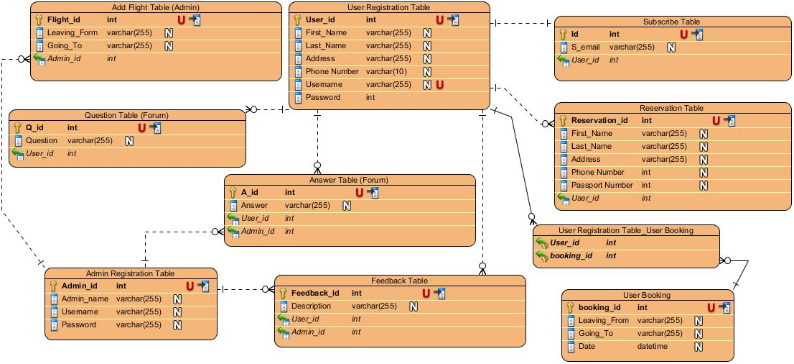

## **3.4 Architectural Model**

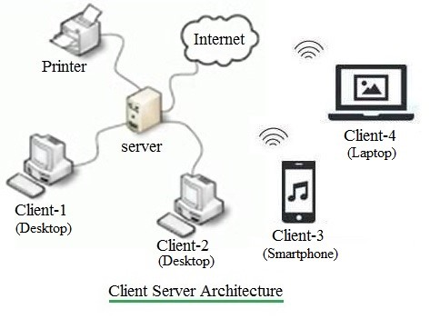

The model used to represent the structure of the overall network used by the system is known as architectural model. For my project I am using the client server architecture. This architecture allows one or more clients systems to a centrally located server. The server holds the responsibility of controlling the services given to its clients.

The justifications for using this model in my project.

* Customers as well as the airlines system will have distinct and specific tasks.
* All data are in a centralized location, so recovering and backing up data is easy.
* Changes can be made easily in a centrally located data.

## **3.5 Protype Design**

It refers to the duplicate of any objects before the actual object is created. I have used Balsamiq mockup in this project. It is a user interface design tool, and faster.

The importance of performing prototype design in my project are as follows:

* It permits us to hide the difficulty of creating new instances from the client.
* It helps in reducing the time and costs.
* It helps in improving the quality of requirements and specifications given to the users.

1. Home Page

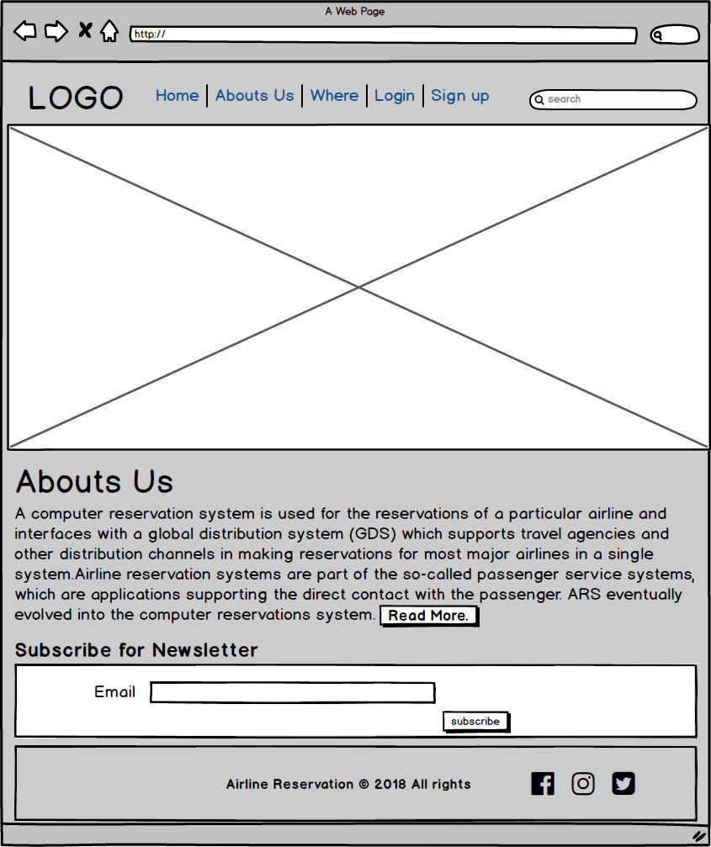

1. About Us

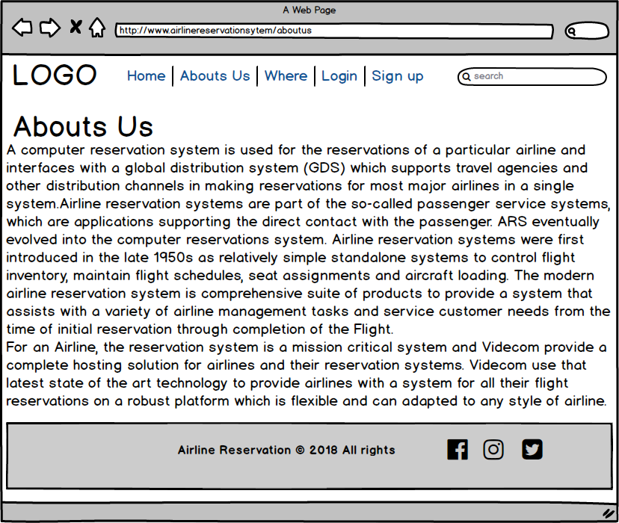

1. Register

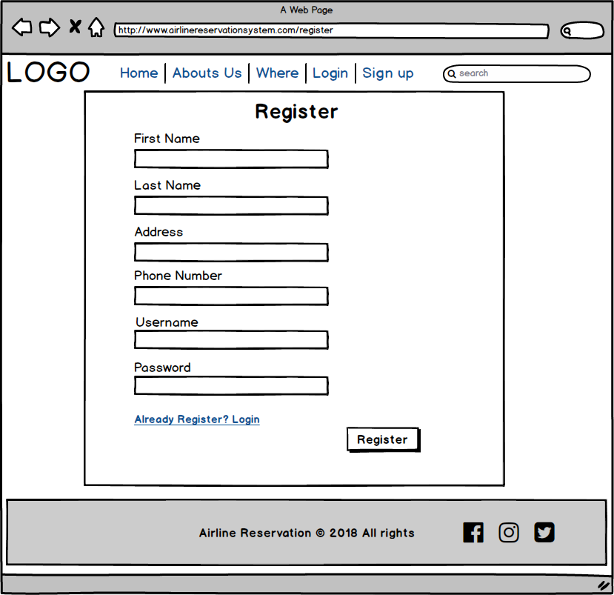

1. Login

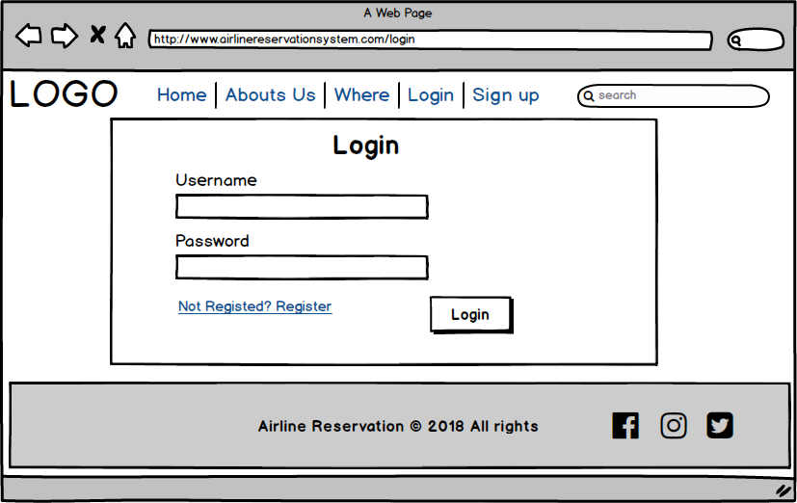

1. Admin Dashboard

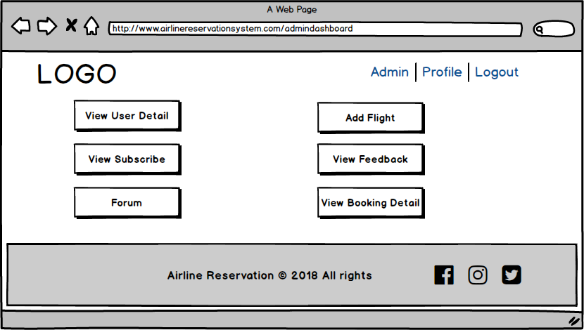

1. View User Detail

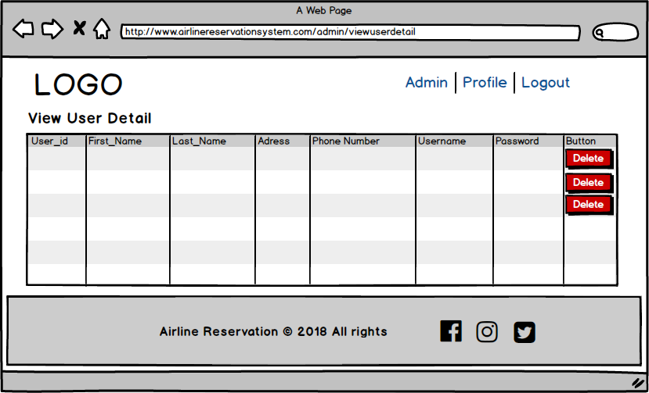

1. Add Flight

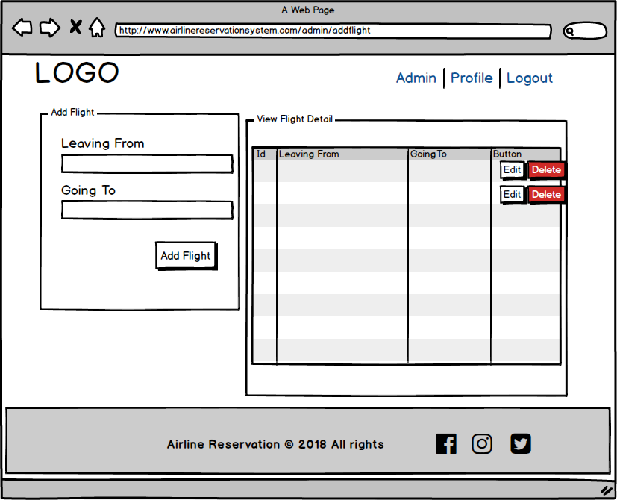

1. Edit flight

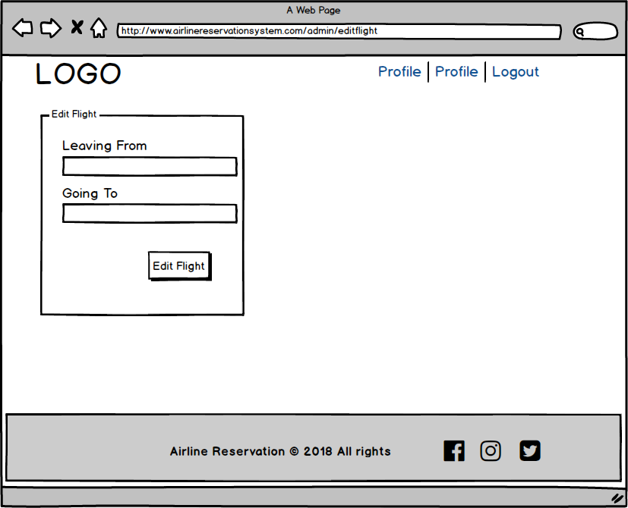

1. Forum

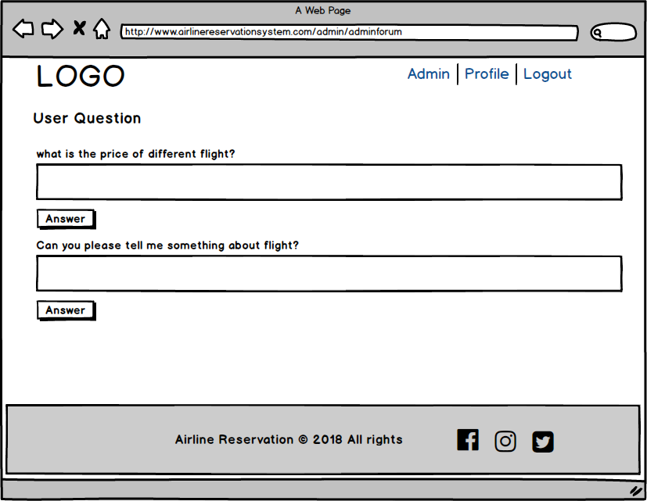

1. View Feedback

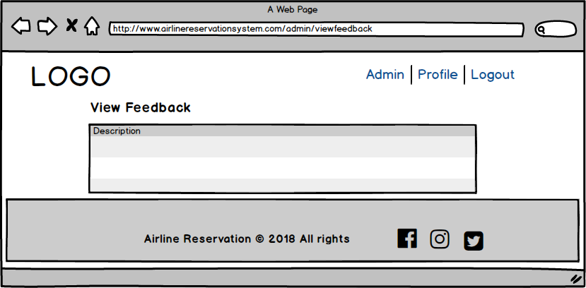

1. View Subscribe

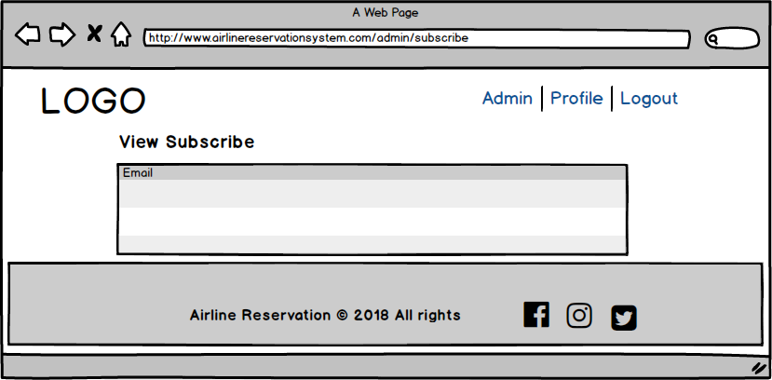

1. Admin Profile

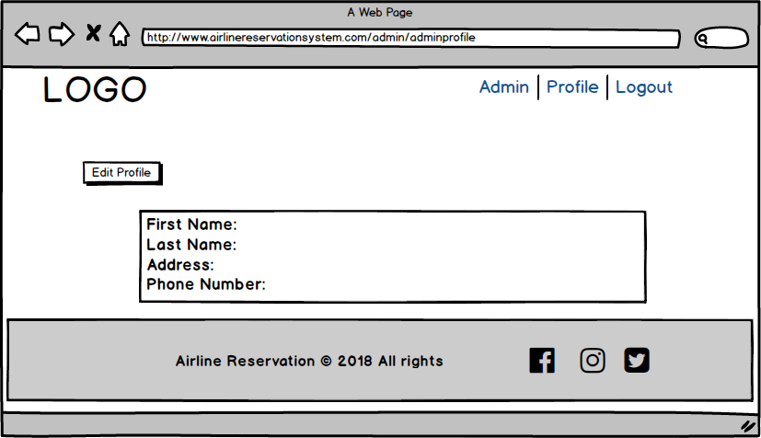

1. Edit Profile

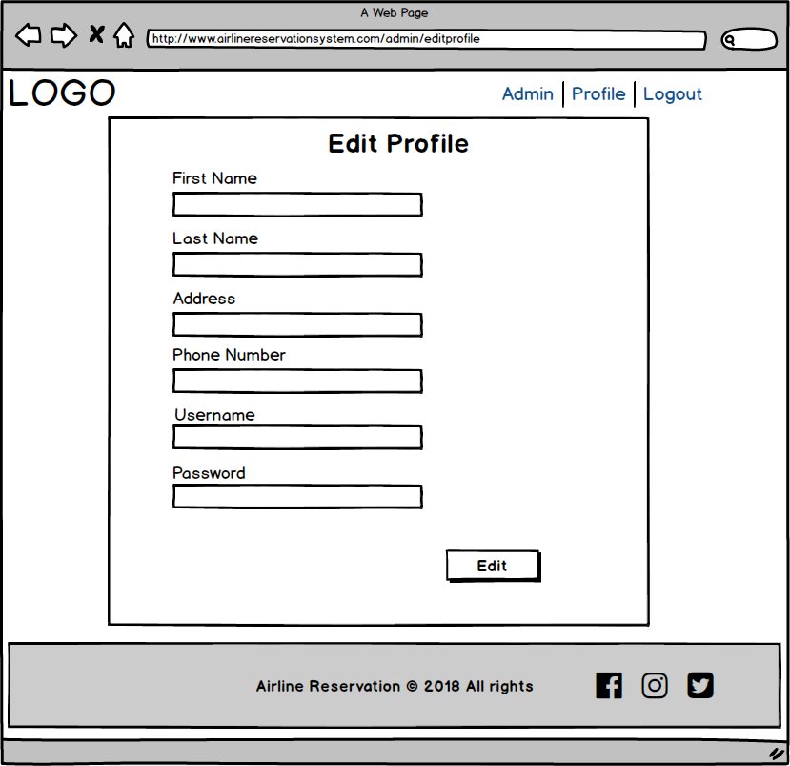

1. User dashboard

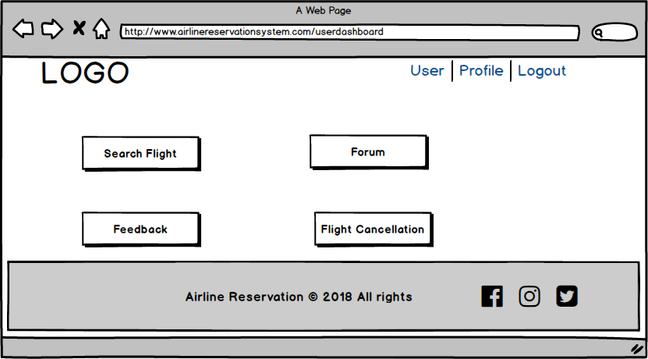

1. Search Flight

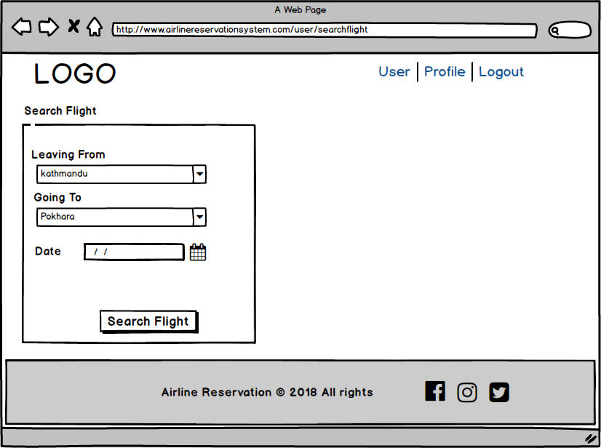

1. Booking

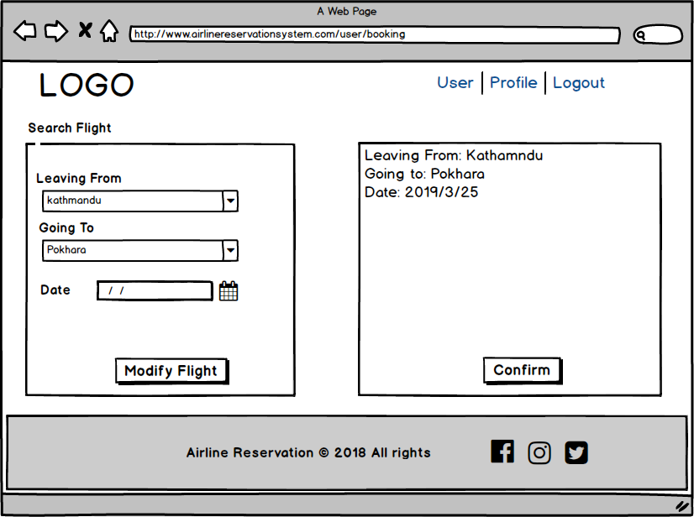

1. Reservation

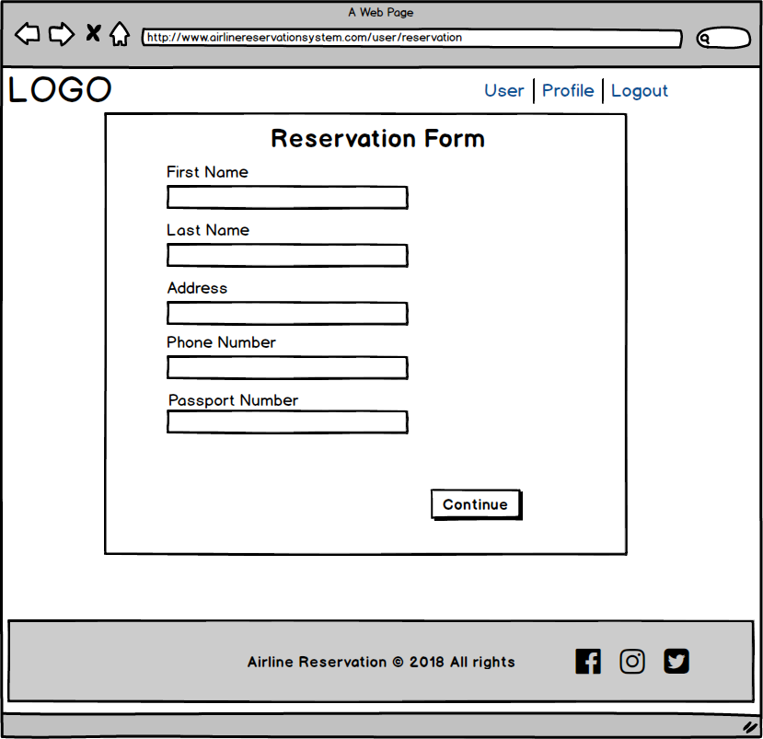

1. Email Confirmation

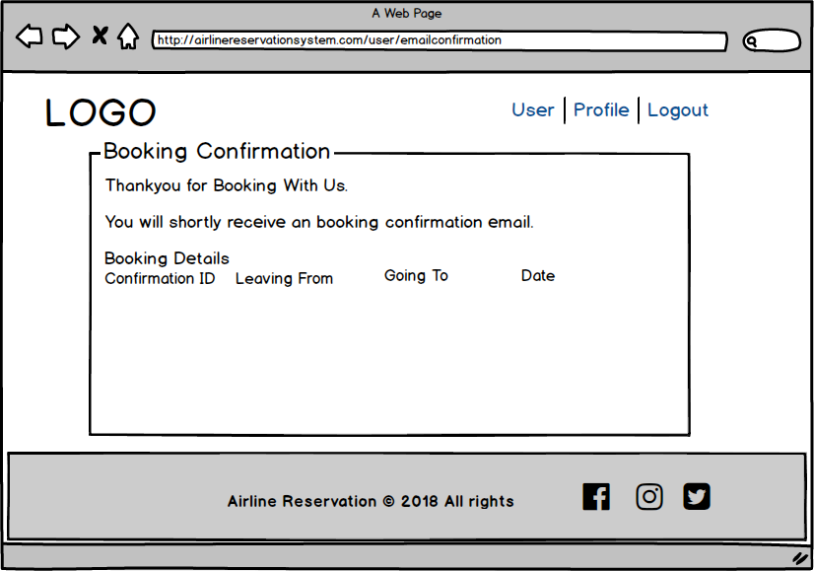

1. Feedback

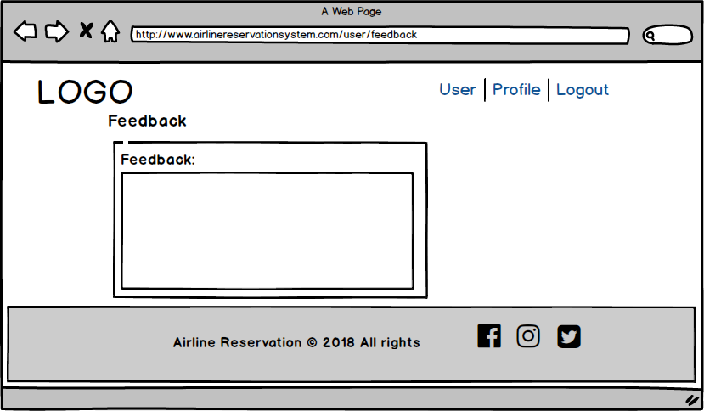

1. Forum

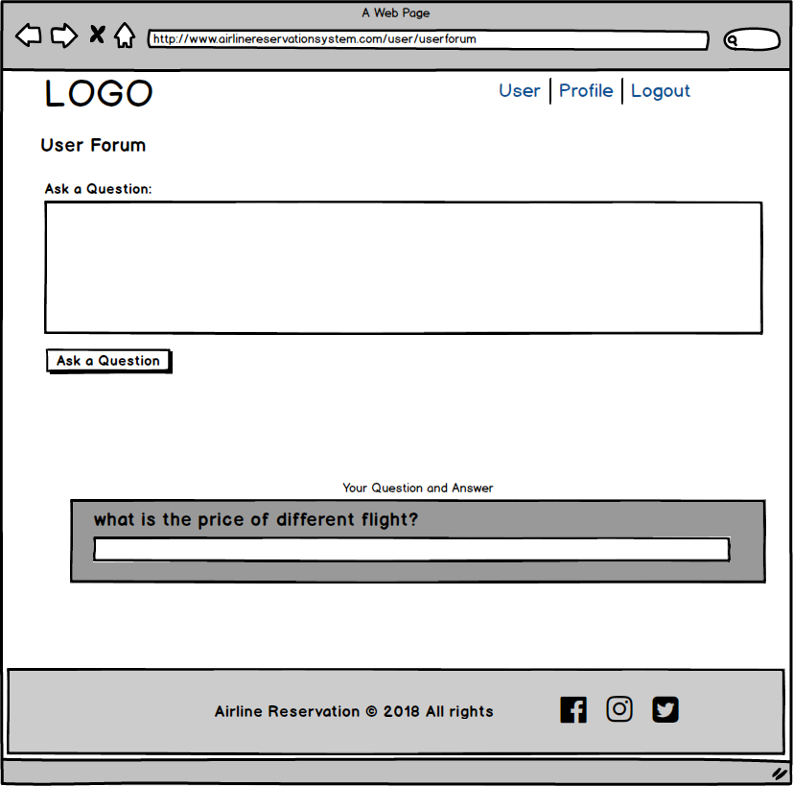

1. User Profile

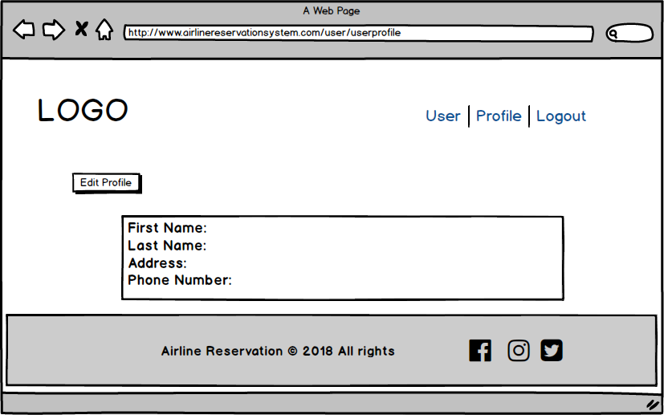

1. Edit Profile

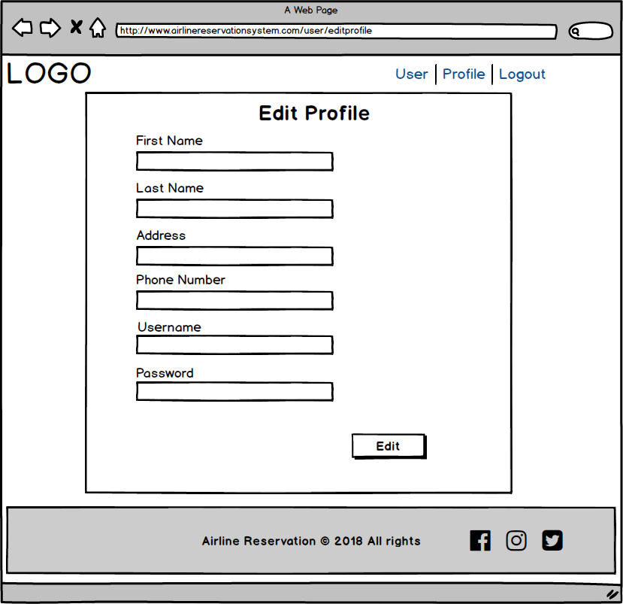

1. Flight Cancellation

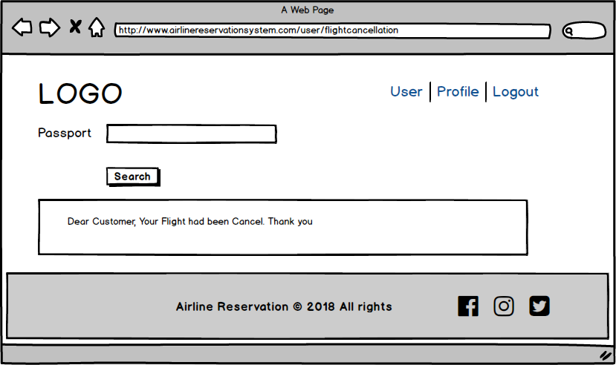

1. Where

