Table of Contents

**Chapter 1: Introduction** 4

**1.1 Introduction** 4

**1.2 Background of the Project** 4

**1.4 Description of the Project** 5

**1.4.1 Features of the Project** 5

**1.5 Overview of the Project** 5

**Chapter 2: Scope of the Project** 6

**2.1 Scope** 6

**2.2 Limitation** 6

**2.3 Aims** 6

**2.4 Objective** 6

**2.5 Overview of the Scope** 7

**Chapter 3: Development Methodology** 8

**3.1 Description of Methodology** 8

**3.2 Design Pattern** 10

**3.3 Architecture** 11

**Chapter 4: Project Planning** 12

**4.1 WBS (Work Breakdown Structure)** 12

**4.2 Milestone** 13

**4.3 Gantt Chart** 14

**Chapter 5: Risk Management** 16

**Chapter 6** 18

**Configuration Management** 18

**Chapter 7 Conclusion** 19

**Chapter 8** 20

**References** 20

**Table of Figure**

**Figure 1: Waterfall Model 8**

**Figure 2: Model View Controller 10**

**Figure 3: Client Server Architecture 11**

**Figure 4:Work Breakdown Structure 12**

**Figure 5: Milestone 13**

**Figure 6: Time Schedule 14**

**Figure 7: Gantt chart 15**

**Figure 8: Likelihood 16**

**Figure 9: Consequence 16**

**Figure 10: Risk Management 17**

**Figure 11: Configuration Management 18**

# **Chapter 1: Introduction**

## **1.1 Introduction**

In this modern age most of the things are all computerized. So to stay in touch with this environment record keeping system of Airline Reservation System will also be created in a computerized way.

This project mainly focuses on providing help to the customers in booking their airline tickets without going to any booking vendors. Airlines Reservation System is not all about only

Booking the tickets but it will also give information on schedule and reschedule flight, seats on flights, flights which are cancelled, available flight dates and their arrival and departure time. Once the flight ticket is booked customer will be able to see the reservation and each details related to his/her reservation. Each and every notice will be updated to the passenger related to his/her flight.

This is a user friendly application so that the user will find it easier to perform task with friendlier interface. Computer experience is not required for using this application.

## **1.2 Background of the Project**

There are high number of airline companies which has outcome tough competition in the industry of airline. People loss their valuable time to book the ticket and also it cost alot in its processing as they need to reach booking vendor or offices. Owners are unable to monitor the business when they are far from company. To update and to notice it consumes time. Data and information cannot be backup when it is loss. These is the reason the Airline Reservation System is needed to be describe and also many more related to it.

**1.3 Problem statement**

The valuable time and energy of people are lost only to book the flight tickets. If any of the data is loss it cannot be backup. The queue of people are there when they need to know their flights departure and arrival time. The system shall allow the users to look after the entire flight detail of the book tickets, airline flights departure and arrival time.

## **1.4 Description of the Project**

Airline Reservation System will contain ticket records, reservation of passenger and also schedules of flights. It will provide online procedure to book the flight which helps in saving time.

To store the record, data My SQL Database application has been planned for the used. The connectivity of the database is planned by using the “SQL Connection” methodology. This will help the customers to look the prices and availability of different air tickets of airlines.

### **1.4.1 Features of the Project**

The features of Airline Reservation system are as follow:

1. Customers can know the flight details.
2. Flight tickets can be booked from mobile.
3. The options for payment are available.
4. The customers can know about the description of reservation once the ticket is reserved.

## **1.5 Overview of the Project**

Airline Reservation System will have details about the records of tickets, flights schedule and reservation of tickets. Customer will be provided with notice related to his/her flights. Payment methods are available. There are total of 10 destinations where flights are operated by Air Alliance in Nepal. They are Pokhara, Chitwan, Kathmandu, Jhapa, Jumula, Jomsom, Jiri, Manang, Mugu, and Janakpur.

# **Chapter 2: Scope of the Project**

## **2.1 Scope**

This project designs and implements Airline Reservation System which is supported by database. Available flight information will be combined together to make the passengers life easy as they will be able to do reservations on any airline through a single system. It will also display the number of passengers that will go to board on a same flight. All users will follow the exact same steps even if they are using any kind of system access which will keep the system consistency.

## **2.2 Limitation**

1. Reservation and Cancellation of ticket services
2. The project will not be focusing on international airlines yet.

## **2.3 Aims**

1. To build the application that will provide easy way of booking flight reservation and know flight details for the customer who will use airline website.

## **2.4 Objective**

1. This system will save time and manpower.
2. To create a secured system to ensure that customer’s information and data are insert into database.
3. Online, booking, reservation form will be created to allow users to make an online booking.
4. To make passenger satisfied by reaching them at their destination.
5. It will have high storage capability.
6. Data redundancy will decrease.
7. To make user friendlier and easier Airline Reservation System.

## **2.5 Overview of the Scope**

It will help Airline Company in department of ticket reservation and administration staff will use this system for helping passenger in flight reservation, providing flight details through website that is integrated. This system will decrease work pressure to the labor and will save time.

# **Chapter 3: Development Methodology**

## **3.1 Description of Methodology**

I am going to use waterfall model. Waterfall model is the sequential design method in which the progress can be seen flowing straightly downwards through different phases. The phases cannot be overlapped perhaps each phases need to be completed to move for next steps.

Advantages of waterfall model are as follows:

1. It is easy to understand and use.
2. It is best to use for the smaller project as the requirement are understood well.
3. Every steps of has exact deliverable and a process of review.
4. The processing of stages are done and finished one at a time.

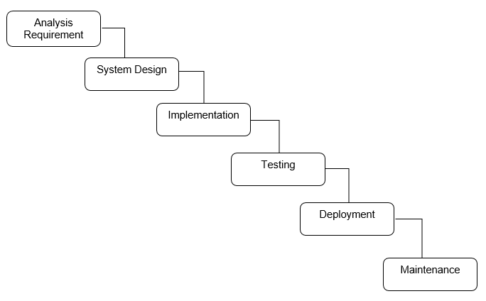

**Figure 1: Waterfall Model**

**Object Oriented Analysis (OOA)**

I am going to use object oriented analysis for developing this website. It is the way of identifying necessary needs or requirements which leads to the success of the system. Object are organized as the requirements in OOA. The information is produce in a conceptual model. Some of the models used in OOA are object model and Use cases. Object model defines the relation of class, name, properties and operations of the objects that are important. Images are defined by Use Cases.

**The reasons of using OOA:**

1. It helps to implement upgrade easily from small to large system.
2. It supports or focuses mainly on data.
3. It helps to develop the systems that cannot be damaged or spoiled by any other system components.

## **3.2 Design Pattern**

For developing my project I will be using Model View Controller (MVC) design pattern. It has three components. The model component connects to all the logic-related data with which the users work. For each and every UI logic of the application the component view is used. The controller process all the logic of business and request that are incoming acting as the interface between model and view components. Using model it manipulates the data and interacts with the views to give the final output.

The reasons to use MVC design pattern are as follows:

1. It supports multiple views.
2. It does not affect the entire system when the modification is applied.
3. It increases the speed of development process.
4. It returns the data without formatting it.

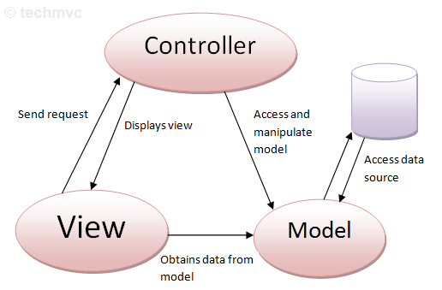

**Figure 2: Model View Controller**

## **3.3 Architecture**

I will use the client architecture for developing my system. The reason for using architecture are as follows:

1. It helps in decreases the network traffic.
2. It permits multiuser updating through a GUI front end to share the database.
3. It guarantee the data integrity.
4. The functions are possibly distributed between the nodes of network.

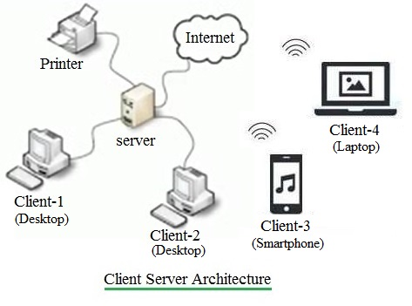

**Figure 3: Client Server Architecture**

# **Chapter 4: Project Planning**

## **4.1 WBS (Work Breakdown Structure)**

A Work Breakdown structure (WBS) is used in the project to break it down into manageable smaller parts making project easy to understand and helps to complete in time.

The reason of using WBS in arrangement for all project are as follows:

1. It helps in organizing the scope of whole project.
2. It helps to assign the control of project, responsibilities, etc.
3. It helps in making deliverables more accurate.

To evaluate the Work Breakdown Structure (WBS)

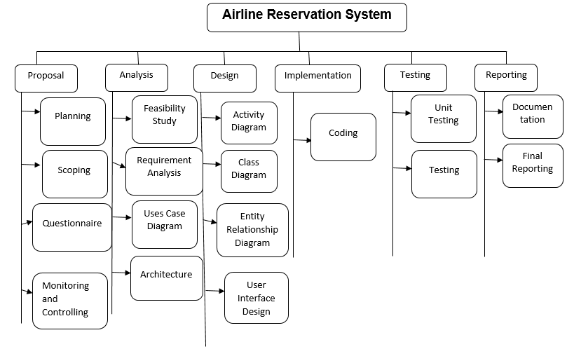

**Figure 4: Work Breakdown Structure**

## **4.2 Milestone**

The tools that are used in project management for measuring the progress of a project moving forward to its goal is known as milestone. It also helps you to be sure that you stay on track.

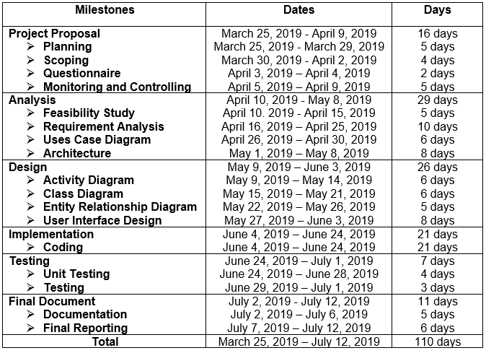

**Figure 5: Milestone**

The figure of my configuration system is created and shown above. I have made seven separate file named Proposal, Analysis, Design, Implementation, testing, Final Documentation and Backup. In the Proposal folder the report are created which includes proposal for this project. Then moving on to Analysis folder I have analyzed all the requirements needed for the development of the project after a good study and research. The Design folder holds the diagram likewise, activity diagram, class design, etc are all stored in design file. All the coding are saved in Implementation file. In testing file the output after unit testing applied in application is stored. In Final Reporting folder Final Documentation of this project is completed. At last in Backup folder the all other folder listed above is saved as per the change for managing the back up.

## **4.3 Gantt Chart**

Gantt chart is used in project management as it helps in representing activities such as events or tasks that is displayed against time. It will help in coordinating, planning and tracking the tasks in a project.

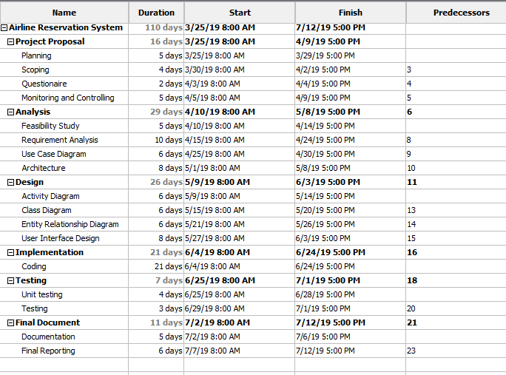

**Figure 6: Time Schedule**

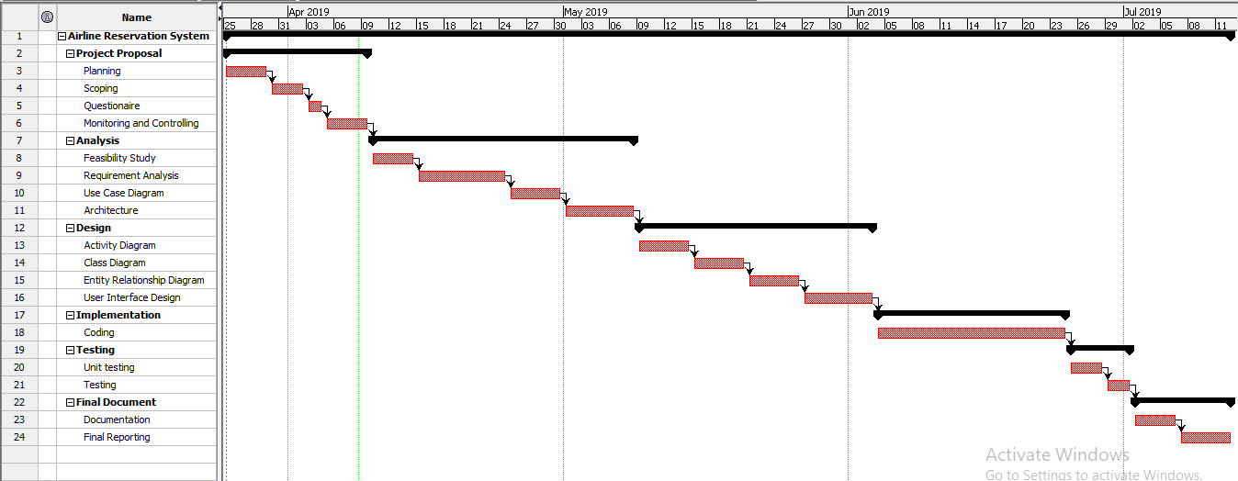

**Figure 7: Gantt chart**

# **Chapter 5: Risk Management**

Risk Management can be defined as identifying and managing the threat. It helps in reducing problems that might affect the project. Risk that occur frequently and makes large amount of loss are handle first and threat with chance of less occurrence and loss are deal in descending order.

Risk can come from different source likewise natural disaster, fail of project and many more. Some risk can be avoided and some cannot be avoided. Natural disaster is unavoidable risk so backup must be kept to face these risk. Analyzation of threats and preventive measures must be taken to reduce the risk.

To evaluate the effect of each risk are:

**Impact = Likelihood * Consequence**

Three options of likelihood are:

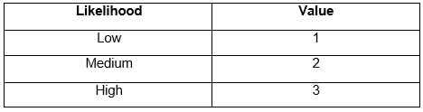

**Figure 8: Likelihood**

There are five options of consequences are:

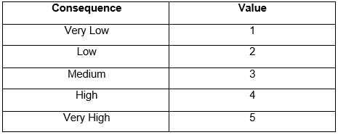

**Figure 9: Consequence**

The following table is of Risk Management:

# 

**Figure 10: Risk**

# **Chapter 6**

## **Configuration Management**

All project are saved in two locations. One is in the local device in which all the files are created and next one is in GitHub (<https://github.com/maharjansumina/Computing-Project>) which is under the title – Computing-Project. These two locations are in sync using the Git Bash.

Configuration Management is the body of collection of tools, activities, methods and projects. Member of project can use configuration management for managing items in the time of project life cycle. The project composition, project documentation and other supporting project is addressed.

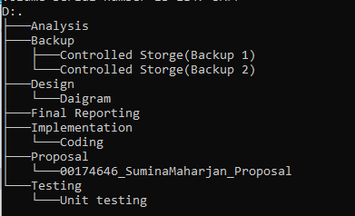

**Figure 11: Configuration Management**

The figure of my configuration system is created and shown above. I have made seven separate file named Proposal, Analysis, Design, Implementation, testing, Final Documentation and Backup. In the Proposal folder the report are created which includes proposal for this project. Then moving on to Analysis folder I have analyzed all the requirements needed for the development of the project after a good study and research. The Design folder holds the diagram likewise, activity diagram, class design, etc are all stored in design file. All the coding are saved in Implementation file. In testing file the output after unit testing applied in application is stored. In Final Reporting folder Final Documentation of this project is completed. At last in Backup folder the all other folder listed above is saved as per the change for managing the back up.

# **Chapter 7 Conclusion**

Therefore, the application will be user friendly and easy for booking flights. In the proposal aim and objective of the project is listed. The application will have it limitation as listed above. Waterfall model will be used for developing this application. Estimation of schedule for project is done after the research and it is presented in diagram called Gantt chart. Configuration Management will be used for the backup of files.

# **Chapter 8**

## **References**

* Workbreakdownstructure.com. (2019). *What is a Work Breakdown Structure - Workbreakdownstructure.com*? [Online]

Available at: <https://www.workbreakdownstructure.com/> [Accessed 3 Apr. 2019].

* www.tutorialspoint.com. (2019). *SDLC Waterfall Model*. [Online]

Available at: [https://www.tutorialspoint.com/sdlc/sdlc_waterfall_model.htm](https://www.tutorialspoint.com/sdlc/sdlc_waterfall_model.htm%20) [Accessed 6 Apr. 2019].

* Apm.org.uk. (2019). *What is configuration management? | APM*. [Online]

Available at: <https://www.apm.org.uk/body-of-knowledge/delivery/scope-management/configuration-management/> [Accessed 7 Apr. 2019].

* Alam, R. (2019). *Object Oriented Analysis (OOA) | Cybarlab*. [online] Cybarlab.com.

Available at: <https://cybarlab.com/ooa> [Accessed 9 Apr. 2019].