# **Chapter 3: Development Methodology**

## **3.1 Description of Methodology**

I am going to use waterfall model. Waterfall model is the sequential design method in which the progress can be seen flowing straightly downwards through different phases. The phases cannot be overlapped perhaps each phases need to be completed to move for next steps.

Advantages of waterfall model are as follows:

1. It is easy to understand and use.
2. It is best to use for the smaller project as the requirement are understood well.
3. Every steps of has exact deliverable and a process of review.
4. The processing of stages are done and finished one at a time.

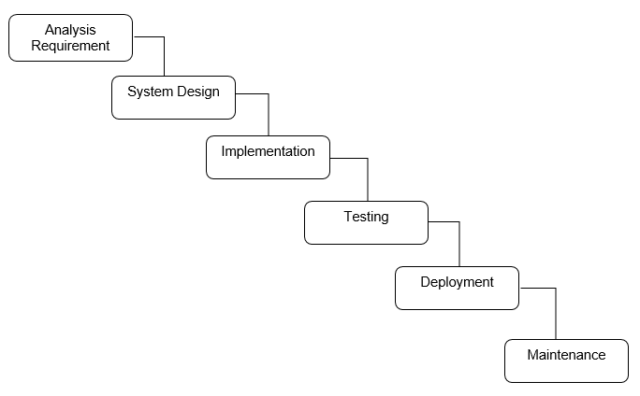

Figure: Waterfall Model

The phases of waterfall model are as follow:

1. **Requirement Analysis:**

As the development cannot go backwards to modify the previous phase the requirement analysis is needed to gather nicely in the beginning.

1. **System Design:**

System design helps in describing the hardware and requirement of software and in defining the overall system architecture. Those software code which will be written in next phase of model is created at this phase.

1. **Implementation:**

Firstly the system is built in units (small program) those are combined in the next phase. After the development of each units the test is performed for its functionality known as Unit Testing.

1. **Testing:**

The units that are developed in implementation phase are now combines and a full system is developed. The whole system is tested before the system is deployed.

1. **Deployment:**

When the testing phase is completed, the product is released into the market deploying it in the customer environment.

1. **Maintenance:**

At the time of using system, errors can occur. So for debugging those errors modification to the system should be involved and fix the errors for long lasting period of time.

**Object Oriented Analysis (OOA)**

I am going to use object oriented analysis for developing this website. It is the way of identifying necessary needs or requirements which leads to the success of the system. Object are organized as the requirements in OOA. The information is produce in a conceptual model. Some of the models used in OOA are object model and Use cases. Object model defines the relation of class, name, properties and operations of the objects that are important. Images are defined by Use Cases.

**Benefit of OOA:**

1. The upgrade can be implement easily from small to large system.
2. It supports or focuses mainly on data.
3. Encapsulation and data hiding helps in developing the systems that cannot be damaged or spoiled by any other system components.

## **3.2 Design Pattern**

For developing my project I will be using Model View Controller (MVC) design pattern. It has three components. The model component connects to all the logic-related data with which the users work. For each and every UI logic of the application the component view is used. The controller process all the logic of business and request that are incoming acting as the interface between model and view components. Using model it manipulates the data and interacts with the views to give the final output.

## **3.3 Architecture**

I will use the client architecture for developing my system. It decreases the network traffic. For sharing the database it permits multiuser updating through a GUI front end. The data integrity is guaranteed, the functions are possibly distributed between the nodes of network.