**Aim: Introduction to HTML and web technology .**

**Code:**

<!DOCTYPE html>

<html lang="en">

<head>

<meta charset="UTF-8">

<meta name="viewport" content="width=<device-width>, initial-scale=1.0">

<title>Lab 1</title>

<style>

body{

}

.pdeu{

width: 100%;

text-align: center;

background-color: #eceeff;

padding: 5px;

}

nav {

width: 100%;

float: left;

text-align: right;

background: #7157b9;

padding:15px;

}

nav a {

color: #fff;

text-decoration: none;

font-size: 17px;

border-right: 1px solid #ffc3c3;

padding:2px 20px;

}

</style>

</head>

<body>

<div class="pdeu">

<h1>Pandit Deendayal Energy University(21BIT057)</h1>

</div>

<nav>

<div>

<a href="#">Department</a>

<a href="#">Course Details</a>

<a href="#">Faculties</a>

<a href="#">Library</a>

</div>

</nav>

<h4>Courses</h4>

<ul>

<li><a href="#">Course 1</a></li>

<li><a href="#">Course 2</a></li>

<li><a href="#">Course 3</a></li>

</ul>

<h4>Departments</h4>

<ul>

<li><a href="#">Department 1</a></li>

<li><a href="#">Department 2</a></li>

<li><a href="#">Department 3</a></li>

<li><a href="#">Department 4</a></li>

</ul>

<h4>Faculties</h4>

<ul>

<li><a href="#">faculty 1</a></li>

<li><a href="#">faculty 2</a></li>

<li><a href="#">faculty 3</a></li>

<li><a href="#">faculty 4</a></li>

</ul>

<h4>Library</h4>

Information about the library course here

<footer>

&copy; All rights reserved by Pandit Deendayal Energy University.

</footer>

</body>

</html>

**Web page :**

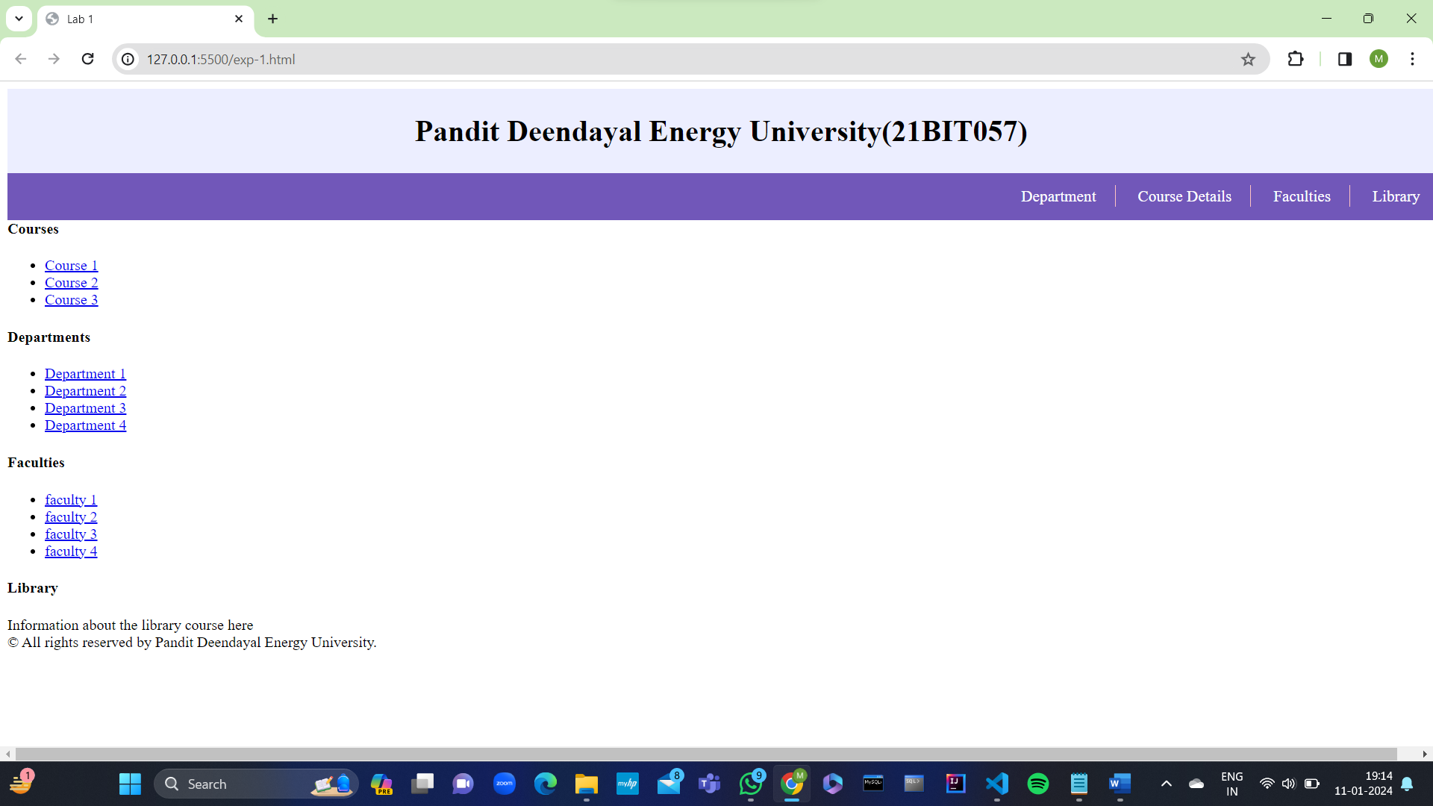

**Questions:**

1.What is Version and its syntax?

Software versioning is the process of assigning either unique version names or unique version numbers to unique states of computer software. Within a given version number category (e.g., major or minor), these numbers are generally assigned in increasing order and correspond to new developments in the software. At a fine-grained level, revision control is used for keeping track of incrementally-different versions of information, whether or not this information is computer software, in order to be able to roll any changes back.

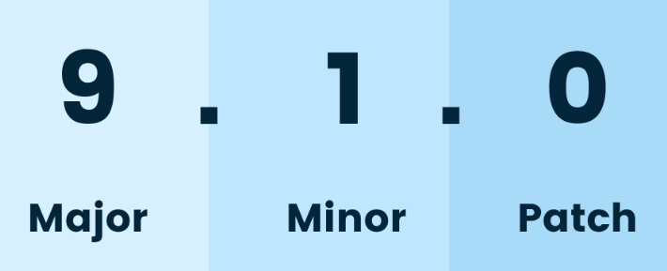

2. What are the latest versions of html css js?

The Latest Version of HTML is HTML5 and for CSS is CSS3. CSS3 is the current version of CSS that implements new animation and transition properties, allows gradients, webfonts, advanced selectors and a few built in functions that differ greatly from CSS2.

3. What is the diff between old and new html css?

HTML 5 is the latest and more advanced version of HTML 4. HTML5 comes with new tags, new features, and has simplified various functions. While many people considered HTML 4 a bit complicated, HTML5 offers more flexibility to developers in making a stunning website.

4. What is UTF-8 ?

UTF-8 is a variable-length character encoding standard used for electronic communication. Defined by the Unicode Standard, the name is derived from Unicode Transformation Format – 8-bit.

Conclusion :

In conclusion, HTML, or HyperText Markup Language, serves as the fundamental building block of the World Wide Web, providing the structural foundation for web content. Its simplicity and versatility make it an essential language for creating and organizing information on the internet. As a markup language, HTML enables the seamless integration of text, images, links, and multimedia elements, facilitating the creation of interactive and visually appealing web pages.