**Experiment-3(a)**

**Aim:** create feed-back from using html and css.

**Code:**

<!DOCTYPE html>

<html lang="en">

<head>

<meta charset="UTF-8">

<meta name="viewport" content="width=device-width, initial-scale=1.0">

<title>Feedback Form</title>

<style>

body {

font-family: 'Arial', sans-serif;

margin: 0;

padding: 0;

overflow-x: hidden; /* Hide horizontal scrollbar */

}

/* Background Animation */

body::before {

content: "";

position: fixed;

top: 0;

left: 0;

width: 100%;

height: 100%;

z-index: -1;

background: linear-gradient(45deg, #3498db, #2ecc71);

opacity: 0.5;

animation: gradientAnimation 10s infinite alternate;

}

@keyframes gradientAnimation {

0% {

background-position: 0% 0%;

}

100% {

background-position: 100% 100%;

}

}

form {

max-width: 600px;

margin: 50px auto;

background-color: #fff;

padding: 20px;

border-radius: 10px;

box-shadow: 0 0 10px rgba(0, 0, 0, 0.1);

animation: fadeIn 1s ease-out;

}

@keyframes fadeIn {

from {

opacity: 0;

transform: translateY(-20px);

}

to {

opacity: 1;

transform: translateY(0);

}

}

h2 {

text-align: center;

color: #333;

}

label {

display: block;

margin-bottom: 8px;

transition: color 0.3s ease;

}

label:hover {

color: #4caf50;

}

input[type="text"],

select {

width: 100%;

padding: 8px;

margin-bottom: 15px;

box-sizing: border-box;

transition: box-shadow 0.3s ease;

}

input[type="text"]:hover,

select:hover {

box-shadow: 0 0 5px rgba(0, 0, 0, 0.1);

}

input[type="radio"] {

margin-right: 5px;

transition: transform 0.2s ease;

}

input[type="radio"]:hover {

transform: scale(1.1);

}

.feedback {

padding: 15px;

background-color: #f9f9f9;

border-radius: 8px;

box-shadow: 0 0 5px rgba(0, 0, 0, 0.1);

animation: fadeIn 1s ease-out;

}

button {

background-color: #4caf50;

color: white;

padding: 10px 15px;

border: none;

border-radius: 5px;

cursor: pointer;

transition: background-color 0.3s ease, transform 0.2s ease;

}

button:hover {

background-color: #45a049;

transform: scale(1.1);

}

/* The container */

.container {

display: block;

position: relative;

padding-left: 35px;

margin-bottom: 12px;

cursor: pointer;

font-size: 22px;

-webkit-user-select: none;

-moz-user-select: none;

-ms-user-select: none;

user-select: none;

}

/* Hide the browser's default radio button */

.container input {

position: absolute;

opacity: 0;

cursor: pointer;

}

/* Create a custom radio button */

.checkmark {

position: absolute;

top: 0;

left: 0;

height: 25px;

width: 25px;

background-color: #eee;

border-radius: 50%;

}

/* On mouse-over, add a grey background color */

.container:hover input ~ .checkmark {

background-color: #ccc;

}

/* When the radio button is checked, add a blue background */

.container input:checked ~ .checkmark {

background-color: #2196F3;

}

/* Create the indicator (the dot/circle - hidden when not checked) */

.checkmark:after {

content: "";

position: absolute;

display: none;

}

/* Show the indicator (dot/circle) when checked */

.container input:checked ~ .checkmark:after {

display: block;

}

/* Style the indicator (dot/circle) */

.container .checkmark:after {

top: 9px;

left: 9px;

width: 8px;

height: 8px;

border-radius: 50%;

background: white;

}

</style>

<script>

function myFunction() {

document.getElementById("form").innerHTML = "<h1>Thank you</h1> for your valuable Feedback";

}

</script>

</head>

<body>

<form id="form">

<h2> Feedback Form</h2>

<div class="student_details">

<label for="sname">Student Name:</label>

<input type="text" id="sname" name="sname">

<label for="sroll">Student Roll: </label>

<input type="text" id="sroll" name="sroll">

</div>

<div class="teachers_details">

<label for="teacher_name">Teacher Name :</label>

<select id="teacher_name" name="teacher_name">

<option value="select">Choose faculty Name</option>

<option value="santosh">Santosh Santhpathy</option>

<option value="shivangi">Shivangi Mehta</option>

<option value="nitin">Nitin Rajput</option>

<option value="hardik">Hardik Vyas</option>

<option value="moro">Mohendra Roy</option>

</select>

</div>

<div class="subname">

<label for="subname">Subject Name :</label>

<select id="subname" name="subname">

<option value="select">choose Subject Name</option>

<option value="AI">AI system</option>

<option value="CCN">Computer Communication and Networks</option>

<option value="Cloud">Cloud Architecture and servises</option>

<option value="web">Web Technology</option>

<option value="Embedded">Embedded System</option>

</select>

</div>

<div class="feedback">

<h3>Rating</h3>

<label class="container">1

<input type="radio" checked="checked" name="radio">

<span class="checkmark"></span>

</label>

<label class="container">2

<input type="radio" name="radio">

<span class="checkmark"></span>

</label>

<label class="container">3

<input type="radio" name="radio">

<span class="checkmark"></span>

</label>

<label class="container">4

<input type="radio" name="radio">

<span class="checkmark"></span>

</label>

<label class="container">5

<input type="radio" name="radio">

<span class="checkmark"></span>

</label>

<br><br>

<label for="sbox">Type your Suggestion Here:</label>

<input type="text" id="sbox" name="sbox">

<input type="checkbox" id="cbox" name="cbox"> <label for="cbox">Send a response to E-mail</label>

</div>

<button type="button" onclick="myFunction()">Submit your feedback</button>

</form>

</body>

</html>

**Output:**

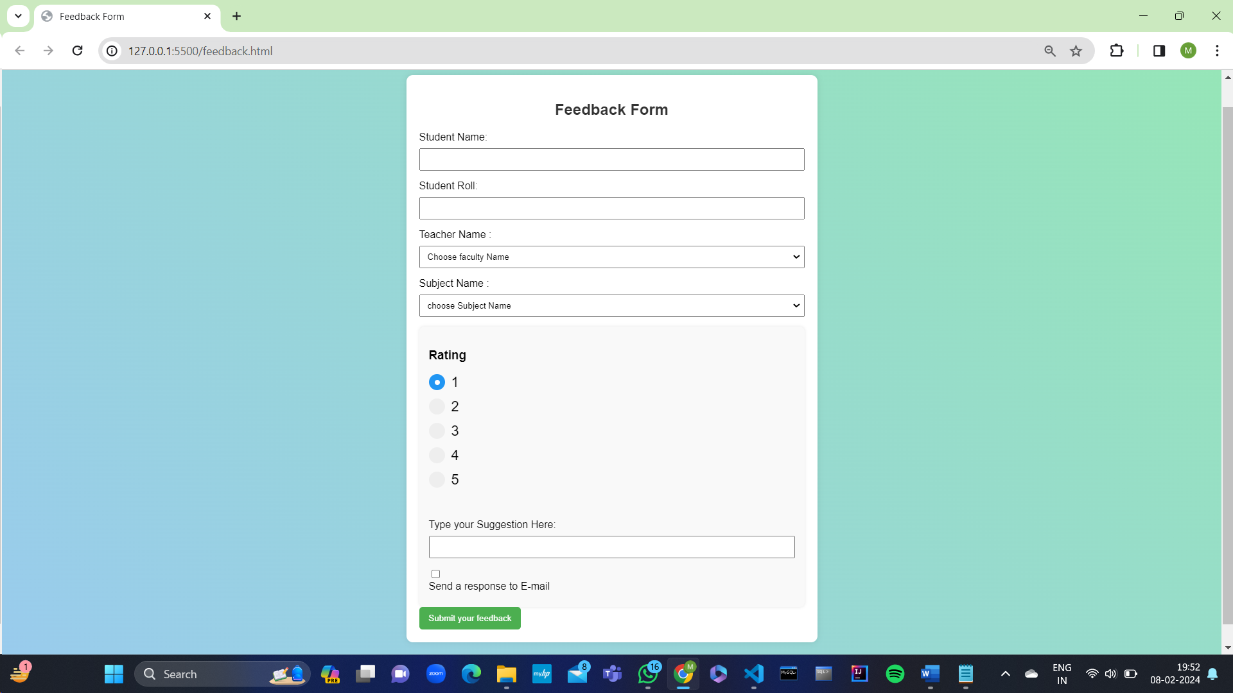

**Experiment-3(b)**

**Aim :** create resume page using html and css.

**Code:**

**main.html**

<!DOCTYPE html>

<html lang="en">

<head>

<meta charset="UTF-8">

<meta name="viewport" content="width=device-width, initial-scale=1.0">

<title>Document</title>

<style>

*{

margin: 0;

padding: 0;

}

.left{

width: 20vw;

height: 100vh;

border: 2px solid black;

border-radius: 10px;

margin-right: 5px ;

margin-left: 2px;

}

.right{

width: 80vw;

height: 100vh;

border: 2px solid black;

border-radius: 10px;

}

.container{

display: flex;

}

</style>

</head>

<body>

<div class="container">

<iframe src="navigation.html" frameborder="0" class="left"></iframe>

<iframe src="display.html" frameborder="0" class="right" name="contentFrame"></iframe>

</div>

</body>

</html>

**diplay.html**

<!DOCTYPE html>

<html lang="en">

<head>

<meta charset="UTF-8">

<meta name="viewport" content="width=device-width, initial-scale=1.0">

<title>Document</title>

</head>

<body>

<h1>welcome to my website</h1>

</body>

</html>

**Navigation.html**

<!DOCTYPE html>

<html lang="en">

<head>

<meta charset="UTF-8">

<meta name="viewport" content="width=device-width, initial-scale=1.0">

<title>Document</title>

<style>

a{

text-decoration: none;

font-size:xx-large;

color:rgb(120, 62, 158);

}

</style>

</head>

<body>

<a href="content.html" target="contentFrame">About me</a>

</body>

</html>

**Content.html**

<!DOCTYPE html>

<html lang="en">

<head>

<meta charset="UTF-8">

<meta name="viewport" content="width=device-width, initial-scale=1.0">

<title>Document</title>

<style>

a{

text-decoration: none;

color: black;

}

h1{

text-align: center;

font-size: 50px;

}

</style>

</head>

<body>

<h1>Maharsh Patel</h1>

<div class="container">

<li>Email : <a href="https://www.google.com/" target="_blank">maharshpatel18@gmail.com</a></li>

<li>github : <a href="https://github.com/maharsh-1803" target="_blank">https://github.com/maharsh-1803</a></li>

<li>Educaion : Infromation and Communication Technology from pandit deendayal Energy</li>

<li>Skills : HTML , CSS , JavaScript , JAVA , c++ , MERN</li>

</div>

</body>

</html>

**Output:**

