 | GoAir(Airport Management System)  Technical Design Document
 | Prepared By / Last Updated By | Reviewed By | Approved By
Name
Role
Signature
Date

Table of Contents

1.0 Introduction 3
1.1 Purpose of this document 3
1.2 Project overview 3
2.0 Solution Summary 3
2.1 Scope 3
2.2 Assumptions 3
2.3 Dependencies 3
2.4 Risks 3
3.0 Schematic Diagram 3
4.0 System Design 4
4.1 Proposed design 4
4.2 Component inventory 4
5.0 Database Design 4
5.1 Data Model 4
5.2 Tables Structure 4
6.0 Appendices 4
6.1 Glossary 4
6.2 Other 5
7.0 Terms & Conditions 5
8.0 Change Log 5

Introduction

Purpose of this document
The purpose of this document is to document the technical design, component details and Database design. This will also capture the scope, assumptions, risk, dependencies of this project.

Project overview
The Airport Management System is a system to add the plane information along with pilot details, add the Hangar and add the allotting Hangars to the planes, scheduling of the Hangars availability.

The following are the important modules in the system

Adding Planes
Adding Pilots
Adding Hangars Details
Allotting the planes into Hangars.
Get Hangar Status
Admin Registration

Manager Registration

Pilot Registration

Solution Summary

Scope
The GoAir is an Airport Management System encompass with different components. Main features of this system are adding planes, adding pilots, adding hangar details, allotting planes to hangars etc. There are three users like admin, manager, pilot and each has got different privileges and functionalities.
Admin has to approve managers and pilots, also he has to add planes and hangars. Manager has the privilege to view the hangars allocated to him and add planes to it. Pilot can update the flight schedule.

Assumptions
None

Dependencies
Technology | Hardware | Software
DotNet | Desktop PC with 8GB RAM | Node.js 10.16.0  Angular 8.3.19  Visual Studio Code IDE  Visual Studio IDE  Enity Framework  Microsoft SQL Server  Microsoft SQL Server Management Studio  Postman  DotNet Core SDK

Risks
None

Schematic Diagram
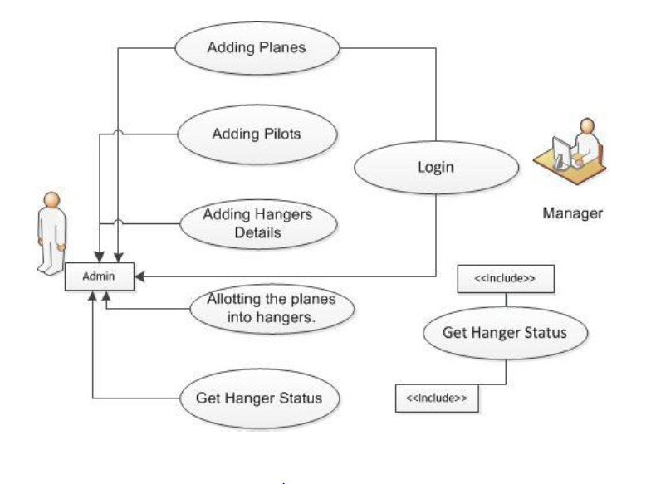

System Design

Proposed design
The Proposed design for GoAir (Airport Management System) is to automate the functionalities of Admin, Manager and Pilot in an Airport. Planes and Hangars can be allocated to pilots and planes easily by using this system.

Component inventory

4.2.1 Admin

Admin home

Admin Login

Admin registration

View Requests
- Approve/Reject Manager/Pilot
- Add, View and update Planes
- Add Hangars
- Schedule Pilot work
- Feedback

4.2.2 Manager

Manager Login

Manager registration

Manager home
- View, Allot Hangars

4.2.2 Pilot

Pilot Login

Pilot registration

Pilot home
- Update Flight Plan

4.2.3 Home
- Home

Database Design

Data Model
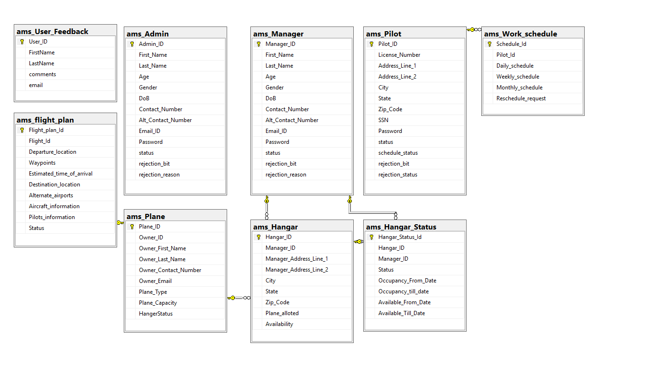

Tables Structure
Manager
Column Name | Data type | Length | Constraint
Manager_ID | bigint | 12 | Primary key, Not null
First_Name | varchar | 50 | Not Null
Last_Name | varchar | 50 | Not Null
Age | int | 2 | Not Null
Gender | varchar | 10 | Not Null
Contact_Number | bigint |  | Not Null
Alt_Contact_No | bigint |  | Not Null
Email_ID | varchar | 50 | Not Null
Password | varchar | 15 | Not Null
DOB | date |  | Not Null
status | Boolean
Rejection_bit | Boolean
Rejection_reason | Varchar | 50

Admin
Column Name | Data type | Length | Constraint
Admin_ID | bigint | 12 | Primary key, Not null
First_Name | varchar | 50 | Not Null
Last_Name | varchar | 50 | Not Null
Age | int | 2 | Not Null
Gender | varchar | 10 | Not Null
Contact_Number | bigint |  | Not Null
Alt_Contact_No | bigint |  | Not Null
Email_ID | varchar | 50 | Not Null
Password | varchar | 15 | Not Null
DOB | date |  | Not Null
status | Boolean
Rejection_bit | Boolean
Rejection_reason | varchar | 50

Pilot
Column Name | Data type | Length | Constraint
Pilot_ID | bigint | 12 | Primary key, Not null
License_Number | varchar | 100 | Not Null
Address_Line_1 | Varchar | 100 | Not Null
Address_Line_2 | Varchar | 100 | Not Null
City | Varchar | 100 | Not Null
State | Varchar | 100 | Not Null
Zip_Code | varchar | 10 | Not Null
SSN | int | 50 | Not Null
Password | varchar | 15 | Not Null
Status | boolean
Schedule_status | Boolean
Rejection_bit | Boolean
Rejection_reason | Varchar | 50

Plane
Column Name | Data type | Length | Constraint
Plane_ID | Int | 12 | Primary key, Not null
Owner_ID | Int | 10 | Not Null
Owner_First_Name | varchar | 50 | Not Null
Owner_Last_Name | Varchar | 50 | Not Null
Owner_Contact_Number | bigint |  | Not Null
Owner_Email | Varchar | 50 | Not Null
Plane_Type | Varchar | 50 | Not Null
Plane_Capacity | bigint | 50 | Not Null
HangerStatus | Varchar | 50 | Not Null

Hangar
Column Name | Data type | Length | Constraint
Hangar_ID | bigint | 12 | Primary key, Not null
Manager_ID | varchar | 100 | Foreign Key, Not Null
Manager_Address_Line_1 | Varchar | 100 | Not Null
Manager_Address_Line_2 | Varchar | 100 | Not Null
City | Varchar | 100 | Not Null
State | Varchar | 100 | Not Null
Zip_Code | varchar | 10 | Not Null
Plane_alloted | int
Availability | Boolean

Hangar Status
Column Name | Data type | Length | Constraint
Hangar_Status_ID | int | 12 | Primary key, Not null
Hangar_ID | Bigint |  | Foreign Key, Not Null
Manager_ID | Bigint |  | Foreign KeyNot Null
Status | Varchar | 50 | Not Null
Occupancy_From_Date | date |  | Not Null
Occupancy_Till_Date | date |  | Not Null
Available_From_Date | date |  | Not Null
Available_Till_Date | date |  | Not Null

Feedback
Column Name | Data type | Length | Constraint
User_ID | bigint | 12 | Primary key, Not null
FirstName | Varchar | 200 | Not Null
LastName | Varchar | 200 | Not Null
Comments | Varchar | 200 | Not Null
email | Varchar | 200 | Not Null

Work Schedule
Column Name | Data type | Length | Constraint
Schedule_ID | bigint | 12 | Primary key, Not null
Pilot_ID | Varchar | 50 | Not Null
Daily_Schedule | Varchar | 50 | Not Null
Weekly_Schedule | varchar | 50 | Not Null
Monthly_Schedule | Varchar | 50 | Not Null
Reschedule | boolean

Flight Plan
Column Name | Data type | Length | Constraint
Flight_Plan_ID | bigint | 12 | Primary key, Not null
Flight_ID | bigint | 50 | Foreign Key, Not Null
Departure_Location | Varchar | 50 | Not Null
Waypoints | varchar | 50 | Not Null
Estimated_Time_of_Arrival | Varchar | 50 | Not Null
Destination_Location | Varchar | 50 | Not Null
Alternate_airports | Varchar | 50 | Not Null
Aircraft_information | Varchar | 50 | Not Null
Pilots_information | Varchar | 50 | Not Null
Status | boolean

Appendices

Glossary
Acronyms | Definitions
IDE | Integrated Development Environment
SQL | Structured Query Language
SDK | Software Development Kit

Other

Terms & Conditions
Interns shall be solely responsible for all its acts and omissions under this program. Interns will comply at all times with all applicable laws. Interns shall not use Cognizant’s name, logo and trademark in any promotional materials or other communications with third parties without the prior written consent of Cognizant. Any materials used by interns in relation to program will not infringe the copyrights, trademarks, patents, trade secrets or other intellectual property rights, privacy or similar rights of any person or entity. Interns agrees not to post, draw, make, display any content that is threatening, libelous, obscene, defamatory, abusive, pornographic, or advocates/encourages any conduct that could constitute a criminal offence or give rise to any civil liability. Cognizant its associates’ personal details including but not limited to name, address, contact number shall not be shared or forwarded to any third party, without prior written consent of Cognizant, its associates. All intellectual property provided by Cognizant, as part of program shall be owned exclusively by Cognizant. Intern shall indemnify, defend and indemnify Cognizant its associates, officers, directors from and against any claims, demands, loss, damage, liability, causes of action, judgments, or costs and expenses of every nature (including attorney’s fees and expenses) incurred by Cognizant based on any claim that any breach of terms and conditions of this program

Change Log
Please note that this table needs to be maintained even if a Configuration Management tool is used.
Version Number | Changes made
V<n.n> | <If the change details are not explicitly documented in the table below, reference should be provided here>
V<n.n> | Page no | Changed by | Effective date | Changes effected

