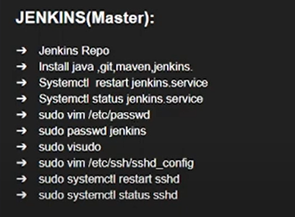
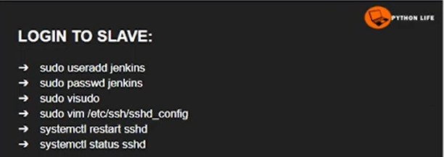
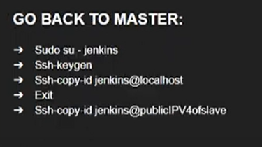
ssh 'jenkins@172.31.35.150'

slave :
sudo yum install -y gcc make wget
cd /tmp
wget https://downloads.sourceforge.net/project/sshpass/sshpass/1.09/sshpass-1.09.tar.gz
tar -xvzf sshpass-1.09.tar.gz
cd sshpass-1.09
./configure
make
sudo make install
sshpass –V
Jenkins pipeline:
node {
stage ("git-install"){
sh "sshpass -p '12345' ssh jenkins@172.31.35.150 sudo yum install git -y"
}
stage ("git-version"){
sh "sshpass -p '12345' ssh jenkins@172.31.35.150 sudo git --version"
}
}
node {
withCredentials([usernamePassword(credentialsId: 'agent-creads', usernameVariable: 'SSH_USER', passwordVariable: 'SSH_PASS')]) {

stage ("git-version") {
sh '''
sshpass -p "$SSH_PASS" ssh -o StrictHostKeyChecking=no $SSH_USER@172.31.35.150 git --version
'''
}

stage ("test-age") {
sh '''
sshpass -p "$SSH_PASS" ssh -o StrictHostKeyChecking=no $SSH_USER@172.31.35.150 sudo chage -l test
'''
}

}
}
---------------------end-------------------

