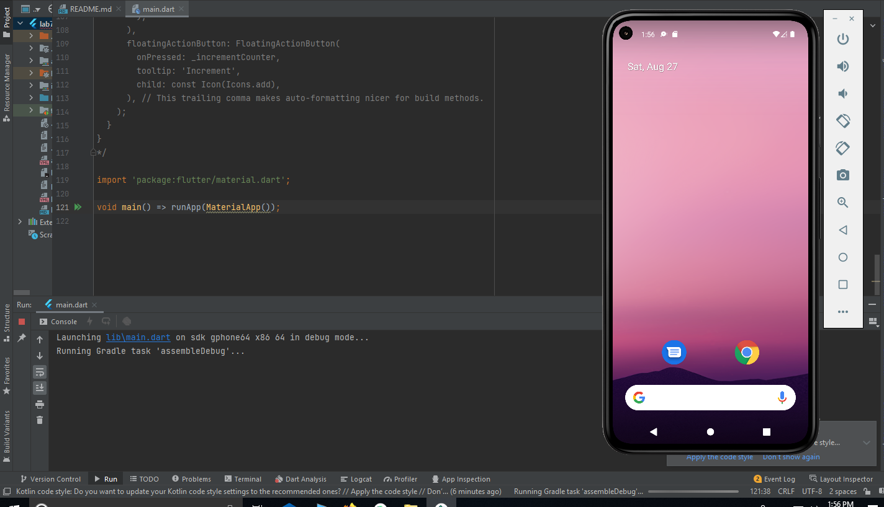

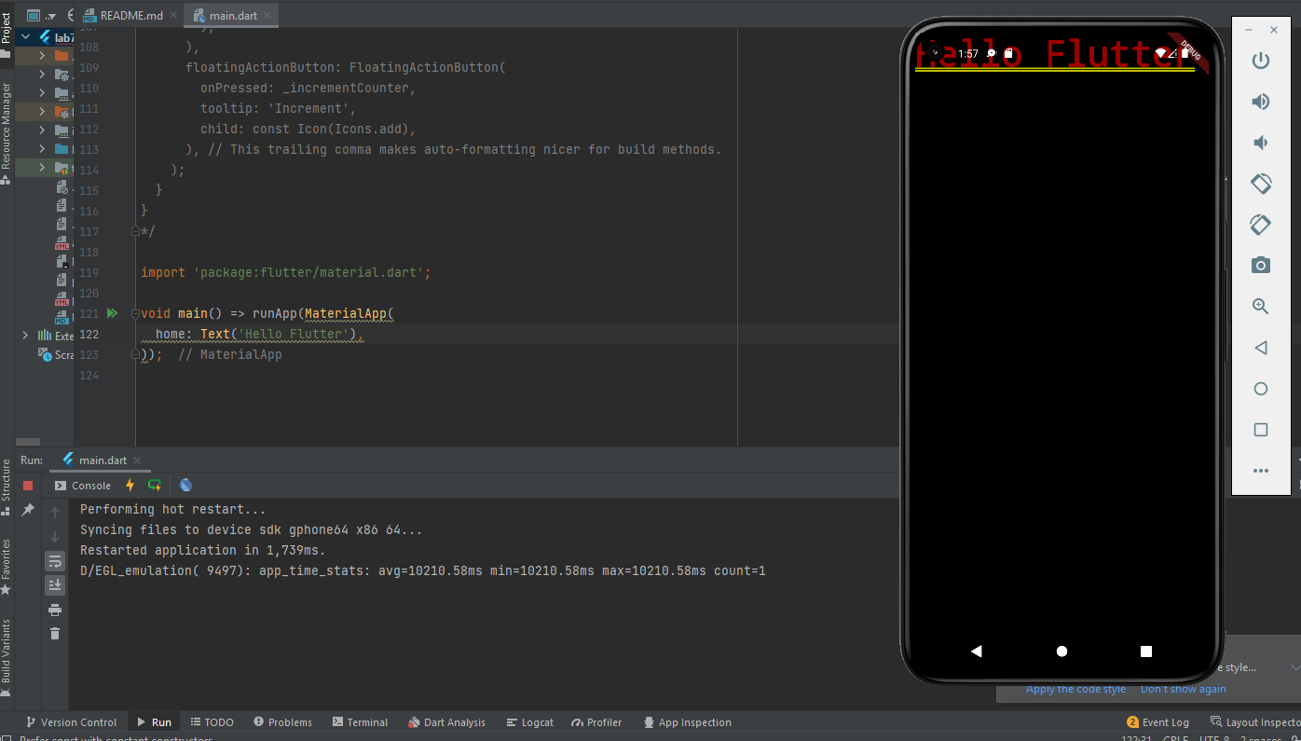

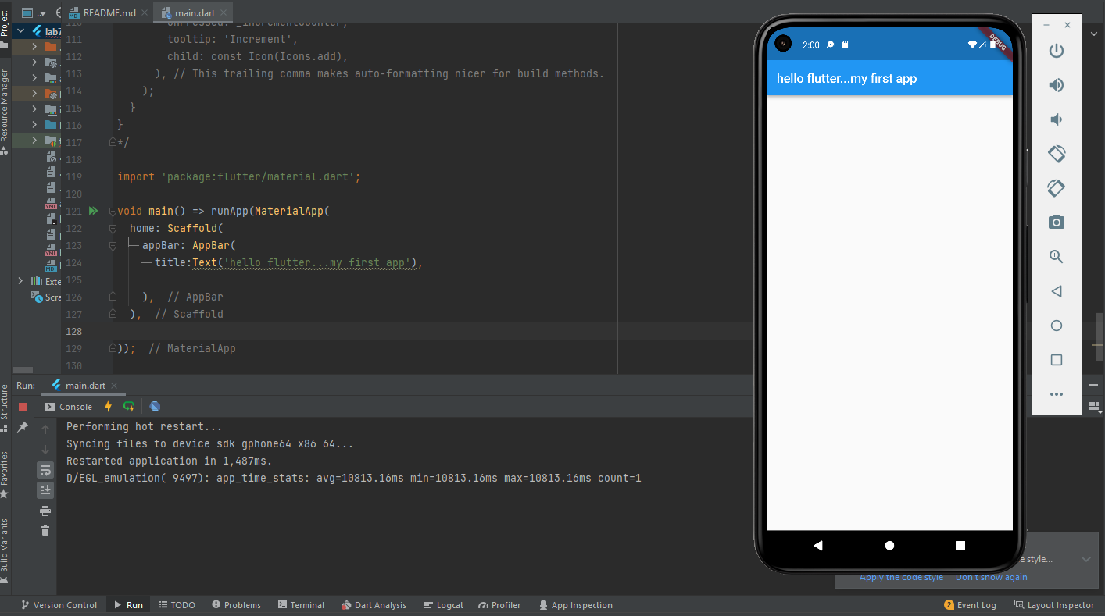

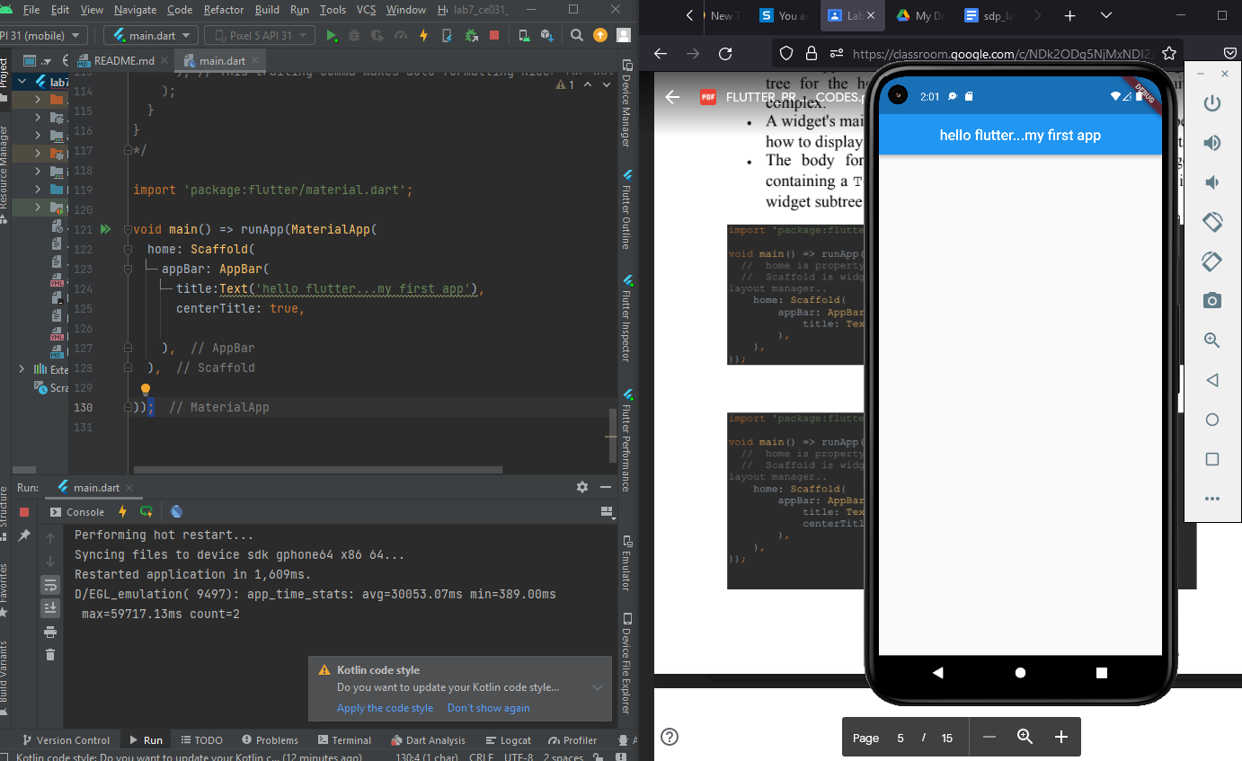

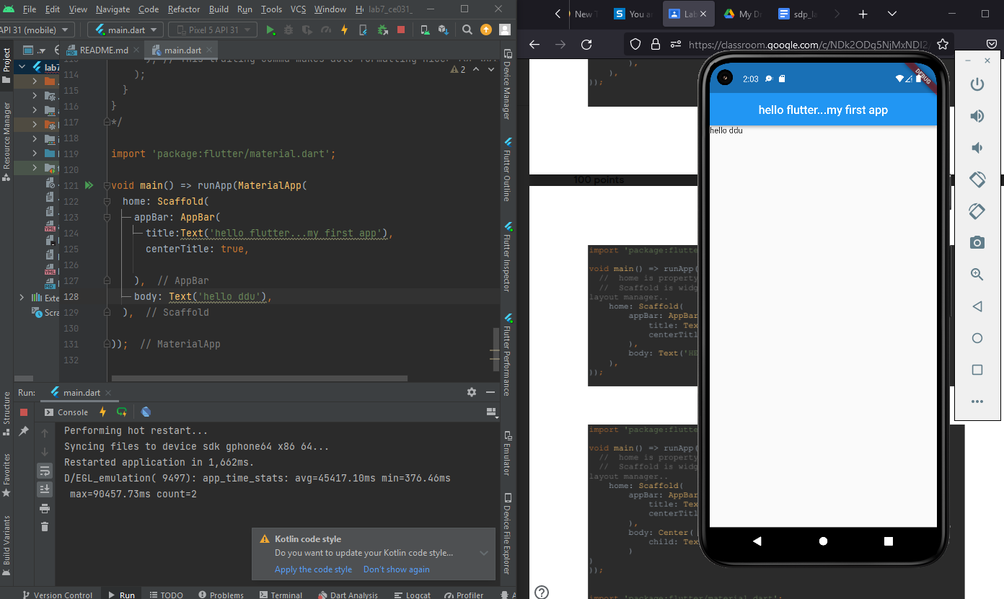

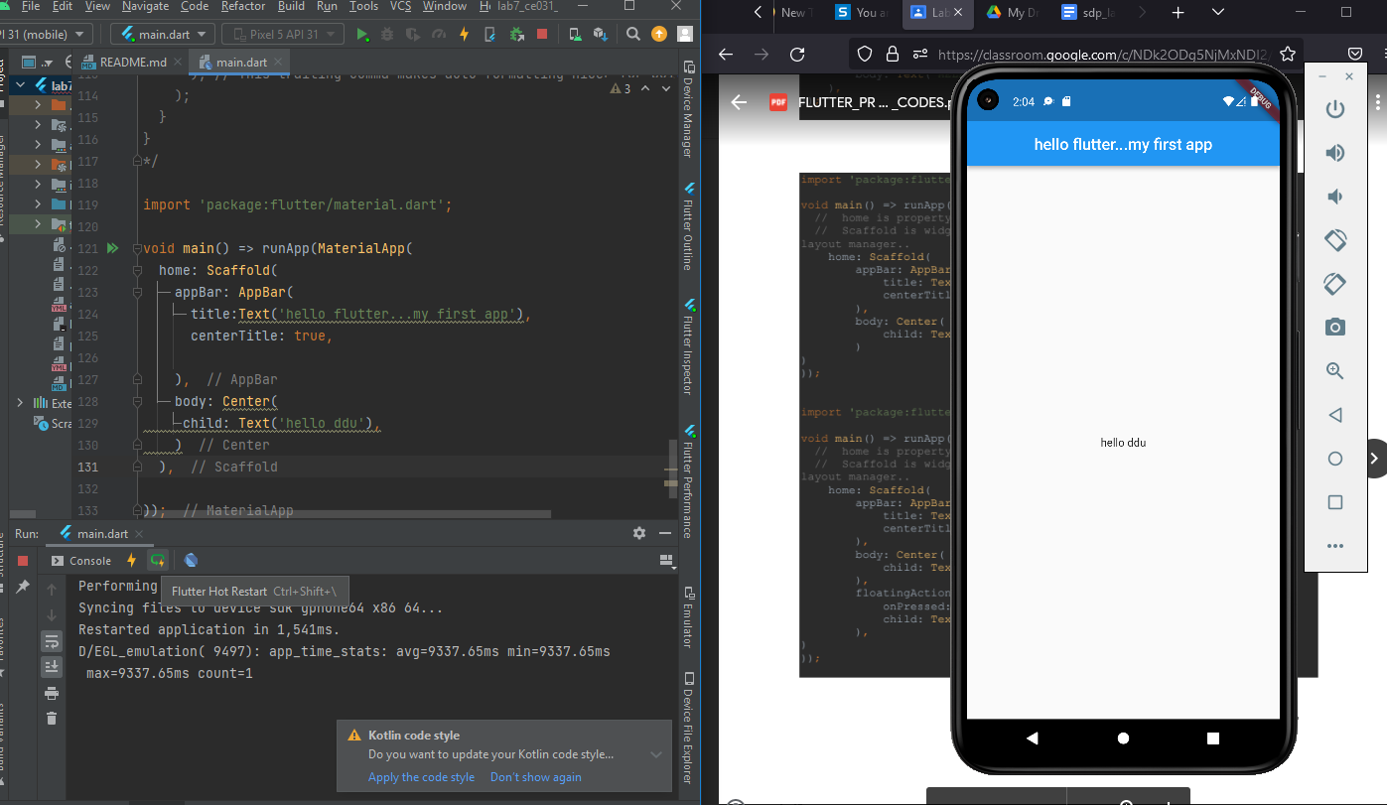

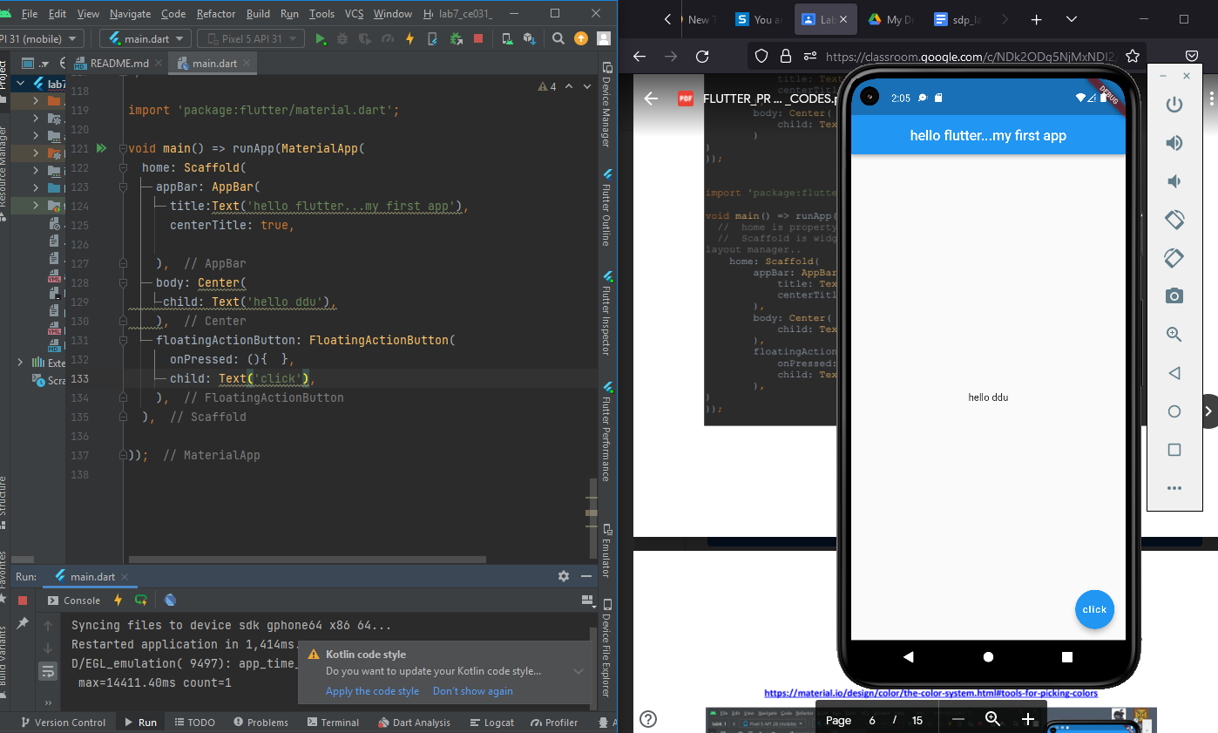

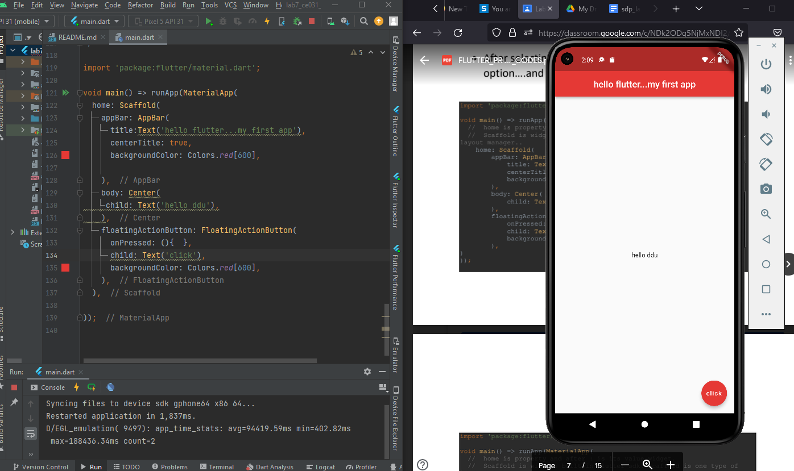

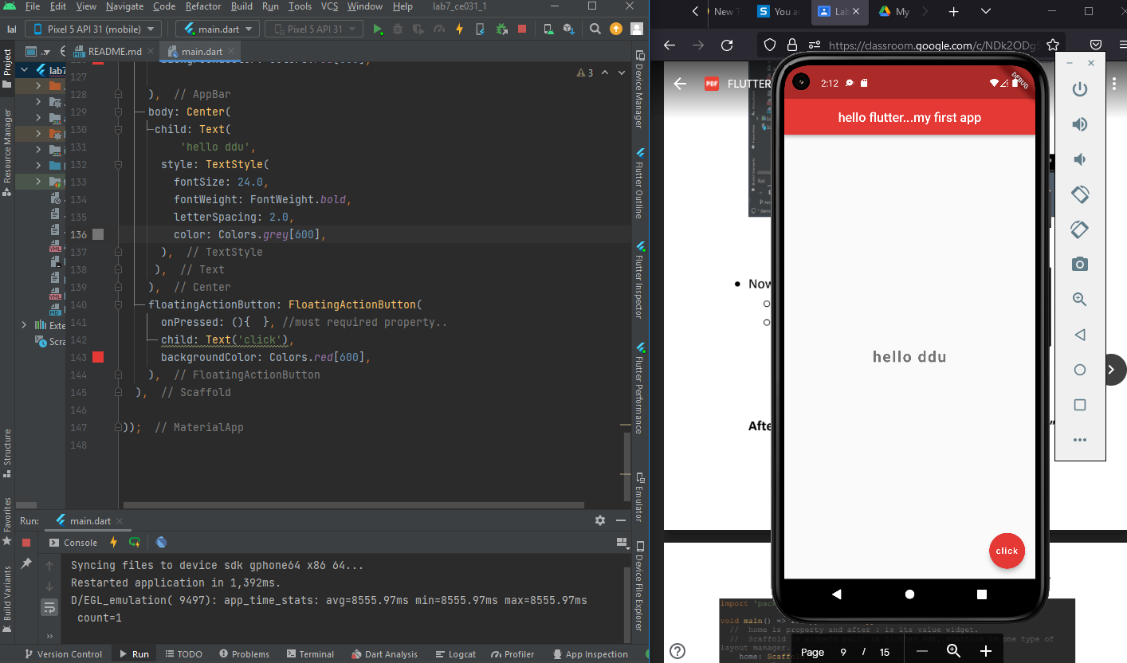

Adding font :-

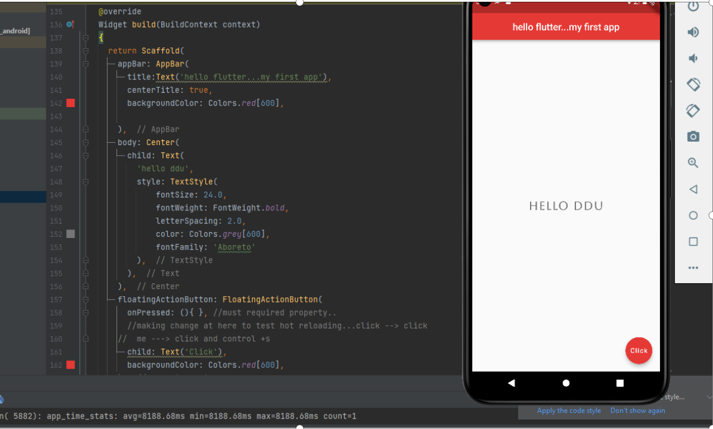

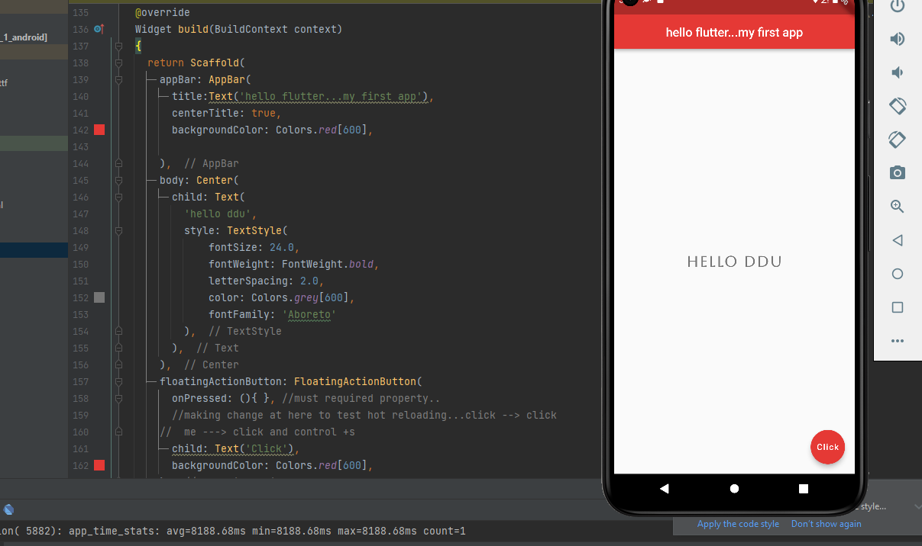

Code ::

import 'package:flutter/material.dart';

void main() => runApp(MaterialApp(

//home is property and after: is its value widget.

//scaffold is widgets built in flutter scaffold is one type of layout manager.

home: Homescreen(),

));

//making your own custom stateless widget...

//used in hot reload and also useful in reuse...DRY feature

class Homescreen extends StatelessWidget{

//const test1((key? key1)) super(key: key);

@override

Widget build(BuildContext context)

{

return Scaffold(

appBar: AppBar(

title:Text('hello flutter...my first app'),

centerTitle: true,

backgroundColor: Colors.*red*[600],

),

body: Center(

child: Text(

'hello ddu',

style: TextStyle(

fontSize: 24.0,

fontWeight: FontWeight.*bold*,

letterSpacing: 2.0,

color: Colors.*grey*[600],

fontFamily: 'Aboreto'

),

),

),

floatingActionButton: FloatingActionButton(

onPressed: (){ }, //must required property..

//making change at here to test hot reloading...click --> click

// me ---> click and control +s

child: Text('Click'),

backgroundColor: Colors.*red*[600],

),

);

}

}

