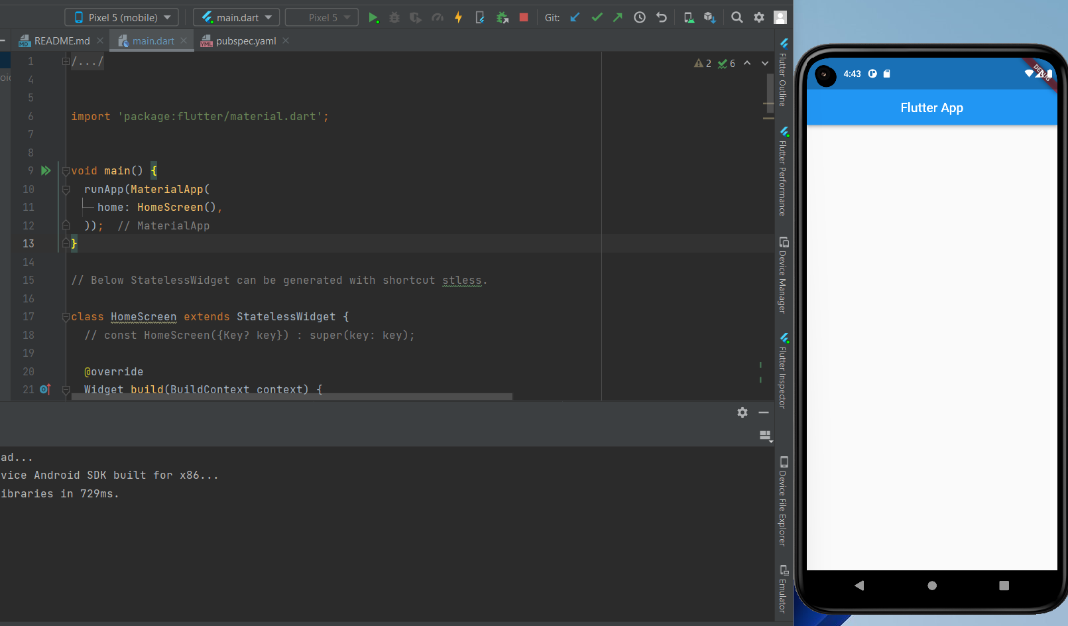

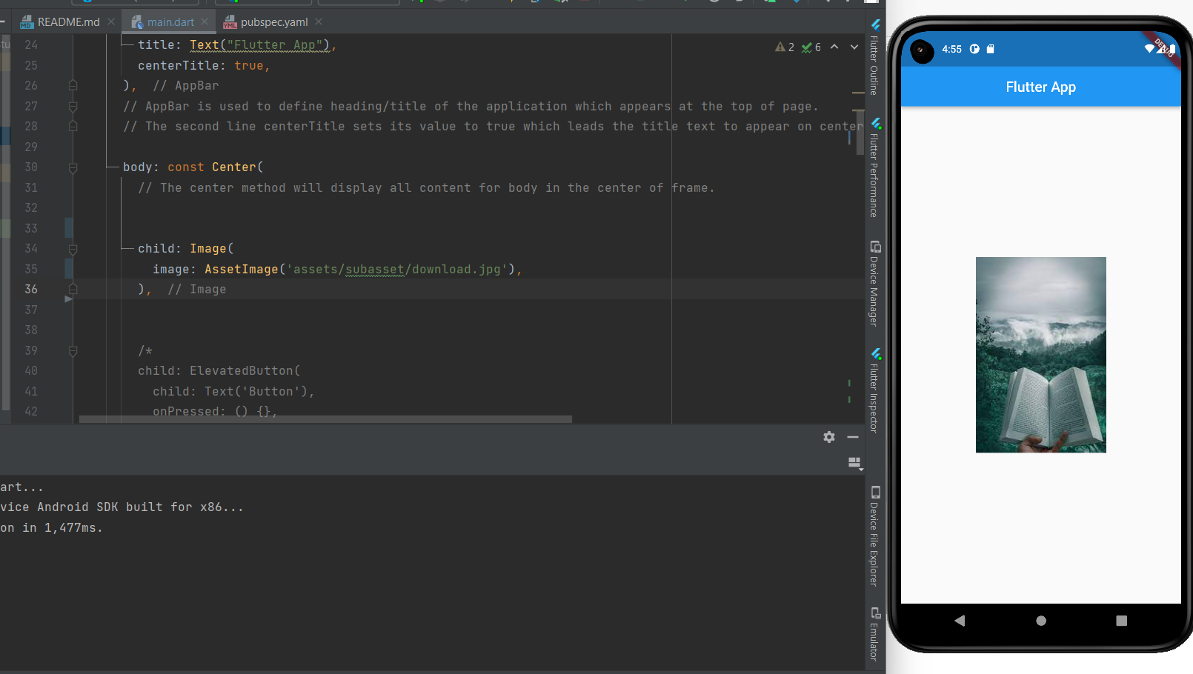

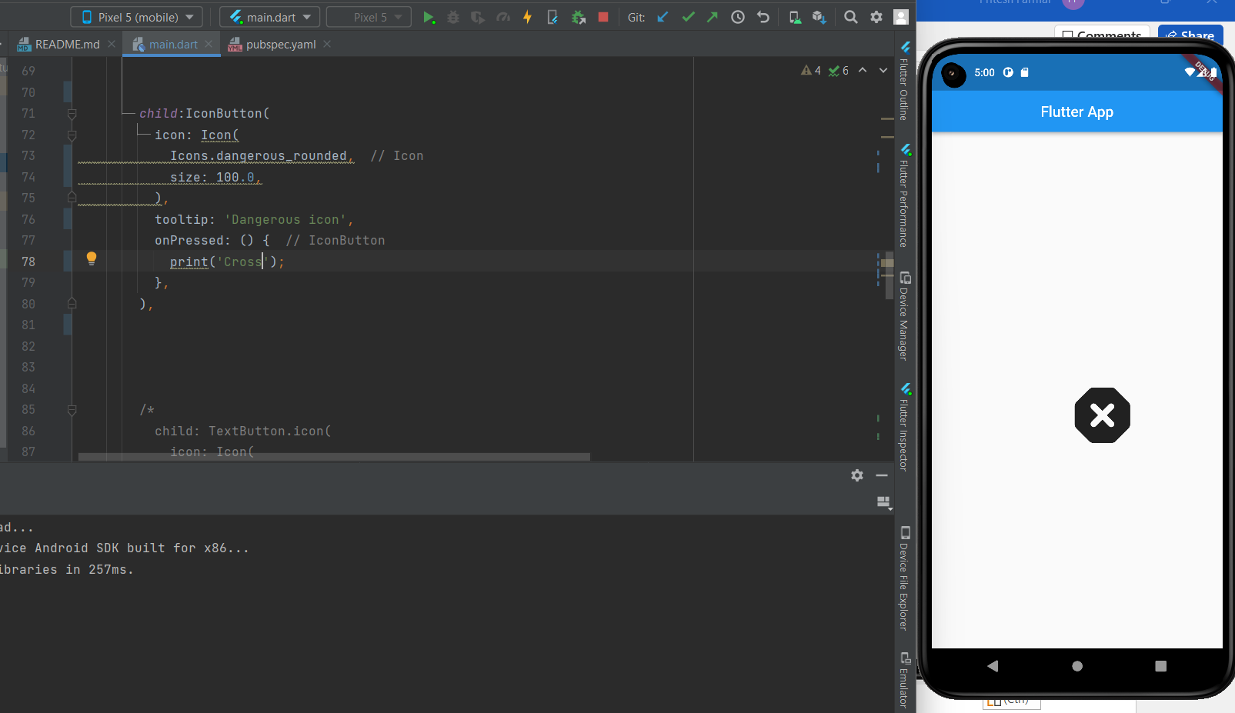

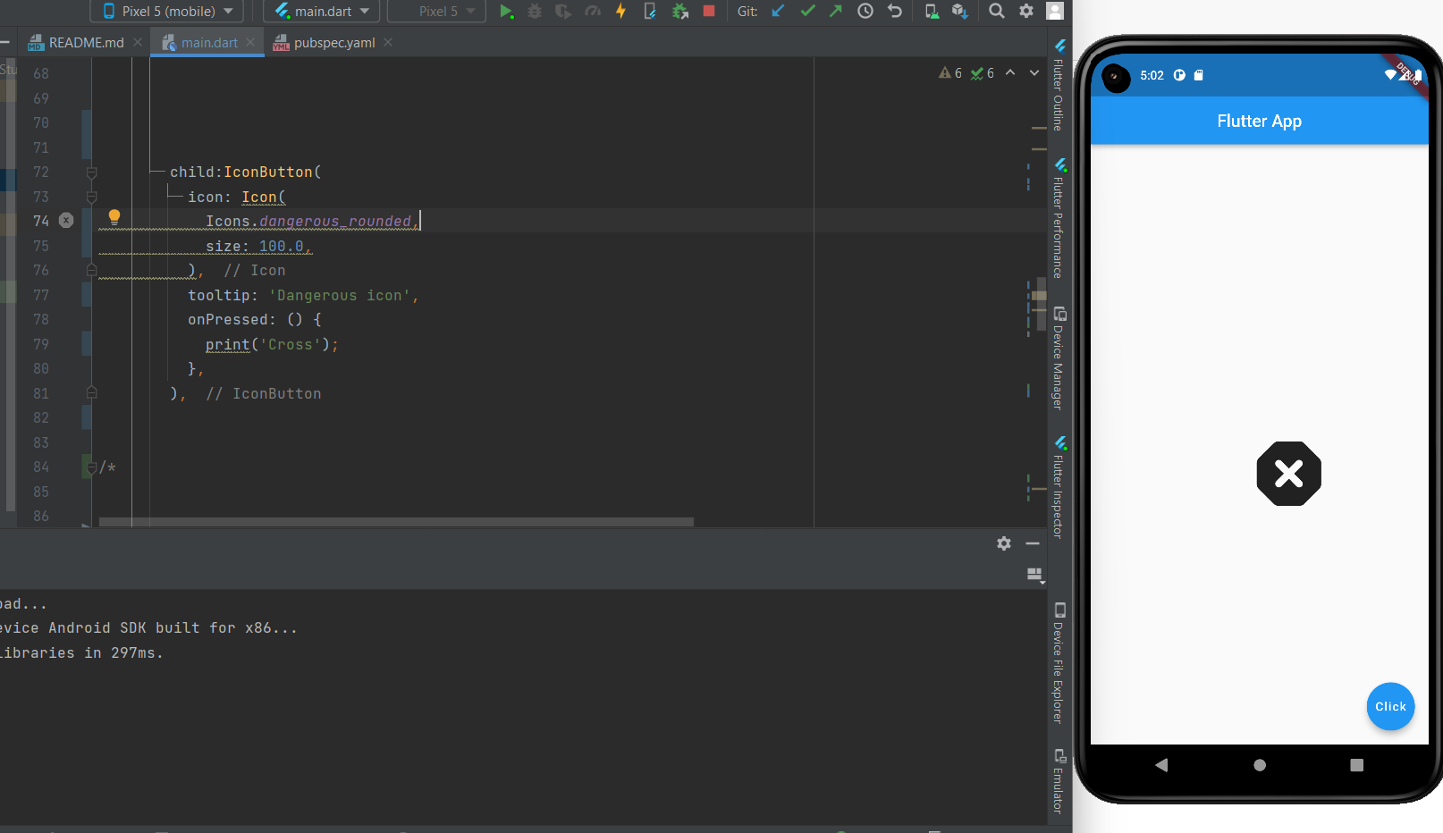

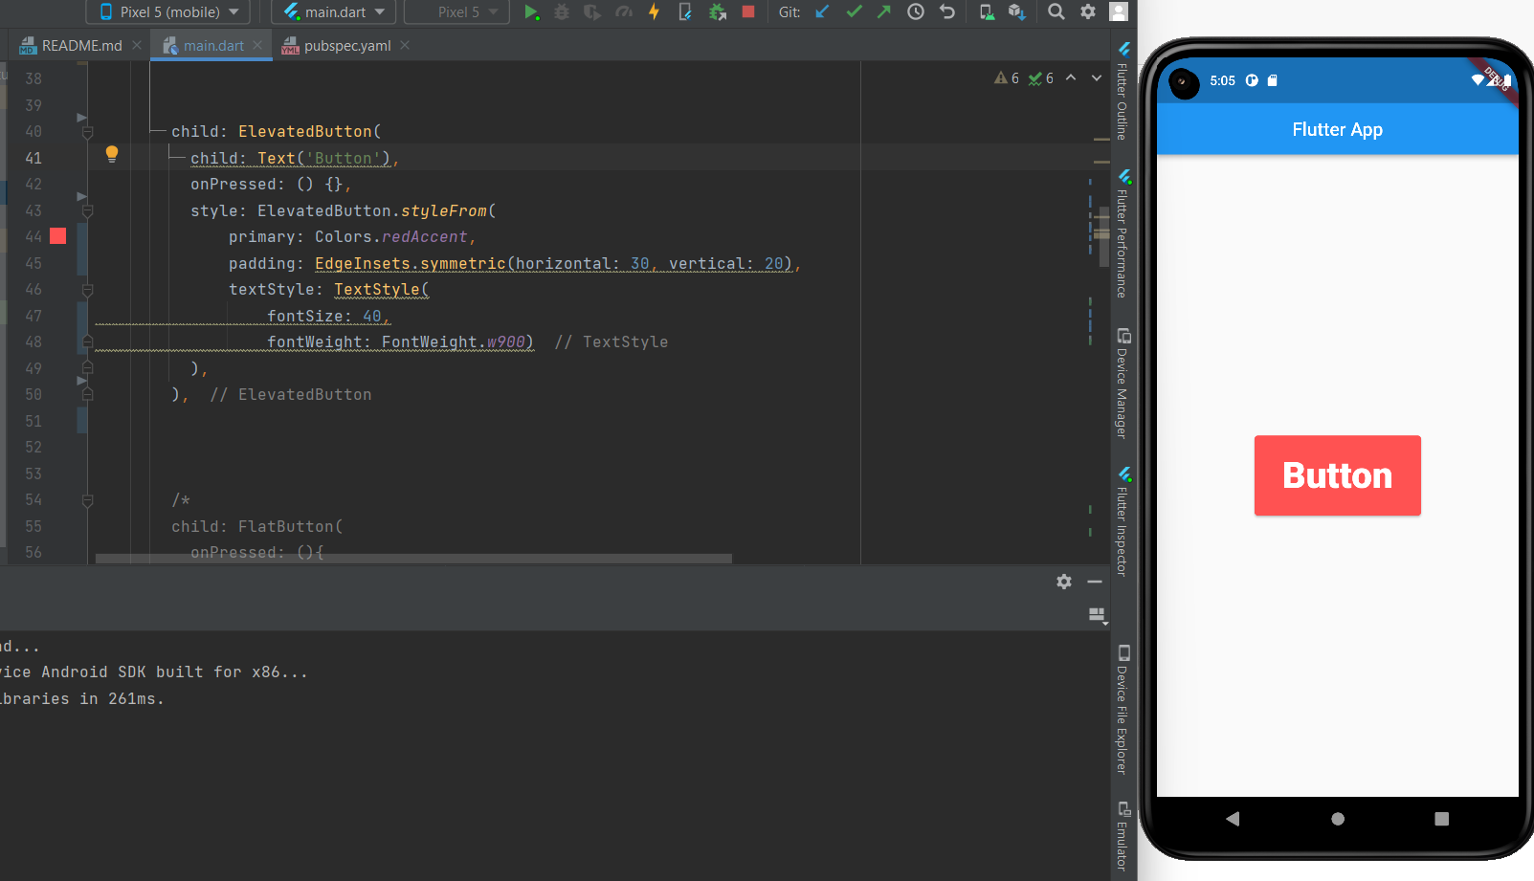

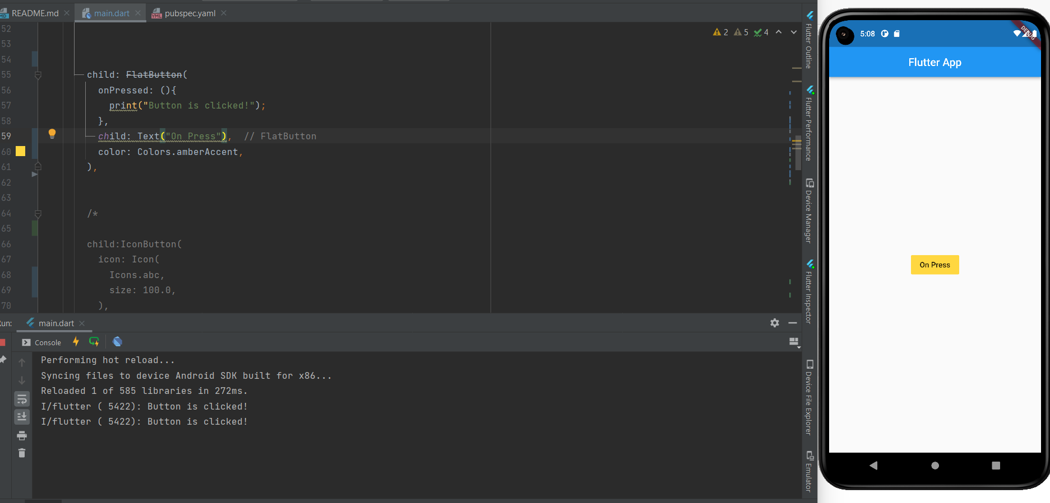

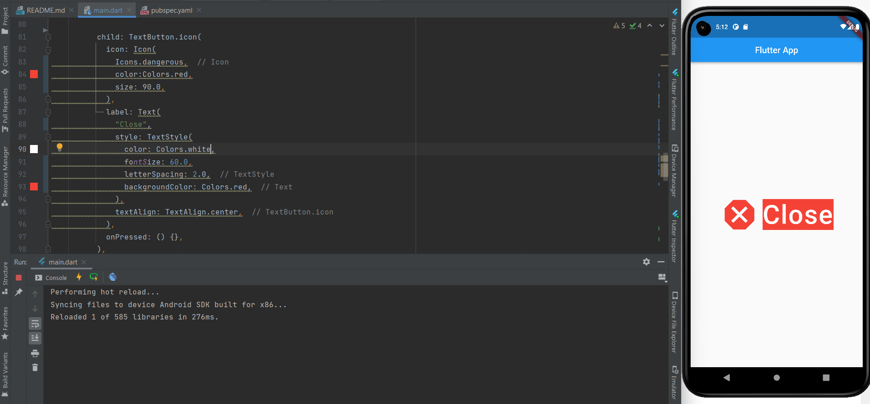

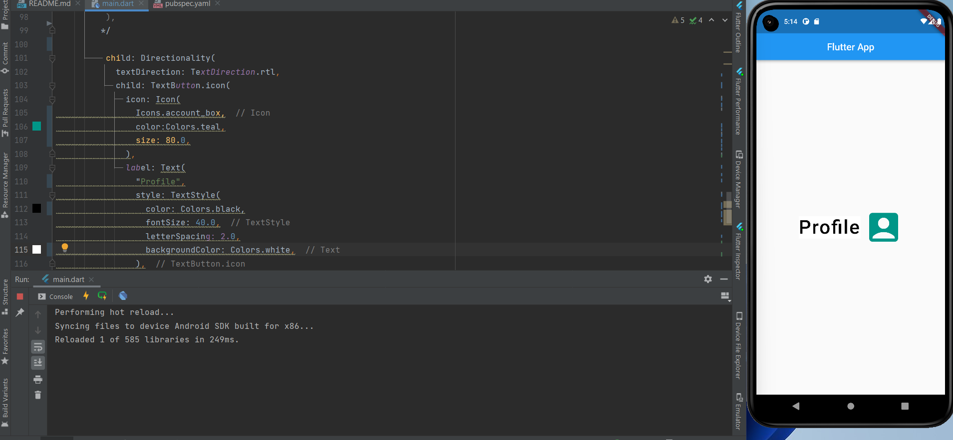

import 'package:flutter/material.dart';  
  
  
void main() {  
 runApp(MaterialApp(  
 home: HomeScreen(),  
 ));  
}  
  
// Below StatelessWidget can be generated with shortcut stless.  
  
class HomeScreen extends StatelessWidget {  
 // const HomeScreen({Key? key}) : super(key: key);  
  
 @override  
 Widget build(BuildContext context) {  
 return Scaffold(  
 appBar: AppBar(  
 title: Text("Flutter App"),  
 centerTitle: true,  
 ),  
 // AppBar is used to define heading/title of the application which appears at the top of page.  
 // The second line centerTitle sets its value to true which leads the title text to appear on center.  
  
 body: Center(  
 // The center method will display all content for body in the center of frame.  
  
 /*  
 child: Image(  
 image: AssetImage('assets/subasset/download.jpg'),  
 ),  
 */  
  
 /*  
 child: ElevatedButton(  
 child: Text('Button'),  
 onPressed: () {},  
 style: ElevatedButton.styleFrom(  
 primary: Colors.redAccent,  
 padding: EdgeInsets.symmetric(horizontal: 30, vertical: 20),  
 textStyle: TextStyle(  
 fontSize: 40,  
 fontWeight: FontWeight.w900)  
 ),  
 ),  
 */  
  
  
 /*  
 child: FlatButton(  
 onPressed: (){  
 print("Button is clicked!");  
 },  
 child: Text("On Press"),  
 color: Colors.amberAccent,  
 ),  
  
 */  
  
 /*  
 child:IconButton(  
 icon: Icon(  
 Icons.dangerous_rounded,  
 size: 100.0,  
 ),  
 tooltip: 'Dangerous icon',  
 onPressed: () {  
 print('Cross');  
 },  
 ),  
  
 */  
  
  
 /*  
 child: TextButton.icon(  
 icon: Icon(  
 Icons.dangerous,  
 color:Colors.red,  
 size: 90.0,  
 ),  
 label: Text(  
 "Close",  
 style: TextStyle(  
 color: Colors.white,  
 fontSize: 60.0,  
 letterSpacing: 2.0,  
 backgroundColor: Colors.red,  
 ),  
 textAlign: TextAlign.center,  
 ),  
 onPressed: () {},  
 ),  
 */  
  
 /*  
 child: Directionality(  
 textDirection: TextDirection.rtl,  
 child: TextButton.icon(  
 icon: Icon(  
 Icons.account_box,  
 color:Colors.teal,  
 size: 80.0,  
 ),  
 label: Text(  
 "Profile",  
 style: TextStyle(  
 color: Colors.black,  
 fontSize: 40.0,  
 letterSpacing: 2.0,  
 backgroundColor: Colors.white,  
 ),  
 textAlign: TextAlign.start,  
 ),  
 onPressed: () {},  
  
 )  
 ,  
 )  
 */  
  
 ),  
  
 /*  
 floatingActionButton: FloatingActionButton(  
 onPressed: (){},  
 child: Text("Button"),  
 backgroundColor: Colors.blue,  
 ),  
  
 */  
 );  
 }  
}