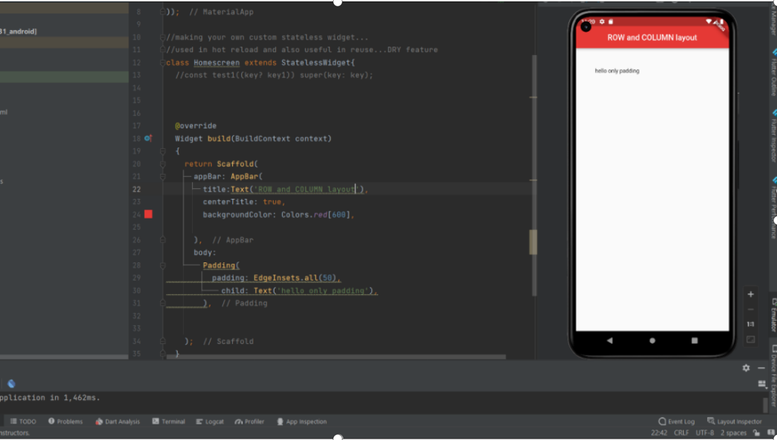

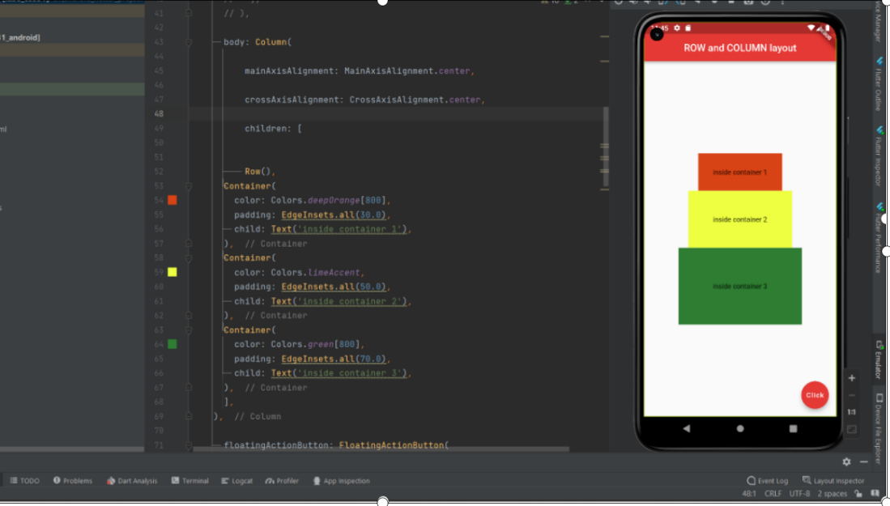

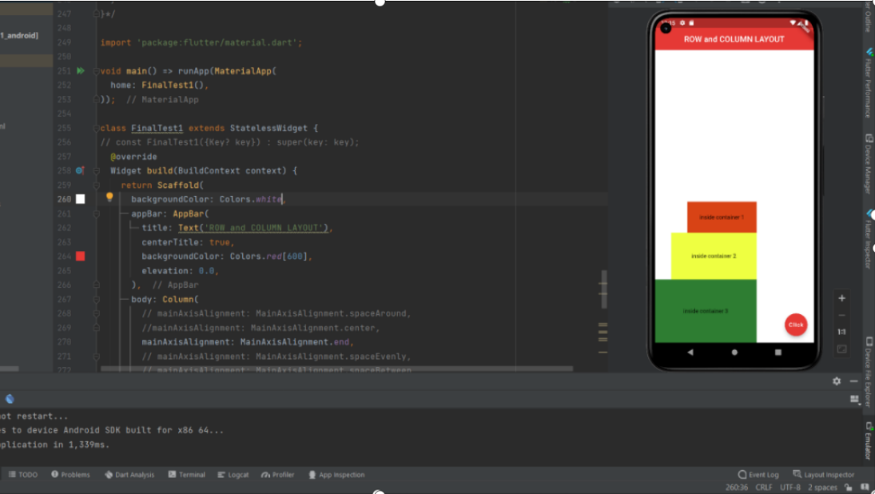

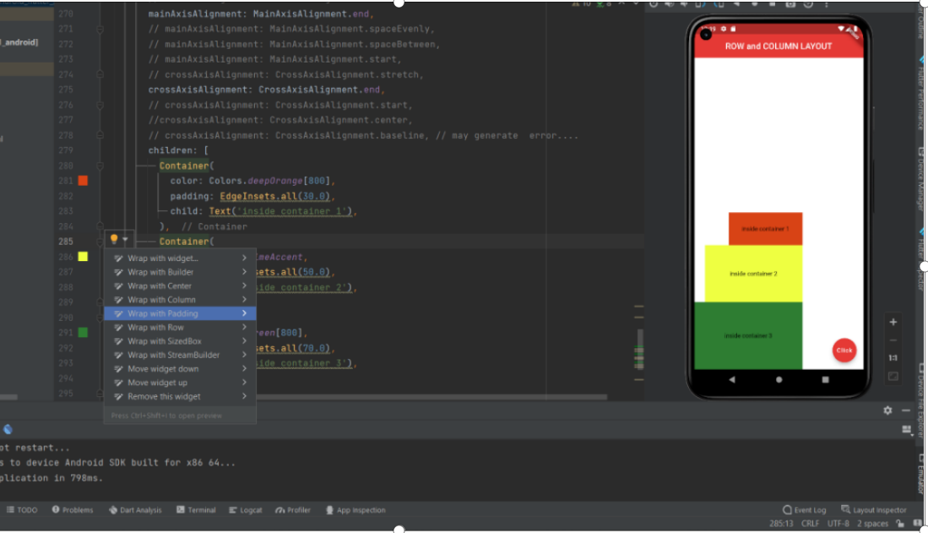

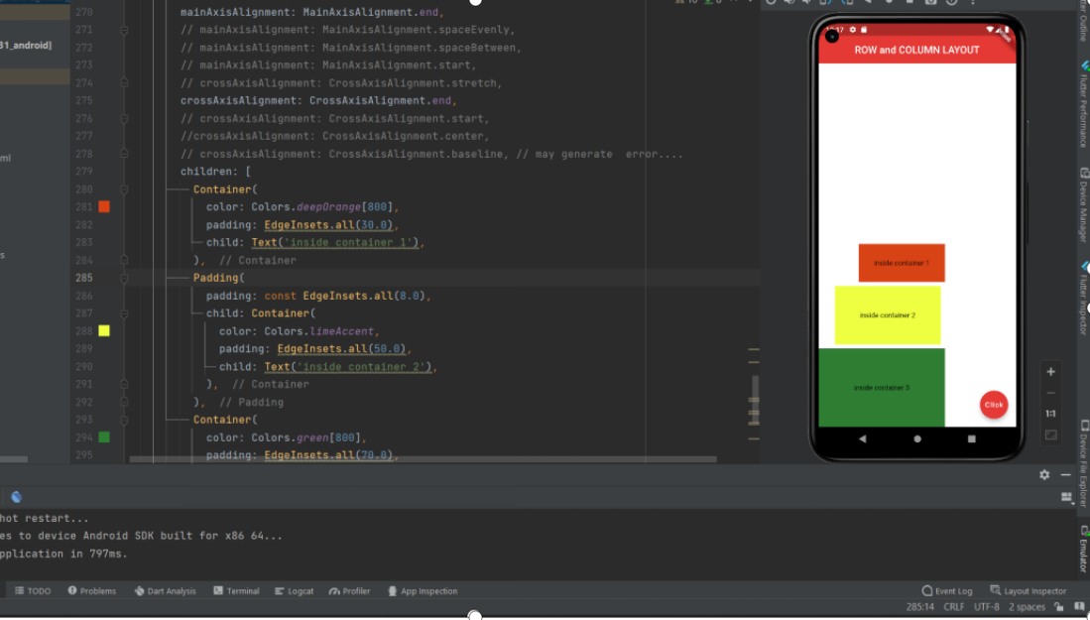

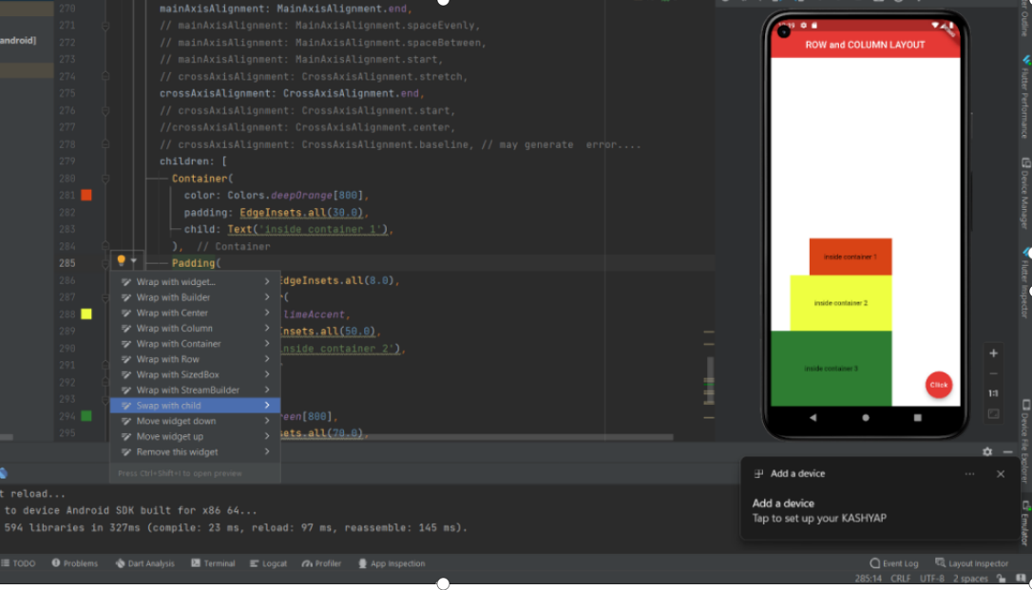

s

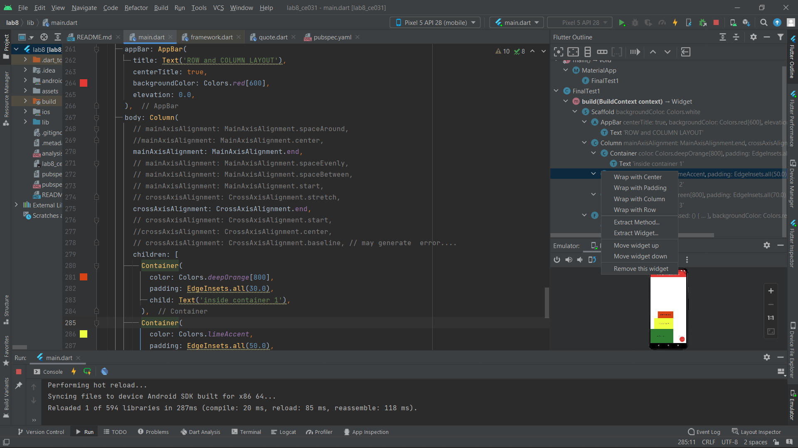

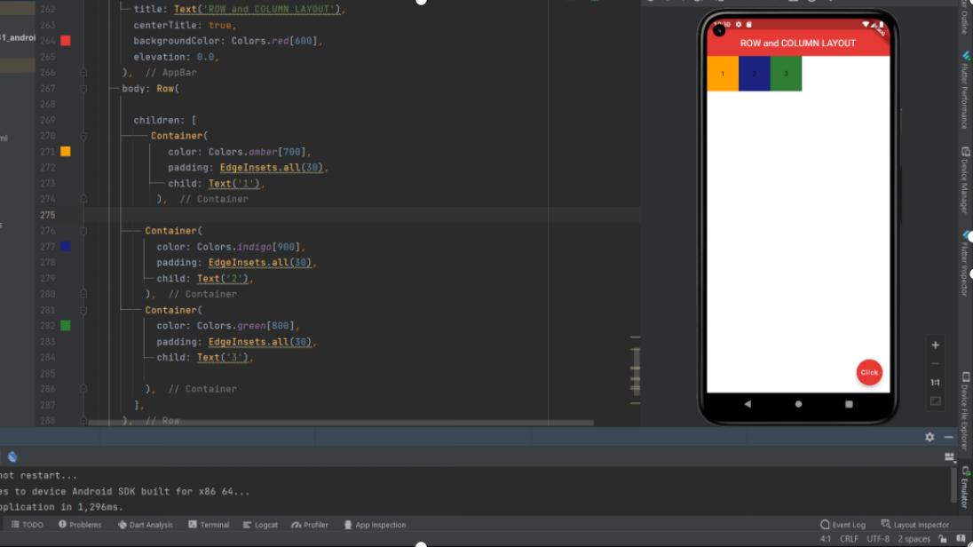

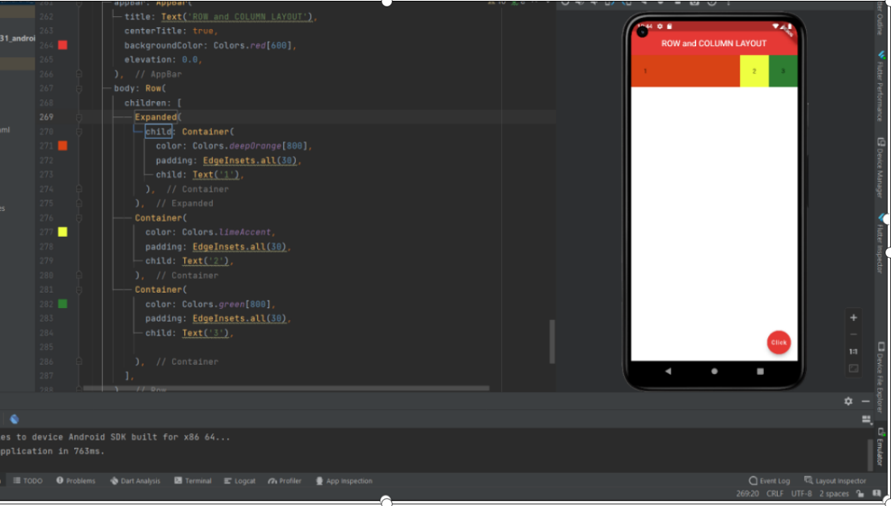

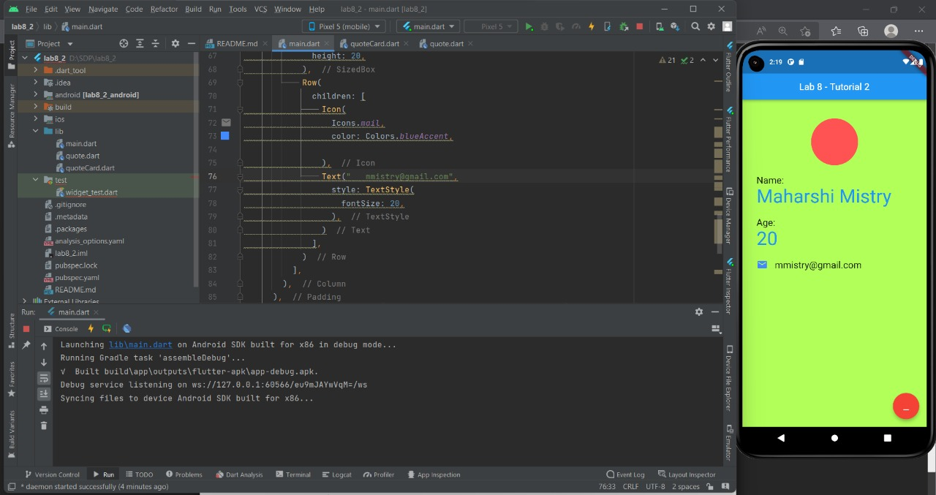

Code ::

—--->

import 'package:flutter/material.dart';

void main() => runApp(MaterialApp(

//home is property and after: is its value widget.

//scaffold is widgets built in flutter scaffold is one type of layout manager.

home: Homescreen(),

));

//making your own custom stateless widget...

//used in hot reload and also useful in reuse...DRY feature

class Homescreen extends StatelessWidget{

//const test1((key? key1)) super(key: key);

@override

Widget build(BuildContext context)

{

return Scaffold(

appBar: AppBar(

title:Text('ROW and COLUMN layout'),

centerTitle: true,

backgroundColor: Colors.red[600],

),

body: Column(

mainAxisAlignment: MainAxisAlignment.end,

crossAxisAlignment: CrossAxisAlignment.end,

children: [

Row(

),

Expanded(

child: Container(

color: Colors.deepOrange[800],

padding: EdgeInsets.all(30.0),

child: Text('inside container 1'),

),

),

Container(

color: Colors.limeAccent,

padding: EdgeInsets.all(50.0),

child: Text('inside container 2'),

),

Container(

color: Colors.green[800],

padding: EdgeInsets.all(70.0),

child: Text('inside container 3'),

),

],

),

floatingActionButton: FloatingActionButton(

onPressed: () {},

child: Text('Click'),

backgroundColor: Colors.red[600],

// child: const Icon(Icons.add),

),

);

}

}

—---------->

/*import 'package:flutter/material.dart';

void main() => runApp(MaterialApp(

home: FinalTest1(),

));

class FinalTest1 extends StatelessWidget {

// const FinalTest1({Key? key}) : super(key: key);

@override

Widget build(BuildContext context) {

return Scaffold(

backgroundColor: Colors.lightGreen[200],

appBar: AppBar(

title: Text('First App'),

centerTitle: true,

backgroundColor: Colors.lightBlue[600],

elevation: 0.0,

),

body: Padding(

padding: EdgeInsets.fromLTRB(30, 40, 30, 0),

child: Column(

crossAxisAlignment: CrossAxisAlignment.start,

children: [

CircleAvatar(

backgroundImage: AssetImage('assets/abc.jpg'),

),

Text(

'NAME: ',

style: TextStyle(

color: Colors.grey[800],

letterSpacing: 2.0,

),

),

SizedBox(height: 10),

Text(

'Maharshi mistry',

style: TextStyle(

color: Colors.blue[900],

letterSpacing: 2.0,

fontWeight: FontWeight.bold,

fontSize: 20.0,

),

),

SizedBox(height: 40),

Text(

'AGE',

style: TextStyle(

color: Colors.grey[800],

letterSpacing: 2.0,

),

),

SizedBox(height: 10),

Text(

'19',

style: TextStyle(

color: Colors.blue[900],

letterSpacing: 2.0,

fontWeight: FontWeight.bold,

fontSize: 20.0,

),

),

SizedBox(height: 50),

Row(

children: [

Icon(

Icons.email_rounded,

color: Colors.deepPurple[800],

),

SizedBox(width: 12.0),

Text(

'nmistry@gmail.com',

style: TextStyle(

color: Colors.brown[800],

fontSize: 16.0,

letterSpacing: 1.5,

),

)

],

)

],

),

),

);

}

}*/

—----------------------------------------------------------------------------