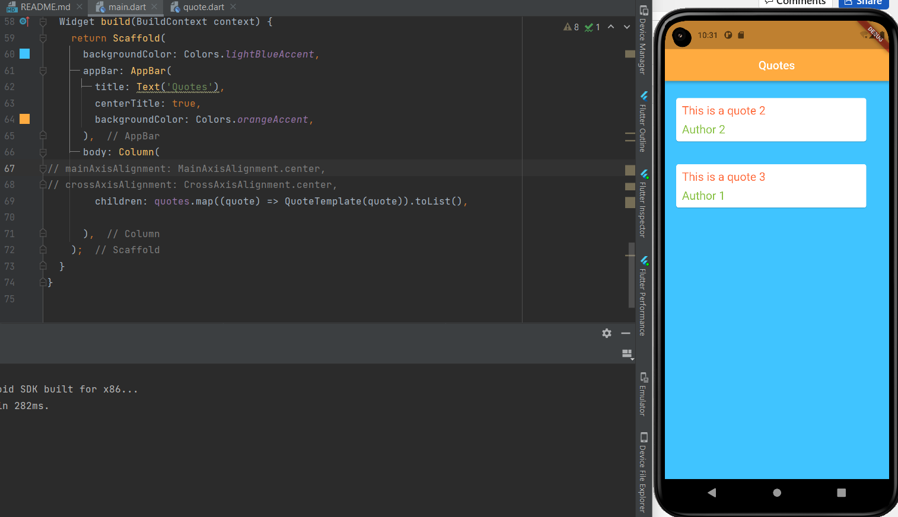

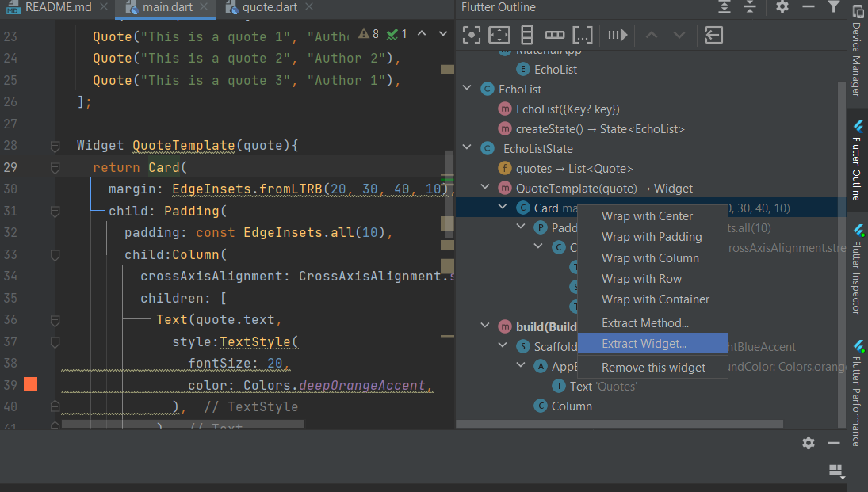

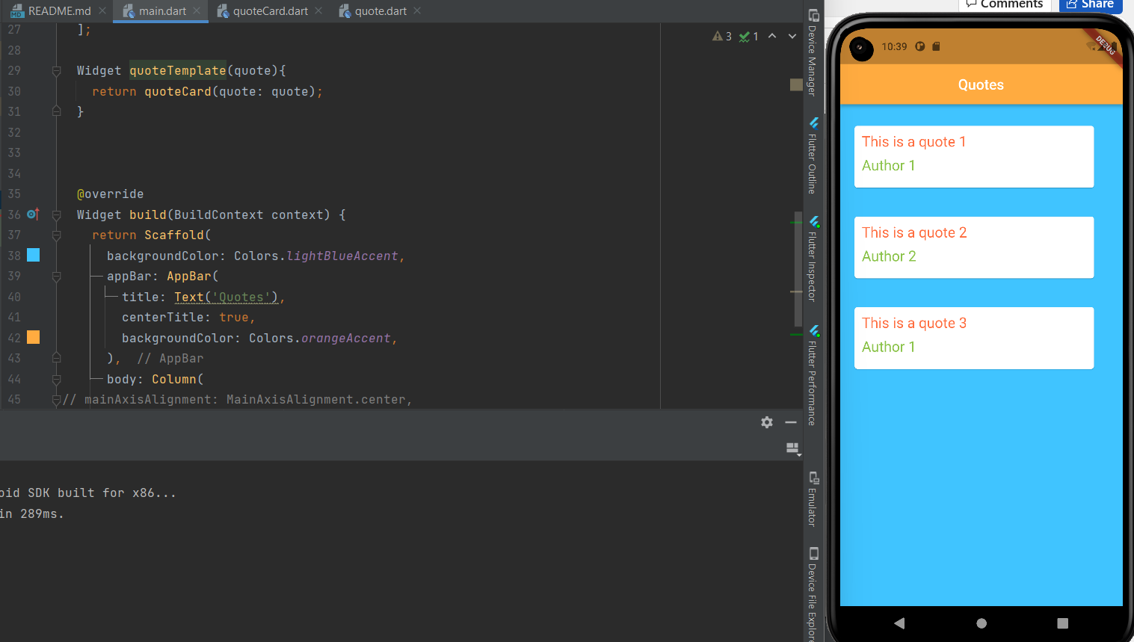

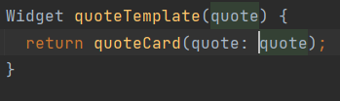

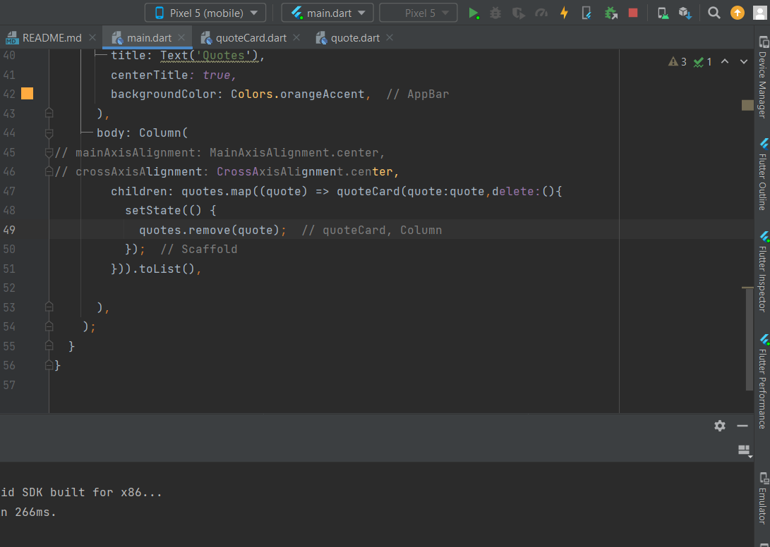

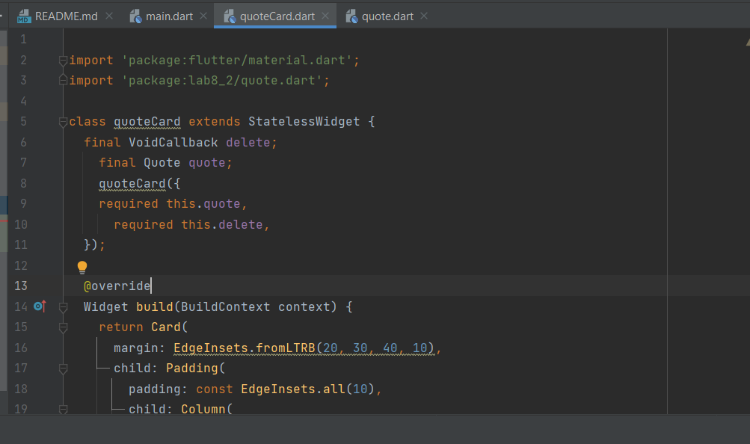

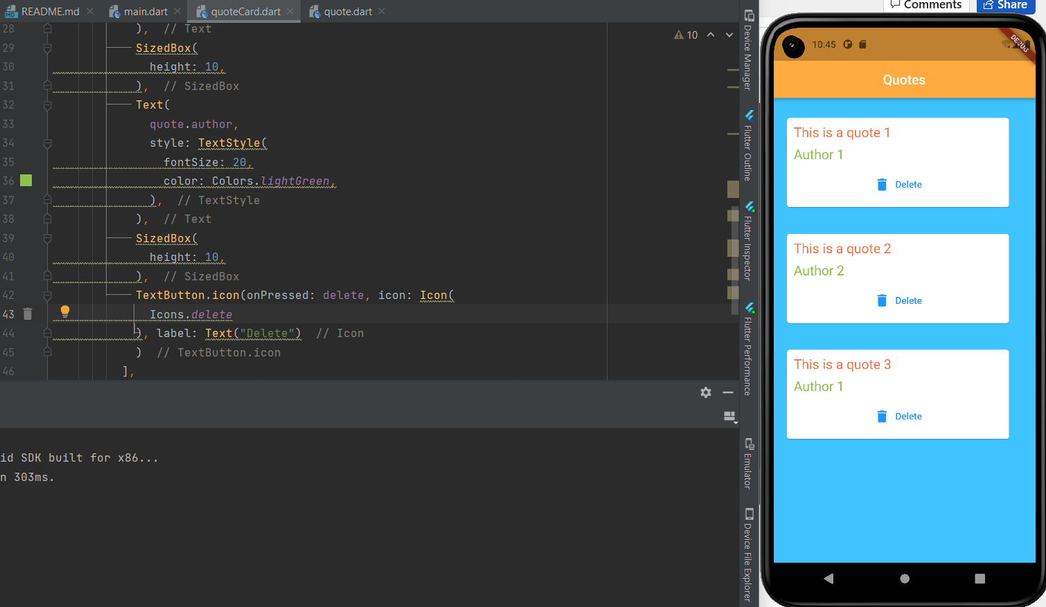

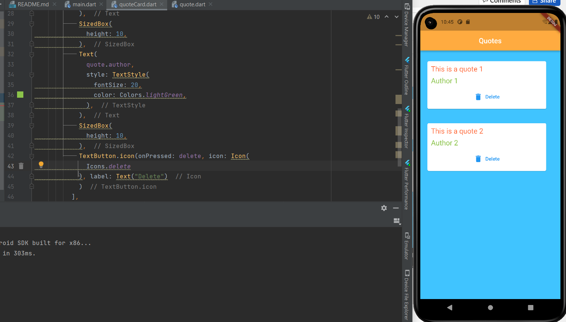

import 'package:flutter/material.dart';  
import 'package:lab8_2/quote.dart';  
import 'package:lab8_2/quoteCard.dart';  
void main() => runApp(MaterialApp(  
 home: EchoList(),  
));  
  
class EchoList extends StatefulWidget {  
 const EchoList({Key? key}) : super(key: key);  
 @override  
 State<EchoList> createState() => _EchoListState();  
}  
  
class _EchoListState extends State<EchoList> {  
 // List<String> quotes = [  
 // 'The truth is realy pure and never simple',  
 // 'I see humans but no humanity',  
 // 'The time is always right to do what is right'  
 // ];  
  
 List<Quote> quotes = [  
 Quote("This is a quote 1", "Author 1"),  
 Quote("This is a quote 2", "Author 2"),  
 Quote("This is a quote 3", "Author 1"),  
 ];  
  
 // Widget quoteTemplate(quote){  
 // return quoteCard(quote: quote, delete: delete());  
 // }  
  
  
  
 @override  
 Widget build(BuildContext context) {  
 return Scaffold(  
 backgroundColor: Colors.*lightBlueAccent*,  
 appBar: AppBar(  
 title: Text('Quotes'),  
 centerTitle: true,  
 backgroundColor: Colors.*orangeAccent*,  
 ),  
 body: Column(  
// mainAxisAlignment: MainAxisAlignment.center,  
// crossAxisAlignment: CrossAxisAlignment.center,  
 children: quotes.map((quote) => quoteCard(quote:quote,delete:(){  
 setState(() {  
 quotes.remove(quote);  
 });  
 })).toList(),  
  
 ),  
 );  
 }  
}

import 'package:flutter/material.dart';  
import 'package:lab8_2/quote.dart';  
  
class quoteCard extends StatelessWidget {  
 final VoidCallback delete;  
 final Quote quote;  
 quoteCard({  
 required this.quote,  
 required this.delete,  
 });  
  
 @override  
 Widget build(BuildContext context) {  
 return Card(  
 margin: EdgeInsets.fromLTRB(20, 30, 40, 10),  
 child: Padding(  
 padding: const EdgeInsets.all(10),  
 child: Column(  
 crossAxisAlignment: CrossAxisAlignment.stretch,  
 children: [  
 Text(  
 quote.text,  
 style: TextStyle(  
 fontSize: 20,  
 color: Colors.*deepOrangeAccent*,  
 ),  
 ),  
 SizedBox(  
 height: 10,  
 ),  
 Text(  
 quote.author,  
 style: TextStyle(  
 fontSize: 20,  
 color: Colors.*lightGreen*,  
 ),  
 ),  
 SizedBox(  
 height: 10,  
 ),  
 TextButton.icon(onPressed: delete, icon: Icon(  
 Icons.*delete* ), label: Text("Delete")  
 )  
 ],  
 ),  
 ),  
 );  
 }  
}