Online Judge Platform (MERN Stack)

1. Objectives
- Create a full-fledged online judge system.
- Secure user authentication and role-based access.
- Enable secure code compilation and execution.
- Prevent malicious activity using containerization.
- Design an interactive user interface with problem-solving workflows.

2. User Roles
- Super-admin: Full privileges; manage users, contests, problems, system settings.
- Admin: Manage problems, contests, view analytics.
- User: Solve problems, participate in contests, view leader-board.

3. Use Case
Actors:
- Superadmin
- Admin
- User
Use Cases:
- Register/Login
- Solve Problems
- Submit Code
- View Submissions
- Participate in Contests
- View Leaderboard
- Admin: Add/Edit/Delete Problems, View Submissions
- Superadmin: Manage Admins, View Reports, Configure Compiler
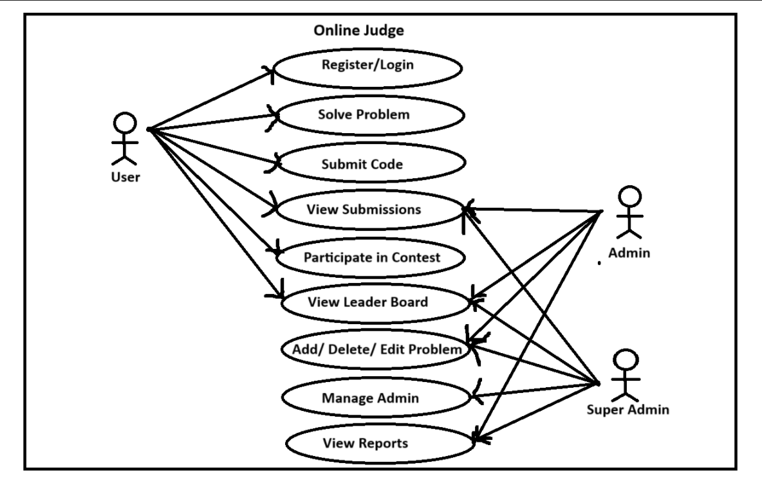

4. Authentication (JWT)
Why JWT?
- Stateless: Doesn't require server-side session storage.
- Scalable: Suitable for microservices and RESTful APIs.
- Secure: Encoded and optionally encrypted payload with token expiry.

5. Component Diagram
Frontend (React):
- Auth Component (Login/Register)
- Dashboard (List of Problems, Profile, Submissions)
- Problem Page (Problem Statement + Code Editor)
- Submission Page
- Leaderboard Page
- Contest Page
Backend (Node + Express):
- Auth Service (/login, /register, /profile)
- Problem Service (/problems, /problem/:id)
- Submission Service (/submit, /submissions/:userId)
- Contest Service (/contests, /contest/:id)
- Admin Service (/admin/problems, /admin/users)
Database (MongoDB with Mongoose):
- Users Collection
- Problems Collection
- Submissions Collection
- Contests Collection
Compiler Microservice:
- Isolated container (Docker)
- Input: Source Code + User Input
- Output: Compilation Result + Runtime Output

6. CRUD Operations
- Create: Register user, Add new problem, Submit solution
- Read: View problems, View submissions, View leaderboard
- Update: Edit profile, Admin edits problems
- Delete: Delete problems (admin), Remove submissions (optional)

7. Security and Isolation (Docker)
- Prevent rm -rf, fork bombs, DDOS
- Each code submission is compiled inside a Docker container
- Network and FileSystem isolation
- Resource limits (CPU, Memory, Time)

8. Time-bound Execution
- Timer for each submission
- Auto-terminate execution if time exceeds
- Record and display execution time

9. Future Enhancements
- Add WebSocket for live contests
- Add test-case visualizer
- Add mobile-responsive UI
- Add analytics for submissions, contests

10. API Endpoints Overview
User Routes:
- POST /register
- POST /login
- GET /profile
- GET /submissions/:userId
Problem Routes:
- GET /problems
- GET /problems/:id
- POST /problems (Admin)
- PUT /problems/:id (Admin)
- DELETE /problems/:id (Admin)
Submission Routes:
- POST /submit
- GET /submissions
Contest Routes:
- GET /contests
- POST /contests (Admin)

11. Technology Stack
- Frontend: React.js, Tailwind CSS
- Backend: Node.js, Express.js
- Database: MongoDB (Atlas), Mongoose
- Authentication: JWT
- Containerization: Docker
- Compiler: C++, Python, Java support

