PROJECT REPORT
FOR
Foundations of Artificial Intelligence

GREENTrace
AI-Assisted Ecological Gap Analysis and Restoration Decision-Support System
A PROJECT REPORT

Submitted by
2116240701219 – JOVITHA. J
2116240701301 – MAHALAKSHMI. S



October, 2026

BONAFIDE CERTIFICATE

Certified that this project report “GREENTrace – AI-Assisted Ecological Gap Analysis and Restoration Decision-Support System” is the bonafide work of JOVITHA. J, MAHALAKSHMI. S who carried out the project work under my supervision.

SIGNATURE OF THE FACULTY INCHARGE

Submitted for the Practical Examination held on _________________

SIGNATURE OF THE INTERNAL EXAMINER

TABLE OF CONTENTS
CHAPTER NO. TITLE PAGE NO.
ABSTRACT
- INTRODUCTION
- LITERATURE REVIEW
3 PROPOSED SYSTEM
3.1 ARCHITECTURE DIAGRAM
4 MODULES DESCRIPTION
4.1 MODULE 1
4.2 MODULE 2
5 IMPLEMENTATION AND RESULTS
5.1 EXPERIMENTAL SETUP
5.2 RESULTS
6 CONCLUSION AND FUTURE WORK
7 REFERENCES

ABSTRACT
Environmental restoration requires an understanding of an area's existing characteristics before intervention decisions are made. GreenTrace is an AI-assisted ecological gap analysis and restoration decision-support system that examines geographical areas defined by coordinates and a radius. It combines environmental data analysis, unsupervised machine learning, knowledge representation and logical inference. Environmental observations are represented as feature vectors and analysed using K-Means clustering to identify groups of areas with similar characteristics. The resulting environmental profiles are converted into facts for a knowledge base containing project-defined ecological rules. A forward-chaining inference engine derives conclusions from these facts and generates an explainable ecological assessment.
GreenTrace integrates Google Earth Engine with the Dynamic World land-cover dataset to obtain environmental observations for the selected study area. These observations support feature extraction, clustering and rule-based assessment. Findings are presented through an interactive web interface, allowing users to explore environmental patterns and inspect the reasoning behind assessments. The system identifies potential ecological gaps rather than making autonomous restoration decisions, keeping the final decision under human control. A local demonstration dataset may also be used for controlled testing when required. GreenTrace demonstrates how machine learning and symbolic AI can be combined to support transparent, human-guided environmental decision-making.

CHAPTER 1 — INTRODUCTION

1.1 Background
Environmental conditions vary considerably across geographical regions. Urban development, agriculture, fragmented vegetation, water bodies and other land-cover types can occur together within a relatively small area. Understanding this spatial composition is useful when assessing whether an area may warrant closer ecological attention. Conventional assessment can require the collection, comparison and interpretation of multiple environmental observations. Recent availability of large-scale geospatial datasets provides an opportunity to automate part of this analysis.
Artificial intelligence provides two complementary mechanisms relevant to this problem. Machine learning can identify patterns in data without requiring every environmental situation to be manually labelled, while symbolic reasoning can apply explicit domain rules to interpret observed conditions. GreenTrace combines these mechanisms rather than replacing ecological judgement with a black-box prediction.

1.2 Problem Statement
Environmental information for a geographical region may be available in large datasets, but transforming that information into a concise and explainable assessment can be difficult. Simple measurements such as total green cover do not necessarily describe the spatial or compositional characteristics of an area. There is therefore a need for a lightweight decision-support system that can analyse environmental features, discover patterns, apply transparent reasoning rules and present the resulting evidence to a human user.

1.3 Motivation
The motivation for GreenTrace is to make preliminary ecological analysis more accessible and systematic. Instead of asking an AI system to make an irreversible environmental decision, the project uses AI to process records and surface patterns that a human can inspect. This distinction is important because restoration decisions can depend on local ecological knowledge, land ownership, feasibility, biodiversity considerations and other factors that are outside the scope of the prototype.

1.4 Objectives
- Accept a geographic coordinate and analysis radius from a user.
- Represent environmental characteristics of the selected area as structured features.
- Use unsupervised machine learning to discover environmental patterns or profiles.
- Represent environmental observations as facts in a knowledge base.
- Implement a forward-chaining inference engine to derive explainable conclusions.
- Identify potential ecological gaps using project-defined reasoning rules.
- Present findings through an interactive decision-support interface.
- Keep the final ecological decision under human control.

1.5 Scope
The core scope of GreenTrace is environmental profile analysis, pattern discovery and explainable rule-based assessment. The implemented scope of GreenTrace includes environmental profile analysis, unsupervised pattern discovery and explainable rule-based assessment. The system uses Google Earth Engine and the Dynamic World land-cover dataset to analyse a user-defined geographical area, subject to data availability and successful service access. The workflow combines environmental feature extraction, K-Means clustering, knowledge representation and forward-chaining inference. Advanced biodiversity modelling, detailed restoration planning, long-term ecological forecasting and automated planting recommendations remain outside the core scope.

CHAPTER 2 — LITERATURE REVIEW

2.1 Artificial Intelligence for Environmental Analysis
Artificial intelligence is increasingly used in environmental monitoring, geospatial analysis and land-use/land-cover classification. These applications are useful because environmental datasets can be large, heterogeneous and spatially distributed. GreenTrace follows this direction but limits its objective to decision support: the system analyses environmental features and presents interpretable evidence instead of attempting to prescribe an autonomous restoration action.

2.2 Land-Use and Land-Cover Data
Dynamic World is a near-real-time global land-use/land-cover dataset produced at 10 m spatial resolution from Sentinel-2 imagery. It provides class probabilities and a top-level land-cover label for categories including water, trees, grass, flooded vegetation, crops, shrub and scrub, built area, bare ground and snow/ice. The dataset is available in Google Earth Engine under the collection identifier GOOGLE/DYNAMICWORLD/V1. These characteristics make it suitable as a source of environmental features for the proposed prototype.

2.3 Unsupervised Machine Learning
Unsupervised learning is appropriate when reliable target labels are unavailable. In GreenTrace, the objective is not to train a model to predict a known restoration label. Instead, K-Means clustering is used to group environmental feature vectors according to similarity. The resulting cluster identifiers are not treated as inherently meaningful; their feature characteristics must be examined before assigning an interpretable environmental profile.

2.4 Knowledge-Based Reasoning
Knowledge-based AI systems represent information as facts and rules and use an inference procedure to derive new conclusions. Forward chaining begins with known facts and repeatedly applies rules whose conditions are satisfied. GreenTrace uses this approach because it allows the system to expose the reasoning path that produced an assessment.

2.5 Research Gap and Project Positioning
Many environmental AI workflows focus primarily on classification, prediction or mapping. GreenTrace is positioned as a small educational decision-support system that deliberately combines unsupervised pattern discovery with symbolic reasoning. The machine-learning component identifies environmental profiles, while the rule engine interprets those profiles using transparent project-defined rules. This hybrid design directly demonstrates the logical reasoning and machine-learning concepts required in a Foundations of Artificial Intelligence course.

CHAPTER 3 — PROPOSED SYSTEM

3.1 System Overview
GreenTrace accepts a location and a radius defining a study area. The system obtains or loads environmental observations for that region, converts them into structured features and analyses the resulting data through an unsupervised machine-learning layer. The environmental patterns identified by the ML layer are then translated into facts. These facts are passed to a knowledge base and forward-chaining inference engine, which applies ecological heuristics defined for the project. The final output is an explainable assessment that supports human review.

3.2 Architecture Diagram
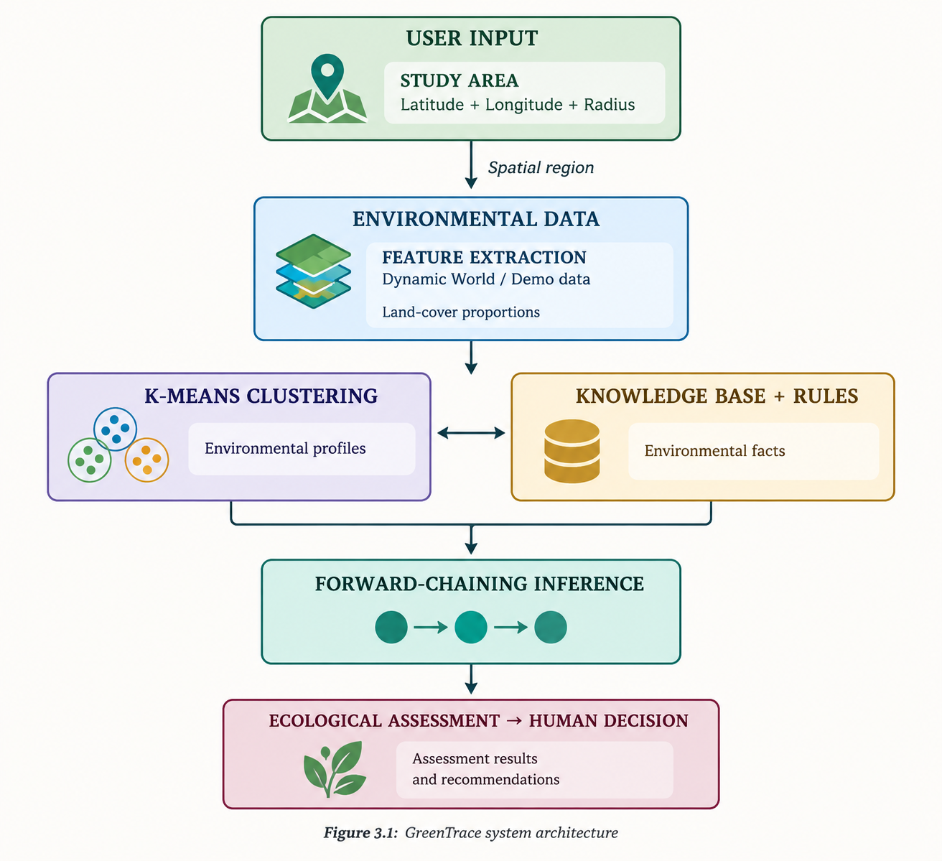
Figure 3.1: GreenTrace system architecture

3.3 Data Flow
- The user defines a study area using latitude, longitude and radius.
- The study area is represented for analysis.
- Environmental information is obtained from real data or Demo Mode.
- Environmental observations are transformed into feature vectors.
- K-Means clustering groups similar observations.
- Cluster characteristics are interpreted into environmental profiles.
- Profiles are represented as logical facts.
- The forward-chaining engine applies matching ecological rules.
- The assessment and reasoning trace are displayed.
- The human user reviews the evidence and makes the final decision.

3.4 Design Principles
- Explainability: conclusions should be traceable to facts and rules.
- Separation of concerns: data, ML, reasoning and presentation are distinct layers.
- Human oversight: GreenTrace supports decisions rather than making autonomous restoration decisions.
- Data transparency: the interface identifies the data source and communicates relevant limitations.
- Scope control: the system avoids unsupported claims about ecological certainty.

CHAPTER 4 — MODULES DESCRIPTION

4.1 Module 1 — Environmental Analysis and Machine Learning
The first module converts environmental observations into structured information that can be analysed by the machine-learning component. The prototype is designed to operate with local Demo Mode data and, after real-data integration, geospatial observations. Each spatial observation is represented by environmental features derived from land-cover information.
- Tree proportion
- Grass proportion
- Shrub/scrub proportion
- Crop proportion
- Water proportion
- Built-area proportion
- Bare-land proportion
- Flooded-vegetation proportion where available
After preprocessing, K-Means clustering is applied to identify groups of observations with similar feature profiles. K-Means requires the number of clusters to be specified and iteratively assigns observations to centroids before recomputing those centroids. Because cluster numbers are arbitrary, GreenTrace interprets clusters using their feature characteristics rather than treating a cluster identifier as a semantic label.

4.2 Module 2 — Knowledge-Based Ecological Assessment
The second module implements the symbolic AI component. Environmental observations are converted into facts such as high vegetation, low tree cover, high built cover, low total vegetation and mixed landscape. A knowledge base stores project-defined rules connecting combinations of these facts to higher-level conclusions.

4.2.1 Knowledge Representation
The knowledge base represents environmental observations as symbolic facts and represents ecological heuristics as rules. This provides a direct mapping between the observed environmental profile and the reasoning performed by the system.

4.2.2 Forward-Chaining Inference
The inference engine begins with known facts. It examines the available rules and fires a rule when all required conditions are satisfied. The conclusion of a fired rule is added to the set of known facts, allowing subsequent rules to fire. The process continues until no new facts can be derived or a safe termination condition is reached.

4.2.3 Example Rule
Component | Example
Facts | low_tree_cover; high_built_cover; low_total_vegetation
Rule condition | All three facts are present
Derived fact | potential_ecological_gap
Interpretation | Candidate for closer human ecological review

The thresholds and rules are project-defined heuristics. They demonstrate knowledge representation and inference and are not presented as universal ecological standards.

CHAPTER 5 — IMPLEMENTATION AND RESULTS

5.1 Experimental Setup
GreenTrace is implemented as a Python-based web application using Streamlit. The application integrates geospatial data retrieval, environmental feature extraction, unsupervised machine learning and knowledge-based reasoning into a unified ecological decision-support workflow.
Google Earth Engine provides access to the Dynamic World land-cover dataset for analysing a user-defined geographical study area. The retrieved environmental observations are processed into structured features, which are analysed using K-Means clustering to identify groups of observations with similar characteristics. The resulting environmental profiles are then interpreted using a knowledge base and a forward-chaining inference engine to derive explainable ecological assessments.
The application presents the analysis through an interactive web interface that enables users to explore geographical areas, inspect environmental patterns, understand the reasoning behind an assessment and record a human decision. The system is designed to support environmental decision-making while preserving human oversight.

5.1.1 Software Requirements
Software | Purpose
Python | Application logic and implementation of the AI pipeline
Streamlit | Interactive web application interface
Google Earth Engine Python API | Retrieval and processing of geospatial data
Dynamic World | Land-cover observations used for environmental analysis
Scikit-learn | K-Means clustering and machine-learning operations
Pandas and NumPy | Data processing and numerical computation
Folium / mapping support | Geographical map visualisation, if used in the implementation
Visual Studio Code | Development and testing

5.1.2 Hardware Requirements
The hardware requirements for GreenTrace are modest because the application is
designed to run on a standard development computer.
- A laptop or desktop capable of running Python and Streamlit.
- Sufficient memory to process environmental feature data and execute K-Means clustering.
- An internet connection for accessing Google Earth Engine and retrieving environmental observations.
- A modern web browser for interacting with the application.
The actual computational requirements depend on the size of the selected study area,
the amount of environmental data processed and the operations performed during
analysis.

5.1.3 Implementation
GreenTrace has been implemented as an integrated environmental decision-support application. The completed system connects geographical input, environmental data retrieval, feature extraction, unsupervised clustering and symbolic reasoning within a single workflow.
The user specifies a study area using geographic coordinates and a radius. The application retrieves environmental observations through Google Earth Engine and uses the Dynamic World land-cover dataset to derive the environmental features required for analysis. K-Means clustering identifies groups of observations with similar feature characteristics. These characteristics are interpreted into environmental profiles and represented as facts for the knowledge-based reasoning component.
The forward-chaining inference engine evaluates the available facts against project-defined ecological rules and derives conclusions that contribute to the final assessment. The interface presents the study area, environmental patterns and reasoning results to the user. Where supported by the implemented workflow, users can also inspect detailed analysis, record their assessment and access the corresponding report or saved analysis.
The completed implementation demonstrates the integration of machine learning and symbolic AI in an environmental decision-support application. Its conclusions are presented as potential ecological considerations rather than definitive ecological diagnoses or autonomous restoration instructions.

Figure 5.1 — GreenTrace Home Page

5.2 Results
The completed GreenTrace application demonstrates the integration of geospatial environmental analysis, unsupervised machine learning and knowledge-based inference.
The system accepts a user-defined study area and processes environmental observations to generate interpretable outputs.
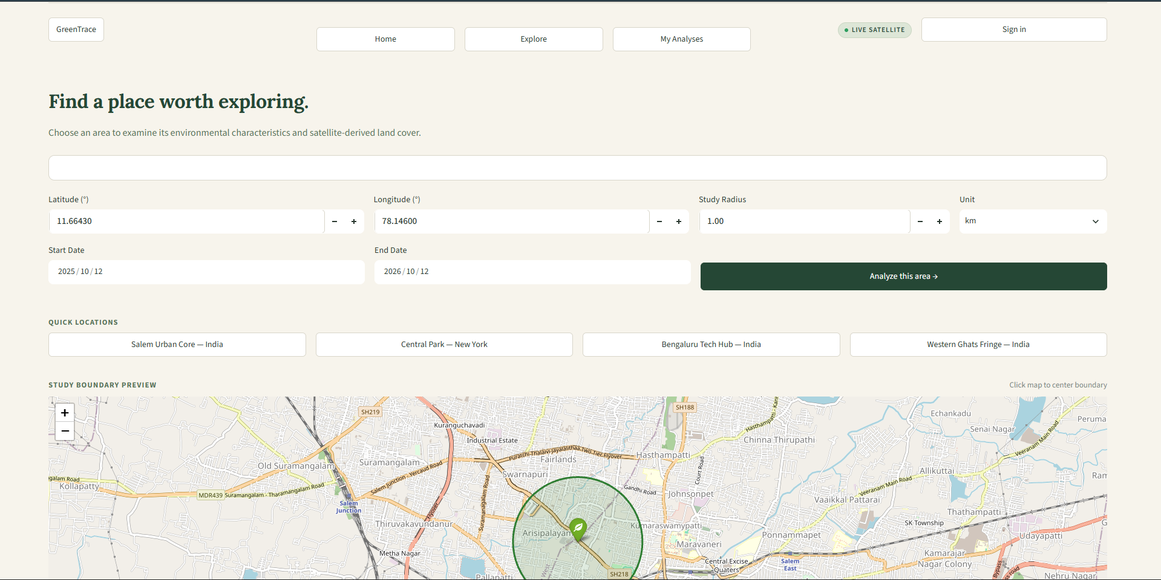
Figure 5.2 — Explore Page and Study-Area Input
The environmental analysis component extracts land-cover features from the selected area. K-Means clustering groups observations according to similarities in their feature values, and the resulting clusters are visualised on a map. The cluster identifiers are interpreted through their environmental characteristics rather than being treated as predefined ecological categories.
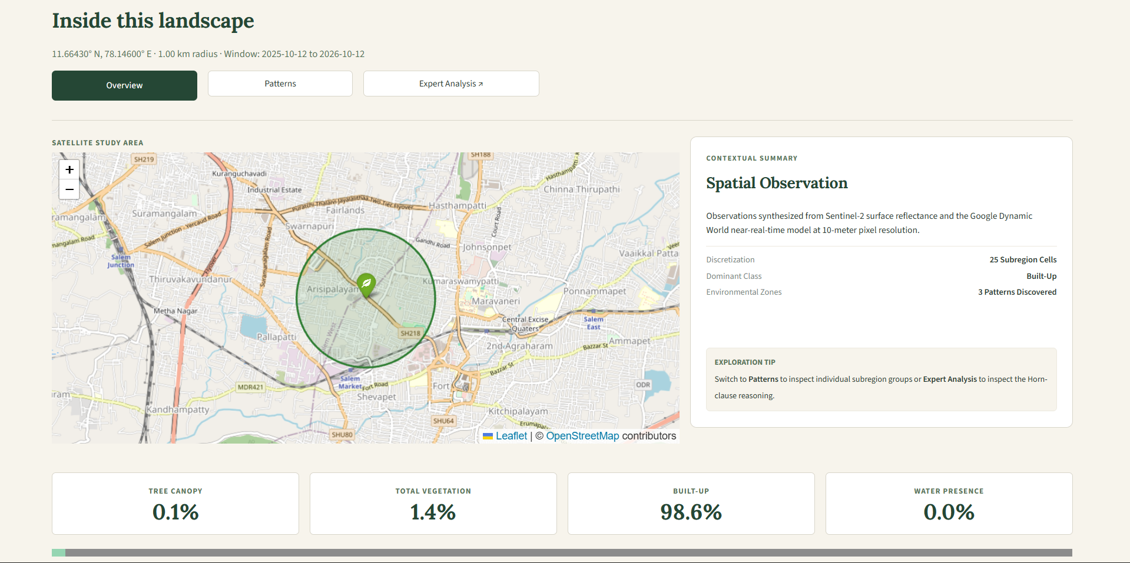
Figure 5.3 — Real-Data Analysis Map
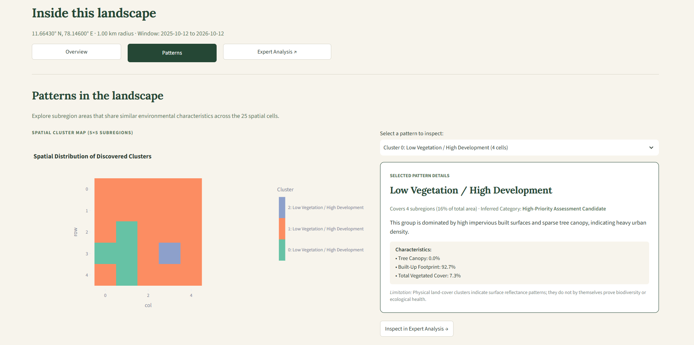
Figure 5.4 — K-Means Cluster Map and Interpretation
The knowledge-based assessment component converts the interpreted environmental information into symbolic facts. The forward-chaining inference engine applies project-defined rules to derive additional facts and support an explainable ecological assessment. The application presents these findings through an interactive interface, enabling users to examine the available evidence and retain responsibility for the final decision.
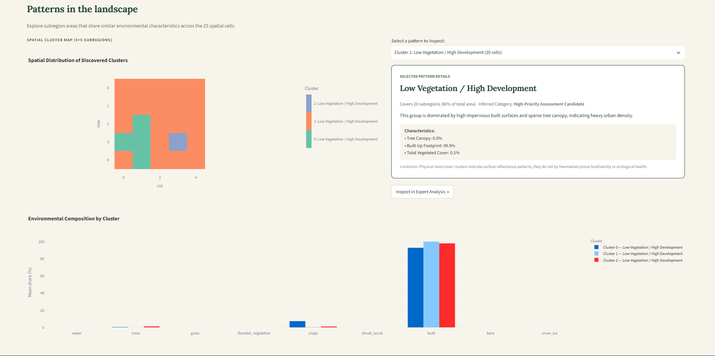
Figure 5.5 — Environmental Composition
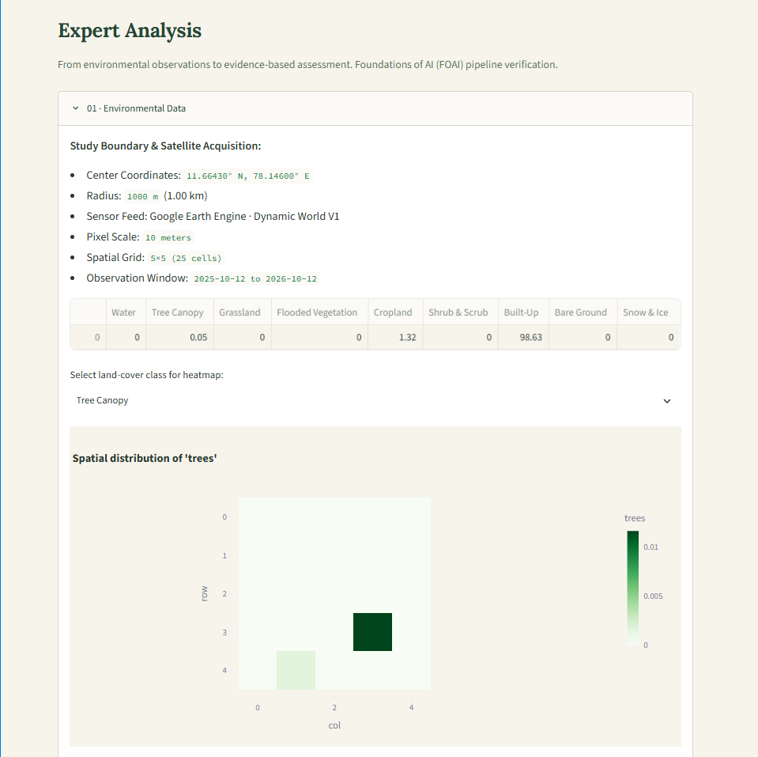
[a]
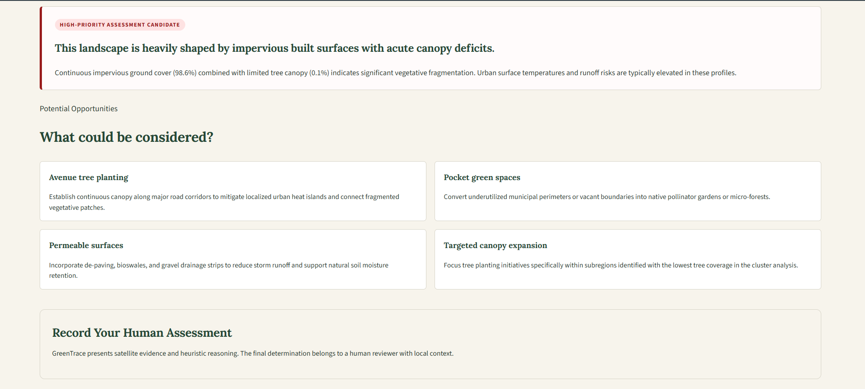
[b]
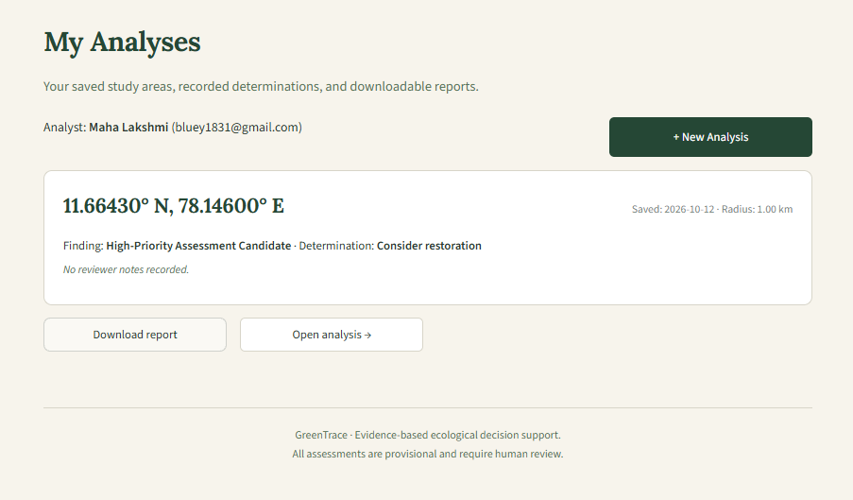
[c]
Figure 5.6 — [a] Expert Analysis and [b] Human Assessment and [c] Saved Analyses
The following figures illustrate the implemented interface and the principal outputs produced by GreenTrace.

5.2.1 Functional Testing
Test ID | Test case | Expected result | Status
T01 | Enter valid coordinates and radius | Study area is accepted | Pass
T02 | Retrieve environmental data | Environmental observations are returned | Pass
T03 | Extract environmental features | Feature values are generated | Pass
T04 | Execute K-Means clustering | Environmental clusters are produced | Pass
T05 | Display cluster map | Cluster patterns are visible on the map | Pass
T06 | Interpret selected cluster | Cluster characteristics can be inspected, if implemented | Pass
T07 | Run forward-chaining inference | Applicable rules derive conclusions | Pass
T08 | Display reasoning trace | Supporting facts and triggered rules are presented | Pass
T09 | Record human assessment | Reviewer can submit a decision, if implemented | Pass

CHAPTER 6 — CONCLUSION AND FUTURE WORK

6.1 Conclusion
GreenTrace demonstrates a hybrid artificial-intelligence approach to ecological gap analysis and environmental decision support. The system combines unsupervised machine learning with symbolic reasoning to analyse environmental characteristics and produce explainable assessments. K-Means clustering is used to identify groups of environmental observations with similar feature characteristics, while a knowledge base and forward-chaining inference engine derive conclusions using project-defined ecological rules.
The application integrates geospatial environmental data analysis with an interactive web interface. Users can define a geographical study area, examine environmental patterns, inspect the reasoning supporting an assessment and make their own decisions based on the available evidence. By separating pattern discovery from rule-based interpretation, GreenTrace demonstrates how different AI approaches can work together within a single decision-support workflow.
The project also highlights the importance of transparency and human oversight in environmental applications of artificial intelligence. Its assessments identify potential ecological gaps for further consideration rather than presenting automated conclusions as definitive restoration recommendations. GreenTrace therefore serves as an educational prototype demonstrating the application of machine learning, knowledge representation and logical inference to an environmental problem.

6.2 Limitations
Despite its integrated analytical workflow, GreenTrace has several limitations.
- Project-defined ecological rules: The knowledge base uses heuristic rules and thresholds developed for the project. These rules are not substitutes for expert ecological assessment or universally accepted restoration criteria.
- Unsupervised clustering: K-Means identifies similarities between observations based on the selected features. Its clusters do not represent ground-truth ecological categories, and their interpretation depends on the characteristics of the input data.
- Land-cover classification: Dynamic World provides land-use and land-cover classifications derived from satellite observations. These classifications have inherent uncertainties and should be interpreted in their geographical and environmental context.
- Limited ecological indicators: The current scope focuses on environmental features derived from land-cover information. It does not comprehensively model biodiversity, species interactions, soil quality or long-term ecological outcomes.
- Decision-support scope: A potential ecological gap identified by GreenTrace is a candidate for further investigation, not an automatic recommendation for restoration. Field observations, local knowledge, feasibility and expert evaluation may be necessary before an intervention is considered.
These limitations define the appropriate interpretation of the system's outputs and identify opportunities for further development.

6.3 Future Work
Several extensions could improve the environmental coverage, analytical depth and
practical applicability of GreenTrace.
- Vegetation condition analysis: Incorporate vegetation indicators such as the Normalized Difference Vegetation Index (NDVI), where suitable data are available.
- Soil and terrain information: Integrate relevant soil characteristics, elevation and terrain data to provide additional environmental context.
- Biodiversity evidence: Incorporate species-occurrence records and other suitable biodiversity observations to complement land-cover analysis.
- Temporal comparison: Analyse environmental observations across multiple periods to identify changes in land cover and vegetation patterns.
- Spatial fragmentation analysis: Introduce additional spatial metrics to examine the distribution and connectivity of vegetation patches.
- Expert-reviewed knowledge base: Refine the ecological rules with guidance from environmental specialists and appropriate domain-specific sources.
- Improved reporting and visualisation: Extend the analytical reports and map-based interface to make the evidence and reasoning more accessible to different categories of users.
- Validation and evaluation: Evaluate the system using carefully defined test cases, suitable reference datasets and feedback from domain experts.
These extensions could improve the depth and reliability of environmental assessment while preserving GreenTrace's emphasis on explainability and human decision-making.

CHAPTER 7 — REFERENCES
- Brown, C. F., Brumby, S. P., Guzder-Williams, B., et al. (2022). “Dynamic World, Near real-time global 10 m land use land cover mapping.” Scientific Data, 9, Article 251. https://doi.org/10.1038/s41597-022-01307-4
- Google Earth Engine. (n.d.). Dynamic World V1 Dataset Catalogue. Google for Developers. https://developers.google.com/earth-engine/datasets/catalog/GOOGLE_DYNAMICWORLD_V1
- Google Earth Engine. (n.d.). Earth Engine Python API Documentation. Google for Developers. https://developers.google.com/earth-engine/guides/python_install
- Pedregosa, F., Varoquaux, G., Gramfort, A., et al. (2011). “Scikit-learn: Machine Learning in Python.” Journal of Machine Learning Research, 12, 2825–2830. https://jmlr.org/papers/v12/pedregosa11a.html
- Russell, S. J., and Norvig, P. (2021). Artificial Intelligence: A Modern Approach. 4th ed. Pearson.
- Scikit-learn Developers. (n.d.). K-Means Clustering. Scikit-learn Documentation. https://scikit-learn.org/stable/modules/clustering.html#k-means
- Streamlit. (n.d.). Streamlit Documentation. https://docs.streamlit.io/

