
Predicting Prevalent Diabetes Using the TUDA Dataset
Artificial Intelligence II - EEE408


Maha Manar Shekfa
B01009722

- Introduction
According to the World Health Organization, diabetes is a significant health problem as it affects millions of people across the globe and, if left unnoticed, may have a life-threatening consequence.
As such, machine learning was subsequently developed and applied to help early find many diseases, leading to earlier identification and better healthcare upkeep techniques.
This study aims to create machine learning models that can predict the presence of diabetes for individuals based on health data from the Trinity Ulster Department of Agriculture (TUDA) Ageing Cohort dataset. Moreover, the dataset consists of clinical information from older adults in Ireland.

- Dataset Description
The dataset from which this study is drawn is sourced from the Trinity Ulster Department of Agriculture (TUDA) Ageing Cohort Study – a large, population-based study conducted in Ireland seeking to explore the nutritional and health determinants of ageing. Demographics, physical, lifestyle, and biochemical data of older individuals were collected by TUDA researchers. Moreover, data was gathered using the 5,186 observation, 104-variable version of the dataset for each subject with the health indicators. These can be demographic (age or gender), anthropometric (waist circumference and hip circumference), laboratory (blood biomarkers), etc., which may contain signs and symptoms related to increased risk of diabetes. A binary target variable (DiabetesFlag) was computed for classification task based on an HbA1C measurement (i.e., average blood glucose over 2–3 months). A 6.5% and greater HbA1C indicates diabetes, according to an American Diabetes Association guideline. Using this, those who had an HbA1C ≥ 6.5 were deemed diabetic and patients that had HbA1C lower than this value were classified as nondiabetic.
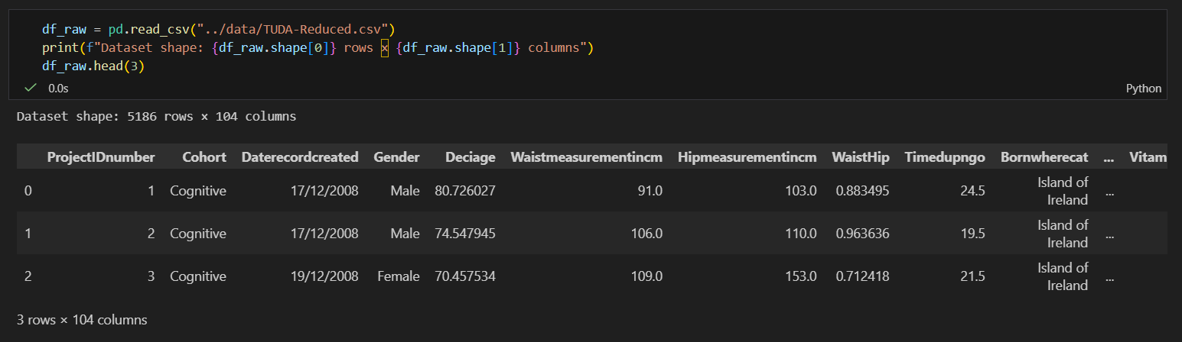
Figure 1: First records and selected variables in the TUDA dataset.

- Data Preprocessing
Preprocessing steps have been taken before the machine learning models were trained, in preparation for analyzing the above dataset. Data preprocessing stage is an integral part of machine learning process since raw datasets may have missing values, inconsistencies as well as variables, which need to be transformed, that will be useful for algorithms to function on them.
The dataset was first checked to discover the missing values and the features were analyzed. Categorical variables were converted to numerical terms to meet any machine learning algorithms. The data were divided at the same time into two groups: training samples and test set, in a consistent 80/20 split as seen in Fig. 2. This dataset has high imbalances with scores significantly higher for non-diabetic than diabetic. A Synthetic Minority Over-Sampling Technique (SMOTE) was used on the training data. This approach synthesizes minor samples and aids in making the sample size representative for the minority class, which facilitates better detection of diabetic cases.
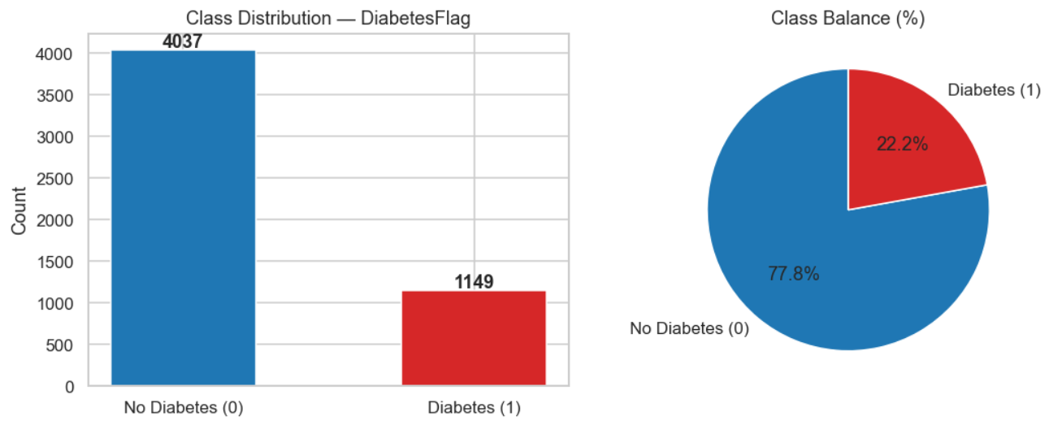
Figure 2: Class distribution of the DiabetesFlag variable in the TUDA dataset.

4. Machine Learning Models
Three machine learning algorithms applied to predict diabetes were implemented in the dataset. Logistic Regression was selected to be a baseline model due to its extensive use in binary classification problems and interpretable outcomes. In addition, two ensemble learning approaches which were Random Forest and Gradient Boosting were used. A Random Forest integrates numerous decision trees to increase performance and reduce overfitting, and Gradient Boosting builds models sequentially correcting errors made by prior models. This multiple-algorithm configuration allows model performance to be compared, and the best decision for the job is made.

5. Model Evaluation
Various classification metrics were applied to evaluate the models. Accuracy represents the percentage of correct predictions (all positive predictions). Precision is the proportion of diabetic cases predicted correctly across predicted positive cases, and recall is the ability of the model to classify correctly diabetic patient cases. With an F1-score that strikes a compromise between precision and recall. The area under the Receiver Operating Characteristic curve (ROC-AUC) is used to examine the model’s ability to distinguish between diabetic and non-diabetic individuals.

6. Results and Model Comparison
The model performance of trained models is reviewed in Table 1 and presented in Figure 4. The Gradient Boosting model obtained the best overall accuracy and ROC-AUC among the tested models, which was a sign of better predictive performance. Logistic Regression achieved better recall indicating it detected more diabetic cases. Since the dataset is unbalanced, evaluation metrics like F1-score and ROC-AUC are important since accuracy alone might give an incorrect estimation of the model as it should be. On the basis of this finding, Gradient Boosting emerged as the best performing model in diabetes prediction for TUDA data. This implies that ensemble techniques might accommodate more complex relationships in the dataset than simple training methods. 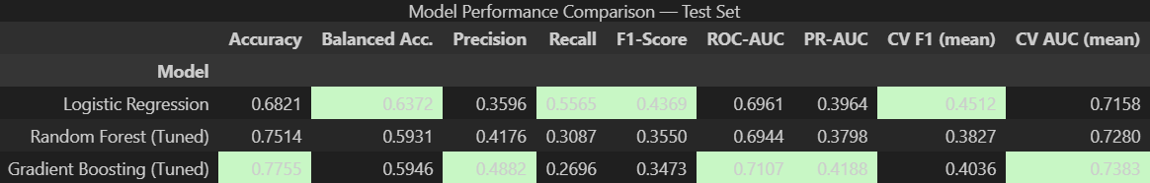
Table 1: model Performance Comparison across evaluation metrics.
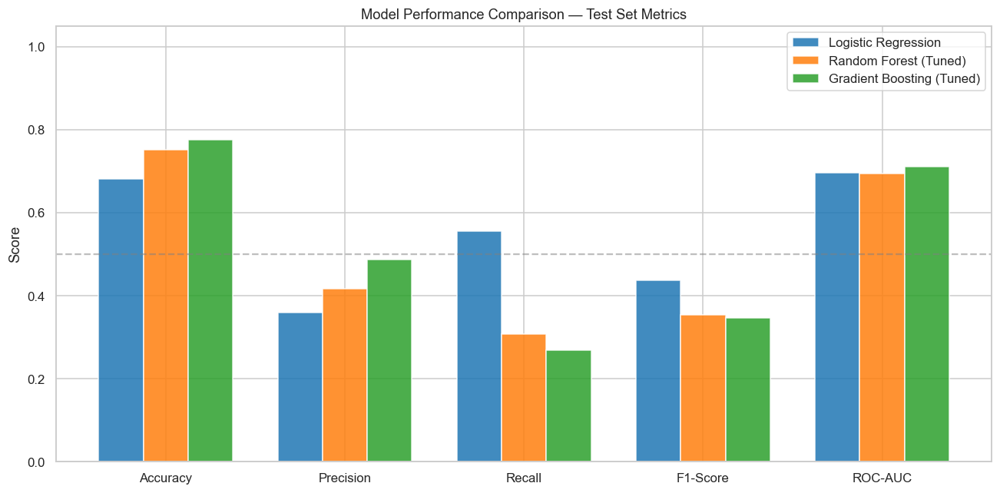Figure 4: comparison of model performance across evaluation metrics.
7. Conclusion
This proposed project uses machine learning models to predict diabetes from the data available from the TUDA Ageing Cohort. Training logistic regression, random forest, and gradient boosting were performed and compared to determine their performance. Overall, ensemble models performed significantly better than the baseline approach with Gradient Boosting performing better with respect to ROC-AUC. The data imply that machine learning may facilitate diabetes risk assessment for health-related domain data. While the results are promising, there is still room for improvement. Future work may add additional relevant features or test different algorithms to obtain better prediction results.

References
- World Health Organization. (2023). Diabetes.
https://www.who.int/news-room/fact-sheets/detail/diabetes
- American Diabetes Association. (2023).
Standards of Medical Care in Diabetes—2023. Diabetes Care, 46(Supplement_1), S1–S291.
- Trinity Ulster Department of Agriculture (TUDA) Study.
Hoey, L., McNulty, H., Strain, J. J., et al. (2017). Study protocol for the Trinity Ulster Department of Agriculture (TUDA) ageing cohort study. Journal of Nutrition, Health & Aging.

