Project 1 — Supervised Regression
Group 2: Fatemeh Sayah Taheri, Mahashree Jatinbhai Ajmeri
Seneca Polytechnic
Professor: Rani Gnanaolivu
October 2026

Predicting Airbnb Listing Prices in New York City Using Machine Learning
Abstract
This study attempts to establish the extent to which machine learning is capable of predicting nightly prices for Airbnb listings in New York City based on the publicly available Kaggle dataset. Exploratory data analysis was applied to a replicable sample of 5,000 listings along with three regression models: Linear Regression, Ridge Regression (alpha 1.0) and Polynomial Regression (degree 3). The models were compared through three sizes of the test set, two values of random seed and five-fold cross-validation. In terms of cross-validated RMSE, Linear Regression proved to be the best performing model with $235.553, closely followed by Ridge Regression ($235.553). Linear Regression also produced the following performance on a separately reserved 10% holdout test set (random state 42): MAE = $85.22, RMSE = $134.90 and R² = 0.029.
1. Problem Statement and Practical Objectives
The main goal of this project is to test whether it is possible to predict the nightly listing price in New York on Airbnb based on the listing characteristics. The target value for predictions is the listing price in USD, whereas an individual observation refers to an Airbnb listing.
Hosts could use predictive models to set a competitive listing price, conduct market analysis, and help rental platform teams identify factors that are associated with price differences . But the predictions should be viewed as estimates and not a guaranteed booking price.
The dataset used in the study was downloaded from Kaggle New York City Airbnb Open Data. The random_state=42 option was used to select 5,000 observations randomly. This was done to make the experiments feasible and reproducible. The sample selected consisted of 16 columns from the original data set.
2. Dataset Understanding
Price was taken as the target variable. The candidate predictors in the original dataset included neighbourhood group, room type, latitude, longitude, minimum nights, number of reviews, reviews per month, calculated host listing count, and availability for the next 365 days.
Variables like id and host_id, together with listing names and last_review, were not meant to be predictors in the final model. The model code selected five numerical predictor variables using absolute correlations with price within each training fold. The five predictors selected when fitting the final model on development data were longitude, availability_365, calculated_host_listings_count, minimum_nights, and number_of_reviews.
Neighbourhood group and room type were part of the candidate predictors list; however, they were not chosen as part of the five predictors. In addition, categorical variables were not included in the models. This is a weakness in the study since these variables may give insights into the difference in listing prices.
3. Data Quality and Exploratory Analysis
The exploratory analysis was conducted on the first few rows of the dataset, its dimension, types of the data, descriptive statistics, missing values, and purpose of each column. There were no exactly identical rows observed in the sample dataset.
Missing numerical values were dealt with by imputation using median. Numerical variables were also standardized before modelling. The final model pipeline used five selected numerical predictors; categorical preprocessing was not applied to these predictors.
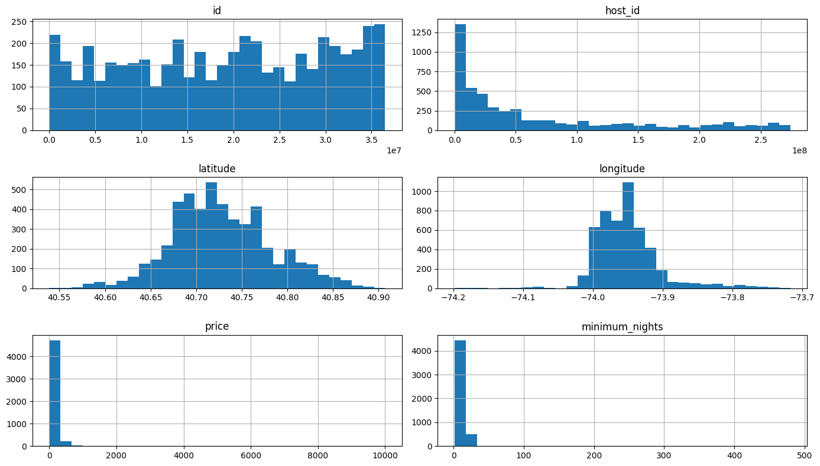
Figure 1. Distribution of the numerical variables in the dataset.
4. Relationships and Feature Preparation
Correlation matrix was utilized to analyse the relationship between numbers. Correlation analysis can be useful in analysing the relationship between variables; however, it cannot be considered as the evidence of causality.
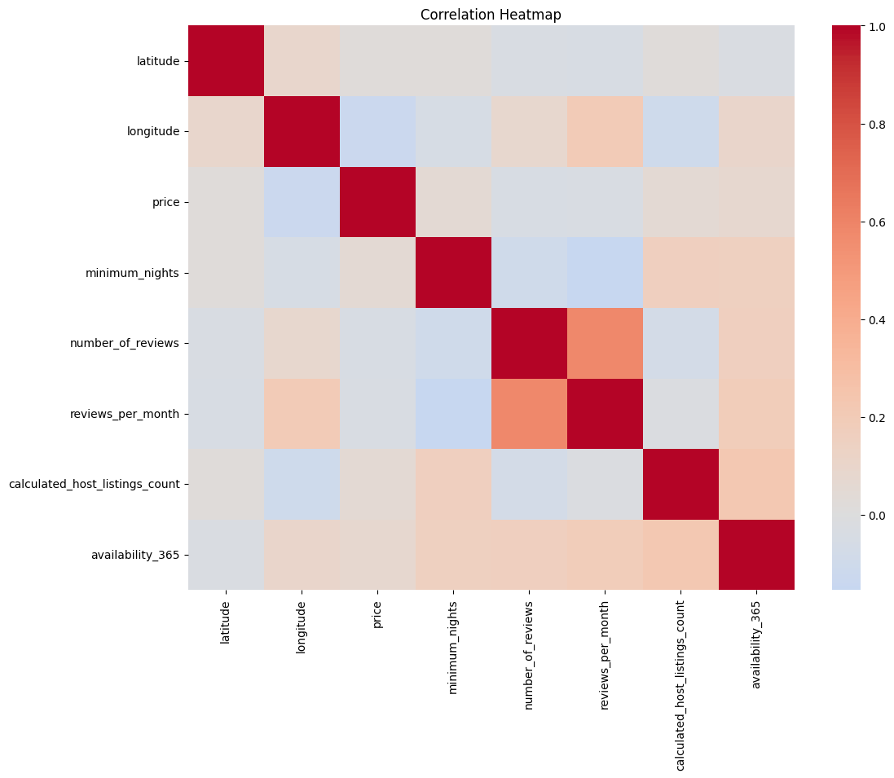
Figure 2. Correlation heatmap presenting the relationships between numerical variables within sampled data set. Correlation proves the presence of association, but not causation.
Furthermore, a predictor-versus-price graph was constructed in order to analyse the relationship between the predictor and the listing price. The variability in price shows that the chosen predictors do not encompass all the factors affecting listing prices.
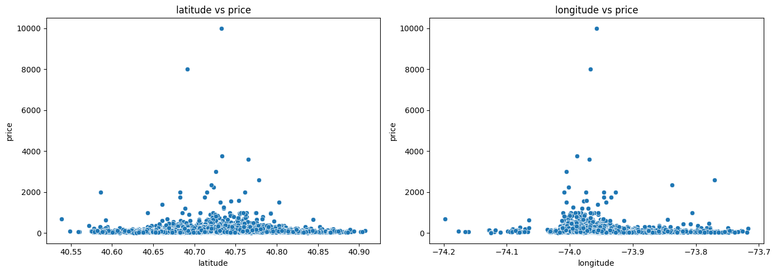
Figure 3. Relationship between the selected predictor and listing price.
The numerical preprocessing steps involved using SimpleImputer(strategy="median") and StandardScaler. These steps were included in a regression pipeline, following a Top5Selector that selected the five numerical predictors using training data only. Feature selection and preprocessing were fitted separately within each cross-validation training fold.
To avoid data leakage, a final 10% holdout test set was reserved before model comparison. The five features were selected using training data only within the cross-validation pipeline, so validation and final test targets were not used to choose predictors.
5. Experimental Design and Model Performance
The following regression models were investigated: Linear Regression, Ridge Regression with alpha set to 1.0 and Polynomial Regression of degree three.
The analysis was carried out using the following configurations of each model, which consisted of different fractions of 10%, 25% and 30% for the test-set and random state settings of 0 and 42 within the development data. Cross-validation was run five times on the training part of each configuration, resulting in 18 model-configuration pairs. A separate 10% final holdout set (random state 42) was reserved in advance.
The performance metrics used were the Mean Absolute Error (MAE), Root Mean Squared Error (RMSE) and the coefficient of determination (R²). Lower MAE and RMSE values correspond to less prediction error, whereas larger R² values usually mean that more variation in the target is accounted for by the model. Mean cross-validated RMSE was used as the main criterion for the comparison of the models.
Model | Mean CV MAE ($) | Mean CV RMSE ($) | Mean CV R²
Linear | 86.449 | 235.553 | 0.035
Ridge | 86.448 | 235.553 | 0.035
Polynomial (degree 3) | 86.961 | 237.922 | 0.006
Table 1. Cross-validated average performance in the six configurations.
The RMSE obtained in the cross-validation process for Linear and Ridge Regression had the least mean value compared to other models; however, there is no considerable gain over Ridge Regression as the mean RMSE values were equal when rounded to three decimal places. The Polynomial Regression model had a relatively high RMSE and a lower R².
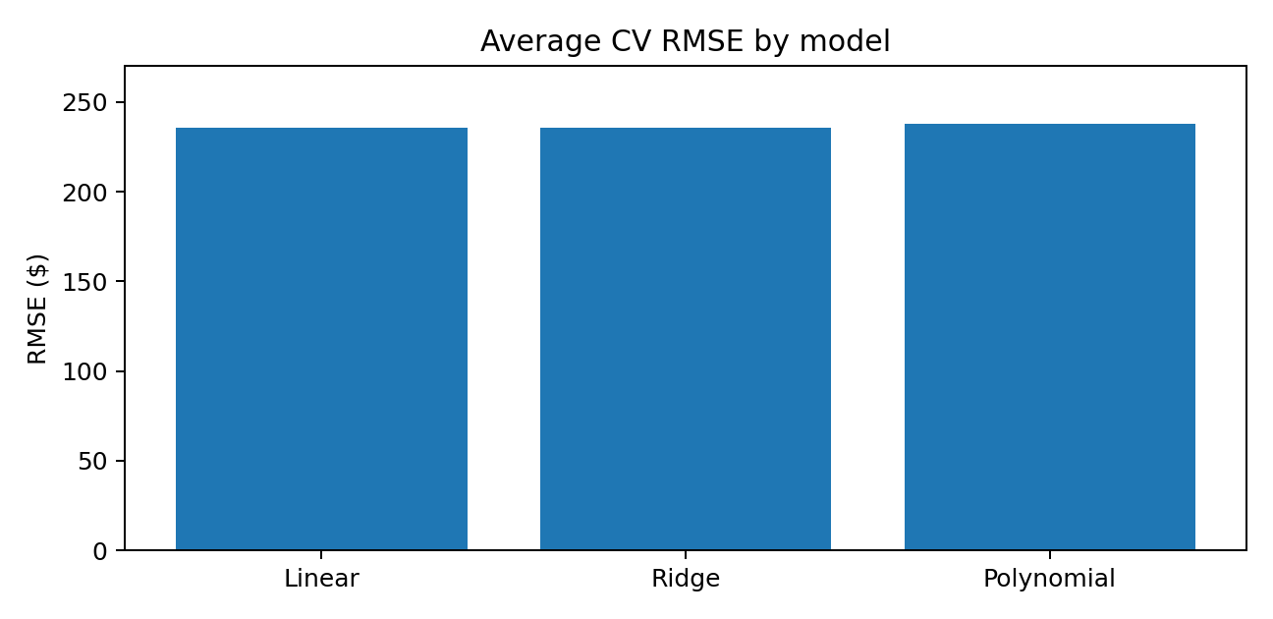
Figure 4. Comparison of the mean cross-validated RMSE for the three regression models.
Configuration Selection and Holdout Testing
The final model was Linear Regression, selected using average cross-validation RMSE on the development data. The best development-data configuration had a 25% test split and random state 0, with cross-validation MAE = $83.021, RMSE = $203.351, and R² = 0.040. This configuration did not determine the final holdout: the final 10% holdout set (random state 42) was reserved in advance.
Upon fitting the model on the training subset, the results on the holdout set were MAE = $85.22, RMSE = $134.90, and R² = 0.029.
The discrepancy between cross-validation and holdout results on RMSE shows that prediction errors may vary depending on the data split. It may be connected to expensive homes or other outlier cases in the data; however, this would need further verification using fold-level results.
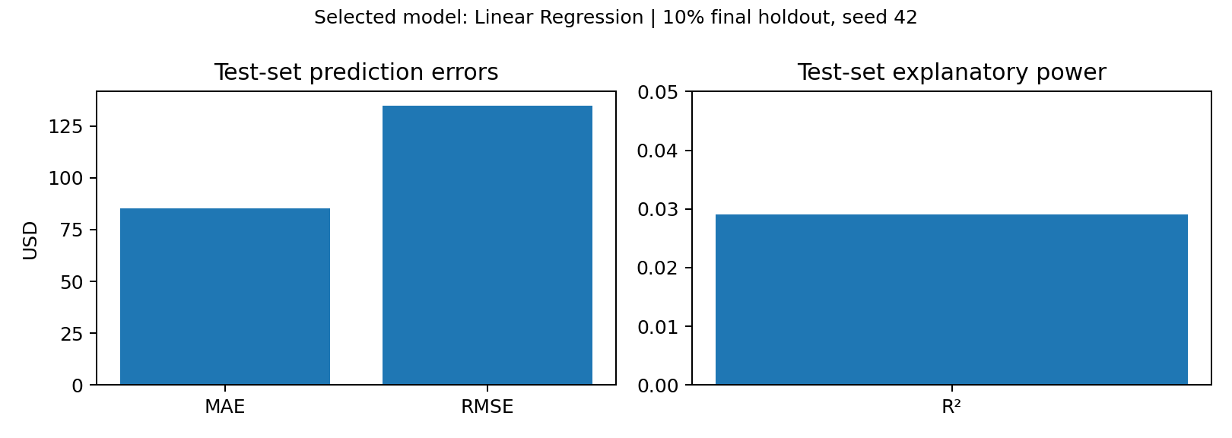
Figure 5. Values of MAE and RMSE for the selected Linear Regression model on the final holdout set in US dollars, and R² separately due to a different scale.
The holdout R² of 0.029 indicates that the model explains only a small proportion of the observed variation in listing prices on this split. The MAE and RMSE also show that prediction errors remain substantial for practical pricing purposes. The final holdout was reserved before model selection, and feature selection was fitted using development data only.
6. Prediction Errors, Bias, and Business Interpretation
Prediction error was performed using actual versus predicted charts, residual chart, and residual histogram. Residual was defined as an actual price minus a predicted price, and a histogram was trimmed to ±$500.
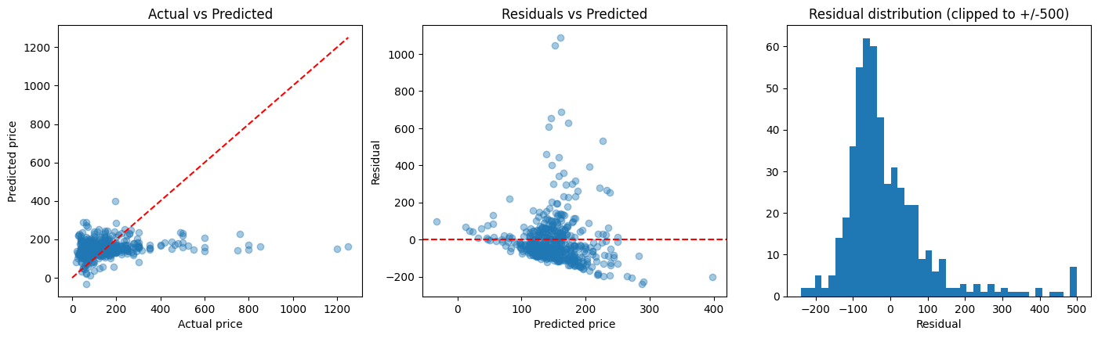
Figure 6. Actual versus Predicted Prices, Residuals, and Residual Histogram for the Selected Linear Regression Model.
From the plots, one can notice that there are cases when the regression underestimates the cost of an expensive listing. The residuals indicate that the prediction error varies across listings, particularly for expensive listings. Room type was used for error analysis but was not among the predictors of the model. The low value of R² equals to 0.029 shows the lack of predictiveness. Lack of data about property size, facilities, location, and seasonal demand may be a reason for prediction errors. The small size of the sample and oldness of the data may also influence the generalization ability of the model. Therefore, the model is not ready yet for automated pricing.
7. Conclusion
Linear Regression had the best average cross-validated RMSE, but its results were not much better than those of Ridge Regression. In contrast, Polynomial Regression yielded poorer results.
Improvements could be adding features like room type, neighborhood, house features and time information. Other approaches that could be worth testing are log prices, robust regression and the median price baseline.
Feature selection was performed using training data only and included in the cross-validation procedure to avoid data leakage. The selected model was then tested on a separate holdout test set.
Monitoring Plan:
If this model were used for pricing support, its MAE, RMSE and R² should be checked regularly against newly observed listing prices. Prediction errors should also be reviewed by room type and price range. A sustained increase in errors would trigger investigation, updated data collection, and retraining before further use.
Limitations and Assumptions
However, the model is trained on advertised prices per night and not booking prices. Reproducible testing was done on a sample of 5,000 listings, which might not cover all the listings in the dataset or the current market situation.
Feature selection was included in the training pipeline to reduce data leakage. However, Ridge Regression was applied with the constant alpha equal to 1.0, and only three regression models and a small set of numerical features were considered. The results may not generalize to current market prices.

Group contribution record
Task | Fatemeh Sayah Taheri | Mahashree Jatinbhai Ajmeri
EDA / quality checks | ✓ | ✓
Preprocessing / feature selection | ✓ | ✓
Regression models / CV | ✓ | ✓
Plots / interpretation | ✓ | ✓
Report | ✓ | ✓

Reference
Kaggle. New York City Airbnb Open Data. https://www.kaggle.com/datasets/dgomonov/new-york-city-airbnb-open-data

