INFUSI-METRICS
An Embedded C Framework for Real-Time IV Fluid Monitoring
and Predictive Depletion Alerting
TEAM MEMBERS
- Mahasri Murugesan [ CB.SC.U4CSE25637 ]
- Sruthica M S [ CB.SC.U4CSE25657 ]
- Mahitha S [ CB.SC.U4CSE25638 ]
CIRCUIT DIAGRAM
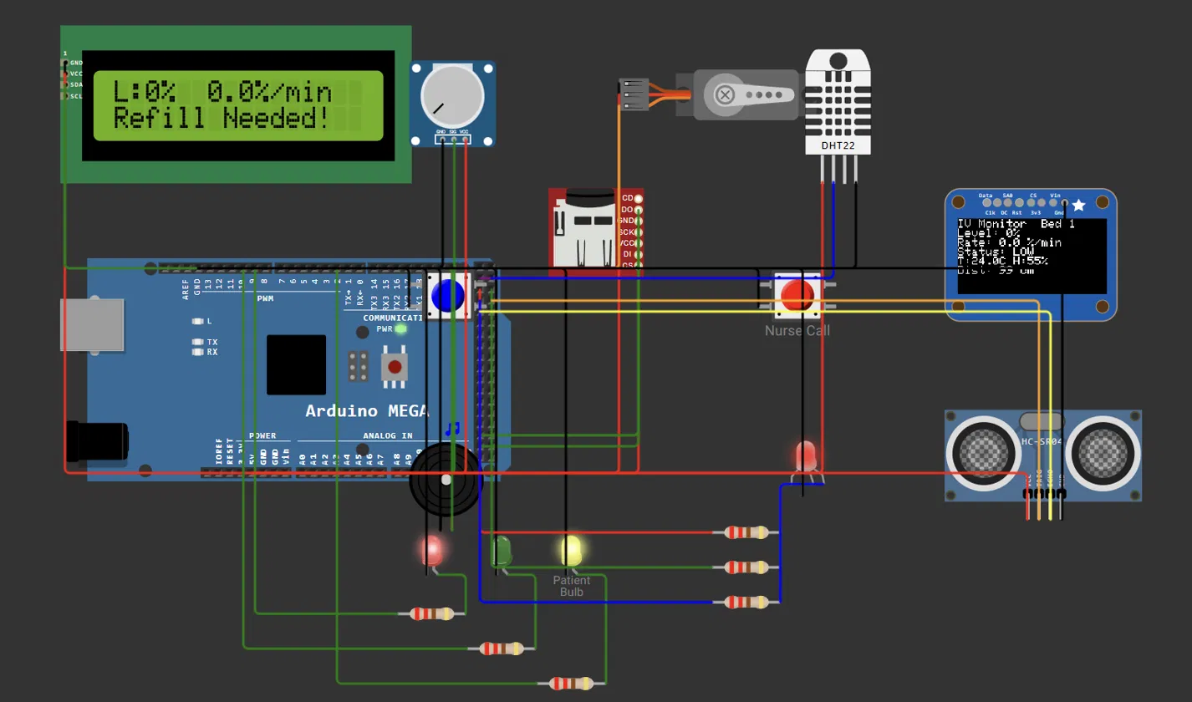
EMBEDDED PLATFORM/TECHNOLOGIES
Arduino Mega 2560, C/C++ (Arduino), Python, Streamlit, scikit-learn, Wokwi simulator, and sensors and modules (potentiometer, DHT22, HC-SR04, servo, SD card, I2C LCD, OLED, GPS).
DASHBOARD
The dashboard is a mobile-friendly web page that lets nurses monitor a patient’s IV drip from their phone, showing the fluid level, drain rate, low-level and nurse-call alerts, and room sensor readings. They can also send commands such as acknowledging a call and get an ML estimate of when the bottle will run low..
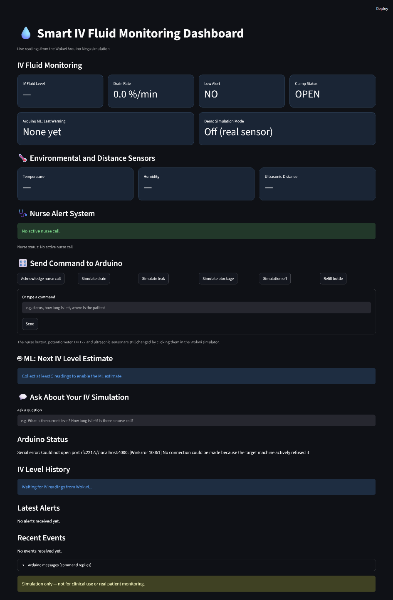
GITHUB LINK
https://github.com/mahasri-mv/infusimetrics
ABSTRACT
Continuous monitoring of IV fluid is essential to prevent air embolism, blood backflow and interrupted dosage. This report presents InfusiMetrics, an embedded C framework for real-time IV fluid monitoring and predictive depletion alerting. The firmware samples the fluid level, raises a low-level alarm below 20%, and automatically clamps the line if the alarm is not addressed within 60 seconds. A regression routine written in C estimates the drain rate and the time remaining, issues an early warning, and flags suspected leaks or blockages. A patient nurse-call button raises an alert that escalates after 30 seconds if nobody acknowledges it, and a DHT22 and an ultrasonic sensor add room temperature, humidity and distance readings. A rule-based command interpreter, also in C, answers plain-English queries and produces readable alert messages with the bed number and GPS location. Events are logged to an SD card and streamed over Serial, where a Python layer using Scikit-Learn and Streamlit provides a dashboard. In simulation, the dashboard displayed a live level
of 29%, produced a next-level estimate of 35.5%, and answered the query “iv low”correctly.
OBJECTIVE
In traditional practice, IV therapy is monitored by periodic manual inspection. This has several drawbacks:
- Delayed Air Embolism & Reflux Risks: an empty bag noticed too late lets air or blood backflow into the cannula.
- Unnoticed Flow Interruptions: blockages or pinched tubing stop medication delivery without immediate staff awareness.
- Nurse Workload & Human Error: frequent rounds across many beds increase fatigue and error, especially in night shifts.
- No Predictive Foresight: gravity-fed sets give no data or forecast about exactly when the bottle will be empty.
- Unanswered Patient Calls: a call button only helps if someone notices it; nothing shows when a call is ignored, especially on a busy ward.
An automated system is therefore needed that tracks the fluid level continuously, forecasts depletion, alerts staff early, and escalates a patient call when nobody responds.

PROJECT SCOPE
InfusiMetrics is an embedded monitoring system that continuously measures the fluid level of an intravenous (IV) bottle, predicts when it will run out, and alerts the nurse station before the line runs dry. It also lets the patient call a nurse and escalates the call if nobody answers. The core of the project is firmware written in C for an Arduino microcontroller, simulated on the Wokwi platform. The scope covers:
- Embedded Sensing & Control (C): reading the fluid sensor, driving the LCD, OLED, buzzer, red/green LEDs, RGB status LED, patient-side bulb and a servo clamp, handling a nurse reset button, and logging GPS-tagged events to an SD card.
- On-Device Prediction (C): a hand-written least-squares regression over a sliding window of readings that gives the drain rate, time-to-empty, an early warning, and leak or blockage detection.
- Natural-Language Commands (C): rule-based intent recognition that lets a nurse type plain-English commands such as “status”, “how long is left” or “ack” in the Serial Monitor.
- Nurse Call & Escalation (C): a debounced patient button raises a call with a buzzer and RGB cue; if nobody acknowledges it within 30 s, the call escalates and its state is sent to the dashboard.
- Environment Sensing (C): a DHT22 reads temperature and humidity and an HC-SR04 reads distance; both appear on the OLED and are sent over Serial.
- Python Extension: a Streamlit dashboard with Scikit-Learn forecasting and a text query box, built on the firmware's data, which also shows temperature, distance and nurse-call status and sends commands back to the Arduino.
ALREADY EXISTING RELATED WORK
1. Novel implementation of IoT based non-invasive sensor system for real-time monitoring of intravenous fluid level for assistive e-healthcare
Ray, P.P., Thapa, N., Dash, D., De, D. (2019). Circuit World, 45(3).
Link: https://doi.org/10.1108/CW-01-2019-0008
- Designs a non-invasive, semi-automatic IoT sensor system that tracks the IV fluid bag level in real time.
- The system is controlled by an ATtiny85 with an LM35 temperature sensor, using low-power, low-cost pervasive sensors.
- Nurses receive a prompt alert when the bag is about to run empty; multi-master operation is left for future work.
2. Low-Cost IoT-Based Intravenous Fluid Monitoring System Using Load Cell Sensor and ESP8266
Aqthobirrobbany, A. et al. (2026). Journal of Computer Electronic and Telecommunication, 7(1).
Link: https://doi.org/10.52435/complete.v7i1.10921
- A load cell with an HX711 amplifier weighs the IV bag, and an Arduino Uno computes the remaining volume.
- An ESP8266 module pushes readings to a ThingSpeak cloud channel so nurses can view the volume on their device.
- Calibration showed about 0.2% error at no load and about 5% near full load, suiting low-cost ward-level monitoring.
3. Design and Implementation of IOT-Based Intravenous (IV) Bag Monitoring and Alert System
Akau, G.T., Airoboman, A. et al. (2025). FUDMA Journal of Engineering and Technology.
Link: https://fjet.fudutsinma.edu.ng/index.php/fjet/article/view/88
- Combines a load cell (HX711) for fluid weight with a laser sensor on the drip chamber to monitor the drop rate.
- Alerts travel over an HC-12 radio module to a nurse-station receiver, while an ESP8266 uploads data to ThingSpeak.
- The prototype detected low-fluid and abnormal drip-rate events with roughly 96.8% success.
4. IOT Based Automatic Intravenous Bag Data Logging Monitoring and Alert System
Sriram, S., Rajeshkumar, G., Saranya, E., Saranya, K., Kavitha, R. (2023). Research Square (preprint).
Link: https://doi.org/10.21203/rs.3.rs-2804610/v1
- Targets the danger of blood flowing back into an empty saline bottle when caregivers miss the low-level moment.
- Uses a load cell and a very low-power microcontroller to convert bottle weight into a measurable signal.
- Sends reliable messages to subscribers and logs data, with the bottle valve closing automatically with human help.
5. Design and Development of Saline Infusion Administration System Using IoT
Otanasap, N., Kanchanawongkul, V., Chalermsuk, C. (2022). ASEAN Journal of Science and Technology Reports, 25(1), 41-49.
Link: https://doi.org/10.55164/ajstr.v25i1.244460
- Addresses nurse shortages during COVID-19 with a system that monitors and regulates saline delivery over IoT.
- An ESP8266 NodeMCU and Arduino UNO calculate flow rate from weight loss and drive a servomotor that compresses the tube.
- The prototype could monitor, alert and automatically control the saline flow rate as specified.
PROPOSED IDEA

We propose a smart IV monitor that tracks the fluid level continuously and alerts the nurse automatically. It predicts when the bottle will run low and takes safety action if nobody responds. A mobile-friendly dashboard lets nurses monitor patients and send commands from their phones.
How it works
- Sensing: A sensor measures the fluid level, and an Arduino Mega reads it every 500 ms. A DHT22 measures room temperature and humidity, and an ultrasonic sensor measures distance.
- Local alerts: Below 20%, the buzzer, red LED, patient bulb and LCD/OLED warn the nurse.
- Auto-clamp: If the bottle stays low and nobody responds, a servo closes the IV line automatically.
- Machine learning: Linear regression on recent readings estimates the drain rate and the time until the bottle is empty. It also flags a suspected leak (fluid dropping too fast) or blockage (flow stopped) and gives an early warning before the level gets low.
- Nurse call: The patient presses a button to call a nurse. If nobody answers within 30 seconds, the system escalates to backup staff.
- NLP commands: Nurses can type plain-English commands such as “how long is left?” or “where is the patient?”.
- GPS and logging: Events are logged to an SD card with the bed location.
- Dashboard: A Streamlit web app shows live readings, alerts and the ML estimate. Nurses can use it on a mobile phone.
ML/DL/NLP/CV & Hardware Specifications
- ML: Linear Regression predicts IV fluid levels and estimates low/empty time; drain-rate analysis helps detect abnormal flow.
- DL: Not implemented; lightweight ML techniques are used.
- NLP: Python answer_question() processes supported user queries and provides IV status information.
- CV: Not implemented; monitoring uses sensors instead of cameras.
- Hardware: Arduino Mega 2560, potentiometer (fluid-level simulation), DHT22 (temperature/humidity), HC-SR04 (distance), OLED, I²C LCD, buzzer, RGB/status LEDs, nurse-call button, servo motor, SD card module, and GPS (NEO-6M).
- Software: Arduino IDE, Wokwi, Python, Streamlit, and PySerial.
Hardware Component | Specification / Purpose
Microcontroller | Arduino Mega 2560
Fluid-level sensor | Potentiometer (simulation)
Temperature & humidity | DHT22
Ultrasonic sensor | HC-SR04
Display | I²C LCD (0x27), OLED SSD1306 (0x3C)
Nurse-call button | Digital pin 22
Alert system | Buzzer, red LED, green LED, RGB LED
Servo motor | IV clamp control (simulation)
GPS module | NEO-6M
Storage | SD card module
Software | Wokwi, Arduino IDE, Python, Streamlit, PySerial
Simulation & Algorithm Execution
The circuit is simulated in Wokwi using an Arduino Mega, a potentiometer as the fluid sensor (A0), an I2C 16x2 LCD, a buzzer, red and green LEDs, a patient bulb, a servo clamp, a reset button and an SD card module. The added parts are a nurse-call button (pin 22), a DHT22 sensor (pin 23), an RGB status LED (pins 24–26), an HC-SR04 ultrasonic sensor (TRIG 27, ECHO 28) and an SSD1306 OLED that shares the I2C bus with the LCD (addresses 0x3C and 0x27). Wokwi has no GPS part, so the firmware uses a fixed bed location when no live GPS fix exists; with a NEO-6M module connected, live coordinates are used instead. Demo commands in the Serial Monitor (simulate drain, simulate leak, simulate block, refill) let each behaviour be tested without hardware. Figure 2 shows the circuit with the added components.
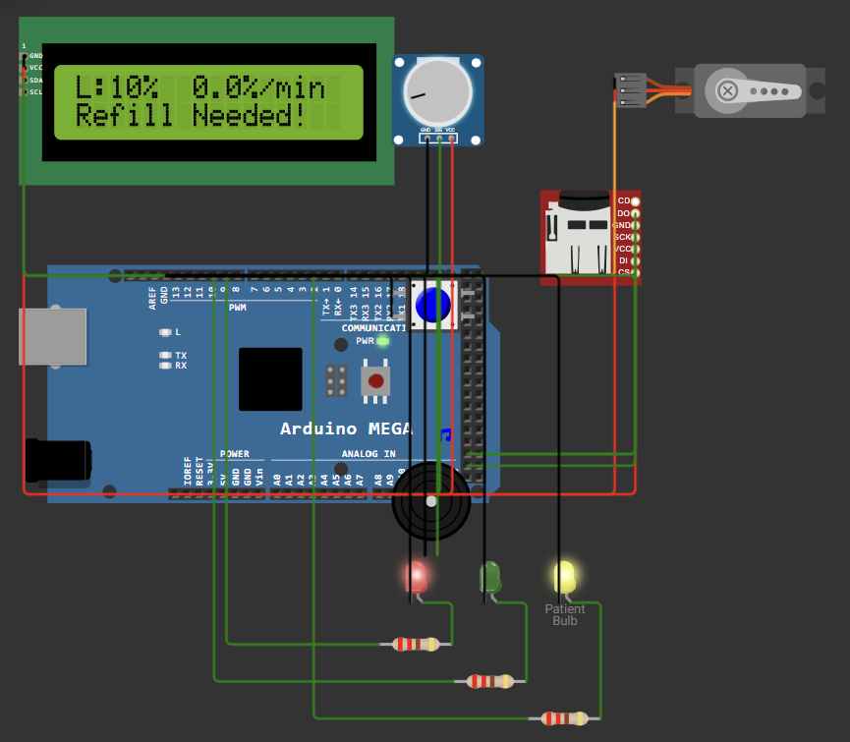
Figure 1: Wokwi simulation in the LOW state (level 10%): the LCD shows “Refill Needed!”, and the red LED and patient bulb are on.
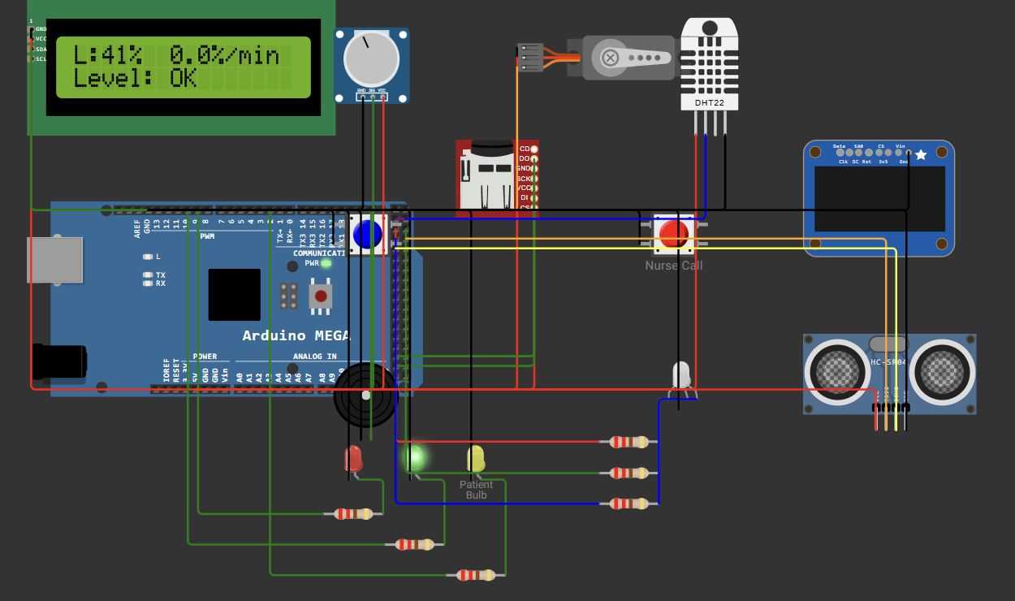
Figure 2: Wokwi circuit with the added nurse-call button, DHT22, OLED, RGB LED and HC-SR04; the LCD shows the level and drain rate.
Algorithm 1: Firmware Main Loop
1: Initialize Serial (9600), LCD, OLED, SD card, GPS, servo and the sensors; set pin modes.
2: Loop forever: check the reset and nurse-call buttons; run the escalation check; read Serial command; feed GPS parser; update the RGB LED.
3: Every 5 s: read the DHT22 and the ultrasonic sensor and send ENV and DIST lines. Every 1 s: refresh the OLED.
4: Every 500 ms: level = average of 8 analog readings mapped to 0–100%.
5: low = (level < 20). If low has just begun: store the time, log LOW, send alert.
6: If low has just ended: clear the timer, release the clamp, log REFILLED.
7: If low for 60 s and not clamped: close the servo clamp, log AUTO_CLAMPED.
8: If level ≥ 25: re-arm the buzzer.
9: Every 5 s: run Algorithm 2 and log the sample.
10: Update the LCD; red LED and bulb ON if low, else green LED ON; sound the buzzer if low and not silenced, or ding while a nurse call waits.
Algorithm 2: On-Device Prediction and Anomaly Detection
1: Add the new level to a 12-reading window. If it rose by 10% or more, treat it as a bottle change and restart the window.
2: rate = −(least-squares slope of the window) × 12, in % per minute.
3: short_rate = drop over the last 3 readings, in % per minute.
4: Once the window is full, learn a baseline rate. If short_rate > 2.5 × baseline and > 3%/min: suspected LEAK. If short_rate < 0.1 × baseline and level > 5%: suspected BLOCKAGE.
5: If rate > 0.3%/min: time_to_empty = level / rate; time_to_low = (level − 20) / rate.
6: If time_to_low < 2 min while level ≥ 20%: sound a chirp and send an early warning.
Algorithm 3: Natural-Language Command Interpreter
1: Read a line from the Serial Monitor and convert it to lower case.
2: Extract the bed number after “bed” or “room”; if it is not this bed, reply accordingly.
3: Match keywords in order: ack, temperature, distance, simulate, refill, silence, location, time/left/empty, clamp, status/level, help.
4: Run the matching action and print a readable reply; otherwise print “Sorry, I did not understand.”
Algorithm 4: Nurse Call and Escalation
1: Read the nurse-call pin on every loop pass; accept a press only after the pin has stayed LOW for 40 ms.
2: On a new press: set the call flag, store the time, log NURSE_CALL, send NURSE,1 and an alert sentence.
3: While the call waits: blink the RGB LED blue and sound a short ding (the LOW and clamp states take priority).
4: If the call is still unanswered after 30 s: set the escalated flag, log NURSE_ESCALATED, send NURSE,2 and an alert.
5: While escalated: blink the RGB LED red quickly and sound a longer, higher tone.
6: When the reset button is pressed or ack is typed: clear the call, log NURSE_ACK and send NURSE,0.
On the Python side, Scikit-Learn LinearRegression is fitted on the buffered readings (minimum 5) and predicts the next level, clipped between 0% and 100%. The question box also answers about the nurse call, temperature, distance and time left.
Proposed Modules
- Sensing & Control Module (C): fluid reading, threshold logic, LCD, LEDs, buzzer, bulb, servo auto-clamp and reset button.
- Logging & Location Module (C): SD card CSV logging, Serial mirroring and GPS location tagging.
- Prediction Module (C): sliding-window regression, time-to-empty, early warning, leak and blockage detection.
- Command Interface Module (C): plain-English intent recognition and alert sentence generation.
- Nurse Call & Status Module (C): nurse-call button with debounce, 30 s escalation, RGB status LED and OLED display.
- Environment Sensing Module (C): DHT22 temperature and humidity and HC-SR04 distance, sent as ENV and DIST lines.
- Python Dashboard Module: Scikit-Learn forecasting, Streamlit display, sensor and nurse-call cards, command buttons and query box.
Input and Output of Modules
Module | Input | Output
Sensing & Control | Analog voltage on A0; reset button | Level (0–100%), LCD text, LED/bulb/buzzer states, clamp action
Logging & Location | Events, samples, GPS data | EVENT and DATA lines (ms, level, event, rate, lat, lon) on SD and Serial
Prediction | Window of the last 12 levels | Drain rate, time-to-empty, early warning, LEAK/BLOCK flag
Command Interface | Typed text, e.g. “how long is left” | Readable reply or alert (bed, level, minutes left, location)
Nurse Call & Status | Nurse button (pin 22), reset button, ack command, alert state | NURSE 0, 1 or 2 line, RGB colour, OLED text, buzzer pattern
Environment Sensing | DHT22 signal (pin 23); HC-SR04 echo time (pin 28) | ENV (°C, %) and DIST (cm) lines every 5 s
Python Dashboard | Logged readings (5 or more); DATA, ENV, DIST and NURSE lines; typed commands | Next IV level estimate, charts, sensor cards, nurse banner, reply to query “iv low”
Novelty of the Work
- Prediction in C on the microcontroller: regression and anomaly detection are coded by hand in C and run on the Arduino, without an external ML library.
- Adaptive leak and blockage detection: the short-term drain rate is compared with a baseline learned during operation.
- Plain-English interface in embedded C: keyword-based intent recognition with bed-number extraction and readable, GPS-tagged alert messages.
- Fail-safe action: an unaddressed low level automatically closes the clamp after 60 seconds.
- Escalating nurse call in embedded C: an unanswered call changes the LED colour, buzzer pattern and serial state after 30 seconds, so the dashboard can show it as unanswered.
- C-to-Python integration: the firmware's serial lines feed a Python dashboard for forecasting and visualization, and the dashboard sends commands back over the same connection.
Complete Results & Performance Analysis
The system was verified through simulation. The observed results are:
- Live monitoring: a level of 29% was displayed on the dashboard metric cards.
- ML forecasting: the Scikit-Learn model produced a Next IV Level Estimate of 35.5% after at least five valid readings were collected.
- Natural-language query: the query “iv low” returned “No low-level alert is currently reported”, matching the simulated state.
- Stability: setting OPENBLAS_NUM_THREADS=1 resolved an OpenBLAS memory allocation error, after which the dashboard ran normally.
The configuration parameters that govern the firmware's behaviour are summarized below.
Parameter | Value | Purpose
LOW threshold / re-arm level | 20% / 25% | Alarm trigger with hysteresis
Auto-clamp delay | 60 s | Closes the line if the alarm is unaddressed
Prediction window / period | 12 readings / 5 s | Regression over the last 60 s
Early-warning horizon | 2 min | Warn before LOW is reached
Leak criterion | > 2.5 × baseline | Detects abnormally fast drain
Nurse-call escalation | 30 s | Marks an unanswered call as escalated
Nurse button debounce | 40 ms | Ignores contact bounce
Sensor read period | 5 s | ENV and DIST lines
The added components are tested in Wokwi with the following test cases.
Test | Action in Wokwi | Expected Response
Nurse call | Press the Nurse Call button | NURSE,1 and a NURSE_CALL event; RGB LED blinks blue; buzzer dings; LCD shows “NURSE CALLED!”
Escalation | Leave the call unanswered for 30 s | NURSE,2 and a NURSE_ESCALATED event; RGB LED blinks red; dashboard shows the call as unanswered
Acknowledge | Press the reset button or type ack | NURSE,0 and a NURSE_ACK event; RGB LED returns to green
Temperature | Change the DHT22 temperature | New ENV line within 5 s; OLED and dashboard card update
Distance | Change the HC-SR04 distance | New DIST line within 5 s; OLED and dashboard card update
Low level | Drag the potentiometer below 20% | RGB LED turns red together with the red LED and patient bulb
Quantitative accuracy measures such as prediction error and response latency were not measured in this study and are left for future work with real hardware.
Conclusion & Future Work
InfusiMetrics shows that an embedded C program can sense the IV level, predict depletion, detect abnormal flow, accept plain-English commands, escalate an unanswered nurse call and act on its own, with a Python dashboard extending it for visualization and control. The system reduces dependence on manual checks and supports earlier nurse response. Future work includes Wi-Fi alerts to mobile nursing stations, including unanswered nurse calls, multi-bed monitoring on one dashboard, ARIMA or LSTM time-series models, bubble detection sensors, and quantitative evaluation on real hardware.

