Token :it is used to push and pull the code

Open github

Settings

Developersettings

Create tokens

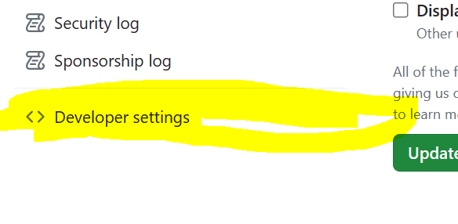



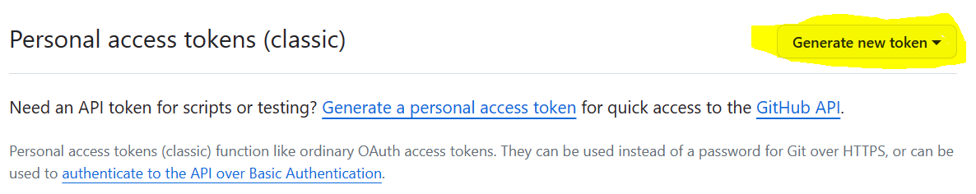

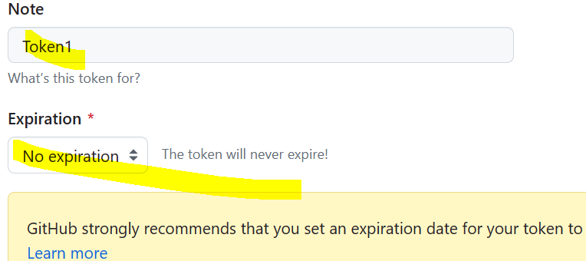

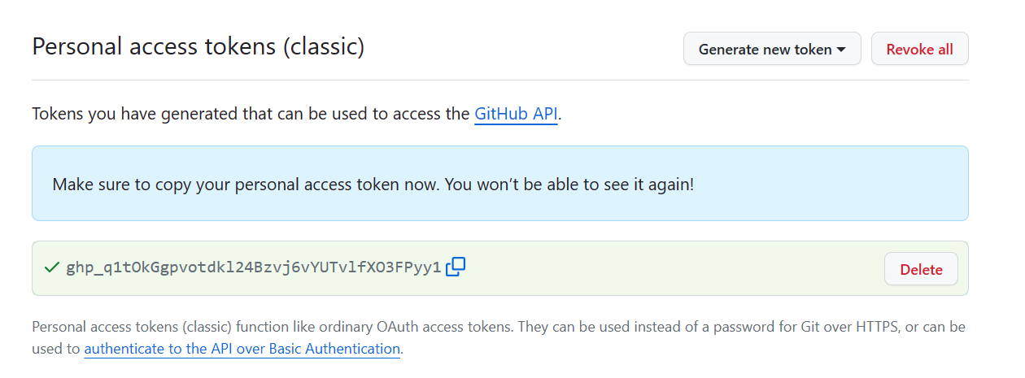

When you do git push for the first time it will ask as shown below

You can copy and paste the token below

