TDAS AD Audit v4
Knowledge Graph-Based Anomaly Detection on Active Directory Logs
Using Ensemble Methods (IF + LOF + EE) and SHAP Explainability

Mahathir Muhammad
Final Pipeline, Ablation Study & Draft Paper (IJIES) — Juni 2026

Slide 2 — Executive Summary: Latar Belakang
__________________________________________________________________________________________
- Insider threat & privilege abuse di Active Directory (AD) adalah vektor serangan paling merusak dan paling sulit dideteksi.
- Log AD bervolume sangat besar (1.8 juta+ events) dan kaya relasi antar entitas (user ↔ host ↔ server ↔ IP ↔ group).
- Metode single-model (mis. Isolation Forest saja) sering false-positive tinggi karena kehilangan konteks relasional.
- Sistem deteksi yang black-box sulit ditindaklanjuti auditor — butuh penjelasan kuantitatif per user.
→ Dibutuhkan pendekatan Knowledge Graph + Ensemble + Explainable AI yang akurat sekaligus dapat dijelaskan.

Slide 3 — Executive Summary: Tujuan & Kontribusi
__________________________________________________________________________________________

Tujuan
- Memodelkan log AD sebagai knowledge graph relasional di Neo4j.
- Mendeteksi anomali pengguna dengan ensemble heterogen (IF + LOF + EE).
- Menjelaskan setiap keputusan deteksi menggunakan SHAP (explainable).

Kontribusi
- Pipeline 7-phase end-to-end: Ingestion → Rules → Features → Ensemble → SHAP → Reporting.
- Severity classification data-driven berbasis quantile (bukan threshold arbitrary).
- Ablation study lengkap atas 7 konfigurasi ensemble (termasuk IF+EE) untuk justifikasi ilmiah.
- Evaluasi empiris pada 887 user dari 1.8 juta events (ManageEngine ADAudit Plus).

Slide 4 — Problem Statement
__________________________________________________________________________________________
"Bagaimana mendeteksi perilaku pengguna AD yang anomali secara akurat DAN dapat dijelaskan, ketika log bervolume besar, multi-sumber, dan tidak memiliki label ground-truth?"

Sub-problem
- Representasi multi-sumber log AD dalam satu struktur relasional yang queryable.
- Feature engineering diskriminatif yang memanfaatkan relasi graph (bukan hanya kolom CSV).
- Deteksi robust tanpa label (unsupervised) + cara mengevaluasinya.
- Transparansi: menjelaskan MENGAPA user dianggap anomali.

Slide 5 — Literature Review: SOTA & Posisi Penelitian
__________________________________________________________________________________________
- Isolation Forest (Liu et al., 2008) — tree-based anomaly detection, fondasi banyak sistem.
- LOF (Breunig et al., 2000) & Elliptic Envelope (Rousseeuw, 1999) — density & statistical outlier.
- SHAP (Lundberg & Lee, 2017) — unified explainability untuk model ML.
- Outlier Analysis (Aggarwal, 2017) & Goldstein-Uchida (2016) — evaluasi unsupervised & thresholding.
Posisi: menggabungkan Knowledge Graph AD + ensemble heterogen + explainability dalam satu pipeline.

Slide 6 — Research Gap & Technical Differentiation
__________________________________________________________________________________________

Research Gap
- SOTA terbelah: ML generik (tidak AD-specific) ATAU rule/signature AD (tidak adaptif).
- Sedikit yang menggabungkan graph context + ensemble + explainability untuk audit AD.

Diferensiasi (TDAS v4)
- Neo4j sebagai core intelligence (bukan sekadar visualisasi).
- Rule engine domain ditanam SEBELUM ML → konteks + anomali statistik.
- SHAP per user + severity quantile-based yang reproducible.

Slide 7 — Metodologi: Pipeline 7-Phase
__________________________________________________________________________________________
AD Log → Neo4j KG → Rule Engine → Graph Features → Ensemble → SHAP → Report
- Phase 2 — Neo4j Ingestion: 7 node types, 10 relationship types.
- Phase 3 — Rule Engine: 10 domain rules (R001–R010).
- Phase 4 — Feature Extraction: 11 graph features per user.
- Phase 5 — Ensemble Detection: IF + LOF + EE + quantile severity.
- Phase 5.5 — SHAP Explainability: top cause per user.
- Phase 6 — Reporting: TXT, JSON, DOCX.
Reproducible: Phase 2 reset database (CREATE OR REPLACE DATABASE) + random_state=42.
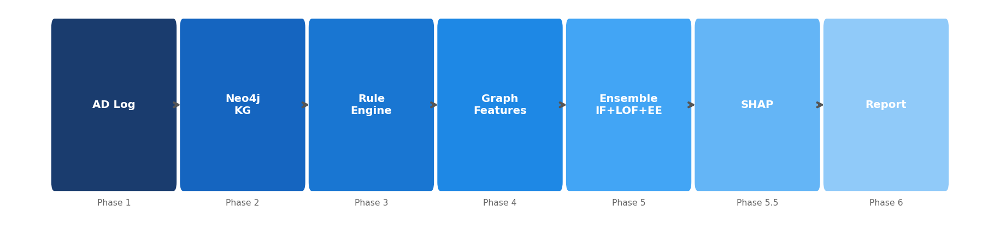

Slide 8 — Phase 2 — Neo4j Knowledge Graph
__________________________________________________________________________________________

7 Node Types
- User, Hostname, Server, IPAddress, Service, Group, Event

10 Relationship Types
- LOGIN_FROM, AUTHENTICATED_VIA, FAILED_LOGIN, CONNECTED_FROM, USED_IP,
- USED_SERVICE, MEMBER_OF, REFERENCES, LOCKED_OUT, ADMIN_ACTION_ON
Hasil ingestion: 887 User nodes, ~680K total nodes dari 1.8 juta events.
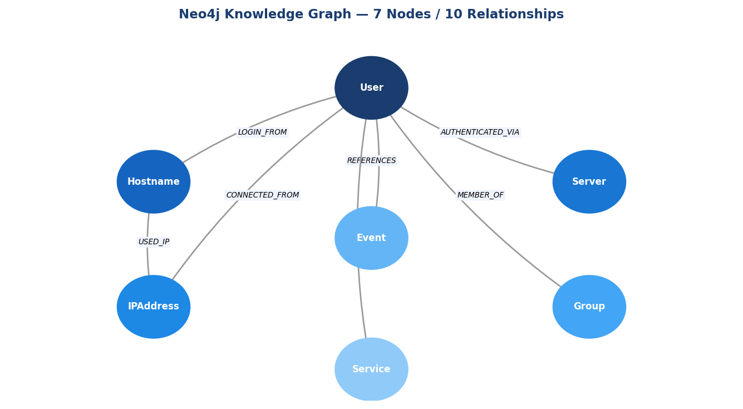

Slide 9 — Phase 3 — Rule-Based Knowledge Engine (10 Rules)
__________________________________________________________________________________________
- R001 Multi-host login (>3 host) | R002 Off-hours login (>10%)
- R003 Shared device (>5 user) | R004 Critical server access (DC)
- R005 Failed login spike (>50) | R006 Unusual IP (luar Office/VPN)
- R007 After-hours privileged | R008 Frequent lockouts
- R009 Excessive admin actions | R010 Sensitive group membership
Output: rule_violations (0–10) per user. Rata-rata 3.39 pelanggaran/user.

Slide 10 — Phase 4 — Graph Feature Extraction (11 Fitur)
__________________________________________________________________________________________

Fitur dasar (8)
- host_diversity, critical_server_ratio, failure_ratio, shared_device_risk,
- ip_network_risk, privilege_level, connectivity, rule_violations

Fitur tambahan (3)
- lockout_count, admin_actions, sensitive_groups
Output: 887 user × 11 fitur — diekstrak dari relasi graph, bukan kolom CSV langsung.

Slide 11 — Phase 5 — Ensemble Anomaly Detection
__________________________________________________________________________________________
- Isolation Forest (IF) — anomali global ekstrem (tree-based).
- Local Outlier Factor (LOF) — anomali lokal di cluster (density).
- Elliptic Envelope (EE) — outlier statistik multivariat (covariance).
final_score = 0.60 × (votes/3) + 0.40 × (rule_violations/10). Anomali jika ≥2 dari 3 model setuju.

Severity Quantile-based (data-driven)
- CRITICAL ≥ P99 (0.3580) | HIGH ≥ P95 (0.2916) | MEDIUM ≥ P90 (0.2377)
- LOW ≥ P75 (0.2095) | NORMAL < P75
Referensi: Aggarwal (2017), Goldstein-Uchida (2016), Liu et al. (2008).

Slide 12 — Phase 5.5 — SHAP Explainability
__________________________________________________________________________________________
- shap.TreeExplainer pada Isolation Forest — menghitung kontribusi tiap fitur ke skor.
- Setiap user mendapat top cause (penyebab utama) dengan label Bahasa Indonesia.
- Hasil ditulis kembali ke Neo4j sebagai property node User.

Top Global Feature Importance (mean |SHAP|)
- rule_violations: 0.5589
- host_diversity: 0.5132
- shared_device_risk: 0.4996
- critical_server_ratio: 0.4764
- lockout_count: 0.4370
Manfaat: audit punya bukti kuantitatif per user, bukan sekadar label 'anomali'.
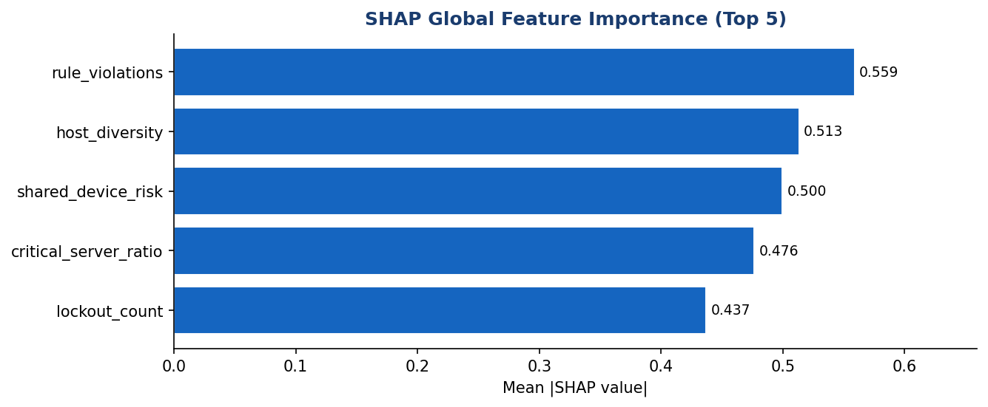

Slide 13 — Experimental Setup: Dataset
__________________________________________________________________________________________
- Sumber: ManageEngine ADAudit Plus (multiple CSV audit report).
- Total events: 1,833,352 logon events.
- Populasi: 887 unique users.
- Implementasi: Python 3.12, Neo4j 5.x, scikit-learn 1.4, shap.
Unsupervised — tidak ada label asli; evaluasi memakai proxy berbasis rule_violations.

Slide 14 — Hasil: Distribusi Severity
__________________________________________________________________________________________
- CRITICAL: 9 user (top 1%)
- HIGH: 36 user (top 5%)
- MEDIUM: 44 user (top 10%)
- LOW: 133 user (top 25%)
- NORMAL: 665 user
Total 89 user terklasifikasi MEDIUM ke atas (perlu perhatian). Score: mean 0.165, max 0.640.
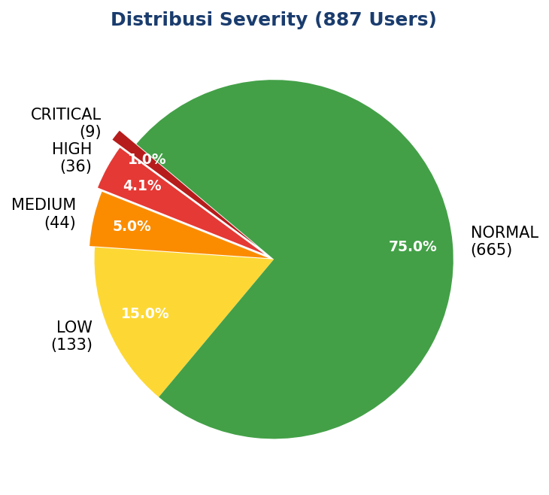

Slide 15 — Hasil: Top-5 Anomali + SHAP Cause
__________________________________________________________________________________________
- mti.admin | Score 0.6400 | CRITICAL | 6/10 rules | Cause: Sering lockout
- andre.saputra | Score 0.3925 | CRITICAL | 7/10 rules | Cause: Banyak admin action
- mahathir.muhammad | Score 0.3914 | CRITICAL | 6/10 rules | Cause: Banyak admin action
- mti.sysadmin | Score 0.3911 | CRITICAL | 6/10 rules | Cause: Banyak admin action
- eris.rismansyah | Score 0.3740 | CRITICAL | 6/10 rules | Cause: Sering lockout
Setiap temuan dilengkapi penyebab SHAP → langsung actionable untuk investigasi.
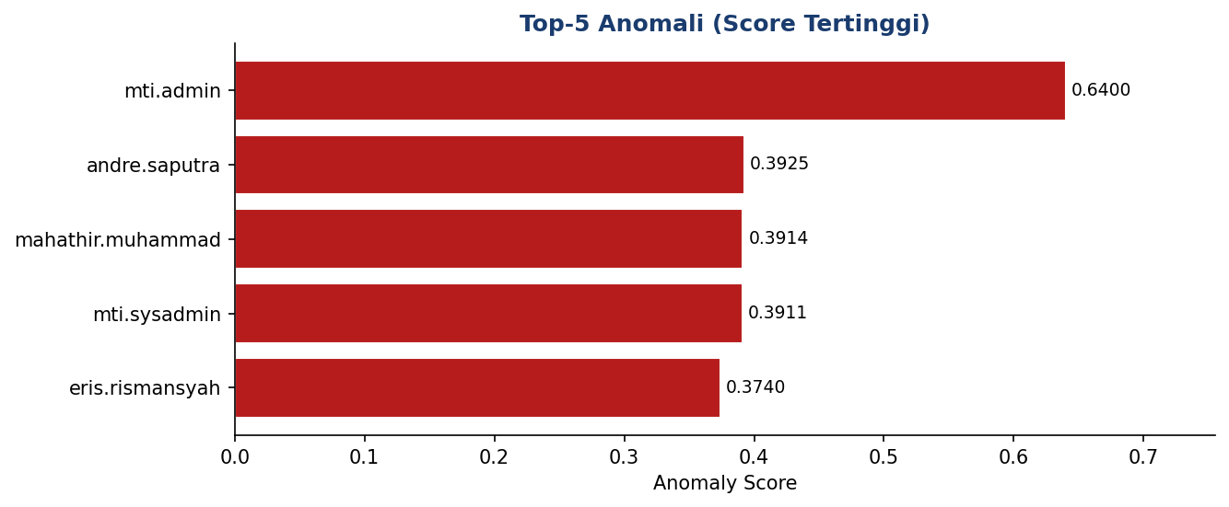

Slide 16 — Ablation Study: IF vs LOF vs EE (Individual)
__________________________________________________________________________________________

Precision@K (selaras rule berat) & Cohen's Kappa
- IF: P@K 0.333 | LOF: P@K 0.044 | EE: P@K 0.533
- Kappa IF-LOF 0.48 | IF-EE 0.70 | LOF-EE 0.18
- EE paling selaras dengan rule; LOF menangkap anomali ortogonal (tersembunyi).
Kappa LOF-EE rendah (0.18) = mereka menangkap jenis anomali berbeda → ensemble bermanfaat.
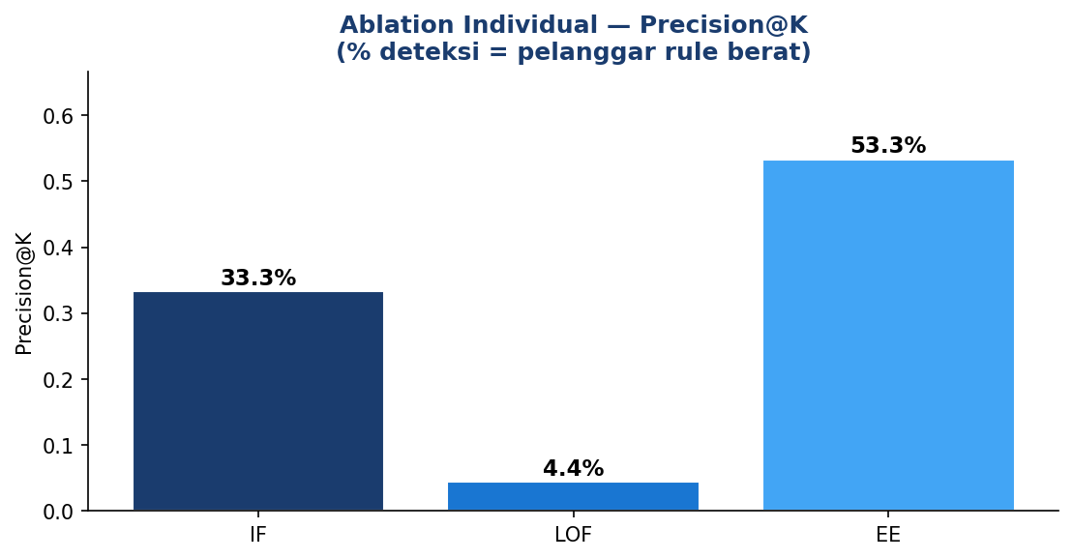

Slide 17 — Ablation Study: 7 Konfigurasi Ensemble (Akurasi)
__________________________________________________________________________________________
Akurasi vs proxy rule_violations≥6 (K=top-57). Termasuk IF+EE (saran Dr. Kelly).
- IF Accuracy 0.912 | F1 0.316
- LOF Accuracy 0.894 | F1 0.175
- EE Accuracy 0.932 | F1 0.474
- IF+LOF Accuracy 0.899 | F1 0.211
- IF+EE Accuracy 0.930 | F1 0.456
- LOF+EE Accuracy 0.930 | F1 0.456
- IF+LOF+EE Accuracy 0.930 | F1 0.456
Temuan: tidak ada konfigurasi tunggal yang dominan mutlak; ensemble IF+LOF+EE konsisten robust (tidak pernah terburuk).
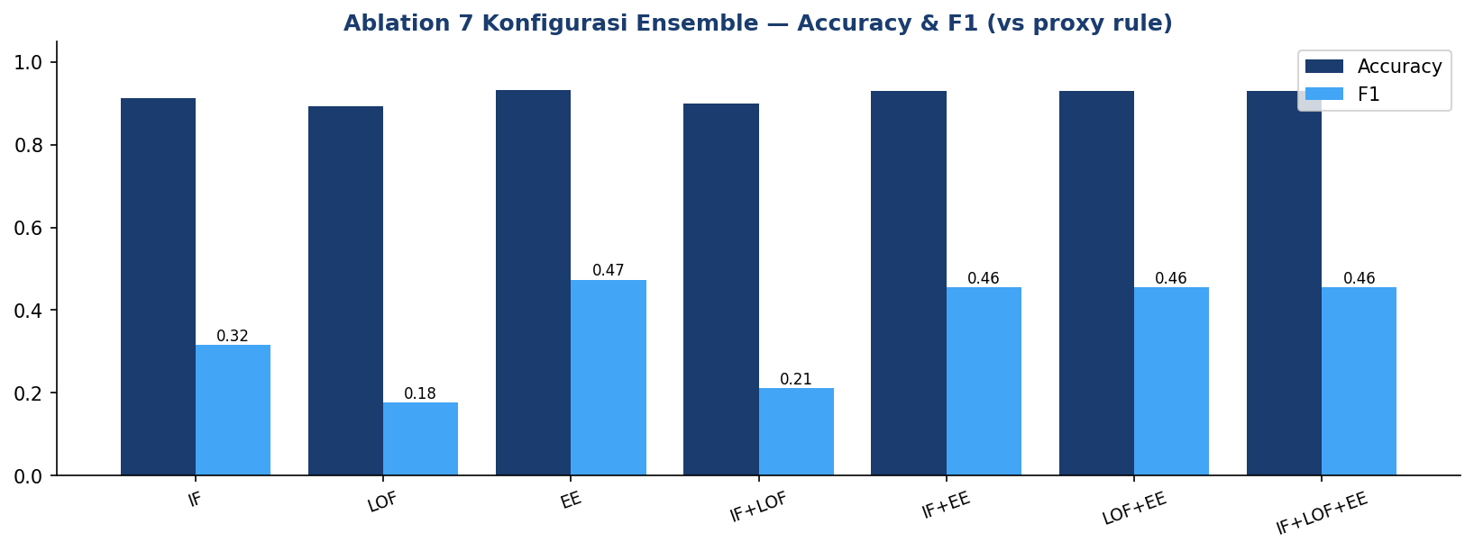

Slide 18 — Justifikasi Ilmiah Penggunaan Ensemble
__________________________________________________________________________________________
- EE skor tertinggi vs proxy — TAPI bias, karena proxy berbasis rule menguntungkan EE.
- Model individual volatil: LOF kuat di satu threshold, anjlok di threshold lain.
- Ensemble IF+LOF+EE: tidak pernah terburuk di semua setting = stabil & robust.
Prinsip: robustness over peak performance — memilih 1 model 'terbaik' berisiko overfit ke 1 definisi anomali.

Slide 19 — Limitations & Future Work
__________________________________________________________________________________________

Limitations
- Unsupervised: 'akurasi' dihitung vs PROXY (rule_violations), bukan label asli — weak supervision.
- Proxy bias terhadap model yang selaras rule (EE diuntungkan, LOF dirugikan).
- Satu dataset; threshold belum di-tuning via ROC.

Future Work
- Label tervalidasi domain expert untuk Precision/Recall absolut.
- Multi-dataset + baseline comparison + uji signifikansi statistik.
- Temporal anomaly (LSTM autoencoder) terintegrasi dengan graph.

Slide 20 — Deliverables & Output
__________________________________________________________________________________________
- output/anomaly_detection_report.txt — laporan teks auditor.
- output/anomaly_detection_detailed.json & anomaly_statistics.json.
- output/AD_Anomaly_Detection_Report_v3.docx — laporan formal (12 section).
- output/IJIES_Draft_Paper_Mahathir_Muhammad.docx — draft paper (format IJIES).
- models/ — IF, LOF, EE, Scaler tersimpan; pipeline reproducible.

Slide 21 — Kesimpulan
__________________________________________________________________________________________
- Pipeline 7-phase berhasil menganalisis 887 user, mendeteksi 89 anomali (MEDIUM+).
- Knowledge Graph + Ensemble + SHAP menghasilkan deteksi akurat sekaligus dapat dijelaskan.
- Severity quantile-based menjadikan klasifikasi objektif & reproducible.
- Ablation 7 konfigurasi membuktikan ensemble paling robust (justifikasi ilmiah).
Status: pipeline final, hasil kanonik & reproducible, draft paper IJIES siap.

Slide 22 — Terima Kasih — Q&A
__________________________________________________________________________________________
Mahathir Muhammad · mahathirmuhammad02@gmail.com
Repo: github.com/mahathirmuh/ad-anomaly-detection

