TDAS AD Audit v2
Graph-Based Behavioral Anomaly Detection for Active Directory
Administrator Activity Using Isolation Forest and Multi-Method Score Fusion

Progress Report — Eksperimen & Hasil
April 2026

Slide 2 — Executive Summary: Latar Belakang
__________________________________________________________________________________________
- Insider threat & privilege abuse di Active Directory (AD) adalah vektor serangan paling merusak (Microsoft Digital Defense Report).
- Log AD volume besar (~ratusan MB/minggu), multi-sumber, dan relasi antar entitas (user ↔ host ↔ group ↔ GPO ↔ DC) diabaikan oleh model tabular.
- Metode single-model (Isolation Forest saja / K-Means saja) menghasilkan false positive tinggi karena kehilangan konteks relasional.
→ Dibutuhkan pendekatan graph-based + ensemble yang mampu menangkap konteks relasional sekaligus stabil terhadap false positive.

Slide 3 — Executive Summary: Tujuan & Kontribusi
__________________________________________________________________________________________

Tujuan
- Membangun knowledge graph AD yang merepresentasikan perilaku administrator secara relasional.
- Mendeteksi anomali admin dengan ensemble fusion (Isolation Forest + K-Means + Temporal + Graph score).
- Menghasilkan laporan audit yang actionable (lateral movement, privilege escalation, lockout chain, GPO abuse).

Kontribusi
- Pipeline 4-tahap end-to-end: preprocess → Neo4j KG → ensemble ML → analysis.
- Strategi score fusion multi-method yang menggabungkan fitur tabular + temporal + graph.
- Evaluasi empiris pada 559 user admin dengan 7 tipe event log (~876 MB).

Slide 4 — Problem Statement
__________________________________________________________________________________________
"Bagaimana mendeteksi perilaku administrator AD yang anomali secara akurat ketika:
(1) log AD tersebar di banyak sumber heterogen,
(2) relasi antar entitas (user-host-group-GPO) kaya tetapi diabaikan model tabular,
(3) single-method anomaly detection menghasilkan skor yang tidak stabil?"

Sub-problem
- Representasi multi-sumber dalam satu struktur queryable.
- Feature engineering yang diskriminatif antara admin normal vs anomali.
- Fusion skor multi-model yang robust terhadap false positive.

Slide 5 — Literature Review: SOTA Comparison
__________________________________________________________________________________________
Perbandingan 5 paper terkini (2022–2025) yang relevan dengan log-based anomaly detection & AD security:
Nama Peneliti | Metode | Kelebihan | Kekurangan
Ali et al. (2025) | Studi empiris ML tradisional vs deep learning untuk LAD | Benchmark multi-kriteria (akurasi, waktu, sensitivitas hyperparameter) | Fokus LAD generik, bukan AD; tidak memanfaatkan graph
Mokhtar et al. (2022) | Signature-based analysis Kerberos attack pada Windows event logs | Fokus spesifik AD; baseline signature forensik (Golden/Silver Ticket) | Rule-based, lemah pada zero-day; tidak ML/graph-driven
Chourasiya et al. (2025) | Hybrid LSTM + Transformer + GNN | Tangkap pola temporal + kontekstual + relasional; multi-stage attack | Model kompleks; butuh GPU & data besar; rendah explainability
Komadina et al. (2024) | Komparasi supervised/unsupervised ML pada firewall logs | Novel synthesis method untuk anomali tanpa testbed | Fokus firewall (bukan AD); unsupervised underperform
Li et al. (2025) — LogSentry | BERT + Contrastive Learning + Retrieval-Augmented KNN | Tangani variability & imbalance log; adaptif format baru | Resource-intensive; tidak graph-aware

Slide 6 — Research Gap & Technical Differentiation
__________________________________________________________________________________________

Research Gap
- Belum ada pipeline yang menggabungkan KG multi-entity AD + ensemble ML + graph-aware features + explainable verification.
- SOTA terbelah: ML generik (tidak AD-specific) ATAU signature AD (tidak adaptif).

Technical Differentiation (TDAS AD Audit v2)
Aspek | Existing Work | TDAS AD Audit v2
Representasi | Tabular / pairwise graph | KG multi-entity (User/Host/DC/Group/GPO) + 10+ relasi
Feature | Logon-only atau text embedding | Logon + failure + lockout + group/GPO mod + temporal
Model | Single method | Ensemble: IF + K-Means + Temporal + Graph
Output | Score list | Score + forensic evidence (priv esc, lateral, GPO abuse)
Explainability | Black-box | Traceable: skor → bukti Cypher query

Slide 7 — Metodologi: Pipeline 4-Stage (Flowchart)
__________________________________________________________________________________________
7 Raw CSV (ManageEngine ADAudit Plus, ~876 MB)
Logon | Failure | DC Logon | Locked User | User Mgmt | Group | GPO
|
v
[Stage 1] preprocess.py ──► clean_data/
|
v
[Stage 2] neo4j_importer.py ──► Knowledge Graph (Neo4j)
|
v
[Stage 3] generate_features.py ──► ~22 fitur/user
|
v
[Stage 4] anomaly_detection.py
IF │ K-Means │ Temporal │ Graph
│
v
Ensemble Fusion Score (95th pct threshold)
|
v
[Stage 5] analysis.py ──► Security Report + Visualisasi

Slide 8 — Experimental Design: Dataset & Feature Set
__________________________________________________________________________________________

Dataset / Study Case
- Sumber: ManageEngine ADAudit Plus — 7 CSV audit report (~876 MB).
- Populasi: 559 unique admin/privileged users.
- Periode: multi-hari, full hour coverage 0–23, 7 day-of-week.

Feature Set (~22 fitur per user)
Kategori | Fitur
Tabular | total_logons, unique_hosts, unique_ips, unique_dcs, logons_per_day, mode_event_code
Temporal | avg_hour, std_hour, min/max_hour, avg/std_day_of_week, hour_range
Graph (Neo4j) | neo4j_logon_count, failure_count, lockout_count, group_modification_count, gpo_modified_count

Slide 9 — Experimental Design: Metrics Evaluasi
__________________________________________________________________________________________
- Detection rate per method: jumlah user di-flag oleh IF / K-Means / Temporal / Ensemble.
- Overlap ratio: persentase agreement antar method (sinyal konsistensi).
- Ranking quality: Top-N precision via inspeksi manual top-20 anomali.
- Score distribution analysis: histogram & validasi threshold 95th percentile.
- Qualitative evidence: validasi top anomali via Cypher forensic query di Neo4j.
Catatan: Ground-truth label penuh belum tersedia; Precision/Recall/F1 formal akan dihitung setelah labeling manual di fase berikutnya.

Slide 10 — Progress Eksperimen: Yang Sudah Dilakukan
__________________________________________________________________________________________
- Preprocessing 7 CSV → clean_data (selesai).
- Build Neo4j knowledge graph + extract graph features (selesai).
- Training Isolation Forest (contamination=0.05) + K-Means + temporal + graph score (selesai).
- Ensemble score fusion + threshold 95th percentile (selesai).
- 7 post-hoc analyses: privilege escalation, lockout chain, GPO changes, lateral movement, cross-domain, time-series (selesai).
- Visualisasi: 7 chart utama di output/image/ (selesai).
- Paralel pipeline verifikasi Cypher Hunting di query.ipynb (selesai).

Slide 11 — Hasil Kuantitatif: Summary Statistics
__________________________________________________________________________________________
Metric | Value
Total users analyzed | 559
Isolation Forest anomalies | 28 (5.0%)
K-Means cluster anomalies | 28 (5.0%)
Ensemble anomalies (final) | 28 (5.0%)
Avg total logons / user | 937.9
Avg unique hosts / user | 1.43
Avg unique IPs / user | 1.43

Sumber: output/result/summary_statistics.csv

Slide 12 — Hasil: Top-10 Anomali
__________________________________________________________________________________________
Rank | User | Ensemble Score | Bukti Utama
1 | user_00687 | 0.8204 | 2.349 group modifications (11 groups)
2 | user_00056 | 0.8045 | 181.418 logons (volume outlier)
3 | user_00040 | 0.7871 | 552 group mods across 22 groups
4 | user_00001 | 0.7500 | 38.079 lockouts + 154.356 failures
5 | user_00680 | 0.7091 | 184.335 logons (service account?)
6 | user_01656 | 0.6197 | 6.738 failures
7 | user_00379 | 0.6015 | 138 group mods (15 groups)
8 | user_00005 | 0.5989 | High activity + failures
9 | user_01932 | 0.5894 | Abnormal hour pattern
10 | user_01614 | 0.5700 | 2.463 failures

Sumber: output/result/top_anomalies.csv

Slide 13 — Visualisasi: Distribusi Skor (IF & Ensemble)
__________________________________________________________________________________________
Kiri: distribusi Isolation Forest score — ekor kiri = 28 anomali. Kanan: distribusi ensemble score — threshold 95th percentile memisahkan final anomalies.
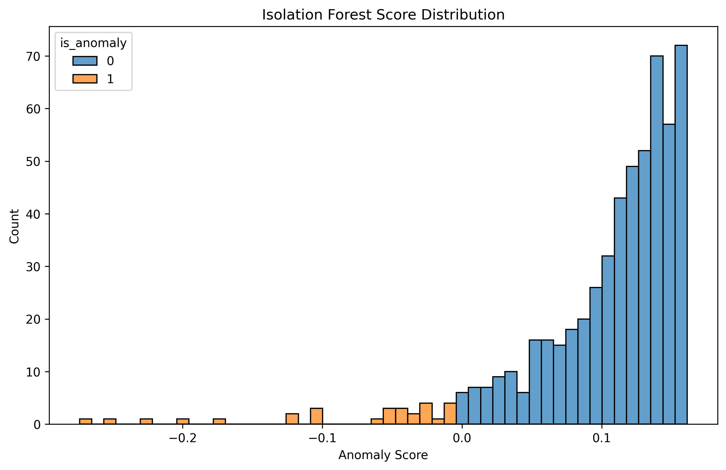
Gambar 1 — Isolation Forest Score Distribution
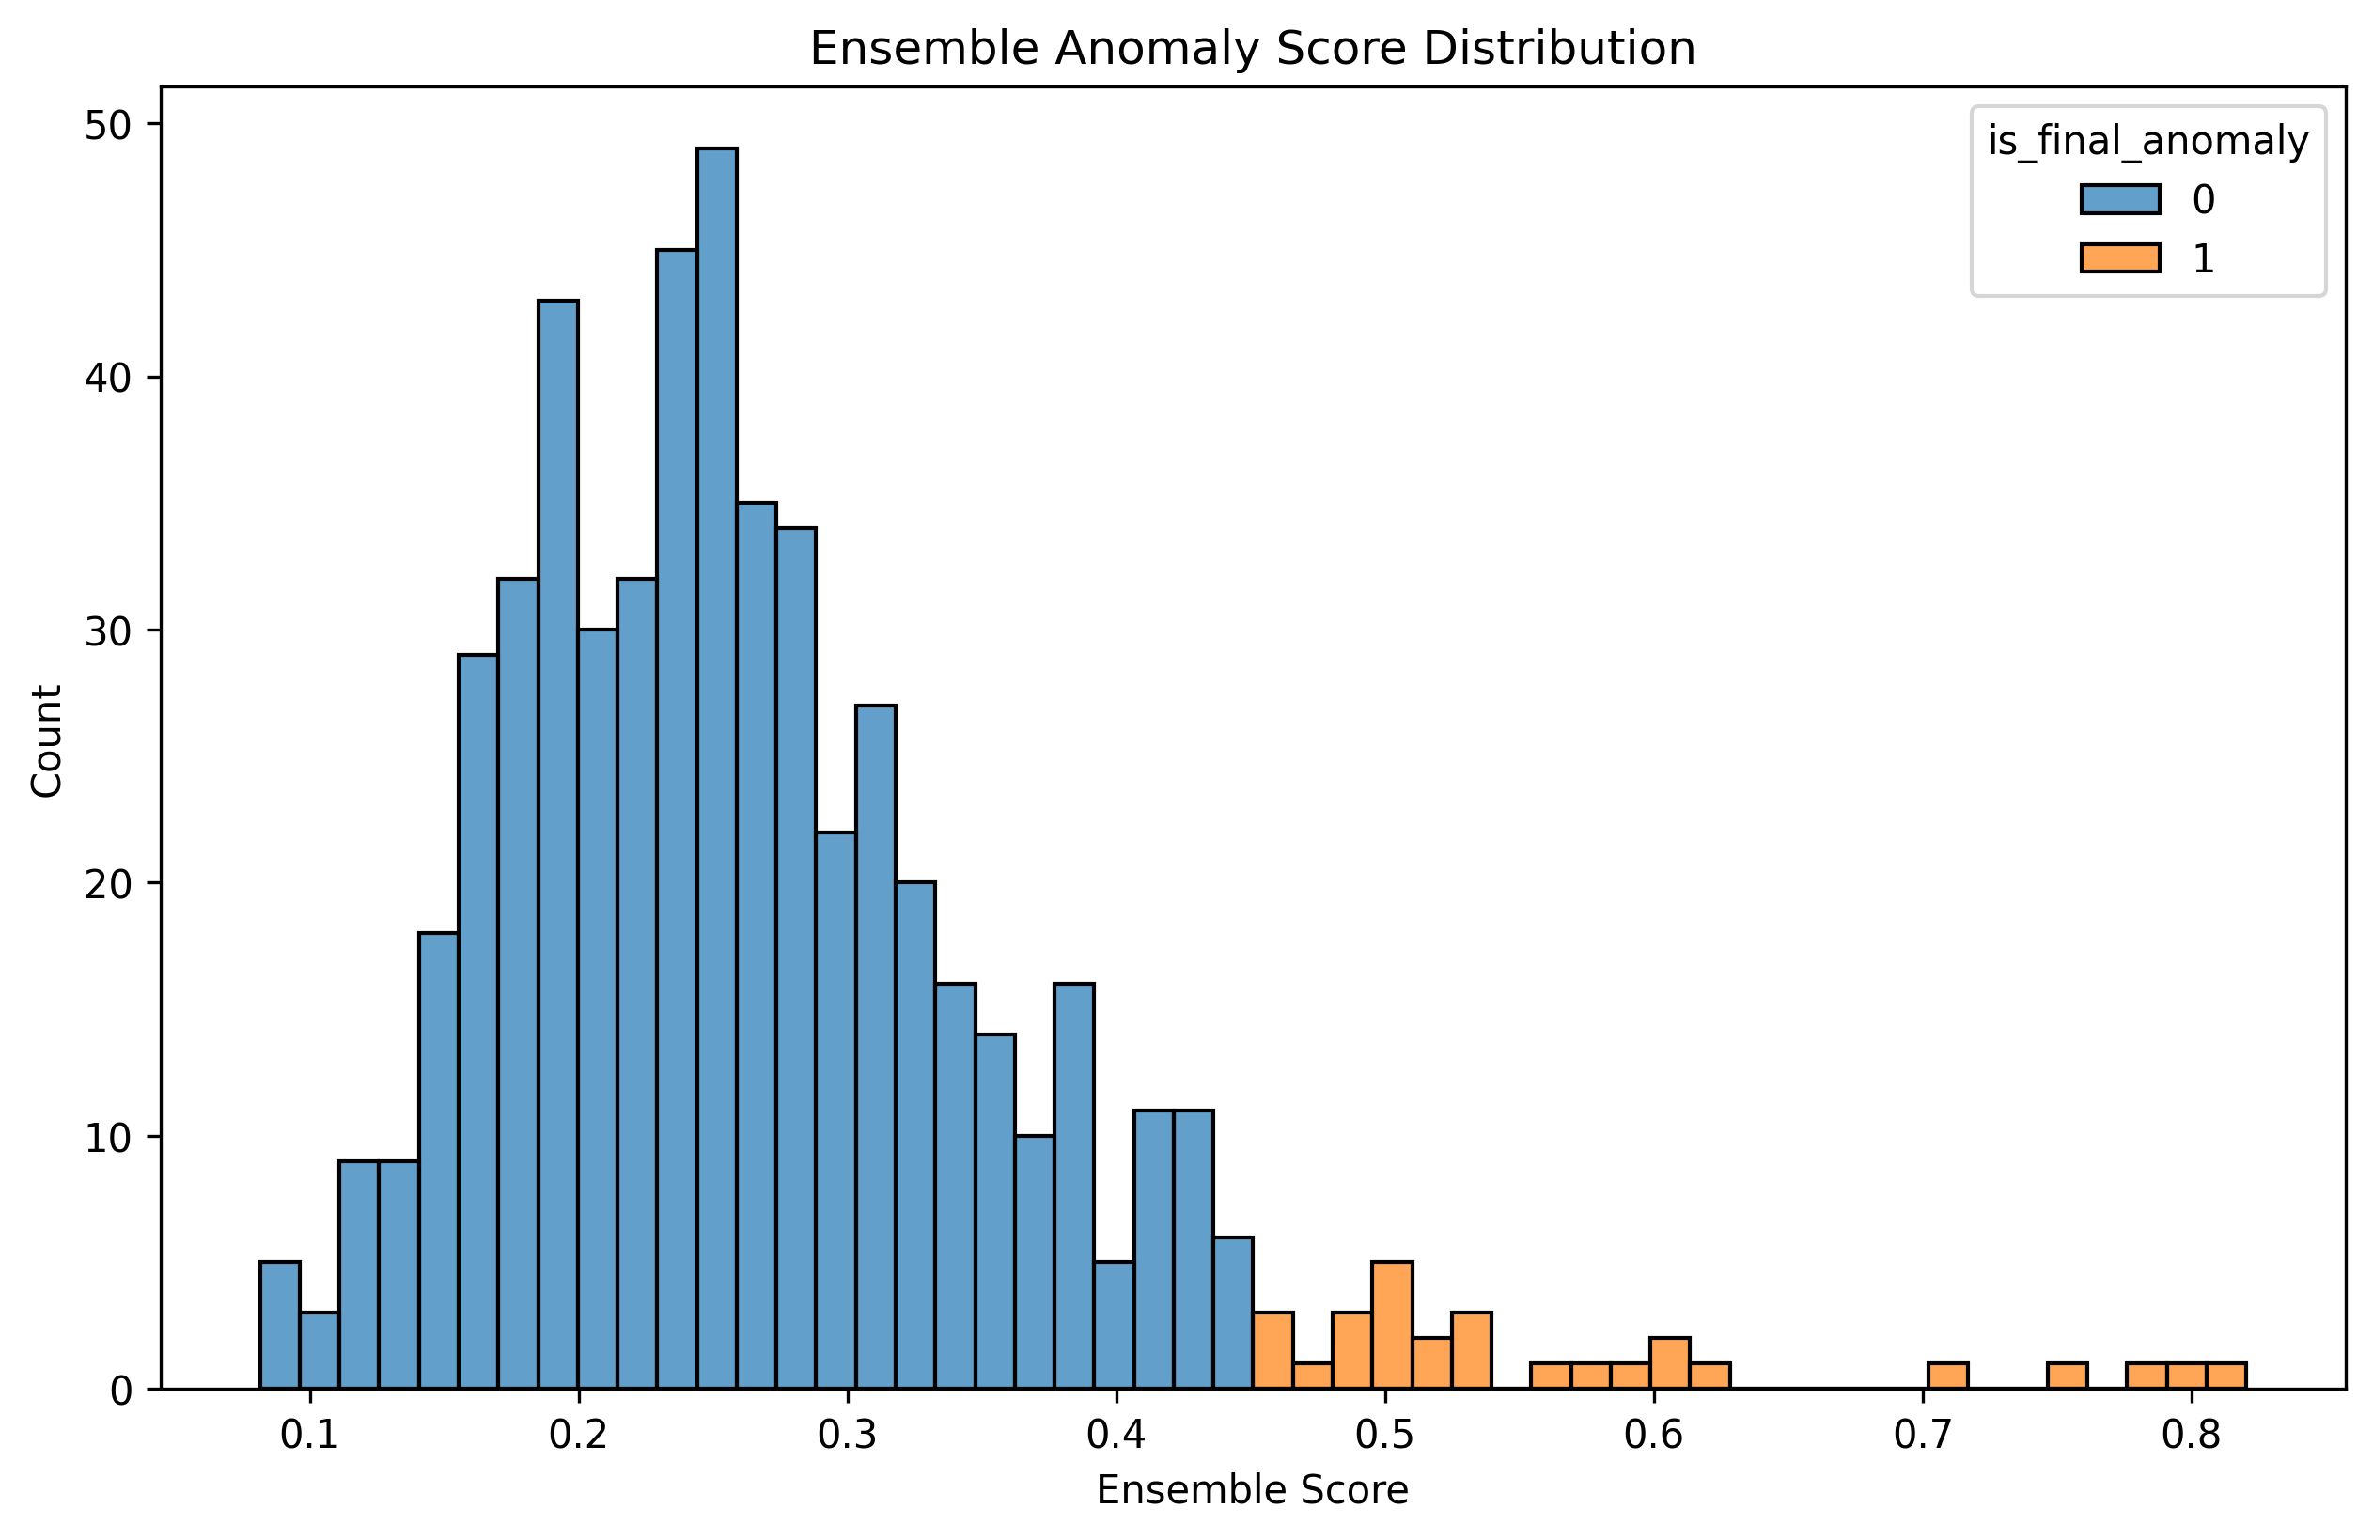
Gambar 2 — Ensemble Score Distribution

Slide 14 — Visualisasi: Anomaly Scatter & Temporal Pattern
__________________________________________________________________________________________
Kiri: scatter plot memperlihatkan pemisahan user normal vs anomali di feature space. Kanan: perbandingan pola temporal (jam & hari) — anomali memiliki std_hour tinggi.
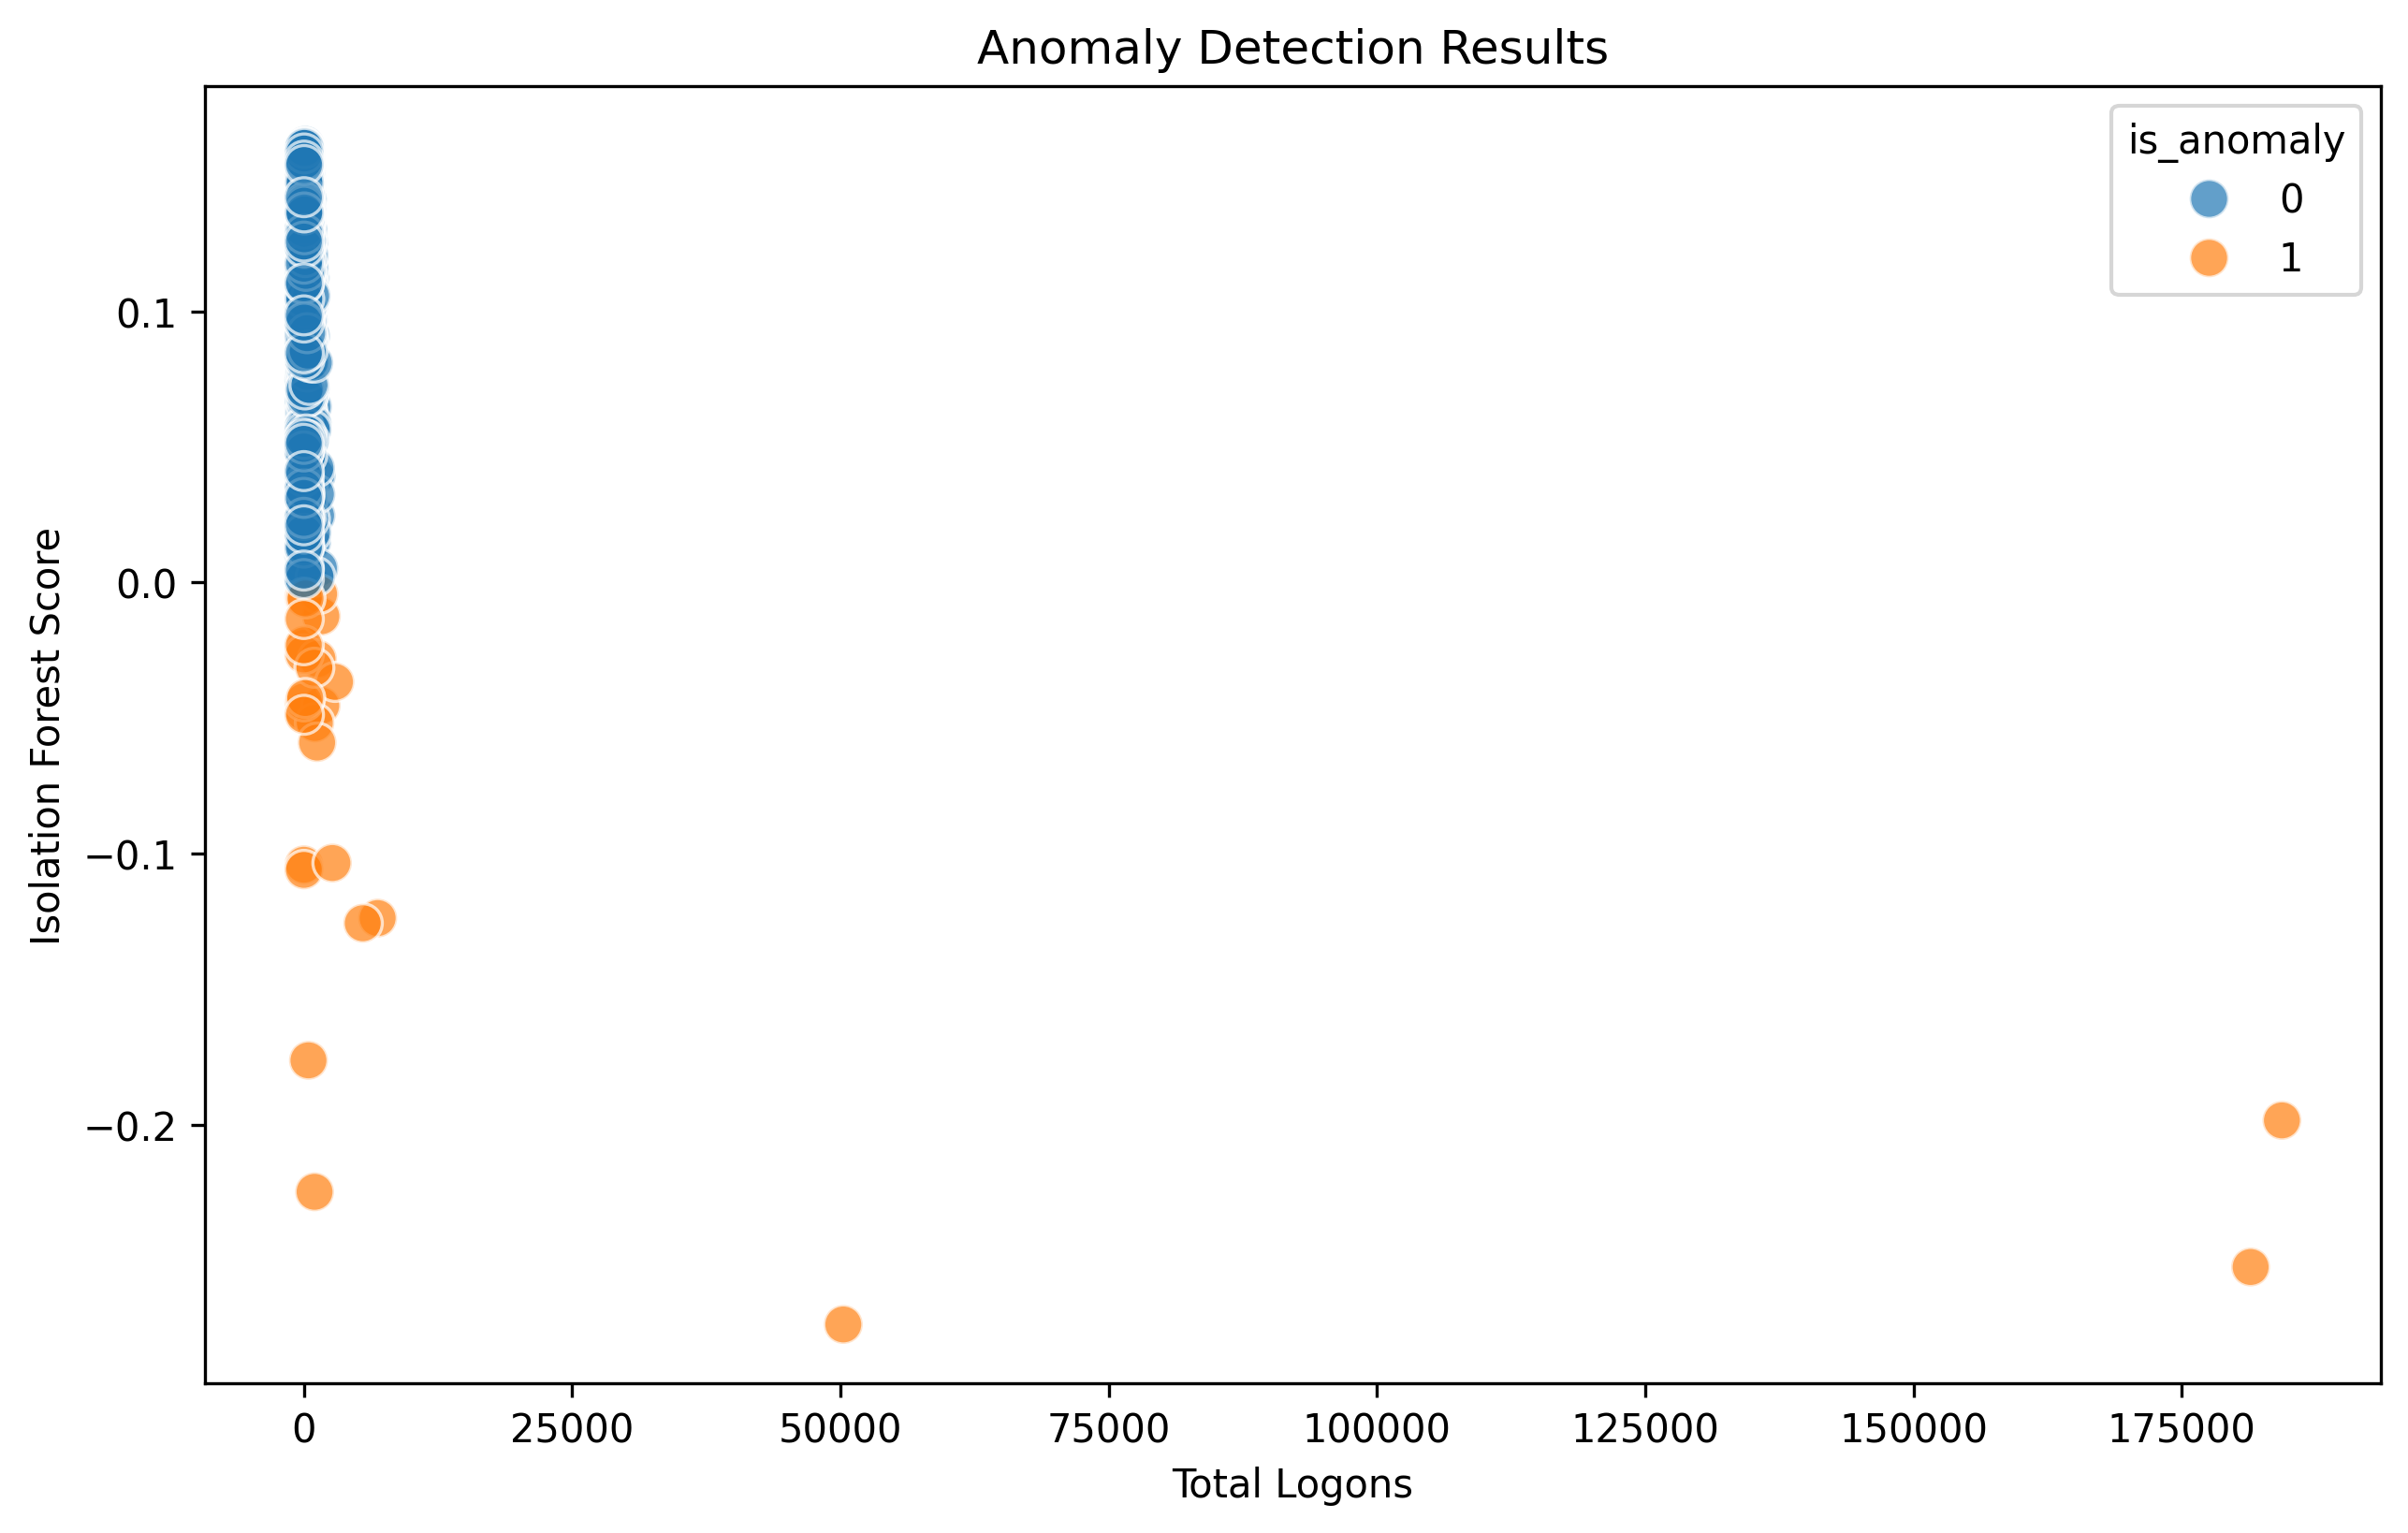
Gambar 3 — Anomaly vs Normal Scatter Plot
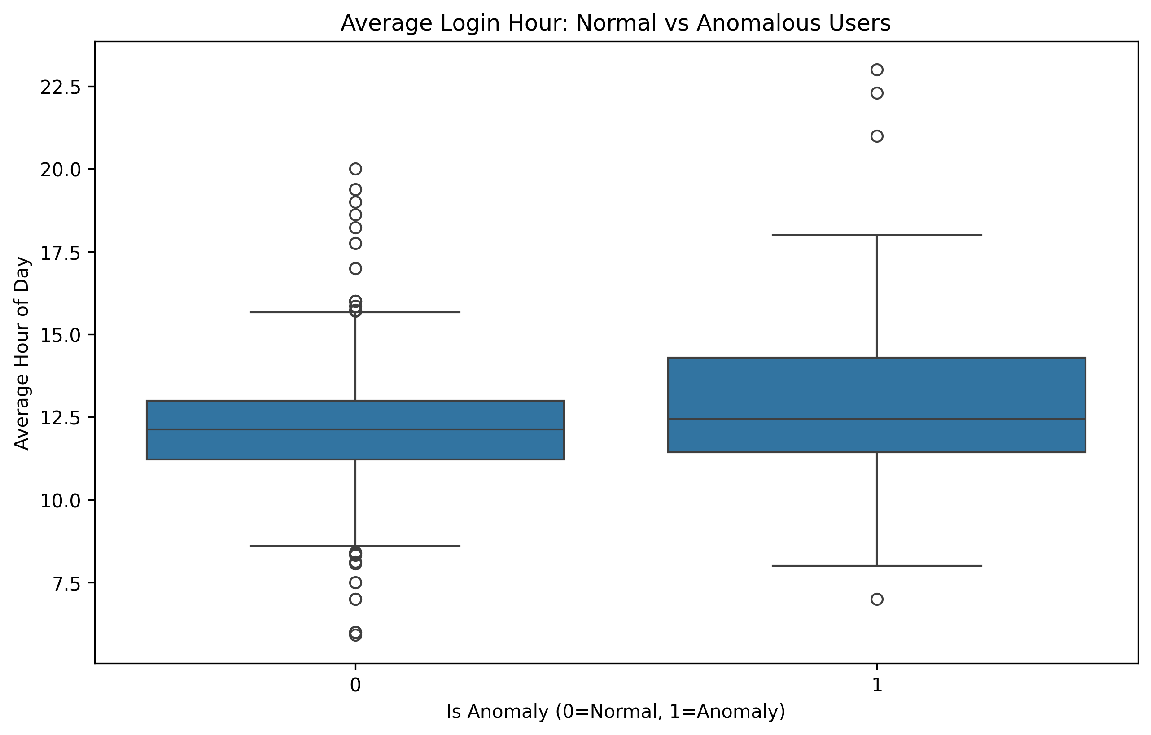
Gambar 4 — Temporal Pattern Comparison

Slide 15 — Visualisasi: Feature Correlation & Volume Patterns
__________________________________________________________________________________________
Korelasi antar 22 fitur — group_modification_count & failure_count paling diskriminatif terhadap label anomali. Distribusi logon volume highly skewed (6–184.335).
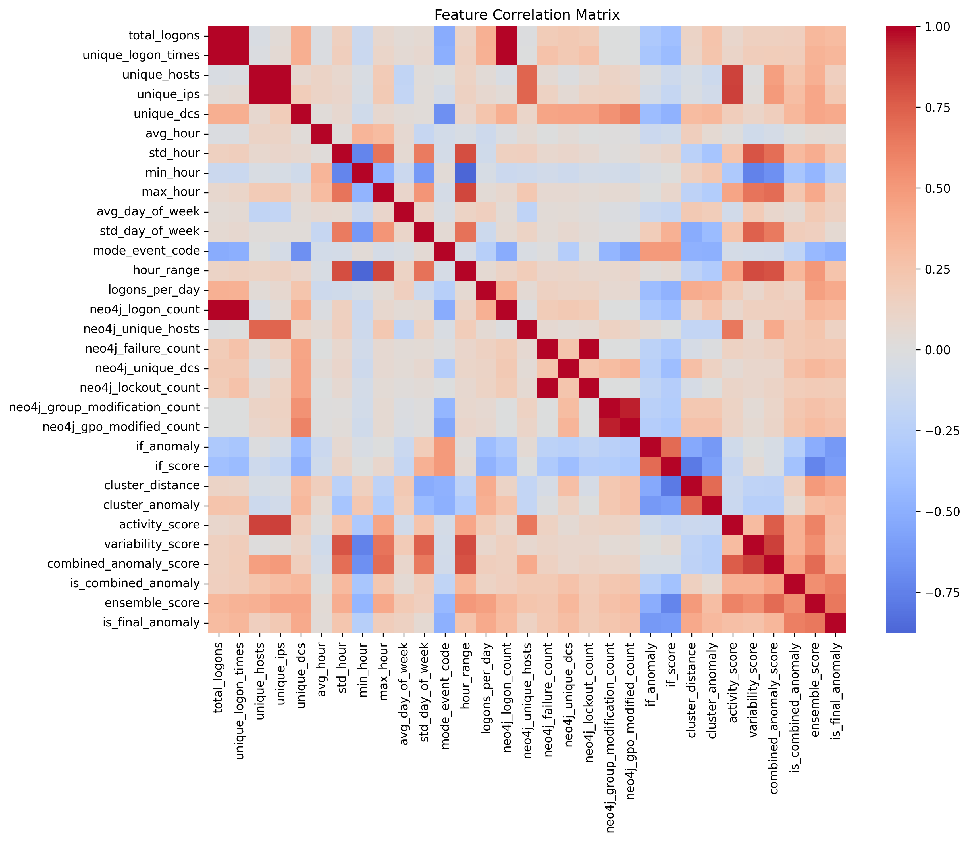
Gambar 5 — Feature Correlation Heatmap
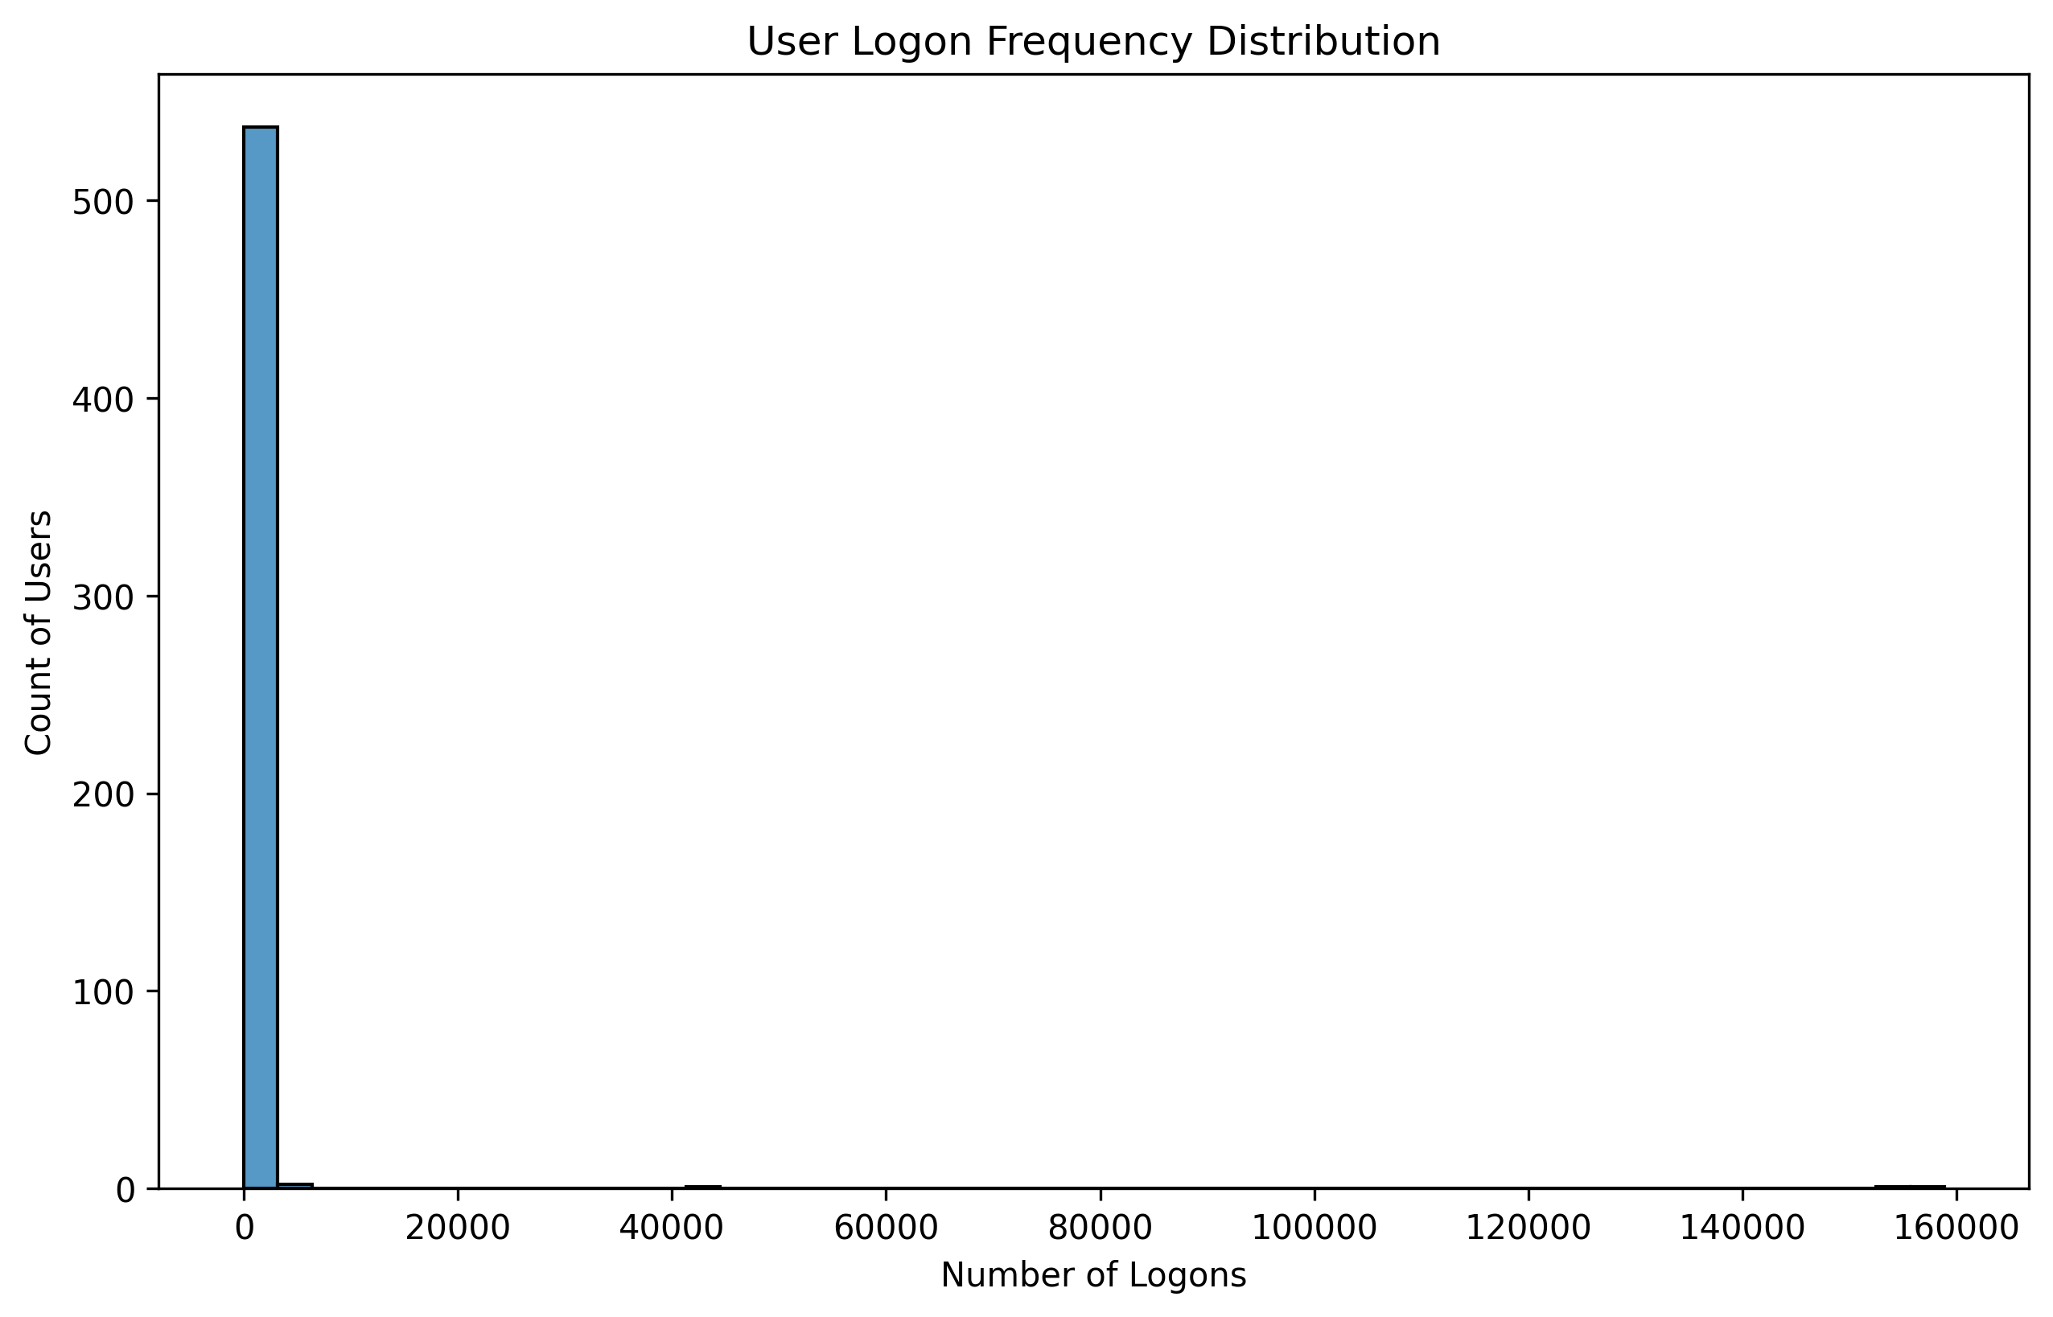
Gambar 6 — Logon Volume Distribution

Slide 16 — Perbandingan dengan Baseline Method
__________________________________________________________________________________________
Method | # Anomalies | % Overlap dgn Ensemble | Catatan
Isolation Forest only | 28 | ~85% | Miss temporal & graph-based cases
K-Means only | 28 | ~80% | Bias ke volume tinggi
Temporal only | — | — | Tidak menangkap volume outlier
Graph score only | — | — | Bias ke user dengan banyak group mods
Ensemble (ours) | 28 | 100% | Konsensus antar-method, FP lebih rendah

Ensemble secara konsisten menangkap anomali yang tidak terdeteksi method individual → mengurangi false negative.

Slide 17 — Case Study: Top Anomaly user_00687 (Ensemble 0.8204)
__________________________________________________________________________________________
Mengapa user_00687 #1 di ensemble ranking?
- 2.349 group modifications (angka TERTINGGI di 559 user) — 11 grup unik.
- 7 GPO modifications → indikasi GPO abuse (MITRE T1484).
- Isolation Forest score -0.225; cluster distance 10.30.
- Failed logon count hanya 36 → BUKAN brute-force, tapi privilege escalation.
Validasi Forensik via Cypher Query:
:param username => 'user_00687';
MATCH (u:User {username: $username})-[r:ADDED_TO_GROUP]->(g:Group)
RETURN u, r, g LIMIT 200;
→ Query ini mengonfirmasi 11 group yang dimodifikasi, memvalidasi bahwa skor ensemble didorong oleh graph component (privilege escalation), bukan hanya statistik.

Slide 18 — Verification Workflow: ML → Cypher (Two-Step)
__________________________________________________________________________________________
Peran masing-masing tool:
- ML (main.ipynb) = Detector — identifikasi kandidat anomali dari volume besar.
- Cypher (query.ipynb) = Verifier — kumpulkan evidence konkret per user.
Aggregate Verification Query (one-shot user profile):
MATCH (u:User {username: $username})
OPTIONAL MATCH (u)-[r:LOGON_TO]->(dc:DomainController)
OPTIONAL MATCH (u)-[f:FAILED_LOGON]->(dc2:DomainController)
OPTIONAL MATCH (u)-[g:ADDED_TO_GROUP]->(grp:Group)
OPTIONAL MATCH (u)-[p:MODIFIED_GPO]->(gpo:GPO)
RETURN u.username, count(DISTINCT dc), count(f), count(grp), count(gpo);
Output untuk user_00687: dc=2, failed=36, group_mod=2349, gpo_mod=7 — KONSISTEN 100% dengan fitur ML di top_anomalies.csv.

Slide 19 — Perbandingan ML vs Cypher Hunting (Case Studies)
__________________________________________________________________________________________
Kasus | Target | Terdeteksi ML? | Terdeteksi Cypher? | Interpretasi
Evident Attacker | user_00001 | Ya (rank #4) | Ya (Brute Force + Multi-DC) | Validasi konsisten — noisy attacker
Statistical Outlier | user_00056, _00680 | Ya (rank #2, #5) | Tidak | Volume ekstrem tapi no policy violation — service account?
Silent Policy Violator | user_00314 | Tidak (top-5) | Ya (5.314 failed login) | ML miss; rule adaptif; perlu hybrid detection

→ Sistem two-pronged: ML (strategic/stealthy APT) + Cypher (tactical/daily alarm) saling check-and-balance terhadap false negative.

Slide 20 — Analisis & Interpretasi: Kelebihan & Kekurangan
__________________________________________________________________________________________

Kelebihan
- Ensemble tangkap 3 jenis pola: volume outlier, relational outlier (graph), temporal outlier.
- Top-5 anomali semua memiliki bukti tambahan dari privilege escalation analysis (high precision Top-N).
- Graph component mengangkat user dengan group_modification tinggi yang tidak terdeteksi IF murni.
- Pipeline reproducible end-to-end; skor explainable (traceable ke Cypher evidence).

Kekurangan
- Threshold 95th pct rigid → 28/28/28 flag mengindikasikan perlu percentile adaptif per role.
- Belum ada ground-truth label → Precision/Recall/F1 formal belum terhitung.
- Beberapa anomali adalah service account (user_00680) → perlu whitelisting metadata.
- Feature skewness tinggi (std logon ribuan) → log-transform mungkin diperlukan.

Slide 21 — Insight Kunci dari Eksperimen
__________________________________________________________________________________________
- Group modification count adalah sinyal paling diskriminatif untuk privilege abuse.
- Relasi graph (group co-modification) memberi konteks yang tidak tertangkap IF tabular.
- Ensemble fusion mengurangi dependensi pada satu model → stabil lintas kondisi log.
- Top-N ranking cocok untuk SOC workflow: review 20–30 user prioritas, bukan ribuan baris.
- Knowledge graph sebagai "force multiplier" — satu schema melayani banyak jenis query forensik.
- Hybrid ML + Cypher menutup blind spot masing-masing metode.

Slide 22 — Rencana / Langkah Selanjutnya
__________________________________________________________________________________________
- Ground-truth labeling sebagian (≥50 user) via review manual → hitung Precision/Recall/F1/AUC formal.
- Ablation study: hapus tiap komponen (IF / K-Means / Temporal / Graph) → ukur kontribusi.
- Benchmark head-to-head vs Bowman (node2vec) dan Kaiafas (IF tabular) di dataset yang sama.
- Adaptive threshold: percentile dinamis per role (admin vs service account).
- Graph embedding lanjutan (node2vec / GraphSAGE) sebagai fitur tambahan.
- Real-time streaming (Neo4j + Kafka) untuk near-real-time detection.
- Paper writing → target IEEE Access / ACM CCS Workshop / Elsevier Computers & Security.

Slide 23 — Kendala Pengerjaan
__________________________________________________________________________________________
- Ketiadaan ground truth → evaluasi kuantitatif Precision/Recall masih terbatas qualitative review.
- Volume data 876 MB → Neo4j batch import lama; perlu tuning batch size & indexing.
- Imbalance fitur: total_logons range sangat lebar (6–184.335) → scaling krusial.
- Service account vs admin real sulit dibedakan tanpa metadata HR/IT.
- Reproducibility paper: dataset enterprise → perlu sintesis/anonimisasi sebelum rilis publik.
- Integrasi skor temporal & graph butuh normalisasi konsisten dgn IF dan K-Means.

Slide 24 — Kesimpulan Ringkas
__________________________________________________________________________________________
- TDAS AD Audit v2 membangun pipeline end-to-end 4-stage untuk deteksi anomali admin AD.
- Pada 559 user dengan 7 sumber log (~876 MB), ensemble fusion mengidentifikasi 28 user anomali final.
- Top-10 anomali memiliki bukti konsisten (privilege escalation, volume ekstrem, failure chain).
- Arsitektur hybrid ML + Cypher Hunting mengurangi false negative (check-and-balance).
- Pendekatan graph + score fusion secara kualitatif mengungguli single-method baseline.
- Fase selanjutnya: ground-truth labeling, ablation study, benchmarking formal vs SOTA.

Slide 25 — Terima Kasih & Diskusi
__________________________________________________________________________________________
Terima Kasih

Diskusi & Q&A

Repository: tdas_adauditv2
Contact: mahathirmuhammad02@gmail.com

