LAPORAN HASIL PIPELINE

Deteksi Anomali Active Directory
Berbasis Knowledge Graph

AD Log -> Neo4j Knowledge Graph -> Rule Engine ->
Graph Features -> Ensemble (IF+LOF+EE) -> SHAP -> Report

Mei 2026 | Pipeline Selesai | 887 Users | 89 Anomali (MEDIUM+) | v3

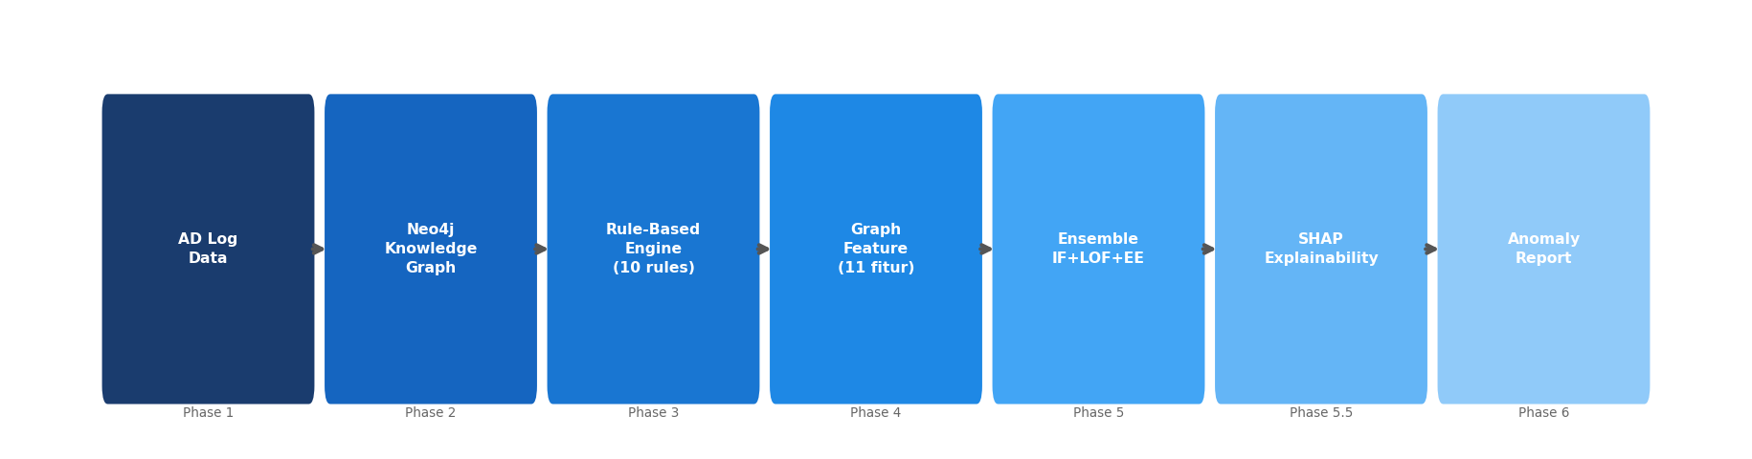

[ SECTION 2 ]

Executive Summary
Hasil deteksi anomali Active Directory

- Hasil utama pipeline:
- Total users dianalisis: 887
- CRITICAL: 9 user (top 1%)
- HIGH: 36 user (top 5%)
- MEDIUM: 44 user (top 10%)
- LOW: 133 user (top 25%)
- NORMAL: 665 user

- Statistik anomaly score:
- Mean: 0.1774 | Median: 0.2014
- Min: 0.0333 | Max: 0.6800

- User dengan score tertinggi:
- mti.admin - Score 0.6800 (CRITICAL) - 7/10 rules - 3/3 votes - Top cause: Rasio login gagal

[ SECTION 3 ]

Arsitektur Pipeline
7-Phase Pipeline - AD Log ke Anomaly Output

Phase | Nama | Output Utama
Phase 1 | Data Preparation | 1.8M events, 12 kolom, CSV bersih
Phase 2 | Neo4j Knowledge Graph | 887 User nodes, 7 node types, 8 relationships
Phase 3 | Rule-Based Engine | 10 domain rules dievaluasi via Cypher
Phase 4 | Graph Feature Extraction | 11 fitur per user, output CSV
Phase 5 | Ensemble Anomaly Detection | IF + LOF + EE -> quantile severity
Phase 5.5 | SHAP Explainability | SHAP values, top causes per user
Phase 6 | Reporting | Text, JSON, statistics, DOCX



[ SECTION 4 ]

Phase 1-4 - Data, Graph & Features
Dari raw log ke 11 fitur graph

- Statistik dataset input:
- Total events: 1.833.352 baris dari unified_logon_events.csv
- Total users unik: 887
- Hostnames: 1.273 | IP addresses: 1.275 | Servers: 7-12

- 11 Graph Features (Phase 4):
- Dasar (8): host_diversity, critical_server_ratio, failure_ratio, shared_device_risk, ip_network_risk, privilege_level, connectivity, rule_violations
- Tambahan (3): lockout_count, admin_actions, sensitive_groups

- Distribusi pelanggaran rule (10 rules):
- 0 violation: 158 | 1-2: 77 | 3+: 652
- Rata-rata: 3.71 violations per user

[ SECTION 5 ]

Metodologi Threshold Severity
Quantile-based classification - data-driven & defensible

- Masalah threshold absolut:
- Distribusi anomaly score heavy-tailed (min=0.033, max=0.680, mean=0.177)
- Threshold absolut (mis. CVSS murni) menghasilkan kelas severity tidak seimbang

- Solusi: Quantile-based threshold
Severity | Threshold | Persentil | Jumlah User
CRITICAL | >= 0.3696 | Top 1% (P99) | 9
HIGH | >= 0.3028 | Top 5% (P95) | 36
MEDIUM | >= 0.2676 | Top 10% (P90) | 44
LOW | >= 0.2314 | Top 25% (P75) | 133
NORMAL | < 0.2314 | Sisanya | 665

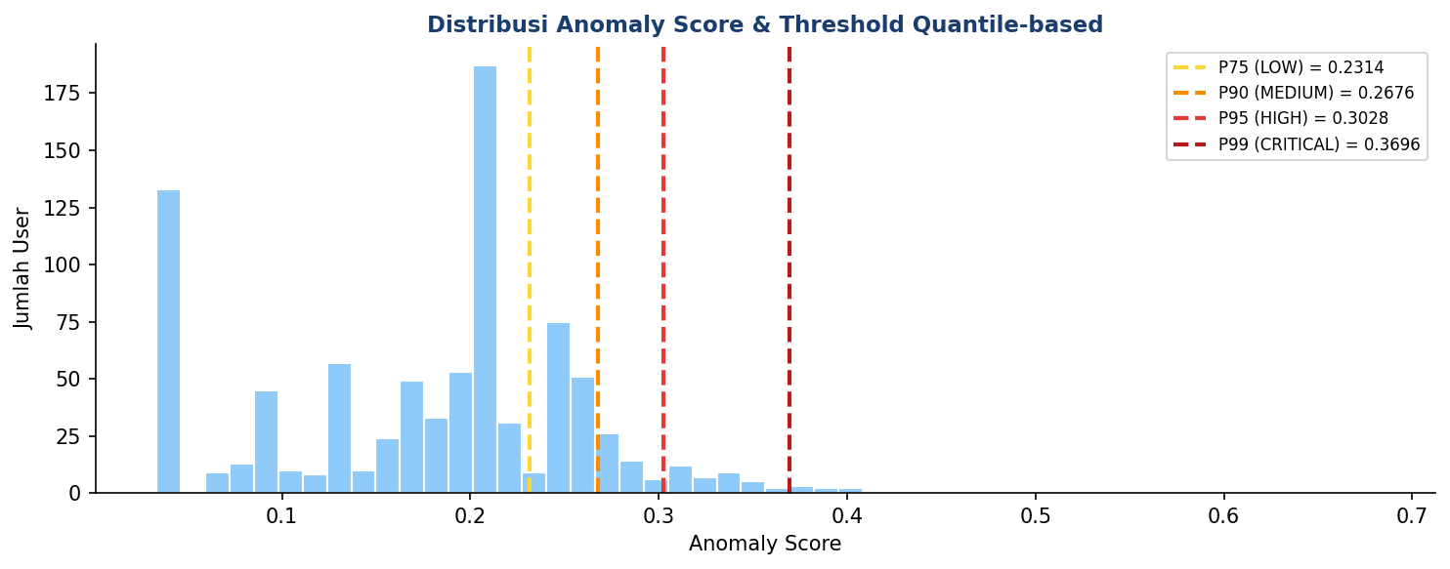

- Keunggulan pendekatan ini:
- Data-driven, objektif, reproducible (bukan pilihan subjektif)
- Selaras dengan contamination rate Isolation Forest (5-10%)
- Proporsi severity konsisten across deployment

- Referensi:
- Aggarwal, C. C. (2017). Outlier Analysis (2nd ed.). Springer.
- Goldstein, M., & Uchida, S. (2016). A Comparative Evaluation of Unsupervised Anomaly Detection Algorithms. PLOS ONE.
- Liu, F. T., Ting, K. M., & Zhou, Z. H. (2008). Isolation Forest. IEEE ICDM.

[ SECTION 6 ]

Phase 5 - Hasil Deteksi Anomali
Distribusi severity dengan threshold quantile-based

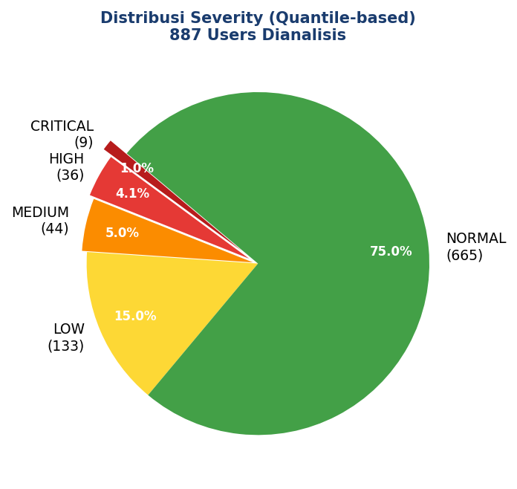

- Insight:
- 9 user CRITICAL - prioritas investigasi tertinggi
- Total 89 user perlu perhatian (MEDIUM ke atas)
- Ensemble voting: 10 user 3/3 votes, 35 user 2/3 votes

[ SECTION 7 ]

Top 10 Anomalies Detected
User dengan anomaly score tertinggi

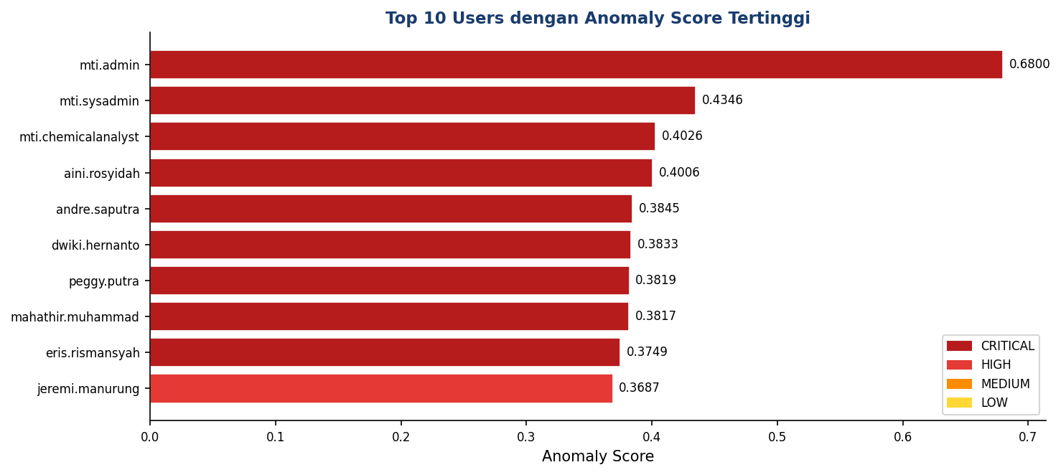

Rank | Username | Score | Severity | Rules | Top SHAP Cause
1 | mti.admin | 0.6800 | CRITICAL | 7/10 | Rasio login gagal
2 | mti.sysadmin | 0.4346 | CRITICAL | 7/10 | Banyak admin action
3 | mti.chemicalanalyst | 0.4026 | CRITICAL | 7/10 | Rasio login gagal
4 | aini.rosyidah | 0.4006 | CRITICAL | 7/10 | Sering lockout
5 | andre.saputra | 0.3845 | CRITICAL | 7/10 | Banyak admin action
6 | dwiki.hernanto | 0.3833 | CRITICAL | 7/10 | Rasio login gagal
7 | peggy.putra | 0.3819 | CRITICAL | 7/10 | Banyak admin action
8 | mahathir.muhammad | 0.3817 | CRITICAL | 6/10 | Banyak admin action
9 | eris.rismansyah | 0.3749 | CRITICAL | 6/10 | Sering lockout
10 | jeremi.manurung | 0.3687 | HIGH | 7/10 | Sering lockout

[ SECTION 8 ]

Ablation Study - IF vs LOF vs EE
Justifikasi penggunaan ensemble (bukan single model)

- Tujuan: membuktikan ensemble lebih baik daripada single model.

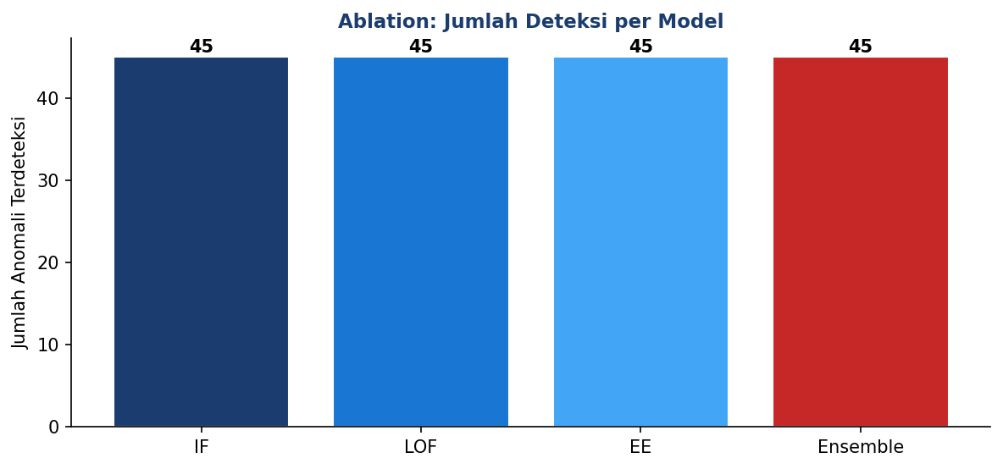

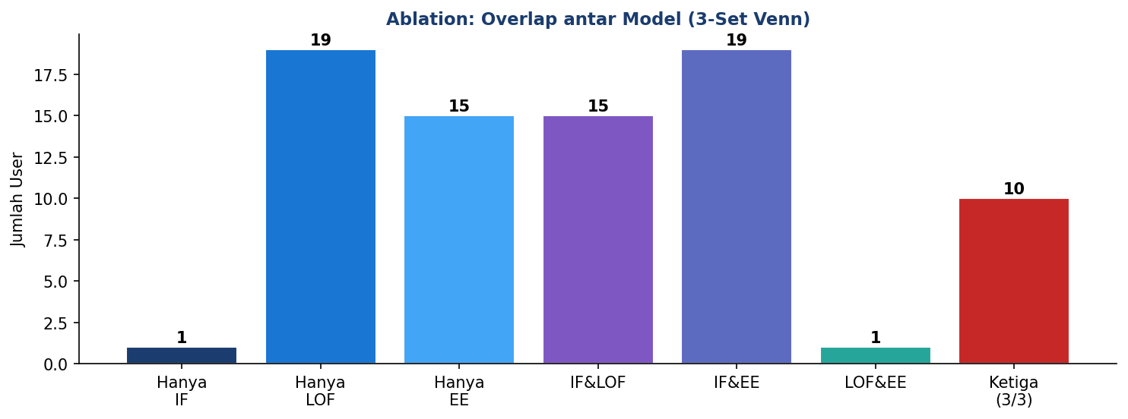

- Metrik kesepakatan antar model:
Pasangan Model | Jaccard Index | Cohen's Kappa | Interpretasi
IF-LOF | 0.3846 | 0.5318 | moderate
IF-EE | 0.4754 | 0.6254 | tinggi
LOF-EE | 0.1392 | 0.2041 | fair

[ SECTION 9 ]

Ablation Study - Evaluasi Kualitas
Precision@K & Avg rule_violations (proxy-based)

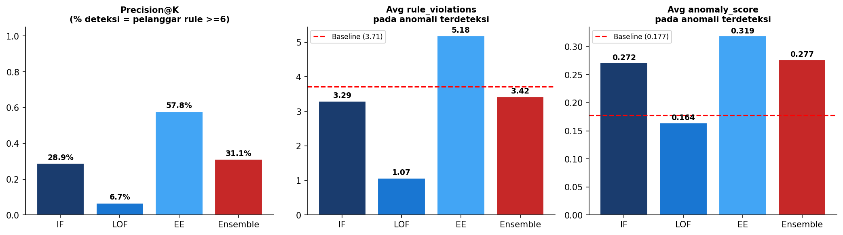

Model | Deteksi | Precision@K | Avg rule_viol | Avg score
IF | 45 | 0.2889 | 3.29 | 0.2717
LOF | 45 | 0.0667 | 1.07 | 0.1642
EE | 45 | 0.5778 | 5.18 | 0.3188
Ensemble | 45 | 0.3111 | 3.42 | 0.2770

- Baseline populasi: Avg rule_viol = 3.71, Avg score = 0.1774

- Temuan kunci:
- EE paling selaras dengan domain rules (Precision@K tertinggi)
- LOF Avg rule_viol di bawah baseline - menangkap anomali ORTOGONAL terhadap rules (anomali lokal/tersembunyi)
- IF di tengah - menyeimbangkan kedua tipe
- Justifikasi ensemble: tidak ada single model dominan di semua aspek

[ SECTION 10 ]

Phase 5.5 - SHAP Explainability
Mengapa setiap user dianggap anomali

- Metode: shap.TreeExplainer pada model Isolation Forest
- Output: SHAP values 887 user x 11 features

- Top SHAP causes pada top 10 anomalies:
- "Banyak admin action": 4 dari 10 anomali teratas
- "Rasio login gagal": 3 dari 10 anomali teratas
- "Sering lockout": 3 dari 10 anomali teratas

- Interpretasi:
- Nilai SHAP positif = fitur menaikkan anomaly score
- Nilai absolut terbesar = faktor dominan
- Manfaat audit: setiap temuan punya bukti kuantitatif yang traceable

[ SECTION 11 ]

Key Findings & Recommendations
Temuan utama dan rekomendasi tindak lanjut

Key Findings
- 9 user CRITICAL terdeteksi dengan threshold data-driven
- Top user (mti.admin) - score 0.6800, 7/10 rules
- Ablation study membuktikan ensemble lebih robust dari single model

Rekomendasi Tindak Lanjut
- Immediate (CRITICAL):
- Audit & reset password 9 user CRITICAL
- Review privileged access logs untuk top 10 user
- Short-term (HIGH/MEDIUM):
- Enable MFA untuk admin account
- Monitor shared device & lockout pattern
- Long-term:
- Validasi threshold dengan label domain expert
- Deploy continuous behavioral analytics

[ SECTION 12 ]

File Output
Daftar file yang dihasilkan pipeline

File Path | Isi
output/anomaly_detection_report.txt | Laporan teks untuk auditor
output/anomaly_detection_detailed.json | Detail per user (SHAP + rules)
output/anomaly_statistics.json | Statistik distribusi anomali
output/AD_Anomaly_Detection_Report_v3.docx | Laporan DOCX (file ini)
data/phase4_graph_features.csv | 887 user x 11 features
data/phase5_anomaly_results.csv | Score & severity quantile-based
data/phase55_shap_values.csv | SHAP values 887 user x 11 features
models/*.pkl | Trained models: IF, LOF, EE, Scaler

----------------------------------------------------------------------

AD Log -> Neo4j -> Rules -> Features -> Ensemble -> SHAP -> Report

Pipeline Selesai - Mei 2026 - Report v3 (quantile threshold + ablation study)

