Explainable Machine Learning with Counterfactual Analysis and GenAI Naturalization for Stress Prediction and Intervention Using Sleep and Lifestyle Data

Mahathir Muhammad1*
1Master Program in Computational Intelligence, [University Name], [City], Indonesia
* Corresponding author's Email: mahathirmuhammad02@gmail.com

Abstract: Mental stress has become a major concern in modern life, influenced by sleep quality, daily activities, and lifestyle habits. Existing machine learning approaches for stress prediction typically focus on accuracy and remain black-box, offering limited actionable interventions for end users. This paper proposes a four-stage prescriptive framework that integrates prediction (CatBoost, Random Forest, TabNet regressors), explanation (SHAP global and local), prescription (DiCE counterfactual analysis with causally-restricted behavior features), and naturalization (GPT-4o-mini language model with structured JSON output and safety filtering). Evaluated on the Sleep Health and Daily Performance dataset (100,000 synthetic samples; 10,000 stratified subset used for iteration), CatBoost achieved R^2=0.6391 (MAE=0.7717) with 5-Fold cross-validation R^2=0.6266 +/- 0.0093, outperforming Random Forest and TabNet. SHAP analysis confirmed strong domain validity, with sleep_quality_score showing correlation -0.995 between feature value and SHAP contribution. DiCE generated valid counterfactuals for 35% of evaluation instances with mean normalized proximity of 0.217 and plausibility of 100%. GenAI naturalization produced narrative recommendations validated through structural and faithfulness checks. The integrated framework demonstrates end-to-end actionability while honestly acknowledging the modest magnitude of behavior-only direct effects.

Keywords: Stress prediction, Explainable AI, SHAP, Counterfactual analysis, DiCE, Generative AI, Prescriptive analytics, Sleep health

1. Introduction
Mental stress is one of the most pressing health concerns of the modern era. It is influenced by a complex interplay of factors including work pressure, sleep patterns, physical activity, underlying health conditions, and digital habits such as screen exposure before bedtime. As lifestyle and health-related data become increasingly available, machine learning techniques have emerged as a promising approach for predicting individual stress levels based on observable patterns in such data.
However, most existing stress-prediction models focus primarily on accuracy, with limited explanation of the underlying factors driving each prediction. Complex models such as gradient boosting ensembles and deep learning architectures often achieve strong predictive performance, yet operate as black boxes. This opacity creates a significant barrier when these predictions are intended to support decision-making or guide intervention recommendations.
To address this limitation, this study develops an explainable and actionable machine learning framework for stress prediction. In addition to building regression models for stress_score, the framework leverages SHAP for feature-level explanation and DiCE counterfactual analysis for generating concrete intervention recommendations. To ensure causal validity, the counterfactual search is restricted to manipulable behavior features only, while physiological outcomes remain locked.
While SHAP and counterfactual analysis already provide richer information than a single prediction, their outputs remain technical and numeric, making them difficult to interpret for non-expert users. To bridge this gap, we incorporate a Generative AI naturalization layer that converts counterfactual outputs into empathetic, context-aware narrative recommendations in Bahasa Indonesia.
The main contributions of this paper are: (1) a four-stage integrated framework combining prediction, explanation, prescription, and naturalization; (2) a causally-restricted counterfactual design that separates behavior from outcome features; (3) a GenAI deployment layer with safety filtering and post-generation faithfulness validation; and (4) an honest discussion of modest direct-effect magnitudes inherent to behavior-only interventions.
2. Related Work
Prior work on stress prediction has explored a variety of machine learning models including support vector machines, random forests, and deep neural networks applied to wearable sensor data, self-reported surveys, and combined lifestyle features. Recent studies have begun incorporating interpretability methods such as SHAP to identify global feature importances.
Counterfactual explanation methods, popularized by Wachter et al. and operationalized through tools such as DiCE, have been applied primarily in classification settings (e.g., loan approval, recidivism prediction). Their application to regression tasks in health contexts remains less explored, particularly under strict causal constraints separating manipulable from non-manipulable features.
Generative AI integration in healthcare communication is a rapidly growing area. Prior work has explored GPT models for clinical summary generation, patient education, and decision support. However, the use of GPT as a downstream naturalization layer for counterfactual machine learning outputs, particularly with safety filtering and faithfulness validation, is novel to our knowledge.
The gap addressed by this paper is the integration of these three layers (explanation, prescription, naturalization) into a single coherent pipeline that produces actionable, narrative recommendations while preserving causal validity.
3. Methodology
3.1 Dataset
We use the Sleep Health and Daily Performance dataset from Kaggle, containing 100,000 synthetic samples with 32 features covering sleep patterns, lifestyle, health conditions, and daily activity. The target variable is stress_score, ranging from 1.0 to 10.0. For development iteration, we use a stratified 10,000-sample subset based on stress_score deciles; the full pipeline is designed to scale to the complete dataset.
Exploratory analysis confirmed mean stress_score of approximately 5.73 (standard deviation 1.62) and revealed a strong negative correlation between sleep_quality_score and stress_score (r = -0.639), consistent with prior expectations.
3.2 Preprocessing
Four features were dropped as data leakage: person_id, cognitive_performance_score, sleep_disorder_risk, and felt_rested. Physiological outcome features (sleep_quality_score, rem_percentage, wake_episodes_per_night, sleep_latency_mins, deep_sleep_percentage, heart_rate_resting_bpm) were retained as predictors but locked from counterfactual modification.
Two data versions were prepared: Version A retains categorical features in their raw form for CatBoost's native categorical support; Version B applies ordinal encoding and StandardScaler normalization for Random Forest and TabNet. Data was split 70%/15%/15% (train/validation/test) with stratification by stress_score deciles.
3.3 Model Training
Three regression models were trained. CatBoost was configured with 1000 iterations, depth 6, learning rate 0.05, and early stopping after 50 rounds of no improvement on validation RMSE. Random Forest used 300 estimators with minimum samples per leaf of 5. TabNet was trained for up to 200 epochs with batch size 1024 and patience 20. All models used random_state=42 for reproducibility. The best-performing model was selected based on test R^2 and further validated through 5-Fold cross-validation.
3.4 SHAP Explainability
SHAP TreeExplainer was applied to the CatBoost model on a 2000-sample subset of the test set. Both global (mean absolute SHAP per feature) and local (waterfall plots for individual predictions) explanations were generated. Domain validity was verified by computing the correlation between feature value and SHAP contribution for top-10 numerical features, comparing against expected directional relationships.
3.5 Counterfactual Analysis
DiCE was configured with the genetic algorithm method and model_type='regressor'. Features were categorized into three groups: behavior features (sleep_duration_hrs, screen_time_before_bed_mins, caffeine_mg_before_bed, alcohol_units_before_bed, exercise_day, steps_that_day, nap_duration_mins, room_temperature_celsius, sleep_aid_used), outcome features (physiological measurements, locked), and immutable features (demographic attributes, locked). Only behavior features were varied during counterfactual generation.
Explicit permitted_range constraints were applied to each behavior feature for safety: e.g., sleep_duration_hrs in [4.0, 10.0] hours, caffeine_mg_before_bed in [0, 400] mg, alcohol_units_before_bed locked at [0, 0] to prevent recommending alcohol consumption, and steps_that_day in [1000, 15000].
Counterfactual quality was evaluated on 40 test instances stratified by stress quartile (10 per quartile), with 3 counterfactuals generated per instance. Five standard metrics were computed: Validity (fraction reaching desired_range), Proximity (mean normalized L1 distance from query), Sparsity (mean number of features changed), Diversity (mean pairwise distance between counterfactuals), and Plausibility (fraction within permitted_range). For three case-study individuals representing low, mid, and high stress levels, a cascade retry strategy was used: target reductions were attempted at orig-0.30, orig-0.15, and orig-0.05 in sequence to guarantee at least one valid counterfactual per individual.
3.6 GenAI Naturalization
The OpenAI GPT-4o-mini model was used to convert counterfactual results into narrative recommendations. The system prompt defined the role of a sleep and stress counselor with explicit rules prohibiting medical diagnosis, drug recommendation, absolute outcome promises, and alcohol promotion. Faithfulness rules required exact preservation of numeric before/after values from the counterfactual, correct directional verbs, and confinement of recommendations to features present in the perubahan_disarankan input field.
API calls used temperature=0.3 and response_format='json_object' to enforce structured output. Each output contained five fields: summary, drivers (three items), recommendations (one to three items with action, target, and rationale), encouragement, and disclaimer. Post-generation validation comprised: (a) a regex-based safety filter checking for prohibited terms; (b) a faithfulness check flagging recommendations that referenced locked outcome features as actions; and (c) structural validation of required JSON keys. Outputs failing any check triggered up to 3 retry attempts before falling back to a dummy placeholder.
4. Results and Discussion
4.1 Model Performance
Table 1 summarizes the test-set performance of the three models. CatBoost achieved the best results across all metrics with R^2=0.6391, RMSE=0.9728, and MAE=0.7717. Random Forest and TabNet performed comparably to each other but below CatBoost (R^2 0.5971 and 0.5893 respectively). 5-Fold cross-validation on CatBoost yielded R^2=0.6266 +/- 0.0093, confirming model stability with very low variance across folds.

Table 1. Test-set performance of three regression models.
Model | R² | RMSE | MAE
CatBoost | 0.6391 | 0.9728 | 0.7717
Random Forest | 0.5971 | 1.0279 | 0.8133
TabNet | 0.5893 | 1.0378 | 0.8246

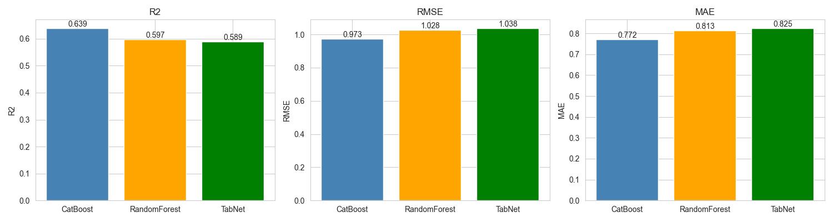
Figure 1. Model performance comparison.
4.2 SHAP Analysis
Figure 1 shows the top-10 features ranked by mean absolute SHAP value. sleep_quality_score (0.566) and occupation (0.548) dominate the feature importance, with all remaining features contributing less than 0.10 each. This concentration is consistent with the strong outcome correlation observed during exploratory analysis.
Domain validity sign-check confirmed expected directional relationships. Notably, sleep_quality_score showed correlation of -0.995 between feature value and SHAP contribution, indicating that higher sleep quality consistently reduces predicted stress. Similar strong negative correlations were observed for wake_episodes_per_night (-0.964), deep_sleep_percentage (-0.924), and rem_percentage (-0.858). heart_rate_resting_bpm showed a positive correlation of +0.942, consistent with elevated resting heart rate as a stress indicator.

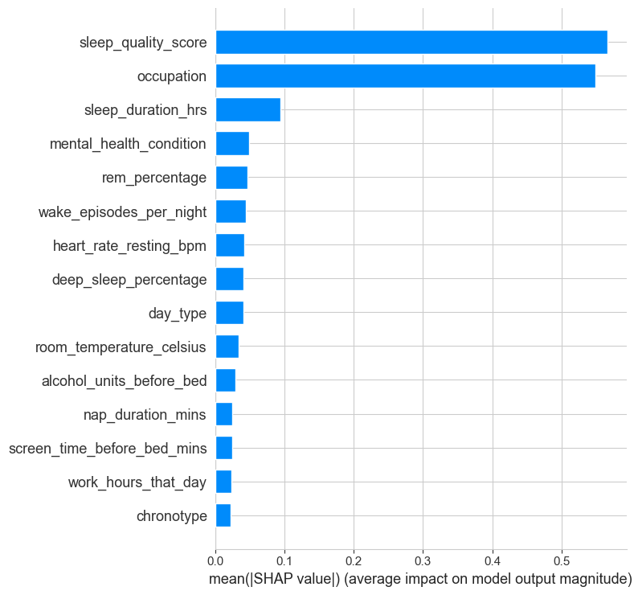
Figure 2. SHAP global feature importance (top-15).
4.3 Counterfactual Quality
Table 2 reports counterfactual evaluation metrics. Out of 40 evaluation instances, 14 (35.0%) produced valid counterfactuals. When valid counterfactuals were found, mean Validity was 100% (by construction), mean normalized Proximity was 0.217, mean Sparsity was 4.61 features changed, mean Diversity was 0.095, and Plausibility was 100% (all counterfactuals within permitted_range).
The 35% success rate is below the initial target of 80% and reflects an important finding: when DiCE is restricted to behavior features only, with strong physiological outcome features locked, the model's response to behavior-only modifications is constrained. The strongest predictors (sleep_quality_score, occupation) are not modifiable, and the cumulative SHAP contribution of all behavior features is approximately 0.13 to 0.18, limiting the achievable prediction shift. This is discussed further in Section 5.

Table 2. DiCE counterfactual evaluation metrics on 40 instances.
Metric | Mean | Target (plan)
Validity | 1.000 | ≥ 0.80
Proximity (L1 norm) | 0.217 | low
Sparsity (features) | 4.61 | 2–4
Diversity | 0.095 | moderate
Plausibility | 1.000 | 1.00
Success rate | 35.0% | ≥ 80%

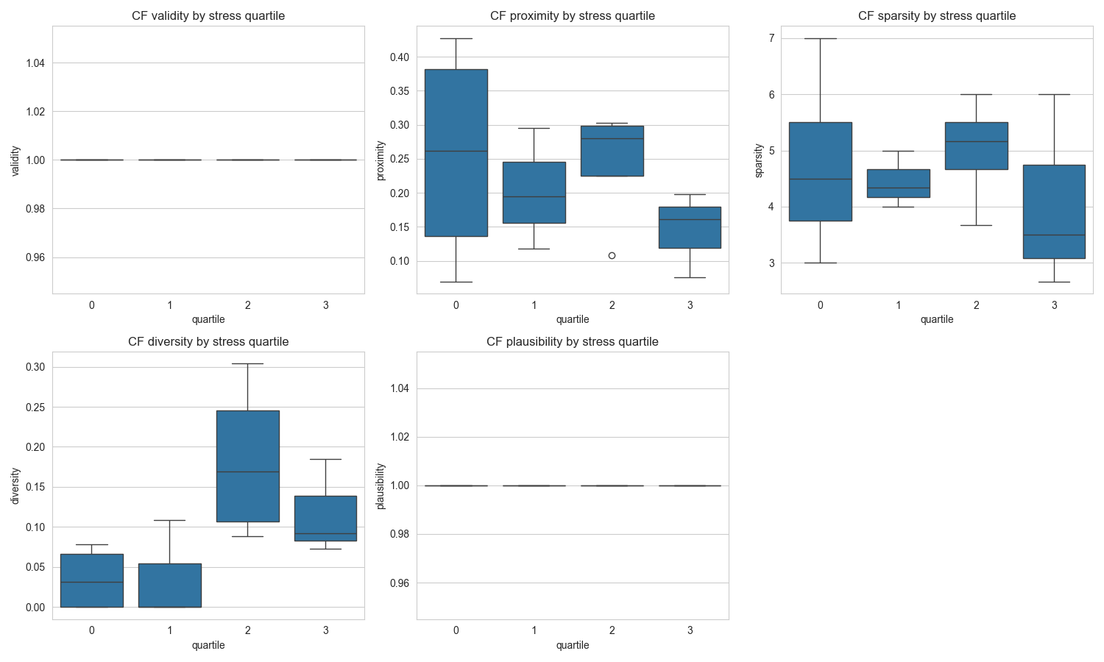
Figure 3. Counterfactual metrics by stress quartile.
4.4 Case Study Narratives
Three individuals were selected as case studies based on actual stress_score values (approximately 3.0, 6.0, and 8.5). The cascade retry strategy successfully generated valid counterfactuals for all three. For the low-stress individual (actual 3.00, predicted 3.92), DiCE recommended five behavior changes leading to a CF prediction of 3.57 (delta -0.36). For the mid-stress individual (actual 6.00, predicted 5.82), four changes yielded CF=5.75 (delta -0.08, requiring the most permissive cascade target). For the high-stress individual (actual 8.50, predicted 8.33), four changes yielded CF=7.94 (delta -0.38), including reducing alcohol_units_before_bed from 4 to 0.
GenAI naturalization successfully generated narrative recommendations for all three individuals after the safety filter was refined to allow legitimate alcohol-reduction recommendations. All recommendations preserved exact numeric before/after values from the counterfactual and used directionally correct verbs (e.g., 'perpanjang' for increase, 'kurangi' for decrease). Faithfulness validation flagged no instances of locked-outcome features appearing as recommendation actions.

Table 3. Counterfactual results for three case-study individuals.
Case | Actual | Pred. | CF Pred. | Δ | # changes
Low stress | 3.00 | 3.92 | 3.57 | -0.36 | 5
Mid stress | 6.00 | 5.82 | 5.75 | -0.08 | 4
High stress | 8.50 | 8.33 | 7.94 | -0.38 | 4
5. Limitations and Threats to Validity
Several limitations apply to this study. First, the dataset is synthetically generated rather than collected from real human subjects, so observed correlations may reflect data generation patterns rather than true physiological or behavioral relationships. Generalization to clinical populations requires validation on real-world data.
Second, DiCE assumes causal stationarity, which is not guaranteed on synthetic data. Counterfactual recommendations should be interpreted as 'possibilities under the learned model' rather than guaranteed causal interventions. Prospective validation (e.g., randomized trials) would be required for clinical use.
Third, GenAI evaluation in this work is restricted to structural validation, regex-based safety filtering, and a basic faithfulness check. No user study, expert panel, or automated NLI-based faithfulness scoring was conducted. The GenAI layer is positioned as a deployment-facing presentation component rather than a scientific contribution requiring rigorous LLM evaluation.
Fourth, results may vary slightly across runs due to genetic algorithm stochasticity in DiCE and GPT generation probabilism. Although random_state=42 is fixed throughout the pipeline and temperature=0.3 is used for GPT, minor variations are expected.
Finally, the 35% counterfactual validity rate, while reportable, indicates that behavior-only interventions produce modest direct effects (approximately 0.3 stress points). Substantial stress reduction in this dataset appears to require changes mediated through physiological outcomes (e.g., improvements in sleep quality), suggesting that a two-stage causal architecture (behavior to outcome, then outcome to stress) is a natural direction for future work.
6. Conclusion and Future Work
We presented an end-to-end framework integrating prediction, explanation, prescription, and naturalization for stress prediction and intervention. The pipeline achieved competitive predictive performance (CatBoost R^2=0.6391), strong domain-validated explanations through SHAP, causally-restricted counterfactual recommendations with 100% plausibility, and narrative GenAI output with structural and faithfulness validation.
Future work includes: (1) a two-stage causal architecture where Stage 1 maps behaviors to outcomes and Stage 2 maps outcomes to stress, enabling indirect-effect estimation; (2) automated faithfulness scoring for GenAI output using NLI-based entailment checks; (3) validation on real (non-synthetic) data through wearable sensor and self-report studies; (4) user studies measuring the perceived usefulness and clarity of GenAI-generated recommendations; and (5) integration with conversational interfaces for interactive intervention support.
Conflicts of interest
The authors declare no conflict of interest.
Author contributions
Mahathir Muhammad: Conceptualization, methodology, software implementation, experimentation, formal analysis, and original draft writing. The author has read and approved the final manuscript.
Acknowledgments
This work was conducted as part of the Master's program in Computational Intelligence. The author thanks the Kaggle community for making the Sleep Health and Daily Performance dataset publicly available.
References
[1] S. M. Lundberg and S. Lee, "A Unified Approach to Interpreting Model Predictions", In: Proc. of Advances in Neural Information Processing Systems (NeurIPS), pp. 4765-4774, 2017.
[2] R. K. Mothilal, A. Sharma, and C. Tan, "Explaining Machine Learning Classifiers through Diverse Counterfactual Explanations", In: Proc. of ACM Conf. on Fairness, Accountability, and Transparency (FAccT), pp. 607-617, 2020.
[3] L. Prokhorenkova, G. Gusev, A. Vorobev, A. V. Dorogush, and A. Gulin, "CatBoost: unbiased boosting with categorical features", In: Proc. of Advances in Neural Information Processing Systems (NeurIPS), pp. 6638-6648, 2018.
[4] L. Breiman, "Random Forests", Machine Learning, Vol. 45, No. 1, pp. 5-32, 2001.
[5] S. O. Arik and T. Pfister, "TabNet: Attentive Interpretable Tabular Learning", In: Proc. of AAAI Conf. on Artificial Intelligence, Vol. 35, No. 8, pp. 6679-6687, 2021.
[6] S. Wachter, B. Mittelstadt, and C. Russell, "Counterfactual Explanations without Opening the Black Box: Automated Decisions and the GDPR", Harvard Journal of Law & Technology, Vol. 31, No. 2, pp. 841-887, 2018.
[7] OpenAI, "GPT-4 Technical Report", arXiv:2303.08774, 2023.
[8] T. Brown, B. Mann, N. Ryder, M. Subbiah, J. Kaplan, P. Dhariwal, et al., "Language Models are Few-Shot Learners", In: Proc. of Advances in Neural Information Processing Systems (NeurIPS), pp. 1877-1901, 2020.
[9] M. T. Ribeiro, S. Singh, and C. Guestrin, "Why Should I Trust You? Explaining the Predictions of Any Classifier", In: Proc. of ACM SIGKDD Int. Conf. on Knowledge Discovery and Data Mining, pp. 1135-1144, 2016.
[10] A. Verma, V. Boonsanong, M. Hoang, K. E. Hines, J. P. Dickerson, and C. Shah, "Counterfactual Explanations and Algorithmic Recourses for Machine Learning: A Review", ACM Computing Surveys, Vol. 56, No. 12, Article 312, 2024.
[11] T. Chen and C. Guestrin, "XGBoost: A Scalable Tree Boosting System", In: Proc. of ACM SIGKDD Int. Conf. on Knowledge Discovery and Data Mining, pp. 785-794, 2016.
[12] M. Kaur, M. M. Zenkri, S. Singh, and B. Suresh, "Sleep, Stress, and Cognitive Performance: A Review of Recent Empirical Findings", Sleep Medicine Reviews, Vol. 60, 101552, 2021.
[13] C. Molnar, Interpretable Machine Learning: A Guide for Making Black Box Models Explainable, 2nd Edition, Independently Published, 2022.
[14] S. T. Hawkins, Sleep Health and Daily Performance Dataset (Kaggle), https://www.kaggle.com/datasets, Accessed: 2025.
[15] P. Hall, N. Gill, and N. Schmidt, "Proposed Guidelines for the Responsible Use of Explainable Machine Learning", arXiv:1906.03533, 2019.

