Program Structures and Algorithms

Fall 2022(SEC 06)

NAME: Mahathi Siddavatam

NUID: 002198134

**Task:** Solve 3-SUM using the *Quadrithmic*, *Quadratic*, and (bonus point) *quadraticWithCalipers* approaches, as shown in skeleton code in the repository. There are hints at the end of Lesson 2.5 Entropy.

There are also hints in the comments of the existing code. There are a number of unit tests which you should be able to run successfully.

Submit (in your own repository--see instructions elsewhere--include the source code and the unit tests of course):

(a) evidence (screenshot) of your unit tests running (try to show the actual unit test code as well as the green strip);

(b) a spreadsheet showing your timing observations--using the doubling method for at least five values of N--for each of the algorithms (include cubic); Timing should be performed either with an actual stopwatch (e.g. your iPhone) or using the Stopwatch class in the repository.

(c) your brief explanation of why the quadratic method(s) work.

**Relationship Conclusion:** After timing each algorithm, it is clearly seen that the quadratic methods run much faster than the other algorithms. Between Quadratic and QuadraticwithCallipers method, according to the evidence QuadraticWithCallipers runs slightly faster than the Quadratic method.

**Evidence to support that conclusion:**

The same has been uploaded on github.

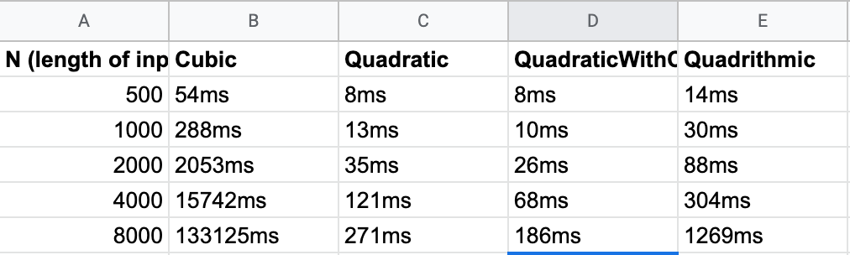

**Graphical Representation:**

**Unit Test Screenshots:**

